Game Design & Asset Creation 1
Written Evaluative Report
M5X02043 // A Head - R. W. Morgan
Hamza A. Qasim // 2103929
University of Wales Trinity Saint David

The Overview
The basis of our whole project was to be a third person survival horror game set in an abandoned ice cream parlour in the late 1980’s. The name our team decided on was “I Scream”, a pun on ice cream, incorporating a horror theme behind it with the “Scream” part of the name.
The game contains two characters, one being the playable main character portrayed as a young girl who got dared by her friends to explore the abandoned parlour during a dark, cold and foggy night. The doors wouldn’t budge and no matter what they threw at the windows, they just wouldn’t break, so she ended up making her way in through the rear entrance. However, this doesn’t go to plan as part of the roof caves in as our character makes it in, separating her from her friends altogether and trapping her inside with no way out.
The other character was initially supposed to be a roaming non playable character (NPC) that would follow the playable character if they were seen but because of limited engine knowledge, and the lack of a finished character, the NPC was put in as just an interactable character with nothing quite substantial behind him.
The aim of the game was to explore the area as a whole and find clues as to what happened to Mr Scream before you could escape, although it is a survival horror, there was a peaceful ending to it, that being figuring out what happened, helping his soul rest and then escaping the parlour. This hadn’t come to fruition in the final version of the project but that is what it was initially designed to be.

Desired Target Audience
The target audience for this game were mainly young adults, between the ages of 17 and 25 who are horror enthusiasts and thrill seekers. The selected demographic was chosen because of the most common reason, that young adults and teenagers to be specific enjoy thrills. These thrills are more likely to excite a younger audience rather than an older one. [1]
The PEGI rating [2] was decided as 16 because it indicates content that depicts violence that looks the same as would be expected in real life. There is also the use of extreme bad language when it comes to voice lines for the playable character, which can be heard during jumpscares, interacting with items and being chased by the non playable character.
The ESRB rating [3] was decided as Mature 17+ for essentially the same reason as the PEGI rating with the addition of a strong language content descriptor.

Design/Theming Choices
As a group we decided what each person was doing for this project. I was in charge of setting the scene within the game itself, where everything was supposed to take place. I researched old “retro” restaurants and ice cream shops to truly get a feel for what I was going to model myself. I wanted to take inspiration from the images but not quite copy them literally. Whilst researching for the images, one scene stuck out to me from the Pixar movie Cars. The buildings around the town of Radiator Springs had a very retro feel to them, granted they had a lot more lighting and weren’t quite horrific looking but it was essentially exactly what I was going for with the over the top exaggerated building features that showcased exactly what the building was used for. 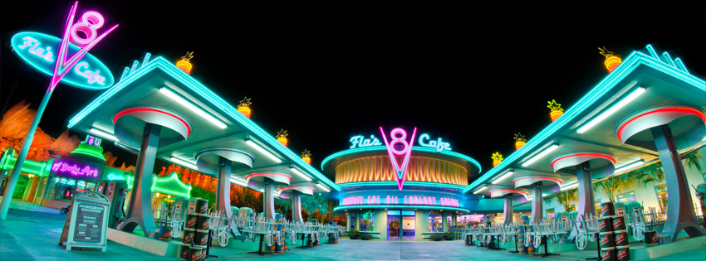
[4]

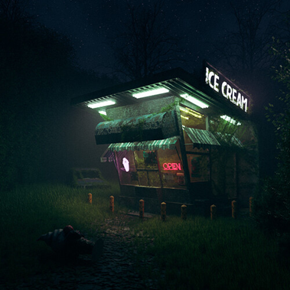
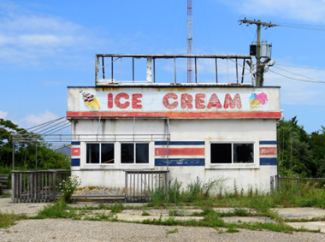
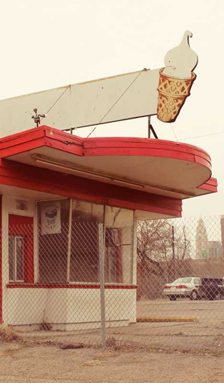
Pictured above is a real restaurant based off of Flo’s Cafe within the fictional town of Radiator Springs from Cars. From the building features alone, one can tell that this is a cafe for cars with V8 engines, providing the best delicacies for them and all other similar cars.
[7]
[6]
[5]
The images above are other references I used as inspiration when designing my building. I wanted it to look run down but still have the aesthetic of an ice cream parlour, I wanted it to look rough and withered but at a glance someone could tell exactly what was going on within the building itself. The signs in Flo’s Cafe in comparison to the pictures above are a lot brighter, capturing the players attention, but keeping in mind with the building now being abandoned, it didn’t make sense for me to use lights to attract the players attention. This meant that I could only use the features of the building itself, as seen in reference no. 5, the ice cream sign shows you what the building is without the need for any text.
Pictured below is what I finalised as the design within the game. It has the overly exaggerated design features that I was so desperately looking for, which convey to the players exactly what the building is used for. The texturing was done specifically to make it look grimy and nasty. This is done on purpose as this is quite an old building and making it look good would defeat the purpose of the horror game being set in an abandoned building as a whole.
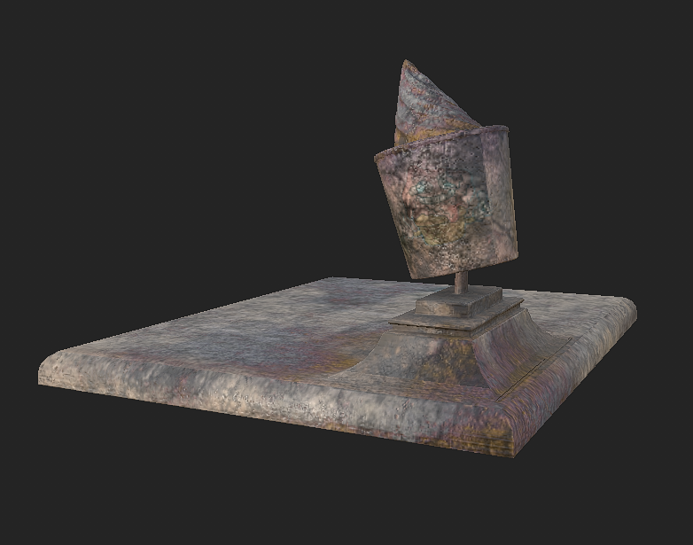
[8]

I also looked into creating a logo for the “brand” we as a team were portraying in the game. We came up with many names such as Scoops n’ Smiles, Scoopy Doo and The Dreamery Creamery. We stuck with the brand being called Scoops n’ Smiles for the sole reason that it rolled off our tongues quite well. I looked at many articles about making logos and what I learned was, that the majority of logos for ice cream companies either had a mascot or some generic clip art relating to ice cream in some way shape or form, whether it was lines or geometry making it seem like something was there or just a picture of a cone or tub.
I decided to mash both of these ideas up and made a logo that made me feel uncomfortable looking at it. I designed the cone mascot in Photoshop using old assets already available to me through my past projects. I made a transparent PNG to be used by everyone in the group should they need to add it to anything they were texturing or modelling, the text however, is white so it won’t show up on a white background. I also made an image with a pink circular background as it reminded me of many logos, all which seemed to have pink as a main colour when it came to anything ice cream related. The results are below.


[9]

Self-Learning
The only thing I didn’t need to research or learn for were the assets modelled in Autodesk Maya. I did however have some software issues with Maya which I kept having to use the internet to find solutions for, a major issue being that every exported FBX file was not centred to the world origin point. Other programs like Blender, 3dsmax and even Cinema 4D do this by default. I did a lot of self learning when it came to using Unreal Engine as that was something I was not familiar with at all. I learned how to use the blueprints within the template we were given to make my assets work in game. I also learned my way around importing my own assets and making sure they were the correct size and in line with the character model from Unreal itself as our group had issues with importing our own characters to use.
After creating all of my assets, I went back to UV unwrap each individual asset so I could texture them using Adobe’s Substance Painter. This is something I had never used before so it was truly a new experience for myself. I watched some YouTube tutorials on this, this helped greatly as I didn’t even know that I had to bake materials onto the mesh itself or what baking did. I also learned how to essentially stamp on textures to part of the mesh when texturing, this helped greatly when I was doing the texturing for the non playable character’s clothing as well as the fabric for the high chairs.
I taught myself how to remesh characters as well. Our original character models made by a team member had roughly 400,000 tri’s. This meant that when working with the mesh, especially UV Unwrapping or even something as simple as smoothing the mesh, would take time to process in Maya. I took it upon myself to Remesh, Simplify and Reconstruct the mesh for the characters as I had more time available for this than my team members and wanted a finished product. I performed explicit remeshing of the triangular mesh by repeatedly applying edge flip, collapse, relax and refine operations to regularise the size and aspect ratio of the triangular meshing. The whole mesh was then simplified using a quadric based edge-collapse strategy and then the surface was reconstructed using the ball pivoting algorithm, starting with the first triangle, the algorithm pivots a ball of the given radius around the already formed edges until it touches another point, forming another triangle. After all these methods were used, I ended up with character models that had 8500 and 12500 tri’s resulting in a 97.88% and 96.88% decrease.
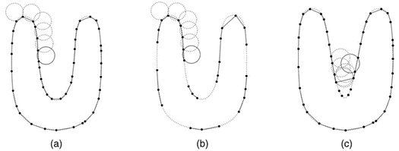
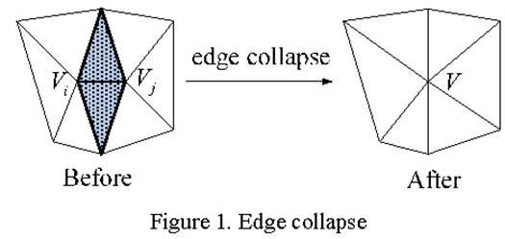
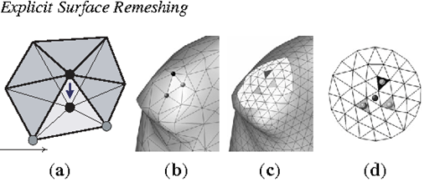
[12]
[11]
[10]

Research

All research relating to my role:
I spent a lot of my time looking through articles that detailed what furniture and buildings looked like in the 1980’s. This was essential in order to find out exactly what kind of aesthetic would be set in place for the building itself as well as the assets that went into it. I also looked at what abandoned and rundown places looked like, so I could improve my own work by following the research to some degree but not making it look exactly like that. I still wanted my work to have my own personal touch to it.

How I researched:
I mainly researched by finding articles on the internet for the design aspect. For everything in relation to modelling assets, texturing and in-engine work, I looked more towards YouTube tutorials as they went a lot more in depth. A 30-minute video on a topic had more knowledge in it than a whole article talking about the same thing. Watching and learning from videos kept me more engaged and focused than simply reading articles about what I should do. I also ended up finding the documentation for the template itself but by then it was too late to actually use it. I would’ve much preferred if we had the documentation to begin with in the first place as it would have stopped me from wasting time looking at tutorials for things that did not work in the template because of the specificity of the template itself.

Bibliography
“15 steps to good research,” Georgetown University Library. [Online]. Available: https://library.georgetown.edu/tutorials/research-guides/15-steps. [Accessed: 13-Dec-2022].
“Basic steps in the research process,” North Hennepin Community College. [Online]. Available: https://www.nhcc.edu/academics/library/doing-library-research/basic-steps-research-process. [Accessed: 13-Dec-2022].
D. Stubbs and D. C. McAllister, “Six elements that make for a quality survival horror game,” The Federalist, 09-Mar-2015. [Online]. Available: https://thefederalist.com/2015/03/03/six-elements-that-make-for-a-quality-survival-horror-game/ [Accessed: 13-Dec-2022].
“How to do research: A step-by-step guide: Get started,” LibGuides. [Online]. Available: https://libguides.elmira.edu/research. [Accessed: 13-Dec-2022].
“How to improve your research skills: 6 research tips - 2022,” MasterClass, 18-Aug-2021. [Online]. Available: https://www.masterclass.com/articles/how-to-improve-your-research-skills. [Accessed: 13-Dec-2022].
J. S. Sterling, “Ten golden rules of survival horror,” Destructoid, 14-Apr-2008. [Online]. Available: https://www.destructoid.com/ten-golden-rules-of-survival-horror/. [Accessed: 13-Dec-2022].
Pekoeblaze, “Three reasons why third-person perspective horror games are amazing,” PekoeBlaze, 22-Feb-2021. [Online]. Available: https://pekoeblaze.wordpress.com/2021/02/24/three-reasons-why-third-person-perspective-horror-games-are-amazing/. [Accessed: 13-Dec-2022].
R. Patterson, “How to do research in 7 simple steps,” College Info Geek, 27-Nov-2019. [Online]. Available: https://collegeinfogeek.com/how-to-do-research/. [Accessed: 13-Dec-2022].
S. Earle, “The best third-person survival horror games,” TheGamer, 30-May-2021. [Online]. Available: https://www.thegamer.com/best-third-person-survival-horror-games/. [Accessed: 13-Dec-2022].
“Ice cream logos: Make an ice cream logo design,” BrandCrowd. [Online]. Available: https://www.brandcrowd.com/maker/tag/ice-cream. [Accessed: 13-Dec-2022].
“80s to 90s Mid Century modern furniture,” Design Market. [Online]. Available: https://www.design-market.co/79-80s-to-90s-mid-century-modern-furniture?redirected=true. [Accessed: 13-Dec-2022].
L. M. Todd, “A retrospective of 1980s furniture visionary Paolo Pallucco opens in Paris,” Sight Unseen, 09-Mar-2022. [Online]. Available: https://www.sightunseen.com/2022/03/paolo-pallucco-retrospective-paris-1980s-furniture/. [Accessed: 13-Dec-2022].
P. Goldberger, “80's design: Wallowing in opulence and luxury,” The New York Times, 13-Nov-1988. [Online]. Available: https://www.nytimes.com/1988/11/13/arts/architecture-review-80-s-design-wallowing-in-opulence-and-luxury.html. [Accessed: 13-Dec-2022].
The People History -- Steve Pearson, “Vintage 1980's furniture with prices, descriptions and images,” Furniture for your home in the 1980's prices and examples. [Online]. Available: https://www.thepeoplehistory.com/80sfurniture.html. [Accessed: 13-Dec-2022].
V. Villeneuve, “Design through the decades: The 1980s,” houzz, 18-Sep-2019. [Online]. Available: https://www.houzz.com/magazine/design-through-the-decades-the-1980s-stsetivw-vs~126026298. [Accessed: 13-Dec-2022].

References
[1] M. Nadal-Vicens and G. Beresin, “The adolescent brain: Primed for thrills and high on life,” MGH Clay Center for Young Healthy Minds, 02-Mar-2020. [Online]. Available: https://www.mghclaycenter.org/hot-topics/adolescent-brain-primed-thrills-high-life/. [Accessed: 01-Nov-2022].
[2] “What do the labels mean?,” Pegi Public Site, 2017. [Online]. Available: https://pegi.info/what-do-the-labels-mean. [Accessed: 01-Nov-2022].
[3] “ESRB ratings guides, categories, content descriptors,” ESRB Ratings, 19-Oct-2022. [Online]. Available: https://www.esrb.org/ratings-guide/. [Accessed: 01-Nov-2022].
[4] T. Bricker, “Flo's V8 Cafe Review,” Disney Tourist Blog, 25-Jun-2019. [Online]. Available: https://www.disneytouristblog.com/flos-v8-cafe-review/. [Accessed: 11-Dec-2022].
[5] M. Jonas, “Ice cream,” Flickr, 07-Jul-2016. [Online]. Available: https://www.flickr.com/photos/89903901@N00/28123065626. [Accessed: 11-Dec-2022].
[6] Bright.Raven, “Retro abandoned ice cream shop!,” Blender Artists Community, 24-Sep-2022. [Online]. Available: https://blenderartists.org/t/retro-abandoned-ice-cream-shop/1408306. [Accessed: 11-Dec-2022].
[7] Steve, “Scooped: 12 chilled out abandoned ice cream stands,” WebUrbanist, 21-Jul-2013. [Online]. Available: https://weburbanist.com/2013/05/19/scooped-12-chilled-out-abandoned-ice-cream-stands/3/. [Accessed: 11-Dec-2022].
[8] H. Qasim, Ice Cream Parlour Roof. 2022.
[9] H. Qasim, Scoops n’ Smiles Logo. 2022.
[10] F. Bernardini, J. Mittleman, and H. E. Rushmeier, “The Ball Pivoting Algorithm in 2D,” Research Gate, Nov-2000. [Online]. Available: https://www.researchgate.net/figure/The-Ball-Pivoting-Algorithm-in-2D-a-A-circle-of-radius-pivots-from-sample-point-to_fig3_2375590. [Accessed: 11-Dec-2022].
[11] L. Li, M. He, and P. Wang, “Mesh simplification algorithm based on absolute curvature-weighted quadric error metrics: Semantic scholar,” Semantic Scholar, 15-Jun-2010. [Online]. Available: https://www.semanticscholar.org/paper/Mesh-simplification-algorithm-based-on-absolute-Li-He/5e32b71c92d460804b894a04d89d9268f9ef5e46#citing-papers. [Accessed: 11-Dec-2022].
[12] V. Surazhsky and C. Gotsman, “[PDF] explicit surface remeshing,” Semantic Scholar, 23-Jun-2003. [Online]. Available: https://www.semanticscholar.org/paper/Explicit-Surface-Remeshing-Surazhsky-Gotsman/fb6d7abe89f65f614b481fd8035ed2bbe099b559. [Accessed: 11-Dec-2022].

