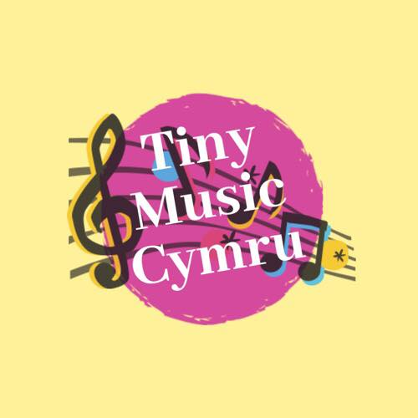 |  |  |  | Cerianne Elizabeth  Davies
Personal Statement
I am an enthusiastic, hardworking individual with experience in teaching children. I am also a classically trained female vocalist with the highest ABRSM qualifications in vocals and Music theory. I am also bilingual. Welsh language is my first language.
I am also a reliable Individual.

Personal achievements & Skills

- ABRSM qualifications in singing and music theory.
- Received classical vocal training.
- First place solo singing in the international eisteddfod shown on S4C.
- Grade 1 to 8 on Horn and Trumpet with ABRSM.
- Grade 3 piano with ABRSM.
- Competent sight reader.
- Experienced in studio recording.
- Experienced in performing live in a covers/function band, performing a wide variety of genres & styles.
- Performed with the Corey Brass Band on trumpet.
- Performed with the BBC Orchestra Of Wales on trumpet.
- A degree in Music Performance and Production.

Work Experiences

- Primary Teacher Assistant
Ysgol Gynradd Gymraeg Pontardawe - Pontardawe
June 2012

- Function Band- Self employed

I
4 Dan Y graig Rd, Port Tennant
Swansea, SA1 8LY
 |  | 07792487351
 |  | elizabeth.davies@tinymusiccymru.co.uk
 |  | Tinymusiccymru.co.uk

References

Jeff Pierce- (Peripatetic)
Mobile: 07745296789

Alun Roberts- (NPTC College Lecturer).
Email: Alun.roberts@nptcgroup.ac.uk

