Student Name: Colwin Kelly

Student ID: 2027494

Module code: BMSW4003: Digital Skills and Research Methods

Assignment title: Component 2 Research Methods

Lecturer’s name: Nauman Ali

Contents

Introduction 3
Problem solving 4
Cause-and-effect analysis 5
Pestle Analysis 6
Decision Making 7
Solution implantation plan 8
Alternative solutions 9-10
Conclusions 11
References 12

Introduction
This report elaborates on task 1, a presentation on work related stress and the impact of the complex problem on employees and their organisations. Work related stress is the negative reaction that people have at work when they are subjected to excessive pressures or other forms of demands. “Stress is a condition, not a disease. Stress, on the other hand, may lead to mental and physical sickness if it is extreme and chronic” (who, 2021). The company this report is based on is the NHS which is part the Health Care Industry. It is Multinational enterprise/Large organisation (MNE) and based only in the UK. The customer type is B2C (business to consumer). This report looks at methods and solutions that could help decrease work related stress; problem solving, cause and effect, pestle analysis. The report will then conclude discussing a solution plan to solve work related stress.

Problem solving
Problem solving is a process of coming up with solutions to fix a problem. This is done through several steps, defining a problem, identifying the root cause of the issue, coming up with a solution, generating alternatives and implement and follow up on solutions (Chevallier 2016). The impact of problem solving on employees is that it can allow them to display more independence by helping them progress upon their practical and creative solutions. Managers can rely upon them to use their initiatives to solve issues, making sure the business is running efficiently.
Complex problems are ones that need the capacity to approach them from many, often conflicting, viewpoints and may have multiple feasible answers, such issues may have unexpected repercussions, necessitating a new problem to be solved (Garrette B, Phelps C. 2018). To meet these organisational problems and possibilities, diverse groups of individuals with relevant experience are required. People, on the other hand, are bound to participate because of personal opinions, preconceptions, and a proclivity to focus on quick fixes that ignore the larger business context.
These issues forces staff not only to collaborate with each other to tackle increasingly complicated issues, but they also generate a force that forces everyone to improve their performance to adapt to others' improvements. Problem-solving allows us to better comprehend connections and make the necessary modifications and improvements to compete and survive in an ever-changing environment.

Cause-and-effect analysis
Cause and effect analysis is a technique we use by visually identifying all possible causes of a particular problem by showing them visually in greater depth, implying causal links between theories. A fishbone diagram, often known as an Ishikawa diagram, is a common kind. A tree diagram may also be used to depict cause-and-effect relationships. A cause-effect diagram aids in the organisation and presentation of numerous views concerning fundamental causes when identifying the source of a problem (Juran, 2018).

Cause and effect diagram
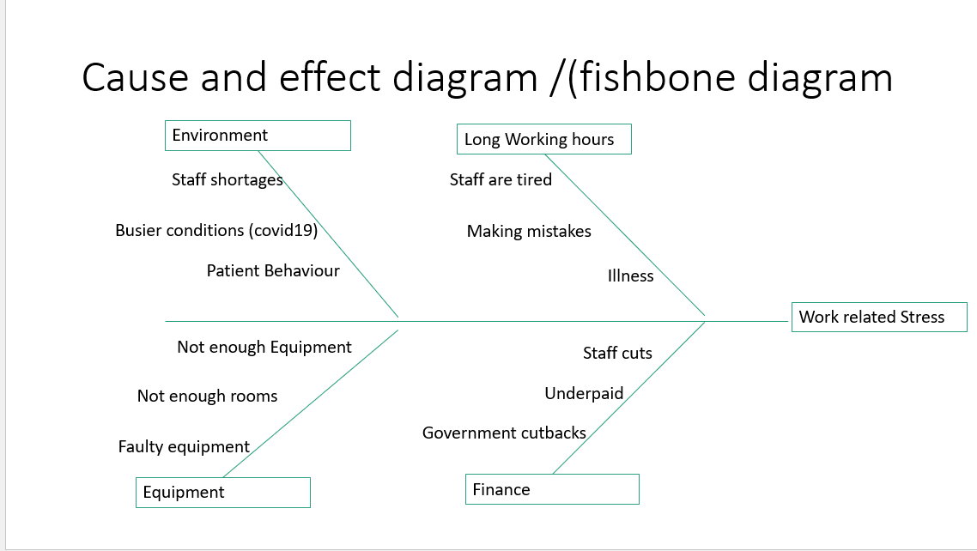

Importance of cause-and-effect analysis for the complex problems
The graphic depiction of this tool's primary strength enables for the display of exceedingly complicated scenarios with obvious links between pieces (Giachetti R.E 2016). When a problem has several different causes with complicated relationships, the cause-effect diagram is a useful tool for recording and organising them all. The Fishbone diagram not only helps you figure out what is causing an issue and how it is affecting your business' growth, but it also helps you plan to avoid similar problems in the future.

Pestle Analysis
A Pestle analysis is an acronym together describing the framework to analyse key factors of a macro environment. It enables a firm to have a sense of the elements that could influence a new business or sector. The letters mean Political, Economic, Social, Technological, Environmental and Legal. Companies carry out a full situational analysis before implementing any tactical plans or any type of strategies in marketing. Pestle analysis can aid a business in identifying potential threats, weaknesses, and other risk factors for the SWOT analysis Perera R (2017). When doing such an analysis, it is critical to not only identify but also evaluate the aspects that impact the organisation. When doing such an analysis, it is critical to not only identify but also evaluate the aspects that impact the organisation.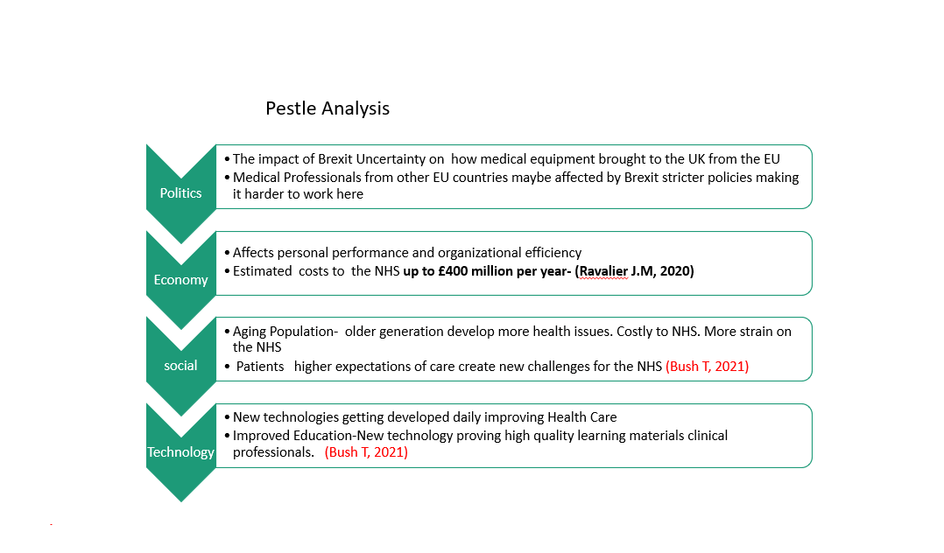
The above picture is an illustration of Pestle analysis for the NHS, it identifies weaknesses threats which are then employed in a SWOT analysis. It demonstrates the impact that Politics, Economy, social and Technology has the organisation. It shows the pollical impact things like Brexit has on the NHS, estimated economical cost per year, new challenges faced an expectations patients have. It also shows what area technology could help the NHS to improved upon.

Decision Making
Decision making is a process of collecting information and choosing between two or more course of action, finding alternatives to provide solution for a particular problem. The decision-making process is an ongoing and essential part of running any business or organisation. Decisions are taken to keep all company operations and organisational functions running smoothly. Furthermore, the decision-making process may be viewed as a check and balance mechanism that allows the organisation to expand both vertically and linearly. It signifies that the decision-making process is aiming for a certain outcome. The objectives are pre-determined corporate objectives, company aims and their vision.
In CW1 Presentation I came up a solution the NHS can implement to continuously improve the working environment and mental wellbeing of staff. The working environment within the NHS has become busier over the last two years because we are facing a Pandemic (COVID19). The proposed solution I came up with is utilising staff and resources through effective communication to meet the service demands. The key justification for this is Systemically through effective communication an affective system of work can be established to deal with the capacity needs of the NHS. If good communication is established across all areas of the NHS, then staff would be provided with enough information to cope and provide any allocation when required.

Solution implantation plan
To help make my decision, I will firstly review some of the factors that are creating these problems. These issues are due to inconsistent communication throughout various departments on a day-to-day basis, there has been confusion about what activities had previously been accomplished and which needed to be completed before patients could be securely accepted to start their session. This had led to staff falling behind with tasks, patient waiting times been delayed causing hostility towards staff (NHS Business Service Authority, 2013). Due to this breakdown of communication, stress levels amongst staff have rose. Whilst the work environment is getting busier staff are applying for leave due to stress. Utilising all resources to establish effective communication between staff in all departments is vital at this stage. Having regular schedule meetings to keep staff updated, they can voice their opinions on any concerns they might have and suggestions on how to make the shift run smoothly. Staff would not feel as much pressure and relationships between them and patients would be improved.

Background Information
44 percent of employees report feeling sick because of work-related stress, according to the results of the NHS annual survey for 2020, in 2019 it was 40%. In comparison to other job sectors in the UK, the NHS has the highest rates of absents due to stress related sickness. As a result, it is critical to address how stress from both within and outside the workplace might harm NHS employees and how it affects the whole organisation, this will help provide necessary support staffs employees require keeping them happy, focused and continuing providing exceptional patient care. This done through various different plans such as the We Are the NHS: People Plan for 2020/2021 (NHS Employers 2021).
According to the NHS Digital statistics 2020 Stress is responsible for 511,000 full time equivalent days lost, making it the most reported reason for absence.

Alternative Solutions
Creating a checklist will consist of a task to be completed every few hours. Having delegated staff members whose sole purpose on that shift is to ensure that any unfinished task gets completed by them eliminating the need of other staff members postponing one task to finish another. This would decrease workload and stress amongst staff. Another alternative solution could be providing staff with on-the-go occupational health on site for different departments. Scheduling two optional ten-minute windows with occupational health for staff to utilise if workload is causing them stress. First one could be few hours into the shift and the second at the end. This will be to find out how staff are coping during shifts. Preparation would be made beforehand to allocate any work to another member of staff whilst the other is in the meeting.
The NHS already have existing trust under occupational health for dealing with the wellbeing of staff and reduce work related stress. Offering unbiased and expert diagnosis, prognosis, and counselling to employees who are unfit to work due to short- or long-term health issues, as well as taking organizational-wide initiatives to limit sick leave.
In an abstract produced by the NHS called Mental Wellbeing at work there is guidelines on how to create the right conditions to support mental wellbeing at work. It provides clear views of their aims and what can be done to help reduce work related stress. It demonstrates the impact between high demand and low control, as well as high effort and low reward is linked to stress.
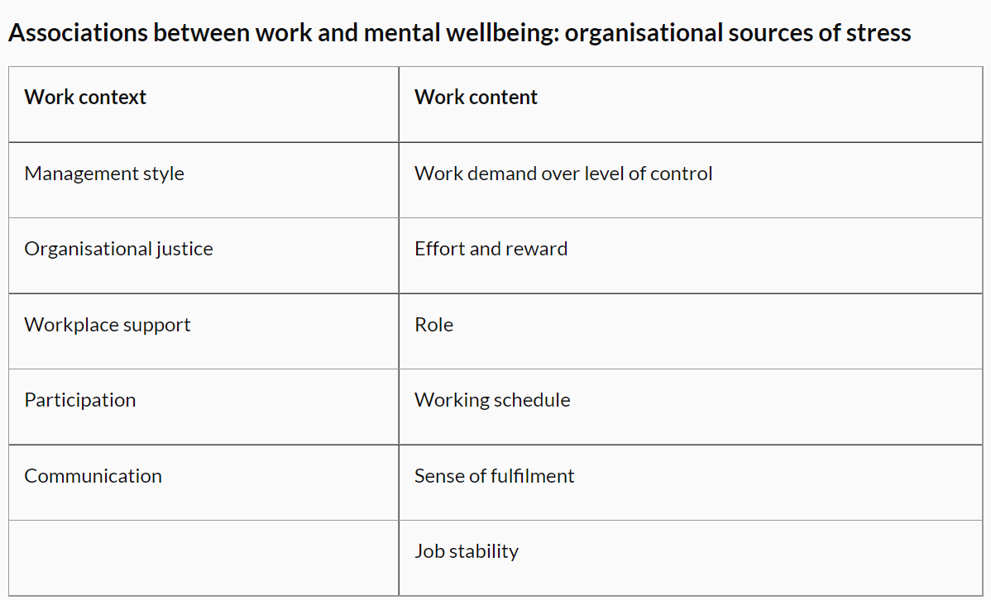

Choosing between alternatives
Choosing the Occupational health route would be more beneficial towards the NHS Organisation as well as for the staff. There is multiple existing occupational health trust who are successful in helping staff cope with work related. Improving by adding new objectives or improving upon existing ones would not be too draining on the NHS finance as opposed to creating a completely new system. The checklist method would mean finding funding for the training, staff would need extra time off work to complete training when the NHS is already heavily understaffed. It would be a new system so there is no evidence or feedback to know if it would be successful or fail. There would not be anything in place for staff that are suffering from stress due to workload on that shift whereas the occupational health approach is more hands on. The option would always be available for staffs to utilise the system if needed be. Mistakes could be made with the checklist method, resulting in major setbacks causing delays with patient care and the cycle of patient staff relationship diminishing even further.

Reviewing Decision and consequences
For work related stress to decrease and the mental wellbeing of staff to improve the government will need to allocate more finance to occupational health to provide the necessary tools resources that is needed. With the right amount of support from occupational health staff would face less work-related stress and improved working environment. The long-term benefits for the NHS organisation are business improvements, loosing less staff, less staff taking time off work due to stress, shareholders would want to keep investing, allocating money to other areas that need improving. The negative side of this is cost effectiveness, there is relatively little information on the cost effectiveness of individual therapies. The Foresight Project carried out an analysis and found that some components of organization-wide methods to boosting mental wellness can provide significant net economic advantages. According to the report, even conducting yearly audits of employee well-being would result in financial advantages about of £100 million each year.

Conclusion
To conclude, the report illustrated possible methods and solutions that could help decrease work related stress amongst staff and create a less stressful work environment. This will not only improve services but subsequently improve relationships between staffsand patients providing the best possible care. Delivering treatments such as counselling through occupational health to encourage a good and supportive atmosphere among employees could help the organisation in combating work related stress (Wilkinson, 2014; RCN, 2005).

References
Chevallier (2016). Strategic Thinking in Complex Problem Solving. United Kingdom: Oxford University Press. 289.
Garrette B, Phelps C (2018). Cracked It!. Oklahoma : Springer International Publishing. 284.
Giachetti R.E (2016). Design of enterprise systems: Theory, Architecture and Methods. Florida: CRC Press. 177.
Juran. (2018). The Ultimate Guide to Cause and Effect Diagrams. Available: https://www.juran.com/blog/the-ultimate-guide-to-cause-and-effect-diagrams/. Last accessed 27 nov 2021.
NHS Business Service Authority. (2013). 2012-13 figures released for reported physical assaults against NHS staff. NHS Business Service Authority. [Online]. Available at: http://www.nhsbsa.nhs.uk/4380.aspx
NHS Employers. (2021). Supporting our NHS people experiencing stress. Available: https://www.nhsemployers.org/articles/supporting-our-nhs-people-experiencing-stress. Last accessed 27 nov 2021.
Perera R (2017). The PESTLE Analysis. Sri Lanka: Nerdynaut. 2.

who. (202). Occupational health: Stress at the workplace. Available: https://www.who.int/news-room/q-a-detail/ccupational-health-stress-at-the-workplace. Last accessed 1st nov 2021.)

Wilkinson, S. (2014). How nurses can cope with stress and avoid burnout: Stephanie Wilkinson offers a literature review on the workplace stressors experienced by emergency and trauma nurses. Emergency Nurse, 22 (7), p.27–31. [Online]. Available at: http://rcnpublishing.com/doi/abs/10.7748/en.22.7.27.e1354

