I would not be the first person who grew up and went to school in south-west Wales to say I have visited Saint Fagans more times than I can remember. Since entry is completely free, our primary school would visit quite regularly, to the point where our last trip in year 6 was spent running about a field for several hours since we had run out of new things to see. I was unsure what to expect when we arrived, I remembered little more than walking along the paths, poking my head into a few old cottages and spending my pocket money on bright purple notebooks in the giftshop – I am certain I still have a few left in my cupboard at home.
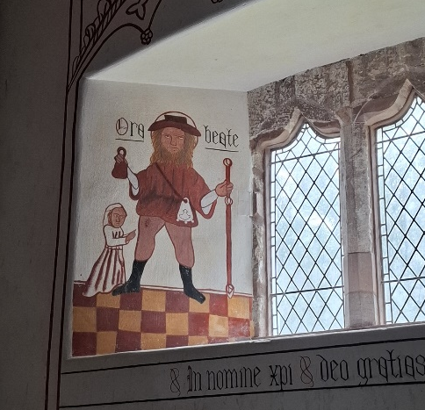
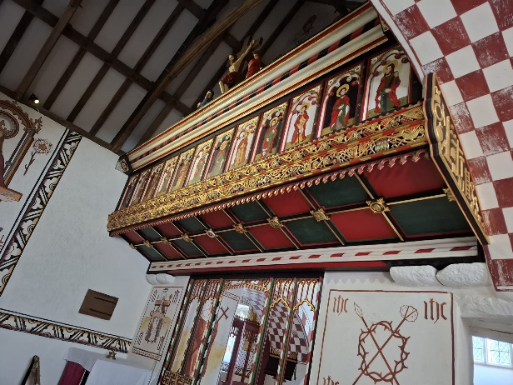
The buildings there truly were lovely, the thatched roof cottages and the brightly painted houses. Even one of the churches we visited was mostly coloured in cheerful shades of blue. One building that really stood out to me was St Teilo’s Church. I did spend twelve years in Catholic schools so I tried my best to decipher the artwork on the walls surrounding us, although some of the paintings did just make me giggle. There was a stunning, golden display over the altar depicting the images of the twelve disciples. On top of that were statues of Jesus on the cross, the virgin Mary and Mary Magdalene. The guide inside was incredibly helpful, going through the meaning and placement of the images on the walls, explaining the history of the church and how the paintings had to be restored by removing layers of paint that once covered them. Later on, after exploring the sites for several hours, popping into almost every building I could find and snapping dozens of photos, I could not help the feeling that something was missing from it all. It felt so empty, despite all of the buildings and the shops, but I couldn’t quite place my finger on why until we’d finished our tour.
Figure 1 Interior of St Teilo's Church, A. Fletcher, 2024
Figure 2 Interior of St Teilo's Church, A. Fletcher, 2024
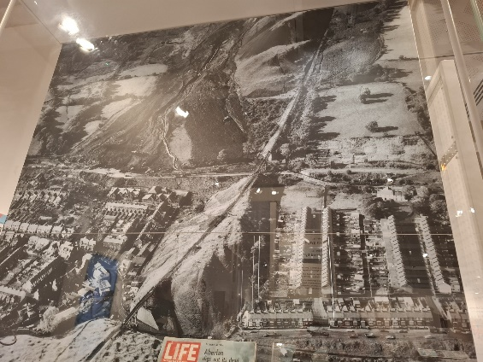
My Nan’s great grandmother lived in the second house in Stack Square next to the ironworks in Blaenafon, a group of cottages where the families that worked down in the coal mines or in the ironworks resided. I have heard stories of children as young as five years old working down in the mines, sitting in the freezing darkness and waiting for another cart to come along to open the door to let it through. People were starving, being paid pittance to labour in the damp darkness until their lungs gave in to disease and they died before they reached their 60s. The valleys of Wales are scarred from the industrial revolution, littered with heaps of slag – the source of the Aberfan disaster 58 years ago. The Aberfan display in the museum upstairs in St Fagan’s was the only reference I could find to the mining industry in Wales. I find it hard to understand how the national museum of Wales, a place to preserve and showcase the culture and history of this country, fails to represent such a crucial part of our past. Saint Fagans has painted a picturesque, idyllic version of Wales with pretty farmhouses and old churches, but in doing so they have erased the people that suffered through the industrial revolution. The countless lives of both adults and children lost to mining accidents, disease and starvation.
Figure 3 Picture of the Aberfan Disaster in the Saint Fagans Museum, A. Fletcher, 2024
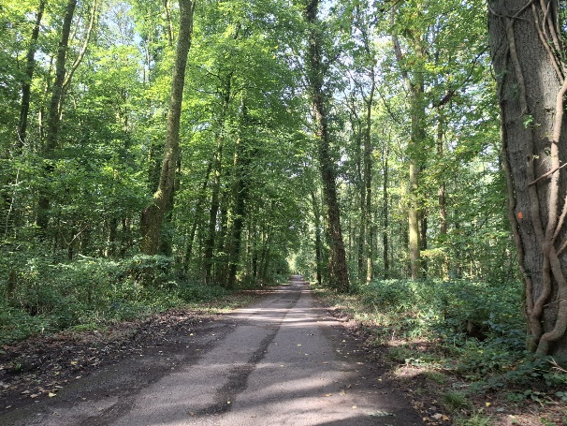
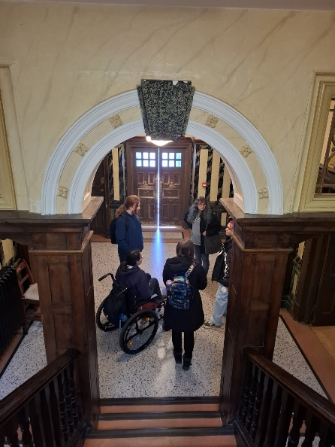
When we arrived at Saint Fagans I borrowed a wheelchair from reception because I knew I wouldn’t cope well with all the walking. I had checked on their website weeks before to see if there would be one available for me to use. From this information I came to the conclusion that the site would be quite accessible to wheelchair users. Unfortunately, I was incorrect. Many of the buildings had a step up into them without a ramp. Due to the kindness and care of the people I was with, I was able to get up the steps with their assistance to see the inside and take photos. The Workmen’s Building had a lift inside but when we asked about it, we were told that it had been out of commission for years. One of my friends offered to take photos of the upstairs and all the other places I couldn’t go which was incredibly generous of her. However, the fact remains that if not for the people I came with, I would not have been able to experience a large portion of Saint Fagans. I also have the ability to stand up and walk unaided when necessary, although not without pain, so that the wheelchair could be transported up one of the bigger steps into a building. Saint Fagans isn’t an accessible place for wheelchair users, let alone wheelchair users that wish to visit by themselves. It is baffling, the lack of thought given to disabled people. I understand the limits of what can be done considering the age and importance of the buildings, but the lack of ramps by the front doors cannot be pardoned. While I was thankful for the lift in the main building and the availability of wheelchairs, the truth is that disabled people shouldn’t be an afterthought and Saint Fagans can do so much better than what they have to accommodate us.
Figure 4 Outside at Saint Fagans, A. Fletcher, 2024
Figure 5 Interior of the Workmen's Building, J. Rees, 2024
Although Saint Fagans is a lovely place to visit, especially on a nice day if you want to have a walk around and learn a bit of history, I do not believe that it lives up to its name as the national museum of Wales. I commend Cadw for preserving these buildings but it is disappointing to know that the history of the coal miners of Wales has been completely glanced over in this manner. In terms of accessibility, the lack of thought is inexcusable.

BIBLIOGRAPHY
Stay in Wales. (n.d.) Blaenavon, Gwent. Stay in Wales, Online. Avaliable at: https://www.stayinwales.co.uk/wales_picture.cfm?p=2690 (Accessed 07/10/2024)
Nation Cymru. (October 2021) Valleys Witnesses: Miners Day details the real life of coal-mining communities in Wales in the 1940’s. Nation Cymru, Online. Available at: https://nation.cymru/culture/valleys-witnesses-miners-day-details-the-real-life-of-coal-mining-communities-in-wales-in-the-1940s/ (Accessed 07/10/2024)
History Extra. (October 2020) Death under the black mountain: surviving the 1966 Aberfan disaster. History Extra, Online. Available at: https://www.historyextra.com/period/20th-century/death-black-mountain-aberfan-disaster-welsh-history-who-blame-how-many-tragedy-survived/ (Accessed 08/10/2024)

Stay in Wales. (n.d.) Blaenavon, Gwent. https://www.stayinwales.co.uk/wales_picture.cfm?p=2690 (Accessed 07/10/2024)
Nation Cymru. (15/10/2021) Valleys Witnesses: Miners Day details the real life of coal-mining communities in Wales in the 1940’s. https://nation.cymru/culture/valleys-witnesses-miners-day-details-the-real-life-of-coal-mining-communities-in-wales-in-the-1940s/ (Accessed 07/10/2024)
History Extra. (21/10/2020) Death under the black mountain: surviving the 1966 Aberfan disaster. https://www.historyextra.com/period/20th-century/death-black-mountain-aberfan-disaster-welsh-history-who-blame-how-many-tragedy-survived/ (Accessed 08/10/2024)

