Myth and Mythology: How Stories Shape our World

In order for us to appreciate how stories shape our world, we will have to demonstrate just how central stories and myth are to ontology and every social organisation that follows. It is necessary to note that this is not a historical or mythological analysis. In our attempt at asking how stories shape the world we will use philosophical and existential inquiry as our main mode of methodology. We will analyse a Benin Bronze as a pivot point to tease out philosophical and linguistic considerations on myth and stories. I wish to stress form the outset that stories and particularly myths are not things of the past. They are an active foundation of our psychology in interpretation and action regarding masses of phenomena. We will not be concluding with a final answer as to how stories shape the world, but underline useful thinking and approaches from other scholars, hopefully providing the reader with a consideration of questions that may be fruitful for further investigation.

Before discussing the Benin Bronze, I would like to draw our attention on a few points concerning language and its ontological counterpart. It will be helpful for us to do so for the simple reason that in dealing with objects, written texts and oral stories, we are faced with language. In whichever way we try to understand myth and stories, we are dealing with a system of signs and meanings (signifier & signified). I neither have the expertise or the time to lay out all the relevant study on literary theory and semantics that would no doubt be relevant, however the crucial point is as follows:

Where there is myth there is language.
Where there is language there is meaning.
When meaning is present, so is Dasein.

Acknowledging Dasein alongside myth and stories tells us the following, that whenever there is a story, there is Dasein who is concerned with Being. In Dasein’s thrownness he is concerned with Ontology and the Ontical. Dasein, who is concerned with its Being must navigate existence from already existing interpretations and formulate new interpretations when the meaning of those interpretations acquire a new understanding. Cautiously, we can say that Dasein interprets the world primarily through story. The present-at-hand is always Temporalized. Temporalizing the present-at-hand in a way that creates understanding, allows the kind of Being that Heidegger calls readiness-to-hand. That to me is nothing other than a description of story telling. Stories are often Temporalized with a beginning, middle and end. From that Temporalization, an understanding can be gained which allows it to be ready-to-hand. This description is rather abstract and so I hope to make clarify what I mean by looking at some examples.

Seeing as my readers will mostly be from the english speaking world, I want you to consider the following. Let us say that you are a parent who lives in England. Your child comes up to you one day and asks “why do we have a king?”. This seems a fair and valid question to ask. The child has been brought into a world where there is a king in England and it seems reasonable for them to want to know why. How can the parent possibly answer this question? It is safe to assume that the parent does not have knowledge of every Ontical contingency that led to an English monarchy. Even if they did, it would take too much time to explain as the parent would also have to explain the countless other phenomena related to the question. Nonetheless, when a child asks such questions, parents typically give an answer of some sort or another. So what kind of an answer do you give your child? You need to give an answer that they can use to participate in a world with an understanding that England has a king. In other words, you must give the child a satisfactory existential approach as to how to interact with the present-at-hand, readiness-to-hand and other Dasein. As we saw earlier, the best way to achieve that is with a story. The parent, to the best of their ability must Temporalize the king of England in a way that a child can gain an understanding that is ready-to-hand. You must endow the child with ways of interacting with the properties and functions of a king. The child can then take the story of the king of England, and integrate it with their existing stories, and combine it to create new ones. If the parent was to answer “England has a king to keep the people safe”, giving examples in the past of defending the country with the military, the child is able to grasp a possible function that gives meaning to the king. An extremely interesting consideration now arises from this. What if the parent tells the child a different story?

Let us take a second example. A child in Wales asks their parent “why do we have a king?”. There is a good chance that the parent from Wales will give a different answer. One possible answer would be “We have a king because England took our land”. With this answer a different Temporalization is given, allowing a different understanding that gives the child a readiness-to-hand that is different which is again different. For our purposes, it is irrelevant which is the more appropriate response, what is important is we get 2 different answers to the same question. In other words, there is more than one possible myth to explain any given phenomena. Claude Levi-Strauss observed something similar, different cultures telling various myths and stories. In a series of lectures entitled Myth and Meaning he comments;

“I don’t think that cultures have tried systematically or methodically to differentiate themselves from each other. The fact is that for hundreds of thousands of years mankind was not very numerous on the earth; small groups were living in isolation, so that it was only natural that they developed characteristics of their own and became different from each other. It was not something aimed at. Rather, it is the simple result of the conditions which have been prevailing for an extremely long time”.

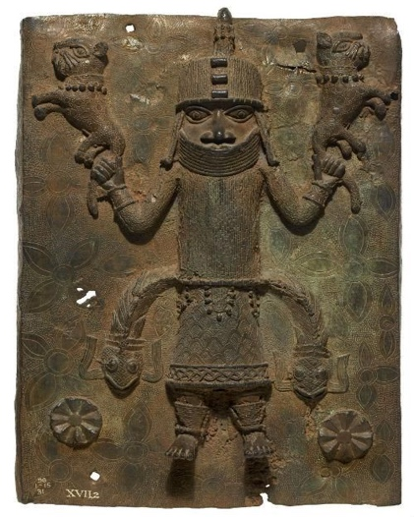
Creating different myths and stories is something humans have done for a long time. Some vanish forever, others transform and there are new ones being created. I Wish to show how myths and stories exist outside of the traditional oral and literary format. In figure 1 below is a Benin Bronze. This sculpture was created sometime around the 16th century, depicting king Oba of Benin City. In this depiction, the king has 2 lions in his hands and 2 snakes fastened to his waist. These signifiers tell whoever sees this sculpture that this individual has the ability to overcome some of the fiercest of the animal kingdom. By associating such power with a king creates a story that shows the people of the kingdom that their leader holds his position because of his capabilities as a hunter/warrior.

References

Claude Levi-Strauss, Myths and Meaning, (University of Toronto Press: 1978), p.7

https://www.britishmuseum.org/about-us/british-museum-story/contested-objects-collection/benin-bronzes <Accessed 14/12/22>

Ferdinand de Saussure, Course in General Linguistics, ed. by Charles Bally & Albert Reidlinger, trans by Wade Baskin (New York: Philosophical Library 1959) p.66

Martin Heidegger, Being and Time: A Translation of Sein und Zeit, (State University of New York Press: 2010

Ferdinand de Saussure, Course in General Linguistics, ed. by Charles Bally & Albert Reidlinger, trans by Wade Baskin (New York: Philosophical Library 1959) p.66
Martin Heidegger, Being and Time: A Translation of Sein und Zeit, (State University of New York Press: 2010
Claude Levi-Strauss, Myths and Meaning, (University of Toronto Press: 1978), p.7
4 https://www.britishmuseum.org/about-us/british-museum-story/contested-objects-collection/benin-bronzes <Accessed 14/12/22>

