Plant and Machinery.
To aid the scheme and projects delivery there will be the need for the addition of core plant and machinery to assist with heavy lifting, excavations, and transportation of materials. Throughout the project there will be a number of additions of plant and machinery needed to complete the scheme. Below is the core machinery that will throughout the scheme.
- Excavators
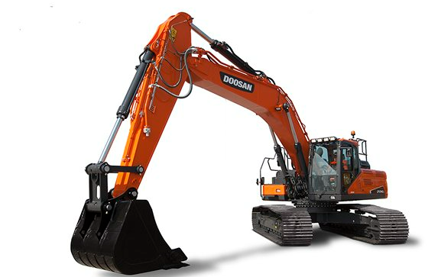
Required for Site Clearance, excavating substructures, movement of loose materials, landscaping etc. For the excavation for the basement construction Activ Leisure will be proposing to use a 36 tonne 360 Excavator. This will aid in mass of subsoil removal with efficiency and speed. (Doosan, 2023)
- Shipping Length | 11380mm
- Shipping Height | 3592mm
- Max Cutting Height | 9994mm
- Max Loading Height | 6882mm
- Max Reach Along Ground | 10382mm
- Max Vertical Wall Digging Depth | 5121mm
- Max Digging Depth | 6931mm

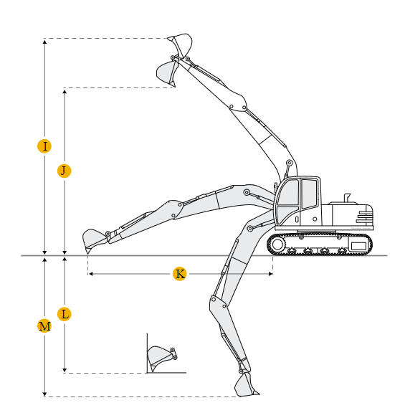
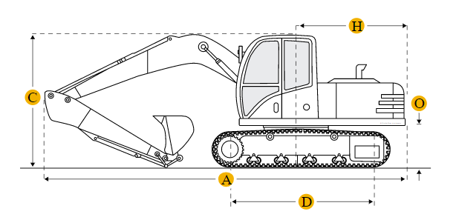

- Telehandlers.
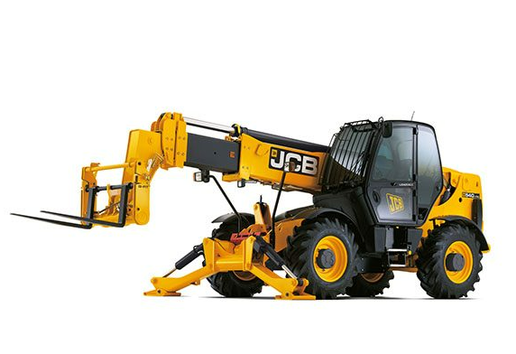
Throughout the Project material movement and storage will be key to the Schemes delivery and organisation. To enable Active Leisure to carry out this timely and safely the addition of a telehandler will be needed throughout the scheme. (JCB, 2023)
Maximum Lift Capacity | 4000kg
Lift capacity to full height | 4000kg
Lift capacity at full reach | 1250kg
Lift height | 13.8m
Reach at maximum lift height | 0.74m
Maximum forward reach | 9.25m
Reach with 1 tonne load | 9.25m
Placing height | 13.25m

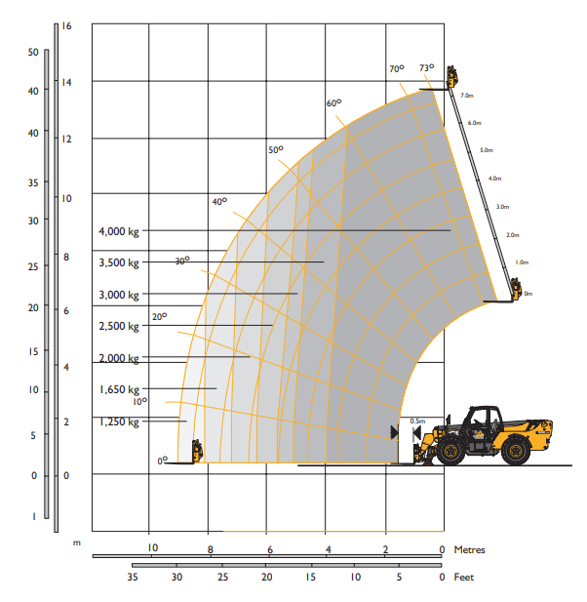
- Dumper.
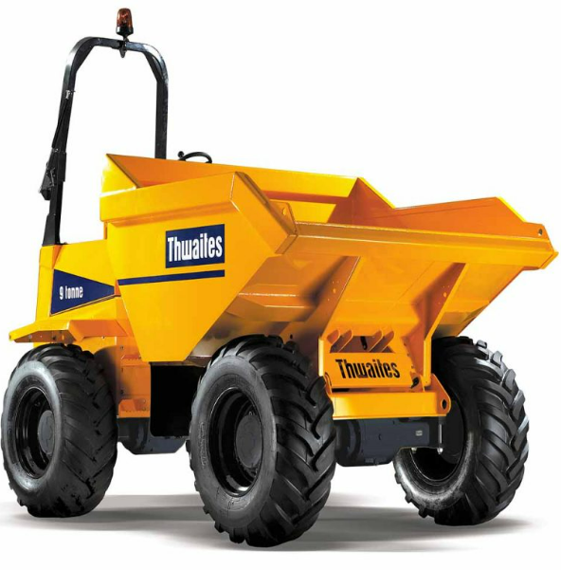
Throughout the scheme the requirement for dumpers is necessary to aid with the movement of loose material such as subsoils, stone, concrete. This will be required from site strip until completion of landscaping. (Thwaites, 2023)
Weight | 5390 kg
Max Safe Load | 9000 kg
Heaped Load | 4600 litres
Struck Load | 3830 litres
Water (load) | 2155 litres

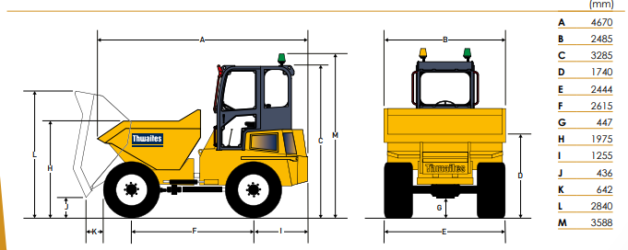

- Piling Rig.
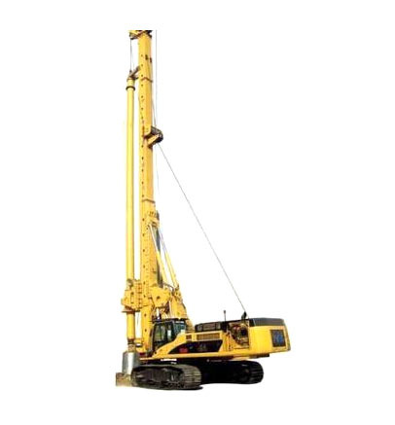
A Pile Rig will be used to construct the foundations/walls for the basement construction. The soil displacement system will give a time saving, quiet and less vibrations to a driven pile system. The auger is drilled into the subsoils displacing the soils outwards as the augers drills through. Once the drill and rig has reached it desired depth its is extracted from its position. As it is extracted concrete is pumped into its place forming the pile foundation. Please see image below for further information. (Skanska, 2023)
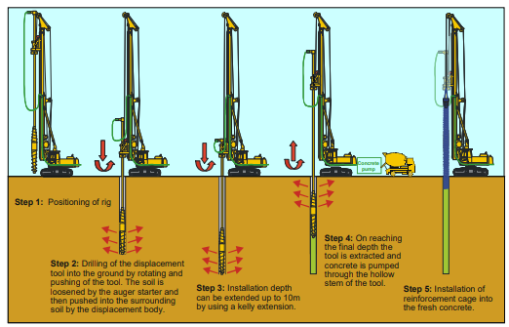

- Compaction Roller.
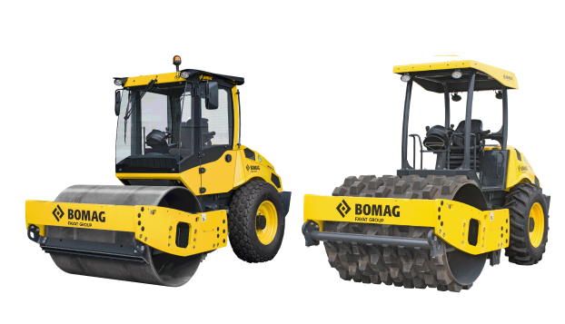
To create adequate ground make/build ups for all aspects of the scheme to mitigate any movement in grounds as possible, the scheme will require load bearing subsoils for car park basement construction and non-load bearing soils such as paths, sports fields etc. This will require rollers compaction rollers to enable the contractors to do so. (Bomag, 2023)
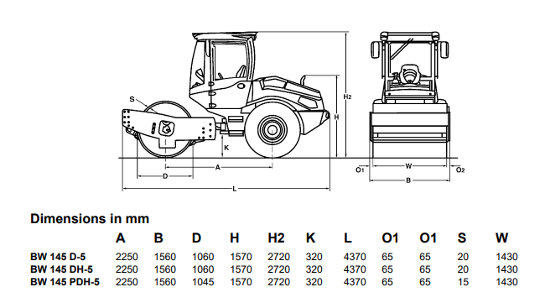
Dependant on the required thickness of compaction and the type of material they may be a requirement to bring in various rollers for their capabilities. Table below shows the compaction output, type of material and machine roller options for consideration.


