2.Executive summary:
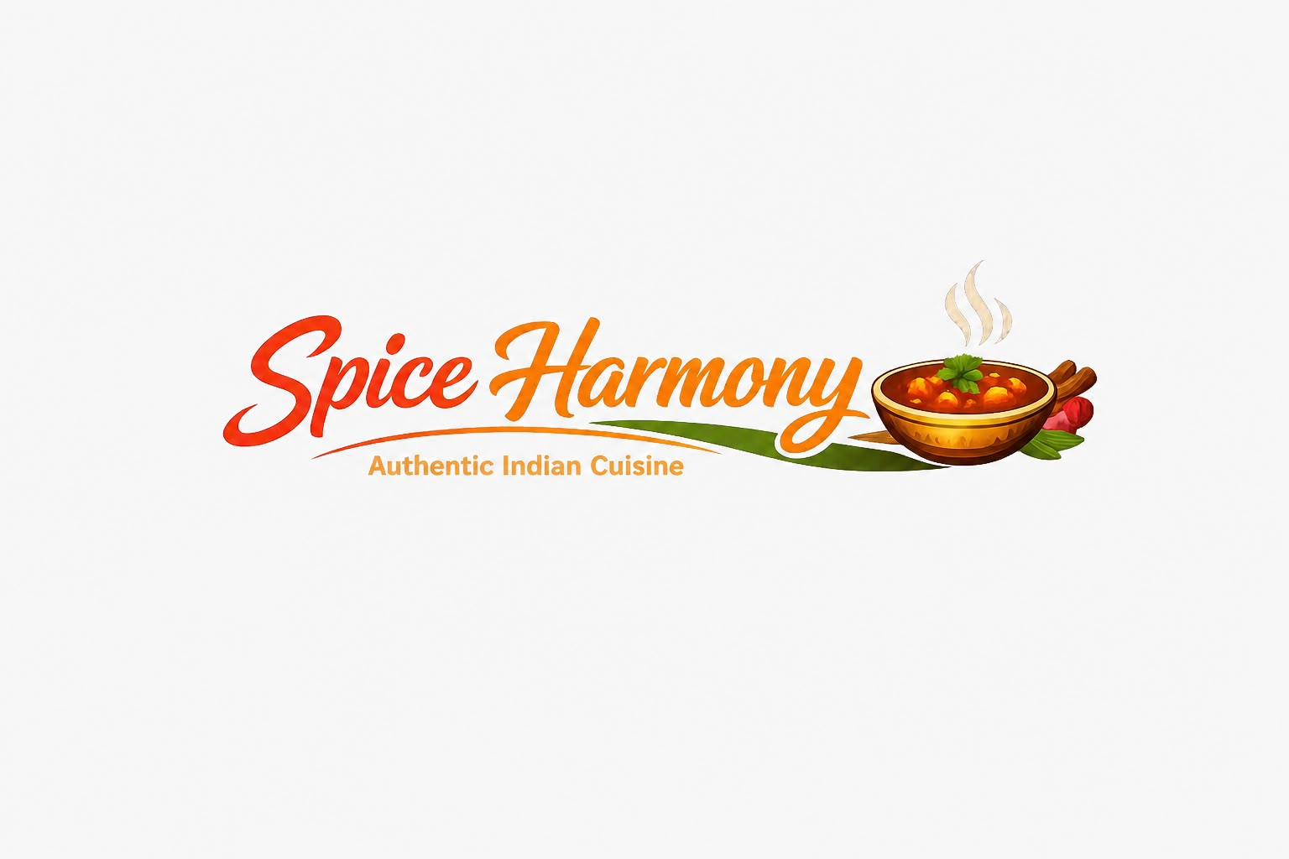
Spice Harmony is a new Indian restaurant concept, focusing on authentic regional cuisine and sustainability and community in London’s diverse food sector. The company wants to meet the rising demand from consumers for a culturally rich food experience and environmentally responsible food choices. “The 1500‑word business plan should have the following key elements of business plan,” the assessment brief said and this brief outlines the direction of the restaurant.
The restaurant will be a Private Limited Company to protect legal status, credibility and scalability over the long term. Its management structure is structured as a functional model with clearly defined roles for the Owner-Manager, Head Chef, Front‑of‑House Supervisor and Marketing & Administration Officer. This structure facilitates efficient operations and is in line with the sustainability of the restaurant.
Market research shows strong demand for authentic Indian cuisine and good political, social and technological indicators. Spice Harmony is unique in its local ingredient sourcing, less waste and community jobs in the way it does things.
The venture needs £45,000 in initial funding from personal investment and a small business loan. First month costs for equipment, inventory, marketing and staffing are £42,500.
Spice Harmony is both culturally authentic and environmentally responsible as well as social in the most effective way to offer the London customer a competitive and fulfilling dining experience.

Table of Contents
- Title Page
- Executive Summary
- Table of Contents
- Overview of the Business Idea
4.1 Business Concept
4.2 Management Structure
4.3 Legal Format
- Market Research
5.1 PESTEL Environmental Analysis
5.2 Competition Analysis
- Marketing Communications
6.1 Target Market
6.2 Marketing Strategy (4Ps)
6.3 Digital and Community Engagement
- Financials
7.1 Funding Requirements
7.2 Funding Sources
7.3 First-Month Startup Expenses
- Reference List

4. Overview of the Business Idea
4.1 Business Concept
Spice Harmony is a contemporary Indian restaurant that serves authentic regional food in the original way and with locally sourced ingredients and flavours. It will focus on North and South Indian cuisine and serve a variety of vegetarian, vegan and gluten-free options on the menu. This product will respond to the increasing consumer demand for culturally rich dining experiences and healthier food options (Burns, 2022). Service of the restaurant is going to be warm hospitality, table service, and an appealing ambience of cultural aesthetics.

Spice Harmony is unique in that it is authentic, sustainable and community oriented. Unlike many competitors that depend on imported food, the restaurant will develop partnerships with local farmers and suppliers to reduce carbon emissions associated with transportation. This is in line with the requirement that the business idea should have “at least one element related to sustainability or community support.” By using seasonal produce in menu planning, the restaurant will also be environmentally responsible and still be very good at food (Kotler & Armstrong, 2021).

Another difference is the restaurant’s commitment to community service. Spice Harmony will offer training and employment to underrepresented groups in the local area and contribute to social inclusion and local economic development. Entrepreneurial opportunity recognition usually comes from identifying unmet social and cultural needs within a community (Burns, 2022), and this initiative aims to address both the demand for authentic Indian cuisine and the need for socially responsible business practices.

Overall, the concept is cultural, sustainable and community motivated to produce a high-quality and competitive restaurant in London’s various food industry.
4.2 Management Structure
Spice Harmony's management will be based on a functional organisational structure so that there is high levels of management responsibility throughout operations and coordination within the organisation. A functional structure is particularly feasible for small hospitality companies, since management can focus on operations, finance, marketing and customer service (Barringer & Ireland, 2020). This is a strong model for efficient decision making and for sustainable food quality, service delivery and sustainability.
The Owner‑Manager will be in charge of strategic planning, financial oversight, supplier negotiations and compliance with food safety and environmental regulations. The Owner‑Manager will also lead sustainability initiatives (e.g., buying local foods and reducing waste) that would be required if a company plan is going to be sustainable or community-friendly.

Reporting to the Owner-Manager will be three key functional roles:

- The Head Chef is responsible for menu development, kitchen management, kitchen operations, staff training and food quality management.

- The Front‑of‑House Supervisor will oversee customer service, reservations, staff scheduling, and community engagement activities.

- The Marketing and Administration Officer will lead digital marketing, social media communications, financial record-keeping and promotional campaigns.

This way, each manager is focused on their field of expertise and services help the restaurant’s mission. Clear role allocations reduce operational ambiguity (Kotler & Armstrong, 2021) and accountability is imperative for new businesses that aim to stay in business for a long time. Spice Harmony also brings community-oriented roles into the Front-of-House role to further build on its commitment to social inclusion and local employment.
The management structure is designed to help to drive operational efficiency, strategic growth, and the sustainability‑oriented value proposition of the restaurant.
4.3 Legal format
Spice Harmony should be established in a Private Limited Company (Ltd). Such a structure can bring good things to new hospitality business such as liability protection, credibility, and long-term growth potential. The Private Limited Company separates the business from the owner and provides security to personal assets in the event of any financial strain or legal problems of the business (Barringer & Ireland, 2020). Such is especially important in the restaurant industry: the safety of food, employment, and customer health need to be so under control.

But having a Private Limited Company not only gives the restaurant a professional image, but also helps in building investor confidence and supplier relationships as well. The assessment specification highlights that “Your 1500‑word business plan should contain the following key parts of your business plan and be legal and appropriate for having strategic planning and operational readiness.” Spice Harmony is in a better position to raise capital by holding a Ltd structure to raise funds through private investment which is in line with the business’s long-term strategy of investing in sustainable food and community programmes.

Moreover, this legal structure is very much in line with the restaurant’s focus on sustainability and community engagement. Operating as a limited company enables clarity of environmental initiatives, ethical sourcing, and social impact activities on which to report to stakeholders (Kotler & Armstrong, 2021) and this can build trust. It also will allow for compliance with UK regulations around employment, waste management, and food hygiene, all of which are fundamental in maintaining a sustainable business.

In general, a Private Limited Company structure provides Spice Harmony with a stable, credible, and scalable foundation in order to achieve its commercial objectives as well as its sustainability‑based mission.

5. Market Research
The external environment is crucial to determine the future of Spice Harmony, an Indian restaurant in London’s competitive hospitality sector. PESTEL analysis takes a macro-environmental assessment (for example, market positioning and differentiation opportunities) and provides context to the business.

5.1 PESTEL Environmental Analysis
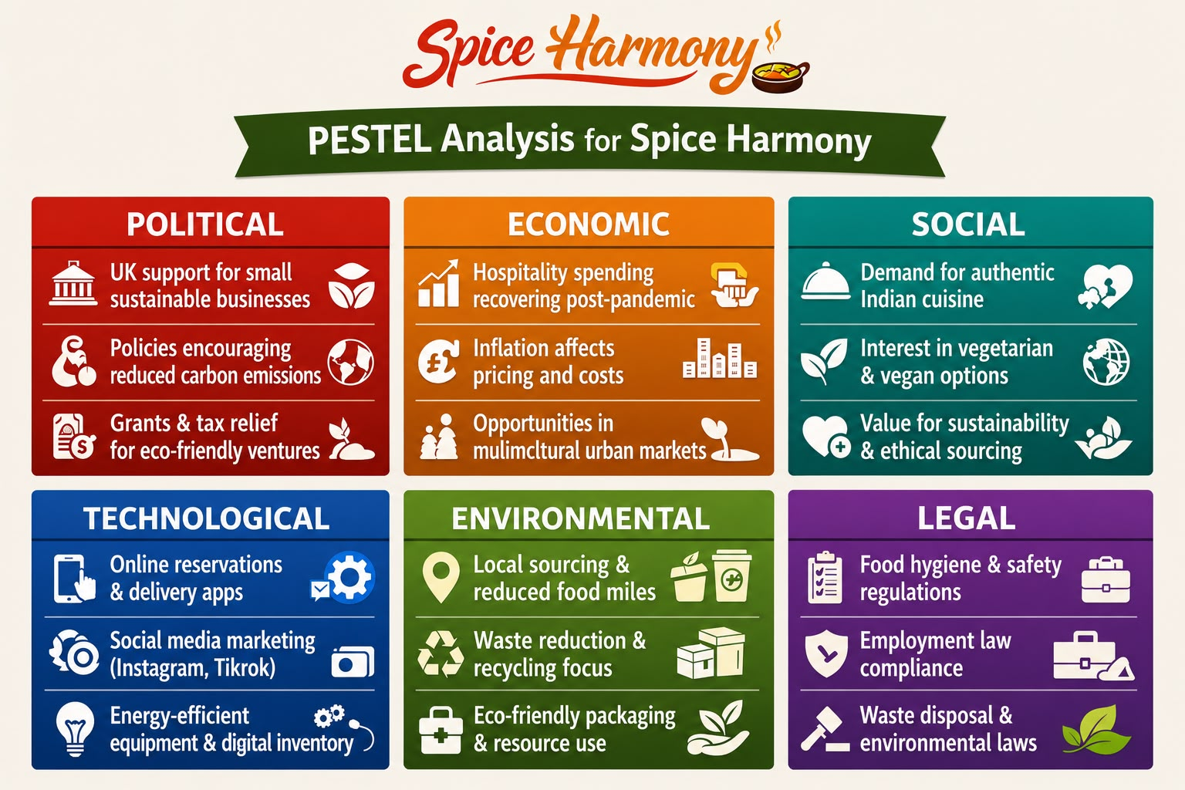

Political: The UK government is still supporting small businesses through tax relief schemes and grants, especially those that behave in a sustainable manner. Policies promoting lower carbon emissions and responsible waste management do impact restaurant operations directly and local sourcing and minimising food waste is more important (Johnson et al., 2020).
Economic: Although inflation has had an impact on consumer spending, demand for dining experiences remains robust in multicultural cities like London. After the recession there has been a steady recovery in hospitality spending (Office for National Statistics, 2024), it is favorable for new restaurant operations to be launched in the long run.
Social: London’s diverse population has a strong demand for authentic ethnic cuisine. People are also more demanding of sustainable, ethical sourcing and healthier food options. This is consistent with Spice Harmony’s focus on local ingredients, vegetarian dishes and community involvement (Burns, 2022).
Technological: Digital platforms are key to restaurant marketing and customer engagement. Online reservations, delivery apps and social media advertising help a restaurant reach a larger audience. Technology also drives sustainable practices like energy‑efficient kitchen equipment and digital inventory (Kotler & Armstrong, 2021).

Environmental: Increasing awareness of environmental issues leads restaurants to be eco‑friendly. Spice Harmony’s focus on local sourcing, lower packaging and recycling is consistent with consumer demand and environmental regulations.
Legal: Food hygiene standards, employment laws and waste disposal regulations are mandatory. The restaurant’s Private Limited Company structure promotes transparent reporting and regulatory adherence (Barringer & Ireland, 2020).
5.2 Competition Analysis

London has many Indian restaurants, from the traditional family‑run ones to modern fusion ones. Its main competitors include Dishoom, Tayyabs and some independent curry houses. Dishoom is known for having a premium pricing and a strong brand image; Tayyabs has affordable Punjabi cuisine.
Spice Harmony's advantage in the competition is the authentic regional menu, sustainability‑driven sourcing and community employment. Many competitors are more concerned with flavour and ambiance, but few incorporate environmental responsibility and social inclusion into their core business model. Spice Harmony has the opportunity to establish itself as a socially conscious, culturally authentic restaurant.
6. Marketing Communications
Effective marketing communications are essential in positioning Spice Harmony as a socially responsible and culturally authentic Indian restaurant in London’s competitive dining market. The marketing strategy integrates both traditional and digital channels to reach diverse customer segments while reinforcing the restaurant’s sustainability and community-based values.

6.1 Target Market
Spice Harmony targets urban professionals, families, and students aged 20-45 who appreciate authentic ethnic cuisine and are environmentally conscious. According to the Office for National Statistics (2024), the UK’s multicultural population continues to grow, increasing demand for diverse food experiences. This demographic is digitally active, making online engagement an important element of communication.

6.2 Marketing Strategy

The restaurant will adopt the Marketing Mix (4Ps) framework to ensure coherence across all promotional activities (Kotler & Armstrong, 2021):

- Product: Authentic Indian cuisine prepared with locally sourced ingredients that highlight sustainability and cultural richness.

- Price: Competitive yet value-based pricing to attract mid-range consumers while maintaining premium quality.

- Place: A central London location complemented by online delivery partnerships with Uber Eats and Deliveroo.

- Promotion: A combination of digital and community-based initiatives, including social media campaigns, influencer partnerships, and local charity events.

6.3 Digital and Community Engagement

Digital marketing will focus on storytelling through Instagram and TikTok, showcasing the restaurant’s culinary artistry and eco-friendly practices. Paid social media advertising will target users within a 10-mile radius of the restaurant. Community engagement will include hosting cultural evenings and sustainability workshops to strengthen brand loyalty and social impact. Integrated marketing communications will ensure consistent messaging across all channels, enhancing brand recognition and trust (Kotler & Armstrong, 2021).

By combining digital innovation with community involvement, Spice Harmony’s marketing communications will effectively convey its unique value proposition—authentic cuisine with a conscience—while fostering long-term customer relationships and positive social outcomes.

7. Financials
An informed financial plan is required to prove the sustainability of Spice Harmony and how the restaurant can thrive in the first place during the launch period. The financial plan shows the total budget to finance, the funding sources to obtain, and the anticipated startup funding for the first month.

7.1 Funding Requirements

Spice Harmony will need about £45,000 in initial funding to cover setup costs, equipment, licensing, early marketing, and working capital. This is in line with the industry standards for small to medium-sized restaurants in London, where rental deposits, kitchen equipment, and compliance costs are significant upfront investments (Barringer & Ireland, 2020). The funding will allow the restaurant to run well in its first month and establish a stable client base.

7.2 Funding Sources

The main source of funding will be personal investment and a small business loan. Personal investment shows owners’ commitment and less reliance on external funding, and a loan provides the capital for equipment and operational costs. The UK government provides favourable loan schemes and support for small businesses, especially those who incorporate sustainability into their operations (Johnson et al., 2020). This is compatible with Spice Harmony’s environmentally responsible approach, which could also qualify for grants or tax relief.

7.3 First-Month Startup Expenses
Projected first-month expenses are outlined below:

Expense Category | Estimated Cost (£)
Kitchen Equipment | 12,000
Furniture & Décor | 6,000
Rent & Utilities | 4,500
Licensing & Insurance | 2,000
Initial Inventory | 5,000
Marketing & Promotion | 3,000
Staff Salaries | 10,000
Total | 42,500

These expenses are in line with the restaurant’s focus on high‑quality equipment, sustainable materials and effective marketing communications. Adequate funds should be put into promotion to attract early customers and increase brand presence (Kotler & Armstrong, 2021).

References:
The financial plan, therefore, is a realistic and well-thought out framework for Spice Harmony’s launch and is a means to ensure an operating climate and to develop it for long-term growth.
Barringer, B. and Ireland, R. (2020). Entrepreneurship: Successfully Launching New Ventures. 6th edn. Pearson.
Burns, P. (2022) New Venture Creation: A Framework for Entrepreneurial Growth. Macmillan.
Johnson, G., Whittington, R. and Scholes, K. (2020) Exploring Corporate Strategy. 12th edn. Pearson.
Kotler, P. and Armstrong, G. (2021) Principles of Marketing. 18th edn. Pearson.
Office for National Statistics (2024) UK Consumer Trends. Available at: https://www.ons.gov.uk (Accessed: 24 July 2026).
Porter, M. (2008) ‘The Five Competitive Forces That Shape Strategy’, Harvard Business Review, 86(1), pp. 78–93.

