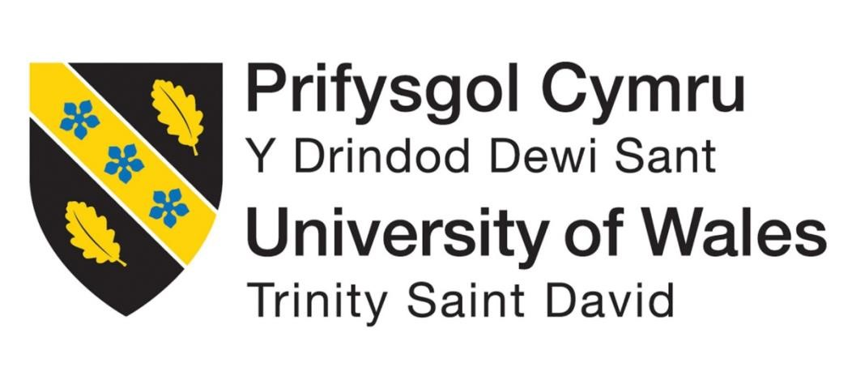

“Investigating Challenges and Opportunities of Indian Manufacturing Sector: the case of UltraTech Ltd Cement industry”

SUPERVISOR: DR AMARE DESTA

SUBMITTED BY: MEET AMRUTIYA

STUDENT ID: 2313572

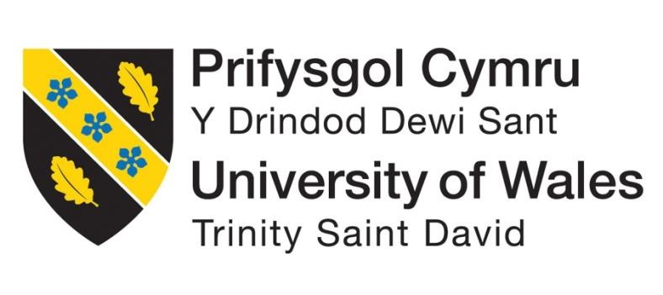

Master’s Degrees by Examination and Dissertation

Declaration Form

I MEET AMRUTIYA declare that this dissertation has been composed by myself, that the work contained herein is entirely my own except where explicitly stated otherwise in the text, and that this work has not been submitted for any other degree or qualification, in whole or in part, except as specified.

Signature: MEET AMRUTIYA

Date: 14/10/2024
Participation Consent Form

Participant Identification Number:

PARTICIPATION CONSENT FORM

(for researcher to fill)

Project Title: “Investigating Challenges and Opportunities of Indian Manufacturing Sector: the case of UltraTech Ltd Cement industry”

Name of Researcher: MEET AMRUTIYA Name of Supervisor: dr amare desta

Email of Researcher: ______2313572___@student.uwtsd.ac.uk

Aim of Research:

(for participant to fill) YES NO

- I confirm that I have read and understood the information sheet dated _________ for the above study.

- I understand there are no material benefits for participating.

3 I have had the opportunity to consider the information, ask questions and have had these answered satisfactorily.

4 I understand that my participation is voluntary and that I am free to withdraw at any time, without giving any reason.

5 I understand that any information given by me may be used in future reports, articles or presentations by the researcher.

6 I consent for my name and title to be used within this study. Where applicable, I understand that my details will not be anonymous.

- I agree to be recorded (audio and/or audio-visual video).
- I agree to take part in the above study.

Researcher’s Name (Print) Signature Date

Participant’s Name (Print)

Signature Date

You may decline to participate in this study. You may end your participation in this study at any time. All data generated from this or any interview will remain confidential. For more information, please view the university’s Research and Data Management Policy.

When completed please email a copy to the below address to be kept on the file of the researcher and retain a copy for yourself.

Subject Title: [NAME OF PARTICIPANT] – Participant Consent Form

Email: _________@student.uwtsd.ac.uk

Dissertation
Topic: “Investigating Challenges and Opportunities of Indian Manufacturing Sector: the case of UltraTech Ltd Cement industry”

Acknowledgement
I would like to express my earnest thankfulness to all participants who contributed a respected understanding to the research work completion. A special thanks to the industry specialists and UltraTech Cement managers for providing time and expertise in the research work accomplishment. I escalated the support and leadership provided by my academic advisors and contemporaries throughout the study. Moreover, constructive feedback and reassurance also become instrumental in determining this investigation. Lastly, I acknowledge the valuable resources and support from my institution, which were vital in effecting the study. However, your contributions become precious in proceeding with our consideration of UltraTech Cement’s possible in the UK marketplace.

Abstract
This study intends to look into market trends, buyer preferences, aggressive characteristics, promotional strategies, group strategic alliances, and environmentally conscious practices that comply with legal requirements and UK market benchmarks in order to support UltraTech Cement Limited's development. The goal of the study is to design the market entry strategy while taking growth opportunity elements into account and including related tactics for survival in international markets. Apart from that, the study's goal is to examine the UK cement industry's current state of the market as well as the elements that support UltraTech Cement's economic expansion.
The research study analyses literature ensuring the growth opportunities and market dynamics of “UltraTech Cement Limited” in the UK cement industry as the Indian company expand the business in the UK industry, highlighting conceptual frameworks and theoretical analysis with the market trends and demands of buyers. The existing study explores market trends influenced by stringent environmental regulations and the drive for sustainability, ambitious by the
“Climate Change Act (2008)” and advancements in low-carbon technologies. It establishes the “Resource-Based View (RBV)” to assess internal resources and capabilities as competitive advantages and applies Institutional Theory to understand regulatory and cultural influences on market performance. Moreover, the research classifies gaps in considering regulatory influences on conflicts between sustainability and efficiency, technological innovations, and patterns of technological progression.
The methodology consists of the processes and techniques that are used in order to do research. The data collection techniques that are used constitute primary data by means of interviews and surveys. The interview is taken from 5 respondents and the survey is conducted from 100 respondents. Moreover, survey respondents are industry experts and clients; selected via stratified random sampling. Interviewees are experienced Ultra Tech Cement managers. The data analysis is both qualitative and quantitative in nature where the qualitative data is analysed by the use of theoretical models. On the other hand, the quantitative analysis is conducted by means of SPSS and statistical methods. The ethical considerations constitute consent forms, anonymity and privacy of the participants.
The research study explores the survey data and discloses that respondents predominantly work as industry experts aged “25-44” with 1-5 years of knowledge in the cement industry, including market trends, consumer behaviour, and operational practices. Moreover, key insights emphasise the cost and environmental sustainability as vital factors in “cement supplier selection”, It is also indicated that UltraTech Cement's product quality is rated somewhat higher than industry benchmarks. The possible scenario is determined, where a strong market presence indicates the regression analysis displays that product quality and cost have a limited effect on market presence. However, qualitative interviews with managers highlight the importance of innovative product appearances, strategic partnerships, prolonged distribution networks, and improved customer service.
The market trends in the UK cement industry are determined, where the industry is heavily influenced by stringent environmental regulations designed to curb carbon emissions and promote sustainability. In this chapter, the cultural disparities between India and the United Kingdom could be problematic, particularly for organisations that rely heavily on management and communication techniques and even provide effective recommendations for the company Ultratech in terms of maintaining its profitability in the UK market and expanding its businesses. The redressing of the issues is possible by implementing crosscultural training, enhance communication strategies, and adopt local market practices to bridge cultural gaps and improve profitability.

Table of Contents
Chapter 1: Introduction 9
1.1 Research background 9
1.2 Research Rationale 11
1.3 Research problem 12
1.4 Aim, objective and scope of research 13
1.5 Research question 14
1.6 Structure of dissertation 14
1.7 Theoretical framework 15
Chapter 2: Literature Review 16
2.1 Overview 16
2.2 Conceptual framework 16
2.3 Market trends, and the demands of buyers of the UK cement industry 17
2.4 Market analysis and growth opportunities of the UK cement industry 19
2.5 Different strategies to enter the UK market and its associated challenges 21
2.6 Marketing approaches and key collaborations that may extend UltraTech Cement
Limited’s marketplace entrance within the UK 22
2.7 Strategies to differentiate UltraTech Cement Limited brand from existing competitors in the industry 23
2.8 Different Sustainable approaches that UltraTech Cement Ltd. use within the cement
industry to maintain its reputation in the UK 24
2.9 Challenges faced by Indian business in the United Kingdom market 26
2.10 Research gaps, conflicts, patterns, and theories 27
2.11 Justification of the research questions by using up-to-date theories and
understanding 28
2.12 Summary 29
Chapter 3: Methodology 30
3.1 Introduction 30
3.2 Research Philosophy 31
3.3 Research Approach 31
3.4 Research Design 32
3.5 Data Collection 33
3.6 Data Analysis 34
3.7 Research Limitation 35
3.8 Ethical Consideration 35
3.9 Summary 36
Chapter 4: Data Analysis and Findings 36
4.1 Introduction 36
4.2 Findings of Primary Data 36
4.2.1 Findings of Quantitative Data 36
4.2.2 Findings of Qualitative Data 50
4.3 Empirical Analysis 52
4.5 Summary 54
References 63
Appendices 70
Appendix 1: Survey Questionaries 70
Appendix 2: Interview Transcription 73

List of Figure
Figure 1: Theoretical framework; Source: Self-made ............................................................. 14
Figure 2: Conceptual framework, Source: Self-Made ............................................................. 16 Figure 3: Resource-based view analysis Framework; Source: (Gitmind, 2024) ..................... 18
Figure 4: Research onion, Source: (Mohajan, 2019) ............................................................... 30
Figure 5:Descriptive Statistics for age group; Source: Self-made; .......................................... 40
Figure 6:Descriptive Statistics for current working field; Source: Self-made; ........................ 41 Figure 7:Descriptive Statistics for experience; Source: Self-made; ........................................ 42
Figure 8: Statistics for rate the standing of cost; Source: Self-made; ...................................... 43
Figure 9: Statistics for quality of UltraTech Cement products; Source: Self-made; ............... 44
Figure 10:Descriptive Statistics for significant factor; Source: Self-made; ............................ 45
Figure 11: Statistics for environmentally friendly practices influence; Source: Self-made; ... 46
Figure 12:Descriptive Statistics for current market presence; Source: Self-made; ................. 47
Figure 13: Descriptive Statistics for focus on for development; Source: Self-made; .............. 48 Figure 14: Statistics for interest in innovative cement solutions delivered; Source: Self-made;
.................................................................................................................................................. 49
Figure 15: Regression Analysis for Growth Opportunity and Success Rate; Source: Self-
made; ........................................................................................................................................ 52 Figure 16:Regression Analysis; Source: Self-made; ............................................................... 52

Chapter 1: Introduction

1.1 Research background
The purpose of this study is to support UltraTech Cement Limited's development by investigating market trends, buyer preferences, aggressive characteristics, promotional strategies, group strategic alliances, and environmentally conscious practices that adhere to legal requirements and UK market benchmarks. By narrowing the field, the development of the Growth Opportunities of the Indian manufacturing sector, the case of UltraTech Ltd Cement industry has been presented. The growth opportunities are considered by all the companies from the different industries as it allows the companies to expand their businesses in the foreign market and increase the revenue stream (Watts, Cope, and Hulme, 2020). Indian manufacturing sector has the substantial in the recent year which is driven by the
“Make in India” initiative of the Indian government. In India, UltraTech Ltd Cement is part of the Birla Group which is the largest the global third largest cement producer. The capacity of the company is over 116.8 MTPA with a presence all over the UAE, India, etc. The cultural disparities between India and the United Kingdom could be problematic, particularly for organisations that rely heavily on management and communication techniques. In this instance, UltraTech has various challenges in comprehending proper company conduct and customer expectations. For instance, ethical behaviour and sustainability are highly valued in the UK, but Indian businesses are more concerned with enhancing customer perceptions of their brands.
To diversify the geographical presence and reduce the dependence on the Indian market, the decision to grow and expand the business in foreign markets is important (Huy, Nhan, and Bich, 2021). The company understands the importance of having a complete understanding of the UK advertising environment, including notable trends, buyer preferences, and challenger hardships, in order to position itself and expand its correspondence (Sutrisno and Kuraesin, 2024). The first phase in this research project concerning the experience will be a complete market evaluation in order to get insightful data that will assist UltraTech Cement Limited in making important decisions. For example, in 2006, the Gujrat Ambuja cement company entered the market in the United Kingdom. There is no direct presence or activity of Ambuja Cements in the United Kingdom. Ambuja Cements has not extended its production or distribution activities to the UK, preferring to concentrate on the Indian market. But its parent business, Holcim Group (previously LafargeHolcim), is a major player in the construction materials industry worldwide, with a significant presence in the UK. At the end of November 2006, when GACL and Ambuja Cement Eastern (ACEL) combine, Holcim's ownership of GACL is expected to increase to 27.5%. Holcim holds a 67% ownership position in Ambuja Cements India, which possesses a roughly 96% share in ACEL (HT Corporate Bureau, 2006).
The opportunities for entering the UK market are that the Construction industry of the UK is focused on reducing carbon emissions, and the Ambuja company is able to leverage its experience for manufacturing eco-friendly and the low carbon cement to meet its demand, on the other hand, the company also face some challenges like increasing the brand recognition. Since the company works under the brand Holcium the high presence of brands like Hanson Cement, Cemex, and Tarmac makes it more difficult for Ambuja Cement to increase its market share in the UK. “Gujarat Ambuja Cement, now part of Holcim Ltd,” extended into the UK market by leveraging “Holcim’s” global network (TNN, 2006). The valuable process engaged acquiring stakes in local cement firms and setting up operations allied with “European” regulations. Moreover, the challenges comprised circumnavigating strict market competition, environmental standards, and supply chain logistics. In order to discourse the aspect, the company should emphasise accepting advanced, eco-friendly skills to fulfil regulations, starting strategic partnerships to improve market attendance, and enhancing logistics through local obtaining. Moreover, continuous investment in R&D and a strong compliance framework will also assist the business in alleviating operational risks.
For UltraTech Ltd Cement, it is important to focus on the market entry strategy, sustainable practices, and brand differentiation strategies to increase market penetration and increase the revenue stream. UltraTech Ltd Cement is able to address the rising need for eco-friendly solutions, efficiently access new markets, and stand out in a competitive sector by focusing on sustainable practices, brand distinctiveness, and market entrance strategy. These tactics raise income, improve brand recognition, and conform to changing legal and consumer
requirements. According to Tang, Ai, He, and Guo, (2023), the market entry strategy to build a partnership with the already existing company or create a franchise in the UK market allows the company to enter the market. The sustainable strategies of using the energyefficient alternative in the business process and producing the carbon cement will allow the company to increase the different selling position in the UK market and reputation among consumers and businesses.
Descriptions of Stakeholders and Relevant Persons
The project team, R&D department, supply chain and logistics teams, marketing and sales team, finance department, and legal compliance team are among the company's key
stakeholders. The chief executive officer is in charge of strategic planning, allocating resources, and supervising the growth of the company. The strategy and execution of the UK market entry are the responsibilities of the managers, staff members, and consultants. Researchers and developers in the field of research and development are working on novel ideas like making low-carbon cement and sustainable practices. Teams are in charge of managing domestic and foreign suppliers, distributing products, and obtaining raw materials. Workers responsible for performing market research, developing brand recognition, and promoting UltraTech's goods in the UK. Aside from that, the finance department's duties include budgeting for investments, managing financial planning, and accounting for the expenses related to entering the UK market. However, if a firm enters a new market like the UK, its Legal and Compliance Teams are responsible for making sure it conforms with UK environmental, market, and regulatory regulations.
UltraTech Cement's external stakeholders comprise “customers, suppliers, investors, government agencies, communities, employees, competitors, and the media
(Ultratechcement, 2024).” The included stakeholders have changing interests and prospects for the company. Moreover, customers and suppliers are directly complicated in the company's operations, while investors and government agencies have a wider perspective (Jhanwar, 2024). However, communities and employees are concerned about the company's impact on their lives and the situation. Additionally, competitors and the media play a vital role in shaping public perception of “UltraTech Cement.”

1.2 Research Rationale
The cement industry is a vital component of the construction sector that drives infrastructure development and urbanisation worldwide. UltraTech Cement Limited is an Indian multinational and a prominent company in the global market. It represents a momentous case scenario for investing the growth opportunities within the UK market. The research ensures the development of potentiality for UltraTech Limited in the UK, a market characterised by the unique regulatory atmosphere developing the competitive landscape and consumer preferences. The rationale of the research stems from the developing significance of market expansion strategies for global organisations looking for penetration into established markets such as the
UK (Paul, 2020). Moreover, The UK’s cement industry is governed by valuable environmental regulations and represented by specific market dynamics that ensure both opportunities and challenges for foreign entrants. The foundation of the study also evaluates the functions of Ultratech Cement Limited and the research provides insights into the Indian Firms to navigate the complexities and leverage the market tendencies to achieve successful market entry and growth. For example, the raw materials supply issues are determined as the cement industry depends on numerous raw materials such as coal, limestone, and gypsum. Moreover, stricter environmental regulations mean higher compliance costs for emission control and waste management.
The study investigates and justifies the market trends and buyer demand in the UK is effective for tailoring marketing strategies and operational approaches. The justification of the research paper also investigates current market trends, counting consumer preferences and industry standards, to classify offers arrangement by UltraTech Cement Limited with UK market demands (Makul, 2021). However, the comprehensive market investigates and offers valuable insights into the considerable needs of UK buyers enabling UltraTech Cement to tailor its products and services effectively. The challenges determined by inefficiencies in transportation and logistics leading to delays and increased costs and poor infrastructure disturb the timely delivery of raw materials and distribution of finished products. Moreover, the study has the rationale for identifying challenges of cement production being energyintensive, and rising energy costs significantly influencing profitability. The research paper has the rationale of considering that marketing approaches and strategic collaboration are important for market expansion (Crick and Crick, 2020). The paper analyses existing market strategies and partnerships within the UK cement industry to assess their effectiveness and ensure possible avenues for UltraTech Cement Limited to enhance its market presence. The foundation of the research study also explores innovative and sustainable practices that UltraTech Cement
Limited adopt to observe UK regulations and distinguish itself from competitors in the market.

1.3 Research problem
The description of growth and the opportunity to expand the business into a new market like the United Kingdom may affect the overall business operation and create a financial strain for the company (Jafari-Sadeghi and Garcia-Perez, 2021). In this case, UltraTech Cement is the leading cement manufacturing company that is exploring the potential to expand its business in the United Kingdom. The cement manufacturing industry in the UK is competitive and regulated by several changes. In the market, companies like UltraTech may face issues related to identifying sustainable practices, and complying with the marketing dynamics and regulations in the new market.
Other associated research problems are that for small and medium-sized companies from the Indian economy, the company may have faced issues in understanding the competitive landscape in the UK market and the use of the existing resources to employee skills mad the retained income to enter into the new market and the increase the brand reputation or survive in the market (Narada Gamage, Ekanayake, and Abeyrathne, 2020). UltraTech Cement is the largest cement manufacturer in India and the third largest in the whole world so expanding the business in the UK might be comparatively easier than the other small and medium-sized cement manufacturing companies from different regions of the world (UltraTech Cement,
2024).

1.4 Aim, objective and scope of research
This research project aims to investigate market trends, buyer preferences, aggressive traits, promotional strategies, group strategic alliances, and environmentally conscious practices that adhere to legal requirements and UK market benchmarks. Additionally, it is important to identify the challenges that the Indian cement industry faces in the UK market.
The objectives of the research are as follows:
- “To accomplish a market investigation of the cement industry in the UK, concentrate on market trends, and the demands of buyers”
- “To analyse marketing approaches and key collaborations that may extend UltraTech
Cement Limited's marketplace entrance within the UK”
- “To investigate new sustainable approaches that UltraTech Cement Ltd. would possibly make use of within the cement industry to maintain the regulation of the UK”
- “To assess challenges faced by Indian business in the United Kingdom market” The scope of the research is to define the market entry strategy consideration of the factors in the growth opportunities and include the associated strategies to survive in the foreign market. Apart from that, the purpose of the study is to analyse the current market condition of the UK cement industry and the factors that allow the UltraTech cement company to grow in the economy. The exploration of the marketing strategies and channels that need to be used to compete against the competitors in the UK market and improve the brand differentiation and reputation. The integration of the low carbon production and energy-efficient alternative allows us to understand the way the sustainability practices can be practised by the cement production leader UltraTech Cement Company in a new market like the United Kingdom.

1.5 Research question
In accordance with the research objectives, the questions have been generated which need to be fulfilled to develop a valid conclusion.
- How does a market investigation of the cement industry in the UK, concentrate on substantial trends, and the demands of buyers?
- What are the marketing approaches and key collaborations that help to extend UltraTech Cement Limited's marketplace entrance within the UK?
- How can UltraTech Cement Limited differentiate itself from existing competitors in the UK cement market?
- What are the challenges faced by the companies during market entry from India to the UK?
- What innovative sustainable practices might UltraTech Cement Limited implement in the cement sector, and why are these tactics crucial for adhering to UK laws and preserving competitive advantage?

1.6 Structure of dissertation
Introduction, literature review, research methodology, data analysis, discussion, and conclusion and recommendation are the six chapters of this dissertation. In the introduction, initial information or considerations like the aim, objectives, research questions, and rationale of the study are presented. In the literature review, the empirical study on the growth opportunities, market expansion, and the different strategies to increase brand differentiation and revenue stream has been reviewed. In the research methodologies, the justification of selecting the appropriate methods like surveys and interviews to collect the data on consumer demand and the marketing strategies used by the competitors or the leading company in the United Kingdom. In the data analysis chapter, the collected data has been analysed and interpreted to fulfil the research purpose. In the discussion chapter, the primary and secondary data have been presented in chapter 5. Chapter six on the presenting the different inferences of the growth opportunities of the cement company in the UK and the recommendation strategies for further research in the future.

1.7 Theoretical framework
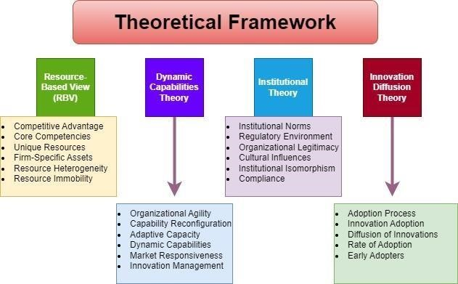
Figure 1: Theoretical framework; Source: Self-made
The research paper designates the theoretical overview that justifies the Resource-Based View (RBV) and emphasises the importance of a firm's internal resources and capabilities as a source of competitive advantage. In the case of UltraTech Cement Limited, the RBV helps in considering the company's resources to gain a foothold in the UK market. Moreover, “Dynamic Capabilities Theory” also concentrates on the Organisation’s capability to adapt and reconfigure its resources in response to changing market circumstances. The
“Institutional Theory” is useful for understanding institutional factors that impact the market entry strategies of UltraTech and related operational practices. However, the “Innovation Diffusion Theory” is relevant for examining sustainable practices and new technologies of UltraTech adopted in the UK cement industry.

Chapter 2: Literature Review

2.1 Overview
The cement industry is growing in the UK market evaluates the possible opportunities from the country and considers the future practices understanding the conceptual ideas of the theoretical analysis. The research paper introduces the chapter on determining the market trends and demands of buyers of the UK cement industry. Moreover, the market analysis and growth opportunities are determined by the UK cement industry with diverse strategies to enter the UK market. The strategies to differentiate the brand from its competitors are also considered in terms of measuring the success of representing sustainable approaches that the company uses within the cement industry (Karttunen, et al., 2021). It maintains the reputation with the strategic approaches and determines valuable scenarios to represent the market aspects. The valuable justification of the research questions is also determined in terms of representing the market scenario and its possible implications to influence the cement industry in the UK.

2.2 Conceptual framework
The conceptual framework is described as an effective illustrative tool in academic research which helps to describe the different factors which are associated with the research (Varpio, Paradis, Uijtdehaage, and Young, 2020). In this research, factors like the market condition of the UK cement industry, marketing approach to increase brand recognition, sustainability practices, and brand differentiation strategies are the associated factors (Ihzaturrahma and Kusumawati, 2021).
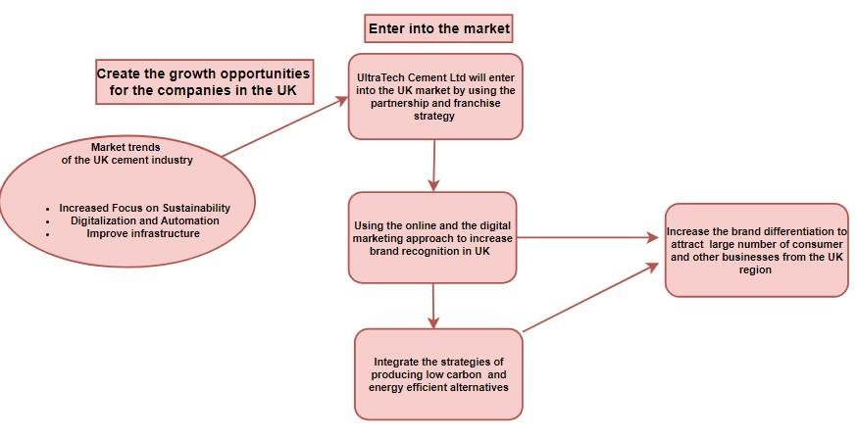
Figure 2: Conceptual framework, Source: Self-Made
From the conceptual framework, it has been found that there are different considerations that help the Ultratech Company to increase the brand reputation of the brand in the UK market. In the recent period of time, UK cement manufacturing companies have followed the trends of focusing on sustainability practices and integrating technologies to improve production and activity to meet the dynamic environment of the market (Möller, Nenonen, and Storbacka, 2020). By using different market entry strategies like building a partnership with the existing company in the UK market or creating a franchise of the Ultratech Company in the foreign market. In order to increase the brand reputation and differentiation, the company has the opportunity to include effective marketing strategies like inclusion of the social media platforms and the integration the sustainable practices. The integration of the strategy to use the energy-efficient alternative and the production the low carbon cement for the construction industry allows the company to increase its reputation in the UK market.

2.3 Market trends, and the demands of buyers of the UK cement industry
The market trends in the UK cement industry are determined, where the industry is heavily influenced by stringent environmental regulations designed to curb carbon emissions and promote sustainability. According to Raybould, et al., (2020), the commitment of the UK is to reduce greenhouse gas emissions and promote sustainability. The market trends are also determined in terms of considering the Climate Change Act has urged demand for lowcarbon cement technologies. Moreover, companies are increasingly investing in sustainable practices, like incorporating recycled materials, using alternative fuels, and developing lowcarbon cement products. The tendencies are also aligned with the global push towards greener construction practices and have significant implications for the market dynamics. However, technological advancement is determined by the market trends that ensure innovation is a key driver in the UK Cement industry. Skillington, et al., (2022) stated that the advances in production technology like automation, energy-efficient kilns, and digital monitoring systems, are ornamental operational efficiency and plummeting production costs. Moreover, the UK cement market has knowledgeable significant consolidation, with a few major players controlling the industry. However, mergers and acquisitions have redesigned the competitive landscape leading to amplified market attentiveness. On the contrary, the market trends also include urbanisation and infrastructure development continue to energy demand for cement in the UK. Karlsson, et al., (2020) denoted that the scenario ensures that major construction projects, including transportation infrastructure, housing developments, and commercial buildings, create a steady demand for cement products. In the UK market, a growing preference for sustainable and eco-friendly building materials among consumers and construction organisations, where green building certifications, like BREEAM (“Building
Research Establishment Environmental Assessment Method”), are becoming more predominant, swaying material choices (Gairola, 2022).
The demand of buyers is also determined in terms of measuring the quality and preferences, where buyers in the UK cement industry prioritise high-quality and high-performance products. However, sustainability is a vital apprehension for buyers in the UK market and increasing demand for cement products that are associated with environmental regulations contributes to plummeting carbon footprints in the market. According to Marinelli and Janardhanan, (2022) noted that cost efficiency is also determined, where cost-effective production methods, competitive pricing, and value for money are important considerations when choosing cement suppliers. In the context of the demand of buyers, it ensured that the buyers are gradually absorbed in innovative and distinguished cement products that proposal specific aids and meet unique necessities. On the contrary, compliance with UK regulations and standards is an important requirement for cement buyers. However, products meet regulatory stipulations associated with environmental impact, safety, and performance.
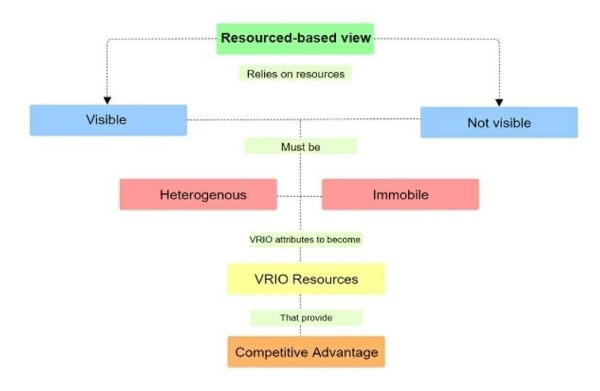
Figure 3: Resource-based view analysis Framework; Source: (Gitmind, 2024)
The Resource-based view analysis is represented in terms of considering the market trends and demands of buyers. The theoretical understanding of “Resource-Based View (RBV)” delivers a valuable framework for considering the importance of a firm’s internal resources and capabilities as sources of competitive advantage (Barney, 2001). The application of RBV involves evaluating the company’s resources like technological capabilities, expertise, and sustainability practices to meet the market demands and navigate the trends. However, the increasing emphasis on sustainability offers an opportunity for companies in the cement industry to leverage their resources in developing low-carbon and eco-friendly cement products. Moreover, RBV also emphasises the importance of cost-effective production methods and efficient supply chain management. Nandi, et al., (2021) stated that the considerable scenario of the RBV also represents the resources used for maintaining the market trends and demand of buyers. The ability of the companies in the market to enhance production costs and confirm reliable supply chains improves their competitive position in the UK market. The theoretical scenario is also used in the research to determine the innovation and product differentiation to consider the market scenario and its possible effectiveness. Olowoyin, (2021) stated that innovation is a key resource of any company that drives product differentiation, where the capability of the businesses to develop innovative cement products that cater to precise buyer requirements provides a competitive advantage. However, by focusing on product differentiation and discoursing unique market demands, the companies in the cement industry capture market share and build strong buyer relationships in the UK market.

2.4 Market analysis and growth opportunities of the UK cement industry
The UK cement industry is a valuable element of the construction sector that is driven by the requirement for infrastructure development and urbanisation. According to Ekinci, et al., (2020), the market analysis required an understanding of the regulatory environment, market dynamics and growth opportunities to consider the UK cement industry. However, the Institutional Theory is applied that offers a valuable framework for determining the institutional norms and cultural factors that affect the operational effectiveness of the industry and its growth. The theoretical insights of “Institutional Theory” focus on the constitutional pressure, regulations and norms that shape organisational behaviour and industry practices (Alam, Karbhari, and Rahman, 2021). The aspect of the Institutional theory also emphasises the role of formal and informal institutions in affecting the firm's operations within the market. However, “Institutional Theory” assists in considering ways the environmental norms, regulatory frameworks, and market structures influence market dynamics and growth opportunities.
The market analysis represents the regulatory environment, where the UK ensure stringent environmental regulations that effectively influence the cement industry. Moreover, the UK government’s valuable commitment to reducing carbon emissions and promoting sustainability is reflected in valuable policies like the Climate Change Act (2008) and the carbon emission commitment (Gov, 2024). The cement producers need to comply with the strict emission limits and adopt environmentally friendly practices. However, the regulatory environment drives the industry towards innovation in low-carbon cement technologies with the commitment to "beyond net zero" by 2050 and sustainable production methods in the UK
(Dezeen, 2021). The UK’s building codes and standards set high requirements for construction materials including cement and it ensures the safety, durability, and performance of construction projects (Gov, 2024). Additionally, Kusuma, et al., (2022) mentioned that the UK government offers incentives and support for adopting sustainable practices in the cement industry to maintain the scenario. Valuable programs like the “Renewable Heat Incentive and the Green Deal” provide financial incentives for companies investing in energy-efficient technologies and low-carbon resolutions (Gov, 2014). The market dynamics are also included in the market analysis for the UK cement industry, which represents the industry that experienced significant consolidation, with a few major players dominating the industry.
However, mergers and acquisitions have redesigned the market, leading to augmented market concentration and competitive undercurrents (Gov, 2024). Moreover, key drivers of demand in the UK cement market involve infrastructure development, urbanisation, and government initiatives.
The growth opportunities are determined to represent sustainable innovation, where change towards sustainability represents significant growth opportunities, recycled materials, and alternative fuels. However, technological advancements provide opportunities for growth and efficiency in the cement industry of the UK. The acceptance of digital monitoring systems, energy-efficient production technologies, and automation improves operational efficiency and reduces costs in the UK cement industry (Cisl.Cam.Ac, 2024). However, the UK cement market delivers opportunities for expansion through mergers, strategic partnerships, and acquisitions. Additionally, collaborations with construction companies, real estate developers, and government bodies make synergies and open new market sections.
According to Tolmie, et al., (2020), the institutional theory applied in the paper evaluates that the formal and informal institutions shape industry practices and influence growth opportunities. However, the theoretical consideration ensures that the UK cement industry pressures from the regulatory framework, market standards and environmental norms play an important role in shaping the market dynamics and growth possibilities. It also understands and navigates the institutional pressures, where the cement industry companies identify strategic opportunities and align the practices with the market expectations. Berrone, et al., (2020) stated that the theoretical framework also determined that companies that adopt sustainable practices in response to regulatory pressures gain competitive advantages and meet the growing demand for eco-friendly products. Moreover, compliance with building codes and standards like “resistance to the passage of sounds” and “conservation of fuel and power” confirm market access and shape credibility with buyers in the UK
(Ukbuildingcompliance, 2024). It also leverages institutional support and aligns with the market norms, and the companies in the UK effectively navigate the cement market and seize growth opportunities accordingly.

2.5 Different strategies to enter the UK market and its associated challenges
The market entry strategies are diverse and ensure the advantages along with the specific risks for the UK cement industry. Shoaib, (2022) mentioned that in the case of determining the strategic aspect, direct investment is the valuable choice, where the establishment of a wholly owned subsidiary and acquiring an existing cement plant in the UK. The strategy of direct investment for the cement industry has advantages that include providing full control over operations, quality, and production processes. However, it also allows direct access to the market and the aptitude to quickly respond to local demand. The UK market entry strategy of the companies also investigates the risks with the strategy like high capital investment and significant financial risk. Moreover, Collinson, et al., (2020) denoted that direct investment navigates the regulatory landscape and integrating into the local market becomes challenging. Joint ventures are a valuable strategy for entering into the UK market for cement companies in terms of partnering with a local firm to found a joint venture or strategic alliance. Oguji and Owusu, (2021) stated that the joint venture strategy ensures advantages for the cement industry entering the UK market like sharing the financial and operational risks with a local partner. Moreover, Tetteh, et al., (2023) mentioned the benefits from the local markets’ knowledge, regulatory expertise, and established networks. However, the strategy ensures risks affecting the business operations like possible conflicts of interest with the partner and loss of control over convinced business aspects. However, Joint ventures also lead to multifaceted management constructions and dependence on the partner’s performance and decisions to influence the scenario.
Al Bakri and Kisswani, (2024) denoted that the strategic view also represents the licensing and franchising that indicates the strategy of licensing technology and branding to a local firm and franchising business operations to utilise in the UK market. The valuable benefits of the strategy for the cement industry ensure lower initial investment and reduced financial risk. Moreover, it provides a way to rapidly enter the market through local expertise and infrastructure representing the values. Conversely, the strategic scenario of entering the UK market indicates less control over product quality and operational standards. Additionally, the risk indicates reliance on the licensee or franchisee’s aptitude to adhere to brand and operational strategies. According to Vaid, et al., (2023), the risk of intellectual property theft and misuse is also seen in the scenario to justify the possible outcomes and measure the success. The strategic view exporting cement products to the UK without founding a physical presence as it benefits lower financial risk compared to founding a physical presence. The valuable strategy for the companies in entering the UK market also ensures acquiring an existing cement company in the UK to increase immediate market attendance and customer base to provide an established market standing.

2.6 Marketing approaches and key collaborations that may extend UltraTech Cement

Limited’s marketplace entrance within the UK
The marketing approaches ensure product differentiation, whereas UltraTech Cement is required to focus on the differentiation of its products through innovation and quality. It offers unique features like high strengths, speciality cement products and low carbon that cater to the construction needs set by the brand. Cisl.Cam.Ac, (2024) mentioned that valuable marketing approaches ensure the implementation by developing and marketing eco-friendly and technological advancements for cement products that meet and exceed the UK building standards. It emphasises the product benefits in the marketing campaigns to attract environmentally conscious buyers and construction firms. Moreover, the marketing approaches also integrate the strategy to capitalise on the growing demand for sustainable construction materials by promoting companies like UltraTech Cement Limited and its commitment to environmental sustainability. Oguji and Owusu, (2021) stated that the valuable implementation of the approach is ensured by obtaining and highlighting certifications like BREEAM or LEED for products. Localised marketing is determined as the marketing approaches by the company by tailoring marketing exertions to the UK market by lecturing local needs and favourites. The online presence and digital marketing are valuable, where the approach indicates enhanced digital marketing exertions to spread a broader audience and drive brand perceptibility.
Key collaboration that extended companies like UltraTech Cement Limited’s marketplace entrance within the UK. It includes partnerships with construction firms with the strategic aspect of strategic alliances with major construction firms and real estate developers (Karlsson, et al., 2020). The key collaboration is possible for businesses like UltraTech Cement by negotiating supply agreements and joint ventures with prominent construction companies to secure long-term contracts and gain entree to large-scale plans. The collaboration also includes joining industry associations and networks to improve market presence and build relationships. However, valuable collaboration is possible by engaging with organisations like the Cement Manufacturers' Association and local construction industry groups (Cmaindia, 2024). Moreover, the partnership with academic institutions and research organisations for product development and innovation is also possible by collaborating on research projects to grow new cement technologies.

2.7 Strategies to differentiate UltraTech Cement Limited brand from existing competitors in the industry
The differentiation strategies of UltraTech cement are possible by developing and delivering unique cement products that encounter specific market needs and differentiate the organisation from competitors. In the case of considering the scenario of the strategic approach, the company has the chance to focus on producing high-performance cement, for example, UltraTech's “UltraTech DuraPlus” which is intended for high strength and durability (Ultratechcement, 2024). Moreover, the scenario is determined in terms of considering the investment in RandD (Research and Development) to innovate cement formulations that increase performance and meet requirements. The emphasis on sustainability is determined, where the position of the business requires a leader in sustainability and eco-friendly practices. For example, the business, UltraTech’s “UltraTech
Weather Pro WP +200” product line incorporates Weather Pro (WP+200) materials and liquids that use alternative fuels that contribute to differentiating the business (Ultratechcement, 2024).
In the considerable scenario of the business, Ultratech ensures setting an Internal Carbon Price (ICP) that ensures an excellent tool for accelerating the value chain and enabling the transition within the business (CDP, 2024). The company’s valuable approaches ensure the business understanding by highlighting sustainability exertions in marketing materials and on the company’s website. Additionally, engaging in partnerships with environmental organisations and participating in green building initiatives to strengthen the brand’s commitment to sustainability is also valuable.
Brand differentiation is the effective model that helps the brand to stand out against the competitors by detecting and interacting with the communications and its capabilities nature in the industry (O’Rourke, Carrillat, and Wang, 2022). In the context of a cement manufacturing company who have the tendency to explore the foreign market, the company needs to include different strategies to differentiate the brand from the competitors. According to (Rokhmad, 2020), companies in the foreign market have the opportunity to become sustainable leaders in the industry and integrate sustainability practices like reducing water consumption, energy consumption, and recyclability processes in the long run. It is important to invest in low-carbon initiatives and technologies to reduce emissions and appeal to the growing demand in the industry. On the contrary, Sahoo, (2022), stated that strategic partnership and collaboration with the existing company in the foreign market allows the company to improve brand recognition in the market, in this case, the company has the opportunity to use the resources and the human capital of the companies to manufacture the product and provide the better services to the consumers. The theory of Dynamic Capability Theory posits that there are some resources that need to be considered when entering into a new dynamic market and increasing the overall business performance (Nayal and Pandey, 2022). The consideration of the adaptive capacity and the dynamic capabilities in the new market allows a business like UltraTech to understand its own capability to increase manufacturing output and use the resources from the partnership companies to meet consumer demand in the end.

2.8 Different Sustainable approaches that UltraTech Cement Ltd. use within the

cement industry to maintain its reputation in the UK
Business sustainability is the marketing trend in the better economy in different countries it allows the business to develop the tendency to align the process with the ecological practices and framework. In the cement industry in the global economy, companies are developing the tendency to integrate sustainable practices like reducing carbon emissions and developing sustainable product ranges to attract a large number of consumers. According to Makul, (2020), in order to increase the business reputation and differentiate the brand from the competitors it is important to focus on the carbon footprint. The strategy to include low carbon cement production, the company has the opportunities to develop the produce that low carbon cement variant. It is recommended that the Ultratech company in the UK market invest in incorporating industrial by-products like slags, pozzolans, and fly ash to reduce the clinker component in the cement, which reduces carbon emission. On the other hand, the integration of the CCS strategy by investing in CCS technology helps the company like UltraTech cement in the UK to reduce and capture the CO2 emissions from cement production that and stored under the ground to t utilise them in the different industries (Huang, Tadikamalla, and Gordon, 2024). On the contrary, Ouyang and Guo, (2020) derived that the companies in the cement industry have the tendency to reduce non-renewable energy consumption and use in cement production. Sustainability practices reduce energy consumption and the use one solar panels and other renewable sources for energy in cement products, For example, in the cement industry in the UK, companies have followed the tendency to upgrade the Kiln technologies like the “Precalciner Systems” “preheater” to reduce the emissions and the energy usage, on the other hand, by adopting the energy management system, the companies are able to optimize the resource and process and reduce the waste generation during the cement production. The perceived advantages of the diffusion theory posit that it is important to integrate the technologies in the business to attain highly competitive advantages. According to the diffusion theory, if Ultratech Cement integrates the electricity management system and other advanced technologies like AI, ML, and business analytics, the company will be able to meet global needs and increase its competitive advantages over the period.
In India, UltraTech participates in "Innovandi," the GCCA-managed Global Cement and Concrete Research Network initiative. Accelerating international cooperation in cement and concrete innovation is the goal as a critical first step toward the industry's climate response. The company is engaged in the RE100 commitment through which the management has decided to interact with 100% electricity management from renewable sources by 2050. The company has increased its capacity up to 555 MW of green energy and committed to reducing carbon emissions by 69% per cementitious materials by 2030 (Ultratech Cement, 2024). it refracts that in the domestic market, the company already leads the industry and in the UK, the company has the opportunity to develop a sustainable framework and align the business process with the sustainable goals. Nayal and Pandey, (2022), add that the sustainable strategy of sustainable raw materials sourcing and the green building solution will allow companies in the cement industry to improve their business reputation. The sourcing of recycled materials and minimising the environmental impact while manufacturing cement allows the business to reduce the need for different virgin resources. Apart from that, the agreement-building solution by the construction industry will allow companies like UltraTech to implement the quarrying process and ensure that our materials have minimum impact on the environment.

2.9 Challenges faced by Indian business in the United Kingdom market
Indian businesses when entering the open economy of the United Kingdom face different types of challenges regarding regulatory complexity, cultural differences, intense competition, and economic fluctuation. According to Brown, Rocha, and Cowling, (2020), the UK has stringent and complex followed by the manufacturing pharmaceutical as well as finance sectors. In this case, the businesses from the Indian market have the responsibility to navigate the different types of regulations related to the labour laws health and safety standard taxation as well as the environment compliances to avoid any legal hurdles in the future. Understanding the regulations and the alignment of the business process can be timeconsuming as well as costly which influences the overall financial health of the Indian company. For example, the UltraTech company may have faced the issues of understanding the specific legal system of sustainability and government initiatives for ecosystem betterment in the UK. UltraTech company needs to interact with the strict carbon emission targets (reduce 100% emission by 2050) as well as waste management practices in the United Kingdom which help the company to increase its brand reputation and differentiation in the industry (GOV, 2024). On the contrary, Huy, Nhan, and Bich, (2021), connote those cultural differences along with communication impacted the overall business process of entering into a new market like the United Kingdom.
The cultural differences between the United Kingdom and India may pose challenges, especially in the businesses from the management and communication practices. In this case, UltraTech encounters different difficulties in understanding business etiquette as well as a consumer expectation. For example, the UK places a high emphasis on ethical practices and sustainability while the Indian companies are more focused on improving the business values among the consumers. In this case, the UltraTech cement company has the opportunity to align its corporate practices like cement manufacturing and consumer services with the values of the UK dynamic market. The manufacturing companies have faced issues of logistical optimisation as well as supply chain management due to the transportation issue as well as the high shipping cost. In this case, the companies who are entering into a new market like the United Kingdom may have faced issues with understanding the new customs and procedures after Brexit and collaboration with the national suppliers. The collaboration with resources like skilled employees as well as suppliers will allow the company to understand the consumers’ needs in specific regions like the United Kingdom and understand the strategy of improving the business model in the new market so that the company will able to improve overall business reputation in the region.

2.10 Research gaps, conflicts, patterns, and theories

Research Gaps
The main research gaps of the research paper lie in considering the nuanced influence of developing regulatory frameworks on market dynamics. Moreover, while existing studies discourse broad regulatory influences, there is a necessity for thorough research on “how specific regulations, like the Climate Change Act and carbon emission targets, impact operational strategies and technological innovations” in cement manufacturing. However, the work analyses limited research on the incorporation of emerging technologies and their efficacy in refining sustainability in the cement industry.

Conflicts
The conflicts in the industry stem from balancing environmental sustainability with efficiency. However, the companies face challenges of adopting low-carbon technologies while managing high preliminary costs and circumnavigating multifaceted regulatory necessities. The conflicts also highlight the gap in considering “how the firms reconcile environmental goals with the financial pressure and effective competitiveness.”

Patterns
The patterns observed in the industry involve the growing emphasis on technological advancement and sustainability. The change towards eco-friendly cement products and energyefficient technologies reproduces broader industry tendencies towards plummeting environmental influence.

Theories
Key theories like Institutional Theory, Resource-Based View (RBV), dynamic capabilities and innovation diffusion theory provide valuable insights into the dynamics. “Institutional Theory” assists in understanding “how regulatory pressures shape industry practices and growth opportunities”, while RBV delivers a framework for analysing “how internal resources and capabilities drive competitive advantage and product differentiation”.

2.11 Justification of the research questions by using up-to-date theories and

understanding
- How does a market investigation of the cement industry in the UK, concentrate on substantial trends, and the demands of buyers?
The Resource View Theory justifies the research question of market investigation of the cement industry in the UK by concentrating on the buyer's demand and substantial change in the market as it helps to understand the competitive advantage of the firm leveraging the different unique sources and capabilities. The investigation of the trends and demands in the UK UltraTech Cement is able to identify the specific capabilities and resources that each needs to align the output quantity with the consumer’s demand.
- What are the marketing approaches and key collaborations that help to extend UltraTech Cement Limited and marketplace entrance within the UK?
The dynamic capabilities theory aligns with the marketing approach as well as the collaborations for the UltraTech cement-related research question. It shows that it is important to understand the firm’s ability to build, reconfigure, and integrate internal and external competence for addressing the rapid change in the dynamic environment. The marketing strategy and strategic collaboration enhance the company’s ability to adopt the specific demand in the United Kingdom.
- How can UltraTech Cement Limited differentiate itself from existing competitors in the UK cement market?
The innovation diffusion theory alliance with the third research question on brand differentiation in the United Kingdom in reference to UltraTech Cement Limited. In the United Kingdom, the integration of advanced technology like sustainability management as well as digital marketing automation allows the company to create a unique USP in the market and improve the business reputation as well.
- What are the challenges faced by the companies during market entry from India to the UK?
Indian enterprises encounter various obstacles while venturing into the open market of the United Kingdom, including regulatory intricacies, cultural disparities, fierce rivalry, and economic volatility. In this instance, in order to avoid any future legal snags, companies operating in the Indian market must negotiate the various regulatory frameworks pertaining to labour laws, health and safety standards, taxation, and environmental compliance.
- What innovative sustainable practices might UltraTech Cement Limited implement in the cement sector, and why are these tactics crucial for adhering to UK laws and preserving competitive advantage?
The institutional theory justifies the fourth research question. In the UK it is important to understand the institutional pressure and for that adoption of the new sustainability approaches and the regulatory and social expectation allows the company to improve the business reputation and revenue string in the new market.

2.12 Summary
It is concluded that Considering "UltraTech Cement Limited's" growth prospects and market dynamics in the cement sector of the United Kingdom by emphasizing theoretical analysis and conceptual frameworks in relation to consumer wants and market trends. The current study examines how market patterns are impacted by strict environmental laws, the "Climate Change Act of 2008"'s ambitious sustainability goals, and developments in low-carbon technology. In order to evaluate internal resources and capabilities as competitive advantages, it develops sustainability practices and uses Institutional Theory to comprehend the effects of regulations and culture on market performance.

Chapter 3: Methodology
“Investigating Challenges and Opportunities of Indian Manufacturing Sector: the case of UltraTech Ltd Cement industry”

3.1 Introduction
Methodology indicates the processes, as well as the techniques that are used in order to conduct research, and without its use, every study becomes academically irrelevant (Mohajan, 2019). In this context, the present study also requires a methodology, and the topic is investigating challenges and opportunities in the Indian manufacturing sector with special reference to the Ultra Tech Ltd Cement Industry. The chapter solely discusses the specific aspects like research philosophy, approach, and design. The philosophy discusses the overall ideological parameter followed in doing the study, the approach provides the ways by which an inference is derived, and the design helps in finding out the methods by which the research variables are linked.
It also discussed the methods of data collection, and analysis, as well as the limitations that are required for doing the research. Furthermore, the consideration of ethical parameters is also being implemented in the context of conducting this research. In order to understand the overall understanding of this research, the methodology onion is being given as follows: -
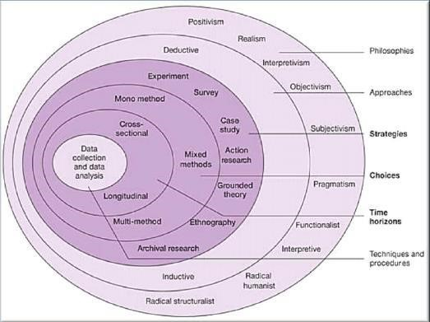
Figure 4: Research onion, Source: (Mohajan, 2019)
From the overall onion, it is understood that the first point that is required to be discussed is philosophy, and several categories are being described, in this research, positivism because of generating authentic data. In the next level, the approach of the research is required to be chosen, which is deductive for generating specific inferences. The next part constitutes the strategies, and then, the methodological choice is given. After that, the discussion pertaining to the time-horizons, and then, the data collection and analysis pertaining to the study are given.

3.2 Research Philosophy
The investigation of the challenges and opportunities of the Indian manufacturing sector mainly within the UltraTech Cement Ltd. in the UK market. The research philosophy adopted in the research is epistemological, focusing on positivism that is grounded in the belief that knowledge results from observable and measurable evidence (Sileyew, 2019). The approach is aligned with the researcher’s goal of quantifying the market trends, and competitive variables through the empirical data and buyers' preferences (Peters, et al., 2022). The positivism philosophy is chosen for the factual data collection regarding the investment challenges and growth opportunities of the Indian manufacturing cement industry. The aim of the paper is also to uncover the objective truths regarding the current industry’s dynamics that are generalised to the broader contexts. The methodology also ensures epistemological stance of positivism is justified as it enables a structured and objective inspection of the sector. Moreover, the philosophy chains the use of quantifiable data and statistical methods to classify patterns and correlations within the composed information. In the valuable study, positivism permits the application of rigorous statistical analyses, like regression and correlation analyses, to comprehend the relationships between numerous factors influencing UltraTech Cement Ltd.'s growth. The considerable approach ensures that the findings are based on dense empirical evidence, decreasing subjective interpretations, and enhancing the reliability of the consequences. With the adoption of the positivism philosophy, the research also focuses on the importance of empirical validation and replicability. It is important for generating actionable insights that inform strategic decisions for UltraTech Cement Ltd. and the stakeholders for considering the scenario. The dependence on the measurable data and the objective assessment of challenges and opportunities in the cement industry is evaluated accurately to draw for both valid and applicable to real-world scenarios.

3.3 Research Approach
The examination of the challenges and opportunities in the Indian manufacturing sector effectively focuses on UltraTech Cement Ltd. within the market. The selected research approach in the work is the deductive research approach and it starts with the theoretical framework and usages empirical data to test hypotheses derived from present theories (Mulisa, 2022). However, the research approach also aligns with the study’s aim to apply a structured analysis based on pre-existing knowledge. The research work is accomplished in terms of establishing the theories related to market behaviour, industry trends, and competitive analysis. The valuable approach is determined in terms of considering the study’s aim to apply the established theories and models to analyse the cement industry’s environment and the growth potential of the UltraTech industry concerning challenges like poor infrastructure that disturbs the timely delivery of raw materials and distribution of finished products. However, the deductive approach is well-suited for the research work as it permits a structured analysis based on pre-existing knowledge. The research paper is systematically tested with the theoretical concepts against real-world data. Moreover, the approach enables a clear connection between theoretical ideas and practical observations, confirming that the analysis is grounded in well-supported academic frameworks effectively. The deductive reasoning helps the researcher in formulating hypotheses regarding the buyer preferences, market trends, and competitive factors upsetting UltraTech Cement Ltd. The valuable hypotheses are tested through empirical data collected from surveys and interviews. However, the method confirms that the research findings are not only reliable with theoretical expectations but also deliver practical understandings of the company's challenges and opportunities effectively. Additionally, the scenario also determined that the deductive approach is justified as it increases the clarity and rigour of the research by focusing on the theory-driven hypothesis and testing specifically. The valuable method allows the researcher to deliver strong and actionable insights that contribute to the capitalising and understanding of the challenges and opportunities in the cement industry. The approach indicates the theories that ensure challenges like inefficiencies in transportation and logistics lead to delays and increased costs.

3.4 Research Design
The research design is appropriate for investigating the relationship between diverse market factors and their implications on the growth of the company’s potential (Sileyew, 2019). The correlational research design is selected in the research work that is effective in identifying and analysing the association between the variables without manipulating them and making it suitable for considering complex and real-world phenomena like consumer preferences and market trends. Moreover, the correlational design is allowable for the comprehensive analysis of determining the diverse factors like the buyer inclinations, industry trends and competitive variables interpreted. The leverage of the approach is also uncovering the significant correlations between the variables offering valuable insights into the dynamics of the current markets. The valuable design is specifically advantageous because it aims to explore and investigate the patterns within the existing data rather than establishing cause-and-effect relationships. The correlational design investigates the scenario of the research paper that ensures challenges of cultural disparities between India and the United Kingdom could be problematic. It is justified to choose the correlational research design as it depends on the ability to tackle large volumes of quantitative data. The provided study also ensures that dependence on the data from the survey’s questionnaires, and interviews, where a correlational design enables the inspection of the data points to recognise meaningful relationships. However, the non-experimental nature of the design aligns with understanding existing trends and patterns rather than intervening and manipulating variables to determine challenges like organisations that rely heavily on management and communication techniques. Moreover, correlational research design supports the researcher's use of statistical techniques, like regression and correlation analysis, to discover associations within the dataset.

3.5 Data Collection
The collection of data is basically of two categories, which are the collection of primary information and secondary information (Lasater, et al., 2019). In this particular study, the primary information is mainly used for conducting the study because it helps in improving the authenticity, as well as aligns with the complex quantitative information as ordained from the positivist philosophy (Hasan, 2021). The data collection is required from definitive clients, organisational construction, and industry specialists, and the information is collected by means of interviews and surveys (Saliya, 2023). The questionnaire, both open-ended (interview), and closed-ended (survey) is used for analysing client behaviour, and market trends along with the use of web analytics, and online metrics.
The procedures that are used provide an extensive amount of data that is collected, and it helps in monitoring the tendencies of consumers, as well as trends in the marketplace, rival attitudes, and inclination of buyers, organised efforts, and practical purposes for a balanced project study about challenges and opportunities in the Indian manufacturing sector. The sampling size is that 100 individuals are chosen from the industry experts, firms, and clients of the UK cement market for the survey. From the survey, it is quite important that the inclination of buyers, competitive variables, as well as market trends are differentiated in the information set. Other than that, the interviews are separately conducted by the Ultra Tech managers who are 5 in number, and 5 specific open-ended questions are devised for the interview in order to form the qualitative data, which is required for doing the analysis.
The sampling process in the field of data collection is stratified random sampling, where it would be linked with the end users, experts, and construction firms that are available in the field (Zhang, 2022). The standard is a kind of careful attitude that has different kinds of perspectives within the sector. Also, it is seen that the end shoppers get a proper understanding linked with purposeful examination, which helps in procedure integration that has effective accomplishment related to proper aims and objectives. It helps in analysing the market tendencies, the inclination to purchase, advertising strategies, coordinated efforts, and sustainable practices.
The overall gatherings of data are conducted by the procedure, and there are 10 specific survey questions with 100 population, and along with that, 5 open-ended questions are made to 5 individuals who are managers and have been working in Ultra Tech Cement for more than 5 years. The sample size is kept at 100 because it becomes easier to determine the percentage of people who have answered certain options that are present in the process, and also, it helps in generating a massive amount of output that is being connected with the study.

3.6 Data Analysis
The scrutiny of information is creating the quantitative methodologies, which are not totally experimental by nature, and also, the regression examination is going to be done by means of correlation analysis, where two specific procedures are used for connections, as well as models that are gathered (Matović and Ovesni, 2023). The insights are employed for summing up, as well as the tendencies of the client, and the contender qualities are being considered. It effectively helps in creating the goals, and purpose related to the understanding of the facts, as well as the challenges in the Indian manufacturing sector that are being involved in the process.
The data analysis is mainly primary quantitative in nature, where specific complex kinds of quantitative information are being analysed by means of the SPSS tool, which constitutes the regression analysis, the correlation analysis, and other kinds of specific parameters like descriptive statistics are used for generating the outcome. Qualitative research is also being performed where the interview questions are being studied theoretically, and the results from the quantitative sources, and the qualitative sources are being compared in the study, also, it is connected with the generation of a proper inference that is linked with the process.

3.7 Research Limitation
The limitation of this study is that the challenges and opportunities in the Indian manufacturing sector are continuously being evaluated with the help of primary sources constituting interviews, and surveys. However, it is also observed from the study that no secondary interpretation from the peer-reviewed journals is being used in this study, which makes the research limited because the knowledgeable expertise associated with the theories, and prospects are quite missing. Along with that, it is also observed from the study that there are limitations that are linked with the proposition that only the Indian manufacturing sector is considered, which means that the research is local, and not global in nature.
Moreover, the limitations also constitute the fact that it is solely focused on the cement manufacturing industry, and keeps Ultra Tech Cement as one of the main factors that are linked with the study. Furthermore, the limitations are also linked with the fact that the survey questions and the interview questions are also quite limited, and if more questions had been used in the research, then the overall research would have been improved in a better manner, and the improvement of the study is made in a better way.

3.8 Ethical Consideration
Ethical considerations are related to the common morals that are being considered as a part of doing the research (Lasater, et al., 2019). In this regard, the ethical factors are the consent that is taken from all the participants, and they are made to sign a consent form, which helps in understanding that the people have willingly participated in the research process. Other than that, the ethical parameters also contain a debriefing statement where it is mentioned that the research is being conducted only for academic purposes, and there are no business intentions that are present while doing the research.
The participants are also provided with the liberty to quit the research at any point in time, or even skip any question that they might want to use. Along with that, the data are all encrypted, and the privacy of the information is maintained, where all the information is stored in cloud computing software with an alpha-numeric password, as well as two-way encryption is used in order to conduct the study. Also, it is found from the study that the anonymity of the participants is maintained, and the overall research is published in bulk as a part of the study.
The ethical parameters are also linked with the fact that the research information is completely stored in the internal server of the university unless it is accepted. Once it is accepted, the research is publicly published in the sources that are mainly linked with the associated problems of this study.

3.9 Summary
The methodology constitutes the processes by which the study is conducted, and the philosophy that is used in this study is positivism in order to procure factual details. The approach is deductive, and also, the correlational design is used in doing the study. The deductive research helps in procuring the specific outcome for the study, and also, the correlational design helps in creating a linking between variables. The data collection and analysis help in generating the fact that statistical analysis with SPSS as well as the qualitative analysis are being used in order to generate the best kind of outcome. Also, it is observed from the study that the ethical considerations are the morals that are being connected with the study, where the consent is provided, and also, it helps in generating a greater number of findings that are linked with maintaining anonymity and privacy that are linked with the process.

Chapter 4: Data Analysis and Findings

4.1 Introduction
The data analysis and findings are valuable for the research questions as it is evident towards determining the market scenario and its possible insights to represent the market data. The analysis is completed based on the findings of the primary quantitative data. The research paper uses primary data towards considering the quantitative and qualitative analysis. The quantitative data analysis is accomplished based on the gathered survey data with 100 participants. Moreover, the primary qualitative data are collected from the interview questions that ensure the deep insights of the managers of UltraTech Cement Company. The overall insights are represented in terms of considering the business growth opportunities in the UK market by considering the quantitative (from survey) and qualitative data (from interview) analysis techniques in the UK market.

4.2 Findings of Primary Data

4.2.1 Findings of Quantitative Data

4.2.1.1 Descriptive Statistics
In order to explore the challenges and potential of the Cement Industry related companies in the concerned industry of the UK, descriptive statistics are estimated and this is conducted over the primary dataset collected by conducting a survey with the related professionals. The reason for the execution of the descriptive statistics is respective competence in the highlight of the central tendency of the participants towards the potential growth opportunity of UltraTech Cement Ltd in the related industry of the UK. The statistical outcome of the descriptive statistics is presented below-
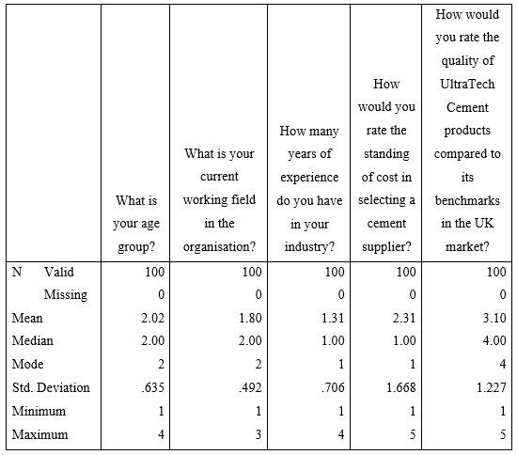
As per the descriptive statistics, the age of the average participants in the primary data collection practice is between 25 years to 44 years and the same range is identified mostly across the sample size which is evidenced by the lesser standard deviation. On the other hand, the response of the participants towards the quality of the cement products of UltraTech Cement Ltd is identified as favourable mostly but the response is identified as varying significantly and this is evidenced by the greater standard deviation.

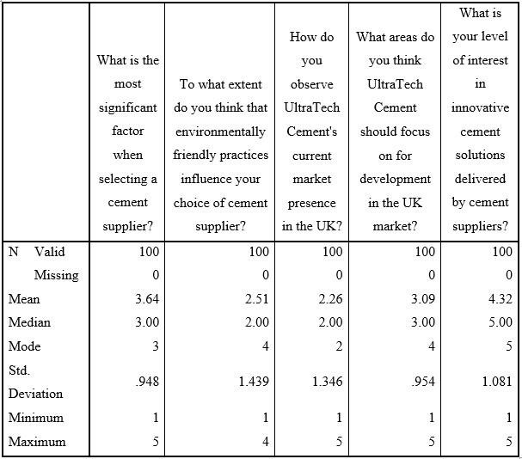
The maximum number of participants are found interested positively in the innovative cementrelated solution provided by the team of UltraTech Cement Ltd but this insight is identified as varying significantly as the related standard deviation is higher than 1.
Q1: What is your age group?
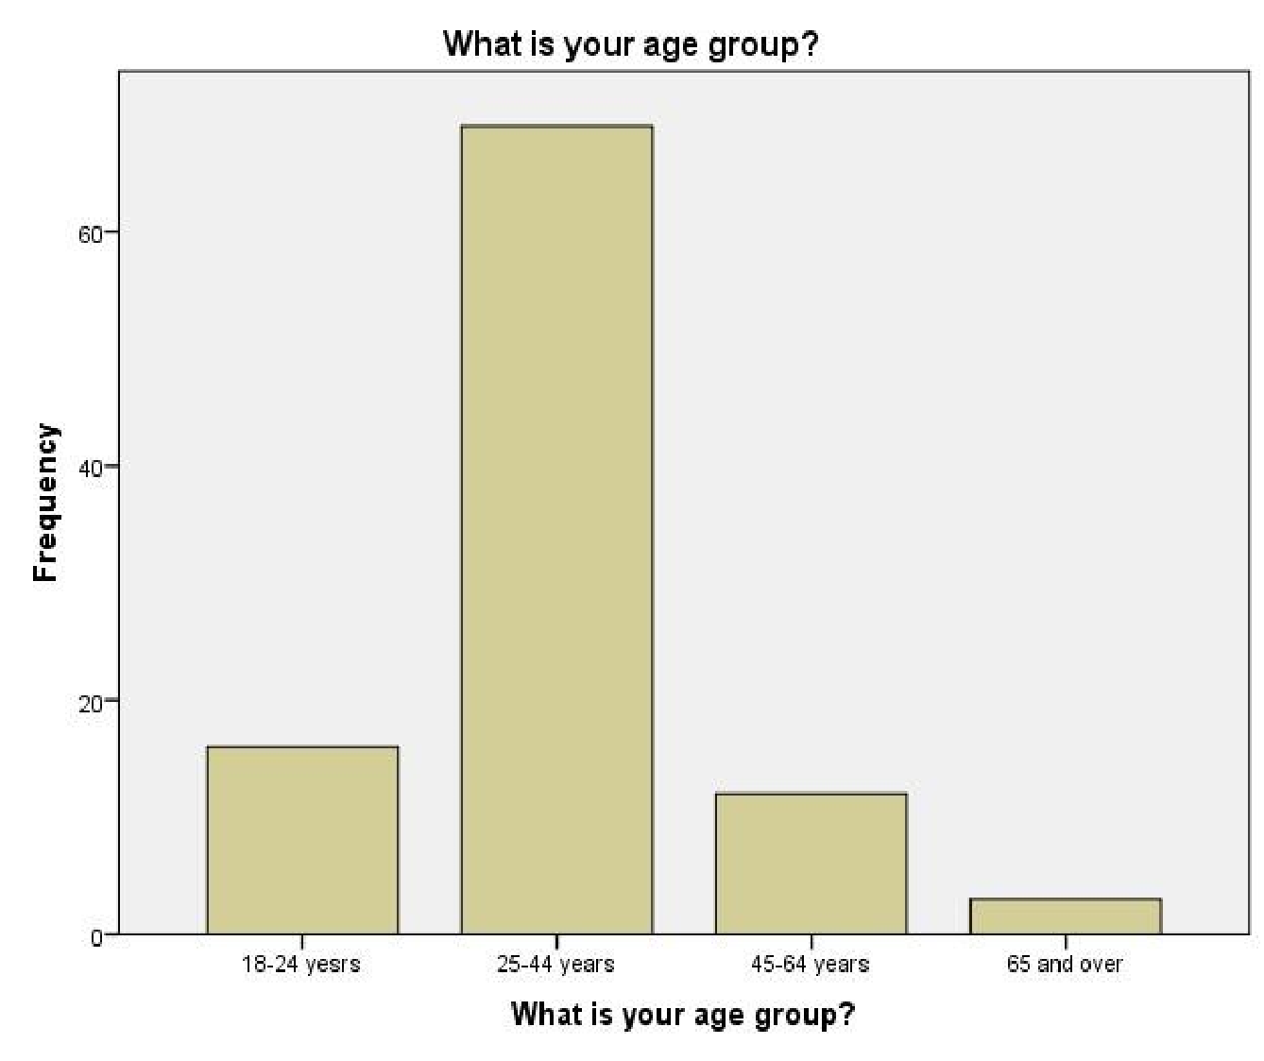 Figure
5:Descriptive Statistics for age group; Source: Self-made;
The visual statistics confirm the dominance of the participants of the age group of 25-44 years in the primary data collection practice while the frequency is least for the individuals of the age range of 65 years and over. The inclusion of the insight of the young individuals in greater frequency has helped in augmenting the relevancy of the deliverables in meeting the objectives.
Q2: What is your current working field in the organisation?
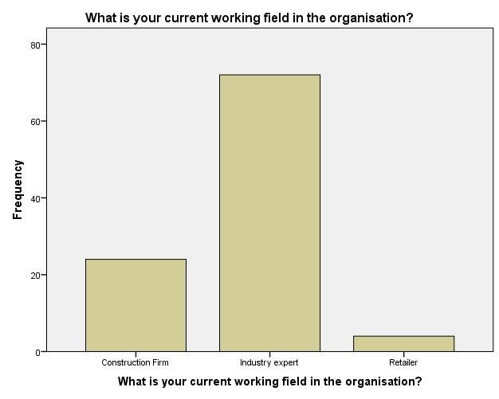

Figure 6:Descriptive Statistics for current working field; Source: Self-made;

The visual presentation confirms the involvement of a maximum number of participants in the industry expert-related field while the frequency is least for the participants belonging to the retailer industry. The involvement of participants from industry experts in greater frequency has aided in increasing the reliance of the deliverables in meeting the goal.
Q3: How many years of experience do you have in your industry?
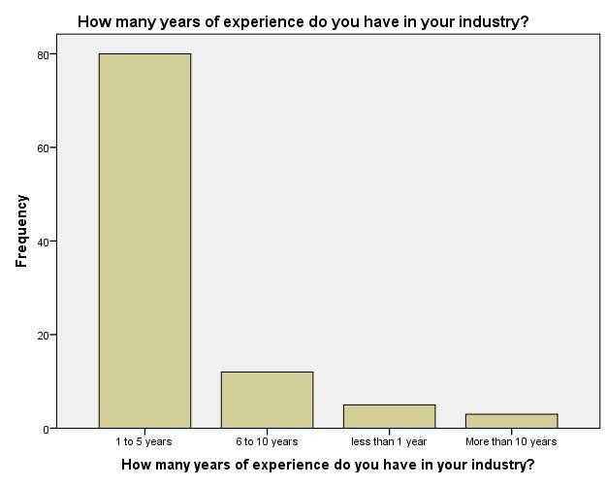
Figure 7:Descriptive Statistics for experience; Source: Self-made;
The illustration confirms that the maximum number of participants involved in the primary data collection practices have work experience of between 1 to 5 years while this is the least for the individuals with work experience of more than 10 years.
Q4: How would you rate the standing of cost in selecting a cement supplier?
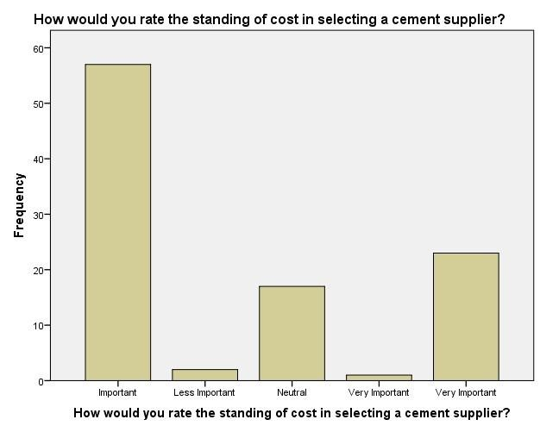
Figure 8: Statistics for rating the standing of cost; Source: Self-made;
The illustration validates that the greatest number of participants have highlighted the importance of the standing cost in the selection of a cement supplier while few of them have highlighted the factor as very important. It means that there is a greater number of positive responses about the importance of the standing cost in the selection of a cement supplier. Q5: How would you rate the quality of UltraTech Cement products compared to its benchmarks in the UK market?
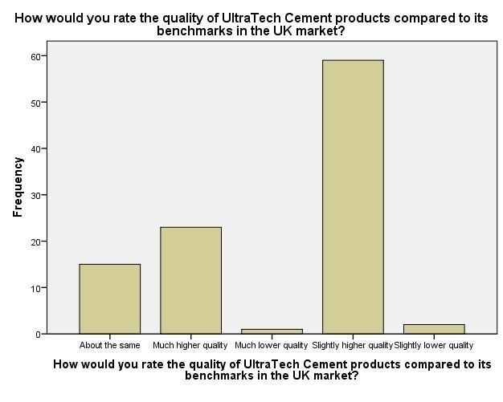
Figure 9: Statistics for quality of UltraTech Cement products; Source: Self-made;
In the visual, it is interpreted that most of the participants have confirmed the availability of slightly higher quality in case of the quality of cement products of UltraTech Cement Ltd in comparison to the benchmark set in the UK industry. On the other hand, the negative response of the participants towards the concerned practice of UltraTech Cement Ltd is identified as lesser in the comparison to positive one.
Q6: What is the most significant factor when selecting a cement supplier?
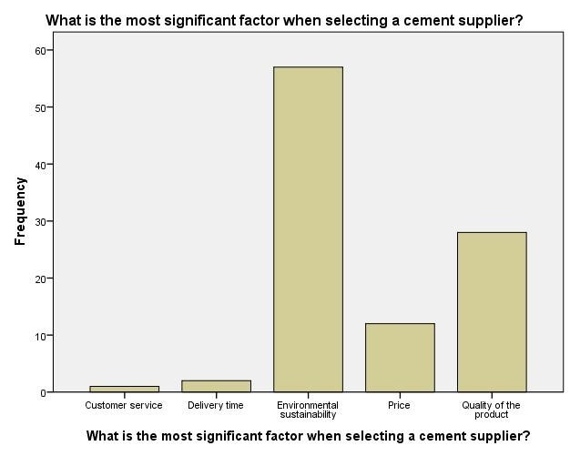
Figure 10:Descriptive Statistics for significant factor; Source: Self-made;
In the assessment of the visual, it is examined that environmental sustainability is the most significant factor while selecting a competitive supplier of business as most of the participants have supported the option in comparison to others. Apart from this, the customer service-related trait is identified least significant factor in the process of selection of a competitive cement supplier and this is evidenced by the lesser number of participants in the respective favour.

Q7: To what extent do you think that environmentally friendly practices influence your choice of cement supplier?
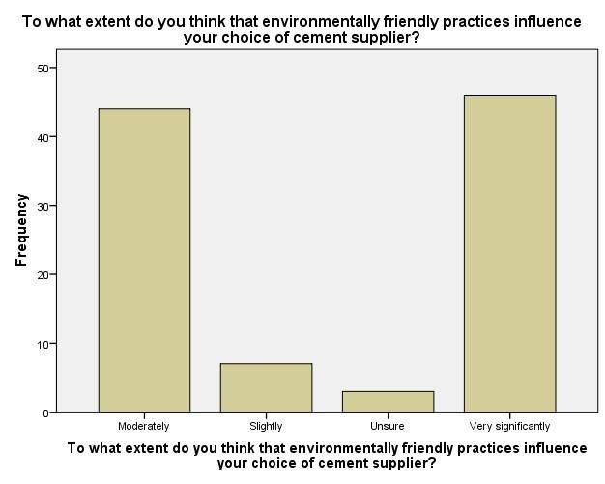
Figure 11: Statistics for environmentally friendly practices influence; Source: Self-made;
The visual analysis confirms the availability of potential and very significant impact of environment-friendly practices of companies like UltraTech Cement Ltd on the respective selection as cement supplier by the customers and this is evidenced by the greater number of related participants. On the other hand, the number of participants who are found in the negative situation of the concerned statement in terms of environment-friendly practices of cement suppliers is the least and this makes the determined assumption justified.
Q8: How do you observe UltraTech Cement's current market presence in the UK?
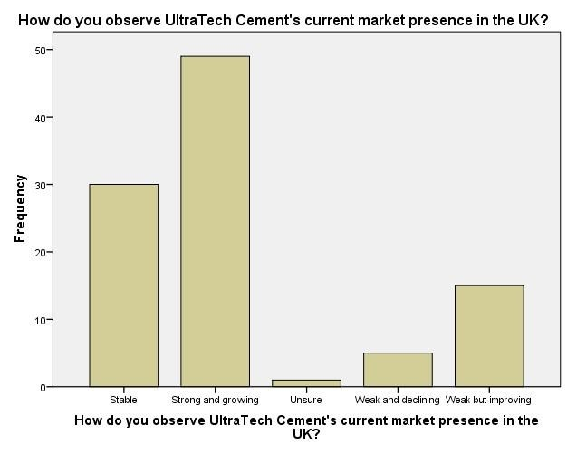
Figure 12:Descriptive Statistics for current market presence; Source: Self-made;

The illustration validates the availability of the growing and strong market presence of UltraTech Cement Ltd in the UK cement industry and this is justified because of the availability of a greater number of participants in the respective favour. On the other hand, the number of participants who are on the negative side of the current market presence of UltraTech Cement Ltd is limited and this validates the considered assumption of the research work.
Q9: What areas do you think UltraTech Cement should focus on for development in the UK market?
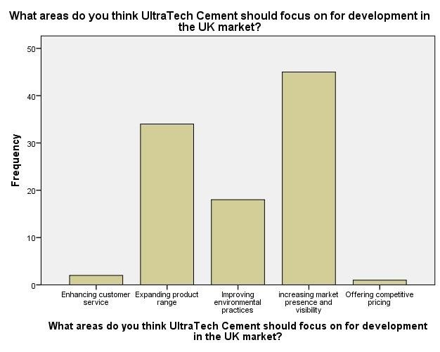
Figure 13: Descriptive Statistics for focus on development; Source: Self-made;
The visual analysis validates the necessity of market presence enhancement-related factors by the team of UltraTech Cement Ltd in order to increase market competitiveness in the industry and this is validated with the availability of a higher number of participants in the respective favour. On the other hand, the factor of customer service enhancement is emphasized in the least number by the participants for increasing the market position of UltraTech Cement Ltd in the UK.
Q10: What is your level of interest in innovative cement solutions delivered by cement suppliers?
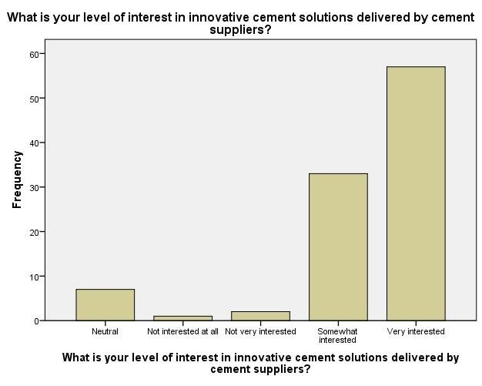
Figure 14: Statistics for interest in innovative cement solutions delivered; Source: Self-made;
The interpretation of the visual confirms that a maximum number of participants is found very interested in the innovative cement solutions delivery by suppliers of cement like UltraTech Cement Ltd. On the other hand, the least number of participants are found least interested towards the creative solutions provided by cement suppliers.

4.2.1.2 Correlation Analysis
In order to examine the strength and direction of the relationship between the competence in the products and solutions of cement companies of India like UltraTech Cement Ltd and respective success in the UK-related industry, correlation analysis is conducted by estimating the respective coefficient which outcome is below-

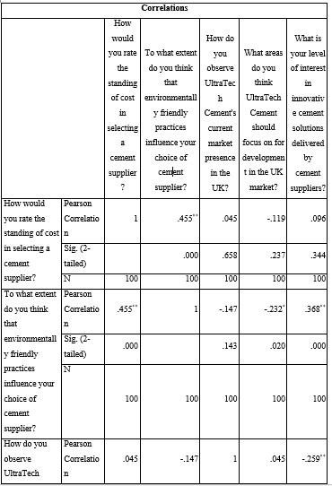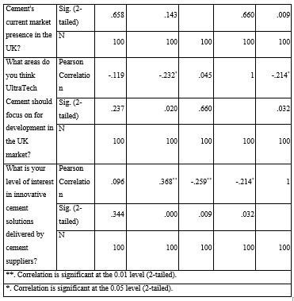
As per the table of the correlation coefficient, the value of the metrics for the variables including the competence of cement companies UltraTech Cement Ltd in terms of cost and innovative solution and respective sustainability in the targeted market like the UK is 0.658 at a 5 % level of significance. In other words, the opportunity for entering cement companies in the UK market will increase with the hike in respective competence in terms of factors like cost and vice-versa.

4.2.1.3 Regression Analysis
Multiple regression analysis is conducted to examine the impact of the competence in the products and solutions of cement companies of India like UltraTech Cement Ltd on respective success in the UK-related industry and respective outcome is presented below-
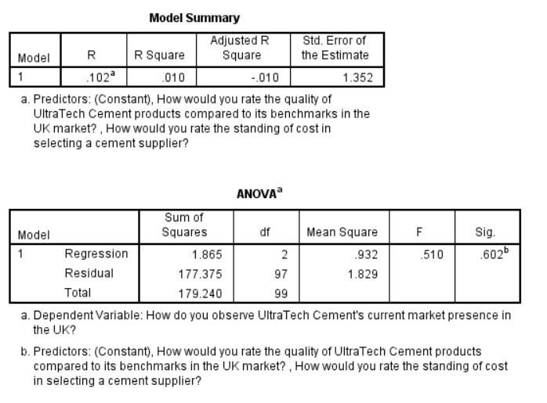
Figure 15: Regression Analysis for Growth Opportunity and Success Rate; Source: Self-made;
The ANOVA table confirms the lesser influence of internal competence on the market presence of cement companies like UltraTech cement and this is validated by the greater “Sig” value.
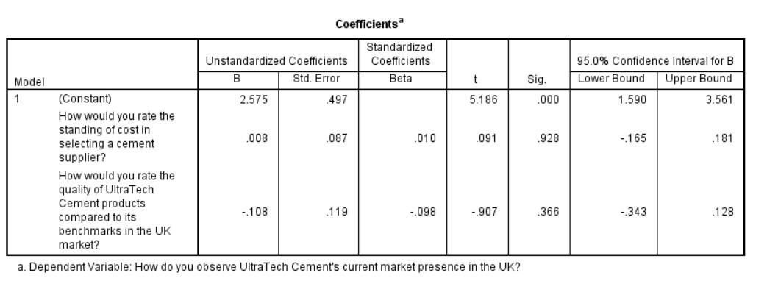
Figure 16:Regression Analysis; Source: Self-made;
The impact of the competence in the products and solutions of cement companies of India like UltraTech Cement Ltd on respective success in the UK-related industry is identified as marginal because of the higher computed “Sig” and this might be a dependency of the situation on other extrinsic or intrinsic factors.

4.2.2 Findings of Qualitative Data

“What strategies do you believe are important for UltraTech Cement Ltd to upsurge its market share in the UK cement industry?”
The interview session with the managers of the UltraTech company ensures several key strategies for enhancing the market share in the UK cement industry. the investment insights towards determining the innovative product line and increasing product differentiation are effective in capturing large market share. Moreover, the focus on the market also creates unique and advanced products. However, UltraTech has the chance to have a broader range of customer analysis as said by the managers. Furthermore, aggressive marketing campaigns expand the distribution network and market presence through targeted promotions in highgrowth regions. The respondents also talked about the expansion of networks and forming strategic partnerships with local construction firms that improve market penetration and reach potential customers. Moreover, the responses also represented that identified in the interview session that improving customer service and delivering flexible delivery options are also vital, as they attract more clients and reinforce market location. Eventually, upholding competitive pricing while ensuring high product quality is critical for offering better value compared to benchmarks.

“How do you observe the influence of environmental sustainability practices on UltraTech Cement Ltd’s growth potential in the UK market?”
In order to get valuable insights regarding the influence of environmental sustainability practices on growth potentials, the interviewees determined their personal insights to be in the industry. The respondents’ responses ensure the adoption of sustainable practices is not only necessary for compliance with regulatory requirements. Moreover, it also opens new market opportunities and challenges as the demand for green products and services increases. The application of eco-friendly technologies also leads to long-term cost-savings and enhances the marketability towards environmentally conscious clients. Moreover, the respondents also said that sustainable initiatives that strengthen the company’s brand image and provide competitive advantages in the market ensure an enhancing focus on environmental issues.
“Can you define any recent market trends or changes that have significantly affected

UltraTech Cement Ltd’s operations or strategy in the UK?”
The interview responses also included valuable insights regarding the market trends and changes that affected the company’s operations in the UK. The respondents responded that the augmented demand for quick turnaround times in construction projects has determined the company to enhance its supply chain and delivery competence. The session ensured the notable change towards green building materials has encouraged UltraTech to quicken the development of sustainable product lines in the UK. One of the respondents also determined that the rise in raw materials has influenced the raw materials costs as challenges that impacted the pricing strategies and profit margins that require cost-effective solutions. Moreover, the valuable respondents also determined that the growing tendency of digital transformation in the construction industry has led UltraTech to improve its technological competencies and accept digital tools.

“What are the key challenges UltraTech Cement Ltd faces in the UK market, and how does the company mitigate these successfully?”
The research findings of the paper analysed and considered that the interviewees ensured several challenges in the UK market. The navigation of the regulatory changes and the environmental regulations needs significant investments in sustainability and compliance initiatives. The respondents of the interview also talked about the increasing demand for faster delivery times has led the company to emphasise refining logistics and supply chain competence. The review of the managers ensured that the intense market competition is a challenge that requires a focus on innovation and product differentiation to stand out from the competitors. The rapidly growing customer expectations also need enhanced customer engagement and the mechanism of feedback to remain responsive towards the market needs.

“How do you consider UltraTech Cement Ltd to enhance its competitive advantage in the UK cement industry?”
The respondents also identified the scenario in terms of considering the enhancement of the competitive advantages in the UK cement industry. The managers responded and recommended that the company should focus on the strategies in terms of developing strategic partnerships with key players in the construction industry to boost market attendance and inspiration. One of the valuable interviewees indicated leveraging advanced technology and innovation in the production processes also results in superior products and assists in staying ahead of the competitors. However, the responses also evaluated that the strengthening of supply chain and logistics capabilities will confirm more reliable and timely distributions, scenery the company apart from its contestants.

4.3 Empirical Analysis

Quantitative Data Analysis
The descriptive analysis of the survey data represented the key insights into the preferences and perceptions of stakeholders in the UK cement market regarding UltraTech Cement Ltd.
However, it is analysed from the descriptive view that the majority of the respondents are aged 25- 24 years old and work predominantly as industry experts. The valuable indication of a knowledgeable and experienced sample also considered and represented 1 to 5 years of industry experience providing a fresh experienced viewpoint. The cost is a significant factor as determined and responded to by participants while selecting cement suppliers with the consideration of environmental sustainability becomes valuable reflecting the growing marketing concerns. Moreover, the cement rating of UltraTech Cement is higher than the benchmarks of the respondents. It is analysed from the data findings that the company’s market presence is perceived as strong and growing proposing a positive market reception. Moreover, it also focuses on the areas for development including the increasing market presence and expansion of the product range is predominant. However, the interest in the innovation solution is presented highly emphasising the market readiness for the advanced cement technologies
effectively.
The above consideration and analysis of the quantitative results ensure the regression analysis to consider the factors affecting UltraTech Cement’s market presence in the UK. The above findings analysed that regression model that explains only 1% of the variance in UltraTech's market presence, representing that the selected predictors (product quality and cost) have a limited influence on its overall presentation. However, the insignificance predictor also represented product quality and cost are not statistically significant predictors of market presence (p-value > 0.05) proposing the scenario. However, the model, amplification of a negligible amount of variance (R-squared = 0.010), proposes that the chosen predictors. The results also ensure insignificant “F-statistic (F = 0.510, p = 0.602)” further supports the scenario, representing that the model as a whole does not significantly forecast UltraTech's market occurrence. The valuable findings of the data are recommended that other, illimitable factors probably play a more considerable role in determining UltraTech's position in the UK market. The growth opportunities are also determined in terms of considering the ANOVA testing values that ensure UltraTech has the chance to explore the factors beyond the product quality and costs like the distribution network, customer relationships, brand reputation and market segmentation. The valuable analysis also investigates the scenario based on considering the market insights that represent the business values with the market position in the UK market.

Qualitative Data Analysis
The empirical study investigation regarding the interview with 5 UltraTech managers investigates the critical scenario of replying to the questions. The analysis shows that the strategies suggested by the managers propose a multi-faceted approach to snowballing market share. The interview indicates UltraTech Cement Ltd faces significant challenges in navigating complex regulatory changes and environmental regulations in the UK. Moreover, the valuable respondents also ensure the investment in innovative product lines and differentiation aligning with the need for differentiation in the competitive market. However, the valuable scenario is critically determined in terms of clarifying the expansion of the distribution networks and forming strategic partnerships to increase the market penetration specifically the regions with high growth potential. It is analysed from the interview session that the increasing demand for quicker turnaround times in construction projects has pressured UltraTech to enhance its logistics and supply chain capabilities. It indicates the interviewee's determination to improve customer service and delivery options to address the increasing demand for convenience and receptiveness from customers. It is analysed from the findings that competitive pricing is a well-determined strategy that needs to be balanced with the maintenance of product quality to avoid undermining the brand’s value. Moreover, it is determined that the cement industry in the UK is highly competitive, posing a challenge for UltraTech to differentiate itself.
It is analysed from the interview data findings that environmental sustainability practices are increasingly crucial for the UltraTech company in the market. However, the considerable insights also represented the manager's recognition that sustainable practices not only comply with the regulations but also open the chances for new market opportunities as demand for green products grows. Moreover, the impact of the environmental sustainability practices also represented the implementation of eco-friendly technologies that lead to cost savings and improve marketability. The scenario is determined in terms of measuring the success of identifying the ability to distinguish the company through environmental accountability enhance brand identity and petition to a section of the market that values ecological applies. It is determined that the rising costs of raw materials have impacted UltraTech's pricing strategies and profit margins.
The recent market trends and demands are also evaluated from the qualitative data analysis, where market trends affecting UltraTech Cement Ltd comprise augmented demand for rapid turnaround times in construction projects. Moreover, the scenario also analysed from the findings represents a change towards green building materials, increasing raw material costs, and the rising trend of digital alteration. The valuable scenario is analysed that ensures rapidly developing customer expectations need UltraTech to recover its customer engagement and feedback mechanisms. The valuable findings analysed that the change towards green building materials designates an essential for the company to revolutionise and mature sustainable products to encounter market demand effectively. Conversely, the respondents of the interview process also investigated the digital transformation trend suggesting that accepting new technologies improves operational efficiency and customer meeting.
The overall scenario is determined in terms of considering the possible scenario of the business in the cement industry facing key challenges. The valuable challenges are recognised that ensure indicative of a competitive and rapidly developing market environment. Moreover, the possible insights are considered in the findings analysed circumnavigating regulatory changes requires continuous investment in compliance and sustainability initiatives, which also help as a competitive advantage. However, the demand for faster delivery times highlights the need for efficient logistics and supply chain management. The responses also represented the intense competition that requires an emphasis on innovation and difference to be obvious in the market. Additionally, evolving customer expectations demand improved engagement and response mechanisms to stay pertinent. The considerable challenges determined in the scenario resolved through the proposed strategies will assist UltraTech Cement Ltd to continue competitive and receptive to market undercurrents.

4.5 Summary
It is summarised from the overall findings and analysis of the data that sustainability with quality and product insights are considered valuable. The survey and interview ensure the aspect of the possible effectiveness in measuring financial development. The questions to the respondents clarified the insights of UltraTech in terms of determining the possible market situation. It is concluded that the regression analysis ensures that product quality and cost competitiveness alone do not significantly predict UltraTech Cement's market presence in the UK. In order to cover the valuable growth opportunities, a comprehensive investigation into the valuable factors affecting the market share is required with the possible outcomes.

Chapter 5: Discussion
5.1 Overview
The discussion chapter is effective for determining and synthesizing the overall findings in the previous literature and chapters aligning with the research questions, theoretical framework and hypothesis. However, the valuable chapter ensures the research that successfully considers the questions posed examines the consistency of the results with recognised theories, discourses any unforeseen findings, and deliberates limitations that prejudiced the outcomes. The determination is to deliver a comprehensive consideration of the inferences of the research and to provide an understanding of the larger background of the study. Through the valuable analysis, the study also aims to deliver a nuanced consideration of UltraTech Cement’s viewpoints and the strategic considerations for expanding into the UK cement marketplace.
5.2 Main Body
It is discussed from the overall analysis that the presented quantitative and qualitative data represent various stakeholders within the UK cement industry involving industry experts and professionals. The valuable information justifies the results that highlight the importance of environmental sustainability, product quality, cost, and strategic partnerships in shaping the market dynamics and preferences of customers (Barney, 2001). The literature review investigates the market scenario that clarifies environmental sustainability, where a significant portion of respondents emphasizes the critical role of sustainability in the supplier's selections and many indications that eco-friendly practices were deceiving factors in making purchasing decision-making. However, the cost of product quality is also determined in terms of measuring the market decision-making based on representing and discussing the cost and product quality that is acknowledged as an important impact on the market presence that ensures less pronounced than expected (Brown, et al., 2020). It is discussed from the overall scenario that forming alliances with local companies enhances UltraTech’s market penetration and overall achievement. The overall scenario indicates the research questions and hypothesis that represent the possible indications of the data and its primary research aims to explore the key factors manipulating UltraTech Cement Limited's potential entry into the UK market, consumer preferences, counting market trends, and strategic deliberations. It is discussed that the confirmation of the study increases the importance of environmental sustainability in the UK cement marketplace. The findings also align with the first research question concerning the role of market tendencies and buyer demands in shaping the UltraTech market entry strategy (Lasater, et al., 2019). The literature review also discussed and emphasised product quality, cost, and innovation in the research question about the key factors persuading consumer favourites. Moreover, the identification of strategic partnerships as a critical success factor (CSFs) lectured the research question about the most actual market entry policies for UltraTech. It is discussed from the literature review that the findings are reliable with the RBV, which suggests that firms gain a competitive benefit by leveraging exclusive internal resources and competencies (Karlsson, et al., 2020). However, UltraTech’s advanced technology and commitment to sustainability were recognised as key strengths that offer a sustainable competitive advantage in the UK market. The considerable insights are represented as the market scenario and its business effectiveness to consider the market values and business decision-making. The data analysis of the secondary research indicated the challenges and opportunities of the Indian manufacturing sector (Karlsson, et al., 2020). The dynamic capabilities theory is also considered in terms of measuring the possible success and business effectiveness of the Indian manufacturing firms and its investment insights towards the UK companies.
The innovation diffusion theory is also considered that represent the market possibilities and its market effectiveness towards considering the business insights. The importance of strategic partnerships highlighted in the data aligns with the institutional theory of international business, which considers the role of considerable institutions in the cement industry to represent market entry and expansion (Kusuma, et al., 2022). However, the UK cement industry faced the possible examples and opportunities for doing business appropriately and measuring the valuable success to represent the business determination. The valuable business scenario and its progression are determined to consider the hypothesis and theoretical uses to influence the paper's insights on the cement industry development. Moreover., the consistency between the data analysis consequences and the theoretical frameworks is attributed to the vigorous design of the research, which is grounded in deeprooted theories relevant to international market entry and modest strategy. Moreover, the study’s emphasis on innovation, sustainability, and strategic corporations reproduces current tendencies in the global cement industry, where the key factors are progressively recognised as serious to achievement. It is discussed from the overall valuation that the market representation also justifies the possible insights towards measuring the study yielded unexpected results and concerning possible explanations (Huang, et al., 2024). However, the possible results ensuring one of the most unforeseen findings was the comparatively low influence of product quality and cost on UltraTech’s market attendance, as designated by the regression analysis. Additionally, the factors were approved as significant, but their effect on market achievement appeared less important than expected.
It is discussed that the homogeneity of product quality and pricing within leading contestants in the UK cement market. However, most companies deliver similar levels of quality and competitive pricing, the factors not being adequate to differentiate one firm from another, plummeting the overall influence on market attendance (Tolmie, et al., 2020). The possible scenario is determined in terms of measuring unexpected results, where the growing importance of sustainability in the market has outshone traditional factors such as quality and cost. Moreover, as environmental apprehensions become more dominant in acquiring decisions, consumers and businesses prioritise sustainability over other qualities, leading to the reduced position of quality and cost in the regression examination. Moreover, it is determined from the overall scenario that the features used in the study prejudiced the results. If the majority of respondents had similar views on product quality and cost, this could have led to a reduced variance in the data, making it more challenging to detect a significant influence on market presence (Oguji and Owusu, 2021). It is determined that the unexpected results warrant the investigation highlighting the changing prioritising in the UK cement industry. The overall scenario is determined in terms of considering the limitations that influenced the research findings. It is discussed that the study's sample size, while adequate for initial analysis, is not considered large enough to detect the full diversity of viewpoints within the UK cement market effectively. A larger, more representative sample could have provided a more comprehensive understanding of market dynamics considering the scenario. Moreover, the geographical scope is also determined in terms of seeing the primary emphasis on the UK market as a whole without accounting for regional changes. However, dissimilar regions within the UK ensure regulatory environments, separate market conditions, and consumer partialities that were not fully discovered in the study (Sahoo, 2022. ). It is determined from the overall consideration that the cement industry is subject to ongoing changes, counting regulatory developments and changes in consumer favourites, which influence the relevance of the conclusions over time. Moreover, the supply chain disruptions, inflation, and geopolitical events were not widely analysed in this research paper but significantly influenced UltraTech's market entry and achievement.
The findings underline the position of sustainability as a key discriminator in the UK market, where UltraTech prioritise the integration of sustainable practices across its operations, from production to advertising, to bring into line with market demands and regulatory necessities. Moreover, the valuable analysis of both quantitative and qualitative data emphasises the current state and future possibility of UltraTech Cement Ltd in the UK cement industry considering the market scenario (Möller, et al., 2020). However, the quantitative data, collected through surveys, exposed that most participants are aged 25-44 years, mainly work in industry expert roles and confirm 1-5 years of experience to work with that. However, the demographic is effective for considering contemporary industry viewpoints and preferences. The consideration of survey results specifies that cost is an important influence in selecting a cement supplier, with environmental sustainability also developing as a key deliberation.
UltraTech Cement’s products are apparent to be of higher quality associated with benchmarks in the market, and the firm’s market presence in the UK is observed as strong and rising. Additionally, the regression analysis suggests that internal factors like product quality and cost have an incomplete impact on the company’s complete market attendance. It indicates that other external factors play a more substantial role in determining UltraTech's market position with the considerable research scenario.
Moreover, the qualitative data, gained through interviews with UltraTech managers, delivers a deeper understanding of policies for market development. However, key recommendations include investing in innovative product lines, increasing product differentiation, and increasing distribution networks (Möller, et al., 2020). The considerable scenario also represents managers emphasised the position of forming strategic partnerships and refining customer service to strengthen market presence. It is discussed from the overall scenario that environmental sustainability not only confirms regulatory obedience but also opens up new market occasions and contributes to long-term cost investments. Moreover, the rising demand for quick turnaround times and digital transformation in construction is pushing UltraTech to improve its logistics and technological competencies. Encounters like competitive pricing, regulatory compliance, and changing raw material costs necessitate a balanced method to maintain product quality and brand worth.
5.3 Summary
It is summarised that the discussion chapter creates findings from both “quantitative and qualitative” data on UltraTech Cement Ltd's market in the UK. It emphasises that product quality, environmental sustainability, and cost are critical for market undercurrents, with sustainability developing as an overriding factor. However, the study confirms that while product quality and cost have some inspiration, other outside factors play a more important role. Additionally, interviews with UltraTech managers underline the position of innovation, strategic partnerships, and refining customer service. However, limitations include a small sample size and lack of regional analysis, proposing additional research to enhance consideration of market tendencies and influences.

Chapter 6: Conclusion and Recommendations
6.1 Conclusions
This research mainly focuses on describing the growth opportunities of companies in foreign countries by defining and developing different strategies like the sustainability and brand differentiation aspects. Indian manufacturing sector has the substantial in the recent year which is driven by the “Make in India” initiative of the Indian government. The cultural disparities between India and the United Kingdom could be problematic, particularly for organisations that rely heavily on management and communication techniques. In case of the Ultratech, it faces several challenges in comprehending proper company conduct and customer
expectations. It is even faced ethical behaviours and sustainability are highly valued in the UK, but Indian businesses are more concerned with enhancing customer perceptions of their brands. The company understands the importance of having a complete understanding of the UK advertising environment, including notable trends, buyer preferences, and challenger hardships, to position itself and expand its correspondence. For UltraTech Ltd Cement, it is important to focus on the market entry strategy, sustainable practices, and brand differentiation strategies to increase market penetration and increase the revenue stream. This study even provides the functions of Ultratech Cement Limited and the research provides insights into the Indian Firms to navigate the complexities and leverage the market tendencies to achieve successful market entry and growth.
The market trends in the UK cement industry are determined, where the industry is heavily influenced by stringent environmental regulations designed to curb carbon emissions and promote sustainability. The tendencies are also aligned with the global push towards greener construction practices and have significant implications for the market dynamics. Moreover, the UK cement market has knowledgeable significant consolidation, with a few major players controlling the industry. The scenario ensures that major construction projects, including transportation infrastructure, housing developments, and commercial buildings, create a steady demand for cement products. The UK cement industry is a valuable element of the construction sector that is driven by the requirement for infrastructure development and urbanisation. The UK’s building codes and standards set high requirements for construction materials including cement and it ensures the safety, durability, and performance of construction projects. Valuable programs like the “Renewable Heat Incentive and the Green
Deal” provide financial incentives for companies investing in energy-efficient technologies and low-carbon resolutions.
6.2 Linking With Objectives
“To accomplish a market investigation of the cement industry in the UK, concentrate on market trends, and the demands of buyers”
Technological advancement is determined by the market trends that ensure innovation is a key driver in the UK Cement industry. In the UK market, a growing preference for sustainable and eco-friendly building materials among consumers and construction organisations, where green building certifications, like BREEAM (“Building Research Establishment Environmental Assessment Method”), are becoming more predominant, swaying material choices. The cost efficiency is also determined, where cost-effective production methods, competitive pricing, and value for money are important considerations when choosing cement suppliers. The increasing emphasis on sustainability offers an opportunity for companies in the cement industry to leverage their resources in developing low-carbon and eco-friendly cement products. The response of the participants towards the quality of the cement products of UltraTech Cement Ltd is identified as favourable mostly but the response is identified as varying significantly and this is evidenced by the greater standard deviation. The maximum number of participants are found interested positively in the innovative cement-related solution provided by the team of UltraTech Cement Ltd but this insight is identified as varying significantly as the related standard deviation is higher than 1 which is linked with the objective of a market investigation of the cement industry in the UK, concentrate on market trends, and the demands of buyers.
“To analyse marketing approaches and key collaborations that may extend UltraTech Cement
Limited’s marketplace entrance within the UK”
The market analysis required an understanding of the regulatory environment, market dynamics and growth opportunities to consider the UK cement industry. The marketing approaches ensure product differentiation, whereas UltraTech Cement is required to focus on the differentiation of its products through innovation and quality. It offers unique features like high strengths, speciality cement products and low carbon that cater to the construction needs set by the brand. It emphasises the product benefits in the marketing campaigns to attract environmentally conscious buyers and construction firms. The online presence and digital marketing are valuable, where the approach indicates enhanced digital marketing exertions to spread a broader audience and drive brand perceptibility. The key collaboration is possible for businesses like UltraTech Cement by negotiating supply agreements and joint ventures with prominent construction companies to secure long-term contracts and gain entree to large-scale plans. The partnership with academic institutions and research organisations for product development and innovation is also possible by collaborating on research projects to grow new cement technologies. The illustration validates that the greatest number of participants have highlighted the importance of the standing cost in the selection of a cement supplier while few of them have highlighted the factor as very important which is linked to analysing marketing approaches and key collaborations that may extend UltraTech Cement Limited’s marketplace entrance within the UK.
“To determine new sustainable approaches that UltraTech Cement Ltd. would possibly make use of within the cement industry to maintain the regulation of the UK”
Business sustainability is the marketing trend in the better economy in different countries it allows the business to develop the tendency to align the process with the ecological practices and framework. The differentiation strategies of UltraTech cement are possible by developing and delivering unique cement products that encounter specific market needs and differentiate the organisation from competitors. The company’s valuable approaches ensure the business understanding by highlighting sustainability exertions in marketing materials and on the company’s website. Strategic partnership and collaboration with the existing company in the foreign market allows the company to improve brand recognition in the market, in this case, the company has the opportunity to use the resources and the human capital of the companies to manufacture the product and provide the better services to the consumers. The integration of the CCS strategy by investing in CCS technology helps the company like UltraTech cement in the UK to reduce and capture the CO2 emissions from cement production that and stored under the ground to t utilise them in the different industries linked with the objectives such as new sustainable approaches that UltraTech Cement Ltd. would possibly make use of within the cement industry to maintain the regulation of the UK.
“To identify challenges faced by Indian business in United Kingdom market”
Indian businesses when entering the open economy of the United Kingdom face different types of challenges regarding regulatory complexity, cultural differences, intense competition, and economic fluctuation. Understanding the regulations and the alignment of the business process can be time-consuming as well as costly which influences the overall financial health of the Indian company. Those cultural differences along with communication impacted the overall business process of entering into a new market like the United Kingdom. The UK places a high emphasis on ethical practices and sustainability while the Indian companies are more focused on improving the business values among the consumers which are linked with the objective such as challenges faced by Indian businesses in the United Kingdom market.
6.3 Limitation
This study mainly focuses on the growth as well as opportunities of the companies in the case of the foreign country in terms of developing some strategies such as maintaining sustainability as well as the differentiation aspects of the brands. It mainly focuses on the growth opportunities in the case of the Indian Manufacturing Sector in terms of the Ultratech Ltd cement industry. The main limitations of the study are that it mainly focuses on the ways specific regulations, like the Climate Change Act and carbon emission targets, impact operational strategies and technological innovations” in cement manufacturing. It does even not gather any information about the new technology implementation in the cement industry in terms of enhancing its business operations and even limits maintaining the efficiency of the processes.
6.4 Recommendations
In this study, the main focus is on the growth and even other opportunities gained by the various Indian companies in the UK through maintaining the sustainability processes and even focusing on enhancing profitability as well as overall revenue. In this case, UltraTech encounters different difficulties in understanding business etiquette as well as a consumer expectation. the UK places a high emphasis on ethical practices and sustainability while the
Indian companies are more focused on improving the business values among the consumers.
It is recommended the company Ultratech focus on maintaining sustainability in the workplace practices in terms of maintaining profitability in the UK and even focus on maintaining the sustainability processes in its streamlined process. The company Ultratech need to implement new technology in the workplace in terms of maintaining sustainability practices.
6.5 Future Research
In this study, the main focus is on maintaining the ways the companies maintain their growth as well as opportunities through maintaining their sustainability processes and even enhancing their strategies in terms of maintaining profitability as well as maintaining overall revenue. The cultural differences between the United Kingdom and India may pose challenges, especially in the businesses from the management and communication practices. This study needs to focus on maintaining the growth and opportunities of the company Ultratech in the UK but it is more readable and even precise when research compares other companies’ statistics with the company in terms of enhancing the chances for making effective consideration of future research. Therefore, it needs to focus on the technological implementation of the streamlined processes of Ultratech in terms of enhancing its profitability and even making the study more future-proof.

References
Al Bakri, A., and Kisswani, N. (2024). Examining the advantages and disadvantages of international franchising and licensing from both legal and business perspectives within the GCC region. International Journal of Law and Management, 66(3), 305-325, DOI:
10.1108/IJLMA-10-2023-0228.
Alam, M., Karbhari, Y., and Rahman, M. (2021). Adaptation of new institutional theory in Shariah governance practice, structure and process. Asian Journal of Business, 11(1), 5-15, DOI: 10.13106/jbees.2021.vol11.no1.5.
Barney, J. (2001). Resource-based theories of competitive advantage: A ten-year retrospective on the resource-based view. Journal of Management, 27(6), 643-650, DOI:
10.1177/014920630102700602.
Berrone, P., Duran, P., Gómez-Mejía, L., Heugens, P., Kostova, T., and van Essen, M. (2020). Impact of informal institutions on the prevalence, strategy, and performance of family firms: A meta-analysis. Journal of International Business Studies, 2(1), 1-25, DOI:
10.1057/s41267-020-00362-6.
Brown, R., Rocha, A., and Cowling, M. (2020). Financing entrepreneurship in times of crisis: exploring the impact of COVID-19 on the market for entrepreneurial finance in the United Kingdom. International Small Business Journal, 14(7), 380, DOI:
10.1177/0266242620937464.
CDP. (2024). UltraTech and sustainability: Reducing emissions through Internal Carbon
Pricing. Retrieved August 10, 2024, from
https://www.cdp.net/en/articles/companies/ultratech-and-sustainability-reducing-
emissionsthrough-internal-carbon-pricing
Cisl.Cam.Ac. (2024). Cement sector deep dive: How could demand drive low carbon innovation in the cement industry. Retrieved August 10, 2024, from
https://www.cisl.cam.ac.uk/files/sectoral_case_study_cement.pdf
Cmaindia. (2024). Optimising Specific Energy Consumption in the Cement Industry. Retrieved August 10, 2024, from https://www.cmaindia.org/
Collinson, S., Narula, R., Qamar, A., and Rugman, A. (2020). International business (3 ed.).
London: Pearson UK.
Crick, J., and Crick, D. (2020). Coopetition and COVID-19: Collaborative business-tobusiness marketing strategies in a pandemic crisis. Industrial Marketing Management, 88(2), 206-213, DOI: 10.1016/j.indmarman.2020.05.016.
Dezeen. (2021). UK cement industry sets out roadmap to "go beyond net-zero" by 2050. Retrieved August 10, 2024, from https://www.dezeen.com/2021/08/25/uk-cementindustryroadmap-beyond-net-zero-2050/
Ekinci, E., Kazancoglu, Y., and Mangla, S. (2020). Using system dynamics to assess the environmental management of cement industry in streaming data context. Science of the total environment, 715(1), 136948, DOI: 10.1016/j.scitotenv.2020.136948.
Gairola, P. (2022). The communication of sustainable qualities of the building (3 ed.).
London: Master's thesis, NTNU.
Gitmind. (2024). A Review of the Resource-Based View Methodology with Examples. Retrieved
August 10, 2024, from https://gitmind.com/resource-based-view.html
GOV. (2024). A legal duty to act - Climate Change Committee. Retrieved Aug 10, 2024, from https://www.theccc.org.uk/what-is-climate-change/a-legal-dutytoact/#:~:text=The%202050%20target,(net%20zero)%20by%202050.
Gov. (2024). Climate Change Act 2008. Retrieved August
10, 2024, from https://www.legislation.gov.uk/ukpga/2008/27/pdfs/ukpga_20080027_en.pdf
Gov. (2024). Manual to the Building Regulations. Retrieved August 10, 2024, from https://assets.publishing.service.gov.uk/government/uploads/system/uploads/attachment_data
/file/1168044/Manual_to_building_regs_-_July_2020.pdf
Gov. (2024). Mergers and acquisitions involving UK companies: January to March 2024.
Retrieved August 10, 2024, from
https://www.ons.gov.uk/businessindustryandtrade/changestobusiness/mergersandacquisitions /bulletins/mergersandacquisitionsinvolvingukcompanies/januarytomarch2024
Hasan, A. (2021). Ethical considerations in the use of secondary data for built environment research. In Secondary Research Methods in the Built Environment (2 ed., Vol. 5). London:
Routledge, ISBN: 978682116541.
HT Corporate Bureau (2006). Holcim is buying Gujarat Ambuja. [online] Hindustan Times. Available at: https://www.hindustantimes.com/india/holcim-is-buying-gujaratambuja/storyWKDxIco6IruGOy2R0dZstL.html [Accessed 29 Aug. 2024].
Huang, C. C., Tadikamalla, P., and Gordon, M. (2024). Valuation and investment strategies of carbon capture and storage technology under uncertainties in technology, policy and market.
Journal of the Operational Research Society, 15(5), 292-300, DOI:
10.1080/01605682.2019.1678402.
Huy, D., Nhan, V., and Bich, N. (2021). Impacts of internal and external macroeconomic factors on firm stock price in an expansion econometric model—a case in Vietnam real estate industry.
Data Science for Financial Econometrics, 15(4), 189, DOI: 10.1007/978-3-030-
48853-6_14. Retrieved from https://www.researchgate.net/publication/346864391_Impacts_of_Internal_and_External_Ma croeconomic_Factors_on_Firm_Stock_Price_in_an_Expansion_Econometric_modelA_Case_ in_Vietnam_Real_Estate_Industry
Ihzaturrahma, N., and Kusumawati, N. (2021). Influence of Integrated Marketing Communication To Brand Awareness and Brand Image Toward Purchase Intention of Local
Fashion Product. International Journal of Entrepreneurship and Management Practices, 14(4), 100, DOI: 10.35631/IJEMP.415002.
Jafari-Sadeghi, V., and Garcia-Perez, A. (2021). Exploring the impact of digital transformation on technology entrepreneurship and technological market expansion: The role of technology readiness, exploration and exploitation. Journal of Business Research, 14(1), 100, DOI:
10.1016/j.jbusres.2020.11.020.
Jhanwar, K. (2024). STAKEHOLDER ENGAGEMENT POLICY. [online] Available at:
https://www.ultratechcement.com/content/dam/ultratechcementwebsite/pdf/sustainabilitypolic ies/UltraTech_Stakeholder_Engagement_Policy1.pdf [Accessed 6 Sep. 2024].
Karlsson, I., Rootzén, J., Toktarova, A., Odenberger, M., Johnsson, F., and Göransson, L. (2020). Roadmap for decarbonisation of the building and construction industry—a supply chain analysis including primary production of steel and cement. Energies, 13(16), 4136, DOI:
10.3390/en13164136 .
Karttunen, E., Tsytsyna, E., Lintukangas, K., Rintala, A., Abdulkareem, M., Havukainen, J., and Nuortila-Jokinen, J. (2021). Toward environmental innovation in the cement industry: A multiple-case study of incumbents and new entrants. Journal of cleaner production, 314(2), 127981, DOI: 10.1016/j.jclepro.2021.127981.
Kusuma, R., Hiremath, R., Rajesh, P., Kumar, B., and Renukappa, S. (2022). Sustainable transition towards biomass-based cement industry: A review. Renewable and Sustainable Energy Reviews, 163(1), 112503, DOI: 10.1016/j.rser.2022.112503.
Lasater, K., Jarrín, O., and Aiken, L. (2019). A methodology for studying organisational performance: a multistate survey of front-line providers. Medical care, 742, DOI:
10.1097/MLR.0000000000001167.
Makul, N. (2020). Modern sustainable cement and concrete composites: Review of current status, challenges and guidelines. Sustainable Materials and Technologies, 14(4), e00155,DOI:
10.1016/j.susmat.2020.e00155.
Makul, N. (2021). Principles of Cement and Concrete Composites (2 ed.). London: Springer.
Marinelli, M., and Janardhanan, M. (2022). Green cement production in India: prioritization and alleviation of barriers using the best–worst method. Environmental Science and Pollution Research, 29(42), 63988-64003, DOI: 10.1007/s11356-022-20217-x.
Matović, N., and Ovesni, K. (2023). Interaction of quantitative and qualitative methodology in mixed methods research: integration and/or combination. International Journal of Social Research Methodology, 26(1), 51-65, DOI: 10.1080/13645579.2021.1964857.
Mohajan, H. (2019). Qualitative research methodology in social sciences and related subjects.
Journal of Economic Development, Environment and People, 7(1), 23-48, DOI:
10.1006.6253.9586.7264-8.
Möller, K., Nenonen, S., and Storbacka, K. (2020). Networks, ecosystems, fields, market systems? Making sense of the business environment. Industrial Marketing Management, 15(4), 380-399, DOI: 10.1016/j.indmarman.2020.07.013.
Mulisa, F. (2022). When Does a Researcher Choose a Quantitative, Qualitative, or Mixed Research Approach? Interchange, 53(1), 113-131, DOI: 10.1007/s10780-021-09447-z.
Nandi, S., Sarkis, J., Hervani, A., and Helms, M. (2021). Do blockchain and circular economy practices improve post-COVID-19 supply chains? A resource-based and resourcedependence perspective. Industrial Management and Data Systems, 121(2), 333-363, DOI:
10.1108/IMDS-09-2020-0560.
Naradda Gamage, S., Ekanayake, E., and Abeyrathne, G. (2020). A review of global challenges and survival strategies of small and medium enterprises (SMEs). Economies, 21(4), 79.DOI:
10.3390/economies8040079.
Nayal, P., and Pandey, N. (2022). COVID-19 pandemic and consumer‐employee‐ organisation wellbeing: A dynamic capability theory approach. Journal of Consumer Affairs, 14(7), 359-390, DOI: 10.1111/joca.12399.
O’Rourke, A., Carrillat, F., and Wang, P. (2022). is brand differentiation necessary for success? The role of purchase goal and confidence in the brand’s position. Journal of Marketing Management, 14(5), 369-397, DOI: 10.1080/0267257X.2021.1966076.
Oguji, N., and Owusu, R. (2021). Market entry into Africa: Acquisitions and international joint ventures. Studies of foreign firms' market entry strategies, challenges, and performance in Africa. Thunderbird International Business Review, 63(1), 5-9, DPOI: 10.1002/tie.22170.
Olowoyin, F. (2021). Impact of Green Innovation on the Performance of Selected Carbonated Drink Manufacturing Companies in Nigeria (3 ed.). London: Master's thesis,
Kwara State University. Retrieved from
https://www.proquest.com/openview/af1245466cdd651dd4b09278f320fa9f/1?pqorigsite=gsc holarandcbl=2026366anddiss=y
Ouyang, Y., and Guo, J. (2020). Carbon capture and storage investment strategy towards the dual carbon goals. Journal of Asian Economics, 21(4), 101527.DOI:
10.1016/j.asieco.2022.101527.
Paul, J. (2020). Marketing in emerging markets: A review, theoretical synthesis and extension.
International Journal of Emerging Markets, 15(`3), 446-468, DOI:
10.1108/IJOEM-04-2017-0130.
Peters, M., Jandrić, P., and McLaren, P. (2022). Viral modernity? Epidemics, infodemics, and the ‘bioinformational’paradigm. Educational Philosophy and Theory, 54(6), 675-697, DOI:
10.1080/00131857.2020.1744226.
Raybould, B., Cheung, W., Connor, C., and Butcher, R. (2020). An investigation into UK government policy and legislation to renewable energy and greenhouse gas reduction commitments. Clean Technologies and Environmental Policy, 22(1), 371-387, DOI:
10.1007/s10098-019-01786-x.
Rokhmad, A. (2020). Configuration and the role of community leaders in the conflict of natural resources of limestone mining for the cement industry in Rembang Indonesia.
International Journal of Energy Economics and Policy, 14(7), 521-528, DOI:
10.32479/ijeep.8321.
Sahoo, A. (2022. ). An Analytical Study on Selected Cement Companies in India and Marketing Strategy as Prevailing Factor. Marketing Strategy as Prevailing Factor, 14(4), 100, DOI:10.34293/commerce.v10i1.4530.
Saliya, C. (2023). Research Philosophy: Paradigms, world views, perspectives, and theories. Social Research Methodology and Publishing Results: A Guide to Non-Native English Speakers, 35-51, DOI: 10.7748/nr.2019.e1598.
Shoaib, A. (2022). Impact of China’s Infrastructure Outward Foreign Direct Investment (3 ed.).
London: Doctoral dissertation, SOAS University of London.
Sileyew, K. (2019). Research design and methodology (2 ed.). London : Rijeka: IntechOpen.
Skillington, K., Crawford, R., Warren-Myers, G., and Davidson, K. (2022). A review of existing policy for reducing embodied energy and greenhouse gas emissions of buildings. Energy Policy, 168(1), 112920, DOI: 10.1016/j.enpol.2022.112920.
Sutrisno, S., and Kuraesin, A. (2024). The role of information technology in driving innovation
and entrepreneurial business growth. Jurnal Minfo Polgan, 202(14),
586597,DOI:10.58812/wsjee.v1i03.151.
Tang, H., Ai, X., He, H., and Guo, S. (2023). Business expansion strategy of two competing software platforms: envelopment vs. connection. Electronic Commerce Research, 15(4), 127, DOI: 10.1002/smj.935.
Tetteh, M., Chan, A., Darko, A., and Nani, G. (2023). Factors affecting international construction joint ventures: a systematic literature review. International Journal of Construction Management, 23(1), 98-113, DOI: 10.1080/15623599.2020.1850203.
TNN (2006). Holcim buys 3.6% more in Guj Ambuja. [online] The Economic Times. Available at: https://economictimes.indiatimes.com/industry/indl-goods/svs/cement/holcimbuys-3-6more-in-guj-ambuja/articleshow/461551.cms?from=mdr [Accessed 29 Aug. 2024].
Tolmie, C., Lehnert, K., and Zhao, H. (2020). Formal and informal institutional pressures on corporate social responsibility: A cross‐country analysis. Corporate Social Responsibility and Environmental Management, 27(2), .786-802, DOI: 10.1002/csr.1844.
Ukbuildingcompliance. (2024). The Essential Guide to UK Building Regulations Compliance. Retrieved August 10, 2024, from https://www.ukbuildingcompliance.co.uk/theessential-guideto-uk-building-regulations-compliance/#
Ultratech Cement. (2024). Sustainability. Retrieved Aug 10, 2024, from https://www.ultratechcement.com/corporate/sustainability/sustainability
UltraTech Cement. (2024). UltraTech Cement The Engineer's Choice: India's No 1 Cement.
Retrieved August 10, 2024, from https://www.ultratechcement.com/
Ultratechcement (2024). ‘ENRICHING LIVES’. [online] Available at:
https://www.ultratechcement.com/content/dam/ultratechcementwebsite/pdf/sustainabilityrepo rts/ultratech-tcfd-report.pdf [Accessed 6 Sep. 2024].
Ultratechcement. (2024). Benefits of Using UltraTech DuraPlus. Retrieved August 10, 2024, from https://www.ultratechcement.com/for-infrastructure/infrastructure-
solution/veryamazing-concrete-/ultratech-duraplus
Ultratechcement. (2024). UltraTech Weather Pro WP+200:A Waterproofing Liquid. Retrieved August 10, 2024, from https://www.ultratechcement.com/for- homebuilders/products/overview-building-product/waterproofing-chemicals/wp---200-liquid
Vaid, A., Parmar, M., Srikkanth, G., and Meera, K. (2023). Intellectual Property Rights And Business Security (3 ed.). lONDON: AG Publishing House (AGPH Books).
Varpio, L., Paradis, E., Uijtdehaage, S., and Young, M. (2020). The distinctions between theory, theoretical framework, and conceptual framework. Academic medicine, 12(14), 989994, DOI:
10.1097/ACM.0000000000003075.
Watts, G., Cope, J., and Hulme, M. (2020). Ansoff’s matrix, pain and gain: growth strategies and adaptive learning among small food producers. International journal of entrepreneurial behavior and research, 15(4), 101-111, DOI: 10.1108/13552559810224567.
Zhang, Y. (2022). Research methodology. In Assessing Literacy in a Digital World, 21(2),
51-71; DOI: 10.1007/978-981-19-5715-4_3

Appendices

Appendix 1: Survey Questionaries
- What is your age group?
  - 18 to 24
  - 25 to 44
  - 45 to 64
  - 65 and over
- What is your current working field in the organisation?
  - Construction Firm
  - Industry Expert
  - Retailer
  - End Client
  - Other
- How many years of experience do you have in your industry?
  - Less than 1 year
  - 1 to 5 years
  - 6 to 10 years
  - More than 10 years
- How would you rate the standing of cost in selecting a cement supplier?
  - Very important
  - Important
  - Neutral
  - Less important
  - Not important at all
- How would you rate the quality of “UltraTech Cement” products compared to its benchmarks in the UK market?
  - Much higher quality
  - Slightly higher quality
  - About the same
  - Slightly lower quality
  - Much lower quality
- What is the most significant factor when selecting a cement supplier?
  - Price
  - Environmental sustainability
  - Quality of the product
  - Delivery time
  - Customer service
- To what extent do you think that environmentally friendly practices influence your choice of cement supplier?
  - Very significantly
  - Moderately
  - Slightly
  - Not at all
  - Unsure
- How do you observe UltraTech Cement’s current market presence in the UK?
  - Strong and growing
  - Stable
  - Weak but improving
  - Weak and declining
  - Unsure
- What areas do you think UltraTech Cement should focus on for development in the UK market?
  - Expanding product range
  - Increasing market presence and visibility
  - Improving environmental practices
  - Enhancing customer service
  - Offering competitive pricing
- What is your level of interest in innovative cement solutions delivered by cement suppliers?
  - Very interested
  - Somewhat interested
  - Neutral
  - Not very interested
  - Not interested at all

Appendix 2: Interview Transcription
Respondent | “What strategies do you believe are important for UltraTech Cement  Ltd to upsurge its market share in the UK cement industry?”
R1 | “Capitalising on innovative product lines and ornamental product differentiation can aid us capture a larger market share.”
R2 | “Aggressive marketing campaigns combined with targeted promotions in high-growth regions can significantly improve our market share.”
R3 | “We require to focus on growing our distribution network and forming strategic partnerships with local construction firms to recover market penetration.”
R4 | “Refining customer service and contribution flexible delivery options will entice more clients and reinforce our marketplace.”
R5 | “We should emphasise competitive pricing strategies while upholding product quality to propose better value compared to competitors.”

Respondent | “How do you observe the influence of environmental sustainability practices on UltraTech Cement Ltd’s growth potential in the UK market?”
R1 | “Sustainable practices will not only obey regulatory requirements but also open up new market opportunities as demand for green products grows.”
R2 | “Applying eco-friendly technologies can lead to cost savings in the long run and recover our marketability to environmentally aware customers.”
R3 | “Environmental sustainability practices are becoming progressively important to customers, and accepting green practices can improve our
 | reputation and attract eco-conscious buyers.”
R4 | “Sustainability initiatives can reinforce our brand image and benefit us gain competitive advantage in a market that is progressively focused on environmental problems.”
R5 | “By leading in sustainability, we can distinguish ourselves from competitors and tap into a position market that values environmental accountability.”

Respondent | “Can you define any recent market trends or changes that have  significantly affected UltraTech Cement Ltd’s operations or strategy in the UK?”
R1 | “Augmented demand for quick turnaround times in construction projects has led us to optimize our supply chain and recover delivery efficiency.”
R2 | “There has been a noticeable change towards green building materials, which has prompted us to hurry our development of sustainable product lines.”
R3 | “The current rise in raw material costs has exaggerated our pricing strategy and profit margins, requiring us to find more cost-effective solutions.”
R4 | "The growing trend of digital transformation in the construction industry has led us to improve our technological capabilities and accept digital tools."
R5 | “Regulatory changes related to carbon emissions have strapped us to capitalise in cleaner technologies and regulate our operations accordingly.”

Respondent | “What are the key challenges UltraTech Cement Ltd faces in the UK market, and how does the company mitigate these successfully?”
R1 | “Navigating regulatory changes and environmental regulations is challenging. We should invest in obedience and sustainability initiatives to stay ahead.”
R2 | “The demand for faster delivery times is increasing. Refining our logistics and supply chain efficiency can discourse the challenge effectively.”
R3 | “One major challenge is the intense competition in the UK market. We can
 | mitigate it by concentrating on innovation and differentiating our products.”
R4 | “Customer expectations are developing rapidly. We need to enhance our customer engagement and feedback mechanisms to stay receptive to market requirements.”
R5 | “The demand for faster delivery times is snowballing. Refining our logistics and supply chain efficiency can mitigate the challenge effectively.”

Respondent | “How do you consider UltraTech Cement Ltd to enhance its competitive advantage in the UK cement industry?”
R1 | “Emerging strategic partnerships with key players in the construction industry can enhance our market attendance and influence.”
R2 | “By leveraging advanced technology and innovation in our production processes, we can propose superior products and stay ahead of competitors.”
R3 | “Capitalising in continuous market research and adapting our strategies based on market insights will help us uphold a competitive advantage.”
R4 | “Strengthening our supply chain and logistics capabilities will allow us to offer more dependable and timely deliveries, setting us apart from competitors.”
R5 | “Concentrating on customer-centric services, such as personalised solutions and exceptional support, can recover our competitive edge.”

