

Individual Business Model Canvas with Entrepreneurial Reflection

Student Name: VICTORIA CHILIANU
Student ID Number: 2208500
The Module Title: Entrepreneurship BMIH5001
Lecturer’s Name: CHARLOTTE JOYNER
Word count: 2040

Crafting an exceptional hospitality firm necessitates an all-encompassing comprehension of the plethora of facets that contribute to its success (Williams, 2021). One of the new ideas is called "REBLOOM – (REST, RELAX and REJUVENATION Centre)", and it combines lodging with a full range of well-being services to create a lodging experience that is geared toward health. Located on the banks of the river Brain in the town of Witham, Essex, which has been a spa centre for centuries (Visit Essex, 2024), REBLOOM will take away the stress of everyday life with the perfect way to relax and re-energise. The three ’’RE’’ rule to BLOOM again. This will make sure that guests' stay feels refreshing.
This idea includes many services and amenities meant to help people relax and stay healthy, with a focus on the mental, social, and physical parts of well-being (Thal and Hudson, 2019). At REBLOOM, health is an important part of every step of the guest's trip. The goal is to completely change the standard hospitality experience.
When reviewing the Customer Segments in BMC (see Appendix 1), REBLOOM decided to target people who are health-conscious and who are looking for a holistic holiday. This group includes wellness fans looking for all-encompassing retreats to rejuvenate their bodies and minds, business leaders looking for a peaceful place to unwind after a long day, and families looking for health-focused holidays to strengthen their relationships while emphasising wellness (Wright and Zascerinska, 2023). Concerning age, the following segments can be highlighted market: children and teenagers, youth (under 30 years old), mature (having the age from 25 - 30 years to that of retirement), and retirees (they are big consumers of spa tourism) are an important category of customers for REBLOOM.
A Value Proposition of this business is individualised workouts and relaxation routines that can help people achieve a range of health goals, ensuring that guests have a relaxing stay (Dias et al., 2022). A holistic health experience sets them different from competitors. Personalised health classes combine physical activity, mental peace, and dietary wellness. Organic farm-to-table food is healthy and environmentally friendly. REBLOOM offer body massage services and medical facial treatments for both men and women. Qualified staff in the field will be able to offer traditional physiotherapy to young and old people with sports injuries or spinal disorders and will also be group or private fitness and yoga classes.
The Channels sections stand out at REBLOOM through digital technologies that simplify bookings and make them more accessible to international tourists (Benckendorff et al., 2019). These boost wellness community profiles by partnering with celebrities on social media and health-focused companies. This will create an internet presence and attract more customers.
The essential elements in the Customer Relationships of this business are the personalised health programmes for each person, offering them information and advice. This approach is based on focusing on ways that are used in the community. The business builds lasting connections with guests by giving them fun wellness programmes run by experts and ongoing support (Abdelli et al., 2023). These connections give people a strong sense of loyalty and identity.
Revenue Streams for REBLOOM are generated from hotel rates, personalised wellness plan packages, premium memberships with extra perks, and smart partnerships that bring in more money through teamwork and extra services.
To start the business, the owner of the holistic centre needs essential Key Resources such as financial, physical and natural, human and intellectual. The company is built on a dedicated group of health workers whose main goal is to make things better for guests. Hotels and gyms with the latest technology that put health first will make them feel happy and pampered (Gao et al., 2020). This rest centre will use organic food, latest-generation equipment and renowned cosmetics for the gym, massage and physiotherapy rooms.
Key Activities refer to doing things that are good for guests' health (McKenzie et al., 2022). This includes planning many different wellness seminars on a wide range of topics, ensuring that each person's wellness plan is tailored to their specific needs and that everyone has a full farm-to-table experience, and maintaining an environment that encourages new ideas to be used in wellness offerings.
REBLOOM's Key Partners help it create a strategic relationship and outperform competitors. The company works with respected wellness professionals to improve knowledge, which makes wellness courses better in both quality and depth. The authenticity and depth of goods are improved by working with well-known brands and buying organic food from nearby fields.
The Cost Structure of this business is more of an analysis and description tool. Maintaining the reputation on the market involves major costs for the business (Streimikiene et al., 2021). Staff salaries, creating and implementing all-encompassing wellness programmes, ongoing facility repair to ensure high quality and smart marketing efforts can increase REBLOOM's market share and reputation.
Driving the success of REBLOOM Company are consumer trends, market demand, brand authenticity and technology integration.
Healthy travel experiences are valued by today's travellers (Lehto and Lehto, 2019). People aren't just looking for relaxing trips anymore; they're actively looking for trips that will make big changes in their lives. This is because everyone values health and happiness today. Many now practise health and well-being as a lifestyle. People deliberately seek getaways that restore physical and mental health. REBLOOM customers will realise the importance of self-care and the desire to travel in ways that benefit their mind, body and soul.
The growth of health tourism has had a big effect on the hotel business (Lee et al., 2020). There has been a paradigm shift in the travel business because people now want wellness-focused immersion experiences over traditional holidays. There is a big need in the market for hospitality ideas that focus on the health of the person as a whole. Wellness-focused spas and hotels are becoming more and more popular (Aluculesei et al., 2021). As a result, it looks like the tourism industry as a whole could be a good place to start a profitable niche.
Visitors put a lot of value on authenticity when they're looking for wellness-focused vacation adventures. Wellness principles must be built into every part of a brand's goods for them to be seen as real (Lahtinen and Närvänen, 2020). This sincerity goes beyond simple marketing claims and affects every part of the guest experience, from the health programmes to the thoughtful design and eco-friendly materials used in the facilities. By genuinely caring about the well-being of guests, the company can earn their trust and loyalty, setting the brand apart as a real supporter of holistic health.
Websites with enticing features like tailored fitness regimens and digital health evaluations keep clients better (Berkowitz, 2021). Technology might make health care more accessible and personalised. VR lectures expand awareness, while AI-powered apps enhance health activities. Making online booking easier and providing real-time health services improves the experience. These features would appeal to clients who are good with technology and want ease of use without sacrificing authenticity.

Through contemporary justifications and examples, the company can inform itself about making decisions related to the business concept.
REBLOOM brand rivals Greenwoods Hotel and Spa and Stoke by Nayland Resort are two well-known hotel names in the Essex area that show how the wellness and hospitality businesses can work well together in the modern world. Both Greenwoods, which promotes mindful living and wellness-focused activities (Greenwoods Hotel, 2024), and Stoke by Nayland, which builds holistic health experiences into high-end accommodations (Stoke by Nayland, 2024), show that consumers are becoming more interested in and demanding these kinds of combined ideas. The performance of these companies' websites shows us that people look for these services in the hotel and find out about their costs, products, location and benefits (Similarweb, 2023). This shows that wellness-focused services can be profitable and widely used in the hospitality industry.
The GWI (Global Wellness Institute, 2024) publishes reports and research studies that provide substantial insights into the rapidly expanding wellness tourism industry. The authors present statistical data, market projections, and patterns of consumer behaviour that underscore the increasing need for hospitality experiences that prioritise wellness. The empirical evidence presented provides a strong justification for integrating wellness-oriented components into the hospitality industry's operational framework.
Wellness travel is becoming more popular, and the media is paying attention to this trend by talking about how people want to have experiences that put a lot of value on healthcare and wellness (Koskinen, 2019). These changes make a big chance for REBLOOM business that combines health and tourism and should think about taking advantage of it.
The objective of REBLOOM is to disrupt the conventional hospitality industry by providing a meaningful experience that emphasises the well-being of attendees. The implementation of a holistic strategy will be how this objective will be achieved. It is crucial to the success of this concept to provide a compelling value offer for health-conscious travellers. The success of this idea is based on the convergence of current wellness trends, market demand, and actual implementation to accomplish this objective.

I just took a class on entrepreneurship, and throughout that class, I was given tests to assess the distinctive entrepreneurial qualities that I possess, as well as the duties that I play on teams. I have always thought of myself as more careful, so the results surprised me at first (see Appendix 2). The results surprised me because they showed that taking chances got a lot of attention instead of what I thought it would. On the other hand, the feedback that I was good at creative thought and working well with others matched up well with how I saw myself and what I had heard before. I was surprised to see that my profile had a lot of information that showed I was willing to take chances when I first looked at it. In particular, this was because I thought I wasn't as willing to take risks as I was. Although this was the case, being told how great I was at working with others and how creative my thought was made me feel better about these things.
After giving these traits some thought, I used well-known models to analyse them (see Appendix 3). While looking at how risk-taking works through the lens of personality traits, I realised that the fact that I tend to be careful could be seen as taking measured risks. It is very important to have this when I am ready to start a business. In the setting of the Entrepreneurial Orientation structure, I also thought about how well I could work with others. I knew that these skills were important for creating settings that encourage people to work together.
These traits suggest that I might be good at joining new business opportunities by taking calculated chances and working together as a team to achieve success for everyone. Still, I know it's important to find a mix between taking risks and being careful when making decisions, while also utilising teamwork to reach goals and generate creative answers.
This way of thinking about myself helped me understand better the qualities I have that make me fit the profile of a business. It shouldn't be a surprise to me that encouraging teamwork and taking calculated chances could have a big effect on my journey as an entrepreneur. Since I've become more aware of my traits, chances for my growth and development have come up. Individual Business Model Canvas (see Appendix 1) completed during the entrepreneurship classes together with my colleagues and the teacher, helped me better structure my thoughts and understand what information I need to have to implement my business idea.
To develop my skills, I aim to find a mentor or enrol in business strategy classes. Both of these opportunities will allow me to further develop my skills. In addition, I would want to take part in activities that involve the formation of teams or classes that are centred on leadership to enhance both my capacity to collaborate well with other people and my leadership abilities.
It has been fascinating to ponder on this topic since it has provided me with insights into my entrepreneurial traits and directed me toward maximising my strengths while examining prospects for growth in my dreams of being an entrepreneur.

References
Abdelli, M.E.A., Ul-Durar, S. and Wasef Hattab, H. (2023) Entrepreneurship Ecosystems and Their Opportunities and Challenges. USA, Pennsylvania: IGI Global.
Aluculesei, A.C., Nistoreanu, P., Avram, D. and Nistoreanu, B.G. (2021) ‘Past and future trends in medical spas: A co-word analysis’, Sustainability, 13(17), p. 9646. Available at: https://doi.org/10.3390/su13179646 (Accessed: 27 January 2024).
Benckendorff, P.J., Xiang, Z. and Sheldon, P.J. (2019) Tourism information technology. 3rd ed. Boston, Massachusetts: Cabi.
Berkowitz, E.N. (2021) Essentials of health care marketing. 5th ed. Burlington, MA: Jones & Bartlett Learning.
Conceptboard (2024) Individual Business Model Canvas. [Visual Workspace]. Available at: https://conceptboard.com/blog/business-model-canvas-free-conceptboard/ (Accessed: 29 January 2024).
Dias, Á., Patuleia, M., Silva, R., Estêvão, J. and González-Rodríguez, M.R. (2022) ‘Post-pandemic recovery strategies: Revitalizing lifestyle entrepreneurship’, Journal of Policy Research in Tourism, Leisure and Events, 14(2), pp. 97-114. Available at: https://www.tandfonline.com/doi/abs/10.1080/19407963.2021.1892124 (Accessed: 26 January 2024).
Gao, Y., Tsai, S.B., Du, X. and Xin, C. (2020) Sustainability in the Entrepreneurial Ecosystem: Operating Mechanisms and Enterprise Growth: Operating Mechanisms and Enterprise Growth. China: IGI Global.
GET2 (2024) GET2 test for enterprising potential. [Reflective Tool]. Available at: http://get2test.net/get2test.html (Accessed: 28 January 2024).
Global Wellness Institute (2024) About us. Available at: https://globalwellnessinstitute.org/about-us/ (Accessed: 28 January 2024).
Greenwoods Hotel (2024) Greenwoods Spa: Relax & unwind. Available at: https://www.greenwoodshotel.com/spa/ (Accessed: 28 January 2024).
Koskinen, V. (2019) ‘Spa tourism as a part of ageing well’, International Journal of Spa and Wellness, 2(1), pp. 18-34. Available at: https://doi.org/10.1080/24721735.2019.1668673 (Accessed: 28 January 2024).
Lahtinen, S. and Närvänen, E. (2020) ‘Co-creating sustainable corporate brands: A consumer framing approach’, Corporate Communications: An International Journal, 25(3), pp. 447-461. Available at: https://doi.org/10.1108/CCIJ-11-2019-0121 (Accessed: 27 January 2024).
Lee, T.J., Han, J.S. and Ko, T.G. (2020) ‘Health-oriented tourists and sustainable domestic tourism’, Sustainability, 12(12), p. 4988. Available at: https://doi.org/10.3390/su12124988 (Accessed: 27 January 2024).
Lehto, X.Y. and Lehto, M.R. (2019) ‘Vacation as a public health resource: Toward a wellness-centered tourism design approach’, Journal of Hospitality & Tourism Research, 43(7), pp. 935-960. Available at: https://doi.org/10.1177/1096348019849684 (Accessed: 27 January 2024).
McKenzie, J.F., Neiger, B.L. and Thackeray, R. (2022) Planning, implementing and evaluating health promotion programs. 8th ed. Burlington, MA: Jones & Bartlett Learning.
Similarweb (2023) Website performance. [Software]. Available at: https://pro.similarweb.com/#/digitalsuite/websiteanalysis/overview/website-performance/*/999/3m?webSource=Total&key=greenwoodshotel.com,stokebynayland.com (Accessed: 28 January 2024).
Stoke by Nayland (2024) Spa experiences. Available at: https://www.stokebynayland.com/spa/ (Accessed: 28 January 2024).
Streimikiene, D., Svagzdiene, B., Jasinskas, E. and Simanavicius, A. (2021) ‘Sustainable tourism development and competitiveness: The systematic literature review’, Sustainable development, 29(1), pp. 259-271. Available at: https://doi.org/10.1002/sd.2133 (Accessed: 27 January 2024).
Thal, K.I. and Hudson, S. (2019) ‘A conceptual model of wellness destination characteristics that contribute to psychological well-being’, Journal of Hospitality & Tourism Research, 43(1), pp. 41-57. Available at: https://doi.org/10.1177/1096348017704498 (Accessed: 26 January 2024).
The University of Edinburgh (2020) Gibbs' Reflective Cycle. [Reflection Toolkit]. Available at: https://www.ed.ac.uk/reflection/reflectors-toolkit/reflecting-on-experience/gibbs-reflective-cycle (Accessed: 28 January 2024).
Visit Essex (2024) Witham. Available at: https://www.visitessex.com/towns-and-villages/witham-p1267041 (Accessed: 26 January 2024).
Williams, S. (2021) FT Guide to Business Start-Up 2021-2023. UK: Pearson.
Wright, D.W.M. and Zascerinska, S. (2023) ‘Becoming immortal: future wellness and medical tourism markets’, Journal of Tourism Futures, 9(2), pp. 168-195. Available at: https://doi.org/10.1108/JTF-05-2021-0119 (Accessed: 26 January 2024).

Appendices
Appendix 1
Individual Business Model Canvas of REBLOOM
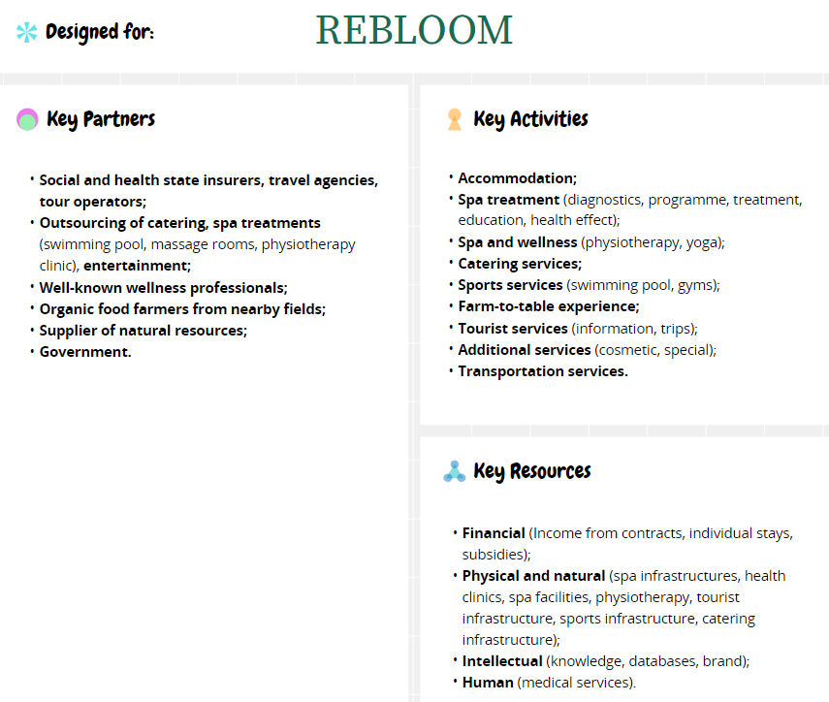
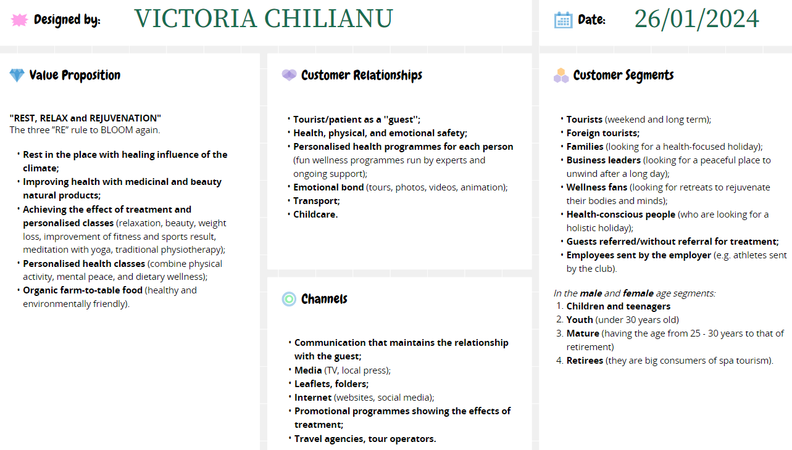
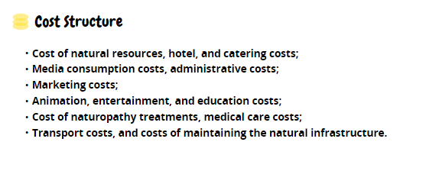
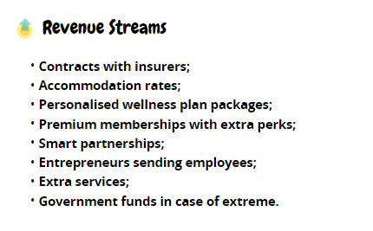

(Conceptboard, 2024)

Appendix 2

General Enterprising Tendency (GET2)
Summary of Own Test Results

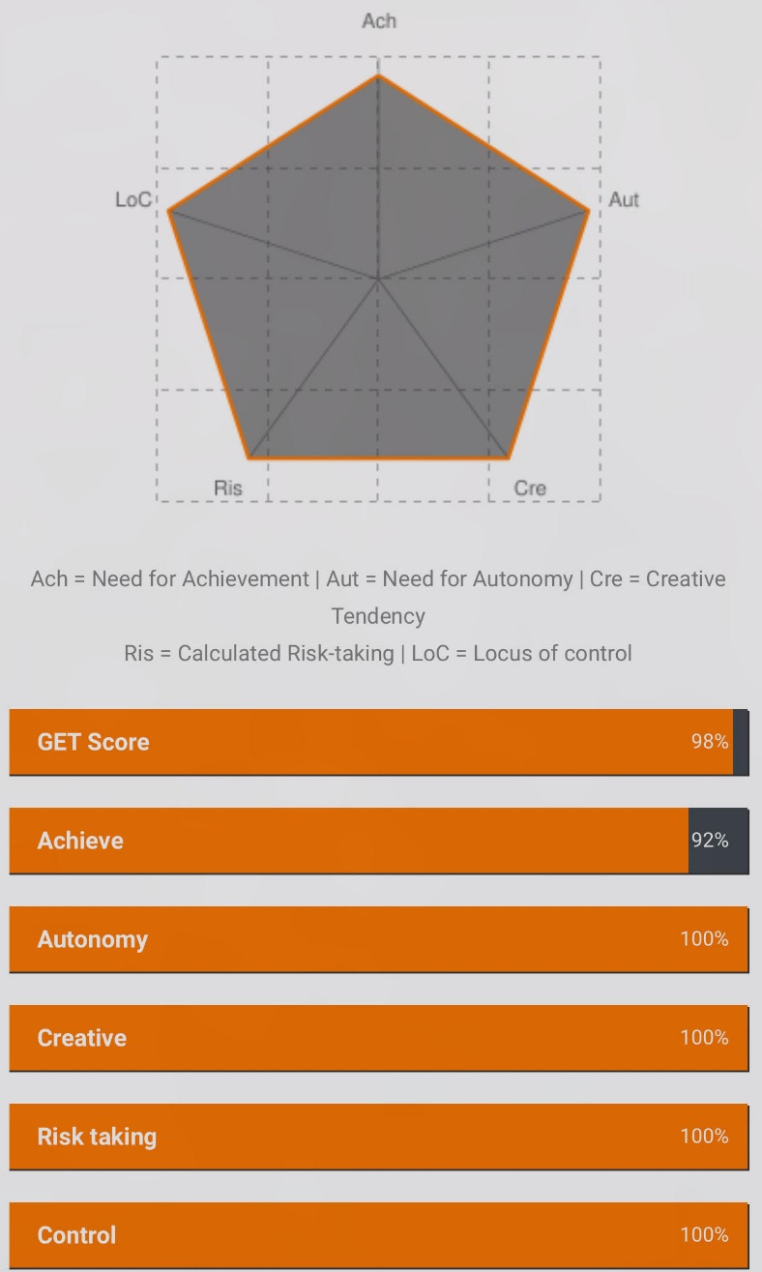

(GET2, 2024)

Appendix 3

Gibbs' Reflective Cycle



(The University of Edinburgh, 2020)

