

Student Name: Omima Suliman
Student ID: 2325135
Assignment Title: Component 2- Individual Report
Module Number: LCLM5004
Lecturer: Dr. Amer Kareem, Dr Oluwaseun Adegbite

Information Systems Improvement Proposal for Kalori Ltd.

Table of Contents
1. Introduction 2
2. Evaluation of Existing Systems 3
3. Recommended Solution 7
4. Implementation Plan 11
5. Conclusion 13
References 14

1. Introduction
Kalori Ltd. currently has thirty retail outlets and a growing e-commerce platform but its operational systems have failed to keep up. There are a number of organisational issues that have an impact on efficiency and quality of service. The warehouse has an inventory that is manually managed hence causing discrepancies between the physical store stock and online ordering. There is no connection in that information about customers is spread over various systems and marketing and support operations are restricted. The decisions that are made by the management have been based on spreadsheets that are prepared manually and hence slows the insights creation. Moreover, the low data protection controls can result in the non-adherence to the General Data Protection Regulation. Lastly, isolated sales, finance and inventory require hand over data transfer value, which makes data entry more erroneous and time consuming to organisational processes.

2. Evaluation of Existing Systems
To get a proper idea of why the current systems of Kalori fail, it is necessary to look at each of them separately and then look at the overall damage that they have produced due to the absence of integration. This is what is meant by defining an information system as a complex of interrelated parts that gather, process, store and disseminate information to help in decision-making and organisational control (Laudon and Laudon, 2004, p. 14). By that standard, Kalori's existing infrastructure fails on almost every count.
2.1 Inventory and Order Fulfilment
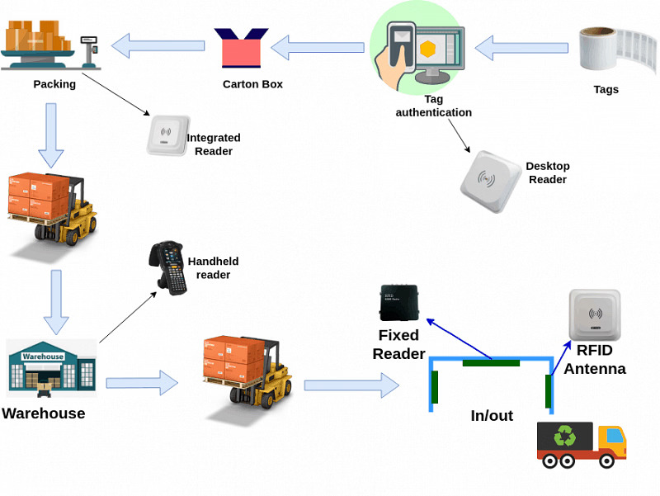
Figure 1: RFID-Enabled Real-Time Inventory Management in Retail ERP (Oghazi et al., 2018).
The most operationally harmful component of the current Kalori setup is the manual inventory ledger. In the absence of real-time synchronisation device, inventory of thirty stores and the e-commerce system drift apart all through the trading day. As Vatumalae et al. (2022) prove through empirical means, the problem of manual inventory management in multi-site retail settings always results in simultaneous and, in most instances, overlapping overstocking and understocking levels of the same product in different locations. Oghazi et al. (2018) also raise a similar and equally crucial point that in the absence of technology like Radio Frequency Identification (RFID) or barcode-linked tracking embedded into an enterprise system, there is no structural system of reconciling the physical stock with digital sales channels. The exact outcome of this gap that Kalori is facing is failed fulfilment, refunds, and declining customer trust.
2.2 Customer Relationship Management
The present CRM setting at Kalori is decentralised. The information about customers is contained in a number of independent databases which do not interact with each other and this implies that the company does not have a single picture of their customers. Consequently, marketing employees find it difficult to divide the audiences properly, whereas the customer service specialists cannot readily get access to purchase history when resolving the support cases. Studies indicate that with integrated CRM systems, organisations have the ability to merge transaction/service interactions and behavioural data into one profile, which contributes to building better customer relationships and retention (Suoniemi et al., 2022). The absence of such integration also results in retailers having less loyalty and repeat customer buying than those firms whose systems are consolidated to crucial customer relationship management (Meyer-Waarden, 2015).
2.3 Reporting, GDPR Compliance, and Departmental Silos
Management reporting using fixed spreadsheets creates compounding risks: a single formula error, version conflicts, and manual typing errors all affect the precision of the forecasts upon which procurement and staffing rely. Koot et al. (2021) list such infrastructure as demand-side visibility as structured, real-time data pipelines, which are in any case mandatory in the modern multi-channel retail, which Kalori simply does not have. The legal gap of the GDPR gives it a pressing legal aspect. According to Labadie and Legner (2023), the organisational capability that is most directly linked with sustainable regulatory compliance is robust data governance architecture such as role-based access controls, encrypted storage, and automated audit trail. Kalori does not have any of these features in its current systems. Lastly, the departmental silos are the glue that hold the system together as a systemic amplifier: any shortcoming in inventory, CRM, reporting is exacerbated by the lack of any mechanism through which the underlying data could flow logically across teams. The mapping of each area of challenges against the AS-IS system state and the TO-BE solution capability is mapped in Table 1 below.
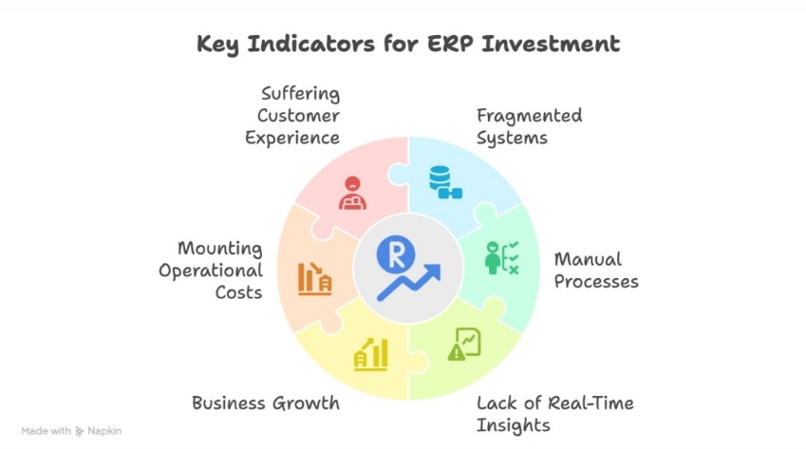
Figure 2: Key Challenges Indicating Need for ERP Investment at Kalori Ltd. (Labadie and Legner, 2023).
Table 1: Kalori Ltd. – Integrated ERP Architecture: AS-IS vs TO-BE System Comparison
Oracle NetSuite ERP – Integrated System Architecture Overview
Business Department | Current System (AS-IS) | ERP Module (TO-BE) | Primary Outcome
Warehouse / Inventory | Manual spreadsheet ledger | Inventory & Order Mgmt | Real-time stock sync across all 30 stores + e-commerce
Sales & E-Commerce | Disconnected POS systems | Omni-Channel Commerce | Unified order pipeline; automatic stock reservation
Marketing & CRM | Multiple siloed CRM databases | CRM & Campaign Mgmt | Single customer view; personalised targeted campaigns
Finance & Accounting | Separate accounting package | Financial Management | Automated reconciliation; real-time P&L visibility
Senior Management | Manual Excel reporting | BI & Analytics | Live KPI dashboards; predictive demand forecasting
Data / Compliance | No access controls / GDPR gaps | Security & Compliance | Role-based access; encrypted storage; audit trails

3. Recommended Solution
Based on the systemic analysis above, this report proposes that Oracle NetSuite should be implemented as a cloud-based, modular Enterprise Resource Planning (ERP) system with its native CRM, Business Intelligence (BI), and compliance management modules (Labadie and Legner, 2023). This suggestion is assessed in terms of four criteria such as the correspondence to the unique business requirements of Kalori, the efficiency, the cost profile, and scalability in the long term.
3.1 Why an Integrated ERP System?
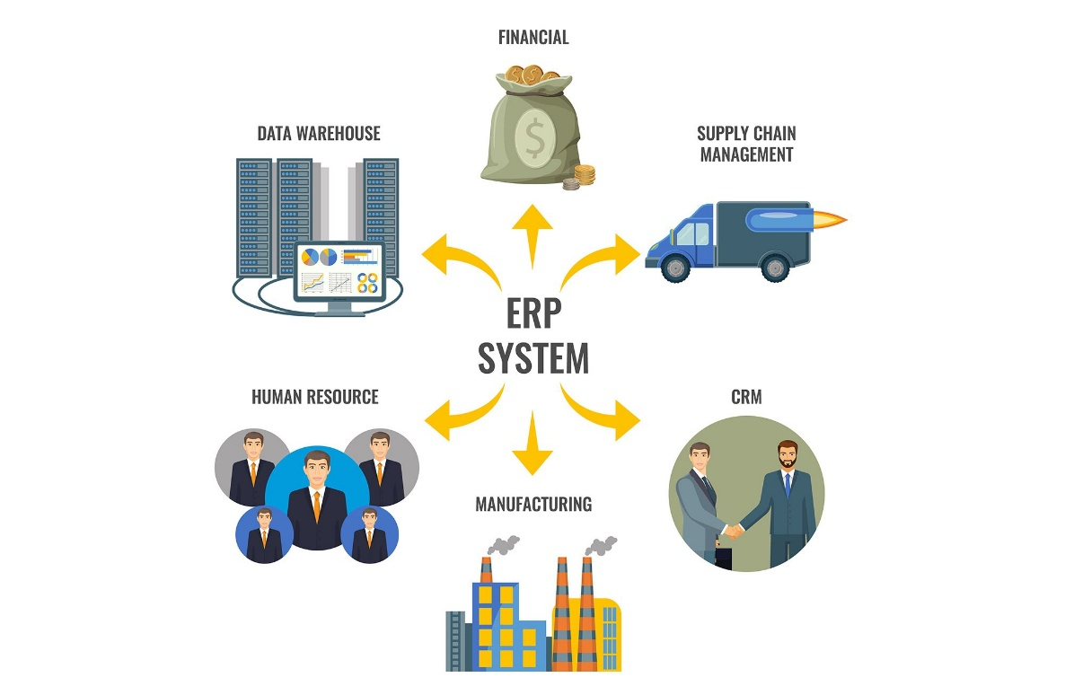
Figure 3: Integrated ERP System Architecture (Connecting CRM, Finance, Inventory & More) (Weerasekara, 2023)
An ERP system incorporates all the key business processes into a common database; inventory management, order processing, financial accounting, CRM, and human resources, and does away with the existing data silos, which in the present case of Kalori, compel the employees to manually transfer data (Laudon and Laudon, 2004). Siddiqui et al. (2023) affirm that ERP implementation into the retailing industry always leads to a decreased rate of data duplication, a faster time of filling orders, and more precise financial reporting. Importantly, with the consolidation of data ownership in a single platform, ERP also provides the governance requirements to meet the requirements of GDPR, which is impossible to do when data is dispersed across the systems that do not communicate with each other (Weerasekara, 2023).
3.2 Why Cloud Deployment?
The cloud-based deployment model fits the profile of Kalori especially well. Tongsuksai et al. (2022) discover that cloud ERP adoption in retailers has a lower initial investment of capital than on-premise deployments, shorter deployment timeframes, automatic updates without interrupting business operations, and scalability of the licencing capacity as the stores increase. As it has already thirty stores running and aims at further expansion, Kalori should have a platform that would not need expensive hardware upgrades to support more transactional volumes. As Canon (2025) shows, cloud ERP systems enhance the logistics system of multi-site retailing systems by ensuring real-time visibility of inventory between all nodes of the supply chain.
3.3 Module-Level Benefits
The inventory module will synchronise the stock in all the thirty stores as well as the e-commerce site in real time whereby RFID integration will help to automatically trigger a replenishment of the stock when the stock levels drop below the set levels. Oghazi et al. (2018) show that this ERP/RFID technology combination forms an ever-updating inventory ecosystem that excludes any manual counting errors. These findings are supported by Vatumalae et al. (2022), who state that automated multi-site systems lead to a significant drop in stock-out occurrences and cost of overstocking.
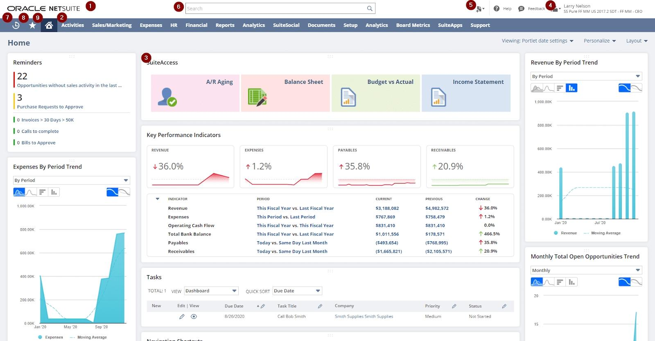
Figure 4: Example of Oracle NetSuite Real-Time Retail Dashboard (Labadie and Legner, 2023).
The CRM module will bring all customer data under one roof, allowing the marketing department to conduct appropriately segmented and data-driven campaigns and providing the support employees with full purchase history. Suoniemi et al. (2022) show that integrated CRM that is facilitated by consultant-managed implementation and active participation by the users can be shown to result in measurable customer retention and cross-selling revenue improvements. Meyer-Waarden (2015) continues that with the availability of unified customer data, the loyalty scheme can be designed more effectively, which results in the direct effect of the increased frequency of repeat visits and the value of an average transaction.
The BI and analytics module will substitute spreadsheets with automated real-time dashboards that will be constantly updated based on real-time operational data. Koot et al. (2021) determine that the demand forecasting accuracy is significantly enhanced by the analytics platforms based on the integrated data. The GDPR toolkit of NetSuite including role-based access control, AES-256 encryption, and automated audit logging addresses the regulatory exposure of Kalori directly on compliance (Labadie and Legner, 2023).

4. Implementation Plan
The translation of the recommendation into functional reality must be a disciplined, gradual process. The concept of rushed ERP implementation is not a novel cause of failure in retail projects, as little focus is given to the adherence to data quality, change management, and personnel preparedness (Garg and Chauhan, 2015). The five stage plan that is suggested below will help reduce the level of disruption and gradually develop internal capability.
Five-Phase ERP Implementation Flowchart
Phase 1  Months 1–2 | Phase 2  Months 3–5 | Phase 3  Months 5–6 | Phase 4  Months 6–8 | Phase 5  Month 9+
▼ | ▼ | ▼ | ▼ | ✓
Needs Assessment  & Vendor Selection | Config. & Data  Migration | Staff Training  & Super-Users | Phased Rollout  & Parallel Run | Post-Go-Live  Review & KPIs
Figure 5: Five-Phase ERP Implementation Flowchart – Kalori Ltd.
Phase 1 – Needs Assessment and Vendor Finalisation (Months 1–2)
A cross-functional project team - including the representatives of IT, finance, sales, and warehouse operations - ought to perform a detailed requirements analysis, visualise the existing data flows, further transaction volumes, and integration dependencies (Labadie and Legner, 2023). According to Garg and Chauhan (2015), thorough pre-implementation planning is the only most important predictor of the success of an ERP project in retail settings, where the interdependence of processes is great, and the impact of configuration mistakes are instantaneous. This stage should be followed by vendor demonstrations and references visit in order to verify the appropriateness of NetSuite.
Phase 2 – System Configuration and Data Migration (Months 3–5)
NetSuite will be set to mirror the organisational structure, product hierarchy, and reporting needs of Kalori. Data stored in the old system will be purged, mapped, and transferred into the new system in inventory spreadsheets, independent CRM system, and departmental applications. Weerasekara (2023) warns that the process of data migration is technically challenging and must be extensively validated before corrupted or duplicated data can compromise the integrity of the system on the first day.
Phase 3 – Staff Training and Super-User Certification (Months 5–6)
Role-specific training programmes will be provided to every user group, starting with warehouse operatives that deal with stock transactions and senior managers that use the live BI dashboards. As Suoniemi et al. (2022) show, the role of users in the training design, facilitated by the professional implementing consultants, has a direct correlation with the increase in the adoption rates and accelerated realisation of the benefits. It should also establish a network of trained super-users in every department to offer lasting support by peers during the period of transitioning.
Phase 4 – Phased Rollout and Parallel Running (Months 6–8)
NetSuite will be launched progressively, starting with a controlled pilot across two or three stores before full deployment. The cost of operating the new system together with the old systems within a specified transition period limits the risk of disruption to the operations in case of unforeseen problems. Siddiqui et al. (2023) suggest progressive implementation as a normal risk management approach in multi-site retail ERP implementations because it gives the opportunity to refine the implementation steps, and only after that, major implementation is undertaken.
Phase 5 – Post-Go-Live Review and Continuous Improvement (Month 9 Onwards)
Key performance indicators such as accuracy rates of stocks, order fulfilment lead times, customer satisfaction rates and management reporting turnaround will be systematically monitored against pre-implementation baselines. According to Tongsuksai et al. (2022), the benefit of structured post-deployment evaluation is that it would help organisations to reap residual efficiency and how to mitigate emerging user concerns before it turns into an embedded problem.

5. Conclusion
Kalori Ltd. finds itself in a familiar place with other fast-growing retailers: commercial success has shown the limitations of an information infrastructure that was never intended to scale. The five issues, which include manual inventory control, lack of unity among customer information, spreadsheet reports, lack of compliance with GDPR, and data silos between departments, are symptoms of one ultimate issue: the absence of a unified system that operates in real-time.
The Oracle NetSuite is a cloud ERP system CRM, analytics and compliance solution addressing all problems. The change can be realised within nine months delivered through the 5 step plan with adequate migration and training. The ultimate efficiency, loyalty, and decision-making benefits easily outweigh the expenses and form the basis Kalori requires.

References
Canon, J.G.F. (2025) ‘Integrated logistics management through ERP system: a case study in an emerging regional market’, Logistics, 9(2), p. 59.
Garg, P. and Chauhan, A. (2015) ‘Factors affecting the ERP implementation in Indian retail sector: A structural equation modelling approach’, Benchmarking: An International Journal, 22(7), pp. 1315–1340.
Koot, M., Mes, M.R.K. and Iacob, M.E. (2021) ‘A systematic literature review of supply chain decision making supported by the Internet of Things and Big Data Analytics’, Computers & Industrial Engineering, 154, 107076.
Labadie, C. and Legner, C. (2023) ‘Building data management capabilities to address data protection regulations: learnings from EU-GDPR’, European Journal of Information Systems.
Laudon, K.C. and Laudon, J.P. (2004) Management information systems: managing the digital firm. 17th edn. Harlow: Pearson.
Meyer-Waarden, L. (2015) ‘Effects of loyalty program rewards on store loyalty’, Journal of Retailing and Consumer Services, 24, pp. 22–32.
Oghazi, P., Fakhrai Rad, F., Karlsson, S. and Haftor, D. (2018) ‘RFID and ERP systems in supply chain management’, European Journal of Management and Business Economics, 27(2), pp. 171–182.
Siddiqui, N.A., Limon, G.Q., Hossain, M.S. and Mintoo, A.A. (2023) ‘A systematic review of ERP implementation strategies in the retail industry: integration challenges, success factors, and digital maturity models’, American Journal of Scientific Research and Innovation, 1(1).
Suoniemi, S., Zablah, A., Terho, H., Olkkonen, R., Straub, D. and Makkonen, H. (2022) ‘CRM system implementation and firm performance: the role of consultant facilitation and user involvement’, Journal of Business & Industrial Marketing, 37(13), pp. 19–32.
Tongsuksai, S., Mathrani, S. and Weerasinghe, K. (2022) ‘Cloud ERP adoption in SMEs of New Zealand retail industry: exploring CSFs and risks’, in 2022 IEEE Asia-Pacific Conference on Computer Science and Data Engineering (CSDE). IEEE, pp. 1–6.
Vatumalae, V., Rajagopal, P. and Sundram, V.P.K. (2022) ‘A study of retail hypermarket warehouse inventory management in Malaysia’, SMART Journal of Business Management Studies, 18(1), pp. 71–79.
Weerasekara, U. (2023) ‘Enterprise resource planning (ERP) system implementation in a manufacturing firm: rationales, benefits, challenges and management accounting ramifications’, Journal of Accounting & Business Research.

