Shelley Lazenby
1905671
Marks & Spencer’s
Presentation

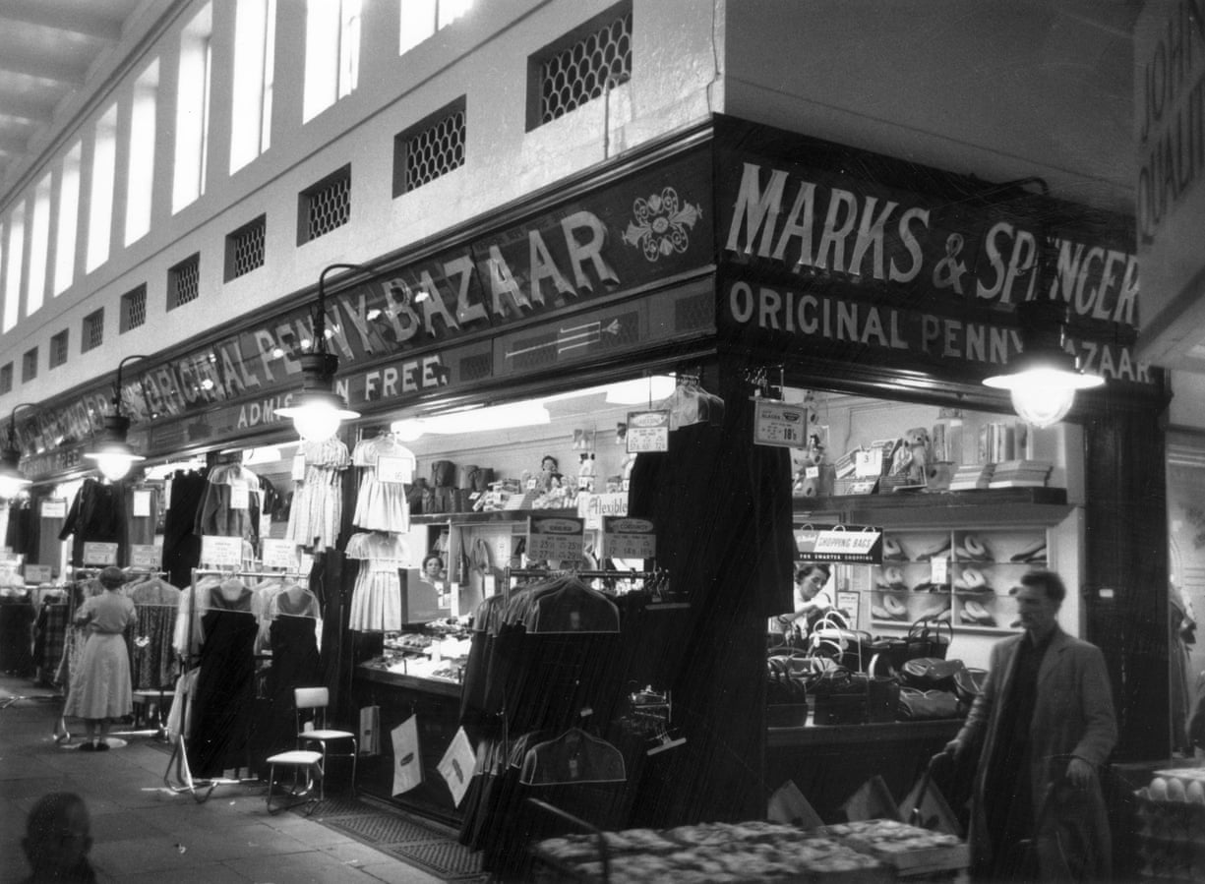

Good afternoon everybody, and welcome to our presentation.

I’m going to start by introducing myself (just in case you forgot my name over half term)…
“ hi, my name is Shelley Lazenby….
And that’s all for today!” ( just kidding)

Let me begin by telling you a short but interesting inside about a big and popular store that’s become worldwide ( well actually it didn’t start off so big)
I will talk about that in a moment!

In the year ‘1884’ A Polish guy by the name of Michael Marks opened a market bazaar (stall) in Leeds, with a very cool slogan above it saying, “ Don’t ask the price, it’s a penny!” (which I’m sure got a few peoples attention everyone loves a bargain)!

A Decade later after putting in 100% into his small business, Michael Marks went into partnership with a guy called Thomas Spencer, who was actually a former cashier from a wholesales company by the name of Dewhirst.

Another decade on Marks & Spencer’s had the pleasure of opening their first shop in Covered Arcade in Leeds. Which I can only imagen to be a very exciting but also nerves times.

I’ve got a few interesting facts about Marks & Spencer’s if anybody would like to hear at the end of our presentation.

Thank you very much for listing, I will now pass you over to my lovely colleague….

Shelley Lazenby
1905671

A few facts about the history of Marks & Spencer’s

Kirkgate Market
- In March 2013 they returned to their roots and opened a stall at Kirkgate Market in Leeds, the exact same place that Michael Marks opened the first penny Bazaar stall in ‘1884’

- Marks & Spencer’s heritage coffee shop is located right beside the famous M&S clock in the “1904” Kirkgate Market building!

- M&S where also in partnership working with the Uni in Leeds!

- Marks & Spencer’s sold their first bra in “1926”



