Electronics exam 17/01/22

Q1:

- IC1 is configured as an integrator within this circuit given to us. It is an OP AMP that does a mathematical formula of integration. By doing this the output of the integrator changes over time depending on the input voltage. Current is given to us by the photodiode, The capacitor above the integrator has very little resistance therefore acts like a short circuit. When the Capacitor C1 charges up that is because of the input current from the photodiode, its impedance Xc gradually rises in a fashion that is proportional to its charge rate. Due to this happening the negative feedback doesn’t give the op amp no choice but to produce an output voltage that keeps the inverting input at a virtual earth. Due to this happening and where the capacitor is connected to the negative output of the OP amp as well as the virtual ground inverting input the voltage across the capacitor increases causing the charging current to drop as the capacitor's impedance rises. Due to this we have a linearly increasing output voltage which continues to do this until the capacitor cannot charge anymore therefore fully charged. When the capacitor is then fully charged it blocks anymore DC current from flowing and performs like a open circuit causing infinite gain. The reset button also connected in parallel to the Capacitor is to discharge the capacitor when you want to reset the circuit, the capacitor will discharge and then the UV light on the photodiode can start the process again of charging up the capacitor. The current from the photodiode produces a positive Ramp at the OP-AMPS output.

- IC2 Is an OP-AMP used as a SCHMITT Trigger. Schmitt triggers is used to give us two different thresholds of voltage, one lower and one higher to account for noisy input signals and spiking where we want to get cleaner square wave signals. Using the hysteresis when the voltage reaches the higher threshold it outputs a 1 or a high therefore turning on. If the voltage were to spike below this threshold it would still stay at a high until the voltage reaches the lower threshold which will give an output of 0 or off. The reason for this is that voltage spikes can happen frequently on noisy inputs and cause the voltage to spike out of the threshold therefore the output will shut off when you need it to stay on, by having two different thresholds the voltage would have to come down very low to hit the other threshold as the difference between them is big as opposed to having just one line in the middle the difference between the two states. This is a OP AMP based Schmitt trigger and it provides positive feedback. Due to Vin being connected to the inverting input, when the voltage is high the output is lower and when the voltage is low the output is higher. The two resistors connected within the Schmitt trigger is to set the hysteresis of the Schmitt trigger, the two resistor values will be used which sets each of the lower and higher thresholds. When the input reaches the higher threshold, the output is given as negative saturation and vice versa when the input reaches the lower threshold the output is given as positive saturation.

- The diode on the far left is a Photodiode and it is used to convert light to electrical current for the circuit. It sends current to the integrator and charges up the capacitor. The UV filter is used to filter the intensity of the UV given into the photodiode. If the filter wasn’t there the Photodiode would charge up with current too quickly and the alarm would come on quicker than you’d want it to. The UV filter is used to only pass the UV light through to the photodiode because that is the light that were interested in.
- The disadvantages of using analogue is electrical noise and the photodiode not being as accurate as digital pulses. The photodiode can produce more current quickly and have current leakage therefore can be less accurate and not have a consistent result each time its used.

Q2:

- CPU – Controls all the instructions and data it receives, it technically acts as the brain of the system.
8K RAM – RAM is volatile memory that will erase every time the system is turned off. It’s used to temporary store variables values and instructions and data. In the RAM you just need to store variables such as counting up etc
EPROM – EPROM is a memory that is read and written and written using a certain program flow. The data and values that get stored within do not erase when it’s powered down.
4CH ADC – This chip converts analogue signals to a digital signal so that other chips can read from it in just on and off states as opposed to analogue. The 4 CH means that 4 separate analogue inputs can be connected. It reads the temperature given in analogue and converts it to digital.
8 bit Counters – The counters within the chip can count up the data given, it has 8 bits therefore 8 physical wires. It means it has 258 bytes of data. It counts the data given by the clock gate logic and logs that into the system.
6522 – These are the I/O ports of where the inputs and outputs of the system are stored, outputs such as the watchdog timer, display and EEProm are given off this and the other chips in the circuit control the I/O chips and send data to and from it.
Display – Displays the current air temperature.
Watchdog timer – helps for brownouts and also delays on when powered up to start the system up slower. The clock within will keep pulsing and pulse the watchdog, the watchdog wont do nothing but if there is a blip in the system the watchdog will have a pre determined time to set a reset to the CPU.
EEPROM – Provides more electrically erasable and programmeble read only memory to the circuit. Uses serial data between it and the I/O ports.
TX and RX – Transducers which travel sound between them both for the speed of sound to be measured.
Temp Sensor – Sends analogue voltage data to ADC.
Clock gate logic- uses logic gates to only send data when certain Inputs are high or low depending on the gates used.
OSC – used as an oscillator in the circuit.
3 To 8 decoder – used for the chip selects of the circuits so only of the chips is running at the same time. Only one of the outputs of the decoder will be high at any time.

- 14 Pins are used for 8k.

- If a designer were to redesign the circuit using a microcontroller its disadvantages would be
- Finding the correct size memory for each of the instructions needed to be done, as a number of executions is more limited.
- It has a more complex structure and would most likely need to add external components to ensure all components needed in the circuit are there.
- Can’t perform tasks as quick as the individual components circuit can
- They need extra power circuits when powering more powerful circuits, it cannot interface a power device correctly.

Q3)

- Thyristor works similar to a transistor. It’s powered on by a small amount of current. The load voltage is then controller by the trigger angle of the thyristor. Only part of the AC waveform is used when using thyristor. The thyristor will only output voltage on the positive half of the waveform unless you add another. Thyristors can handle very high voltages and currents as opposed to transistors and have very high-speed switching. Also, have a lack of moving parts. In the diagram below it shows the example of a thyristor waveform when receiving certain amounts of AC power and its output.
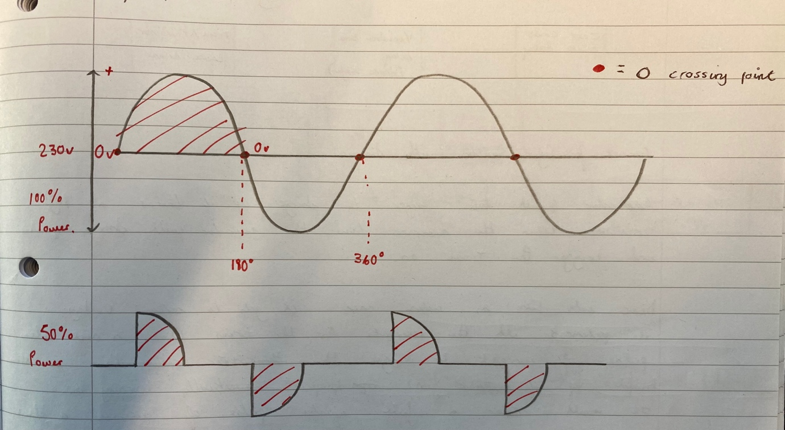

- The zero-crossing point is the point where the voltage changes from + to -. There is no voltage at the zero-crossing point. In a full cycle, this occurs twice. In the diagram above in the previous question, the zero-crossing point is shown on the first diagram being the straight line between both sides of the waveform, A red dot is used as a key to show them.
- The two semiconductors given to us in the circuit are DIACS. They are switching devices that are bidirectional and allow current to travel in both directions and can be connected in either polarity. They help to provide sharper and more triggered instant pulse and are good for variable power control.
- A load is supplied and put through a fuse which protects to circuit from overcurrent. The inductor charges up and stores current for when the load is in the negative side. The DIACS allow the current to travel in both directions, the capacitor charge up and store current also for when it is needed. The Variable resistor is used to increase and decrease the resistance of the circuit by doing so it can increase and decrease the light intensity the more resistance means the less current that the light is going to receive which displays the light as less bright. R1 and R2 are used to limit the current going through the circuit from the load.

- 

