Project Planning and Management in Workplace
Module Code : BMSW5104

Student Name : Muhammad Ali
Student ID: 1814835

Assignment Title : Project Planning and Management in Workplace

Table of Contents
Introduction 3
Overview of project management 4
Techniques used in project management 5
Overview of the warehouse plan 8
Critical analysis of the following 10
Iron triangle for addressing risk to the project 11
Conclusion 13
Reference list 14

Introduction
In this report, a warehouse plan and the importance of project management has been outlined and discussed in details so that Vintners antique firm can easily implement it within their company and generate huge benefits from them. Project development has increased in importance around the world. Project development has increased in importance around the world. According to the study, more than 30percent of people of organizations struggle to complete their projects successfully due to a mismatch of business objectives and organizational development. Many businesses are faced with the question of a differentiating factor between business strategy and program management. Alignment becomes expected to deliver high-quality service and achieve the company's objectives. Top management is also crucial in ensuring that corporate plans including project management are aligned. Projects would be any intermittent tasks with a begin and end date, as well as success metrics. Projects are constrained by three factors: time, expense, and efficiency. It was believed that in accordance with the aims, three constraints must be met: time, budget, and efficiency. Project management has been considered the foundation of an enterprise because it plays a significant role in accomplishing organizational goals. Objectives according to the project of expertise to accommodate the expectations of projects. Project management becomes critical to achieving plans, company objectives, and desired results.

Overview of project management
The mechanism of guiding a group's efforts to achieve goals and achieve performance assumptions within a fixed time period is known as project management. The key obstacle of project management is to achieve and manage all of the project's goals including objectives while staying within the restrictions of budget and time. Project management would be the utilization of procedures, tactics, expertise, information, and experiences to meet particular project goals within agreed-upon guidelines while adhering to project approval requirements. Final deliverables become limited by a finite budget and time frame in managing projects. It's a method of organizing, preparing, implementing, and controlling capital only with aim of achieving clear deliverables on schedule and within budget (Picciotto, 2020.). A successful project manager is one who can see the whole project from beginning to end and has the courage to carry it out. The goal of project assessment is to improve everyone's ability to anticipate the risks and obstacles that might prevent a project from being completed on time. It utilizes tried-and-true methods and techniques and modem firmware tools to help users schedule, manage, and track individuals, processes, or other products highly. Project management enables companies to address tasks in observable and distinct phases, allowing them to better fulfil milestones, goals, and budgets while minimizing the impact and concerns. The project management system is a collection of expertise, procedures, strategies, and resources aimed at achieving project objectives in a timely and consistent process, enabling one to be fully qualified if issues arise. Make comprehensive activities in response to the use of improvement, which could be driven by a multiplicity of mechanisms including improving overall efficiency, increasing creativity, lowering costs, expanding customer interaction, keeping up with the latest market climate, or pursuing business goals and objectives. Plan preparation is important in influencing partners, supporters, groups, and also the project coordinator via the various stages of the project. To define the intended outcome, minimize risks, prevent unscheduled downtime, and produce the agreed-upon product, service, or outcome, planning is essential. The goal of project management is to achieve outcomes that optimize a firm's profits. Here have been a few more effective ways to use project management. It includes the following features:
- Strategic goals and a strong focus
- Quality Assurance
- Management of Risk

Heagney & J., (2016) says that it is a systematic process of identifying, quantifying, analysing the risk of a project. Organizations have faced a challenging problem of rapidly adapting to a changing market climate. Companies must be able to formulate plans for fast market performance and development if they are to remain successful in the industry. Project leaders will waste endless hours implementing projects due to a complete lack of strategy implementation. For example, there could be a brilliant idea, however, the time may not have been appropriate to devote all of the attention to a project centred on it (Demirkesen and Ozorhon, 2017). Workers will lose confidence throughout the company's objectives, vision, as well as value if the objectives of the organization are really not clearly visible. The advantages of achieving strategic coordination within a business are as follows:

Quality Standards Speed: Complexity can stifle efficiency and cause timelines to be postponed (Radujković and Sjekavica, 2017). When a company's key goals are aligned, it makes decisions faster and executes them more efficiently. This is also the reason behind the project planning emphasizes the importance of transparency.

Better Worker Involvement: Project management requires cooperation and coordination with staff in order to achieve strategic unity in a company. Staff members become much more active and happier with their jobs as they recognize that their work relates to the overall company plan.

Limited Resources Wastes: In a company, strategy formulation distinguishes between practices that facilitate development as well as those that serve as a control mechanism. Advancements in the field imply that scarce resources are allocated to the right projects, allowing the organization to expand and match financial and accounting goals.

Techniques used in project management
Project management would be a vast field. It spans a variety of sectors and necessitates a diverse set of skills. The tactics which project managers are using to get work completed, however, seem to be the consistent theme that binds this complex profession together. Project management methods allow process improvement to be simpler and much more productive. They can also be used on every project, regardless of the sector or profession (Papke-Shields and Boyer-Wright, 2017). Completion of tasks in the workplace necessitates the use of the new and most sophisticated technologies and methods in order to produce meaningful performance, which is valid in most parts, however, there are instances when the conventional and easiest strategies seem to be the most suitable for successful project creation.

Classic technique
The classic technique is also an impressive method that involves a reasonable plan to manage all forthcoming work events, which responsibilities need to be completed and redistributing specific and assets to the roles as per their significance, offering and getting proper input from the group, which aids in teamwork, and tracking the quality of work accomplished and the expectations met.
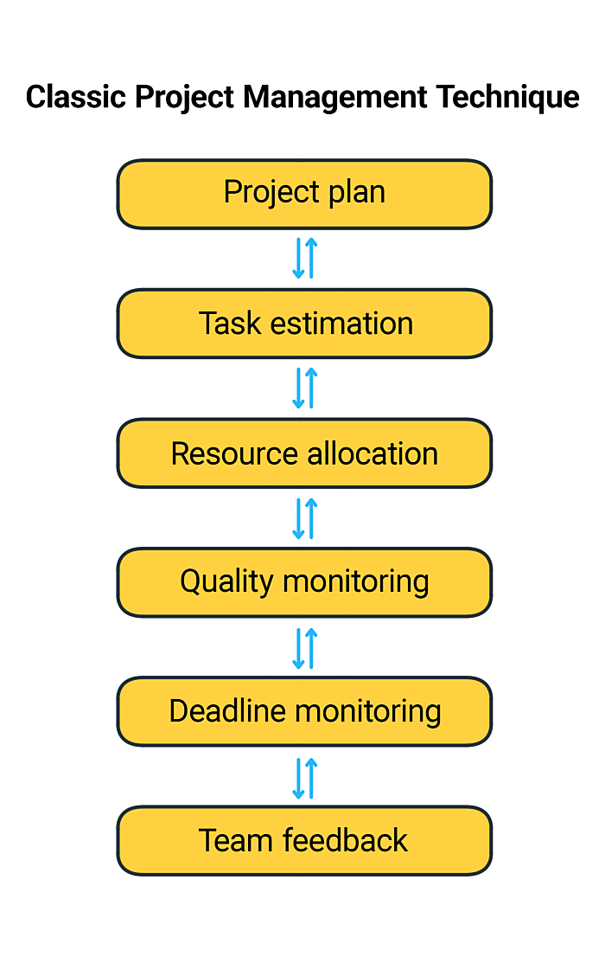
Fig: Classic Technique
Source: (Papke-Shields and Boyer-Wright, 2017)

Waterfall technique
Since it develops on the above-mentioned Classic approach which brings it to a whole different extreme, the waterfall methodology is often deemed a conventional project management method. The Waterfall method, as the name indicates, has been centred on certain project management activities being done in a reasonably predefined sequence, for the next project only being undertaken and executed well after the subsequent task is finished (Cooper and Sommer, 2018). Workloads flow seamlessly throughout the specific goal, like a waterfall, and only when they are done in a correct sequence. The waterfall technique seems to be a fantastic method for dealing with complex things that the general method cannot handle.
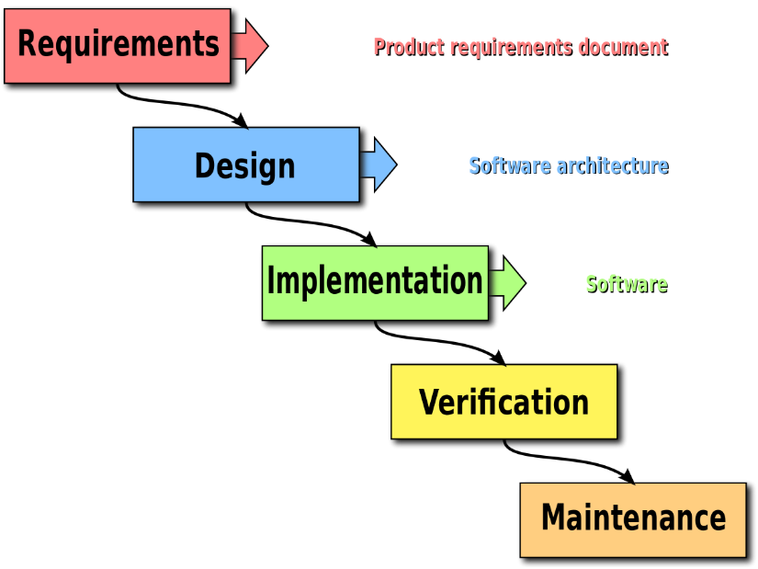
Fig: Waterfall Technique
Source: (Cooper and Sommer, 2018)
Agile project management technique
The Agile Project Management methodology was very well and can be quite remarkable in its implementation although it interacts with tasks in a manner that is rather distinct from most standard techniques. The Agile method involves breaking down large project phases into smaller sprints, which allows for a more thorough review of the entire procedure mostly during the production cycle. As the project takes form, this thorough review aids in proactive and flexible preparation in response to the changing needs and improvements that are needed. Several of these practices contribute to gradual progress mostly during developmental phases, as the groups become even more cohesive and cooperative to improve the performance of employees (Cooper and Sommer, 2018). Agile project management has been used in activities where the production is broken down into tiny, specific phases by small, extremely team environments. Since the Agile management plan is so well-known, it seems there is a multitude of task and workflow automation software applications available to assist businesses in the planning process.
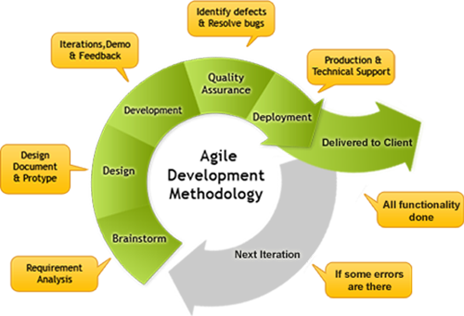
Fig: Agile Methodology
Source: (Cooper and Sommer, 2018)

Overview of the warehouse plan
Warehouses must be streamlined or revamped as the range of alternatives increases, production requirements change, and new program architectures arise. Another explanation for storage preparation and the need to improve productivity and streamline operations. A reasonable reason would be that warehouse system, most of which are paired with companies that outsource logistics service providers including in frameworks, become obsolete throughout time (Rasnacis and Berzisa, 2017.). Workflow collaborates with clients to produce a variety of outcomes by adopting a critical strategy to warehouse strategy, which includes:
- Reduced logistics costs throughout the short run by creating and implementing optimization opportunities.
- By establishing and executing a stated objective, lengthy logistics costs and infrastructure needs can be reduced.
- Designs, warehouse systems, and choosing methods that are appropriate.
- Advanced analytics principles focused on judgment papers, business scenarios, and contracts for warehouse tools and methods have streamlined resources use.
- The convergence of warehouse systems reduces costs and complexity.
- Stock reduction in the supply chain and warehouse management.
Due to many factors concerned, developing a warehouse layout plan could be a difficult task. This procedure entails systematically designing a maintenance strategy that makes the maximum use of resources space, facilitates the smooth running of activities, and boosts performance. Constructing a realistic warehouse seems to be important since it has a significant impact mostly on the warehouse's performance and effectiveness. The layout must place the functions in chronological order to help run the business smoothly, increase efficiency, and cut costs (Hidalgo, 2019). With the help of this layout Vintners antique will be able to reconstruct its new warehouse in an effective manner. There are certain aspects that Vintners antique needs to keep in mind before executing the warehouse plan:

Cost of labour: The architecture of a complex can have a significant impact on labour performance. Including international air shipping charges, internal and external labour forms a major part of the expenditure per contract. In several states, the basic income is expected to rise to $15 an hour during the next 5 years. Amongst the most relevant design requirements should have been to save labour time in the planning and design, and also in the business processes. A range of the suggestions below will help to increase worker productivity.
Placing, replenishment, and direction control mechanisms are the core of the process and therefore should be given sufficient recognition they deserve. If they are properly cared for, the majority of the activity will run smoothly.

Operational and layout flexibility: It is critical to prepare for unknown potential changes to the market or fulfilment model in order to avoid incurring unexpected costs as a result of unscheduled facilities and unexpected delays (Buganová and Šimíčková, 2019). Do not even build a layout or method that is not even adaptable or portable.
The physical attributes of its layout and operation are just one factor to consider whenever constructing a warehouse. Scheduling, operation, and the way manpower has been used are all factors to take into account when designing a warehouse.

Critical analysis of the following
Time
Time estimates influence project service and planning timelines, and thus have an effect on other people's perceptions of your durability and professionalism as a project manager. Time estimates are frequently used to determine procurement pricing and, as a result, the contract/commercial project's productivity.
There are three simple steps for evaluation of time to plan a project.

- Understanding the project outcome- First and probably most important, you must fully comprehend what you are attempting to accomplish. Examine the project thoroughly to ensure that there are no "unknowns." There are a few tricky, complicated problems that take the most time to solve. The right approach to review the job is to make a detailed list of all major categories.
- Estimate Time- You can commence considering how long also every task will take once you have a comprehensive step by step plan you must complete to complete the project (Ciric et al., 2018). Make time besides project management regime, a precise proposal, liaison with external bodies, funds, and officials, meetings, system integration, developing any necessary additional information or procedures, and preparation. There should be always buffered time for other emergency situations like internal/external meetings, health issues, quality control rejection and so forth.
- Plan for going it wrong- There should be always time for credibility as if things go south and if there are delays in the timeline of the work-frame. If the accuracy of time estimates is critical it affects the project.

Cost
The actual funds necessary to replace and implement a company transaction or working project are referred to as project costs. The following elements are included in the cost of the project:
- Direct costs: Direct costs were those who were specifically associated with, and expected to accomplish, a project (Shastri et al., 2017). As a result, they should be included in the budgets of each project.
Every project comes with a budget that needs to be followed strictly so that it does not create any cost issue at the end of the execution. Appropriate cost control demonstrates that somehow a project's schedule stays on target and also that the project scope statement is met. An organization can actually make revenue if expenses are not regulated, and costs will likely surpass gross profit divided. The benchmark for project costs is established by budget planning.

Scope
Scope refers to the specified functional requirements of a project or even the statement of work involved in completing the project objectives and goals throughout project management. Wysocki & R.K., (2011) defines the “Scope is a project definer which explains the boundaries of a project”. Scope refers to gathering the details needed to begin a project as well as the functionality that the project would also have to satisfy the demands of the people. Project scope creates key parameters that could be used to fix attributes that influence shifts during the lifecycle of the project (Rew et al., 2020). A clear description of all dimensions of a task, along with all relevant tasks, funding, schedules, and performance metrics, and perhaps even the project's dimensions, is called an operation scope.

Iron triangle for addressing risk to the project

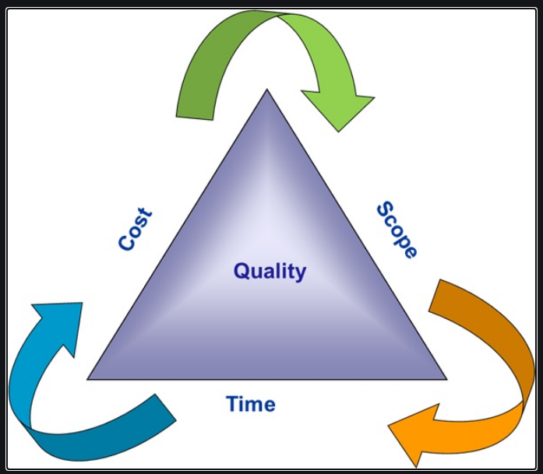
Figure 1: Iron triangle
(Source: Bellón et al., 2018)
Budget, scope, and timeframe were its three constraints that project managers must function under. The base of the model has been the timeframe (or schedule) (shaped like a triangle). The scope of the project seems to be on the left side of the triangle, while the budget (or expense) has been on the right. - certain restrictions could be the most relevant to end-users, based mostly on activity and who is participating (Hirata and Bortoletto, 2019). In order to become successful, project managers should therefore maintain the rise and fall of considerations among these three components. This long-standing framework enables for a realistic plan that includes goals and promotes defining things of importance in a project, specifically because each group member is unique.

Cost: This is indeed a project's economic limitation, also known as the budget. A project's expenses can involve a number of factors, such as resources mostly materials as well as people and any externalized costs that seem to have a bearing on the project.

Scope: This involves the activities required to meet the project's objectives. Regulating scope becomes particularly important because changes in scope almost always result in a time and budget effect. Recognize that coordinating project scope necessitates understanding how long each job will take. Robert & P., (2011) says that Briefly and properly define is an inability, the quaility of the project depnds on communicate and understand.
Example Activites : Vintners antique change the business location, trello board help business to manage the project.
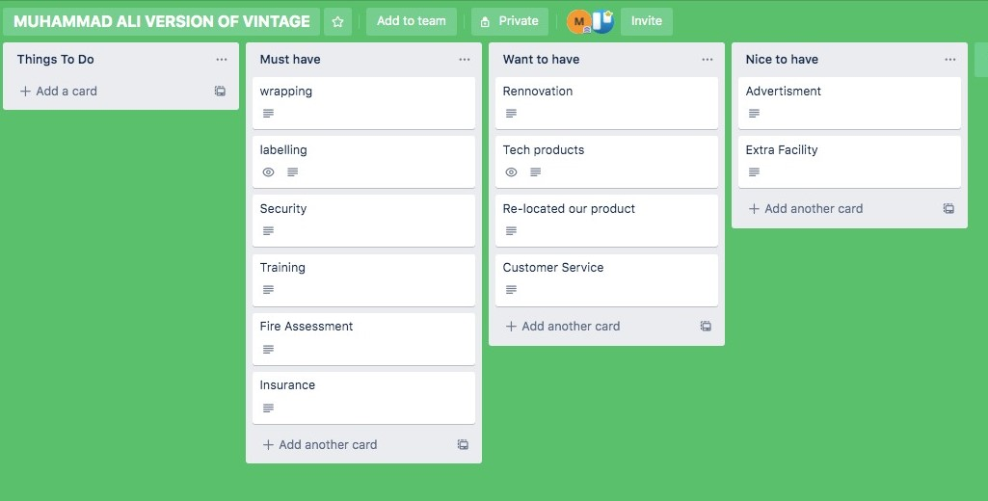

Time: This is when the development process is supposed to be finished. Since the overall timetable remains separated by specific activities and their planned pacing, controlling time appears closely linked to responsibilities for managing (Bellón et al., 2018). Project leaders should define activities that can only be performed in a certain sequence that are mutually dependent in order to overcome these issues. A project's timetable may be very precise, ensuring compliance with a particular milestone or information. The timetable for many other activities would be much more versatile. Users generally recognize any time for delivery, much like budgets also rarely infinite.

Conclusion
Based on the work presented in this article. It seems to be important to remember that one of the report's key concerns is the massive imbalance of project business management strategies. Coordination, project manager or project team integrity, participating PM and project team in strategic thinking, executive engagement, motivation and encouragement, and personal situation are only a few of the problems that occur during the project being tied to the plan. According to the most recent research results from Quality Improvement Consultants, the most common explanation for failed projects is that too many companies may not determine that certain projects which undertake are consistent with their firm's growth strategy. In reality, the research found that an 80% of people of the companies surveyed had no structured value proposition for expanding their Project Management Offices. Since the sustainable project would not have been a problem if companies only implemented programs that were aligned with their strategic priorities, their performance rate could accelerate. this report provides ample data on the main topic and has initially fulfilled all the criteria of the report to conclude pieces of evidence. All the information contained in this report are of utmost relevant and authentic at the same time and does not contain any mistakes with the ethical codes.

Reference list

Bellón, B.L., Viñoles-Cebolla, R., Bastante-Ceca, M.J. and González-Cruz, M.C., 2018 The Utilization of Project Management Tools and Techniques and Their Relationship with the Success in Chemical Engineering. In Project Management and Engineering Research (pp. 103-115). Springer, Cham.

Buganová, K. and Šimíčková, J., 2019. Risk management in traditional and agile project management. Transportation Research Procedia, 40, pp.986-993.

Ciric, D., Lalic, B., Gracanin, D., Palcic, I. and Zivlak, N., 2018, March. Agile project management in new product development and innovation processes: challenges and benefits beyond the software domain. In 2018 IEEE International Symposium on Innovation and Entrepreneurship (TEMS-ISIE) (pp. 1-9). IEEE.

Cooper, R.G. and Sommer, A.F., 2018. Agile–Stage-Gate for Manufacturers: Changing the Way New Products Are Developed Integrating Agile project management methods into a Stage-Gate system offers both opportunities and challenges. Research-Technology Management, 61(2), pp.17-26.

Demirkesen, S. and Ozorhon, B., 2017. Impact of integration management on construction project management performance. International Journal of Project Management, 35(8), pp.1639-1654.

Hidalgo, E.S., 2019. Adapting the Scrum framework for agile project management in science: a case study of a distributed research initiative. Heliyon, 5(3), p.e01447.

Hirata, E.I. and Bortoletto, W.W., 2019. PLANNING OUR EVERYDAY USING TOOLS AND TECHNIQUES OF PROJECT MANAGEMENT. Iberoamerican Journal of Project Management, 10(2), pp.14-29.

Heagney, J., 2016. Fundamentals of project management. Amacom.

Papke-Shields, K.E. and Boyer-Wright, K.M., 2017. Strategic planning characteristics applied to project management. International Journal of Project Management, 35(2), pp.169-179.

Picciotto, R., 2020. Towards a ‘New Project Management’movement? An international development perspective. International Journal of Project Management, 38(8), pp.474-485.
Radujković, M. and Sjekavica, M., 2017. Project management success factors. Procedia Engineering, 196, pp.607-615.

Rasnacis, A. and Berzisa, S., 2017. Method for adaptation and implementation of agile project management methodology. Procedia Computer Science, 104, pp.43-50.

Rew, L., Cauvin, S., Cengiz, A., Pretorius, K. and Johnson, K., 2020. Application of project management tools and techniques to support nursing intervention research. Nursing Outlook, 68(4), pp.396-405.

Robert, P., 2011. Effective Project Management Kogan Page

Shastri, Y., Hoda, R. and Amor, R., 2017, February. Understanding the roles of the manager in agile project management. In Proceedings of the 10th Innovations in Software Engineering Conference (pp. 45-55).

Wysocki, R.K., 2011. Effective project management: traditional, agile, extreme. John Wiley & Sons.

