Name; Fariza Begum Suleman; 2334483
Date;17 November 2025
Programme; BSc Health and Social Care
Module; Changemaker; Creativity and Value Creation
Module Code; BMHP5014
Lecturer; Tsiwani Khumalo
Assignment Title; Component 2 Poster and Written Assignment (report)

Report: Healthy Quest & SmartBand jr

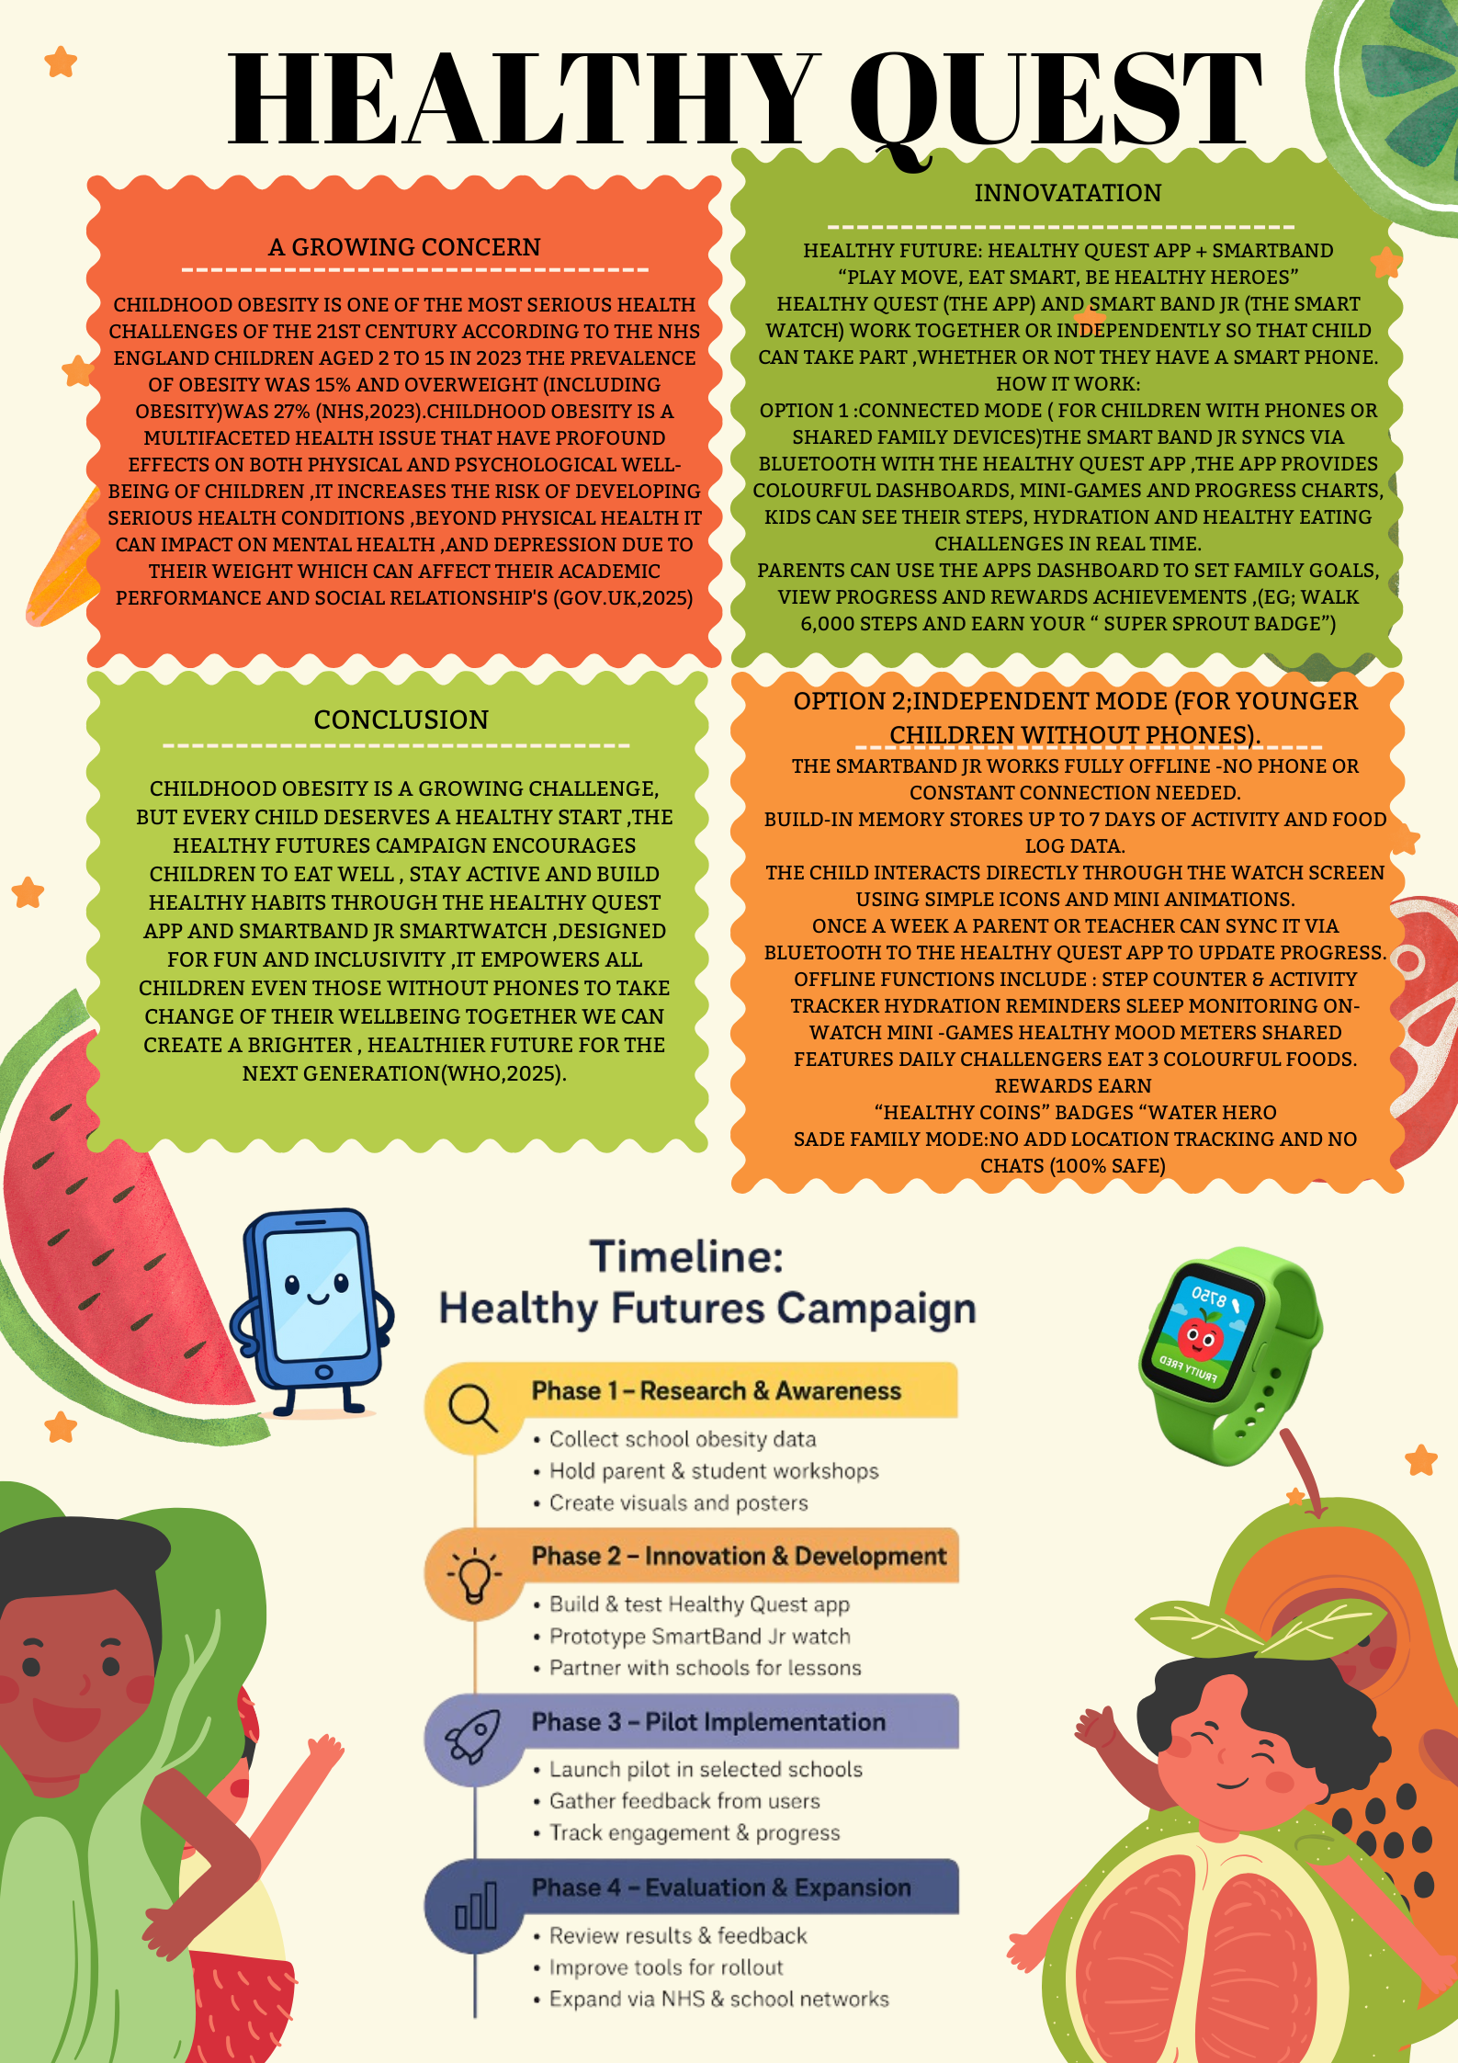
Table of Contents

1.Poster
2.Introduction
3.Healthy Quest and SmartBand jr
4.Target Audience
5.Implementation Plan
6.Value of Innovation
7.Feasibility Analysis
8.Pitch&pilot Program
9.Recommendations
10.Conclusion
11.Reference list

Childhood obesity has become one of the most urgent public health challenges of the 21st Century, over the past decade the number of children experiencing weight – related complications including physical activity, unhealthy eating habits, disrupted sleep and increased screen time has continued to rise( Bagchi,2019).These early lifestyle patterns place children at risk for long-term health issues such as diabetes, heart disease and poor emotional well-being, Schools, families and communities now face the critical responsibility of finding innovative, accessible and engaging ways to promote healthy behaviour among young learners ((Andersen&Thompson,2020).
To address this growing concern the Healthy Quest and the SmartBand jr intervention was developed as a modern, technology – based solution designed to support children in building positive daily routines, Healthy Quest is a gamified wellness app that encourages children to complete fun health missions related to movement ,nutrition , hydration and sleep. The SmartBand jr is a child-friendly wearable device that tracks real time physical activity, sleep duration and sedentary behaviour, providing immediate feedback and motivation, together these tools transform health promotion into an interactive experience that blends education technology and behavioural changes.
This report outlines the conceptual foundation, development process and implementation plan for the Healthy Quest and SmartBand jr innovation, it examines where the intervention ca be most effectively pitched , identifying the target audience and discussing its overall feasibility and value ,a pilot program is included to demonstrate how the innovation will be tested , evaluated and refined before full scale adoption ,in addition ,recommendation are provided to enhance sustainability ,stakeholder involvement and long –term impact, overall this intervention aims not only to reduce the risk of childhood obesity but also to empower children to take control of their well-being by combing fun ,motivation and real world behaviour tracking Healthy Quest and the smartBand jr offers a promising approach healthier future for the next generation.

3) Healthy Quest and SmartBand jr Innovation

The Healthy Quest and SmartBand jr offers a modern technology –based solution to the growing issue of childhood obesity, the core features of Healthy Quest and Smartband jr are,
3, a). Daily health missions, children receive three to five missions per day like.
- Drinking a full bottle of water
- Choosing a fruit or vegetable for a snack
- Completing 10 – 15 minutes of free play
- Practicing a relaxation or breathing exercises
- Going to bed at their recommended time
Completing missions earns points, stars, badges and level upgrades
3.b). customising Avatar a reward s system, children create a personalised Avatar that evolves as they complete missions, rewards include.
- Digital accessories
- Achievements badges
- Unlockable mini games
- Special “wellness champions” milestones
This strengthens intrinsic motivation through fun and personalisation.
3, c). Interactive Health Education modules, the app includes short, animated lessons on;
- Basic nutrition
- Importance of sleep
- Hydration
- Physical activity benefits
- Reducing screen time
Lesson is designed to visual simple and child appropriate.
3, d). Parental and Teacher Dashboard
A monitoring dashboard allows adults to view a child's progress, mission score and activity patterns. Teachers can assign classroom health challenges; parents can adjust goals at home.
SmartBand jr a child friendly wearable activity device is lightweight, safe, waterproof fitness band created for children; it works seamlessly with Healthy Quest automatically syncing real life health behaviours into the game. The core function of the SmartBand jr is activity tracking steps, sleep, screen time & movement reminders, if a child is sedentary for too long smartBand jr ,vibrates with “Movement reminder” suggesting a stretch or short activity break.
It is also a safe child cantered design with no geolocation tracking, soft hypoallergenic material, breakaway strap for safety, long battery life (5-7 days) and tamper resistant interface.
4). Target Audience
The primary users of Healthy Quest and the SmartBand jr are children aged 6-12 years this age group is particularly suitable for several reasons they are highly receptive to gamified and interactive learning; early habits formed at this age can strongly influence long term health and they regularly participate in structured school routines where the intervention can be integrated seamlessly .
The secondary audience includes parents who play a critical role in reinforcing healthy habits at home the parent's dashboard provides visibility into children activity level, sleep patterns and screen time habits enabling families to work collaboratively towards healthier routines (Thompson,2016).
The third audience is teacher and school administrator who guide students' participation and help implement the program in the classroom their involvement ensures consistency and supports student engagement and the fourth group through indirect includes community leaders, local government units and health advocates their support enhances programs credibility long term sustainability (Waters et al ,2011).

5). Implementation Plan
The success rollout of the intervention requires a clear, multi-phase implementation plan comes in 4 phases:
Phase 1: Preparation and training
Teachers and parents receive training on using the Healthy Quest app and SmartBand jr ,workshops introduce mission, structure, reward system, device maintenance and syncing procedures school set clear guidelines regarding daily usage and data protection policies.
Phase 2: Distribution and Orientation
Students receive the SmartBand jr and are introduce to Healthy Quest, they learn how missions work, how points are earned and how their activity influences in –app rewards, Baseline readings of steps, sleep and screen time are recorded to support later comparisons.
Phase 3: Active use and Engagement
Students begin participating in daily wellness missions, including hydration goals, walking challenges, stretching breaks and nutrition tasks, SmartBand jr tracks movement, sleep and sedentary behaviour, teachers conduct weekly challenges to build excitement, while parents receive weekly progress summaries.
Phase 4: Monitoring and Evaluation
Program data is analysed to identify improvements, challenges and engagement trends, Teachers track students' progress, note barriers and feedback, adjustments are made to the mission, difficulty levels or technical processes if needed.

6). Value of the Innovation
Healthy Quest and the SmartBand jr offers significant benefits for those children, families. schools and the wider community, for children the value lies in turning healthy behaviours into an enjoyable experience, gamified increases motivation while the SmartBand jr provides immediate feedback, encouraging self –awareness and consistency, parents benefiting from greater insight and involvement in their children health habits, the dashboard allows them to understand trends and promote healthier routines at home(Baraa,2023).
Schools benefit from a structured data –driven wellness tool that aligns with health education curriculum and national wellness standards, improved health directly enhances learning, concentration and overall health performance, community health organisations gain access to objective data to support obesity –prevention efforts and evaluate community level health initiatives(Medicspot.UK,2025).
7). Feasibility Analysis
The innovation is highly feasible due to its simplicity, affordability and comparability with existing school systems SmartBand jr is inexpensive, durable and easy for children to use ,the Healthy Quest app runs on standard devices commonly used in schools ,training requirements are moderate and most schools already have experience using the digital platforms ,the intervention requires minimal infrastructure and can be supported through local partnerships or sponsorships, data security and privacy are manageable through encrypted systems and school-level guidelines, overall the innovations low cost ,adaptability and ease of use contributes to a strong feasibility.
8). Pitch &Pilot Program
The Healthy Quest and the SmarBand jr will be pitched to organisations and sectors that directly influence children's daily habits and health environments, the most effective pitch targets are primary schools where structured routines and groups activities are support consistent use of the intervention, school administrators PE coordinators and district level education planners can easily integrate to the program into existing wellness or physical education efforts(Institute of Medicine,2011).
Before full –scale rollout a structured pilot program is essential to refine the intervention and ensure real world success, the pilot program aims to assess ease of use for parents and teachers, measure engagement and missions' completion, evaluate changes in physical activity, nutrition awareness, sleep and screen time and to identify technical or behavioural challenges also to gather in-depth feedback from all stakeholders.
The aim is to set the program into one partner school to participate in the 8-10 weeks pilot, the participants aged 6-12, twenty students' teachers who can manage their daily implementation and inform parents who can reinforce their habits at home.
Weeks 1-2 Orientation and Baseline Data Collection:
Training sessions are held, and students receive SmartBand jr baseline measurements of step count, sleep duration and screen time behaviour are recorded.
Weeks 3-6 Intervention Phase:
Students complete daily Healthy Quest missions ,SmartBand tracks their activities while teachers facilitate weekly goals and class challenges parents receive summaries to support engagement at home.
Week 7-8 Evaluation and Feedback:
Post –intervention data is collected and compared with baseline values. Surveys and interviews provide additional insight from students, teachers and parents. The pilot program is expected to show improvements in student achievements healthier daily routines, increased motivation and positive feedback from teachers and families, potential refinements will be identified to strengthen the program before expanding to more schools (NICE,2025).

9). Recommendations
- To enhance the interventions long term success the following are suggested,
- Strengthen community and government partnerships (Sahoo et al .2015).
- Integrate Healthy Quest into school's subject for deeper learning
- Providing ongoing parents engagement sessions
- Continually update missions and rewards
- Offer subsidies for lower –income communities
- Conduct regular monitoring and evaluation to maintain effectiveness

10). Conclusion
The Healthy Quest and the SmartBand jr intervention offers an engaging and effective way to address the rising issue of childhood obesity by combining gaming with wellness challenges with real time activities ,nutrition ,sleep, and screen time management ,grounded in behaviour change and supported by parents and teachers the system provides a fun practical and measurable approach to improving children's health with strong potential for implementation in schools ,community health programs and paediatric settings. The intervention is both feasible and scalable, the pilot program will help refine its features and demonstrate its impact before broader adoption, overall Healthy Quest and SmartBand jr presents a modern child –cantered solution that supports healthier lifestyle and promotes long term well-being.

11). Reference List
Andersen, L.M. and Thompson, D.A. (2020). Managing Excessive Weight Gain in Children <2 Years of Age: Interviews with Primary Care Providers. Childhood Obesity, 16(5), pp.332–339. doi:https://doi.org/10.1089/chi.2019.0315.
Author, M.S. (2025). Obesity in Children: How to recognise and respond. [online] Medicspot. Available at: https://www.medicspot.co.uk/weight-loss/health-conditions/obesity-in-children [Accessed 17 Nov. 2025].
Bagchi, D. (2019). Global perspectives on childhood obesity : current status, consequences and prevention. London: Academic Press.
Baraa Alghalyini (2023). Applications of artificial intelligence in the management of childhood obesity. Journal of family medicine and primary care, 12(11), pp.2558–2564. doi:https://doi.org/10.4103/jfmpc.jfmpc_469_23.
Health (2025). Government acts to tackle rising childhood obesity epidemic. [online] GOV.UK. Available at: https://www.gov.uk/government/news/government-acts-to-tackle-rising-childhood-obesity-epidemic [Accessed 11 Nov. 2025].
Institute of Medicine, Children, Y. and Early (2011). Early Childhood Obesity Prevention Policies. National Academies Press.
NHS (2023). Obesity. [online] NHS. Available at: https://www.nhs.uk/conditions/obesity/ [Accessed 11 Nov. 2025].
NICE (2025). Overweight and Obesity Management. [online] Nice.org.uk. Available at: https://www.nice.org.uk/guidance/ng246 [Accessed 11 Nov. 2025].
Sahoo, K., Sahoo, B., Choudhury, A.K., Sofi, N.Y., Kumar, R. and Bhadoria, A.S. (2015). Childhood obesity: Causes and Consequences. Journal of Family Medicine and Primary Care, [online] 4(2), p.187. doi:https://doi.org/10.4103/2249-4863.154628.
Thompson, T. (2016). Childhood obesity. Farmington Hills, Mich.: Greenhaven Press, A Part Of Gale, Cengage Learning.
Waters, E., Swinburn, B., Seidell, J. and Uauy, R. (2011). Preventing Childhood Obesity. John Wiley & Sons.
World Health Organization (2025). Obesity and Overweight. [online] World Health Organization. Available at: https://www.who.int/news-room/fact-sheets/detail/obesity-and-overweight [Accessed 11 Nov. 2025].

