Assignment Title

Individual project report- global business management

TASK DESCRIPTION

- Identify and select a Global Business from the Services sector in the UK
- Open discussion of the impact on the business environment
- Identify two global factors from PESTLE and Porter's Five Forces

Programme: BA (HONS) Business Management
Module: Global Business Management
Module code: LCBB4005_BIRM



MODULE COORDINATOR: Dr Eric Orisei
Internal Verifier: Yohan Mendis
ZHIVKO PLAMENOV PANEV
STUDENT ID: 2198289

Contents
Introduction 1
Revolut 2
PESTLE ANALYSIS 3
Porter's Five Forces 4
References 6

Introduction

This report will discuss the Global Business Environment on Revolute. The international economy has grown massively in recent decades and seems more integrated. (Guy, 2008) The company was started up in London in 2015. Revolute is a Fintech technology used to support or enable baking and financial services. Revolute is an online banking app where you can exchange currency and Crypto simultaneously. The app helps you allocate and understand your expenses and how you spend your money. Legal acts are making a significant impact on a company's future. The Brexit deal brings new rules and requirements for Revolute to proceed to deliver its service to the European market.
The company implement strategies to change the interaction with technology and shape the future of financial and lifestyle experiences. This report will bring discussion involving PESTLE and Pooter's five analyses. PESTLE helps you analyse the external environment; this can help you start a new business or enter the market. The external environment is everything surrounding the company, such as competitors, suppliers, distributors, etc. These external factors all the time correspond with the firm. But some of them are part of the task environment; PESTLE analysis strictly discusses the macro business factors. Each of the external factors can affect the business, but the company cannot have an impact on these environments. We will discuss Pooter's five elements and their impact to bring a clear image of the task environment. The task environment is everything which stays between the micro and the macro factors of a business. The World is changing each minute massively, which is why we need to analyse and define the strengths and weaknesses of a particular company. Every operative firm must follow the legal acts and the new guidance for business. When we have a global business, we must consider whether any restrictions or support come from the territories' governance.

Revolut
Revolut is building the first global financial platform, so their customers can get more from their money- they can follow everyday spending or make plans for future investments. The forum started in 2015 and launched in the UK, offering money transfers and exchanges. At the start of 2021, Revolut developed customers worldwide and reported 150 million monthly transactions. Beyond the personal and business accounts, the organisation focuses on helping customers improve their financial health, giving them more control over their money and future investments. (Statements, 2020)
The organisation's long-term plan is to develop the World's most extensive financial super-app. Its mission is to provide the customer with the power to manage all financial needs in a single app, promising to be cheaper and easier to use than its competitors. To achieve their plans, Revolut organisation aim to create a truly global bank. (Statements, 2020) The progress between 2015 and 2020 gives us a positive outcome. For five years, the company expanded and gained a Banking Licence granted by the Bank of Lithuania. The organisation made their first expansions to Australia and Singapore and launched new donations partnerships with international charities to support global causes. (Statements, 2020)
Martin Gilbert, chairman of Revolut, pronounced:
"Our revenue growth through the year reflected the increasing relevance of our product mix,
the attractiveness of subscriptions and our continued customer growth." (Statements, 2020)
Supported by the Chief Executive's reviews – Nikolay Storonsky support the report on growth. The founder of Revolut also explains that they were challenged in 2020, but they remain focused on achieving their aim. The company continue to focus on international expansion. (Statements, 2020)
Revolut business strategies
Each organisation uses strategies to achieve its plans. A Global Strategy refers to the operations discussing the future and clarifying which ways will be adequate to turn their goals into fact. Every strategy requires analysis; these reports bring a clear vision of the position of the business and help identify strengths and weaknesses.
Revolut's Growth Strategy was prosperous compared to their competitors, Monzo and N26. Proof of that is achieved in their 100 thousand users for a year. The company is positioned at the front as UK's most valuable private company. The earliest strategy was to bring in as many users as possible and make them deposit 5 euros without marketing. Later the company added new products and expanded into new markets, such as spoiler alerts, and Crypto was a key propellor to the company's growth. After listening to their latest products, Relatestut increased its revenue by 130% in the first quarter of 2021. (Genes, 2021)

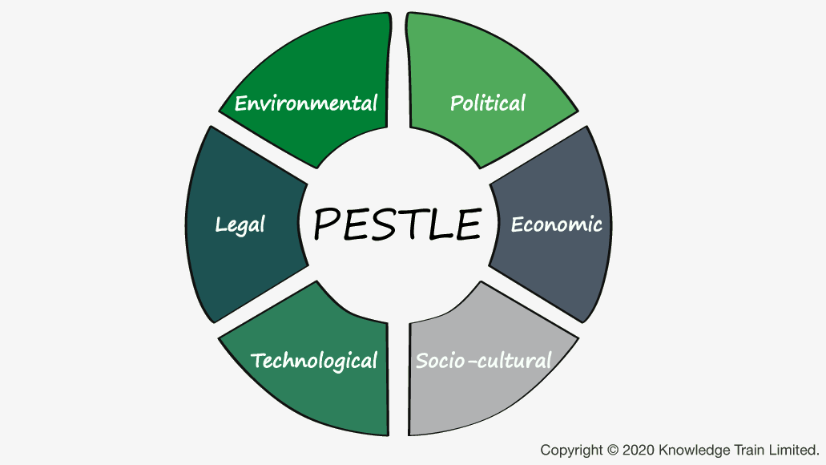 (Buehring, 2021)

PESTLE ANALYSIS
Pestle analysis is a tool which helps firms to identify the macro (external) forces. The letters explain the Political, Economic, Social, Technological, Environmental and Legal. Before an organisation steps into a market, it is significant to get a situational analysis. This analysis needs it's needed at least every six months to identify the changes in the macro-environment. (Marketing, 2022)
The macro-environment refers to the number of conditions affecting a particular organisation. This environment discusses the circumstances in the economy as a whole, not in a specific sector or region. Generally, the macro environment includes trends in the gross domestic product(GDP):
Inflation, employment, spending and monetary and fiscal policy in this environment impact the general business cycle. (Team T. I., 2021)

Political factors for Revolut
The political factor clarifies which government and government policy can affect a firm or specific industry. Revolut gained a Lithuanian banking license, which caused some political arguments between Lithuania and Russia. The Russian government have concerns were the father of Revolut CEO Storonsky used to be a director at a division of Gazprom. Revolut denied that the Storonsky family had a connection, but the company soon accepted their mistake and confirmed it. This fact hurt Revolut, making the CEO Storonsky release an open letter rejecting the links between Revolut and Kremlin. (Conversation, 2019) As Revolut is a British service-based company, the impact of Brexit pushed the firm to make some more changes. Due to Brexit, companies must stop passport their services across the EEA from 1 January 2021. This change brings new challenges to company customers, who need to continue trading on Revolut without EU regulatory protections and risk their money or trade with RTL based on an ongoing relationship. (MccGrath, 2020)

Economic Factors for Revolut
Back in 2019, the World experienced one of the most significant pandemics. The Covid19 Pandemic remained for almost three years. The challenge of the Global Covid 19 Pandemic required new solutions from the World's innovative global market. Uk is a world-leading fintech industry, providing solutions and partnerships that have been able to offer solutions to the pandemic period. Fintech bridges allow ordinary citizens and organisations to use financial services on a global level. (World- leading fintech expertise, 2022) Revolut is a British company, and the support given by the government is favourable to the company.

Social Factors for Revolut
Neon banks look like the new trend in banking services around the World. A neon bank is 100 per cent digital and accessible through online platforms or apps. This change helps customers receive their papers online, not through traditional physical branches. (Life, 2022) This fact supports the organisation of Revolut to increase its customers and deliver more services as the environment changes globally. But the company must assure their customers that their privacy and safety concerns are secured. Social communities meet more and more frauds against their database, which is available on online platforms or online sources. The company need to focus on new partnerships with developers within the security sector.

Technological Factors for Revolut
The company need to continue with innovation so to be able to attract new investors. This type of industry depends on its stakeholders and shareholders. The first organisation's customers need to be impressed with the quality of the product, and the stakeholders from the other side need to adapt the strategies of a company. Each technological process requires investments, so Revolut must bring more ideas to attract new investors and customers. The failure to defend and block suspicious transactions negatively affected Revolut's organisation. The company failed to detect illegal transfers and switched off its defensive systems. The company raised security concerns twice, so they need to look for improvement within their security systems. (Nonninger, 2019)

Legal and Environmental Factors for Revolut
Revolut's organisation need to improve their frameworks to meet the UK Government's requirements for a banking license. The company is looking forward to gaining a UK banking license and facing all security regulations under this matter. This license will bring thousands of new customers and allow them to pronounce a new list of products, such as loans and other bank services. The company should carry on getting new joints and reduce their footprint on our environment.

Porter's Five Forces
Porter's Five Forces model helps to identify your competitors in the market, allowing you to define the threats of the market and which weaknesses of a firm need to be improved. (Team M. T., 2022)
This analysis can be applied to economic factors and determine the long-term profitability profile of an organisation's strategies. This model is named after Harvard Business professor Michael E. Porter.
"This model originates from the traditional approach and provides a useful basis from which decision-makers can begin to build a picture of their competitive positions." (Brooks, 2010)
The frame could guide the business strategy to get more advantage over its competitors. Here we can look at our competitors' advantages and build a plan to outstand in the market as a leader. The Potential of new entrants into the industry is the second factor. Here each organisation should be aware of a new business model in the market and how they will compete with it. The power of suppliers is a significant factor for all organisations. To be supplied with the goods you need to deliver your service cannot be avoided. The supplier's long-term plans must be well organised. Power of Customer as to the significant impact of e-commerce, we now can see that if you have the right strategy, you can bring a cold audience into your market. Building trust and getting new customers can guarantee the success of an organisation's long-term strategy.
The threat of substitute products, each company deliver a service or product, but there is also someone else who is a part of your external environment. Sometimes you can find substitute products, and this product could be expressed as a new one on the market so you can attach more attention. Having more than one option guarantees that your clients will spend more time looking into your organisation. Porter's five forces framework can bring a clear vision of an organisation. You understand the five forces and how to get positive outcomes for the organisation's long-term models. In these fast-changing global environments, the criticism of Porter's Five models can help each organisation be dynamic and aggressive to stay at the top of the market. Michael Porter's five modes are a powerful tool for every firm. This model can help you increase your products' attractiveness and find areas where you can improve.

Conclusion
The Global business environment is a significant factor for each firm with plans to go on the global market. It is essential to produce a PESTLE analysis every six months and update the strategies with global changes. Identifying the differences and what political and legal facts are threatening your business can help you to get positive outcomes even in adverse situations. Porter's five forces help you identify where your business needs improvement and where you can force it to generate more revenue. Understanding your industry's macro-environment could help you attract new investors and look at the right places for more customers. Revolut is the first neon-banking app, which has dramatically improved over the last five years. Reaching millions of new clients and starting new collaborations worldwide could make a fact of their aim to become the World's most significant financial app.

References
- Brooks, I. (2010). The international business environment.: challenges and changes. Pearson Prentice Hall.
- Buehring, S. (2021). The PESTLE Business analysis technique. Retrieved from https://www.knowledgetrain.co.uk/business-analysis/business-analyst-course/business-analysis-technique-pestle
- Conversation, T. (2019). Revolut: Could allegations of Russian involvement sidetrack a fintech revolution? IMD, 1.
- Genes, P. (2021, 09 14). www.paymentgenes.com. Retrieved from Payment Genes: https://www.paymentgenes.com/all-about-payments-videos/revoluts-growth-strategy-explained
- Guy, F. (2008). Technological Change and International Production. In F. Guy, The global environment of business (p. 20). Oxford University Press.
- Life, B. I. (2022). WHAT ARE NEOBANKS, AND HOW ARE THEY CHANGING FINANCIAL SERVICES? Retrieved from Bringing Ingenuity to Life: https://www.paconsulting.com/insights/what-are-neobanks-and-how-are-they-changing-financial-services/
- Marketing, O. C. (2022, 06). What is a PESTEL Analysis? Retrieved from Oxford College of Marketing: https://blog.oxfordcollegeofmarketing.com/2016/06/30/pestel-analysis/
- MccGrath, E. (2020, 11). What Brexit means for you and Revolut Trading. Retrieved from Revolut.com: https://blog.revolut.com/what-brexit-means-for-you-and-revolut-trading/
- Nonninger, L. (2019, March). Revolut may be in trouble over new security concerns. Retrieved from Insider: https://www.businessinsider.com/revolut-security-concerns-2019-3?r=US&IR=T
- Statements, A. R. (2020). Revolut Ltd. https://assets.revolut.com/pdf/Revolut%20Ltd%20Annual%20Report%20YE%202020.pdf: Revolut Ltd.
- The team, M. T. (2022). Porter's Five Forces. Retrieved from MindTools: https://www.mindtools.com/pages/article/newTMC_08.htm
- The team, T. I. (2021, 03). Macro Environment. Retrieved from Investopedia: https://www.investopedia.com/terms/m/macro-environment.asp
- World-leadingding fintech expertise. (2022). Retrieved from www. the global city.UK: https://blog.revolut.com/what-brexit-means-for-you-and-revolut-trading/

