

BA Business Management
Marketing Fundamentals
LCBB4004
Task 2

Student name and ID`s:
Mona-Alexandra David – 2111962
Module name: Marketing Fundamentals
Module code LCBB4004
Lecturer name: Dr Piyumika Kithulgoda Gamage
Submission date: 02/04/2023

Contents
Abstract 3
Stages of the marketing process 4
Companies Overview 6
PESTLE 6
Political 7
Economical 7
Social 7
Technological 8
Legal 9
Environmental 9
Porter’s 5 Forces 10
Ansoff Matrix 11
Conclusions 12
References 13

Abstract
Reynolds and Lancaster (2005) contend that there is no universally recognised definition of marketing. There is no commonly accepted definition of marketing. People's judgements of its worth and contribution to an organization's performance and the competitive health of the economy are dependent on how it is understood. Most people equate the term customer with a profit-generating enterprise. While it is true that the marketing concept is more widely accepted and exercised in the for-profit sectors, the marketing fundamentals are equally applicable in the non-profit sectors, which is often overlooked. Marketing, as an organisational theory and practise, applies to the great majority of organisations, whether for profit or not. (Reynolds and Lancaster 2005)
According to Blythe (2006), marketing is a very young science, and there is still substantial dispute and controversy amongst scholars and practitioners as to what marketing is and isn't. There is significant dispute over the bounds of marketing. All marketing scholars agree on one essential principle: marketing places the client at the centre of all marketing ideas. This is not to say that marketing is a philanthropic institution; organisations exist to achieve their own goals; nonetheless, marketers contend that all organisational actions should be influenced and motivated by customers and consumers. Following this notion is not always simple in practise: customers are not always consumers (imagine a mother purchasing clothing for a tiny child), and consumers may have different demands than consumers. Furthermore, it is very easy to make presumptions as to what consumers need and want – often, these biases are centred on what the planner needs and wants, rather than what the purchase power need and want. The final result of marketing is the firm's competitive advantage: businesses that take after their consumers should perform better than those that do not. Simply said, marketers place consumers at the heart of everything they do as this is the most effective method for them to make money. Marketing practise may be defined as all of the actions that take place at the company's contact with the outside world.
Different authors believe that this interface should be restricted to customers only, while others believe that marketing should have an impact in all contact with general public, including employees and other "insiders."
Another typical way to characterise marketing's job is as exchange management. Marketing is the process of creating items and services that benefit consumers and then delivering them in exchange for cash. The marketer is in charge of the exchange's terms, location, timing, and circumstances. This definition has significant conceptual challenges because customers frequently play a role in choosing a variety of these issues (especially when trading on the Internet . However, in recent years, it has proven to be an effective method of defining marketing boundaries.(Blythe,2006)

Stages of the marketing process

The strategic marketing process is a planned sequence of stages that aid in goal identification and achievement. Furthermore, it determines what customers want and develops products to meet those needs. The process of developing goals and objectives, analysing business factors both internal and external, developing products, putting those plans into action, and monitoring progress are all components of strategic marketing planning. (Weller,2017)
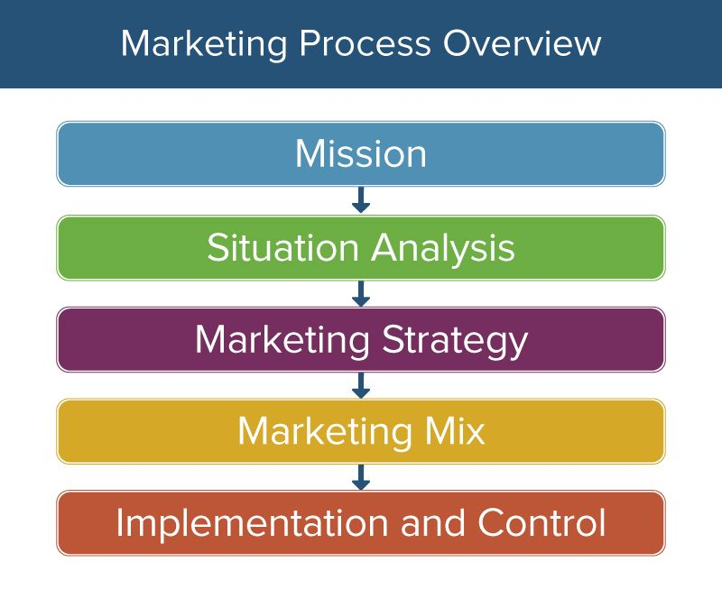
https://www.smartsheet.com/strategic-marketing-processes-and-planning
According to Donnelly, Harrison and Megicks (2009) marketing planning looks to be a straightforward, step-by-step procedure. It is viewed as a sequence of actions leading to the establishment of marketing goals and the development of plans to achieve them. However, it is a multifaceted, complex, bridge activity that affects all aspects of organisations. The procedure may be informal in small organisations, but it is more likely to be formal in bigger organisations. Marketing strategy is part of the yearly planning cycle once it is initiated. The steps of marketing planning are as follows: analysis, planning, and implementation.
Control Analysis: this includes an examination of the market structure, both micro and macro, as well as the industry, markets, and competitors. A scenario analysis of a marketing plan occurs when strategists examine the marketing situation or place of a company's marketing strategy for their target audience. To do a company's marketing strategic analysis, you must analyse the present status of the business and how it may affect your capacity to attract to customers as a marketer. In a situation analysis for marketing, you may investigate consumer perceptions, your rivals' customer attractiveness, and what separates your services from others. A few significant ways for doing a marketing plan scenario analysis are the 5Cs Analysis (business, customers, competitors, collaborators, climate), Swot analysis, and Porter 5 forces analysis. (Indeed Editorial Team,2023)
Planning entails the development of plans and marketing programmes, as well as the identification of assets and timing. In order to achieve the bigger, more long-term goals, marketing objectives are broken down into a series of smaller, more immediate activities. A competent marketer or marketing division is responsible for completing these tasks. You are able to develop marketing objectives by employing the SMART goal-setting process. This will ensure that the established goals provide direction to everyone involved in marketing, provide clear guidance for selecting strategies and determining the best way to better target your ideal customer, and define the true intent of the marketing team. Those involved in marketing will also benefit from the direction that the established goals provide. (Indeed Editorial Team,2023)
Implementation: this encompasses the actual implementation of the plan, as well as any necessary revisions. A marketing implementation plan has several advantages, including assisting the team in implementing the marketing strategy, albeit a successful project helps the entire firm. Here are three common advantages of an advertising implementation plan: It gives direction, establishes clear timelines, and ensures ownership and accountability. You may create a marketing implementation strategy in six phases, which are as follows: set reasonable expectations; de determine what you need to put in place; e examine your marketing plan; create workflows for all of your content and tasks; c communicate with the group; as you go, keep an eye on everything and collect data. (Indeed Editorial Team,2022)
Control includes screening against predetermined goals, control methods, and performance measures.

Companies Overview

Transonics, Alan Anderson, and Lewmax are the firms that are the topic of this piece. All three are a group of companies based in the United Kingdom that are owned by the same person and operate under the same roof. They will be referred to as Group during the following report.
Transonics PLC was established in 1976 and is a prominent family-owned and operated franchised provider of local and global electronic part distribution and design solutions. They provide custom design solutions by offering a unique line-up of franchised components from top brands and emergent technology specialists, as well as specialised in-house resources such as technical and engineering personnel.
UK experts in the production of printed circuit board assemblies - surface mount and through-hole - suited to the design, specification, and volume of any project, while maintaining high quality standards. Alan Anderson Manufacturing Ltd. was founded on quality, service, and manufacture. They collaborate with clients early on to understand their requirements and provide feedback on design and production techniques. Their experience aids in forecasting lead times, allowing sales and purchase orders to be adjusted to minimise production disruptions, or buffer stocks to be used to ensure supply. Before prototyping, they collaborate with customers on technical and NPI issues to share their design and production expertise. Bulk production is also supported using the Customer New Product Introduction interface.
Lewmax is the third company that belongs to this group. They are experts in the process of programming and generating microchips that may be customised to meet the requirements of the client.

PESTLE

The macroenvironment of a company may be analysed using a technique called the pestle analysis. It is utilised by businesses, and primarily the marketing departments of those businesses, in order to grow or market new items. The macroenvironment of each of the aforementioned companies will be analysed with the assistance of the aforementioned instrument.

Political
Because the electronics industry operates in a highly regulated sector, political happenings have the potential to influence its day-to-day business. Legislation passed by the government, international trade treaties, and import-export rules are all factors that can affect a company's supply chain, which in turn can affect manufacturing costs and access to markets. The most significant influence on the Group's commercial activities is the Brexit. They are required to pay customs charges on any items that come from the EU that they import. In addition, all of their customers are required to pay applicable taxes on the products and services they purchase from them. Time is yet another significant element that has been altered as a result of Brexit. Due to the fact that the orders are being held at customs, there are delays in both ways. They are concerned about losing their prior customers who are based in countries other than the UK due to these two issues, given that every company wants to find a more easy and safe way to trade their products.

Economical
The status of the world economy may have an influence on Group's operations. A recession, for example, might restrict consumer spending, resulting in lower interest in their goods. Exchange rate variations may also have an impact on their import/export expenses and profit margins as the Group’s main business is outside UK.
The economy of the United Kingdom is not doing very well at the present. All types of businesses have been negatively impacted as a result of the energy crisis, Covid, and rising costs of living. According to the Office for National Statistics there were an estimated 185.6 million working days lost due to illness or harm in 2022, a new historic level; in March 2023, the government sector managed to spend in excess of what it did receive in tax payments as well as other revenue, requiring a £21.5 billion borrowing; retail sales volumes (the quantity of stuff bought) are estimated to have fallen by 0.9% in March. As reported by the Office for National Statistics, online job ads were 17% lower on 21 April 2023 than in the same time frame in 2022.

Social
The category consists of companies that work in the electronics sector, which is characterised by a dynamic environment characterised by rapidly shifting client preferences and trends. The firm has a responsibility to take into account these societal challenges and to adapt the product offerings in accordance with those considerations. In addition, socioeconomic factors like shifting demographics and cultural norms may have an impact on the target market that the firm is aiming for and the marketing technique that it employs. The state of the economy has caused a decline in people's interest in various forms of technology.
In February 2023, 5% of people reported that they had run out of food and were unable to afford more in the previous two weeks, as stated by the Office for National Statistics. Running out of food was more common for individuals in certain groups; for example, one in five people who experience moderate to serious depressive symptoms reported running out of food in the most recent period.
In recent weeks, about half of the population in the United Kingdom has voiced worry at the high cost of power and food. This is what the results showed when participants were asked by the ONS in their most recent Views and Lifestyle Survey what worries they had been concerned about in the most recent two weeks. According to the replies gathered between April 5 and April 16, 2023, the cost of food and power were cited as the two primary challenges, with each receiving 49% of the total votes.
According to the most recent information provided by Dataloft, the cost of rent is presently higher than it was at the beginning of 2019, but it has essentially remained the same over the course of the preceding two years.

Technological
The electronics industry thrives on innovation and the development of new technology. In order to maintain its competitive edge, Group must stay abreast of developing technologies. In addition, the corporation has to be aware of the impact that emerging technology will have on both its goods and its operations.
According to techuk.org, the annual Tech Nation Report, which analyses the state of the UK's technology industry in 2020, highlighted yet another year of considerable progress despite the challenging conditions. This was the case even though the industry faced a number of challenges.
The IT industry has demonstrated its resiliency by continuing to expand in spite of the extraordinary circumstances, which include the conclusion of the transitional phase of the Brexit process, societal alienation, and several lockdowns induced by the epidemic.
The United Kingdom's information technology sector attracted the third-most venture capital (VC) funding in the world, trailing only the United States and China. At the same time, investment in cutting-edge technologies like artificial intelligence, blockchain, and quantum computing has increased, and the country as a whole has become more appealing to investors.
According to the findings of the research, the pandemic has also impacted people's perspectives and behaviours about technology. Sixty-six percent of individuals reported that they had modified the way in which they use technology, with the greatest increases in communication to combat loneliness, socialising, working from home or remote learning, and entertainment.
According to the findings of the research, technology and the technology industry in the UK have played a significant role in assisting the United Kingdom to adapt to the effects of the pandemic while also supporting economic development and jobs. This is the case despite the fact that 2016 was a challenging year. Not only is it important for our economy to make sure that we continue to have the appropriate legal and regulatory framework in place so that we can enable the future expansion of the UK technology industry, but it is also important for making sure that we can build an economy that is more robust, creative, and environmentally friendly.

Legal
Because the Group operates in an industry that is highly regulated, there is a possibility that legal considerations will have an impact on its business practises. The company is obligated to be knowledgeable about all applicable rules and regulations on product quality, copyrights, and the protection of data. Alterations to the laws and regulations may also have an impact on the costs incurred by the firm and the way it does business. The United Kingdom has less regulations governing its workforce and a more flexible job market when compared to other nations in Europe. As a result, the United Kingdom is an excellent location for the success of both those who run their own businesses and talented workers.
The process of defending intellectual property rights and putting them to productive use is quite well established in the United Kingdom. There will be a significant amount of information pertaining to international trade.

Environmental
According to Pereira (2023), the environmental analysis takes into account not only the physical environment but also governmental policies or directives regarding climate change, the availability of energy or connected retail price trends (for example, a lack of supply of oil could result in an increase in the price of petrol; a lack of certain metals could affect the price of parts; and so on).
All of these factors have the potential to have a significant impact not only on operations but also on other critical aspects such as the desire of customers to purchase a particular item and the productivity of employees. As a consequence of this, it is essential for business owners to investigate the implications of environmental pressures before making important strategic choices. Failing to do so could be disastrous for both short-term cash flow forecasts and long-term sustainability projects if they are not effectively managed.

Porter’s 5 Forces

Porter's Five Forces is a popular feature for analysing a company's competitive environment. Here is a Porter's Five Forces analysis of Group Plc:
New entrants pose a threat: Group works in the electronic components business, which has low entry barriers. New entrants can easily begin producing and supplying electronic components, potentially increasing competition and lowering Group' prices. Group, on the other hand, has been in the industry for a long time and has built a good reputation for quality and dependability, which might be a hurdle for new entrants. Group also has connections with several significant manufacturers, which might be a barrier to entrance.
Supplier bargaining power: To produce its products, Group relies on a variety of suppliers for raw materials and components. Supplier negotiating power is quite low because there are several suppliers in the market and Group may easily move between them if necessary. However, if the supply chain is disrupted or there are shortages, suppliers may have more bargaining power.
Buyer negotiating power: Since Group offers electronic components to a wide range of sectors and consumers, buyer bargaining power is quite high. If Group raises its rates or fails to satisfy their needs, buyers can easily move to another provider. However, Group has a reputation for quality and dependability, which may deter buyers from switching to other suppliers.

Substitute threat: There are several replacements for electronic components, such as various types of components or other manufacturers. As a result, the threat of alternatives is rather significant, and Group must continually invent and enhance its goods in order to stay ahead of the competition.
Rivalry: The electrical components sector is extremely competitive, with several firms vying for market share. Group confronts competition from both major and small manufacturers, which can place pricing and margin pressure on the company. Group, on the other hand, has a solid reputation for quality and dependability, which might provide a competitive edge in the market.
In the electrical components sector, Group confronts moderate to high levels of competition and threats. However, its strong reputation for quality and dependability, as well as its alliances with large manufacturers, can act as entry barriers and help it maintain a competitive advantage.

Ansoff Matrix

Peterdy ( 2023) says that the Ansoff Matrix, also known as the Product/Market Expansion Grid, is a two-by-two structure that management teams and analysts use to plan and analyse expansion projects. The tool, in particular, assists stakeholders in conceptualising the amount of risk related to different development plans.

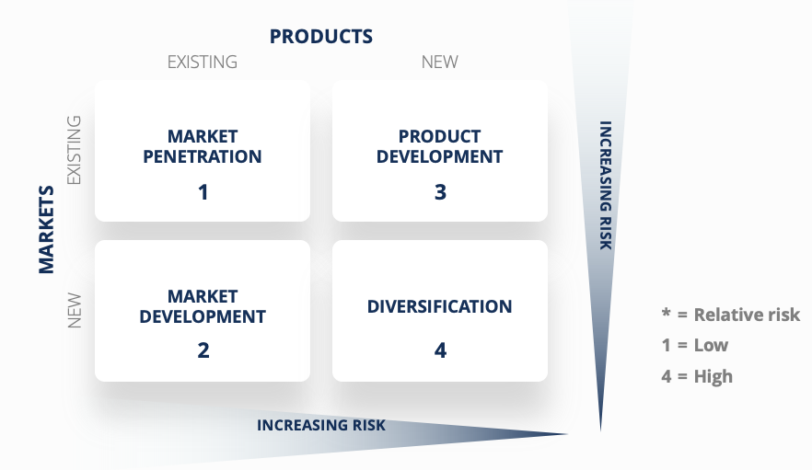
The Ansoff Matrix will be used to describe the two strategies that the Company should employ for future growth. Product development is one of the tactics, which involves introducing new items into an existing market. The group of enterprises is now selling personalised items to their consumers. They need to increase this portion of the business in the future because they have a competent engineering staff that specialises in prototypes. The corporation should concentrate on inventing and innovating things that its consumers purchase elsewhere.
The second strategy need to be diversification, which is the process of entering a new market with completely new products.
They should search for new clients both within and beyond the UK and provide them customised solutions because they already have expertise in NPD. Also, they should look for new consumers in the UK.

Conclusions

According to macro environment analysis and Porter 5 Forces, the company's best future depends on how successfully it will employ diversification and product development plans in the future.

References

- Penningtons Manches Cooper. Available at: https://www.penningtonslaw.com/international/usa/doing-business-in-the-uk. (Accessed: April 30, 2023).
- 10 marketing plan objectives to consider and the Kpis to ... - indeed (no date). Available at: https://www.indeed.com/career-advice/career-development/marketing-planning-objectives (Accessed: April 27, 2023).
- https://pestleanalysis.com/what-is-pestle-analysis/
- Jim Blythe (2006) Marketing. London: SAGE Publications Ltd (SAGE Course Companions). Available at: https://search-ebscohost-com.ezproxy.uwtsd.ac.uk/login.aspx?direct=true&db=nlebk&AN=251186&site=ehost-live (Accessed: 29 April 2023).
- Joe Weller (2017) The Definitive Guide to Strategic Marketing Planning. Available at https://www.smartsheet.com/strategic-marketing-processes-and-planning (accessed : 18 April 2023)
- Marketing implementation plan: What it is and how to create one - indeed (no date). Available at: https://www.indeed.com/career-advice/career-development/marketing-implementation-plan-example (Accessed: April 30, 2023).
- Paul Reynolds and Geoff Lancaster (2005) Management of Marketing. Oxford: Routledge. Available at: https://search-ebscohost-com.ezproxy.uwtsd.ac.uk/login.aspx?direct=true&db=nlebk&AN=130271&site=ehost-live (Accessed: 29 April 2023).
- Pereira, D. (2023) Pestle analysis: Environmental factors affecting business, Business Model Analyst. Available at: https://businessmodelanalyst.com/environmental-factors-affecting-business/ (Accessed: April 28, 2023).
- Person (2021) UK economy latest, UK economy latest - Office for National Statistics. Office for National Statistics. Available at: https://www.ons.gov.uk/economy/economicoutputandproductivity/output/articles/ukeconomylatest/2021-01-25 (Accessed: April 28, 2023).
- Peterdy, K. (2023) Ansoff matrix, Corporate Finance Institute. Available at: https://corporatefinanceinstitute.com/resources/management/ansoff-matrix/ (Accessed: April 28, 2023).
- Ray Donnelly, Graham Harrison and Phil Megicks (2009) CIM Coursebook: The Marketing Planning Process. Oxford, UK: Routledge (CIM Coursebook). Available at: https://search-ebscohost-com.ezproxy.uwtsd.ac.uk/login.aspx?direct=true&db=nlebk&AN=335994&site=ehost-live (Accessed: 29 April 2023).
- Situation analysis of a marketing plan: Example and definition (no date). Available at: https://www.indeed.com/career-advice/career-development/situation-analysis-marketing-plan-example (Accessed: April 28, 2023).
- Tech Nation's 2021 report shows a resilient UK Tech sector despite Brexit and the pandemic (no date) The UK's technology trade association. Available at: https://www.techuk.org/resource/tech-nation-s-2021-report-shows-a-resilient-uk-tech-sector-despite-brexit-and-the-pandemic.html#:~:text=The%20UK%20tech%20sector%20raised,relative%20attractiveness%20for%20investment%20improved (Accessed: April 28, 2023).

