1701466
ECAD6002
Module Lead: Gail Parker
Assignment Title:
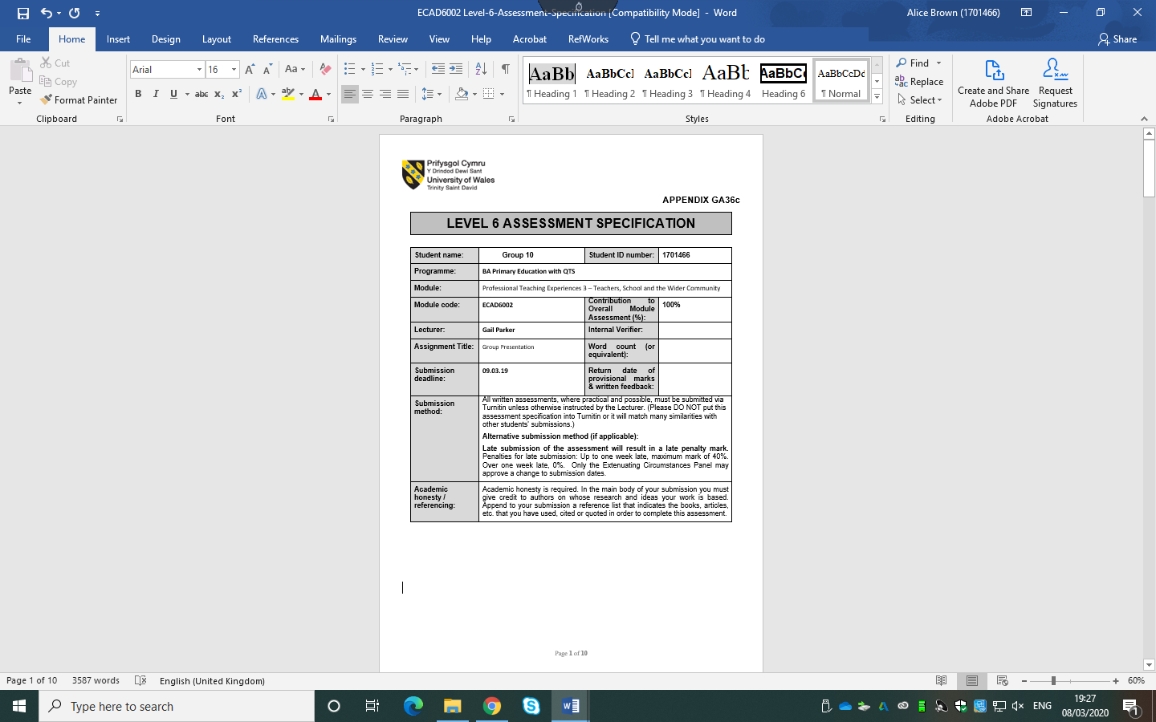
Based on school’s set of class data, present a group presentation that outlines how you would improve the pupils’ current performance, with clear rationale and justification for any initiatives or strategies.

