HILL HYDE Restaurant Bar & Grill Glasgow under Hotel Trinity Chain
Restaurant concept, audience and menu choices.

Name: Constantin-Adrian Vasiliu
Student ID: 2229175
Module: Food & Beverage Operations BMIH4002
Lecturer’s Name: Jaliya De Silva
Word Count: 394

Hello and congratulations on embarking on a new and exciting journey. The menu offered emphasises Mediterranean cuisine that has been modified to cater to a diverse range of taste preferences. HillHyde, our dining establishment, deviates from the conventional restaurant experience. The culinary expert, Chef Adrian, possessing over five years of experience in the field of reinterpretation, has meticulously curated an assortment of flavours that are bound to astound you. The ingredients utilised in our products are sourced from nearby farms and are consistently procured in a fresh state. Ever since the initiation of collaboration with us, the agricultural produce of Greenock farmers has been experiencing a surge in demand and sales. Our team is pleased to report that we have successfully restored the prestige of the former James Watt metropolis. Since the restaurant's opening, it has consistently maintained full occupancy throughout the day and night. As of present, the restaurant's reservation wait period is approximately one month, which can be attributed to the establishment's prioritisation of hotel guests. Our foremost priority is to provide excellent customer service while striving to achieve the highest level of success. We exercise great caution with regards to allergens and have meticulously created a menu that has minimal allergenic characteristics. We extend a warm welcome to individuals adhering to a vegan lifestyle to partake in our offerings. Our menu offers a variety of dishes that are crafted to achieve a high level of culinary excellence. Defined as “the art or science of eating well”, the gastronomy study is the understanding of the production and preparation of food and beverages, as well as the place, time and reason for which they are consumed (Gillespie, 2001). Our establishment attempts to provide service to all kinds of customers, ensuring that each individual is treated equitably upon entering our premises, regardless of their socioeconomic status. Our organisation maintains a strict policy against discriminatory and racist conduct, and we clearly reject any such behaviour from both our employees and customers. Our guiding principle is to provide quality service to our valued customers while also expecting mutual respect in return. The following narrative relates to our establishment, in which we cordially invite you to explore our menu, consume our specialty beverages, and enjoy in our revitalising ambiance. The experience involves a simple yet fulfilling process of arriving, observing, indulging, relaxing, and later repeating the adventure.


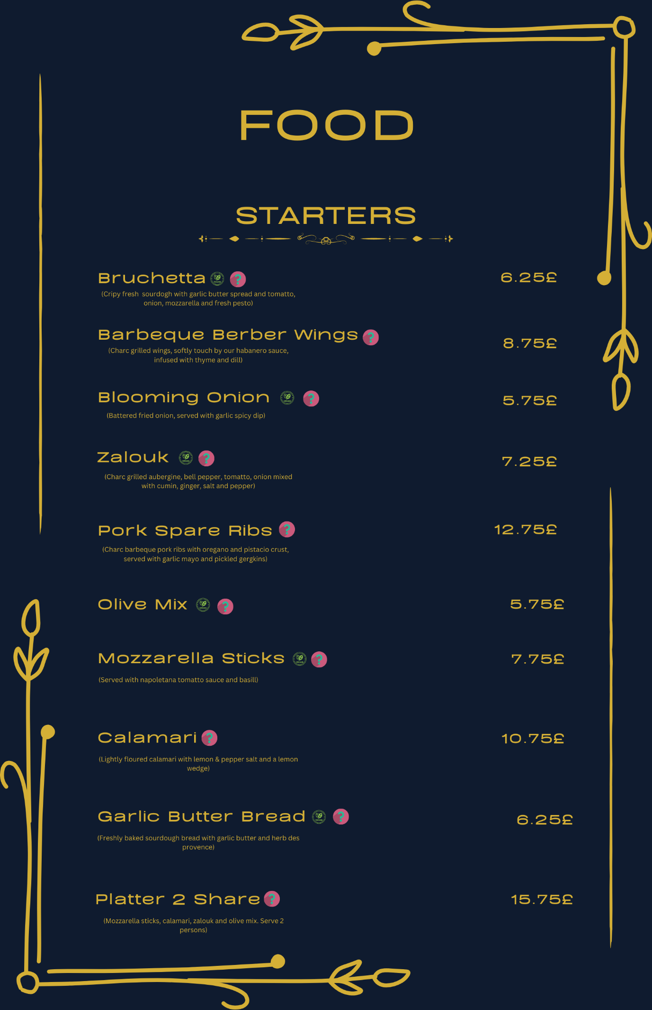
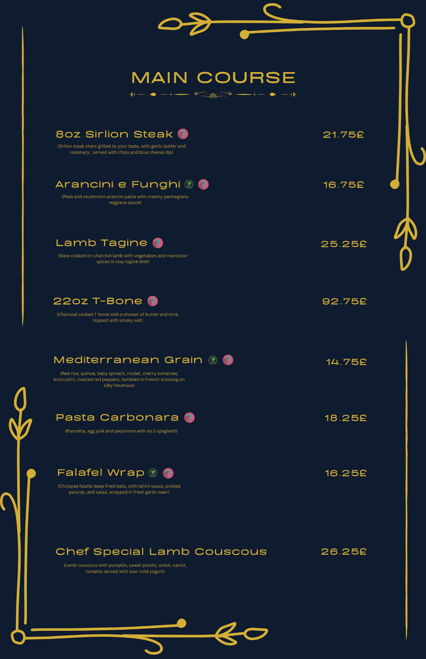

Koppelman, S.J. and Hefle, S.L., 2006. Detecting allergens in food. Woodhead Publishing Ltd.
Steinman, H.A., 1996. “Hidden” allergens in foods. Journal of allergy and clinical immunology, 98(2), pp.241-250.
Aldrich, L., 1997. Rural economic development: What makes rural communities grow? (No. 737). US Department of Agriculture, ERS.
Drabenstott, M., 2003. A new era for rural policy. Economic Review-Federal Reserve Bank of Kansas City, 88(4), pp.81-98.
Privitera, D., Nedelcu, A. and Nicula, V., 2018. Gastronomic and food tourism as an economic local resource: Case studies from Romania and Italy. GeoJournal of Tourism and Geosites, 21(1), pp.143-157.
Lang, M. and Lemmerer, A., 2019. How and why restaurant patrons value locally sourced foods and ingredients. International Journal of Hospitality Management, 77, pp.76-88.
Tuberoso, C.I.G., Boban, M., Bifulco, E., Budimir, D. and Pirisi, F.M., 2013. Antioxidant capacity and vasodilatory properties of Mediterranean food: The case of Cannonau wine, myrtle berries liqueur and strawberry-tree honey. Food chemistry, 140(4), pp.686-691.
Hermann, M., 2009. The impact of the European Novel Food Regulation on trade and food innovation based on traditional plant foods from developing countries. Food policy, 34(6), pp.499-507.
Bojanic, D.C., 2007. Global pricing strategy for a quick-service restaurant chain. Hospitality Review, 25(1), p.4.
Al-Tit, A.A., 2015. The effect of service and food quality on customer satisfaction and hence customer retention. Asian social science, 11(23), p.129.

