Internet Technology and Security
Adam Horton (1702203)

Introduction
This report will include the specific requirements of the website, the target audience and its subject matter. Also included are screen shots of the webpages and will also show validation methods used within the making of this website. Then there will be an evaluation and a reference table to show any and all information received or any sources used for help and guidance.

Requirements of the website
This website was designed for the future use of a game idea the author had for their final project within their final year. The purpose of this website is to be a gaming website specifically about the game ‘End Of The Line’. The target audience for this is not limited to age as if this were a real game anyone could by it regardless of age and its relevance to the author is a steping stone for his final project which he wishes to become a reality.

Implementation and change
Home page before 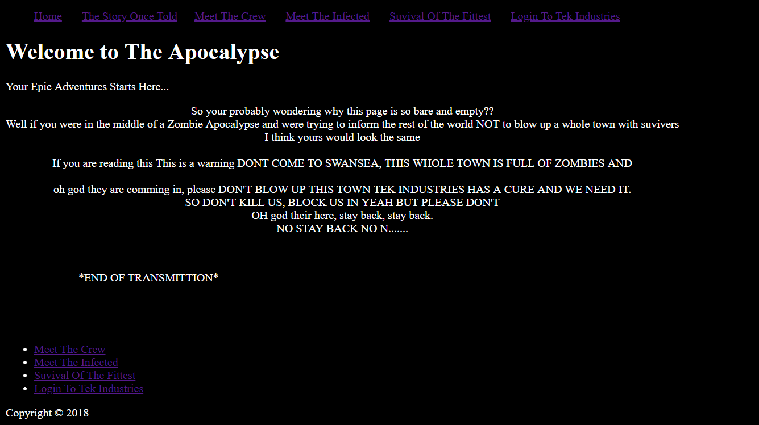
This was the original design for the website’s main page which would include basic text about what is happening within the website and would also allow for the user to move to the other pages the writer had created for this website.
Home Page After
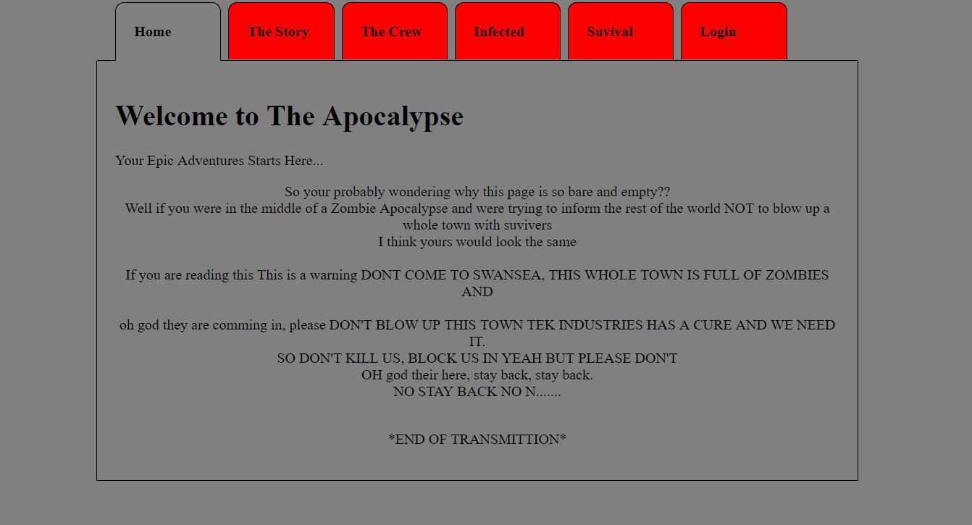
This is the new home page for the website
Meet the suvivers
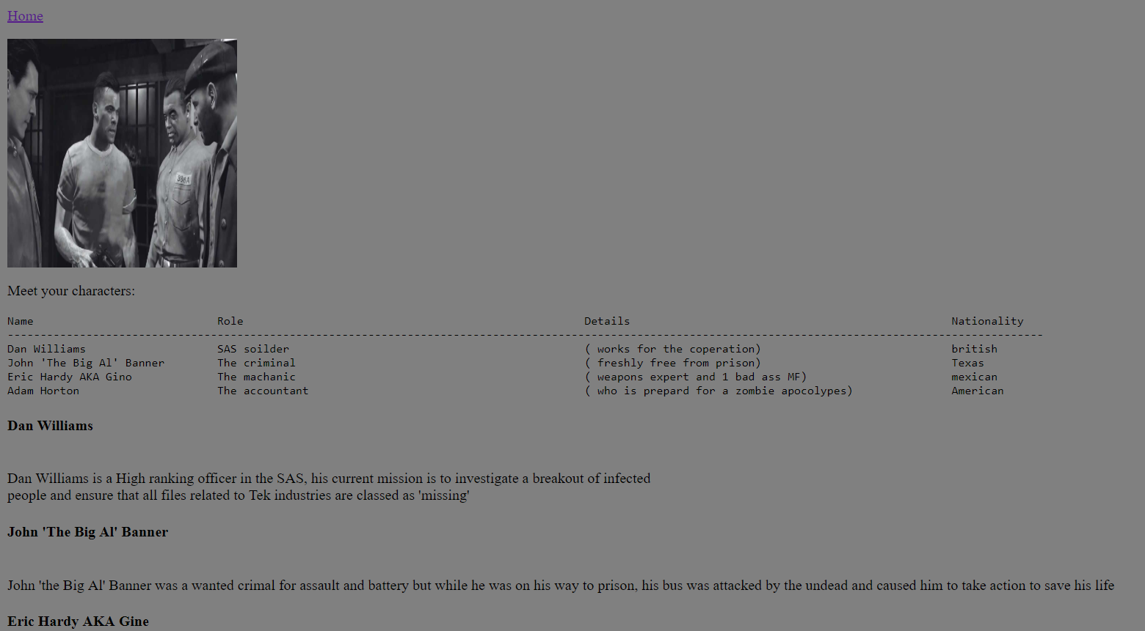
Meet the infected
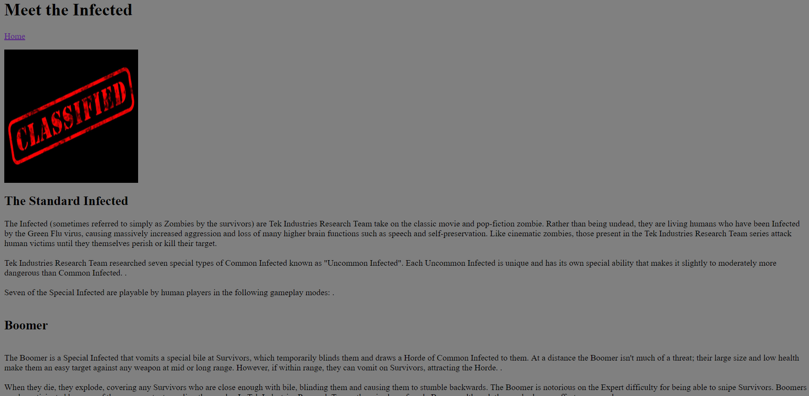
The story so far before
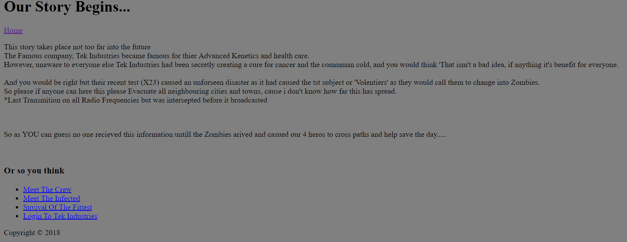
The story so far after
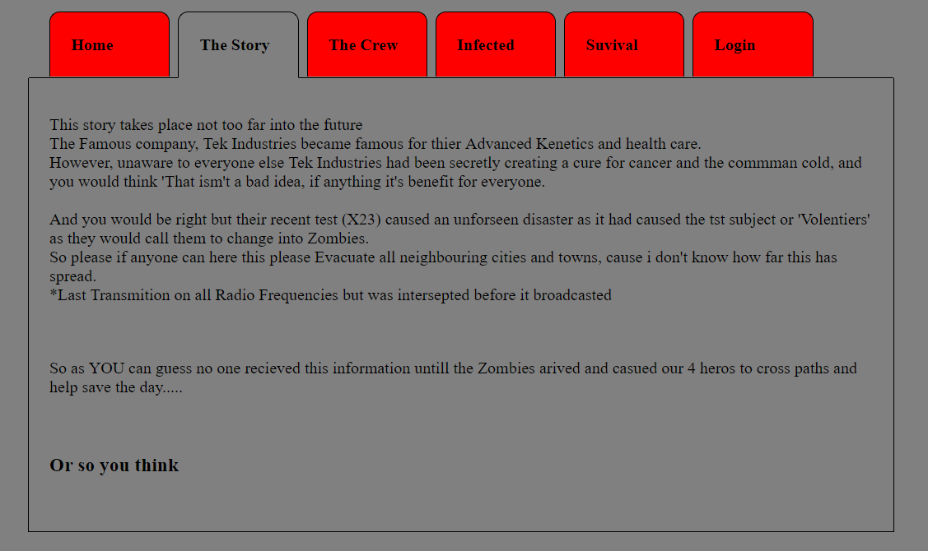

Login to Tek Industries
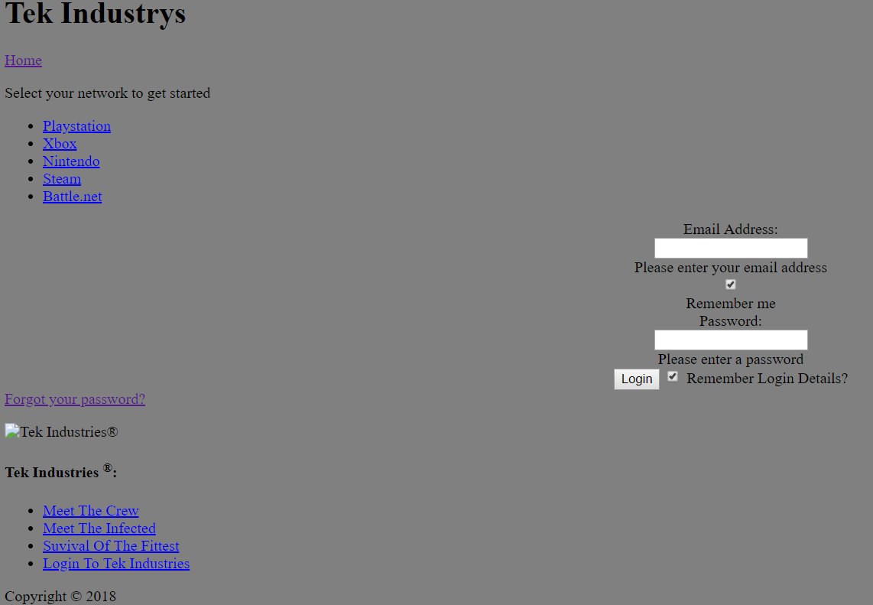
Suviving the Apocolypse
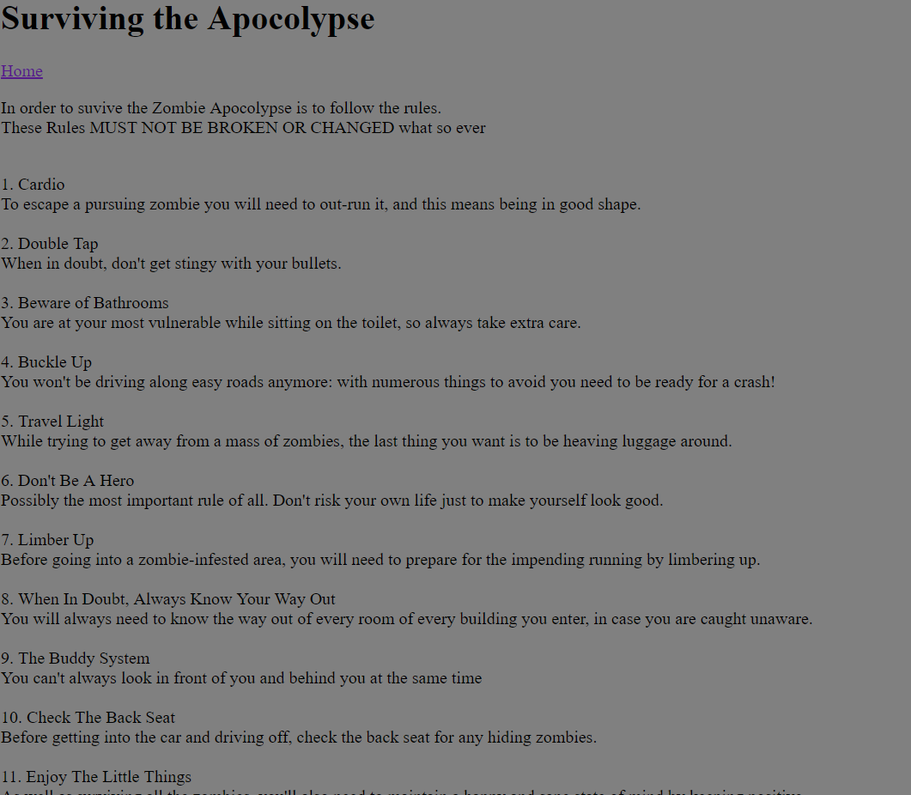
Evaluation

References

marking criteria and Student FEEDBACK

This section details the extent to which the assessment criteria are demonstrated by you, which in turn determines your mark. The marks available for each category of skill are shown. Lecturers will use the space provided to comment on the achievement of the task(s), including those areas in which you have performed well and areas that would benefit from development/improvement.

Common Assessment Criteria Applied (Assignment 1) | Marks available | Marks  awarded
1. Engagement with Literature Skills

Unfortunately, there is no evidence of the use of appropriate reference sources. The submitted work does not include a reference list or bibliography. (Grade mark: 0.00%) | 5 | 0
2. Knowledge and Understanding Skills

Demonstrates satisfactory understanding of the standards used to design and implement a website. There is, however, room for improvement especially with using CSS to improve layout and formatting. (Grade mark: 45.00%) | 20 | 9
3. Cognitive and Intellectual Skills

No evaluation of the website has been provided. As such, the submitted work does not really satisfy the requirements for this section of the assignment. (Grade mark: 0.00%) | 30 | 0
4. Practical Application Skills

A satisfactory attempt featuring a simple website. Some improvements have been made to the original submission and the website now follows a more consistent colour theme, but there is still some room for a number of improvements. See your report for additional comments. (Grade mark: 60.00%) | 40 | 24
5. Transferable Skills for Life and Professional Practice

The report is satisfactory. Aim to improve the quality of your writing and use the spelling and grammar check tool to improve the quality of your reports. (Grade mark: 40.00%) | 5 | 2

Assignment Mark (Assessment marks are subject to ratification at the Exam Board. These comments and marks are to give feedback on module work and are for guidance only until they are confirmed. ) | Late Submission Penalties (tick if appropriate) |  | 35%
 | Up to 1 week late (40% Max) |  | 35%
 | Over 1 week late (0%) |  | 35%

Note that as this is a RESIT attempt, the mark is capped at 40%.

