Integrated group Project - Vito Construction

Project A
- Build a 3 storey student residence hall in the SA1 development (seafront). Top two floors for accommodation, ground floor for multi-function
- Growing number of overseas student.

Location
- C4 (from the map given)

- Introduction
- The need - overseas student needing student residence for access to university quick, easy and convienent. To accommodate the growth of the university and overseas student.
- Location - plot C4 on the map plan. C4 the location is suitable for commuting around Swansea city centre and also convenient access to the university with 30 seconds walking distance. Shops would be ideal not only for the students but for the local people living in the area. 10-15 cars ideal for car park.
- Constraints - traffic and a security to keep an eye on who comes in and out. Pilling vibration, can cause damage, vibration monitoring system to ensure the vibration is always kept to a minimal. Built up areas. Restrictions on deliveries. Building next to a seafront and loads of water. If piling is required - risk to existing buildings, dock walls.
- Ground Investigation - pollution. Ground water. Boreholes. Contaminants. Understanding the soil profile to choose what foundations to go with. Drainage systems and where the gas mains are running through.
- EIA - environmental impact assessment - dockers and pollution. Local materials. Wildlife. Materials transported from different location. Using green transport for different materials. If something went wrong what preventions are there. Noise
- Feasibility study - (leave this to Nathan to get back to us). Tackling risks and problems such as cars coming in and out.
- The aims and objectives along with a thesis -
Take a photo of the site and put it into the plan.

Contents page

1.0 Abstract………………………………………………………….page 3
1.1 Introduction……………………………………………………..page 3
1.1.1 Location……………………………………………………page 3
1.1.2 Constraints………………………………………………...page 4
1.1.3 Ground Investigations………………………………….....page 4
1.1.4 Environmental Impact Assessment……………………..page 5
1.1.5 Aims And Objectives……………………………………..page 5
References……………………………………………………….page 6

Vito Construction LTD

Proposal For a Three- Storey Student Residence Hall in the SA1 development (Seafront).

1.0 Abstract

This group proposal is an indication of more overseas students wishing to attend university, therefore it is essential there are more Halls of Residence for these individual students to stay in. The new three- storey building will allow two floors to be occupied for the students all designed with En-Suite. The ground floor will be used as a multi-function floor which will have a reception desk, shops and little booths for the students to sit down and do any work and to socialise along with other required essentials for the student to feel welcome and to go there if they need anything. Furthermore, it is vital to always keep in mind the rental income and ensuring that it will reach maximum income from each student, it would need to be reasonable otherwise students can have difficulty renting and may lead to debt so their circumstances will be taken on board. The rooms will all be a suitable size and be modern with good aesthetic appearance and not too plain.
Figure 1. showing the plot C4 where the student resident building is going to be built.
1.1 Introduction

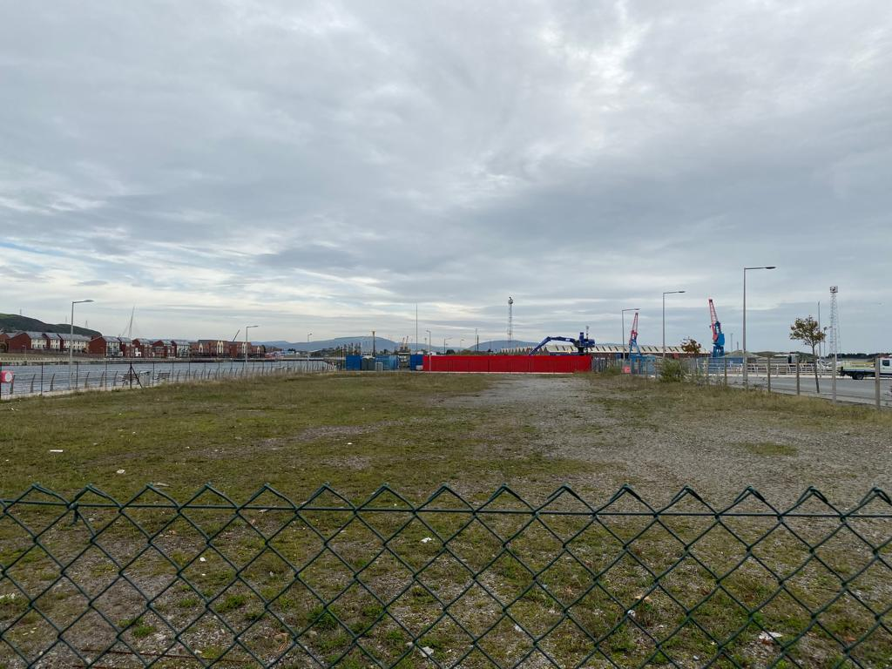
The purpose of this development from our company is to provide accommodation along with social aspects to overseas student who wish to study in the SA1 UWTSD campus. The development will match the needs of the student so there is quick, easy and convienent access to the university additionally to the city centre of Swansea.

1.1.1 Location

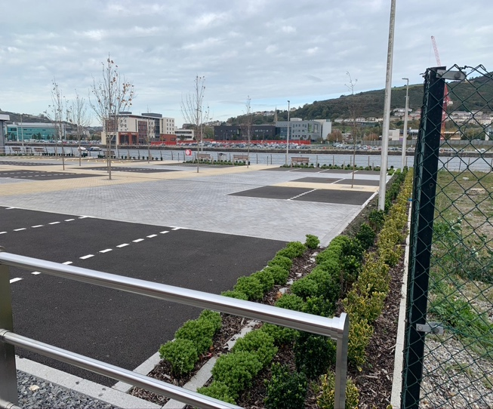
The location for this specific build will take place on the plot C4 which we have discussed and thought thoroughly about. Main benefit is that it is walking distance to the SA1 campus only a couple seconds away which is really cost effective, also car park spaces are available for the shop workers, receptionist and any other customers wishing to purchase from the multi shop floor. The multi-shop floor would be both beneficial for the students and the local residents in the area for their everyday convenience. The small car park will be ideal for 10-15 cars, security measures will also be put in place allowing 24/7 visuals ensuring the cars are safe.
Figure 2. The image represents the car park spaces besides the building, which will be used for various purpose as mentioned.

1.1.2 Constraints

With every construction plan and building there will be constraints as nothing is perfect but we do our best to reach a perfection level here at Vito Construction. The main key points we have identified for the constraints that may arise in this project are as follows. Firstly, the pilling vibration can cause damage to the underground earth, therefore using vibration monitoring system to ensure the vibration is always kept to a minimum. Secondly, built areas can restrict deliveries but choosing a time which traffic will likely to be less will rectify this constraint. Thirdly, building next to a seafront with loads of water this can easily affect the soil underground which we are working with, therefore getting samples and understanding what the soil parameters are and checking whether it meets the requirements or not. The water can additionally affect settlement, which means the water may need a temporary block off just for further safety and once done the extension block off can be removed and water can be of no issue. Finally, if pilling is required, it can be risks to existing buildings nearby and also the dock walls, therefore we will have a comprehensive findings and look into each detail of the ground and understand what stages to take into tackling each section as a team.

1.1.3 Ground Investigations

The ground which we will work on needs to meet various requirements which we will have set out. We do our best to be as sustainable as possible and go the extra mile to protect the environment and re use as much as possible. Ensuring that the ground investigation is thoroughly done, the budgeted cost can be saved as the contractors can see an issue before it becomes costly. Brown belt land which was previously used as industrial land and is more than likely to be polluted. Before any work is carried out, the first phase of a ground investigation is to do a desk study. This allows development of any initial ground model known as a conceptual site model. The desk study can allow you to understand any risks that can be posed to the development from either current or previous contaminant uses and the geotechnical or environmental hazards of the site and its surrounding area. The information which is normally sourced during this process are as follows
- Past land use
Figure 3. picture shows ground investigations taking place during early hours of the morning.
- Mining activity
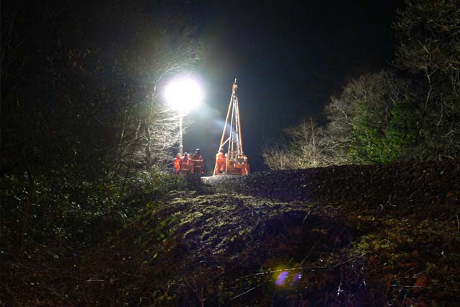
- Land stability
- Pollution incidents
- Historic map review
- Geological and hydrological setting
- Walkover survey
- Ground investigation recommendations
- Radon category
- Groundwater designations
- Unexploded ordnance
- Conceptual site model
- Topography
- Archaeological setting
1.1.4 Environmental Impact Assessment

Ensuring that the noise of work causes less of a disruption to the local residents along with the wildlife. As there will be very expensive equipment and pilling machines which do tend to give out a loud disruption, but going around and speaking to the local residents about the project and how long the estimated time to construct this building to finish is key as we are reassuring the residents. The docks will not be affected by this build and we will do our best to keep out of their traffic congestion and do our work with minimal disruption. With the idea of using green transport is to be as efficient and environmentally friendly as possible, and getting materials from different locations ensuring quality upon delivery. There will always be other methods and prevention when something may not work and we will always carry back up plans and support. VITO Construction Ltd take great pride in the environment and use up as much materials as possible without wasting time and capital invested. Ensuring to save as much money as possible and not skipping important investigations of the land as it could lead to more financial problems if they weren’t checked. The local residents will complain about the noise disruptions however always need to give them reassurance and notify them of timescale to complete project. The Town and Country planning (EIA)(England and Wales) regulations 2015, states that planning applications need to do an EIA before any large scale of work.

1.1.5 Aims And Objectives

Our company VITO Construction Ltd main aims and objectives are;
Aims

- To provide accommodation for overseas student with their needs met.
- To be sustainable with every project we do.
- Maximising rental income, bearing in mind each room will require an En-suite.
- Ensuring that there is space and access for users and delivery.
- Top security measures are put in place.
- Making sure the ground earth is suitable and won’t cause disruption to local residents and businesses nearby.
- Making use of the land as much as possible and not wasting, we at Vito Construction take great pride in our land and resources.

Objectives

- To finish an overseas residential accommodation with extras to fit their taste and requirements near the university.
- To be sustainable with the equipment and materials which are used.
- To ensure health and safety is met and that all risk assessments are in place.
- Local residents are happy with the development and minimum disruptions are caused.

References

Figure 1. picture was taken on 30th October 2019. Used in the introduction page 2.
Figure 2. Image taken on 30th October 2019. Used in the introduction page 2.
Figure 3. picture used from this website to illustrate ground work investigations
Page 3. https://www.soils.co.uk/item/73-ground-investigation.html [accessed on 12/11/19].

