EFFECTIVE TEAM WORKING AND COMMUNICATION
NILIMA BEGUM ID: 2027887

REPORT

Miss Joy Botu

CONTEXT

- Introduction………………………………………………………………………………………3

- Main body………………………………………………………………………………………4

- Conclusion………………………………………………………………………………………9

- Reference…………………………………………………………………………………….10

INTRODUCTION
Communication Skills
Definition of communication skills is to convey information and thoughts to one person to another that is done effectively and efficiently, in the workplace people should be able to communicate verbally and have good written communication skills to share information between people in the company this will facilitate and benefit the company. How we speak or even what we say plays an important role in communication. Good communication skills are making sure your message is heard and understood properly and making sure your message is moved to action by another person. Good communication can help to prevent any loss to the business, which is a very important aspect in the workplace.
Lack of knowledge and communication amongst the employees can lead to negativity at the work especially when people do not have the information or knowledge that is required, this can lead to employees to show low productivity at work as a result this will show a big impact to the company. The reason is people tend to sidestep situations in which they will be seen as not knowing or not understanding, or not having the required skills for the job. Nobody wants to look like they do not know the job task. Also, the fear of being embarrassed or mocked at work by other work collegues. Bad communication at work can lead to problems and loss for the company (Grossman, 2020).
Communication by its very nature and in its various forms corresponds with many important issues such as confidentiality, confidence, reality, effectiveness, understanding communication is important because it directly impacts all aspects of life, including human and technology.

MAIN BODY
Models of communication
Shannon and weaver (1948/49) model of communication
Shannon was a mathematician and weaver was a scientist, both of their theory later become known as Shannon and Weaver model of communication they wrote an article on mathematical theory of communication or mother of all models. Communication is very important it is the key to understanding the message between two people, the new generation that are using telephone and internet don’t have to wait days weeks or month to receive information or message.
The concepts in Shannon Weaver model

INFORMATION SOURCE, is the sender who chooses the channel and sends the information

TRANSMITTER, is the encoder the transmitter which converts the message into signals

CHANNEL, air waves or cable

RECEIVER, decoder

NOISE, the messages are transferred from encoder to decoder through the channel if the message is distracted by noise, it will affect the communication and the receiver may not receive the correct message

SIGNAL RECEIVED SIGNAL, destination where the receiver receives the message.
Shannon developed the theory to progress understanding of communication with the telephone and ultimately develop the quality of phones and noise.

Case study of Maria and Pedro
Maria and Pedro explain how noise can make communication difficult when speaking to each other and that the outside noise made it difficult to receive the correct message. Pedro was working in the building site and Maria, his wife, called Pedro to bring chicken on way back home after work, Pedro replied okay but without understanding the full text of the message, when Pedro got home, he went straight to the kitchen. When Maria asked where the chicken is, Pedro was confused he said you asked me to go in the kitchen when I come home, that is when they realised the confusion. The Shannon and Weaver model of communication explains how there can be a confusion when noise can change the message. Maria should have checked the feedback of the conversation, and this way they both would have understood the message. Schramm’s model of communication (below) explains how it can be avoided.
Schramm’s Model of communication
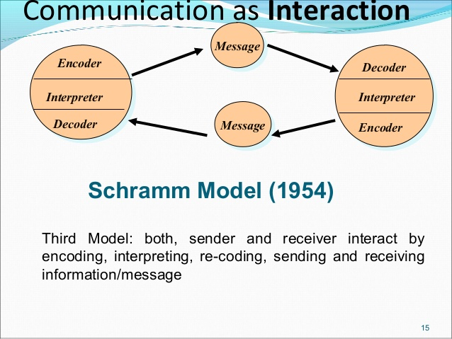
Wilber Schramm came up with the model of communication in 1954. Compared with the Shannon Weaver Model, he highlighted more on the significance of communication concerning the sender and the recipient. The sender encodes his thoughts into content and sends to the recipient. The recipient receives the message and tries to understand the meaning the speaker intends to convey which is called decode message. Then the receiver must give feedback to the sender to show how he understands the message. Therefore, the sender can explain more about his thoughts if the receiver can’t get the right meaning. The full circle is incomplete unless the sender receives the feedback from the receiver. And encoding and decoding are the two essential parts in effective communication. And the communication can become clearer because the sender can give more clarification based on the recipient's understanding of the message. Schramm's model of communication emphasizes on the encoding and decoding of the meaning, especially the decoding part. Only the recipient decodes the message and sends the feedback to the sender and the sender explains further to improve the conversation if the conveyed meanings can't be understood by the receiver. Thus, the whole circle of communication can be complete (Lin, 2022).
Schramm’s model helps us to articulate what happens in communication especially in the learning environments, sometimes feedback can be negative due to the noise.
Case study of THE PROFESSOR and THE VILLAGE PEOPLE
The well-known professor who worked in the Welsh University didn’t live very far from the village. He did his shopping when he went to the local town, he had nothing in common with the village people who the majority were uneducated and mostly worked manually. They never met each other. One evening the professor fell asleep while smoking his pipe, his pipe fell to the carpets and the carpet caught fire. When the professor woke from the smoke and fire, he started running to the village people shouting, “The edifice is being consumed by a great conflagration!” but the village people just looked at the professor confused, and they did nothing.
The next day, the professor went to the village again and he asked the villagers, “I was asking for your help, why didn’t you help me? My house caught fire, and everything got destroyed.” The villagers said, “Professor, why didn’t you say that your house is on fire? We then could have helped.”
The villagers didn’t help the professor because he was speaking a different language and there was a different language barrier. The professor should have spoken in simple words. Berlo’s model of communication (below) explains the professor and the villager’s situation as well as the social system.
BERLO’s SMCR Model of communication
David Berlo 1960

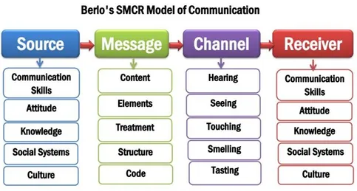

David Berlo’s SMCR Model of Communication

David Kenneth Berlo wrote the book, The Process of communication. Berlo’s Model of Communication has been described in his book as he focused on the purpose of communication. His model observes on verbal and non-verbal communication. His model also considers the emotional aspect. This model is used in newspapers, television, magazine advertisements, social media, and other forms of communications.
“The prime goal of communication was persuasion and attempt to sway other men to the speaker’s point of view,” (Berlo,1960).
The four Elements of Berlo’s model of communication
- Source
The source means the message’s sender who initiates the communication process by sending information to the Receiver. David Berlo describes five factors related to the source: Communication, Skills, Attitude, Knowledge, Social Systems, and Culture.
- Message
The message is when an individual converts his thoughts to a message then a message is created this process is also called encoding.
- Channel
The channel is the medium of how the information flows from the sender to the recipient the five senses are the channels which can help a person to communicate with each other.
- Receiver
The receiver is when a message is sent to the receiver, he attempts to understand the message. This is also called decoding.
There have been many criticisms in this model. Firstly, there is no feedback in the Berlo’s model of communication. Secondly, it does not mention about the barriers of communication. Lastly, there is no room for noise. This is a complex model because it is a linear model for communication, this model only needs people to be on the same level for communication to occur (Kobiruzzaman, 2021).
Case study at the workplace
The GP surgery
The work environment at the GP surgery is always busy. Most patients come in the surgery with many requests, sometimes for prescriptions or to see the doctor. The surgery has a baby clinic which is two days every week. Those days can get busy, and I do a lot of overtime at the clinic. Majority of the patients in this practice are from an ethnic minority community, mostly the Bangladeshi community. Patients find it hard to communicate with the English-speaking staff at the reception because of the language barrier and cultural differences. Patients were finding it hard to communicate and getting the service they need. After the feedback from the angry patients, the practice manager had to employ two interpreters to help with the communication in the surgery. The Berlo’s SMCR model of communication helps demonstrate this as the model understands the culture and social system.
Case study Barry and communication Barriers
Barry is a middle-aged manager in a very busy restaurant in the town of Wales. His work tasks are to supervise and manage the kitchen staff. All the employees are of different ages from 16 to 55 years old. The staff in the kitchen are from a diverse culture and different ethnic backgrounds. English is not the first language for them therefore Barry is finding it hard to communicate with them.
Barry is a qualified food and safety officer and is aware of the importance of hygiene by keeping the place clean and sanitised. He understands the importance of handling food safely. Most of the staff have some to little training in food safety so they are not doing their job properly. The owners of the restaurant know and understand the importance health and safety. If is not met by the health and safety inspectors and if it is found not to be in the standards required, they could be out of business. Barry has made many efforts to give them information on the importance of food safety. He has put up large signs over the kitchen wall such as ‘KEEP HOT FOOD HOT AND COLD FOOD COLD’ signs and ‘WASH YOUR HANDS OFTEN.’ Staff are given thermometers to check the food temperatures. Staff need to do the full food health and safety training; Barry needs to put up information of food safety in different languages as this will help educate the staff of the food san safety and hygiene requirements.
CONCLUSION
The outcomes of the studies show that the application of communication theories is very essential in every aspect of our communication and that all the models are very important. The Shannon and Weaver Model of Communication, Schramm’s Model of Communication, Berlo’s SMCR Model of Communication are well recognised in the world and used in all forms of communication in work and businesses furthermore in our social system.
The speaker must have a good communication skill he must put his thoughts in words, this is called encoding, similarly if the receiver cannot grasp the message, then the communication will not be effective. The speaker must be clear and accurate on the message from beginning to the end.

REFERENCES

Grossman, D., 2021. 4 Main Problems That Come with Poor Communication. [online] Yourthoughtpartner.com. Available at: <https://www.yourthoughtpartner.com/blog/4-main-problems-that-come-with-poor-communication> [Accessed 25 December 2021].

Kobiruzzaman, m., 2022. SMCR Model of Communication- Berlo's SMCR Model of Communication. [online] Newsmoor.com. Available at: <https://newsmoor.com/smcr-model-of-communication-david-berlos-smcr-model-of-communication-example/> [Accessed 5 January 2022].

Lin, x., 2022. [online] Atlantis-press.com. Available at: <https://www.atlantis-press.com/article/125936954.pdf> [Accessed 4 January 2022].

