Title: Personal Reflection

Name of the student: Nikol Bekirska
Student Number: 2023248
Module Title: Professional Career Development
Module Code: BMSW4005
Lecturer’s Name: Soban Sadiq

Executive Summary
In this report, a bright idea has been provided about entire planning process for enhancing the career development plan. This report also comprises of a personal SWOT analysis for analysing the strength and areas for future development. With the help of personal development plan, it has become easier to identify the employability goals for a particular job option. In this report, major focus has been made upon the personal skills gaps and the future career goals.

Table of Contents
Introduction 4
Recruitment and Selection (Personal Reflection using Gibbs Reflective Cycle) 5
Personal SWOT Analysis 7
Personal Development Plan 9
Conclusion 11
References 12
Appendices 13
Appendix 1: Job Application Form 13
Appendix 2: Interview Questions 16

Introduction
This report comprises of a personal reflection. This reflection is based on career development planning and roleplay. This role play mainly discusses about the role play which has taken place between an interviewer an interviewee. In this role play major focus has been laid on an interview process which is conducted for the post of an event manager within an organisation. Moreover, in this report a bright idea has been provided about entire planning process for enhancing the career development plan. However, Gibbs reflective model has been used for providing the personal reflection on career development planning and role play. This report also comprises of a personal SWOT analysis for analysing the strength and areas for future development. It also includes a personal development plan for analysing the future goals.

Recruitment and Selection (Personal Reflection using Gibbs Reflective Cycle)
Description: In this role play, major discussion was between an interviewer and an interviewee. I was playing the role of an interviewee in the role play. The main objective of conducting this role play was to determine the importance of career development planning. This interview was basically conducted for the role of an event manager (Aguinis, and Gabriel, 2021). Through this role play, I came to know that there are certain employability skills which should be present within an individual in order to get selected within a particular job. My experience in this entire roleplay was very much excellent. I had come to know a lot about the ways in which an interview is conducted and how to answer the questions presented by the interviewer.
Feelings: In the entire interview process, I was feeling very much nervous as well as excited. Whenever a question was asked, I was answering then confidently and patiently. From this role play I came to know that it is very essential to become calm and confidence at the time of answering the questions in the interview process (Alharahsheh, and Pius, 2021). I have understood that one of the ways through which an interview can be cracked easily is through confidence and smartness.

Figure 1: Gibbs Reflective Cycle
Source: (Escalante, 2020)
Evaluation: After taking part in the roleplay, I have analysed that there were certain positive as well as negative experiences which I have gathered through this role play. Some of the positive experiences involves gathering experience and knowledge regarding conduct of interview process. The interviewer was asking me questions slowly and was very kind to me. This was one of the good experiences in the entire roleplay. There were certain situations in the role play in which I was unable to understand the question (Ayala Calvo, and Manzano García, 2021). In this case my interviewer was very gentle and kind in helping me to understand the question. On the other hand, there was certain negative experiences which I have gathered through this role play. At the time of the interview process, there were three to four members. At the very beginning I was mumbling. This has created a negative impact on my image in front of the interviewer.
Analysis: After the entire role play, I was feeling very lucky that I had got an opportunity to witness and became a part of an interview process. This entire process has helped me to make the best use of the opportunities and to analyse my career opportunities effectively (Lejeune, et al.,2021). This was one of the most essential steps in my personal as well as professional development. I also believe that I could have made the best utilisation of this opportunities if I had good communication skills and management skills.
Conclusion: From this entire experience I have gathered a lot of understanding and knowledge about the conduct of an interview process. This role play has helped me to analyse my strengths and weaknesses and to determine the necessary areas for future improvement. I came to know that some of the duties of an event managers are- to plan an event from the beginning to the end, manage budget for the event, perform all the responsibilities relating to sponsorship negotiations, manage and control logistics and to select event locations, determine the best marketing plan for the event, manage all the activities relating to organising virtual events.
Action Plan: If I get this opportunity again, I will try to overcome all the problems which I had faced. I will try to be much more confident and develop an interactive connection with my interviewer. Moreover, I will also focus on analysing each and every question effectively and then providing answers to those question in the interview process (Pieper, et al.,2021).

Personal SWOT Analysis
I am a professional Event Manger. I have worked in reputed event management houses in the last 3-4 years. I have come as an applicant for getting the post of event manager in your company. I have professional qualification in Event Management. I have done my qualification in Event Management from the School of Event Management in UK. 5 months on the job training as an event manager in a reputed organisation. Some of my qualifications include- BBA in Event Management (3 years) Graduation degree, Diploma in Event Management (1 year) Diploma Course, PG Diploma in Event Management (1 year) PG Diploma Course. I am looking for good career opportunities and to get maximum scope in the event management industry.
Strength | Weakness
There is certain strength which are present within me. I am a good interactor and communicator. I can easily understand each and every situation effectively and efficiently (Pitts, 2021). I have the ability to manage time effectively and to achieve all my goals within the time period. There are certain leadership skills which are present within me. This helps in making me a good supervisor and guide for my team. I have a lot of technical knowledge and skills for handling technical work. Moreover, the presence of creativity and innovation helps me to implement my work effectively and successfully. There are certain skills which are present within me. These skills are –interpersonal skills, time management skills, problem solving skills, customer services skills and creativity skills. | Some of the weaknesses which are present within can be explained as follows. I have certain weaknesses in terms of lack of patience level. There are certain situations in which I lose my patience and the things become worse for me. Moreover, I start overthinking when multiple tasks are allotted to me. I believe that there are various situations in which I face problem in taking quick decisions. I also feel certain problems in taking appropriate decisions. This acts as a negative aspect in my personal and professional development (Schmidt, et al.,2021). Moreover, there are certain situations in which these decisions act adversely. I have also understood that I have limited knowledge about the market conditions. This acts as a negative side of my career development plan.
Opportunities | Threats
There are certain opportunities which are enjoyed by me as a result of my strength. I believe that I have a good academic background which makes me much more preferred as compared to other applicants in the job interview (Ayala Calvo, and Manzano García, 2021). I also analysed that I possess certain good interpersonal skills which helps me to interact with my superiors effectively. This helps in developing good relationship with my colleagues and it helps in the timely achievement of the organisational goals. I have applied for different job because of the wide range of growth and career development prospects which can be enjoyed by doing those job. Moreover, I have a good knowledge and past experience in this field. This experience can contribute towards the growth of the organisation in the future. Previously, I had worked in ABC Event House in the post of an Event manger. I had worked in that organisation for 3 years. In that job I had to organise an event and manage the budget for the event. This has increased my management skills and budgeting skills. | There are situations in which my weaknesses create a threat for me in my personal and professional development path. One of the major threats is related to extensive amount of competition prevailing in the employment market. Moreover, there are new skills present within an individual. I have observed that my lack of knowledge about the current market also acts as a threat for me (Scott, and Willison, 2021). Certain measures are undertaken for the purpose of overcoming these weaknesses.

Personal Development Plan

Goals | Skills I have | Skills level |  |  |  |  | Skills to be developed | Time required | Actions undertaken
Goals | Skills I have | 1 | 2 | 3 | 4 | 5
To develop good idea about the market. | I have good communication skills (Tan, et al.,2021). |  |  |  |  |  | Good leadership skills. | Time taken is 4 months. | I will try to read the newspaper daily.
To solve all the problems effectively. | I can take quick decisions. |  |  |  |  |  | Good managerial skills. | Time taken is 6 months. | I will analyse each and every situation effectively.
To manage all the activities with the team effectively. | I have the ability to manage time. This skill is required because it will help me to increase and sharpen my knowledge about the event management process. I will get to know a lot more ways for generating creative and innovative ideas by working for your company. |  |  |  |  |  | Presence of creativity skills (Williams, et al.,2020). | Time taken is 4 months. | I will allocate the work among my team members for effective management of the team. For manging a group of people within my team I try to allocate roles and responsibilities to each and every member. This helps me in managing my team of people effectively.
To provide proper motivation and support to my team members. | I can critically analyse every situation (Varlejs, 2017). |  |  |  |  |  | Develop employability skills. | Time taken is 2 months. | I will provide constant encouragement and motivation to the team members. This will help me to achieve the team goals effectively and smoothly.
Interpretation: I want to become an Event manger because of my passion and creative skills. I can manage difficult situations effectively. Moreover, I have the capacity to organise and manage a big event. There are some interpersonal skills which are present within me which makes me a good event manager as well as an event organiser. For the event management process my basic motto is to make the best use of creative in organising an event. I always follow the principle of customer satisfaction by providing them best quality services and output. Hence from the PDP it can be analysed that my main goals are to generate new and effective ideas. I will try to manage all the activities within my team smoothly. Moreover, my major focus will be to provide necessary support and guidance to my team members. This will play an essential role in the timely achievement of the organisational goals. I will also focus to apply necessary plan of action for taking effective and timely decisions. This will help me to analyse each situation effectively. These goals play a very essential role in the personal as well as professional career development path.it has been observed that all the goals are achieved within the respective time period.

Conclusion
From this report, it can be concluded that, a proper plan of action should be prepared in advance for the purpose of development of career path. However, it is important that there are certain employability skills which should be present within an individual. These skills play a very essential role in discharging the duties within the organisation smoothly and effectively. With the help of personal development plan, it has become easier to identify the employability goals for a particular job option. In this report, major focus has been made upon the personal skills gaps and the future career goals. An effective personal reflection has been clearly understood by giving examples of own experiences in the role play and for career development planning process. This report also comprises of a personal SWOT analysis for analysing the strength and areas for future development.

References
Aguinis, H. and Gabriel, K.P., (2021). If You are Serious About Impact, Create a Personal Impact Development Plan. Business & Society, p.00076503211014482.
Alharahsheh, H.H. and Pius, A., (2021). Exploration of Employability Skills in Business Management Studies Within Higher Education Levels: Systematic Literature Review. Research Anthology on Business and Technical Education in the Information Era, pp.1147-1164.
Ayala Calvo, J.C. and Manzano García, G., (2021). The influence of psychological capital on graduates’ perception of employability: the mediating role of employability skills. Higher Education Research & Development, 40(2), pp.293-308.
Escalante, K., (2020). Lesson Plan Template.
Lejeune, C., Beausaert, S. and Raemdonck, I., (2021). The impact on employees’ job performance of exercising self-directed learning within personal development plan practice. The International Journal of Human Resource Management, 32(5), pp.1086-1112.
Pieper, M., Roelle, J., vom Hofe, R., Salle, A. and Berthold, K., (2021). Feedback in reflective journals fosters reflection skills of student teachers. Psychology Learning & Teaching, 20(1), pp.107-127.
Pitts, R.T., (2021). Pinpointing Where to Start: A Reflective Analysis on the Introductory Evaluation Course. Canadian Journal of Program Evaluation, 35(3).
Schmidt, M.C., Pryser, E.A., Baumann, B.C., Yaqoub, M.M., Raman, C.A., Szentivanyi, P., Michalski, J.M., Gay, H.A., Knutson, N.C., Hugo, G. and Sajo, E., (2021). Development and Implementation of an Open Source Template Interpretation Class Library for Automated Treatment Planning. Practical Radiation Oncology.
Scott, F.J. and Willison, D., (2021). Students’ reflections on an employability skills provision. Journal of Further and Higher Education, pp.1-16.
Tan, L.M., Laswad, F. and Chua, F., (2021). Bridging the employability skills gap: going beyond classroom walls. Pacific Accounting Review.
Varlejs, J., (2017). Shape your career-design your professional development plan: rationale and workshop template.
Williams, D., Cox, L.A., Ofori, E., Louvet Sr, M., Nino, M.M. and Cui, A.G., (2020). Course Development Plan Template.

Appendices

Appendix 1: Job Application Form
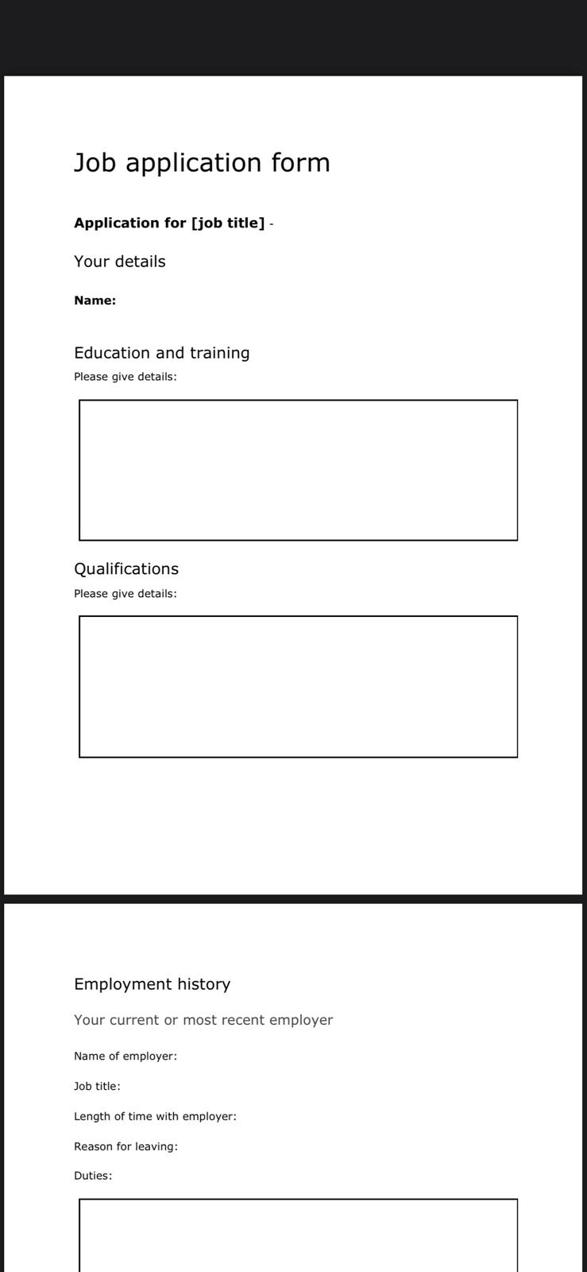
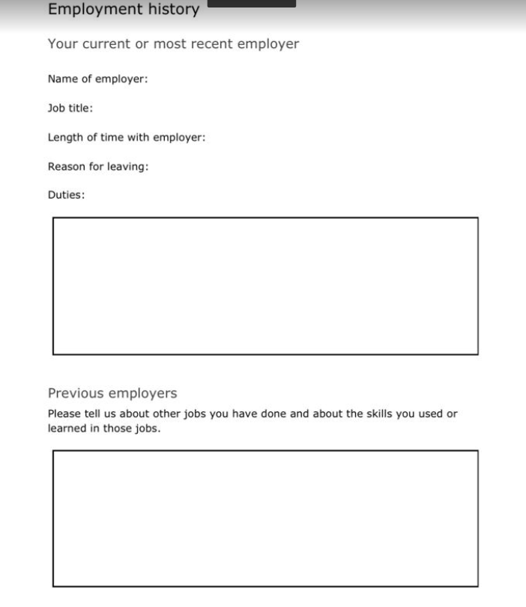

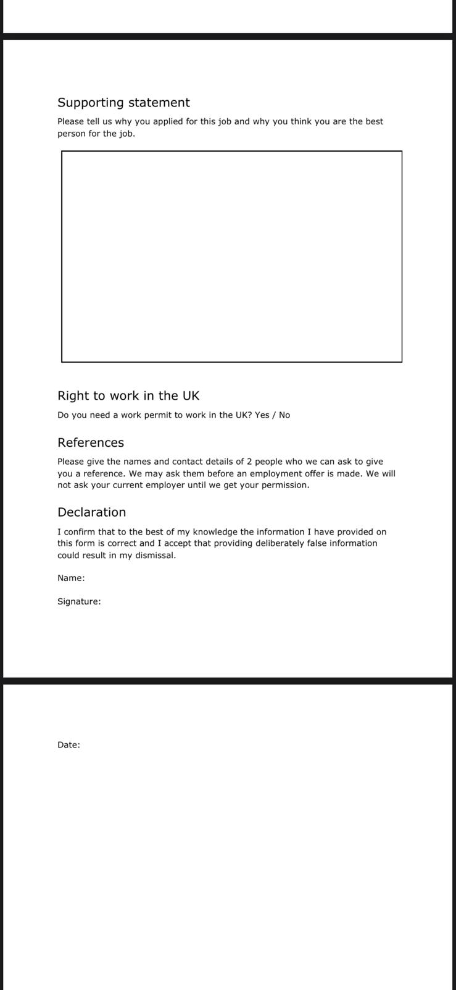

Appendix 2: Interview Questions


