Title: A comparison of the marketing methods of the two multinational hotel chains (Six Senses and Holiday Inn)
Student Name: Shila Laskar
Student ID: 2245345
Module Title: Marketing Essentials BMIH4005
Lecturer: Gayathri Nadeeshani Senanayake Mudiyanselage
Due: 19th May 2023
Word Count: 1572

In business activities, the role of marketing is beyond description. Marketing is the process by which companies make their products known to potential consumers. Kotler and Keller, (2016) stated that marketing is a two-way process that includes creating value for the customer and building strong bonds with the customer so that the business, in return, can earn value from the customer. In this context, this writing will present how the two brands ‘Holiday Inn’ and ‘Six Senses’ make themselves useful to satisfy their customer’s needs and how they build relationships with their customers to make a profit. InterContinental Hotels Group (IHG) owns both the ‘Holiday Inn’ and ‘Six Senses' brands and categorises them differently (InterContinental Hotels Group, 2023). Two assorted brands are always distinctive in terms of name, design, symbol, or any other feature that give them a separate identity from each other (American Marketing Association, 2023). This essay will also attempt to compare marketing strategies between Holiday Inn and Six Senses hotels in terms of their strengths, weaknesses, opportunities, threats, target markets, services offered, locations.

Situational analysis is highly beneficial in ensuring the required research is carried out for a company’s success. In this case, there are six aspects that would be considered. The current situation of the company, objectives, strategies, tactics, action and control management are the elements that are included in the situational analysis. Also, the model includes two business environments - one is internal, which can be controlled and maintained by the internal entities of a company. Another environment is external which is influenced by the global business aspects such as consumers, climate, competitors and collaborators that influence the activities of the external environment. For analysing the internal environment of a company, it is useful to evaluate using a SWOT analysis (Amankwah, 2021). It closely analyses the unique selling point (USP), competitive advantage, service quality, current goals vs future opportunities and consumers’ preferences. The SWOT analysis of Holiday Inn and Six Senses is required to compare in order to identify the difference. Firstly, Holiday Inn’s advertising policy is highly innovative and has aided the chain in establishing 1200 hotels around the world. The company is entering into the continental hotel market, as it has a high brand value. Over 100 million consumers have shared their positive reviews about the company. on the contrary, the Six Senses Hotel has earned its popularity by providing spa and bar services. It has become a creative industry by ensuring the pleasure of the six senses of human beings (Gossling, 2020) - sight, smell, touch, thought, sound and taste. In a nutshell, it has the potential to avail all types of services to consumers (Robinson, 2020). Secondly, the Holiday Inn hotel has a weakness of increasing penetration in emerging economies. Also, the company has had to face difficulties due to the presence of a huge number of competitors. Comparatively, the Six Senses Hotel faces difficulty in providing diversified services. Like the Holiday Inn, it also has to face pressure from its competitors. Thirdly, the company has the opportunity to expand its branches in more areas as the travelers have preferences. Moreover, the country-specific seasonal offers may increase the demand of the company. On the contrary, since the Six Senses Hotel provides the service of a spa, it can provide a combination of family and alternate packages to achieve a wide range of consumer positive reviews. Finally, the Holiday Inn has increased its costs which may become a future threat to the company. Intense competition from potential competitors may become the biggest threat to the company; the same threats are applicable for the Six Senses. This is the internal analysis of the two companies.

PESTLE analysis helps to analyse the influence of external factors affecting the companies. In most cases, the influence of external factors on the hotel industry is the same for all hotels. Therefore, the PESTLE analysis for the two hotels is required for evaluation. Firstly, political influence is orders and legislations from the government that may cause suffering for all hotels (Ranasinghe, 2020). For example, any kind of political instability or global health issues may bind a government to impose travel bans. A good example is the effect of the Covid-19 pandemic and a long-term lockdown which resulted in a long-term travel ban. Therefore, the hotels faced difficulties in their activities. Secondly, the economic factors include taxation, inflation, unemployment and recessionary effects of global economic activities. For example, the pandemic had an adverse impact on the hotel industry as the economy was facing a recession (Horner, 2020). Thirdly, the hotels have to consider the cultural, religious and multidimensional factors in the case of providing services to the consumers. Tourists come from different backgrounds and hence, have different cultural and religious needs from accessibility to dietary requirements (Schänzel, 2022). Fourthly, hotels are now adopting different technological aspects like online booking and online payments in the presence of advanced technology. Fifthly, the hotel industry must ensure environmental protection and reduce the wastage of resources (Karim, 2020). Finally, every hotel has to follow some form of legal structure from the government following employment laws, and criminal laws for the safety of their consumers (GOV.UK, 2023). The internal factors of these two companies slightly differ from each other however, the external factors and challenges are the same for the two companies.

Marketing strategy is an important portion of the marketing activities of the companies. It helps to analyse the set-up of important elements including products, price, place, promotions, people, physical evidence and the process of the companies. These seven P's are useful in denoting how the companies are managing their activities to achieve desired outcomes. The hotels Holiday Inn and Six Senses are multinational hotels and are involved in providing multidimensional services. Therefore, in the case of selecting their services, they consider the activities of the competitors. For example, Holiday Inn prioritises the preferences of its target consumers; Six Senses target the audience who have a passion for more leisurely holidays. Secondly, place and location is a prime concern for both the company owners and the consumers. Therefore, taking this into consideration, the companies have expanded their branches all over the world. Thirdly, the price-setting of services depends on the cost of services provided. The higher the cost, the higher the prices (Bhaskara, 2021). It depends on location, consumer preferences and the company’s facilities. Fourthly, promotional activities are presented to make the consumers aware of newly available services developed within the company. In this era of digitalisation, hotel chains are adopting and engaging with social media platforms to stay connected with their target customers. It is a cost-effective method of getting more consumers as there are a huge number of users on the social media platform (Labanauskaitė, 2020). Fifthly, hotels are required to hire qualified individuals as their employees as staff have a higher interaction with the consumers. In that sense, a good gesture and strategic behavior with the consumers would increase the rating of the company. Sixthly, the companies have to maintain physical evidence that would ensure their brand image (Sobaiah, 2021). For example, the Six Senses maintains the pleasure of the tourists by providing them with multidimensional services of spa, music and entertainment. Again, the Holiday Inn provides tourists with a leisurely vacation with their family and friends. Finally, the process includes the convenience of the consumers in the case of booking, checking in, checking out, payments and reviews.
Historically, hotels used to operate their activities in classical methods. In that sense, the consumers were unable to access desired services. The companies differ in their services as Six Senses provides spa services and the price also varies according to the services. But the Holiday Inn doesn’t provide this service; they ensure the preferences of the consumers in the case of holiday packages (Sharma, 2021). The similarities include both companies follow the same type of promotional activities and they train their staff according to the preferences of the consumers.
The marketing policy also considers the market segmentation according to the consumer’s preferences. Segmentation is the process by which the services are divided according to the preferences of the consumers. The segmentation can be divided into different types-demographic, psychographic, behavioral and geographic. The hotel industry mainly follows demographic segmentation. The Holiday Inn strictly follows the preferences of business consumers aged 35- 54. Also, the hotels consider gender, income, occupation, family size, religion, marital status, education and ethnicity. According to the consumer’s preferences and demographic features, the companies promote and market services to attract target consumers. The market positioning also depends on the market segmentation of the companies. On the contrary, the Six Senses follow income and occupation in setting their price. The market positioning reflects the position, where the company is placed according to its services and consumer reviews against the competitors (Morrison, 2022). The market positioning tools are market development, market penetration, diversification and product development. According to these tools, the hotels have developed their positions (Blog Marketing, 2019). The positioning map is shown as an image in the Appendix 1.

Conclusion
Marketing tools are important in analysing the success of the business industry. The SWOT (Strength, Weakness, Opportunities and Threats) Analysis, PESTLE, marketing mix, and market segmentations are important elements that have been used to analyse in this essay on the marketing methods of multinational hotel chains Holiday Inn and Six Senses. This evaluation is useful to understand the success of the companies.

References
Amankwah-Amoah, J., Khan, Z. and Wood, G., (2021). COVID-19 and business failures: The paradoxes of experience, scale, and scope for theory and practice. European Management Journal, 39(2), pp.179-184.

American Marketing Association. (2021). What is marketing? Available at https://www.ama.org/resources/Branding/ (Accessed on 12.5.23).

Blog Marketing (2019). Differentiation and Position of Six Senses. Available at blogmarketing9113BC_10.3 (wordpress.com) (Accessed 12.5.2023).

Gössling, S., Scott, D. and Hall, C.M., (2020). Pandemics, tourism and global change: a rapid assessment of COVID-19. Journal of sustainable tourism, 29(1), pp.1-20.

GOV.UK (2023). Marketing and Advertising: The Law. Available at https://www.gov.uk/marketing-advertising-law/advertising-codes-of-practice#Enforcing%20The%20Rules (Accessed on 11.05.23)

Haskara, G.I. and Filimonau, V., (2021). The COVID-19 pandemic and organizational learning for disaster planning and management: A perspective of tourism businesses from a destination prone to consecutive disasters. Journal of Hospitality and Tourism Management, 46, pp.364-375.

Horner, S. and Swarbrooke, J., (2020). Consumer behavior in tourism. Routledge.

InterContinental Hotels Group. (2023). Our Brands. Available at https://www.ihg.com/content/us/en/about/brands (Accessed on 10.5.23).

Jobber, D., and Ellis-Chadwick, F., (2016). Principles and practice of marketing. McGraw-Hill Education: Maidenhead, UK.

Karim, W., Haque, A., Anis, Z. and Ulfy, M.A., (2020). The movement control order (MCO) for COVID-19 crisis and its impact on the tourism and hospitality sector in Malaysia. International Tourism and Hospitality Journal, 3(2), pp.1-7.

Kotler, P., and Keller, K. L., (2016). Marketing Management. Pearson: Harlow, UK.

Labanauskaitė, D., Fiore, M. and Stašys, R., (2020). Use of E-marketing tools as communication management in the tourism industry. Tourism Management Perspectives, 34, p.100652.

Morrison, A.M., (2022). Hospitality and Travel Marketing. Taylor & Francis.

Ranasinghe, R., Damunupola, A., Wijesundara, S., Karunarathna, C., Nawarathna, D., Gamage, S., Ranaweera, A. and Idroos, A.A., (2020). Tourism after corona: Impacts of COVID 19 pandemic and way forward for tourism, hotel and mice industry in Sri Lanka. Hotel and Mice Industry in Sri Lanka (April 22, 2020).

Robinson, P., Lück, M. and Smith, S., (2020). Tourism. CABI.

Schänzel, H.A., (2022). Family tourism. In Encyclopedia of Tourism Management and Marketing (pp. 215-218). Edward Elgar Publishing.

Sharma, G.D., Thomas, A. and Paul, J., (2021). Reviving tourism industry post-COVID-19: A resilience-based framework. Tourism management perspectives, 37, p.100786.

Sobaih, A.E.E., Elshaer, I., Hasanein, A.M., and Abdelaziz, A.S., (2021). Responses to COVID-19: The role of performance in the relationship between small hospitality enterprises’ resilience and sustainable tourism development. International Journal of Hospitality Management, 94, p.102824.

Appendix 1

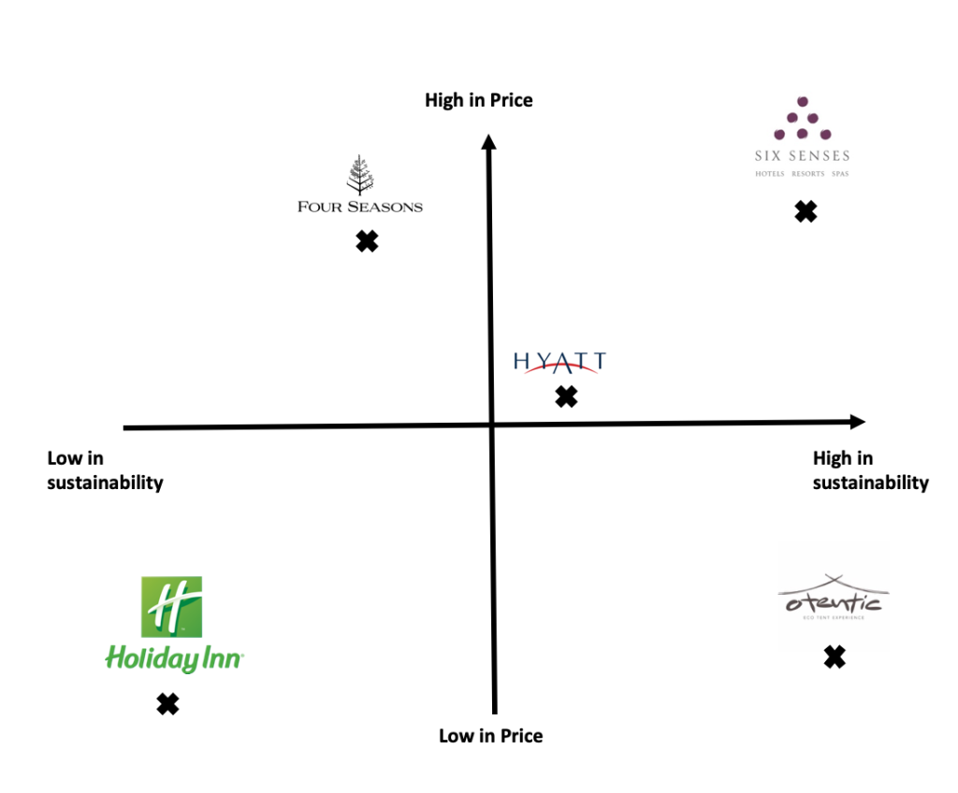

Retrieved from: blogmarketing9113BC_10.3 (wordpress.com)

