Report

Student name: Sanah Ellahi
Student number: 2019343
Module code: BMHP4019
Lecturer: Rebecca Kavanagh
Assignment title: Case Study Report

The report will discuss and guide the practise manager in the local health centre on the current situation they are facing. The report will explain possible causes of behaviours related to the service users of psychological theories involving social identity (SIT), attribution theory and frustration aggression hypothesis (FAE). The report will advise how counselling will impact the service user giving brief knowledge relating to rates of suicide within young teenagers, using this information to further rely on certain actions that should be considered for prevention of this. Lastly the report will conduct recommendations regarding the complaint.

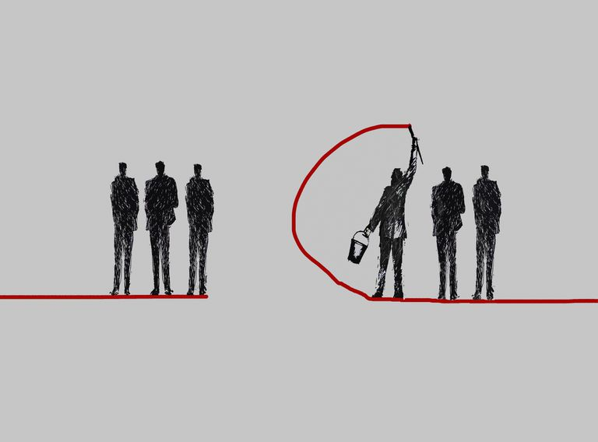

Table of Contents
Information 3
Counselling 3
Social identity (SIT) 3/4
The three social logical approaches 4
Attributions 5
Fundamental attributions 5/6
Frustration aggression (FAE) 6
Conclusion 6
Reference page 7

The information on the service user that we know of indicates they are a 15-year-old male who has a condition Emery Dreifuss Muscular Dystrophy which is a rare genetic disorder affecting parts of the body primarily manifest as muscular weakness and wasting in the shoulders, upper arms of calf muscles of the legs. The service user’s has anxiety and depression keeping in mind that they have been persuaded for counselling after a serious incident of a suicidal attempt.
Upon research evidence in the literate indicates that over an estimate of 15-24 years olds in the UK rate of suicide attempts has immensely fallen nut again in 2018 has risen highly statistic showing that since 2013 in England a quarter of 11–16-year-olds and half of 17- 19-year-olds (46.8%) involving mental health disorders reported of self-harm or attempted suicide. (Royal college of paediatrics and child health 2020 state of child health London RCPCH).
The office of national statistics publishes suicide data in England show male suicide rates was 15.3 per 100,000 compared to females. (Latest Suicide Data 2021).
Counselling
The impact counselling can have on young teenagers with mental health can really make a difference. It helps children and young people understand their emotions better, build emotion resilience, coping skills and it helps them develop into adulthood. it provides a safe confidential space in expressing emotions. Counselling is a great deal in making one feel less overwhelmed and identify early then better for children and young adults mentally and physically.
Social identity (STI)
Social identity is a perception of individuals or as a group specifying the circumstances. It is how an individual define they place in society. Psychological attachments to groups whereby emotionally attachments have implications for one’s wellbeing and behaviour. Desiring to view our specific social groups in positive aspects but this may lead to intergroups, prejudice and conflict. An individual sense of belonging to a group, the negative and positive feelings process what their social identity is.
From serious of studies conducted by British psychologist Henn Tajfel and John Turner in early 1970’s evidence in the studies informs that group of individuals were designed to be meaningless and incomprehensive as possible. Relating to the studies Participates were assigned systematically awarded more points to group members who were out.

The three social logical approaches
The theory of evidence suggested mere act of categorizing individuals into groups can make them think more and ship rather than separate individuals in terms of group members. Provided as with knowledge that social identify theory shows that group membership can help individuals to instil meaning in social complex situations defining who we are and determines how we related to others., it can also neglect the factors such as uniqueness of individuals behaviours by the group characteristics. The theory is described as cognitive progression and behavioural motivation. Tajfel’s students elaborated the theory of cognitive factors by social identification suggesting how people may interpret own position in different social context by factors like stereotyping as well as own behaviours in groups by social influence. Our service user is a great football enthusiastic and an ex-football player, so this identity emerges only when they are in relevant to social situations.
As a person’s collective identity becomes their in-group for example family or friends this forms a closeness for the exact purpose of boosting self-esteem and create a sense of belongingness. A group of individuals that may indicate as a threat is a out group, along the lines of outside family, new member in class or someone from a different background. The process makes people emotionally invested in their group setting adapting behaviours to show loyalty to their group.
The service user in the case with emery-dreifuss muscular dystrophy possibly categorizes himself with this condition. They are sport Aston Villa and trained at the football academy, so he adapts to this identity and making his self-esteem bound up with groups who have the same identity. (Mc leod, 2019).
Social comparison is the process were many begin to compare their group with other groups in prestige and social status also known as the mental process, but your self-esteem is maintained in your group needs to compare favourably with other groups. Tendencies of this is understanding prejudice because groups may seem themselves as rivals and forced to complete to maintain self-esteem.
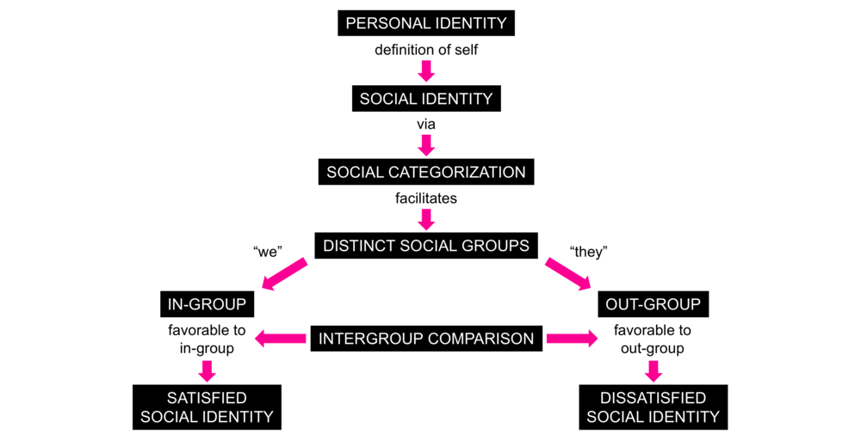
Competition and hostility become highted and in the case of the staff member they may have proceeded themselves as having a higher social standing than the service user based on their position comparing the different social comparison they have.

Attribution
Attribution is a social psychology term referring to the process of evaluating the reasons for behaviour or event. In the daily life most of us attribute causes without realising our biases and understanding processes.
According to the theory of attribution people attempt to understand why others do things by attribution causes of actions. A person seeking to understand why others another person something does may attribute one or more cause pf action.
Fritz Heider suggested in his literature that people observe other, examine their behaviour, and provide logical explanations for their actions in his 1958 book titled ‘The psychology of interpersonal relations’.
His explanations can be classified into either externally or internally. Internal attributions refer to characterises and attributions of individuals while external attributions refer to circumstances and situations. First the behaviour must be observed deciding what the motivation. Secondly the observer must determine that behaviour that was observed deliberate, in such as the observer must determine that behaviour was intentional, and the final assessment identifies whether the observer behaviour is due to internal or external factors.
Fundament attributions
When assessing a person’s behaviour, they tend to overestimate the influence of personal factors and underestimate the influence of situational factors. As such, when observing behaviour, a person is more likely to think it is due to them rather then to the situation and vice versa. So, in the case of our staff member as a manger this may be ideal to assume that the employee’s poor performance is a consequence of lack of ability or effort rather than the task difficulty or luck. (heider 2015).
Manger of the home should act based on the attributions. When aware of this attributional process, and how they can move their own and other decisions based on their own and staff motivation, they can better understand their own behaviour and the behaviour of others too. In this case you would look externally at the staff member keeping in mind of the service user’s behaviour as well, looking into aspects of the environment of the situation.
The situational attribution lies on the staff member and the behaviour due to the stressful outcome around covid guidelines and the pressure of keeping protocols in place. Having this said the staff member was out of character when speaking unpleasantly to the service users as she Is known for being a polite and friendly individual.
But also keeping in mind, again, the service users externally reasonable behaviour could have been down to his conditions of being is pain or discomfort. Some of the internal behaviours could possibly have been due to the external reasons where the staff is using the internal viewpoint on service user.
Frustration Aggression
It is a psychological theory claiming that aggressive behaviour originates from frustration with goals. When you are prevented in reaching a target you become frustrated this can lead to aggression.
The theory believed that direct reinforcement could not account all type of learning. Believing people learn new information and behaviour by watching others which is described as observed modelling and having a internal mental state. The theory suggests that something can be learned, but that does not result in a change of behaviour. (Bandura 1973).
General aggression model (GAM)
Factors related to the current situation or related to individual (personal factors) can trigger blatant aggression. The situational factors affect the affective cognitive and arousal states e.g., insults, exposure or behaving aggressively, high tempered or failing a test.
The personal factors can lead to thoughtful or impulsive aggression actions e.g., high irritability, certain attitudes or beliefs on violence, tendency to perceive hostile intentions in others behaviour, general skills rated to aggression.
As we know that the staff member is usually a polite person by identifying their internal factors. Looking at the general aggression model the aggression may not have been an overall summary of aggressive behaviour due to the nature of the individual.
Situation factors apply more on the service user, and some may apply on staff member too which could be the likely hood of bad mood, social stress, provocation, violent media and pain or discomfort, due to their condition which should be understandable in their circumstances because pain increases hostile and anger.
Conclusion
So, social identify where people categorised others to understand them and adapt identity themselves then compare other groups which serves basic needs for certainty, self -esteem and meaning. Attribution is achieving cognitive control over environment by understand causes behind behaviour and environment occurrences which we identify in the staff member and service users.

References
Anderson, C.A. and Bushman, B.J. (2018). Media Violence and the General Aggression Model. Journal of Social Issues, 74(2), pp.386–413.
Cherry, K. (2019). Attribution Can Be Prone to Biases When Explaining Behavior of Others. [online] Verywell Mind. Available at: https://www.verywellmind.com/attribution-social-psychology-2795898.
Counselling-directory.org.uk. 2021. [online] Available at: <https://www.counselling-directory.org.uk/childrelatedissues.html#whatshouldibelookingforinacounsellororpsychotherapist> [Accessed 2 November 2021].
Ellemers, N. (2019). Social Identity Theory. In: Encyclopædia Britannica. [online] Available at: https://www.britannica.com/topic/social-identity-theory.
health, M., 2021. Suicide – RCPCH – State of Child Health. [online] Stateofchildhealth.rcpch.ac.uk. Available at: <https://stateofchildhealth.rcpch.ac.uk/evidence/mental-health/suicide/> [Accessed 2 November 2021].
Heider, F. (2015). The psychology of interpersonal relations. Mansfield: Martino Publ.
https://www.facebook.com/thoughtcodotcom (2018). Social Identity Theory and the Cognitive Processes Behind In-Group Favoritism. [online] ThoughtCo. Available at: https://www.thoughtco.com/social-identity-theory-4174315.
McKeown, S., Haji, R. and Ferguson, N., 2016. Understanding peace and conflict through social identity theory. Springer International Publishing AG, p.7.
McLeod, S. (2019). Social identity theory. [online] Simplypsychology.org. Available at: https://www.simplypsychology.org/social-identity-theory.html.
Naveed, F. (2016). Summarize Three Different Theories of Aggression. [online] Mass Communication Talk. Available at: https://www.masscommunicationtalk.com/summarize-three-different-theories-of-aggression.html.
Samaritans. 2021. Latest suicide data. [online] Available at: <https://www.samaritans.org/about-samaritans/research-policy/suicide-facts-and-figures/latest-suicide-data/> [Accessed 2 November 2021].

