Networks
Programmability
Module Code: ACCA5029
ASSESSMENT 2
STUDENT:
MD ALIF ALAM (1915307)
LECTURER:
Sadeque shaikh

Table of content
Introduction………………………………………………………………………………..3
Ansible Background……………………………………………………………………...3
Advantages of Ansible………………………………………………………………….3
Disadvantages of Ansible………………………………………………………………3
Ansible characteristics…………………………………………………………………..4
Playbooks………………………………………………………………………………………4
Play vs playbooks…………………………………………………………………………...4
Network automation tools……………………………………………………………...5
Chef………………………………………………………………………………………………….5
Ansible vs Chef…………………………………………………………………………………5
Installation and Configuration of Apache Server……………………………8
Installation and Configuration of MySQL………………………………………..17
Installation and Configuration of PHP sever……………………………………24
About ansible and how it works/Advantages/disadvantages and performance of ansible and ansible playbook with YAML…………….25
List of reference…………………………………………………………………………..26

Introduction
In this report I will demonstrate and apply appropriate, design, implementation and testing techniques for programming and automation of network devices learn throughout my second academic year. The software in particular that I am going to use throughout the whole coursework is Ansible giving a brief introduction to ansible and the steps that I am going to carry to complete the configuration with alongside practical and theories followed by screenshots of my own work.
Ansible Background
Ansible is frequently referred to as a configuration management tool, and is frequently cited alongside Chef, Puppet, and Salt[1]. When discussing configuration management, we typically refer to writing a state description for our servers and then using a tool to ensure that the servers are in that state: the correct packages are installed, configuration files contain the expected values and have the expected permissions, the appropriate services are running, etc. Similar to other configuration management solutions, Ansible provides a domain-specific language (DSL) for describing the status of your servers.
Advantages of Ansible
Ansible in the recent time has been popular by any individual associated whit IT, so in automatic we ask the question what are the reason behind his success below I have listed different benefits that made Ansible popular today [2]:
- Easy to learn - The biggest benefit of Ansible that is mentioned is its simplicity. The simplicity is intended for both pros and beginners. It is simple to learn, allowing users to learn Ansible rapidly and increase their productivity. Ansible is supported by exhaustive and easily comprehensible documentation.
- Playbooks are written in YAML - Ansible's usage of Playbooks is a further explanation for its numerous advantages. Playbooks are configuration files for Ansible, and the language used to write them is YAML. In this instance, YAML is a superior choice for configuration management and automation, which is an intriguing aspect.
- It is written In python - One of the most notable advantages of Ansible is that it is built in Python. Python is a human-readable programming language that forms the backbone of Ansible. Due to the inclusion of Python libraries by default on the vast majority of Linux distributions, the installation and execution of Ansible is facilitated.
Disadvantages of Ansible
As any software deployed on the market Ansible has his own setbacks too [2]:
- Inadequate User Interface - The first downside of Ansible is its primitive user interface. Initially, Ansible was a command-line-only tool. Ansible's initial attempt at a user interface was the AWX graphical user interface. The third component of the user interface was the REST endpoint, which facilitates infrastructure maintenance.
- Ansible lack of experience - The absence of corporate support experience diminishes Ansible's appeal. In contrast to its competitors Puppet and Chef, Ansible does not have much experience dealing with major companies Chef & Puppet. Even though Ansible claims to offer enterprise-grade extended support solutions, its lack of actual expertise diminishes its credibility.
- Ansible is a recent market entry - Finally, one of the most prevalent downsides listed in Ansible's pros and disadvantages is a notable drawback. Ansible is a newcomer to the market, in contrast to its established rivals. As a result, its developer and user communities are small. In addition, Ansible's expanded market presence raises the possibility of undetected vulnerabilities, software problems, and edge cases.
Ansible characteristics
Typically, as systems engineers, we must automate infrastructures containing complicated multitier applications. There is also topology involved, as several of these programmes must collaborate to deliver a service [3].
Down below we will find attached an example playbook that translates the blueprint into policies enforceable by Ansible:
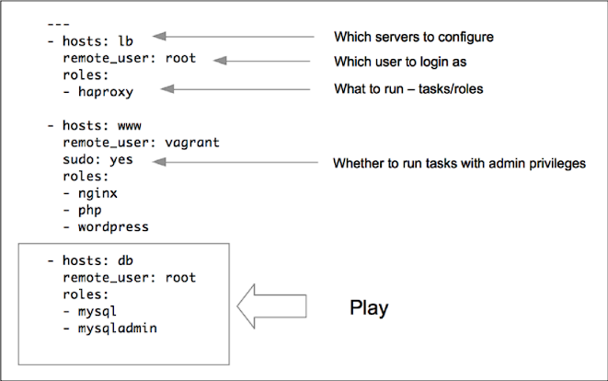
(Figure 1.0) [4]
Playbooks
A playbook consists of one or more plays that assign well-defined duties to groups of hosts. The preceding example (figure 1.0) has three plays, each of which configures a different layer of the multitiered web application. Plays also determine the configuration order of jobs. This allows us to organise deployments with several tiers. For instance, setup the load balancers just after starting the web servers, or do a two-phase deployment in which the first phase adds settings and the second phase begins the services in the appropriate sequence.

Play vs playbooks
To comprehend the ansible playbook, one must be familiar with the Ansible Ad hoc commands. One-time ad hoc commands can execute a single, basic action against a collection of targeted hosts. However, the true power of Ansible lies in understanding how to utilise playbooks to execute many, complicated operations against a collection of targeted hosts in a simple, repeatable manner [4].
Brief:
- A play - is a sequence of tasks that should be executed on hosts chosen from your inventory.
- A playbook - A playbook is a text file containing a list of one or more plays to be executed sequentially.
Network automation tools
Past years the number of devices connected to the internet are steadily increasing due to a quick expansion of the IT industry. To coordinate many devices and control them from remote and to specifically reduce the time spent of a traditional configuration of a network equipment they came up with the concept of network automation. Network automation is a solution for many reasons, enhancing the effectiveness of network maintenance by implementing methods that are simpler to follow and apply on a broad scale, but also improving the time spent for each individual configuration [5].
Chef
Chef is an automation software that configures and maintains on-premises and cloud-based infrastructure. You may deploy to whatever infrastructure type makes the most business sense. Using Chef, you may accelerate application deployment and even create a continuous deployment pipeline. Chef is so effective because it transforms infrastructure into code.
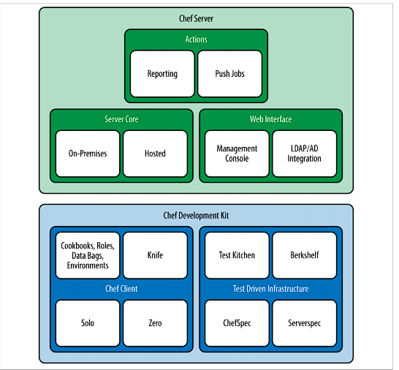

Figure 1.1(Chef architecture) [6]

Ansible vs Chef
Set-up: we
- Chef utilises a client-master architecture. The server component operates on the master machine, while the client component operates as an agent on all client machines. Workstation is an additional component of Chef that keeps all configurations that are tested and subsequently uploaded to the central server.
- Ansible simply employs a master operating on the server and no agents running on the client. It utilises an SSH connection to log in to the client systems or nodes you wish to configure, and the client machine virtual machine (VM) requires no specific configuration.
Playbooks vs cookbooks:
- Chef cookbooks are more complex to learn but it gives you more options and in case the configuration require a complex build than it fits better than ansible
- Ansible playbooks on the other hand are much easier to grasp as learning as well as to create, but due to the simplicity it creates limitation in case of a complex configuration tasks
Result
Chef has been in existence longer and is able to handle exceedingly complicated jobs with ease. Ansible is easy to instal and utilise, limiting the difficulty of the jobs it can perform. It is just a question of determining what is essential for your organisation, which goes beyond a simple Ansible vs. Chef exercise.

Installation and Configuration of Apache Server
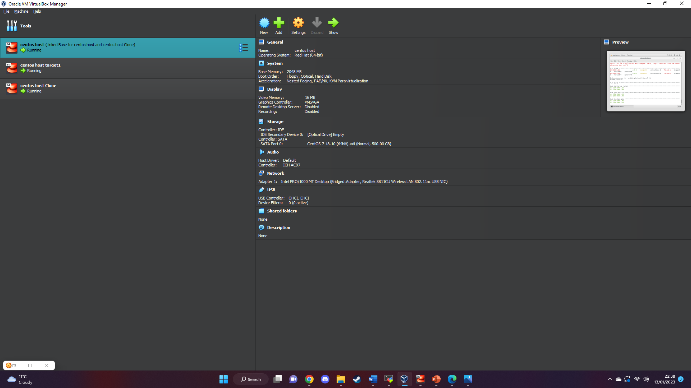
Figure (1.0)
Lab setup for the configuration in this case I have used virtual machine which is a virtualization machine that allows to built an Operative system that can function by using the resources of the Host pc for example storage, network, Ram, and Cpu.
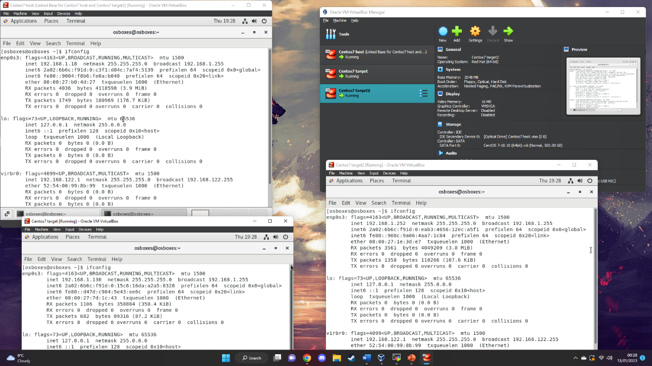
After the configuration of our host and the target machines we can check their Ip addresses using the command ifconfig.
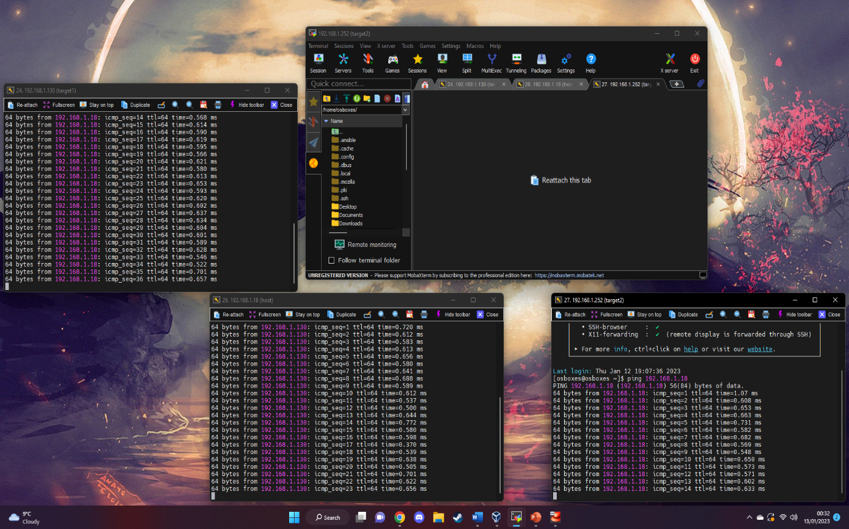

However, to check their connectivity I have used MobaXterm which I have established with an ssh connection through port 22. As we can see above with the command ping we can receive and send packet to a device to another.

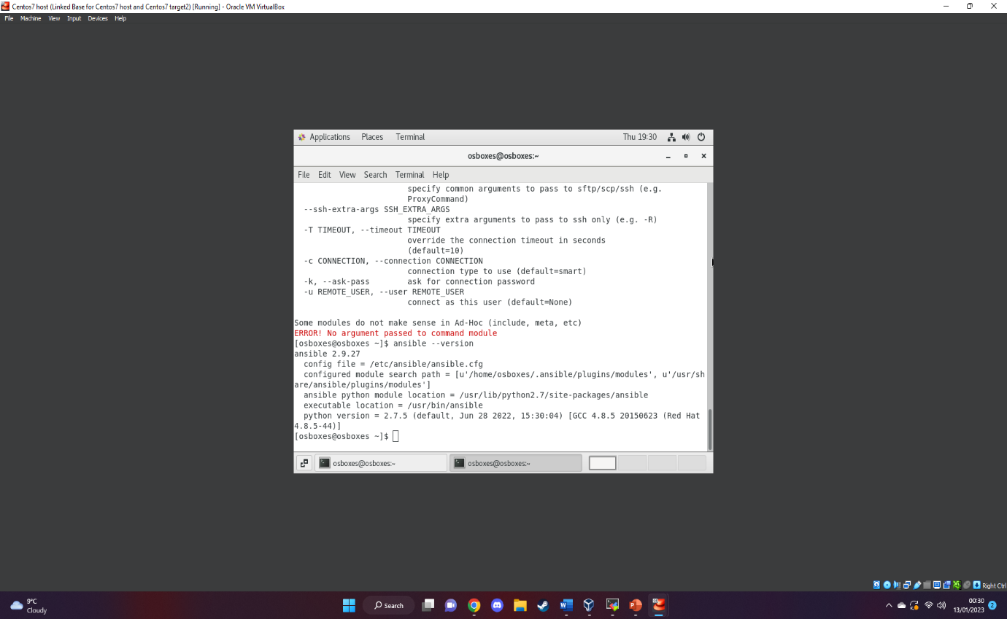
Next we have installed Ansible our network automation tool by using the command :
- Sudo yum install ansible.
Above we can also check if the installation has been successful by using the command:
Ansible version - -
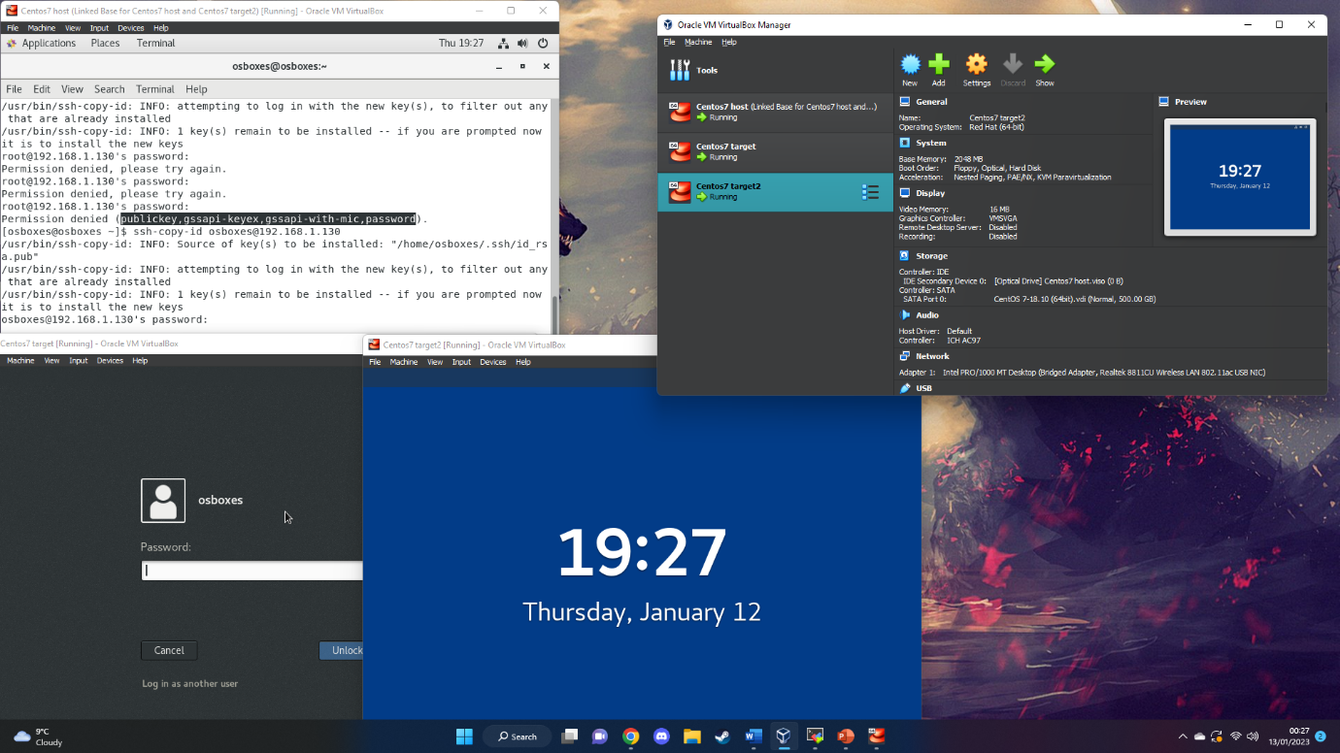
Next we have generated a publick key by using the command:
Ssh-keygen
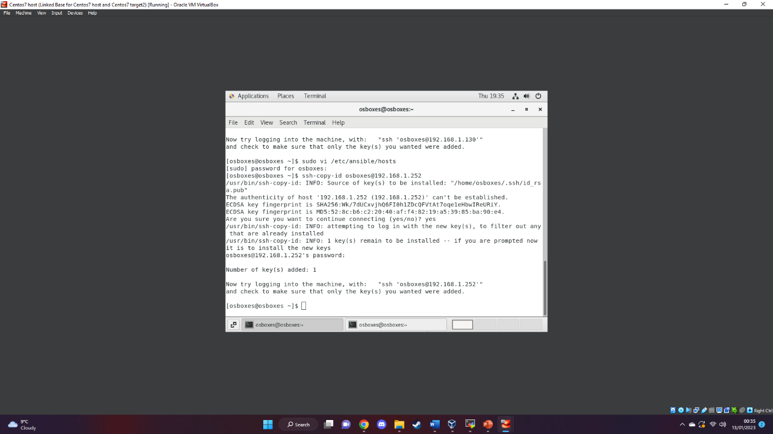
Next step we assign the key generated to our target machines using the command:
Key-copy-id root@ip address
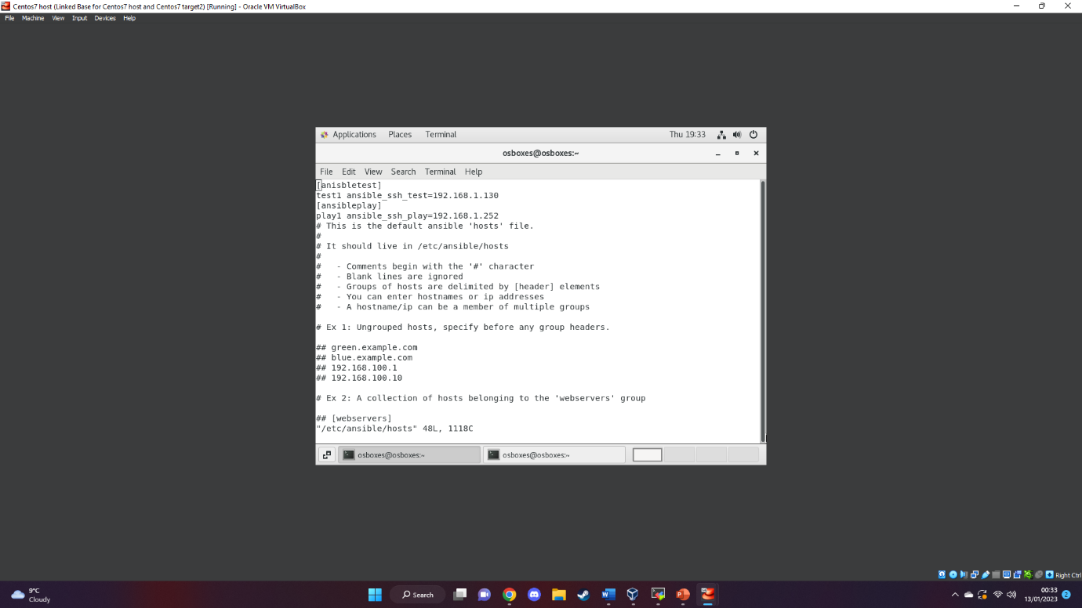
In the screenshot attached above we can see the method of creating a group server on ansible
[name of server]
Ip address
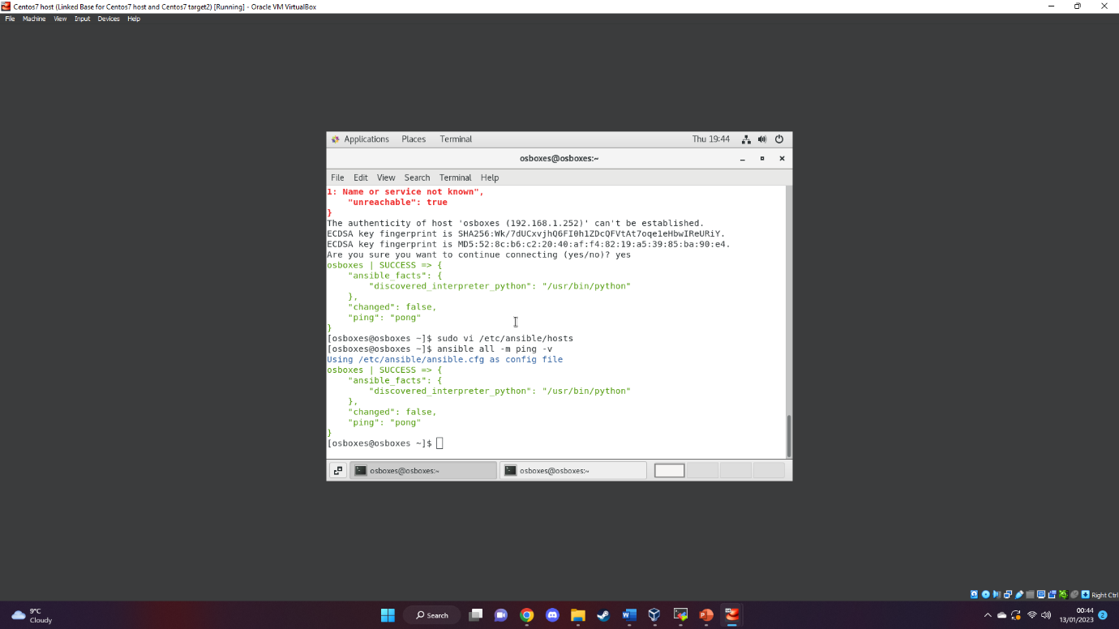
And to check if the local host has been configurated successfully we can run the code:
Ansible -m ping all
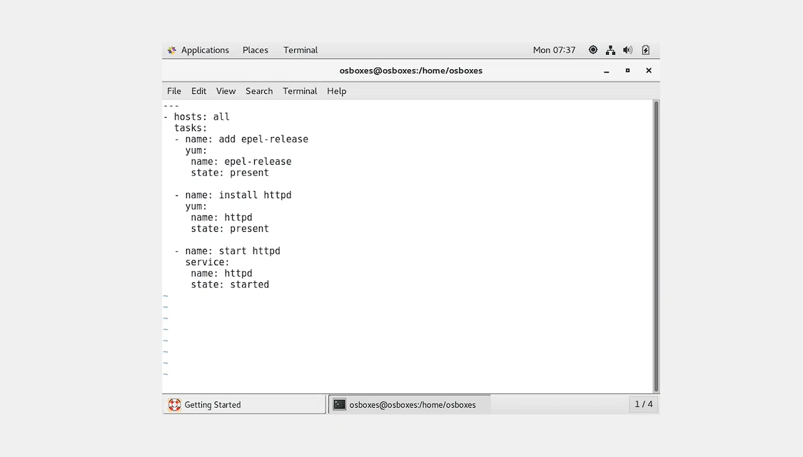
Our first playbook task is to download and run httpd
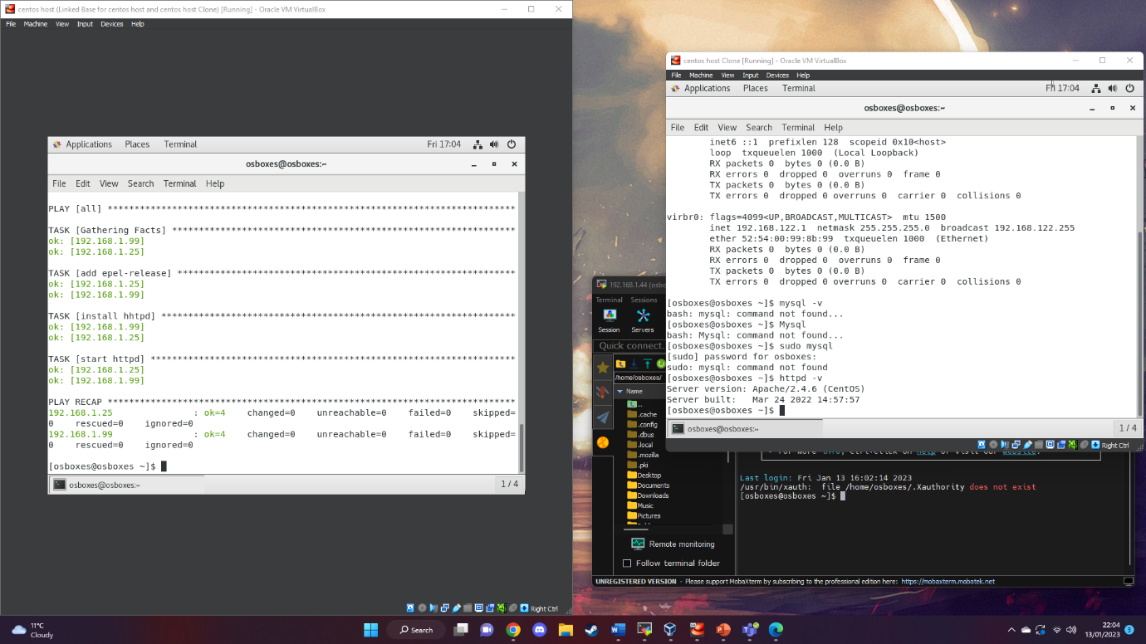
After running the command:
Ansible-playbook “name of the file”.yml -C
We can check whether the task has been ran successfully
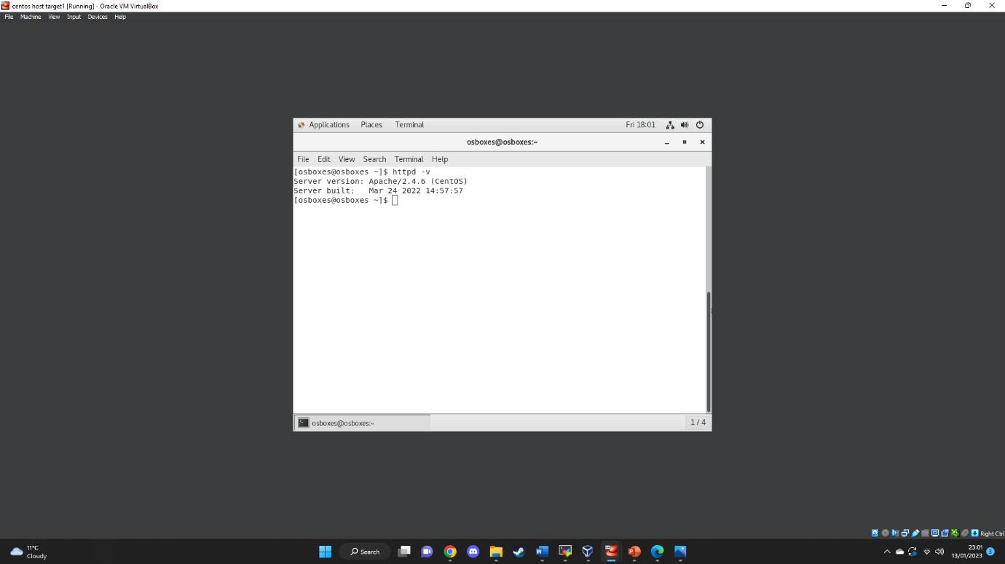
For furthermore checks we can move onto the target machine via ssh connection and use the command httpd – v
Installation and configuration of MySQL
Lab setup for the configuration in this case I have used virtual machine which is a virtualization machine that allows to build an Operative system that can function by using the resources of the Host pc for example storage, network, Ram, and CPU.
After the configuration of our host and the target machines we can check their Ip addresses using the command ifconfig.
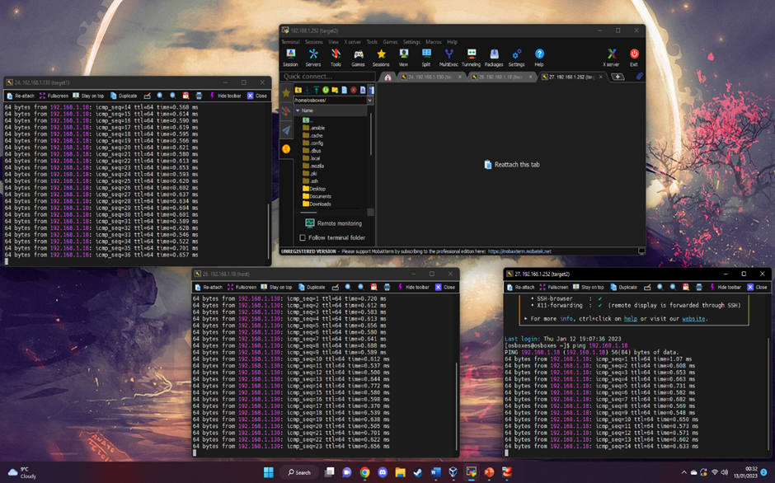
However, to check their connectivity I have used MobaXterm which I have established with an ssh connection through port 22. As we can see above with the command ping we can receive and send packet to a device to another
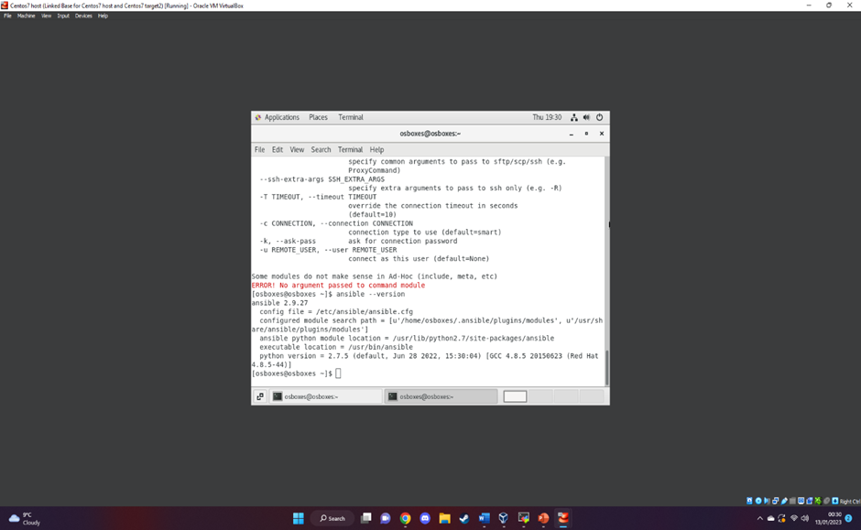
Next we have installed Ansible our network automation tool by using the command :
- Sudo yum install ansible.
Above we can also check if the installation has been successful by using the command:
Ansible version - -
Next we have generated a publick key by using the command:
Ssh-keygen
Next step we assign the key generated to our target machines using the command:
Key-copy-id root@ip address
In the screenshot attached above we can see the method of creating a group server on ansible
[name of server]
Ip address
And to check if the local host has been configurated successfully we can run the code:
Ansible -m ping all
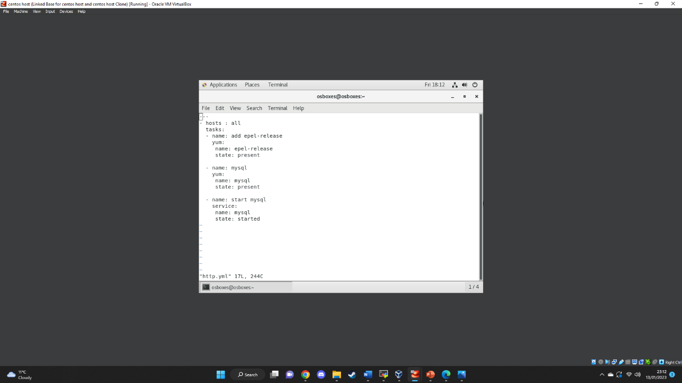
Our first playbook task is to download and run mysql
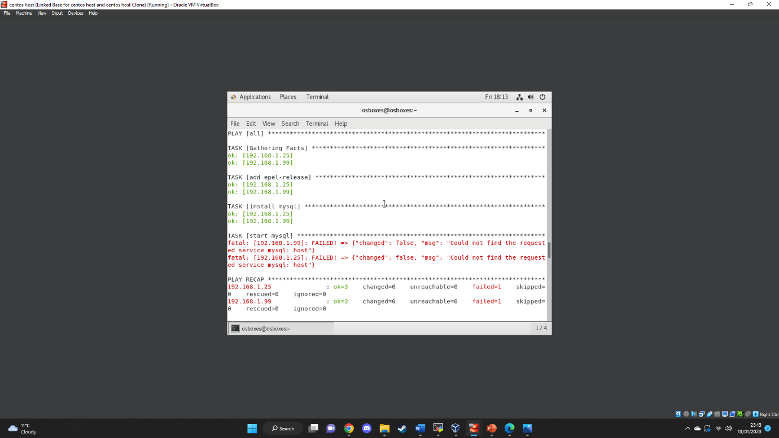
After running the command:
Ansible-playbook “name of the file”.yml -C
We can check whether the task has been ran successfully
As we can see it gave me an error to fix the issues I have searched on internet and to troubleshooting I had to went to my.ctf and locate the library.
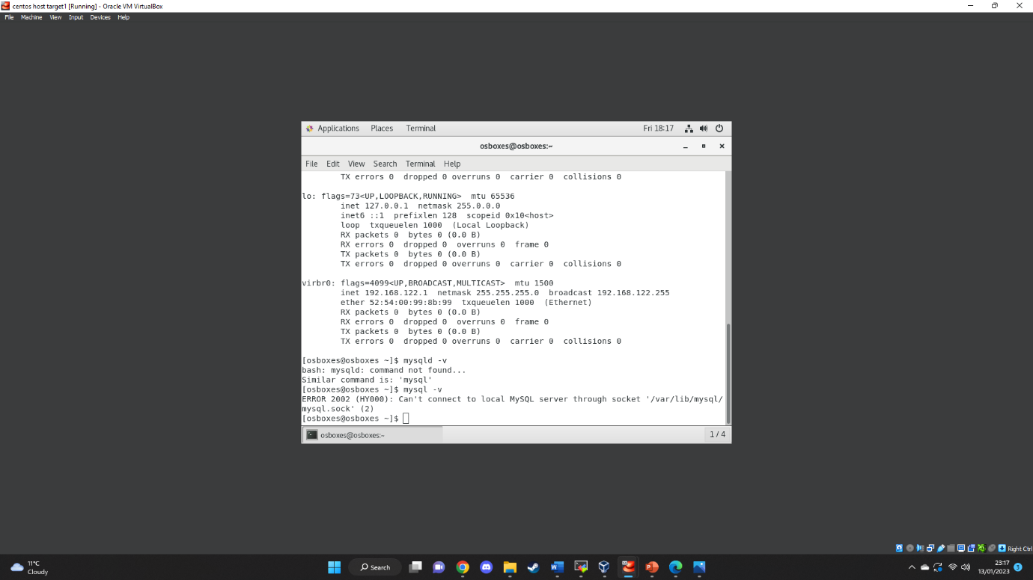
For furthermore checks we can move onto the target machine via ssh connection and use the command mysql – v

Installation and configuration of MySQL
Lab setup for the configuration in this case I have used virtual machine which is a virtualization machine that allows to build an Operative system that can function by using the resources of the Host pc for example storage, network, Ram, and CPU.
After the configuration of our host and the target machines we can check their Ip addresses using the command ifconfig.
However, to check their connectivity I have used MobaXterm which I have established with an ssh connection through port 22. As we can see above with the command ping we can receive and send packet to a device to another
Next we have installed Ansible our network automation tool by using the command :
- Sudo yum install ansible.
Above we can also check if the installation has been successful by using the command:
Ansible version - -
Next we have generated a publick key by using the command:
Ssh-keygen
Next step we assign the key generated to our target machines using the command:
Key-copy-id root@ip address
In the screenshot attached above we can see the method of creating a group server on ansible
[name of server]
Ip address
And to check if the local host has been configurated successfully we can run the code:
Ansible -m ping all
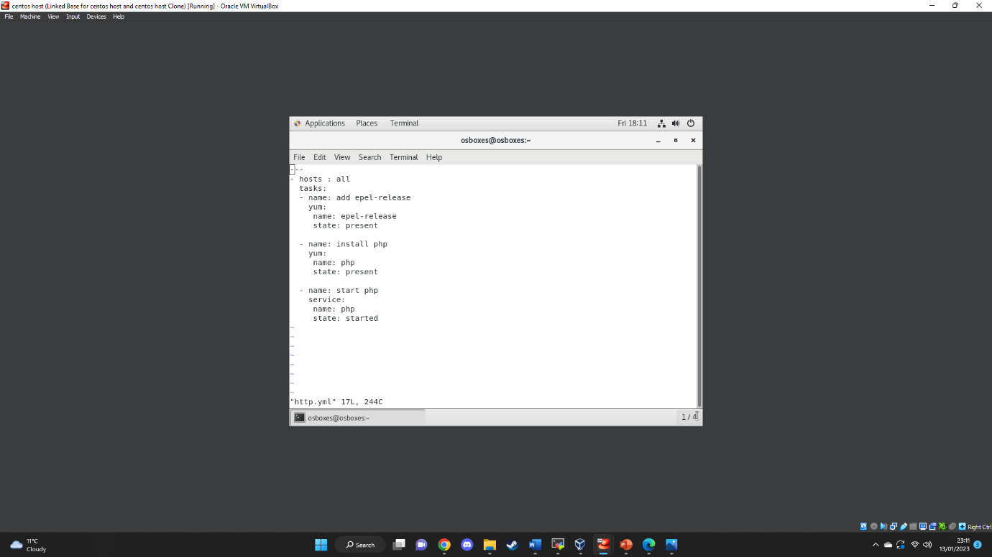
Our first playbook task is to download and run php
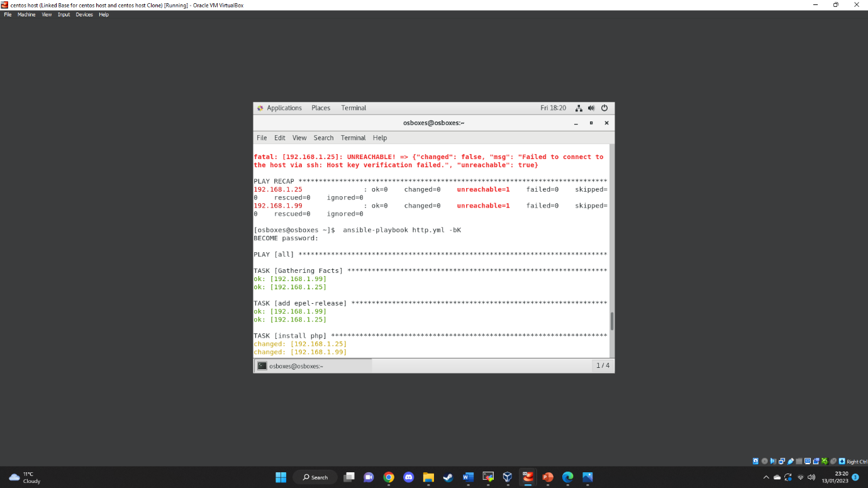
After running the command:
Ansible-playbook “name of the file”.yml -C
We can check whether the task has been ran successfully.
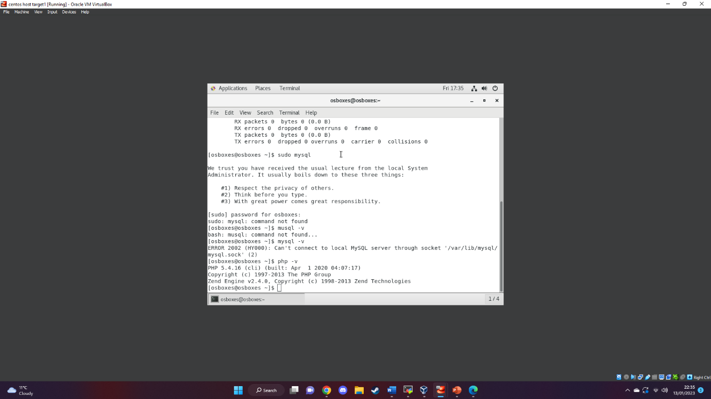
For furthermore checks we can move onto the target machine via ssh connection and use the command php – v .

About ansible and how it works/Advantages/disadvantages and performance of ansible and ansible playbook with YAML.
Overview:
Benefits of Ansible
- Ansible is a free, open-source utility.
- Very easy to instal and operate: No coding expertise is required to utilise Ansible's playbooks (more on playbooks later).
- Powerful: Ansible lets you model even highly complex IT workflows.
- Flexible: You can orchestrate the entire application environment no matter where it’s deployed. You can also customize it based on your needs.
- Agentless: You don’t need to install any other software or firewall ports on the client systems you want to automate. You also don’t have to set up a separate management structure.
- Efficient: Because you don’t need to install any extra software, there’s more room for application resources on your server.
Setbacks of Ansible
- No concept of state : Ansible, unlike related automation tools such as Puppet, has no concept of state. Since it does not maintain track of dependencies, the tool simply conducts a number of tasks in sequence, halting when they are completed, fail, or meet an error. Many like their automation solution to retain a comprehensive library for ordering (à la Puppet), which enables them to reach a predefined state independent of external variables.
- Lack of UI :Ansible launched its first try at a graphical user interface with AWX: a graphical user interface and REST endpoint to simplify infrastructure administration. Eventually, AWX developed into Ansible Tower, a web management user interface that offers visual management features and a team-based workflow tool. Even while Ansible Tower is a significant advance over AWX, it still has a long way to go; only 85% of what can be done via the command line can be completed using the user interface.
- Minimal enterprise experience: Since is new in the market and does not have much support ansible cannot be very tempted by the big organizations which they require guaranty [7].
Playbooks (yaml)
Ansible playbooks are similar to task instruction manuals. They are basic files created in the data serialisation language YAML, which stands for YAML Aren’t Markup Language. Playbooks are important to the popularity of Ansible because they explain the actions to be performed without requiring the user to know or remember any specific syntax. In addition to declaring settings, they may also orchestrate the phases of any manually ordered job and perform tasks simultaneously or at various times. Each playbook has one or more plays, the purpose of which is to assign a set of hosts to well-defined responsibilities, represented by tasks.

List of reference
[1] D. Hall, Ansible Configuration Management. Birmingham: Packt Publishing, 2013.
[2] D. N and P. Gumaste, “Advantages and disadvantages of Ansible,” Whizlabs Blog, 01-Feb-2021. [Online]. Available: https://www.whizlabs.com/blog/ansible-advantages-and-disadvantages/. [Accessed: 09-Jan-2023].
[3] B. A. S. MEIJER, Ansible up and running. S.l.: O'REILLY MEDIA, 2022.
[4] G. Shah, Ansible Playbook Essentials. 2015.
[5] P. Mihăilă, T. Bălan, R. Curpen, and F. Sandu, “Network automation and abstraction using Python programming methods,” MACRo 2015, vol. 2, no. 1, pp. 95–103, 2017.
[6] M. Taylor and S. Vargo, Learning chef. Beijing: O'Reilly, 2015.
[7] “The Pros and cons of Ansible: Upguard,” RSS. [Online]. Available: https://www.upguard.com/blog/top-5-best-and-worst-attributes-of-ansible. [Accessed: 10-Jan-2023].

