Awe and Wonder
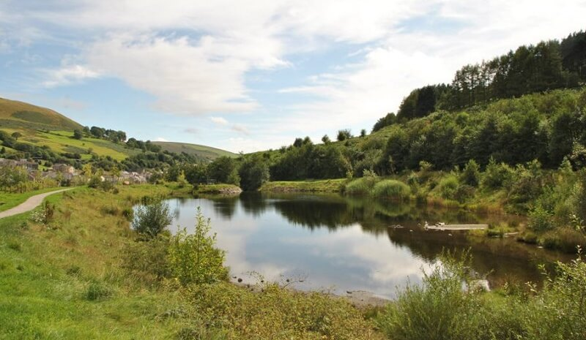

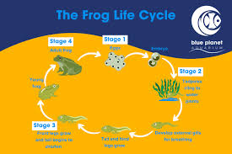
I am going to discuss several elements in this photograph of Park Calon Lan and look how differentiated activities can provide and support children with their learning of science and maths in the outdoor world. The area in the photograph provides children with the freedom to enjoy a big open space. Children could be involved in a focus activity involving loose parts such as tyres and balls to roll down the sloped hill. During this activity, children can explore some scientific concepts like measuring and predicting. The children can predict how long the tyres will take to roll from the top to the bottom of the hill. The children can predict if they think the tyres will roll straight or down the sides of the hill. They will be able to explore different sizes of tyres and what force will be expected to enable the children to push and pull them. Children will be exploring other scientific concepts such as speed, distance and force.
When the children are running around and exploring up and down the hill, they may notice their heart rate increasing, and this may be an opportunity to explain to the children why they are experiencing shortness of breath and what happens to our body when we run and why our heart beats faster. The children could also work in small groups or pairs, and roll a ball back and forth, at the flat part of the track, taking a step back each time. This will give the children a perspective of distance and how they need to use more force as they move further back. Staff will always be close by to observe the children and to scaffold if needs be, Staff may also ask open-ended questions such as “Why did that happen?” Or “What would happen if you pushed it a little harder?”
The second element of this photo I would like to discuss is the lake. Children love exploring water and this will provide them with excellent learning opportunities. Water is also the perfect opportunity for children to demonstrate scientific and mathematical concepts, such as volume and weight. When stood in the water, staff working with the group will have the opportunity to ask the children questions like, “how much water do you think I can fit into my bucket?” or “what do you think will happen if we drop a heavy rock in to the bucket?”
I am going to introduce the children to a “pond dipping” activity. The children will be working in small groups and given a bucket to collect their findings in. The children will use their maths skills to count how many objects they have and explore the different textures. They will be wearing appropriate clothing and wellies for this activity and will have a talk about water safety and the dangers before starting. This activity could be enhanced as the children could learn about lifecycles, such as the lifecycle of a tadpole.

Source: (Google, 2024)

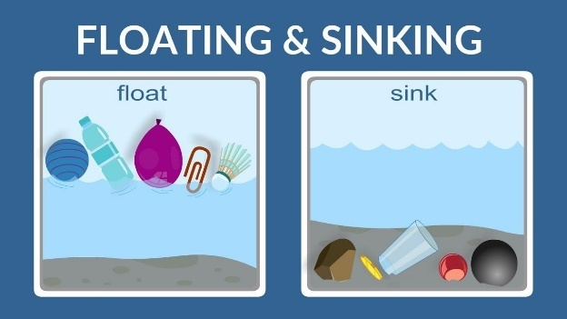
Another activity that children can take part in is a sinking and floating activity. The children can use natural materials such as leaves, wood, paper, grass, sticks and pebbles. The children would each have a piece of paper with a table and the materials listed and will write either “floats or sinks” next to it. This activity could be enhanced for the children by demonstrating how a floating object, can also sink. This could be done by adding heavier items to the floating object. The children will see the object floating in the water, however with heavier items added, it will sink. This will be an opportunity for the children to ask questions and predict what may happen with other materials in the water. The New Curriculum for Wales encourages curiosity about science and technology and states that it gives us the opportunity to ask questions about the world.

(Source: Google 2024)
Similarly, according to Early Childhood News, as children explore water play materials, they build their scientific problem-solving skills, and they begin to understand why and how things happen. For example, when completing our floating and sinking activity, a child may notice that one object sinks in the water and another object floats, which will then prompt them to add more objects to the water to see what happens. At the end of the activity, the children should understand that a heavier object will sink, and lighter objects float.
Children can enhance their mathematical skills by counting how many buckets of water used to fill a large tub.
The final element of this photo I am going to discuss are the trees. Trees provide excellent opportunities for learning in the outdoors. Children can explore the concepts of light and dark. In the photo above, it is a bright sunny day, the trees would provide some shady cooler areas which will allow the children to ask questions such as “why is there shade here?” and “what causes the shade?” They may also ask questions about colder, more cloudy days and ask if there would be shadows and how is the temperature colder.
A simple but engaging activity for the children will be leaf collecting. The children will be given a tub to collect their leaves in and will be asked to sort the leaves into groups of colour and size. Leaves can be used to paint with, the children can keep the leaves to take back to their class and engage in a painting activity. This will allow the children to see the different patterns leaves have and will hopefully lead the activity to become more enhanced to an activity on photosynthesis and the process.
Another activity the children can take part in is den building. Den building allows children to interact with natural elements, problem solve, negotiate and work as a team. Mathematical skills are challenged when den building as a good design is key to a successful den. Natural materials such as role, string, pegs and tarpaulin can be used by the children to help support the den. Children must think about the size and shape of their den and acknowledge that a bigger den will need more support than a smaller den. The curriculum for Wales (2021) acknowledges the importance of play for the early years, in the development of mathematics and numeracy and how it enables learners to explore ideas, establish connections, solve problems, and collaborate with others. This supports children to become ambition, capable learners.

RISK BENEFIT ASSESSMENT

Location / Activity: | Park Calon Lan and Lake | Date: | 25.09.2024
Assessor: |  | Review date:

The boxes in the table below will expand as you type into them; pre-entered text is simply for illustration. You should delete irrelevant items and replace with text relevant to your circumstances.
Your overall risk rating – Low, medium or high – is based on your judgement about whether the BENEFITS of the activity or opportunity outweigh the RISKS.

Experience exploring outdoor space in photograph | How will young people BENEFIT from this activity? | Hazards and associated risks | Who is at risk? | PRECAUTIONS in place to reduce the risk of injury | Overall risk after precautions  RATING: L/M/H
Pond Dipping | Children will be supported when exploring the water. Pond dipping will improve the child’s agility as they will need to ensure they are stable when walking down to the water. They will build up their confidence when entering and coming out of the water. This will also encourage independence as the children will need to be wearing their wet weather clothing, and wellies. Children may find fish swimming, or tadpoles, and can then learn about their lifecycle. | Children may fall into the water.  There is a potential for infection, through the children putting their hands in their mouth whilst in the water. The children may also have some cuts or bruises.  Falling into the water.  Small knocks to the children when they are working within proximity to each other. | Adults and children | Children will be always supervised during this activity, and staff with adhere to the correct ratios. Children will be working in small groups and will be wearing all the correct gear for the water, such as wet weather clothing and their wellies. Children will be spoken to beforehand about only entering the water up to the top of their wellies.  Children will be asked and checked for any cuts before entering the water, as they will not be able to enter the water if they do.  The children will be reminded that they must not put their hands in their mouth or anywhere near their face until they have washed them afterwards. A first aid kit will always be present if needed. | Medium
Floating and sinking | The children will be placing and lifting objects up out of the water, and this will help to develop and strengthen their fine and gross motor skills. This activity will also help improve their confidence when entering and exploring water. | Children may fall into the water.  There is also a risk of potential infection from disease via open cuts or putting hands in mouth during this activity. | Adults and Children | The appropriate child to adult ratio will be adhered to. Children must be wearing all correct gear such as wet weather clothing and wellies. The children will have a talk before entering the water on how to carry out this activity safely and sensibly and will be always supervised. Children must not enter the water without an adult being in there first. Practitioners must be aware if any child has cuts, as they will not be able to enter the water if they do. The children must be reminded not to put their hands in their mouth or anywhere near their face until they have been thoroughly washed afterwards. A first aid kit will always be with the group. | Low
Den Building | Den building encourages teamwork. Children will work together to make the most stable den they can. They will learn to problem solve and use their initiative as well as work as a team with their friends. Children may count the amount of sticks they need to keep the den up, which will increase their mathematical development. | The den building tools many cause trip hazards.  Children may pick up materials such as wood that are full of splinters or nails.  Children may carry the materials they find incorrectly and may poke other children in the eye.  Den may not be fully stable at times and could fall on the children. | Adults and Children | Children will be supervised at all times. They will be shown how to handle and carry all equipment and materials they find correctly before starting the activity. The correct ratios will be adhered to. The children must be wearing suitable clothing such as closed toe shoes and leggings and, if available, safety gloves to prevent injury such as splinters. A first aid kit will always be available for use. | Medium
Tyre Rolling | The children will be required to roll the tyres down the slope of the track. There will be a range of varied sizes, and this will allow the children to understand their own strength and if something is too heavy for them. When standing the trye up it will improve their balance Rolling the tyre will require the children to be aware of their own bodies and know when to roll the tyre. When the children are at the end of the slope, they will need to make themselves safe from injury and make sure they are not in the way of the rolling trye. This can provide an opportunity for special awareness. | Children may fall over and cause grazes and bumps  Friction burns from the tyres. | Members of the public, and adults and children | Children will have a talk about this activity before it begins and will be always supervised by an adult. The adult will be responsible for taking the tyre back to the top of the slope. The correct ratios will be adhered to, and the children will be working in small groups, this will be to prevent too many children rolling the tyres at the same time, and possibly injuring members of the public.  A first aid kit will always be available for use, if needed.  . | Low

Adults supporting and encouraging scientific and mathematical development in the outdoors
It is vital that adult’s approach outdoor learning with the same excitement and professionalism as they do with the learning that takes place indoors. Vygotsky’s model of social learning (1978) supports this by suggesting that higher order functioning must be central to create a meaningful outdoor learning environment, and therefore the timing and frequency of interactions between the children and practitioners is important. In addition to this, The Reggio Emelia approach (2006) acknowledges that teachers encourage children to oversee their own learning and to problem solve themselves. The children will use practitioners as individuals who can ‘lend’ information and support when needed. The Foundation Phase Framework advocates a holistic, play-based and experiential approach to all children aged three to seven years. The framework emphasizes that children are provided with stimulating learning activities that support outdoor learning, as much as indoor.
Pillman (2002) identifies that outdoor learning has become increasingly important. The recent Covid-19 pandemic has made the world more aware of the importance of spending as much time in the outdoors as possible, as this impacted the health and well-being of children and young people and therefore The Curriculum for Wales (2022) emphasises that outdoor learning has greatly supported the physical and mental wellbeing of children.
Furthermore, Forbes and Hollyhock’s 2014) state that outdoor learning is an extension of a classroom, and this sees learning spaces radiate to the outdoors, including the local community. There are significant benefits to children having multiple outdoor learning experiences, such as better engagement, an increased enjoyment of learning and feeling as their health and wellbeing is supported. Teachers also benefit from this with being satisfied with their job, and they found improvements in their professional developments and practice. Similarly, Gilchrist and Emmerson (2016) recommend whole-school approaches to outdoor learning as well as communities of learning of local schools.
McLennan (2017) emphasises the importance of children needing to spend a vast amount of time learning outdoors. He stresses that the outdoors is filled with a significant amount of learning opportunities for mathematical and scientific learning. The outdoors can interest and engage children in real life problem solving. Williams and Scott (2019) explored research within secondary schools. They found that outdoor learning can impact children’s behaviours, engagement and mood in positive ways, and that practitioners would benefit from more professional development in making use of outdoor learning. The Foundation Phase Handbook (2008) stresses the imp0ortance of outdoor learning and how the environment provides children with opportunities to be noisy, run around, be creative and be involved in risk taking. A child’s learning can be enhanced by factors such as textures, smells, sounds and even the weather. Children’s health and fitness will benefit from skipping, jumping and running in the outdoor environment. Children can use the outdoor equipment and will learn a vast number of natural experiences, such as how plants grow in different seasons, how the weather changes, and how animals are born and when. Framework for children’s learning for 3- to 7-year-olds in Wales states it is vital that the Foundation Phase environment promotes discovery and independence with a greater influence on using the outdoors as a resource for children’s learning.
Montessori (1920) had the idea of unrestricted access between indoor and outdoor learning. However, there is criticism that “choice” may have been restricted, and furthermore, the outdoor space was not a place for play or to enable children to be imaginative. Frobel, however, stresses the importance of exploration in the outdoors and play, and encourages experiences in the outdoors to be structured and purposeful.
The outdoor environment has an abundance of scientific learning opportunities. The curriculum for Wales states that forces can be used to describe the behaviour of anything from small building blocks to the motion of our planet. Children can learn about forces with an activity such as tyre rolling down hills, this allows the children to predict how much power they need to push or pull tyres up and down hills or slopes. An understanding of forces and energy can help learners overcome future challenges and use our planet’s resources efficiently and sustainably, helping them become responsible citizens of Wales and the world.
“Learners who are enterprising, creative contributors, ready to play a full part in life and work embrace such challenges, as they are encouraged to take risks, to innovate and evaluate, and learn to develop solutions. Thus, they can become more resilient and purposeful learners across all areas of learning and experience.” The Curriculum for Wales (2022)
Children’s experiences are influenced by their outdoor environment, as well as the space they have to explore, and the practitioners who explore the outdoors with them. (Kiewra & Veselack, 2016; Moore & Wong, 1997). Emilsen & Koch, 2010; Moser & Martinsen, 2010 express how effective and engaging learning experiences and opportunities require certain types of outdoor space, and more importantly professional practice. Steiner, R (1920) emphasised the importance of outdoor learning as he believed that this promotes holistic education, and that children need direct interaction with nature as it fosters a sense of responsibility towards the environment. Steiner also stresses that the outdoors provides numerous opportunities for imaginative play, which is essential for a child’s cognitive and social development. Tucker (2010) states that children observe and participate in mathematical activities before starting nursery. Children are introduced to maths through daily tasks at home and that pre school is play that can provide a link between home and school. Through play, children can refine their skills and practice what they understand. Bruce (1991) argues that the term ‘play’ is too broad. However, Bennett et al. 1997) emphasises that if play is valued and there is encouraged adult involvement, it can enhance and raise standards of learning opportunities.
Furthermore, The Forest Schools movement is an educational approach that emphasizes outdoor learning and play. This approach is child led and children spend a significant amount of time I natural settings. This allows children to enhance their learning in the outdoors and supports physical emotional and cognitive development through hands-on exploration. Children are supported to build resilience and to challenge their problem-solving skills. Individuals are encouraged to work together which fosters a sense of belonging and good communication between peers. Forest School aids children in building resilience, gaining a sense of achievement, and increases concentration. Mathematical activities such as counting natural objects can improve a child’s ability to count. Practitioners can ask simple questions relating to mathematics such as ‘how tall are the trees in the forest?’ ‘Which one is the biggest?’ ‘Which one is the smallest?’ ‘can you count the trees?’ The right questions can turn conversations into math lessons.

References
Gwen (2023) The Pros and Cons of Forest Schools | Landscapes 4 Learning. Available at: https://landscapes4learning.com/the-pros-and-cons-of-forest-schools/#:~:text=Pros.%20Case%20studies%20have%20shown%20that%20Forest%20School%20aids#:~:text=Pros.%20Case%20studies%20have%20shown%20that%20Forest%20School%20aids. [Accessed: 26th September 2024)
Hunter, J. et al. (2019) ‘Balancing Outdoor Learning and Play: Adult Perspectives of Teacher Roles and Practice in an Outdoor Classroom’, The International Journal of Early Childhood Environmental Education, 19th September. Available at: https://files.eric.ed.gov/fulltext/EJ1254849.pdf (Accessed: 18th September)
Hwb (2020) Area of Learning and Experience. Science and Technology. Available at: https://hwb.gov.wales/curriculum-for-wales/science-and-technology/ (Accessed: 18th September 2021).
Hwb (2020) Curriculum for Wales. Introduction. Available at: https://hwb.gov.wales/curriculum-for-wales/introduction/ (Accessed: 11th September 2024)
Learning and Teaching Scotland (2006) The Reggio Emilia Approach to Early Years Education. Available at: https://education.gov.scot/nih/Documents/ELC/ELC35_ReggioEmilia/ELC35_ReggioAug06.pdf (Accessed: 10th September 2024)
Maynard, T. (2014) Exploring Outdoor Play in the Early Years. London: Open University Press.
McLennan, D. (2017) ‘Teaching Young Children’, NEAYC, April/May2017. Available at: https://www.naeyc.org/resources/pubs/tyc/apr2017/math-learning-outdoors (Accessed: 10th September 2024)
Moser, T. and Martinsen, M,T. (2010) ‘ The outdoor environment in Norwegian kindergarten as pedagogical space for toddlers’, European Early Childhood Education Research Journal, 18(4), pp. 455-474
Puddles, M. (2024) The Pros and Cons of Forest School - Muddy Puddles Children's Waterproofs. Available at: https://muddypuddles.com/blogs/blog/pros-cons-forest-school#:~:text=What%20are%20the%20Pros%20and%20Cons%20of%20Forest%20School?%20Forest. [Accessed: 15th September 2024]
The Steiner Waldorf approach (no date).Available at: https://app.croneri.co.uk/feature-articles/steiner-waldorf-approach#:~:text=Children%20are%20given%20the%20opportunity%20to%20appreciate%20the,them%20to%20experience%20science%20and%20the%20four%20elements. [Accessed: 23rd September 2024)
Trisha Maynard , Jane Waters & Jennifer Clement (2013) Child-initiated learning, the outdoor environment and the ‘underachieving’ child, Early Years: An International Research Journal, 33:3, 212-225, DOI: 10.1080/09575146.2013.771152 Available at: Child-initiated learning, the outdoor environment and the ‘underachieving’ child: Early Years: Vol 33, No 3 (tandfonline.com)
Tucker, K. (2010) Mathematics Through Play in the Early Years. London: SAGE Publications.
Welsh Government (2009) Foundation Phase Outdoor Learning Handbook. Available at: https://hwb.gov.wales/storage/fcb8539c-9be7-4883-8542-35d7b54b56f2/foundation-phase-outdoor-learning-handbook.pdf#:~:text=The%20Framework%20for%20Children%E2%80%99s%20Learning%20for%203%20to,more%20they%20want%20to%20be%20outdoors%20with%20them (Accessed: 26th September 2024)

