Developing Workplace Critical Thinking
Assignment Title: How do organisational beliefs, attitudes, and value systems affect workplace behaviour
Module code: BMSW5101
Lecturer: Yajesh Kumar
Words count: 4913
Student name: Samata Khatoon
Student number: 1919228

Executive Summary

This report contains the importance of critical thinking with an organisation in the context of Age Concern UK. In addition, several management theories have been evaluated, analysed, and compared in organisational context as well as the current pandemic context. Finally, RED strategy has been used in order to evaluate the impact of COVID-19 in the organisation with critical argument. A brief recommendation from the author’s perspective has been also included at the end of the report.

Contents

Executive Summary…………………………………………………………………………..ii
Introduction……………………………………………………………………………………1
Beliefs, attitudes and values within organisation: Concept and difference…………………….2
Critical assessment of beliefs, attitude and values……………………………………………..5
Impact on work behaviour in the Pandemic……………………………………………………7
Impact of Brexit within an organisation……………………………………………………….9
Application of the critical assessment on an appropriate management theory……………….10
Application of some critical thinking model…………………………………………………14
Red Model……………………………………………………………………………………14
Recommendation……………………………………………………………………………..16
Conclusion……………………………………………………………………………………17
References……………………………………………………………………………………18
Appendix lecture notes ……………………………………………………………………….20

Introduction

Age Concern UK is a UK based charity organisation that works for older people in the UK. The charity was first formed in February 2009 and launched in April 2009. The charity started as Age Concern England and Help the Aged until the new brand came in and started its operation in April 2009. The charity organised and ran its functions separately but in an interdependent manner in different regions under different brands. A survey revealed that 48% of charities risk losing their voluntary income during the pandemic situation. 41% of the direct debit cancellation has been reported in April 2020, which is a clear impact of dropping individual as well as national income. As known to all, charity activities are largely dependent on individual and organisational donations. A sudden drop in the cash flows certainly put the normal flow of activities at stake. This type of abrupt and sudden situation requires a prompt and accurate decision. Therefore, critical thinking ability has been being considered as the prerequisite of recruitment in the modern era. Apart from that, maintaining regular activates in business requires constant critical thinking. The quicker a manager responds to a change, the higher the competitive edge a firm gets.

Beliefs, attitudes and values within the organisation: Concept and difference

“The power of knowledge to organise, select, learn and the judge comes from values and beliefs as much as, and probably more than, from information and logic”
- Thomas Davenport and Laurence Prusak
Professional skill set and knowledge are inevitable to improve the performance of the employees within an organisation. Positive values and belief systems can boost work motivation, drive towards success and increase engagement for a specific task. Humans subconsciously interact with their peers using their core values and attitudes and surprisingly develops a good relationship and harmonise with the individuals who share the core beliefs and values, reflecting the intrinsic nature of human being. Thus, beliefs, attitudes and values perform a significant role in the performance development as well as interpersonal relationship development of the employees within an organisation.
A precise brief will certainly ease the path of explaining the importance of values, beliefs and attitudes in the workplace. Values are the core concepts and ideas that guide our behaviour and lead us to the right avoiding the wrong. Values motivate people to act one way or another. Since values are deeply rooted in individuals, they are long-lasting and generally difficult to alter. However, beliefs are ideas and prejudice that are based on experience or pre-convictions. Beliefs are not driven by fact necessarily. An individual has spiritual, moral, social, intellectual, economic, and political beliefs (see figure 01). Individuals use beliefs as a reference to interpret real-life events in their way. Beliefs are not so deeply rooted as values. However, it takes strong evidence and purpose to persuade someone to alter the beliefs he/she holds. Finally, attitude is the immediate disposition towards a concept or object. Attitude is the hypothetical construct that represents the likings and disliking of an individual. It is a judgement on a concept or object made by the person, and the judgement can range from positive to negative or neutral. Unlike values and beliefs, attitude can alter immediately by any corresponding event.
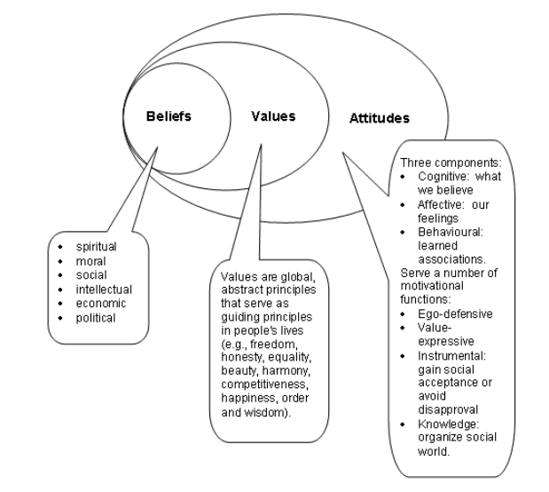
Figure 01: Beliefs, values, and attitude (Source: owlcation.com)
Some instances may be helpful to get these concepts in a more meaningful way. For example, an individual may like a practice session for several reasons. If one of the factors that are responsible for the positive attitude towards the session changes, the overall attitude of the participant may alter, emphasising the fact that attitude is subject to change. Another example may be helpful to get the concept of belief. One belief is that the practice session is very important for developing the communication skill and since higher communication skill adds value to one’s resume, the practice session is important for one’s career. Finally, another relevant example to make the concept of values is as follows. An individual may highly value personal independence and strongly support the idea of making their own choice independently, even if it is taking a drug or other addictive substances. As value is deeply rooted, it will not easily be altered. However, if one of his family members get severely addicted to any drug that causes a serious impact on the health condition of the addicted as well and the financial condition of the family, the individual with a strong value of self-independence will consider the value. He might still prioritise the freedom of choice in personal life and advocate strict anti-drug laws simultaneously.
In the modern world, an era of globalisation, the workplaces are getting highly diversified. Diversified workplaces contain employees from heterogeneous backgrounds and cultures, nourishing different cultural values and beliefs. Therefore, managing the cultural, and moral gaps within the workplace and complementing the rift has become one of the core challenges for the management. Research shows that Equal Employment Opportunity/ Affirmative Action (EEO/AA) creates more scope for diversification within the workplace (Ng et. al., 2018). Moreover, top management’s approach towards diversification largely reveals the instrumental as well as moral beliefs regarding the potentiality of diversification. Moreover, as discussed previously, attitude, a parameter of judgement towards an event or concept, range from positive to negative including neutral, may have a significant impact on the employees’ performance. It is redundant to mention that, positive attitude of an employee towards the workplace increases the work performance as it creates motivation that works in a parallel manner with the skillset and knowledge level of that employee. Research has found a significant positive correlation between organisational spirituality and employees’ attitude in the workplace (Milliman et. al., 2013). Therefore, managing the organisational spirituality and ensuring the proper interpretation of organisational values become an important part of managing the positive attitude of the employees.
A proper alignment of individual and organisational values is much more important to ensure organisational performance stability. If employees’ value spontaneously harmonises with the organisational values, employees will be more satisfied with the organisation and thus, a positive attitude will improve towards all aspect of one’s job. On the other hand, if organisational values and individual values collide with each other, an apparent dissatisfaction will bring out the negative attitude of the employees resulting in the overall poor performance of the organisation. Therefore, it can be concluded that managing the values, beliefs, and attitudes hold a great impact on the organisation’s performance.

Critical assessment of beliefs, attitudes and values

The report is aimed at demonstrating the importance of beliefs, attitudes and values within an organisation and their impact on the organisational performance based on Age Concern UK, a charity organisation that works to make the lives of older people more comfortable and sounder. Nevertheless, since it is a charity organisation, the major portion of their cash inflow comes from the will, donation. Apart from that, they run charity shops, whose revenue is directly used for the charity purpose of the Health Concern UK.
Similar to any other organisation, Health Concern UK have organisational values that include understanding, sensitivity and respect towards the work. Apart from that, according to Health Concern UK, they respect individuals’ confidentiality, equality in opportunity, and demonstration of full active commitment to user involvement. However, organisational values are not as rigid as individual values. Unlike individual culture, organisational culture is derived from the philosophy of the founder/s. in most cases, organisational values are subject to change to align with the local values in case of geographical expansion and dynamic demand. Therefore, alignment or modification of organisational values is normally intentional and deliberate.
However, as discussed, Age Concern UK hold some particular values including respecting individuals’ confidentiality, ensuring equality, understanding and maintaining flexibility to ease the diversification. These values are reflected in their daily activities. As a charity organisation that looks after the elderly, if they do not recognise the diverse necessity of the old people it will be difficult for them to ensure the maximum benefit of the old aged people under the supervision of Age UK.
The attention can be drawn upon another significant fact that, the core values the organisation follow to serve the community create a positive attitude among the employees even though the task of looking over the veterans may seem to be tiresome to some extent. The deeply rooted organisational values induce the employees to demonstrate a positive attitude towards the various aspects of the job task.
As the attitude is the accumulative impact of the beliefs and values, proper communication and management of the beliefs and values will certainly be helpful to derive the expected attitude of the employees. Beliefs are derived from spiritual, political, social, economic, and moral factors, and are subject to change less frequently, organisations focus more on establishing their organisational values. Organisational values are the reflection of the founders’ perception towards a different aspect of the organisation. The values are preserved by different ceremonials, managerial activities, stories, rituals and material artefacts and symbols. For example, the human resource department emphasis perseverance and understanding behaviour while recruiting the staff for Age UK as the reflection of the organisation’s culture and values. The organisational values are passed by different material artefacts and symbols as well. For example, the organisational internal facilities, attire of the staff, lifestyle of the top management etc. are the materials and symbols that represent the organisational culture and values. At world Now, an online news portal places a drill bought for $2 from a thrift shop in the office to demonstrate that, the core objective of the organisation is to drill down to reveal the truth behind the events. These conveyors of organisational values teach the employees what is right or wrong from the organisation’s perspective.

Impact on work behaviour in the pandemic

The Covid-19 pandemic started in 2019 and continues to have affected the lives of entire 8 billion people in the world. Not surprisingly, the organisations have been severely affected by the pandemic put a significant impact on the ongoing beliefs, values and attitude. Individuals values influence the behaviour and attitude of the individuals. Social values played a predominant role in the pandemic by the degree of compliance of social distancing and travel restriction. A particular number of people’s values induce them to be more health-conscious and thus, constraining themselves in their homes whereas, some other disobeyed the travel restrictions and social distancing policy to join the workforce (Bonetto et. al., 2021). In this case, the values could not become a significant barrier in demonstrating a highly positive attitude to the workplace.
Similar to many natural disasters, the Covid-19 crisis has shaken many deeply rooted beliefs of society as well as individuals separately. Belief is the centre of values and attitude. In a negative aspect, fear of any crisis generally gives rise to social imbalance and anarchy. The pandemic situation has curtailed the economy. Moreover, the vaccinations have just started. Thus, it can be easily assumed that going back to the normal economic as well as the social position will take substantial time. Therefore, communities see no positive hope of early recovery. Many individuals have lost their jobs and been thrown away from the workforce. Moreover, the downward economy with no near hope of recovery in near future disappoints new ventures as well as the existing ventures. Even though the government is trying hard to motivate the citizens to start new ventures to revive the sluggish economy, it is very much difficult to come out with effective business ideas in short possible times. In addition, the fund transfer and the salary compensations declared by the government is barely satisfied the basic needs of the people who have been thrown out of the economy. The unemployment rate abruptly jumped to its peak and it’s nearly impossible to come out with a solution that minimises the rate of unemployment. However, the rate may slightly improve as few of the new start-ups actually will be feasible and some of the other unemployed individuals voluntarily remove themselves from the workforce. Nevertheless, it is will not create any sustainable positive impact on the economy. Economic insolvency will result in lowering the individual values and induce them to engage in any kind of illegal activity that ensures them the fulfilment of the necessities. Thus, the negative impact of beliefs directly or indirectly affects the workers’ attitudes and values.
From Age UK’s perspective, the scenario is not significantly different. As the fear of the pandemic mixed with the pessimistic economic vibe alters the attitude of the employee as well as the management. The fear of economic collision certainly led the management to a thriftier policy whereas, the paradoxical employees showed a more engaging attitude to their work as the employment vacancy got scarce. Simultaneously, it is true that the core value of the organisation, to ensure the maximum convenience for the aged people, had to be reconsidered.

Impact of Brexit within an organisation

Brexit has already demonstrated an immediate impact in the last couple of years. Economists and policymakers have predicted several long-term impacts of Brexit not only on the native economy but also on overall geopolitics and human behaviour in the geographic location. Here are some short term and long-term impacts of Brexit on the organisations
1. It resulted in a 1.7 % inflation hike in the UK economy. This higher inflation reduces the real growth rate of the economy as an immediate impact.
2. Moreover the cost of the Brexit vote was almost 2% of the total GDP in 2018, resulting in losing economic growth consistency.
3. According to Financial Times, the UK lost their national income by 0.6% to 1.3% in 2018.
4. As a long-term impact, UK will lose their Per Capita Income to a substantial margin, according to many economists
5. Moreover, it is estimated that the UK’s economic growth will be stunned by 2%-8% within the following 15years (Thomas, 2021).

Application of the critical assessment on an appropriate management theory

Classical and modern management theories help to explain the different management practices and their efficiency with various circumstances. Modern management theories are more human-centric than classical ones. In addition, classical management theories including Henry Fayol’s General administrative theory, which mentioned 14 universally accepted basic management principles, F. W. Taylor’s scientific management theory that suggested to carry out the managerial functions in a scientific manner contains the formal representation of the successful management practices within the organisations, since, before the age, management was not a recognised field of thought. However, later on, modern management scholars started developing new theories that are known as the Modern Theories of management. Some of the modern management theories substantially acknowledged the impact of the action of the people and considered the employees merely not as production resources. They focused more on Organisational Behaviour (OB) that includes the study of how people act in the workplace. The approaches are more likely known as the Behavioural Approach. Elton Mayo, Robert Owen, Hugo Munsterberg, Mary Parker Follet, Chester Barned are the prominent names of the Behavioural approach.
Following the Behavioural Approach era, managerial scholars emphasized quantitative data to evaluate organisational performance and shape the managerial procedure. More specifically, from the 1940s to the 1950s, the quantitative approach became more popular among management scholars. Applying statistics, computer simulation, information model development, etc. mathematical and tech-based approaches became more and more popular among the management of the organisations. Following the quantitative approach, new management theories are mostly known as the contemporary theories that started in the 1960s and continue.
However, the management practice, as well as the interpretation of the management theories, differ from person to person heterogeneous beliefs and attitudes. For instance, F. W. Taylor highly suggested the completion of managerial tasks in scientific methods. Certainly, any progressive person welcomes the changes and takes the change in a positive way to boost his productivity and efficiency. Therefore, the adaption of the scientific method will be appropriate in the context of the individual. On the other hand, a manager or employee with a conservative nature normally does not take changes positively. He likes to stick with the traditional methods and procedures to perform his organisational duties. Therefore, abruptly shifting to the scientific method of management of the completion of the task may seem to be difficult for him to adjust. There is also a chance of reverse output in case the alteration affects his productivity. However, the scientific managerial practice has already become a worldwide practise in the contemporary world. Especially, in the era of digital technology, where all organisations thrive for maximum efficiency and productivity, organisations use scientific methods to get the competitive edge. Specifically, the pandemic has revealed the importance of installation a complete digitalisation within the organisation. A study reveals that 31% of the employees feel it more convenient to work from home using IT facilities (Study reveals most employees want to keep working from home | University of Strathclyde, 2021). In addition, only the organisation that have the access to the interrupted technology find it convenient to carry on the business or their respective functions even in adverse circumstances.
In addition, the Behavioural approach by Elton Mayo, also known as the Human Relation Approach, where he suggested giving more focus on workers satisfaction, an informal organisation within the workplace and ways of influencing the productivity of the workers to achieve organisational success. Elton Mayo believed that employees are motivated more by the overwhelming interpersonal relationship at the workplace and other social factors than the financial benefits and environmental conditions. Elton Mayo took the assumption that humans like to socialise by nature no matter what. His theory was more likely applicable in a workplace where all the employee’s secured sources of their basic needs. Recalling Abraham Maslow’s “Need Hierarchy” theory, employees are supposed to be above at least Safety, which means they have secured the basic needs.

Figure 02: Abraham Maslow’s Need Hierarchy (Source: Simple Psychology)
Elton Mayo’s theory became subject to criticism later. Daniel Bell later criticised Mayo for adjusting man to machine and not acknowledging the necessity of enlarging human capacity. Moreover, the theory is targeted towards a niche individual and not universal. This management theory becomes volatile in a society with adverse economic conditions, where ensuring financial security works as the most efficient motivation factor.
Moreover, Contingency theory claims that there is no universal management rule that fits without any modification or change. Moreover, contingency theory suggests evaluate the employees within an organisation and apply an appropriate management approach.

Figure 03: 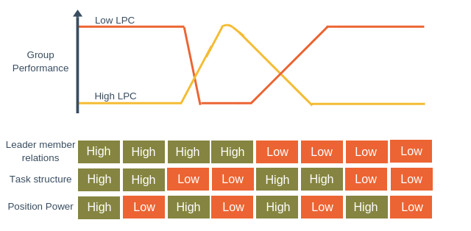
Figure 03: Fielder’s Contingency theory (Source: Universal Management)
In the pandemic situation, the managerial approach becomes more meaning bearing. Regular managerial practice becomes less feasible as the work practice and the financial performance of the organisations has altered severely. Therefore, the needs, as well as the motivation factors of the employees, also changed. As a result, top management may find it difficult to satisfy the employees with the traditional motivators.
Joseph N. Scanlon (1897-1956) designed the Scanlon Plan which combines the total human resource within an organisation, the workforce education, leadership strategy and reward system which has an interrelation with the organisation’s performance. It is a gain sharing strategy where formal employee participation is necessary. Employees normally share their pre-established cost saving based upon the employee effort method.
Dr Edward de Beno designed a six hat thinking strategy to make an abstract thinking session more fruitful and success-oriented. The strategy ensures a broad diversity of perspectives of several viewpoints in team discussion. The hats are white hat focuses on objective, red hat focuses on emotion and instinct, black hat that aware of negative outcomes, a yellow hat which represents optimism, green hat which represents creativity and innovation, the blue hat that represents managerial control.

Application of some critical thinking model

RED Model
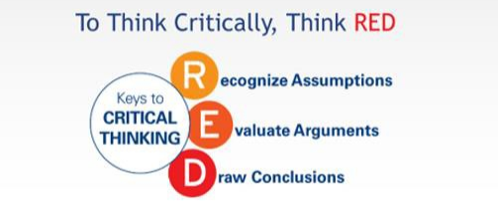
Figure 04: the RED model of critical thinking
According to Claudia Wood (2021), the impact of the covid-19 pandemic on the charitable sector is substantially severe and long-lasting. Claudia showed most of the charity and other social wellbeing organisations are largely dependent on donations and other sorts of fundraising. But the pandemic has severely affected the economic condition as well as the public health issue. Moreover, restriction on travelling and social gathering has minimised the scope of business and trades. Several lockdowns compelled the employees to stay away from the workplace. In addition, sinking financial performance made many firms curtail their human resource. Therefore, many people lost their jobs and were wholly dependent on government fund transfers. All these events minimised the consumable income of the general people. Charities are among the direct victim of the pandemic.
Recognise Assumption
The core claim in the above-mentioned report is charitable organisations are severely affected in the pandemic situation. Several assumptions are made to support the claim. First of all, most of the wellbeing organisations including AGE Concern UK are dependent on third-party donation and they do not have any own source of cash inflow, which is in particular senses do not sound reasonable. Secondly, the pandemic situation has created a systematic impact on the market that has affected the entire economy regardless of section or geographic location. The second assumption is accurate in the contemporary context. Entire 8 billion people are the victim of the adverse situation and none could escape in a real sense from the COVID-19 impact, direct or indirect.
Evaluate argument
Wood (2021) claimed that the systematic impact of COVID-19 on the economy directly affected those wellbeing organisations. The statement is well backed with available evidence and data. First of all, the major portion of the fund of these charitable organisations come from the donations. Conventionally, people donate the portion of their wealth and revenue that is the access to their needs. However, the pandemic has curtailed the income of the individuals as well as the revenue of the firms. Therefore, as the disposable income reduced with the systematic adverse impact of the pandemic, the donation tendency of the donors also reduced.
However, there are other wellbeing firms like Age Concern UK, which has own charitable business whose revenue is used for the charity purpose. Even though they have other sources of revenue, the closed economy has affected the functions too. Therefore, it can be certainly said that the claim that says the pandemic has directly affected the charitable and wellbeing organisations is rational and well backed.o
Drawing Conclusion
Based on the above argument, there should not be any contra opinion that claims the impact of the pandemic has little to do with the activity of a charitable organisation like Age UK. The argument showed that the correlation of the fund crisis and the systematic economic downturn has a high level of positive correlation. Moreover, the fund crisis certainly affects the other operational and managerial activities within the organisation. For instance, before the pandemic, the Age UK was determined to manage the maximum level of comfort for the aged people whereas in the pandemic, as failed to manage the expected fund, they had to curtail the expenditure that certainly affected the way they used to provide service to their veteran guests. Moreover, the top management had to reconsider the recruitment of new employees as they are short of funding and uncertain about the situation to get normal. Therefore, it can be concluded that the pandemic has minimised the fine collection of charitable organisations by severely affecting the whole economy. In addition, the impact of the pandemic is not only confined to the financial aspect of the organisation but also the overall managerial function within the organisation.

Recommendation

The biggest and severe impact that Age Concern UK took is the curtailed sources of fundraising. As the economy shrank, the donation rate severely collapsed. Nevertheless, the major issue, limitation of funds, can be checked by curtailing the unnecessary expenditures and optimising the consumption so that the cash outflow does not exceed the cash inflow. However, when the adverse impact is finally over, the organisation must go for a long-term plan. First of all, they need to design a secure source of cash inflow. To do that, they can enter into a long-term donation agreement with any firm. Moreover, they can digitalise the charitable business they run for the organisation. Therefore, when other external sources will become uncertain, they can continue their revenue-making activity with minimum interfere.
Secondly, Age UK should redesign their expenditure sheet to optimise it for good. Lavish expenditure is a big hindrance in the way of achieving organisational success. Therefore, they must ensure an optimum expenditure to carry out their goal, which is ensuring a quality lifestyle for the senior citizens. In addition, even though, they manage to ensure a secure source of cash inflow, an optimised expenditure pattern will let Age UK care for the maximum number of veterans simultaneously, which is more proximate to their value than providing maximum comfort to a smaller number of people.
Finally, communicating the adapted and improvised value to the employees and staff so that, they can mould their attitude accordingly. Organisational culture is preserved through ceremony, story, and mutualistic symbols. Therefore, the organisation must contain the symbol of their values and perspective so that they can work as a reminder to the employees that they must be supportive and understanding. These symbols and stories will inspire the employees to be more respectful of diversity and differences. Thus, Age Concern UK can be a great organisation that not only aims at serving the veterans but also represent the imitable organisational practice.

Conclusion

The importance of critical thinking is beyond description nowadays. The ability of critical thinking enables the entities within an organisation to think critically, diagnose a problem and take prompt decisions. The modern business era has become highly competitive and the business and other organisations must be ready to encounter several contemporary problems every day. Therefore, the decision-making processes of modern organisations are mostly decentralised enabling the employees to make prompt decisions making the organisational activity smoother and more efficient. Therefore, employers seek critical thinking capacity among the recruits. In short, critical thinking ability has become one of the most important factors to sustain and succeed in the modern business era.

References

- Bernacer, J., García-Manglano, J., Camina, E. and Güell, F., 2021. Polarisation of beliefs as a consequence of the COVID-19 pandemic: The case of Spain. PLOS ONE, 16(7), p.e0254511.
- Bonetto, E., Dezecache, G. and Dambrun, M., 2021. Basic human values during the COVID-19 outbreak, perceived threat and their relationships with compliance with movement restrictions and social distancing. PLOS ONE, 16(6), p.e0253430.
- Clara, J., 2019. Contextualising Classical and Contemporary Management Theories. Information and Knowledge Management,.
- Gerwe, O., 2021. The Covid-19 pandemic and the accommodation sharing sector: Effects and prospects for recovery. Technological Forecasting and Social Change, 167, p.120733.
- Godet, M., 1989. Effective strategic management the prospective approach. Technology Analysis & Strategic Management, 1(1), pp.45-56.
- Kuhn, D., 2016. A Role for Reasoning in a Dialogic Approach to Critical Thinking. Topoi, 37(1), pp.121-128.
- Kumar, M., 2018. The Relationship Between Beliefs, Values, Attitudes and Behaviours. [Blog] Owlcation, Available at: <https://owlcation.com/social-sciences/Teaching-and-Assessing-Attitudes> [Accessed 2 August 2021].
- Leonard, J., 1979. A strategy approach to the study of primate dominance behaviour. Behavioural Processes, 4(2), pp.155-172.
- Lumen, 2021. Attitudes, Beliefs, and Values | SPCH 1311: Introduction to Speech Communication. [online] Courses.lumenlearning.com. Available at: <https://courses.lumenlearning.com/atdcoursereview-speechcomm-1/chapter/attitudes-beliefs-and-values/> [Accessed 2 August 2021].
- Milliman, J., Czaplewski, A. and Ferguson, J., 2013. Workplace spirituality and employee work attitudes. Journal of Organisational Change Management, 16(4), pp.426-447.
- Mohylova, A., 2015. Capitalisation of the industrial enterprise: specifics of modern management. Economics, Entrepreneuship, Management, 2(2), pp.45-50.
- Ng, E. and Sears, G., 2018. Walking the Talk on Diversity: CEO Beliefs, Moral Values, and the Implementation of Workplace Diversity Practices. Journal of Business Ethics, 164(3), pp.437-450.
- Robbins, S., Martocchio, J. and Long, L., 2018. Management. Harlow, England: Pearson.
- Strath.ac.uk. 2021. Study reveals most employees want to keep working from home | University of Strathclyde. [online] Available at: <https://www.strath.ac.uk/whystrathclyde/news/studyrevealsmostemployeeswanttokeepworkingfromhome/> [Accessed 3 August 2021].
- Thomas, D., 2021. Six months in and UK businesses are still battling with Brexit. Financial Times,.
- Yuliarini, S., 2016. Remuneration and Management Behavior Evaluation: A Critical Review. Archives of Business Research, 4(6).
- van Zyl, M., Bays, C. and Gilchrist, C., 2013. Assessing Teaching Critical Thinking with Validated Critical Thinking Inventories: The Learning Critical Thinking Inventory (LCTI) and the Teaching Critical Thinking Inventory (TCTI). Inquiry: Critical Thinking Across the Disciplines, 28(3), pp.40-50.
- Lecture notes: by Yajesh Kumar
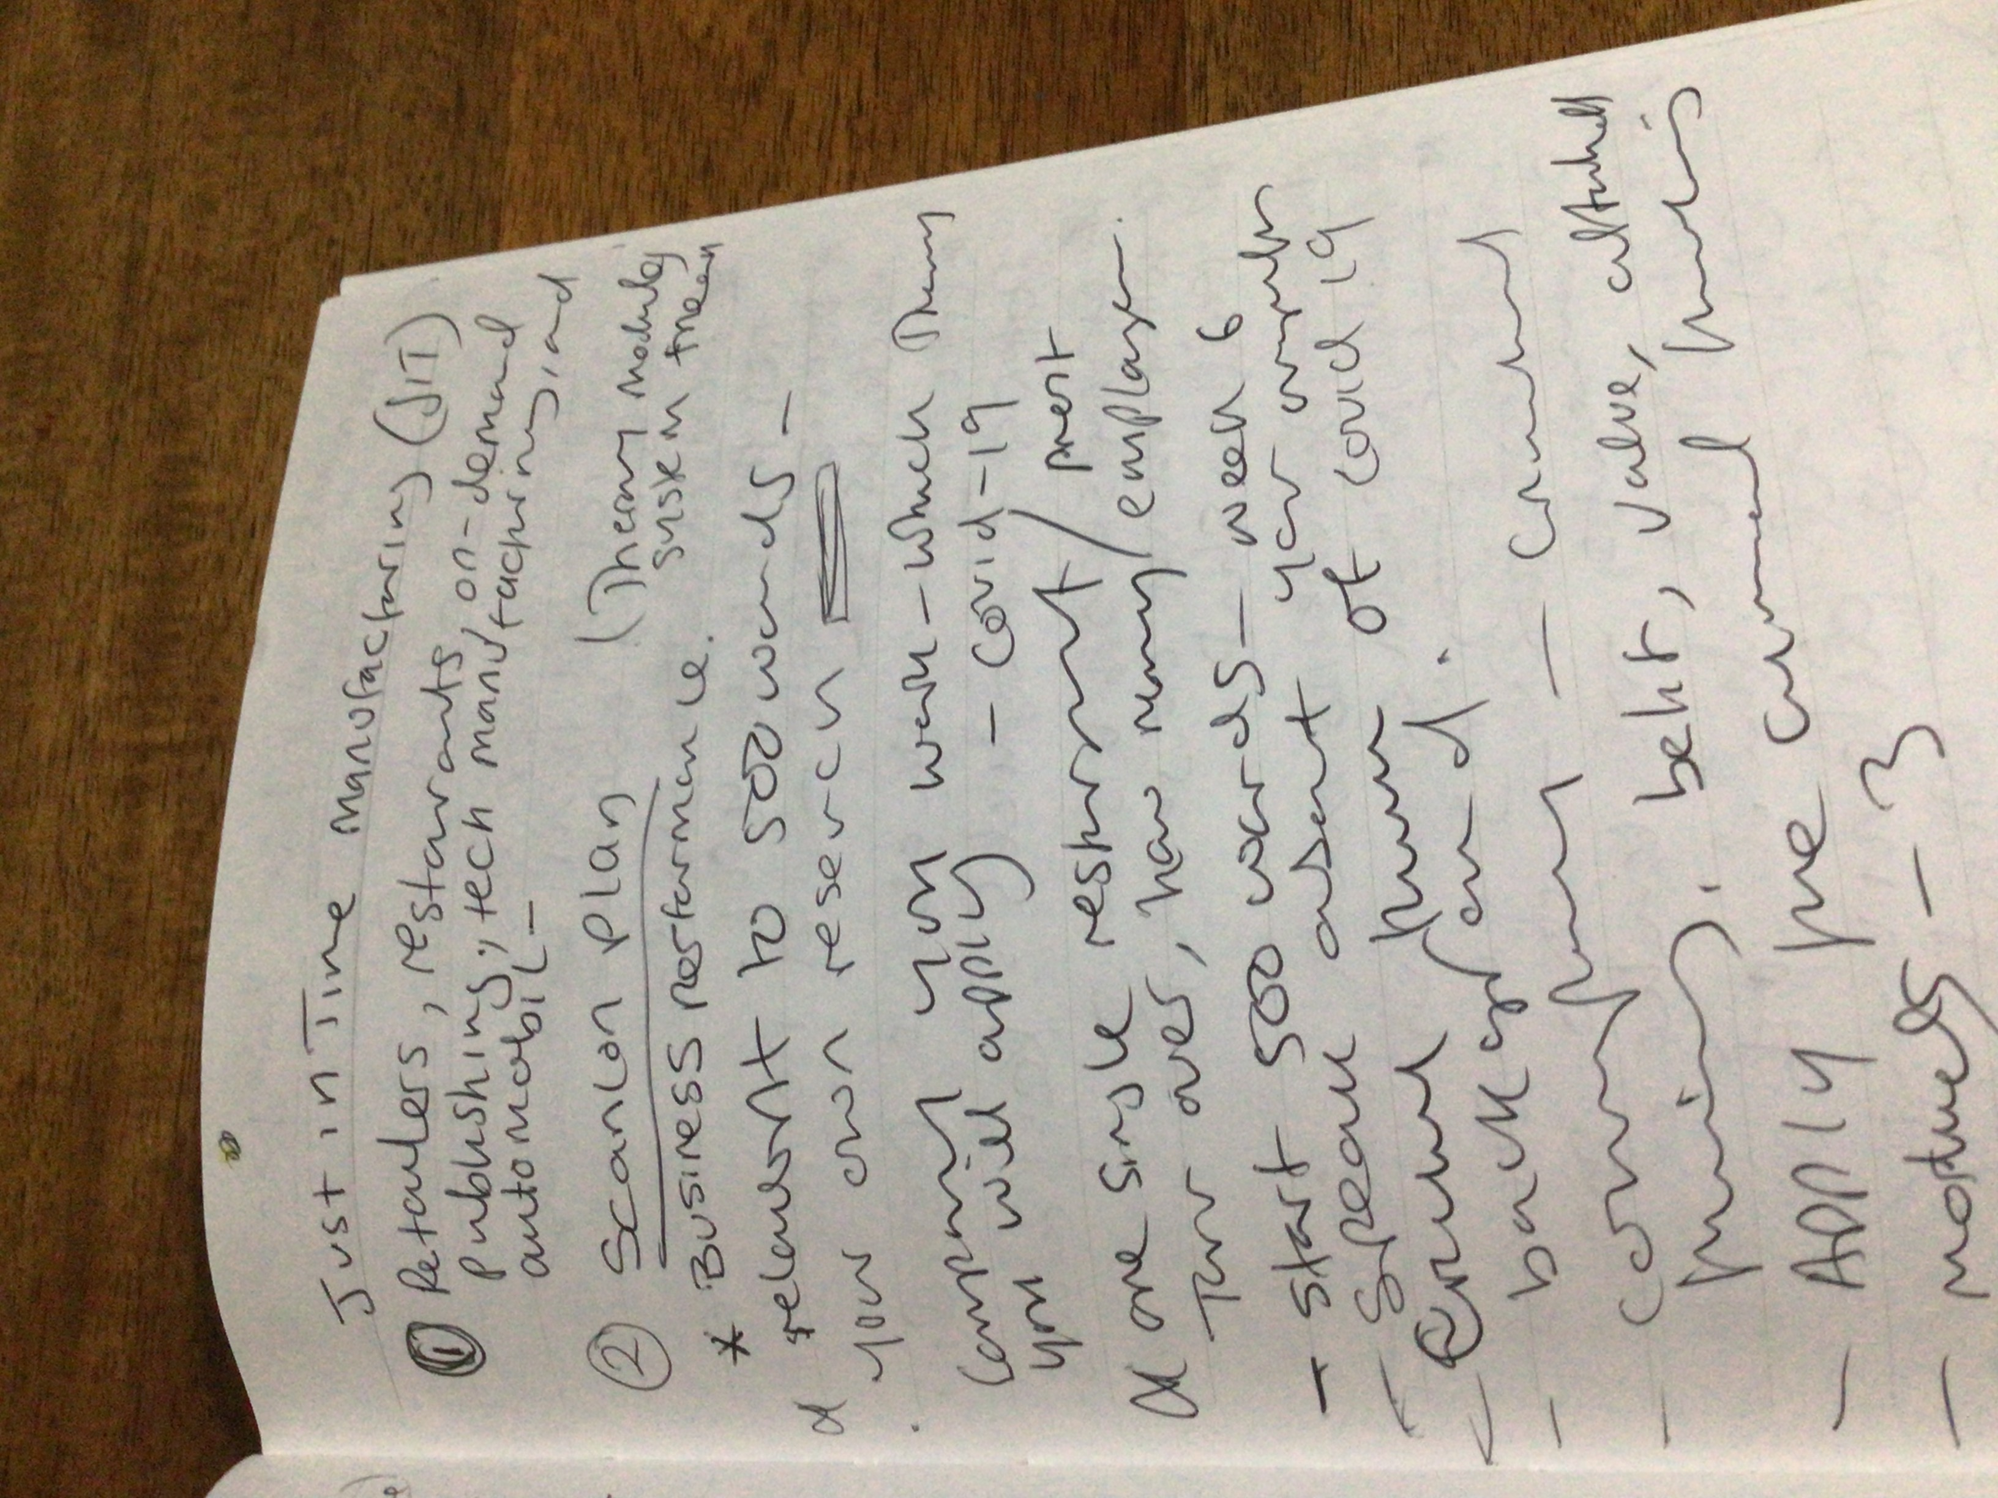
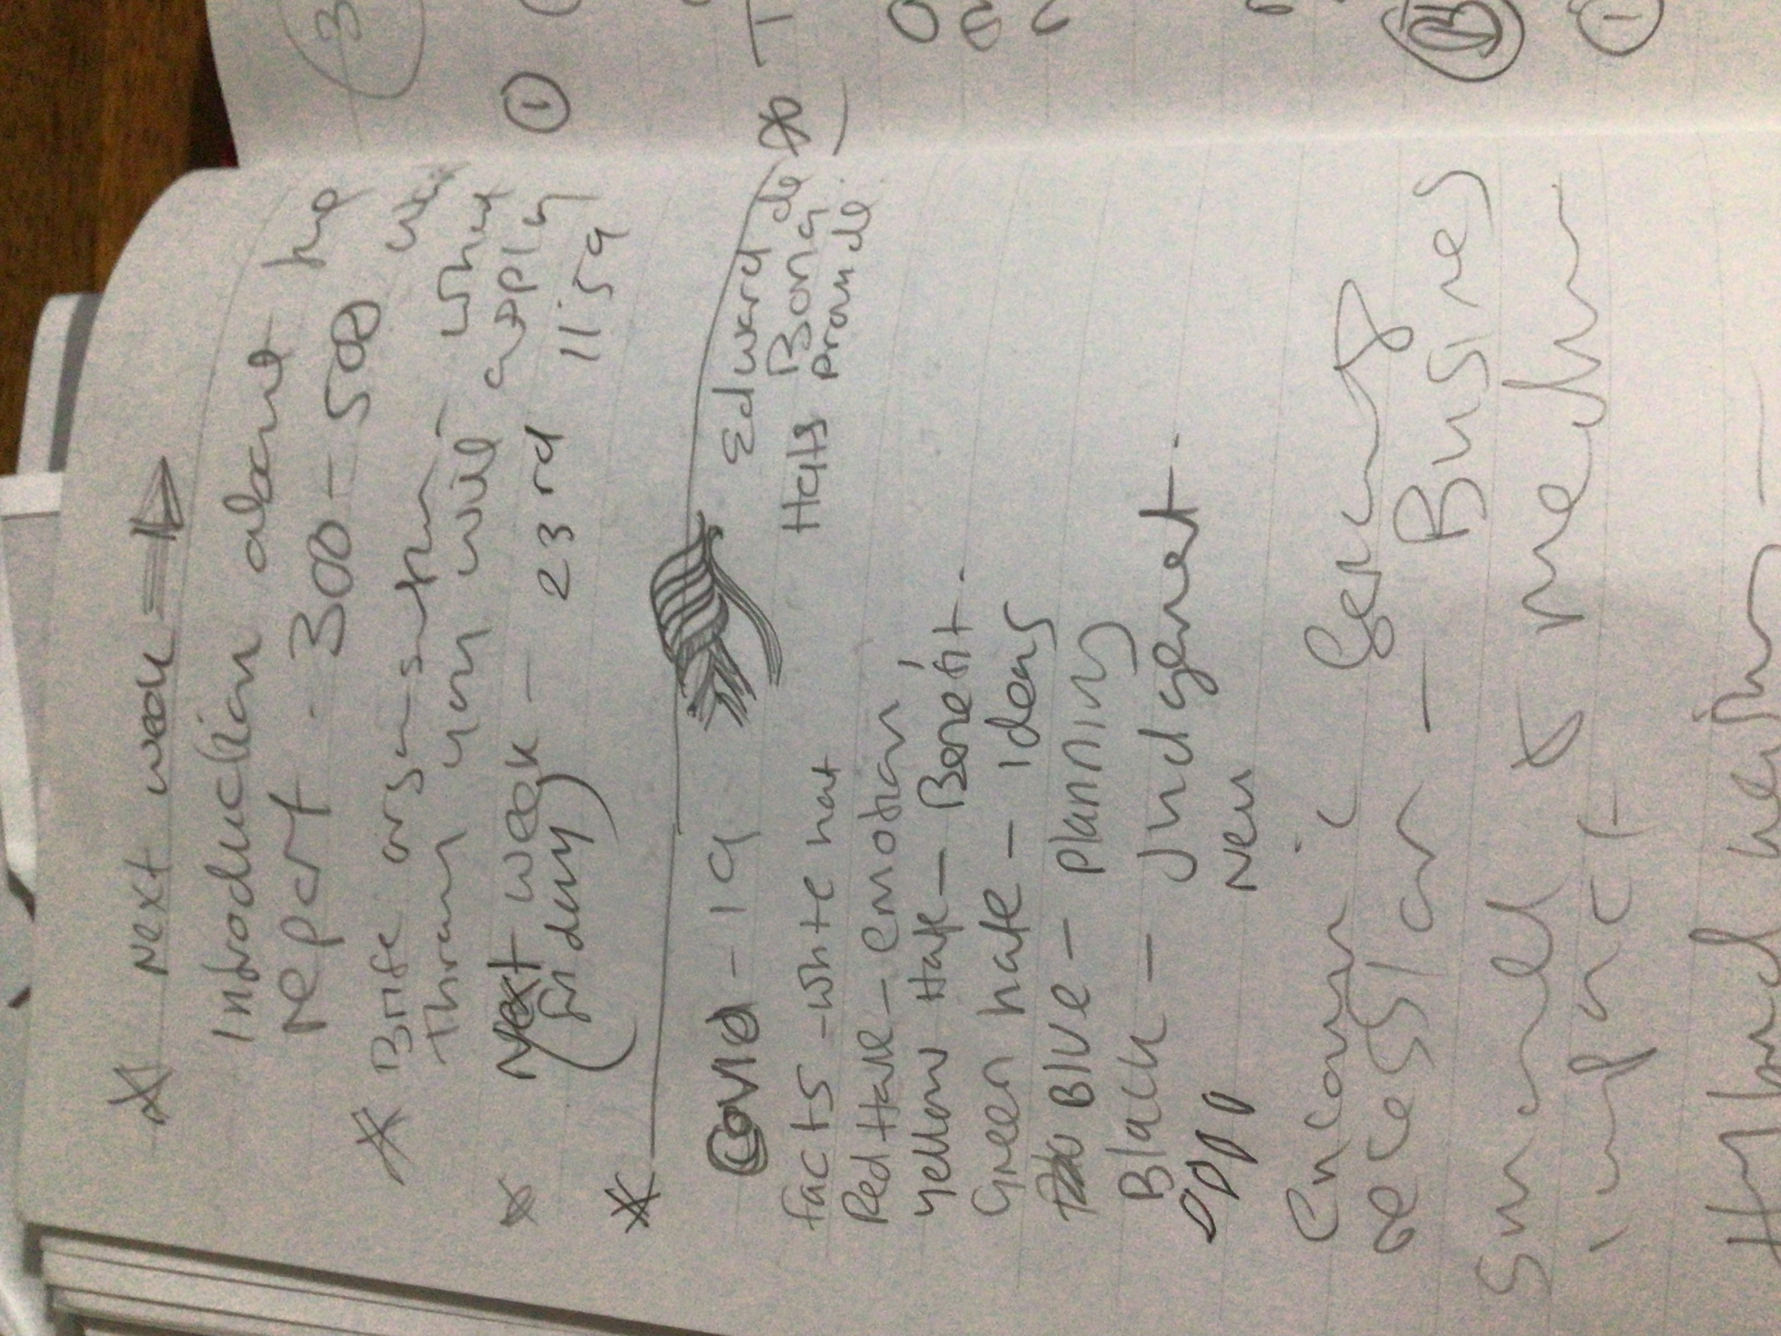
Appendix



