Learning in the Digital Era
Preparing for Higher Education
2022704
(BMPL4007/C)

James West

Preparing for higher education is an important factor when it comes to academically achieving your personal goals. Not only does it require knowledge and a variety of skills, but it also requires effective time management, careful planning and discovering what works best for you when it comes to studying. A key element of preparing for higher education is finding out what is your most efficient way to study. Different students have varying preferences when it comes to effective learning. While one student may find listening to the instructor more helpful, another student may prefer the method of taking notes. (Shier, 2020)
Time keeping and setting personal targets can also be important as it helps students achieve their given deadlines. According to (Whipple, 1927) when it comes to studying, you must actively work towards your objective, also you must not allow your attention to stray from the work at hand. Short breaks throughout study have also been proven to be beneficial for students, regularly taking breaks prevents the brain from experiencing exhaustion and restores cognitive functions, leading to improved motor skills, better information retention, and enhanced ability to recognize patterns and make conclusions. (StudySmarter UK, 2023) Another important skillset to develop when starting higher education is planning and organisation, keeping up to date with emails and deadlines will prove to be crucial throughout the academic year. Engaging in effective planning offers a well-structured lifestyle, enabling you to manage your education, work, and personal life. This balance ensures the successful completion of coursework while maintaining control over day-to-day activities. (Hoost, 2020)
When it comes to preparing for higher education, students at UWTSD are provided with the HWB application, the HWB serves as a central hub that provides you with all the necessary information and assistance to maximize your experience at UWTSD. As shown in the image below, it is the single destination where you can access the comprehensive support needed for your academic journey. Becoming familiar with the tools offered by UWTSD will significantly contribute to your academic growth and help you make the most of your educational experience at UWTSD.

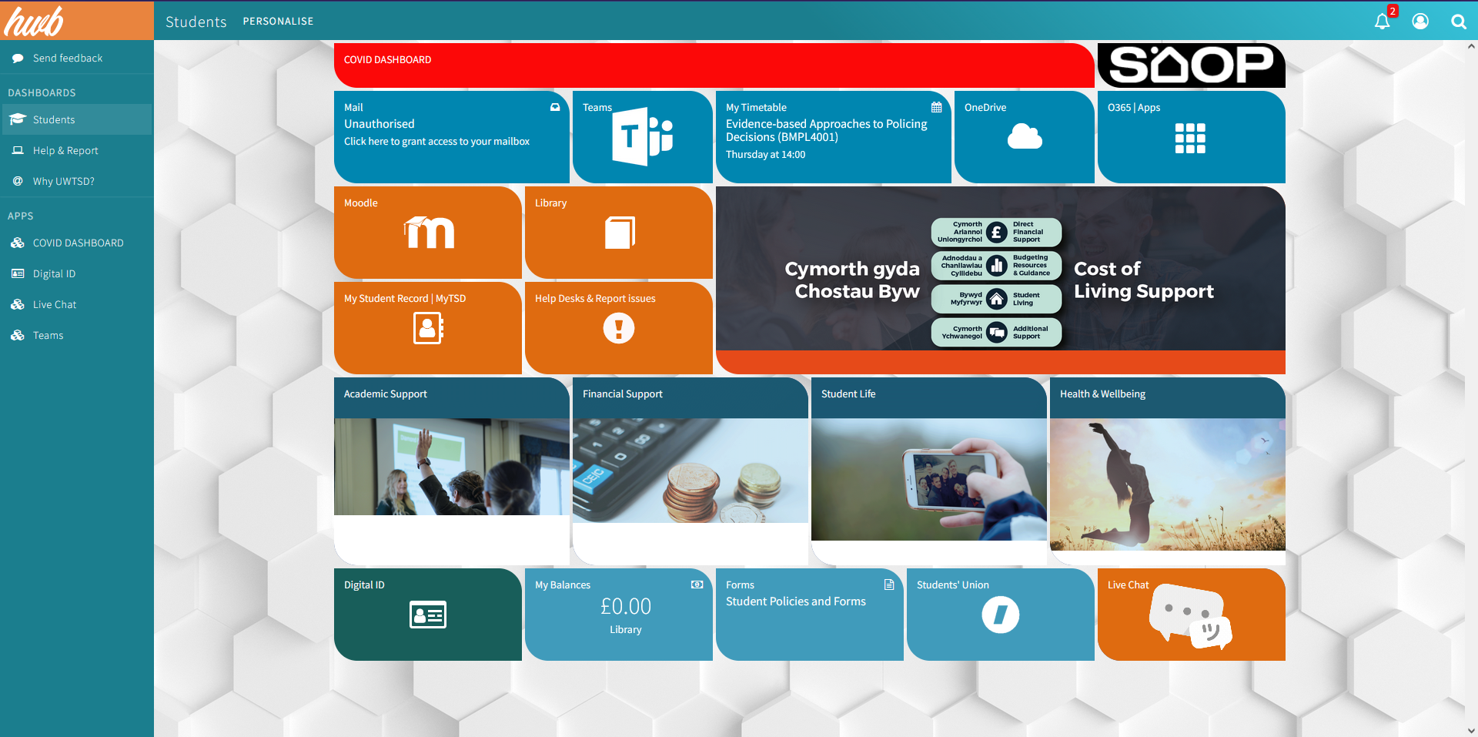
Figure 1:https://hwb.uwtsd.ac.uk/dashboard/student
Mind map: Becoming a Digital Learner

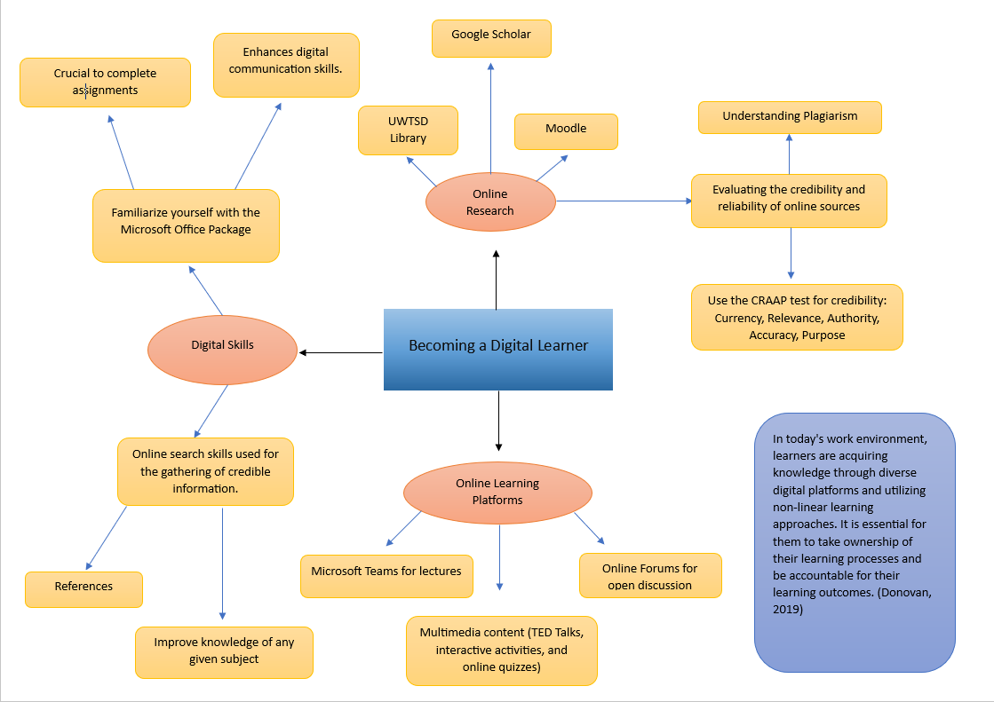

Personal Identity Video Presentation

https://uowtsd-my.sharepoint.com/:p:/r/personal/2022704_student_uwtsd_ac_uk/_layouts/15/Doc.aspx?sourcedoc=%7BF1FD5791-C33C-44AE-AE81-2054F161734F%7D&file=Personal%20Identity%20Video%20Presentation%20.pptx&action=edit&mobileredirect=true

Reflection on Starting University

Starting university can offer mixed emotions depending on the individual. Although, the beginning of a new journey it can be nerve racking for new students or students who have been a long time out of full-time education, it can also be a time for excitement, offering students a new career path and life goal to work towards. During 2020 I enrolled into higher education for the first time, choosing to study CertHe Digital Skills here at University of Wales Trinity Saint David. Once enrolled I was curious to see if I cope with the tasks offered to me throughout the year as I had been out of the classroom since secondary school in 2009. Not having written a single assignment in my life I had no idea where to begin, although having the guidance of the lecturers and all the help provided at UWTSD I slowly started to get to grips with things. At first, I found a few struggles as I had zero idea how to reference, and as I am a shy individual, I found it difficult at times to get involved in the lectures as I would have liked, but over time became more comfortable around my classmates. I found that becoming friendly with fellow students was a huge positive throughout the academic year as I found that all the stresses and confusion I was going through, they were experiencing also, and with that we managed to help one another throughout the course. Since starting CertHe Policing Profession in May, I have found there are some changes that I need to adapt to. Whilst studying Digital Skills the referencing on the assignments provided were referenced using IEEE, having done an entire year of doing so, I am struggling to adjust to the Harvard School of Referencing that is required for this year’s assignments, but I’m confident that over time and with enough practise I’ll develop a better understanding of what is required.
Although having a previous understanding of online learning, I have had to refresh my memory with the online resources provided by UWTSD. At first, I was having a few struggles with logging into Microsoft teams but after watching a few tutorials online to jog my memory I have quickly got to grips with things. Without the ease of access and the simplicity of resources such as Outlook, Moodle, and the online university library it would making writing this assignment an even bigger task for myself than it already is. Starting life again as a student will take time getting used to a routine where I have time for work, study, lectures, social life and all the stresses that life has to offer. The first thing I had to do once preparing for study is make a clean and clear work area in my spare room, and to limit the room of any distractions. Maintaining a tidy and organized workspace is highly significant. Research has consistently shown that a cluttered work area hinders information processing and makes it challenging to concentrate on important tasks, priorities, and projects. (Day, 2022)
When it comes to preparing to write my first assignment, the first thing I had to do was carefully read and understand the assignment brief provided. With the knowledge of what was expected of me and the deadline date I could then begin to set myself personal deadlines throughout the month giving me something to work towards, instead of waiting until last minute like I done a lot in my previous year of study. Although I find the panic and stress a good form of motivation for myself, I have found doing assignments one piece at a time a lot easier to manage. By understanding the value of time and using it efficiently to concentrate on our objectives, we can accomplish a great deal with minimal exertion. (Panigrahi, 2022) The following step I would take would be to start by thinking of ideas and creating a plan or structure for my assignment. I’d proceed to do in-depth research using trustworthy sources to collect important information and evidence that supports my arguments throughout. As this being my first assignment I have written using the Harvard School of Referencing, I certainly expect feedback regarding my references as I am still slightly unsure if the sources, I have used throughout are ‘credible’ or not. As university is all about learning whatever feedback is given will be taken on board and will only improve my writing skills throughout the academic year on further assignments. Finally, once I have completed the main body of my assignment, I would allocate a sufficient amount of time to thoroughly go through my assignment, carefully examining every aspect including potential spelling or grammar mistakes. This process ensures the overall quality of my work and verifies its adherence to the provided guidelines, resulting in a more polished and hopefully compliant submission. According to (Maroof, 2017) when creating a document, avoid assuming that there is no requirement to review or proofread your writing, or that there isn't enough time to do so. It is always beneficial to review your work or seek assistance from a third party. Allow yourself and your work some time before submitting your essay, as taking a fresh perspective will assist you in editing your paper with a clear and objective viewpoint.
In conclusion, beginning my journey at UWTSD has filled me with excitement and anticipation. As I take my first steps into higher education and a return to online learning, I am eager to immerse myself in the learning opportunities, connect with like-minded individuals, and explore new horizons. I am confident that this experience will be productive and shape me into a knowledgeable and well-rounded individual. I look forward to the challenges, growth, and memorable experiences that await me at the UWTSD.

Personal Development Plan

Student Name |  | Student Number |  | Module |  | Code
James West |  | 2022704 |  | Learning in the Digital Era |  | BMPL4007  BMPS4009
What goals do I want to achieve? | How will I measure my progress? |  | What resources or support will I need? |  | How is the objective relevant to my personal aspirations? | What is the timeframe for the achievement of my goals?
Specific | Measurable |  | Achievable |  | Relevant | Timebound
Improve my time keeping, planning and organisation | Creating a weekly rota where all my tasks and objectives will be logged. |  | I aim to create a schedule using Microsoft Excel which will be updated daily on upcoming tasks and objectives. The tasks will be colour coded green, yellow and red which would be relevant to the importance and urgency of each given task, with red being urgent and green being a minor task. |  | After being out of higher education for a few years I have struggled with time keeping, planning and organisation. By creating a rota, it will give me the opportunity to strictly follow a schedule keeping me in a line with tasks provided by UWTSD. Not only will this improve my time keeping, but it will also help me organise plans outside of university and improve my social life by being able to make time around my work. | Creating the rota is an imminent objective that needs to be kept on top of weekly throughout the year.
Learn how to correctly reference credible sources using the Harvard School of Referencing | Using the weekly rota, I will schedule a time slot each week to educate myself on how to correctly reference using the Harvard School of Referencing |  | Spending time studying online tutorials and listening to feedback provided by lecturers at UWTSD I will gain a better understand of the task at hand. |  | Learning about what is acceptable as a credible source and correctly referencing using the Harvard School of Referencing, I will be able to correctly acknowledge and give credit to the original sources of information and ideas used in my work, ensuring academic integrity, and avoiding plagiarism. By doing this I will achieve higher grades in all my work moving forward. Referencing involves recognizing and attributing the sources of information utilized in academic work, giving proper credit to the original authors for their ideas, research, or words incorporated into essays or research papers. (Nyadzi, 2023) | I will be taking weekly steps to improve my referencing and I’m hoping with further feedback and personal study my referencing will have improved vastly by my next due assignment.
Maintain and improve fitness | Coinciding with the weekly rota, scheduled in time for daily gym work and meal prep. |  | By using the rota to make time for the gym each day I will be able to maintain a reasonably decent level of fitness. |  | According to (CDC, 2023) engaging in physical activity can enhance cognitive abilities, facilitate learning and problem-solving, and contribute to emotional well-being. It can boost memory, alleviate feelings of anxiety or depression, and promote a sense of emotional balance and enjoyment. By maintaining good levels of fitness will keep my body and mental health intact for the foreseeable future. | The maintenance of my goal will require daily training and a balanced diet, although I would like to see a large improvement on my fitness levels within the next 6 months.
Become more familiar with the online library provided at UWTSD | By regularly using the library at UWTSD for research for my work throughout the year. |  | When looking for references moving forward, instead of just looking online I’ll take more time to learn the ins and out of the online library. |  | The library at UWTSD has a large variety of information that can be used for references on all the assignments set for me over the course of the year. By becoming more familiar with how it works will provide me with better quality references and credible sources. | My goal is to become more familiarised with the online library at UWTSD within the next 6 weeks. By doing so I can provide more credible sources in my work in future assignments.

References
Carmack, N., 2017. What does team player really mean?. https://www.citethisforme.com/cite/sources/websiteautociteconfirm ed. s.l.:BOS Staffing.
CDC, 2023. Physical activity boosts brain health. https://www.citethisforme.com/cite/sources/websiteautociteconfirm ed. s.l.:Centers for Disease Control and Prevention.
Day, L., 2022. Importance of a clean & tidy work area. https://www.momentumjanitorial.com/reasons-to-keep-your-work-area-clean-and-tidy/ ed. s.l.:Momentum Janitorial.
Donovan, M., 2019. Becoming an effective learner in the age of Digital Evolution. https://www.citethisforme.com/cite/sources/websiteautociteconfirm ed. s.l.:Training Industry.
Hoost, R., 2020. Planning is key. https://www.eccollege.org.uk/news/planning ed. s.l.:Ebenezer Community College.
Kurp, Y., 2021. What is identity and why is it important?. https://dis-blog.thalesgroup.com/identity-biometric-solutions/2020/09/15/what-is-identity-and-why-is-it-important/ ed. s.l.:Thales blog.
Maroof, N., 2017. The Importance of Proofreading Your Documents. https://www.linkedin.com/pulse/importance-proofreading-your-documents-nayab-imran ed. s.l.:LinkedIn.
Nyadzi, R., 2023. 10 importance of referencing and citation in academic writing. https://www.citethisforme.com/cite/sources/websiteautociteconfirm ed. s.l.:Cegast Academy.
Panigrahi, S., 2022. Importance of Time Management skills for Students. https://www.thehighereducationreview.com/news/importance-of-time-management-skills-for-students-nid-1135.html ed. s.l.:Higher Education Review .
Shier, M., 2020. 2.1 learning preferences and strengths. https://opentextbc.ca/studentsuccess/chapter/learning-preferences-and-strengths/ ed. s.l.:BCcampus.
StudySmarter UK, 2023. Study breaks: Importance, productivity, ideas: Studysmarter. s.l.:StudySmarter.
Whipple, G. M., 1927. How to Study Effectively. Bloomington, Illinois: Public School Publishing Co..

