Take-Away Test

Q. How effective was Medieval artwork at portraying ideas about death?

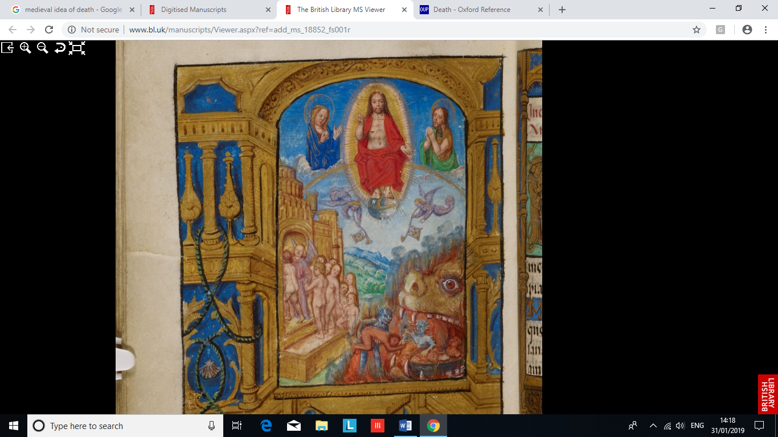
In the eyes of medieval people, death was not seen as the complete termination of life, as the Oxford English Dictionary suggests, but instead only the end of its earthly aspect, as it was believed that the soul continued onto the afterlife (Ed. by Angus Stevenson). This was either in the form of Heaven, for the most pious individuals, Hell, for the most sinful, or purgatory, for those who required the cleansing of their souls. Not only this, but the concepts of resurrection and reanimation were not unheard of at the time, and it was believed that these outcomes were entirely plausible for the dead. As such, the topic of death intrigued the artists of the Medieval period, resulting in a number of artworks portraying aspects of death, to varying degrees of success.
Figure 1: Miniature of Christ and the Last Judgement, 1486 – 1506, from MS 18852, fol. 293v. Accessed from The British Library (http://www.bl.uk/manuscripts/Viewer.aspx?ref=add_ms_18852_fs001r).
Firstly, the concept that there is a life after death is demonstrated by the ‘Last Judgement’, whereby everyone who has ever lived will be judged by God and sent to either Heaven or Hell. Figure 1, which dates from the late 15th century, is an image of the ‘Last Judgement’, as it clearly depicts one group of souls being led up to Heaven, while another group is being fed to Hell. This idea of feeding the souls of the damned to Hell, which is depicted as a beast-like creature, is quite common during the period and, as Alixe Bovey points out, is evident in various other medieval manuscripts such as the ‘Winchester Psalter’ (Alixe Bovey). Furthermore, this depiction of Hell is reinforced by ‘the vision of Tundale’, which claims that Hell is full of fire, in the form of pits, mountains and valleys, which is all similar to Figure 1’s portrayal (Vision of Tundale, accessed from Eileen Gardiner). As such, Figure 1 is relatively effective in its portrayal of the ideas of death, but an analysis of its depiction of Heaven is also necessary to fully understand how effective this image is.
Continuing from this, Heaven, in Figure 1, is depicted as a golden building, magnificent in structure, with the staircase leading up to it full of the pious and the just. Again, accounts of Heaven being a building are common in the period, with references to such being found in the ‘vision of Thurkill’, which claims that Heaven, or the Mount of Joy as the text refers to it, is a “large church of wonderful structure”, which again demonstrates the accuracy of Figure 1’s portrayal of Heaven (Vision of Thurkill). As such, all of this demonstrates the medieval idea of life after death in an effective way, as the story of the ‘Last Judgement’ and the characteristics of the afterlife would have been well known to all Christians, meaning that the image’s portrayal of the afterlife is effective.
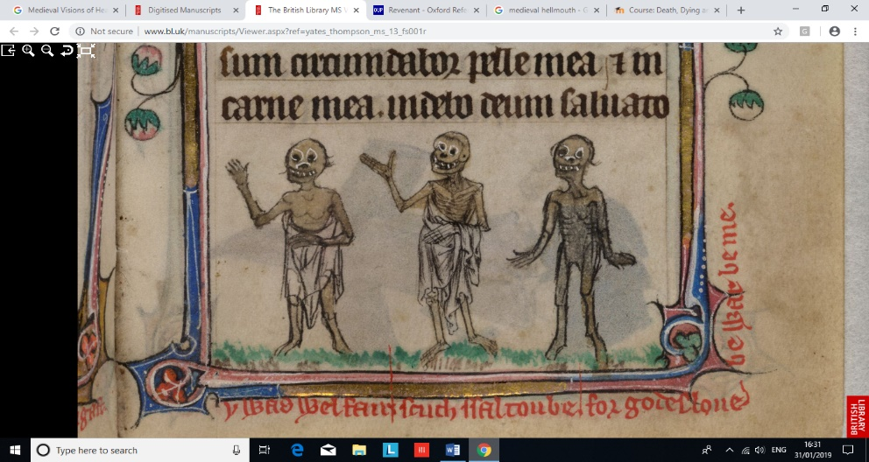
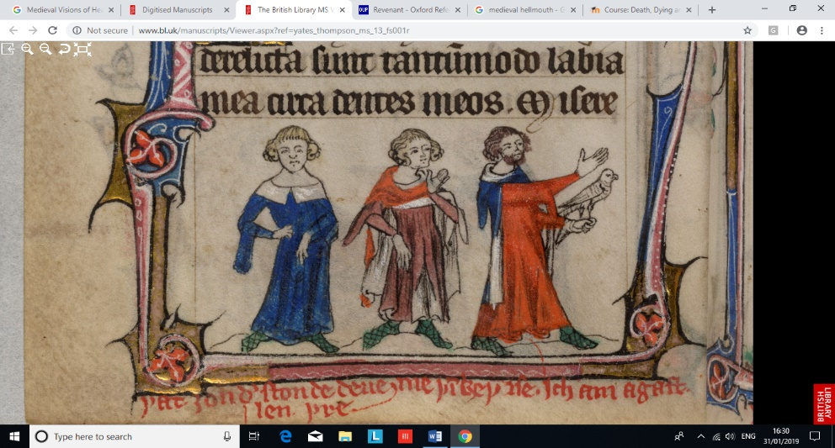
Figure 2: The 3 Living and the 3 Dead, from Yates Thompson MS 13, fol. 179v & 180r. Accessed from The British Library (http://www.bl.uk/manuscripts/Viewer.aspx?ref=yates_thompson_ms_13_fs001r).
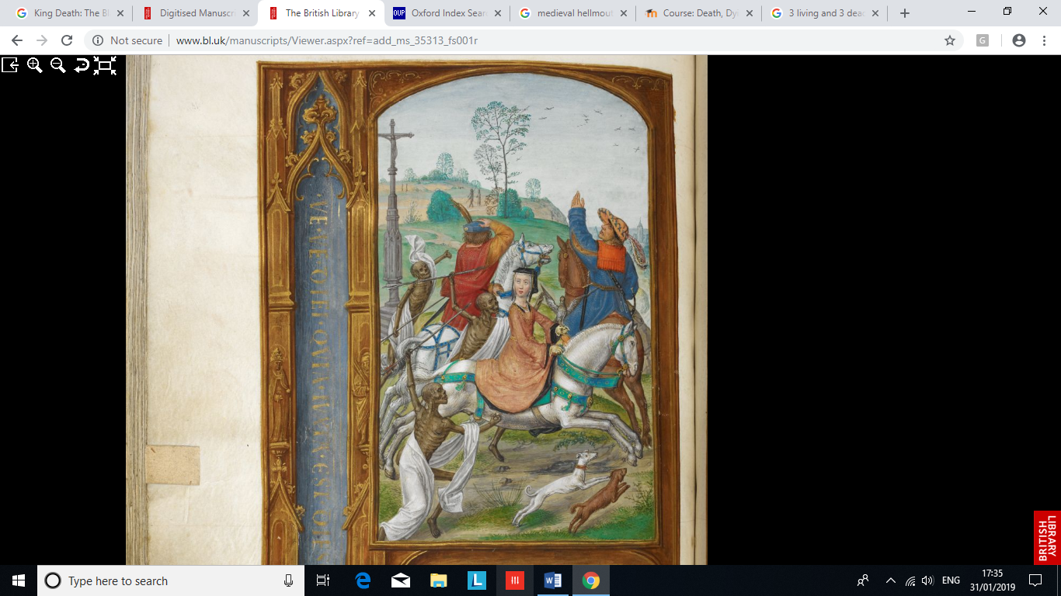
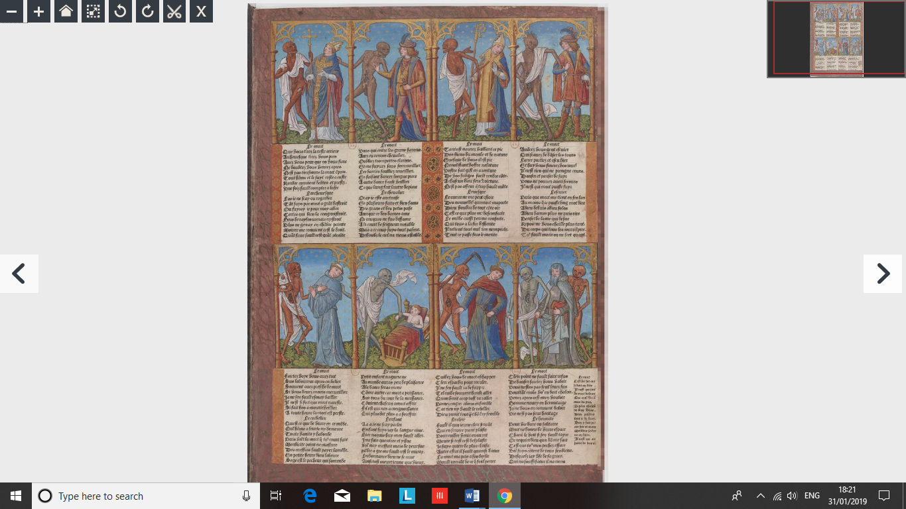
Another idea of death that medieval artwork portrays is that the dead can come back to life. The most famous example of this in Christianity is Jesus’ resurrection, whereby Christ was crucified but was then brought back to life by the power of God. Again, images and artwork of the Crucifixion reinforce the medieval idea that death was not the end. However, another example of the dead coming back to life, although for a different reason, is evident with the idea of revenants, which, according to the Oxford English Dictionary, are people who have returned from the dead (Ed. by Angus Stevenson). The best example of this is artworks depicting the Three Living and the Three Dead (see Figure 2), which, unlike Jesus’ death, is more about reinforcing Christian ideals rather than reminding them that death is not the end. The tale goes that three noblemen, seen on the left of Figure 2, were out hunting when suddenly three revenants, seen on the right, appear. The dead, who according to Colin Platt, are depicted as rotting corpses, inform the living that they are their ancestors, and that the living need to remember and commemorate their dead in the correct Christian way, instead of neglecting their duties as they had been (Colin Platt). As is evident here, not only does this reinforce the medieval idea of life after death, it also focuses on the concept of the dead returning to the living in order to warn their descendants. However, there is some question over who the living actually represents, as some suggest they are noblemen, while others claim they are kings. Interestingly, Figure 3, a Book of Hours attributed to Joanna I of Castile, portrays a noblewoman, potentially Joanna herself, as one of the three living characters (The British Library, MS 35313 fol. 158v.). Due to this, the questions raised over the participants of these images is further demonstrated, leading to a decrease in the effectiveness of this type of medieval art and its ability to portray ideas about death.
Figure 3: The Three Living and the Three Dead, c. 1500, from MS 35313, fol. 158v. Accessed from The British Library (http://www.bl.uk/manuscripts/Viewer.aspx?ref=add_ms_35313_fs001r).
Figure 4: The Danse Macabre, 1491 – 1492 from ou l’Empire de la Mort, sur tous les états de la vie humaine. Accessed from Gallica (https://gallica.bnf.fr/ark:/12148/btv1b10542297k.r=danse%20macabre?rk=85837;2)

One final idea that medieval art can portray about death is its ability to take anyone at any time, no matter the social status, wealth, or piety of an individual. It is clear, even nowadays, that death can strike at any time, and this was the same during the medieval period, as is evident by artwork that depicts the ‘danse macabre’. The Dance of Death is the personification of death and its ability to take anyone of whatever age or profession, as depicted in Figure 4, which portrays a number of different people, including a baby and a hermit. The baby is obviously an example of youth, while the hermit, who is depicted as an old man with a walking stick and grey beard, is meant to portray the elderly. Not only this, but the position of an individual in society, or their piousness, has no impact on their ability to combat death either, as death is taking individuals from the higher ends of society, such as the knight, as well as the most pious, such as the archbishop, to the lower ends of it, such as the cleric or squire. As is evident with all of this, age, wealth, or piousness seem to make no impact on death and cannot save anyone from it, no matter how hard the individual tries to protect themselves. This is all reinforced by the presence of the Black Death, which according to John Kelly killed 200 million people worldwide (John Kelly). It is due to the activity of this plague, that death was clear to the people of the Medieval period as it was occurring almost on a day to day basis. Due to this, medieval artwork portraying the idea that death can take anyone is highly effective.

In conclusion, medieval artwork does indeed seem to be effective in its portrayal of death during the period, as is evident by the ‘Last Judgement’, the ‘Three Living and the Three Dead’, and the ‘Danse Macabre’. Whether artwork is representing the Christian afterlife, the idea of reanimation, or that death can strike at any time, it is clear that, as long as a basic understanding of the Christian faith was known, these artworks all effectively portray death as the unpredictable end of our physical life on this Earth.
Words: 1184.

