Table of Content

1.Introduction
2.Career Development and Personal Developments
3.Employability
4.Conclusion
5.References

Personal and Professional Career Development

1.Introduction
I am focus on increasing my capacity and my potential to gain better employment and develop my employability skills. This assignment will give me the opportunity to highlight strategies for personal reflection and career development planning through reflective evidence. My aim is to be fully confident in my understanding of the topic by the end of the work and to show through reflection that I can demonstrate my Employability. I will be able to reflect, analyse and learn from research to support and encourage my Self-Understanding. I will be able to show the ability to plan and develop using Self-Belief and Self Awareness.
This assignment will show self-awareness of my personal characteristics, using my ability to identify and articulate my values, strengths and weaknesses. My understanding and demonstration will prove the capability for gaining and maintaining employment. I am passionate about Customer Service and Customer Care and I wish one day to become a Customer Service Operations Manager. Career Development is so important to my personal development and l like to refer to it as Career Progression which also put everything into perspective. Career Progression is a result of a Career Promotion which is simply based on your personal development within an organization. It is the way you conducted yourself making good use of all Employability skill that you possess and handle well.
Career Development and Employability are all about adaptability to a professional environment, I believe they influence a positive Change Management which could benefit to the employee or student if the manager the process well using all skill required. An individual development only depends on their determination and willingness to embrace training and development in order to increase their performance on a daily basis. The ability to learn and improve are the only factor that can lead to a real self-development and a long term Career.

2.Career Development and Personal Development (Self-Managed Learning)
It is very important for a student to have a serious dedication to his career development. This is important in order to gain confidence for any future employer chosen. An effective process of learning will help attain core competence with a strong working process; any student will find satisfaction in discovering their skills and strengths. And they will find their full potential through self-managed learning.
According to Bryson (D. 2011), in order to develop self-managed learning you can use monitoring, seminars & coaching centres, use of internet and social network.
- Professional Development and Personal Development
Self-Reflection: According to Davies (2005), recording personal reflection can help to find the areas of professional development focus.
Personal Leadership: According to Moon (2006), it helps individuals to work with highest potential by pursuing self-mastery.
As stated by Cottrell, personal development planning (PDP), I understand that PDP can improve my personal learning and planning I believe PDP can encourage a positive attitude throughout my learning life.
Also, as stated by Moon (2013), good communication is very effective if it is concise and direct. Saving time through time management can lead to success.
According to me, getting organised through effective planning, self-analysis and self-control is the best time management strategy.
Referring to Cottrell (2010), I wanted reflect on the PDP cycle chart below.
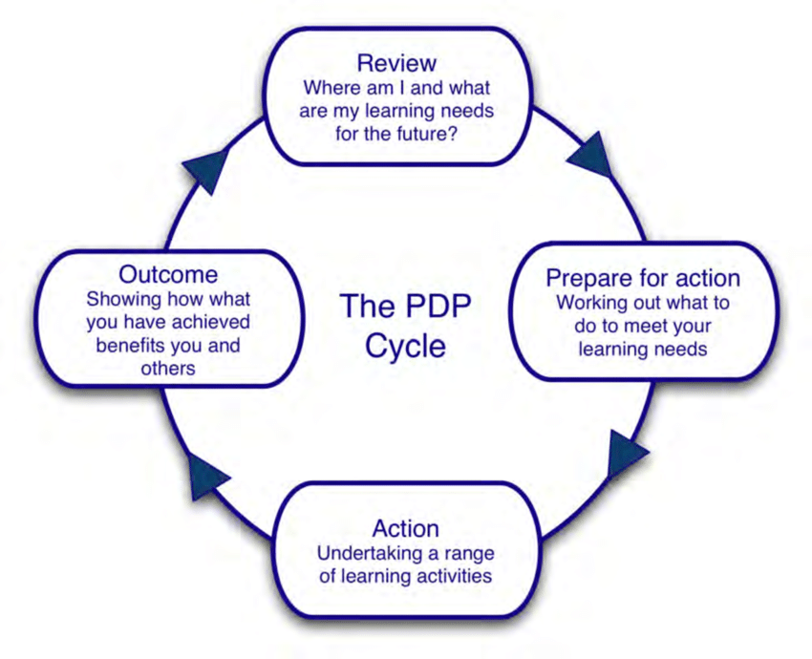
- Career Planning and Career Development
Donner and Wheeler produced a plan for professional development based on four phases:
Scanning the environment, my conceptual career-planning model is about identifying employability skill for the role and thinking about how they may change in the future. The questions I ask myself are will new technology impact on my current working environment or what skill do I need to acquire?
Undertaking a self-assessment, I will identify strengths and weaknesses and target areas for future development. I can describe how that may affect my work.
Visioning the future, it is about beginning to outline an ideal career vision. I keep asking myself what skills I need to develop to position myself where I would like to be.
Strategically planning how to achieve those goals, this plan included what the career vision and goal is. A good question to ask myself is what resources I need to achieve my strategic plan, in terms of people, and finances per example.
My primary career interest is in Business management. It is a long-term goal to become a manager in Customer Service.
My short goal is to acquire advanced computer skill. The problem is the lack of time to do it due to job constraints. In order to overcome this, I need to find new training for more efficiently complete the tasks.
- Skills and Competences (Strengths and Weaknesses)
Chlebikova et al (2015), believes that shot analysis is the best technique to analyse your strengths and weakness / Opportunities and Threats:
Strengths: I am full of energy and determined, my professional backgrounds is good bases on my previous. Multitasking is one of the key strengths, having effectively and efficiently been able to respond diplomatically to many situations.
Weaknesses: It is when you do not know when to stop; I work so hard sometimes that I may lose, focus on others opinion. Some of my experience were not too long.
Opportunities: My talents and strengths are being fair and open-minded, strong communication skills. I also possess good research skill and the ability to follow details appropriately. An excellent work ethic is very important. I am very good at adapting to working environment. Based on Grainger’s Strategies, I could use my knowledge
According to Harvey (2001) and Knight & Yorker (2004), Organisational change is key to achieve employability goals. This change can be processed with the auditing of the curriculum to assess the level of racing & learning methods to meet employability Goals. Kindly see below my CV current status. it is a good way to assess the current state of skills and Experience.

My personal career progression is very important to me and I provided special attention on future opportunities:
Noella Wudala Pashome CV / Evidences of Experience
__________________________________________________________________
Baccalaureate with Fluent French and good English.
Hard working with strong interpersonal skills and great attention to detail, Ability to demonstrate a passion for exceeding expectations. Personality-wise, warm, professional and able to respond to others with sensitivity. Clear thinking, a solid work ethic and a real focus on customer experience.

Skills

- Passion about hygiene, flexible, reliable and be able to work at a fast pace
- Good Team Player
- Able to work shifts including early mornings and nights
- Can work well in a busy and demanding environment

Work Experience

- May 2018 – Present, Customer Adviser at Ventrica (For Jimmy Choo)

-To be the first point of contact for all customer queries
-To act as a brand ambassador for the client
-To reply to customer requests and enquiries in a professional manner
-To escalate any issue to the manager or relevant department
-To contact the company courier to book a collection/delivery of customers items.
-To be the voice of this esteemed brand
-To make sure that the customer is at the heart of every conversation.

- January 2016 – September 2017 Premium Manager, TLS, Visa Application Centre

-To offer a Premium Service package in the visa application Center for those who would like a higher quality and more personalized service in order to smooth the application process in a timely manner.
-Provide details on online purchasing for a travel insurance, which is compliant with the Shengen regulation

- 2015 – Receptionist & Event Coordinator at Elements Personnel | For 5 Stars Hotels

- Providing a first class meet and greet service to customers / visitors
- Management & care of our client's needs
- Dealing with customer enquiries (daily by email and phone)

- 2013 - Front of House Assistant / Guest Assistance Officer at Virgin Active Health Club

- Providing remarkable customer service by creating a great impression from the moment our members pick up the phone or walk into the club, enthusiastically welcoming them and providing a faultless representation the Health Club
- Effectively handling class bookings, payments, queries and managing member expectations to the highest standard.
- Deal with any member feedback in a timely and professional manner, showing that you take ownership of the situation and making sure to escalate the issue to the appropriate member of staff where necessary.

- 2012 - Female Member Care Assistant at Virgin Active Health Club

- Responsible for a variety of cleaning duties, ensuring the inside and outside of the Club is kept to a high standard of cleanliness, hygiene & safety.
- Deliver great customer service by actively seeking customer feedback and implementing improvements and solutions.
Personal Skills
Languages Fluent French and good English
Social Skills Good Listener, very punctual and extremely focus
Interests Debating society, sports like basketball and walking
- Career Development
According to knight & Yorke (2004), sustainable employability which is constantly remaining employability which is constantly remaining employable is important for a secure career development.
The Universities UK Report Enhancing Employability (Harvey et al 2002) attributes willingness to learn the development of career management skills.
Regarding my career development learning, I would like to say that in the light of changing circumstances.
My own development focus keeps me committed to lifelong learning and able to learn from my mistakes. I focus on learning from my experiences and understanding different style of learning. I want to explore my future career based on the relevance of the skills; this will definitely increase my motivation for employability box ticking.
Extra curriculum activities are powerful skill: such as computer-assisted career development learning Programmes and self-preservation. Sessions on career management skill.
- Development Plan
Training Plan Implementation: Through obtaining a certificate in management
Learning Plan; Acquire Effective skills in problem solving and decision-making
Action plan: to complete course in management problem solving
Evidence: I know present myself better and communicate in a professional manner. I successfully achieved those training through previous. The chart below from Komiya (S. 2014) perfectly describe my development plan.
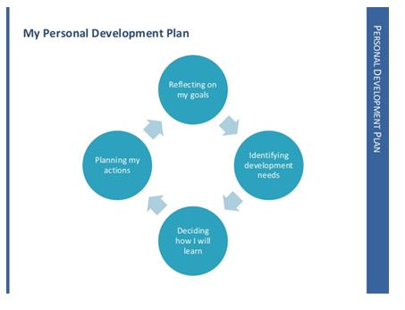

- Personal Development Planning
My professional growth and career aspirations are to use my knowledge to contribute to better management processes. The knowledge and skills that I need to enhance are my technical skills and creating efficient presentation.

Common Development activities: are as followed:
-Read more relevant material
-Engage in training and receive coaching
According to Watts and Hawthorn (1992), Self-Awareness’ is very important as it helps understand the kind of person you are and the kind of person you wishes to become. I have the ability to build constructive working relationships through cooperation and mutual respect.
Personal Development planning processes are important as an effective bank of evidence useful for the future employers. I did find that process was useful in helping m reflect on my personal development.
In the past, I was able to resolve difficult challenge using diplomacy, especially while working in customer service / customer care.
For my personal development planning, I can use my previous knowledge acquired through previous employment to accomplish goals and develop the organizations’’ culture,
I believe it is important to gets along and interacts with people who understand and relates to others. My competences and willingness to work with others are personal skill that I want to keep developing.

- Personal Development and Action Plan
Strategies to achieve personal goals are supported by “Smart” approach; specific, meaningful, action based, realistic and time based. My strategies to achieve personal goals are to display a strong commitment to learning and self-improvement. To accomplish that, it is important to acquire new knowledge or skill.
Customer Service is one of my main area of expertise and development. My performance goals are to builds and maintain customer satisfaction. It will be an excellent service to future internal & external customers. I believe that listening to others and communicating in an effective manner will help me achieve my personal development.
It is important to be confident at all time as self-belief will increase the ability to perform. My personal performance should improve by developing fresh ideas that provide long-term solutions for all types of work place in general. It is a winning formula to pay attention to details and search for quality in accomplishing tasks. In addition, self-management will help me manage my own time and priorities.
Teamwork is good too, as it will promotes cooperation and commitment to achieve professional goals. In order to achieve professional development, I think that earning others’ trust and respect through professionalism will help me for consistent interactions. Demonstrating a capacity to adapt to working with a mixture of situations, individuals and groups.
This is a great sign of willingness and flexibility. From my own experience, I should carry on handling challenges diplomatically to keep on developing my interpersonal skills. Accuracy and commitment are essential to successfully complete a professional career.
- ACTION PLAN
Fundamental skills | Thinking skills | People and Social skills
Oral/Written Communication / Good Overall  G | Reflection / GOOD | Team working / work very well in a team
Numeracy / I am quite good with numbers and I was good at school with Mathmatices | Action Planning and Organisational skills / My CV sample that is included on this assignment proves that I was able to plan and coordinate activities for my team at TLS | Self-Belief / I believe it is link to self-confidence which is one of my quality
IT Skills / This is a skill I wish to further develop as IT is huge as an expertise, in the future IT skill will be worth so much more than today | Analysis and Decision Making / My work experience at TLS as stated in my CV part proves that Decision Making has been part of my job. | Influence and Negotiating / At TLS I had to Negotiate with clients all the time, internal and external clients
Use the empty columns on this page to make notes about where / when / how you use or demonstrate each skill.  I selected 2 in Yellow that I can / I need to improve and I made a small action below. | Problem Solving / I had issues to solve on a daily basis which I responded to in a very firm and delicate manner | Leadership / I had a team under my supervision a TLS , and as their Leader I was very open and flexible to their suggestions
 | Ability to put theory into practice / I NEED TO WORK ON THAT | Networking / Good networker always happy to meet new people with a smile.
 | Enterprise, Creativity, Innovation & Initiative / I am very open minded and full of fresh ideas, which how I was able to provide great initiative a TLS Contact Centre for Visa | Interpersonal skills / I have good manners when it comes to communicating with people.

Action Plan for Developing Your Skills
The first skill I am developing is: IT Skills
I will achieve this by starting next month with some special extra courses mainly on Excel training and development
The second skill I am developing is: Ability to Putting Theory into practice I will try to visit an Independent Business Consultant / a Tutor maybe supplied by the council. They will maybe be able to support me hopefully at a minimum cost.
PDP: Employability Action Plan
Objective for improvement and development | The practical steps I will take to achieve this objective | The resources I will utilise to help me | Date by which I will take practical steps required
Improving my Employability by developing my IT Skills and my Ability to putting theory into practice. | Take tutorial classes for each skill  It is now essential to acquire technical skills. | An expert tutor or assistance from the Council who can provide free support | End of September.  My aim is to become an empowered learner, with full set of competencies. I do possess good attribute, I am just trying to further my talents to be competitive enough for future careers.

3.Employability
Bawork by Yorke & Knight (2006) identified the word with an enhanced understanding of academic knowledge.
In my opinion, Self-Awareness, Integrity, Honesty, Career Management, Adaptability, Flexibility and Commitment are all very essential Personal Development skill that you can directly associate to Employability skills.
According to me, Employability is directly connected to all rational ways and methods that one would like to apply in order to provide an outstanding professional. To appeal to future employer based on employability skills, I think it will be very important to consider “change management” as a student will have to change their habits and corporate behaviour in order to adapt. To adapt you must change; this will help allow anyone to gain a professional maturity.
I want to have a professional career and improve my job prospects. This will helps me access well-paid career through my employability skill better known as work-readiness skills. It is important to make the most of opportunities within studies to develop employability skills, through group project work, presentations, student exchange programs, internship subjects, and mentoring programs.
Analytical skills and Numeracy Skills are very important: the ability to debate interpreting complex material; analysing data from an experiment and interpreting and constructing statistics; analysing data and presenting it in graphical format.
Self-management is about getting on with your work without someone having to check up on you. You should also be able to control and manage of your own deadlines and be able to delegate tasks to other people to make sure things get done on time.
It is essential to get involve in extracurricular activities such as clubs and societies, sport, public speaking, special interest groups, or community activities, as these experiences will also provide with evidence of skills for future job applications. For meaningful career development, you must align your work goals with the mission and vision of your employer.
- Employability characteristics/skills that I want to further develop:
Problem solving: Problem solving is about being able to find solutions when faced with difficulties or setbacks. Even if you cannot think of a solution straight away, you need to have a logical process for figuring things out, such as being willing to start, stop, and switch duties.
Communication skills: communication involves being confident about speaking to people. It also involves writing well enough and expressing ideas clearly when speaking or writing.
Leadership: such as to demonstrate efficiency and to seek to simplify processes.
Negotiating: it is having the skills to communicate diplomatically with someone in order to find solutions.
Interpersonal relationship: such as resolving conflict in a calmly manner and appropriately.
Critical and creative thinking: Initiative and enterprise are about being able to think creatively and to make improvements to the way things are.
Teamwork Customer service: means being good at working with people - both the people you work with and other people that come into contact with your organisation, such as contributing to team goals.
Planning & organising: Planning and organising are about things like working out what is required to get a job done, and then working out when and how you will do it. They are also about things like developing project timelines and meeting deadlines.
While studying, I can improve my skills via:
Mentoring,
Studying abroad and further study
More work experiences
Skills training
Entrepreneurship

4.Conclusions
Self-managed learning provided very helpful outcomes. Personal development is a very efficient alternative, which offers strong technique for individual’s development. To further my career development in the future, I will also seek support and expertise from senior career advisers for work in large organizations. Career development is an efficient and effective way for me to learn strengthens my employability. I gained strong insight on the personal development and career development through my research. It is safe to say that I have gained strong confidence and competence as effective employees. I am grateful to the high level of skills and knowledge that I was able to discover through this work. I have demonstrated a great readiness for employability and personal advancements.
I was able to identify my own personal strengths and the key areas for further development. My employment goals are now my focus for the next few weeks and months with an action plan.
Professional Career Development are very essential, it facilitate to demonstrate to potential employers your employability.
I think that Reflection, Action Planning, Organizational skills, Analysis, Decision Making, Problem Solving, Ability to put theory into practice, Creativity, Innovation, Initiatives and Work Awareness are very important thinking skills that will help boost a student personal and professional development if they are implemented the right way.
It is fundamental to use IT Skills, Numeracy, Oral and Written Communication, as I believe that they are key to an efficient and effective action plan.
I can demonstrate relevant work experience and ability to assess current and future situations.
5.References

Cottrell, S. (2010) skill for success: personal development planning handbook. London: pal Grav Macmillan, 2nd
Bryson, D. 2011, The Personal Development Planning Cycle, (Journal of visual communication in Medicine)
Chlebikova.et.al.2015 (SWOT Analysis)
Grainger.A, 2014 “Your Personal Development “
Komiya,S. 2014 ”Personal Development Through plan”
Donner, G, and Wheeler, M.(2001), Career Planning & Development, Fornures: The Time has come. Int Nurs Rev 48, 79-85
Davies, B. 2005, Educational Leadership Personal Growth for Professional Development, International Journal of Educational Management.
Moon.A.J.2006. Learning Journals: A Handbook for reflective practice & professional development. Taylor & Francis
Moon.A.J. 2013. Reflection in Learning & Professionals Development: Theory and Practice.
Harvey. L (2001). Defining and Measuring Employability. Quality in higher Education
Knight . p & Yorke, M (2004). Learning, Curriculum & employability in higher education. London:Routledger falmer
Harvey,L.Locke.w..&Morey,A. (2002). Enhancing Employability, Recognising diversity:making links beteew higher education and the world of work. London: Universities UK / Careers Services Unit
Yorke, M. and Knight, P.T. (2006) Embedding Employability in the Curriculum. York: Higher Education Academy.

