STUDENT NAME: Annette Smith

STUDENT NUMBER: 2512419

LECTURER: Christopher Wilkin

MODULE: BMSW4014

ASSESSMENT TITLE: AI Washing In Big Tech

DATE: 12th June 2026 Time: 23.59

Contents Page

1, AI Acknowledgement
2, PowerPoint slides
3, Supporting Notes 300 Words
4, The use of AI 200 Words
5, Appendix 1,2,3 & 4

AI Acknowledgement

I confirm that I have used AI in this assignment. I used ChatGPT to find information and I have included the screenshots as evidence.

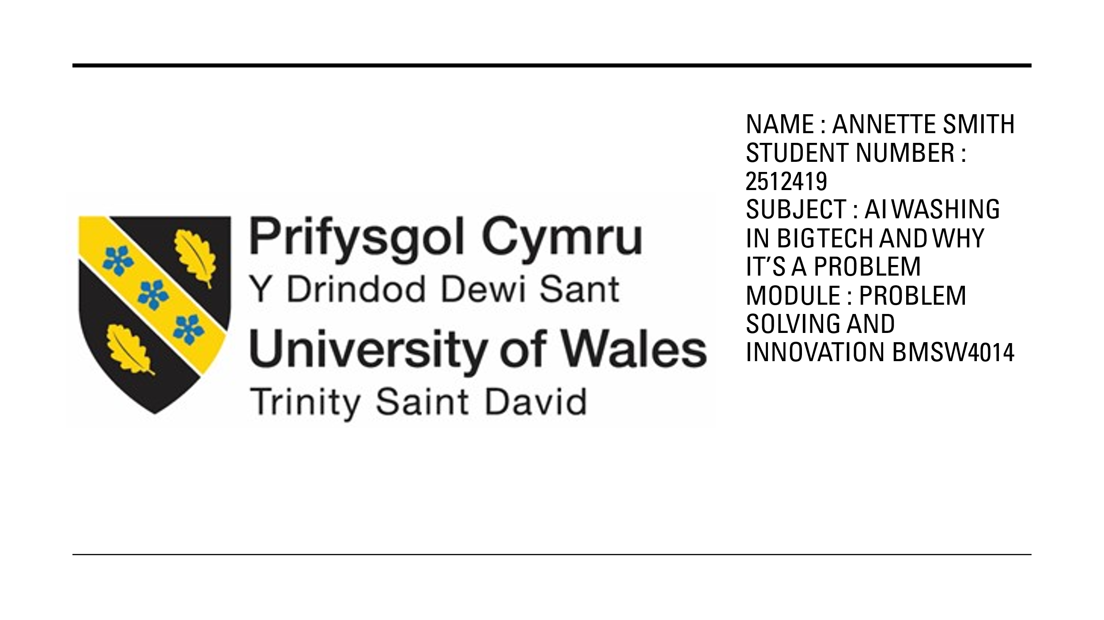
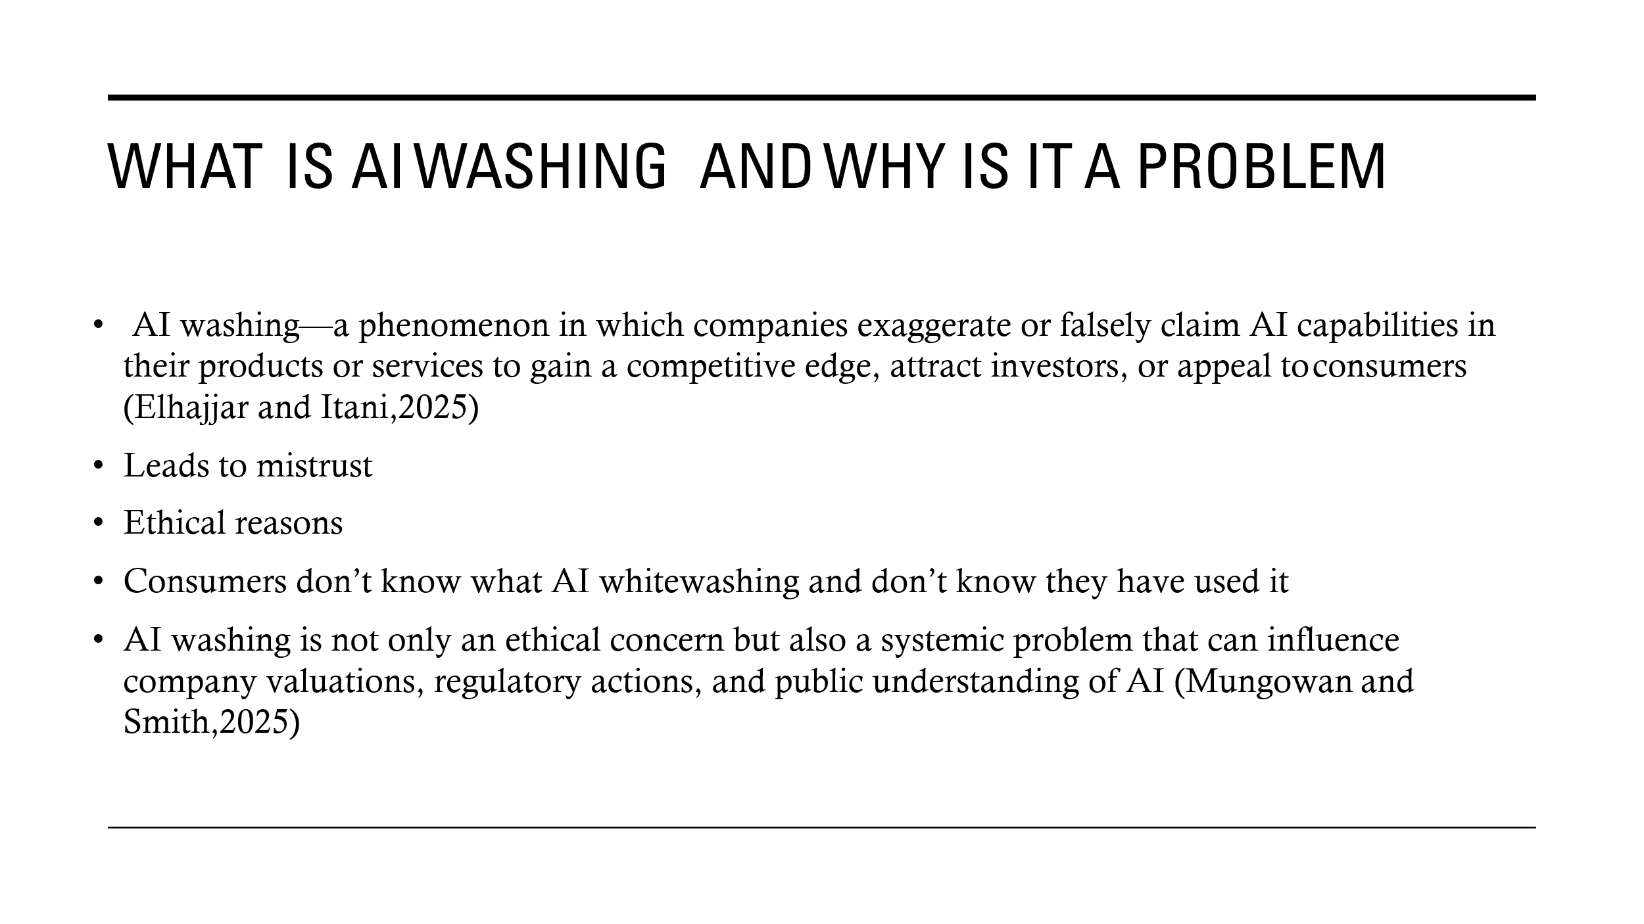
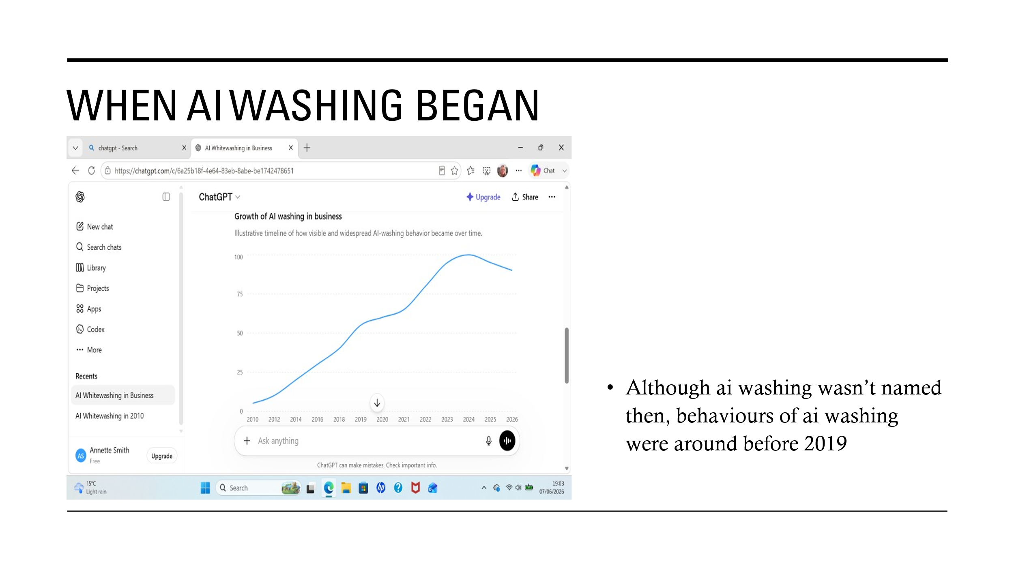
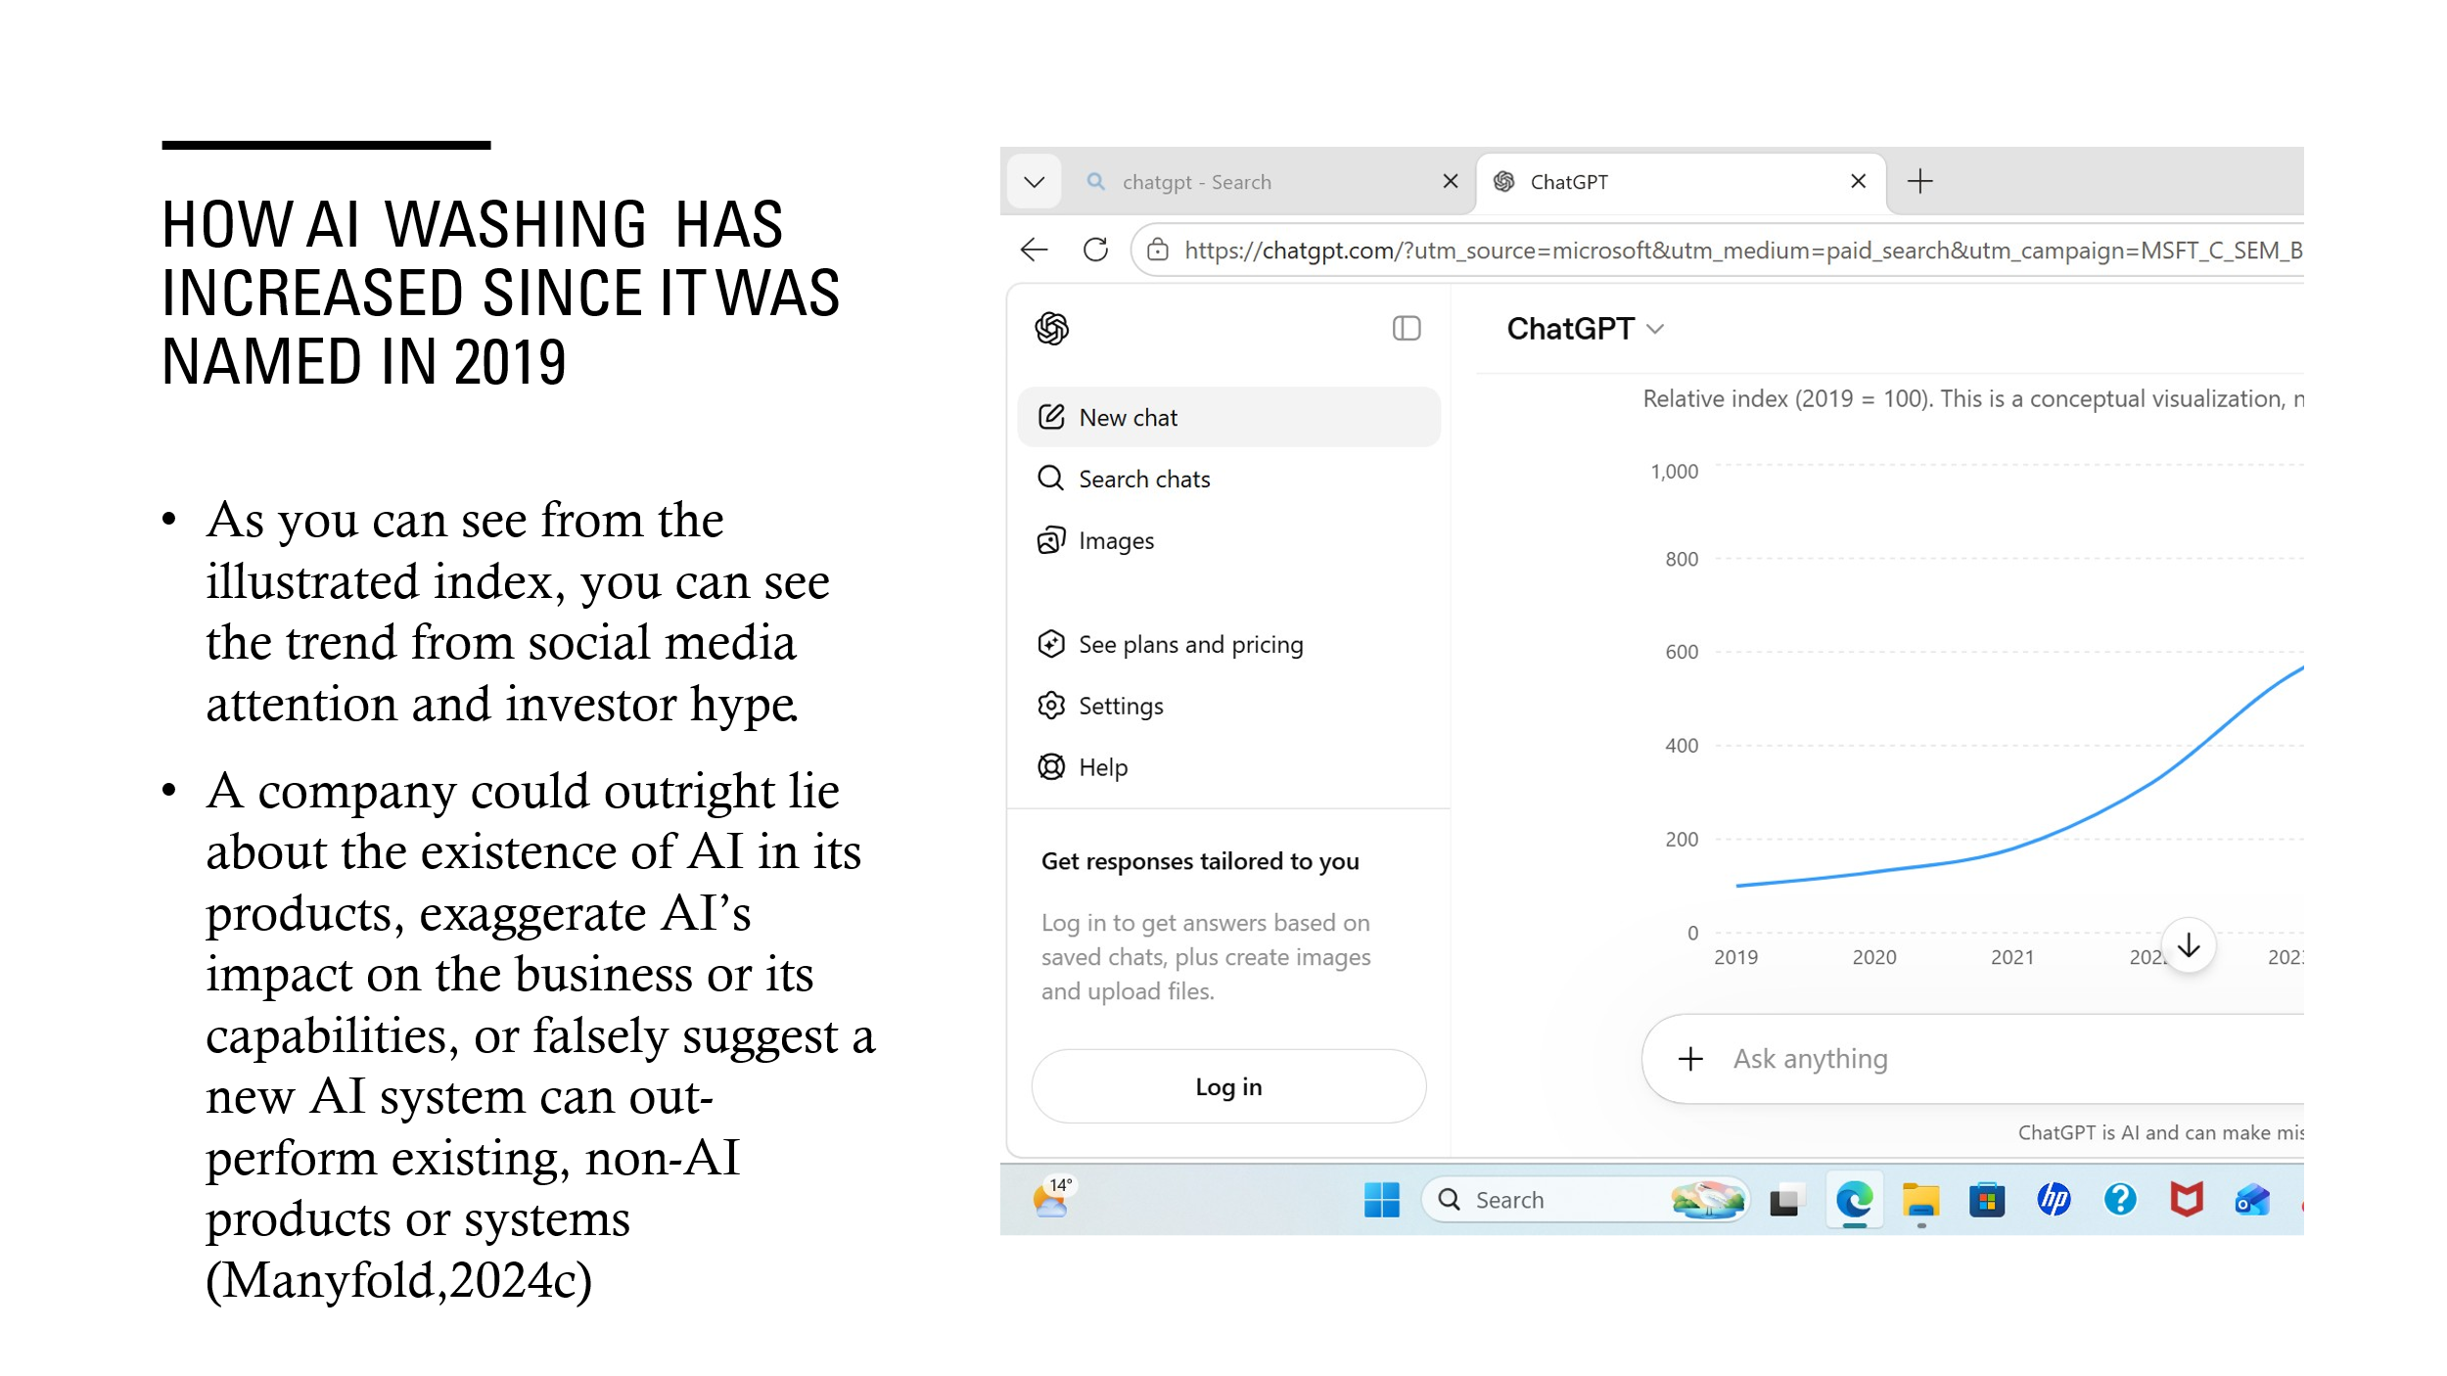

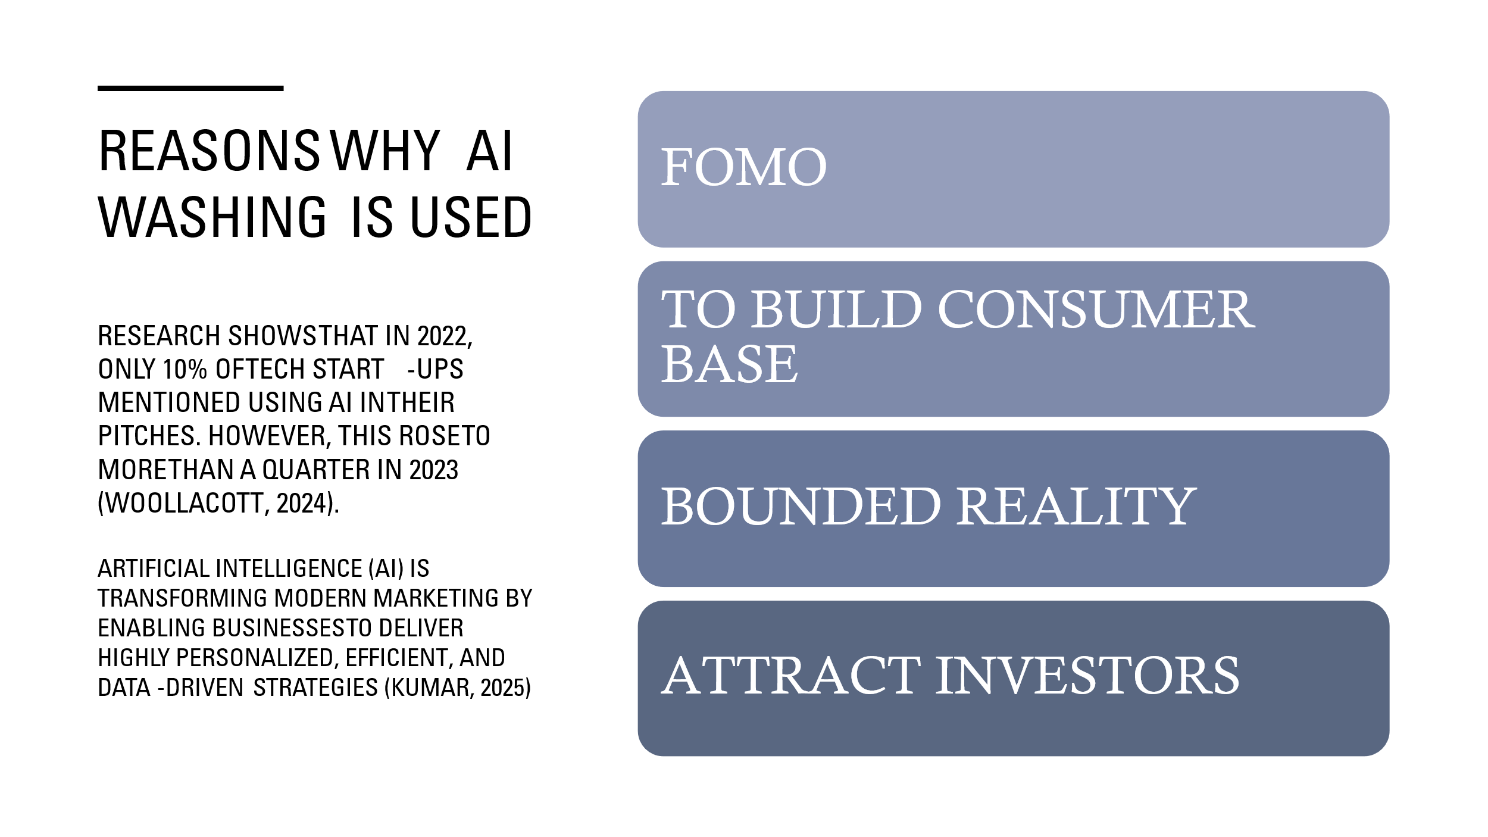
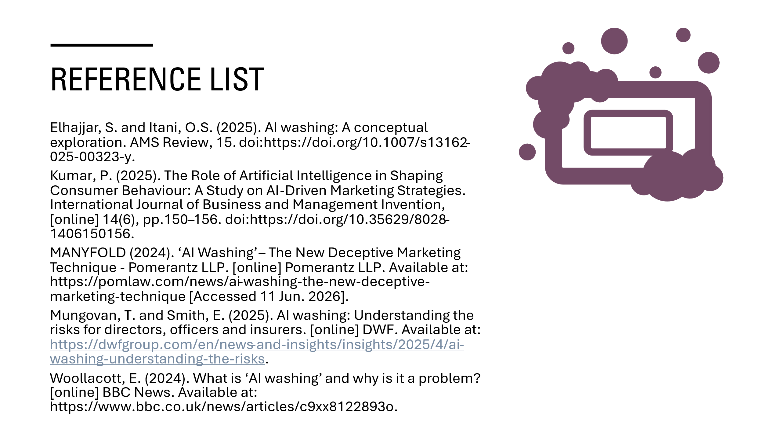

Slide 2
The modern-day term AI washing came into effect in 2019. Companies around the globe use AI washing to promote and exaggerate their services or products. They use false claims to entice consumers to invest within their company.

AI washing can appear in several ways. A company may falsely claim that its products use AI, or it may overstate how much AI improves its performance or capabilities. It can also incorrectly suggest that a new AI system is better than existing non-AI alternatives.

Slide 3 & 4
As you can see from the illustrated index, you can see the trend from social media attention and investor hype.

2019 – 2021 - gradual increase as businesses began rebranding analytics, automation and machine learning features as AI

2022 - sharp acceleration after the release of ChatGPT, which triggered intense interest in generative AI

2023 - peak growth phase as companies access software, finance, healthcare and retail rushed to market AI powered products and services

2024 – 2026 - continues growth, but at a slower pace as regulators, investors and customers became more skeptical of unsupported AI claims

Slide 5
Companies like amazon brought doubt to consumers minds by claiming they had a store that claimed to be run by AI power, but it later emerged that there was actually 1000 people in india manually processing every transaction made. This false claim is the perfect example of whitewashing and how it can reel in consumers by saying it is using the latest technology so there is a quick, no waiting in queues experience and you are automatically charged to your account and the store is run using cctv etc.
By doing this, companies can lose public trust in their products and brand when their claims are proven inaccurate. This may lead to reduced sales, as well as a higher risk of legal action and increased regulatory scrutiny.

Slide 6
References

Using AI

I thought that the task using AI tools was going to be easy as I would be asking a question and instantly getting the answer but that wasn’t the case. I found using AI very challenging. AI is very misleading, not everything that comes up is what you are looking for, meaning you must research the answer it throws out to check its credible. I really struggled to find what I needed by using ChatGPT. I found unless you ask the exact question, it just throws out any answer, so you have an answer. You have to be very clear about what you are searching for and that is really challenging when searching about a subject you don’t know. No matter how much I searched, I couldn’t find any information about whitewashing before 2019. I found information saying there was behaviours of it but I could only find whitewashing from 2019 as it stated that was when it was named. I don’t think I will use AI again for anything important. I would ask Alexa maybe for the weather but for any kind of research or important work, I will continue to use the library or search in articles or journals. Please see appendix below.

Appendix 1
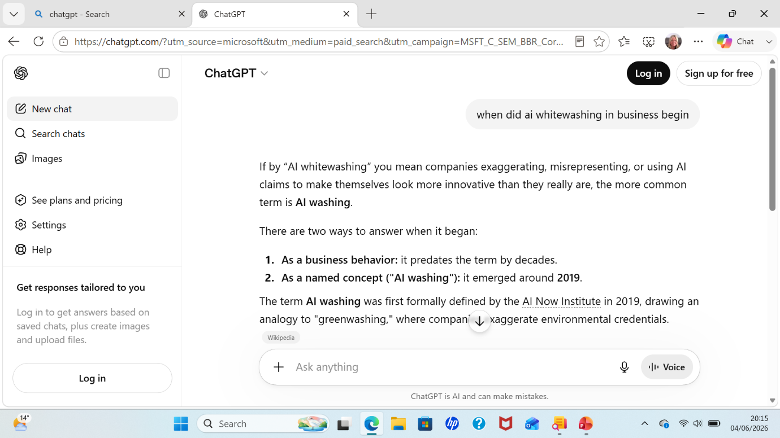

Appendix 2
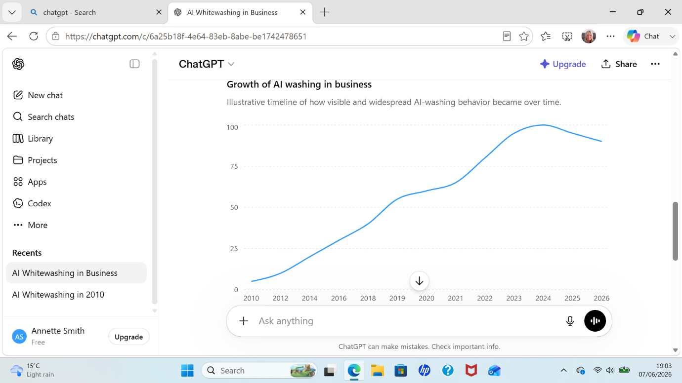

Appendix 3 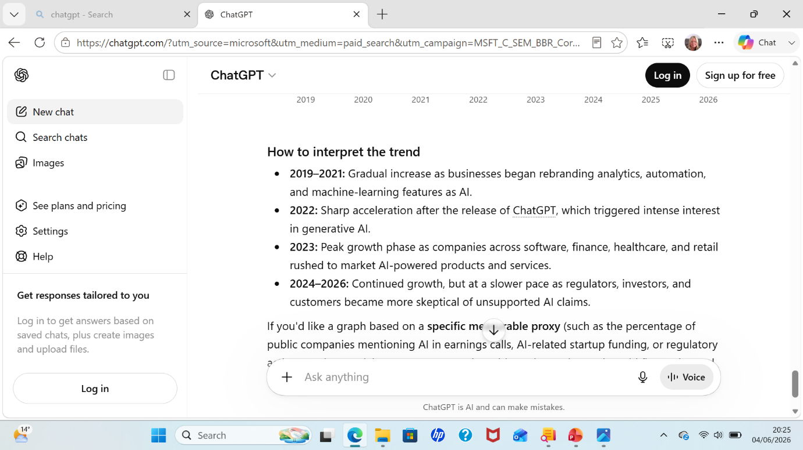

Appendix 4
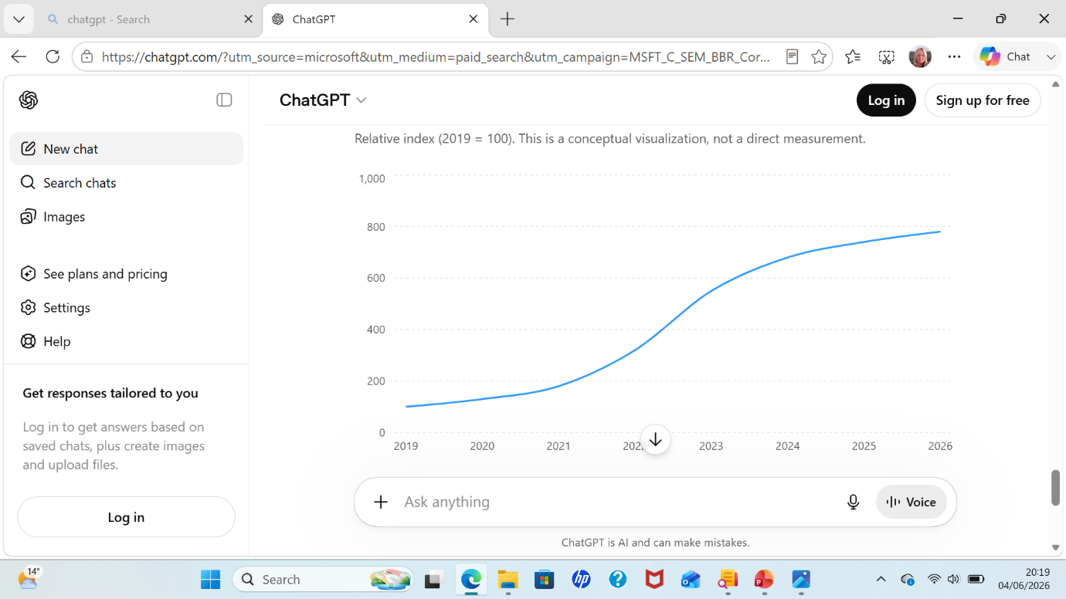

Reference List

Elhajjar, S. and Itani, O.S. (2025). AI washing: A conceptual exploration. AMS Review, 15. doi:https://doi.org/10.1007/s13162-025-00323-y.
Kumar, P. (2025). The Role of Artificial Intelligence in Shaping Consumer Behaviour: A Study on AI-Driven Marketing Strategies. International Journal of Business and Management Invention, [online] 14(6), pp.150–156. doi:https://doi.org/10.35629/8028-1406150156.
MANYFOLD (2024). ‘AI Washing’ – The New Deceptive Marketing Technique - Pomerantz LLP. [online] Pomerantz LLP. Available at: https://pomlaw.com/news/ai-washing-the-new-deceptive-marketing-technique [Accessed 11 Jun. 2026].
Mungovan, T. and Smith, E. (2025). AI washing: Understanding the risks for directors, officers and insurers. [online] DWF. Available at: https://dwfgroup.com/en/news-and-insights/insights/2025/4/ai-washing-understanding-the-risks.
Woollacott, E. (2024). What is ‘AI washing’ and why is it a problem? [online] BBC News. Available at: https://www.bbc.co.uk/news/articles/c9xx8122893o.

