Socio-opoly, a game based on the tragedy of the commons inspired by monopoly; focusing on the socio-economic and the polycentric approach to global environmental politics.
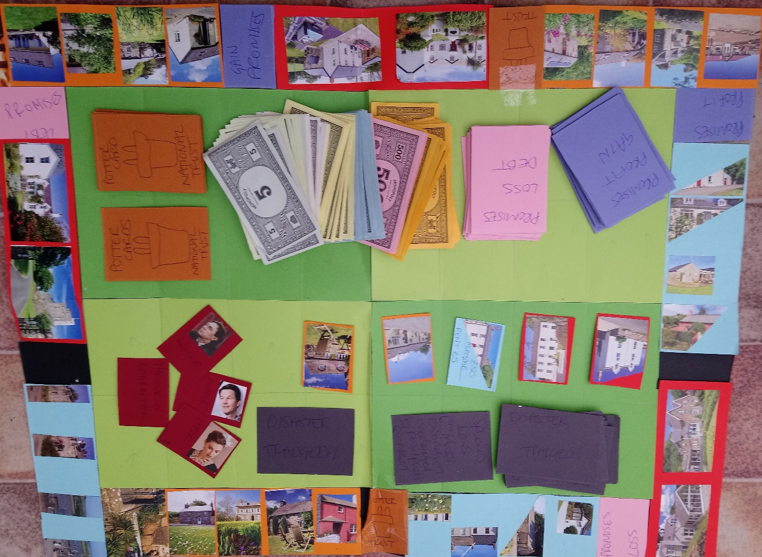

The tragedy of the commons was a ‘parable’ introduced by Hardin an American ecologist in 1968, the tragedy is: ‘so long as human freedom was respected, and land and natural resources were freely available for anyone to use, they would slowly but inevitably be destroyed’ ( Hardin cited in Stevenson, H. 2018.p.20). This is an adopted idea from an earlier essay by William Forster Lloyd (1832) who wrote a similar argument a century earlier, commenting on the ‘bare worn’ land of commons, and the well managed system of enclosed land (Stevenson, H. 2018.p.20). The basic premise for the tragedy is that humans cannot self-regulate the resources of the global commons by themselves. Either a social system of governance or a privatization of the commons is the only way to regulate and create a sustainable commons resource for the future generations.

Hardin intended to address the concept of over population, although the main point taken into policy was environmental degradation. Hardin made some fundamental assumptions, that humans are self-regarding and short sighted, Hardin’s presumption that there would be no regulation on common land came from these assumptions, he neglected to take into account as did Forster Lloyd that disparities in wealth and ownership, property rights, were reflected in the land use of commons and enclosed land. The landlord-serf relationship was embedded in the structure of the system. The agency of the player, in the game is dependent of the thrownness in possibility of the character, on the system within it exists, relating to the structure (Laidlaw, J. 2014.p.5). The class distinctions relate to what Bourdieu would say is habitus of the player (1977). For Marx (Capital, 1978) this relates to the suprastructure, invisible though visible in its effects. Hardin neglects to give agency as much as he neglects to take it away, levelling all the farmers and users of the commons as one allowing for no distinctions in personal praxis.
It is ‘assumed that the commons equates to open access’ (Stevenson, H. 2018.p.22). His assumption of human nature being self-regarding, leads to assumptions that commons are unmanaged and freely accessible and that degradation will follow. He assumes freedom and autonomy for individuals, giving equal degrees of agency. He strongly believed that privatism was a better solution to socialism, as he believed that bureaucracy in distant institutions would hide their mistakes to the loss of the commons for all. Yet private owners would have an economic interest in preserving the common as a resource for the future.
Another critique of Hardin’s is the aspect of historical accuracy, the context is lacking. Hardin uses the enclosure act to support his privatism but neglects the surrounding overwhelming inequalities of the era, he leaves them out and fails to show the complexity of the issues. Hardin creates a thought experiment using a limited common with farmers each grazing cows, arguing that each farmer would see the economic benefit of adding another cow to their herd, assuming that all farmers would logically do the same thing and add another cow to the common, thus degrading the land and resulting in the ruin for all. It could be argued that Hardin was a neo Malthusian theorist (Stevenson, H.2018.p.39), trying to address the population growth. Believing in innate selfishness of humans. A polycentric comprehension of theoretical understanding on a global scale is needed to manage the global commons sustainably.

The Game:
I created the game to represent the theories of the tragedy of the commons to think through the theory and the issues raised. When playing the game, it is easy to practically experience the complexity of the issues, as opposed to writing the full theories down or deciding whether I subscribe to them. During the game the actions of the players speak for themselves, whereas in a thought experiment of assumptions of human nature and the like are based on subjective ideals, and personal perspectives or pre dispositions of the writer. The game forms a model for policy makers to experience in a hypothetical dimension what it is like to be the ‘other’, as in upper or lower class, to have restrictions upon a character according to its position within the game, which may or may not reflect a reality for the player.
The game represents the capitalist system the aim is to accumulate wealth, money and property in order to survive, to cover the commons and end the game with the highest economic value. The board consists of private property around the edge, with spaces for disaster, tragedy-representing pollution and anthropocentric forms of degradation, national trust-representing socialism, the opportunity to preserve the commons for the sake of all.
The promises cards are inspired by Graeber’s (Debt the first 500 years. 2012) ideas of people being sold as promises to the banks, or the dead man’s insurance in America. Also, these are relatable to Marx in Das Capital and in ecological Marxists first contradiction of profit being the driving force of capitalism with the surplus value the unpaid wages of the workers being the profit. Marx presumed that socialism would be the result after revolution (Stevenson, H.2018. p.61). The economic wealth of a character is counted at the end and is the measure of success in the game. Only there is a catch, this game inspired by monopoly is more like real life because each character starts with a different status, as the player is thrown in, at the beginning, getting a character out of their own control, representing being born in the world, as in Heidegger’s Sein und Zeit. Dasein is a ‘thrown in possibility’ (Fell, J. Heidegger and Sartre an essay on being and place.1979. p.39) where, who, how you are born, determines your social class in the game, the world already exists, and the player is already a part in it. Being in time is ‘being as one as a unity’ (Fell, J.1979.p.35). Being at one with the ground, ontological unity.
The game is quite basic with upper, middle and lower classes representing in Marxists terms the bourgeoise and the proletariat. There is more chance that you will be thrown in a lower or middle class. Upper comes with a property to start whereas lower struggle through gameplay just to own a property and hold onto it. Although the promises cards like the chance cards of monopoly contain lottery and ways to profit and gain so there is a possibility to change the economic status of a character, just as theoretically can be said of the capitalist neo liberal, lasssaiz faire model. The middle of the game board is the commons, representing the limited global commons of the earth, an ecological Marxist perspective which Hardin also employs. Divided into 32 squares when a property is bought it covers the common and that represents privatization. Once the whole common is covered gameplay ends, like with the Earth once all the resources of the global commons are used up, polluted, tragedy unfolds. The apocalyptic idea of the Anthropocene is presumed. Ecological Marxism Express’ this tension between the limited supply of resources and the limitless nature of capitalism (Stevenson, H. 2018.p.61).
For Pierre Bourdieu (Distinction 1984) class is a useful tool for analysis, in Marxian terms how it applies to society may be outdated but using habitus (Bourdieu, P. 1977) and making distinctions within personhood, identity, habitus is being enacted in praxis which is operating within the system as well as on a person co creating structures relating to class, wealth, power, aesthetics, are people self-determined, are they acting freely? For Bourdieu (democratic politics 2005) institutions are not just recording the game, they are performing it in the recording, ‘producing culture’ the habitus of players in their class. Foucault (2002) argues that power exists in the structure between people individual, groups, governments alike in the very discourse, each person represents a part of the whole system. Class can be considered a rigid Marxian hierarchical reality, whereas global environmental politics sees the globalized world as anarchic (Stevenson, H. 2018). Although Marx shows some freedom of movement, it is limited, a proletariat worker can obtain wealth in a free market, this neo liberal rise is based in a market which has competition laws, which regulate free movement of goods. Once the system of the feudalist lords is overturned for a free market theoretically in capitalism the law loses legally defined sets of class as distinction. Theoretically any person can move in the system beyond the bounds of class. For the sake of the game the class system is purely defined in economic terms. A subject to the system already in play in a world already existing when a player is thrown in, the game seeks to explore the power dynamics between classes and human nature. I agree that the tragedy of the commons is too simplistic it does not take account of the historical context of the enclosure act. The lack of context is the tragedy., of Hardins parable. One of Marx’s major concerns was the question of freedom, who is truly free, what agency does a person express if being exploited?
Also represented in socio-opoly is Beatrix potter, friend of the founder of the national trust, in Britain (1934). An entrepreneur with no heir to leave her fortunes to and with a keen conservationists view, a social obligation felt so much that she left over 4000 acres in Derbyshire to the national trust, privatized although left in a socialist act, in trust to be kept as a resource for the public it is still relevant today in the U.K. managed for the benefit of all, open to the public. The potter cards in the game are picked up by chance, if a player, lands on the square, randomly, after throwing the dice. The card can then cover two squares of the commons, it can cover the personal property of the player or the open common, the deliberation of players when in the game serves to show the thought employed within the player a social act to cover open common and lose no value to their own property or a loss in the endgame of the economic value of their own property, for a gain in the short term by increase in rent on said property.
As an afterthought of playing the game I was thinking that it should be able to cover an opponent but only with their permission to encourage the strategy of co-operation. Which is the preferred strategy for global environmental politics. It is shown throughout human history by scholars such as anthropologists that conflict is not the only mode of negotiation that co-operation is a strong contender, that humans may be innately good, and not self-regarding as Hardin suggests (Stevenson, H. 2018.p.81).
In the global politics it is either co-operation or conflict (Stevenson, H. 2018).The cards serve to represent the question of, human natures potential for innate goodness, with examples of past success between states in inter-governmentality agreements, multilateral understandings, civil society and the power of protest, co-operative societies, the discourse between holds the power of the structure. As is also understood by Heidegger it is the in between that dasein is already a part. Difference is manifest upon boundaries within ideas of nationalism. Conflict is a negative power relationship. Conflict could be argued to be a main tool in environmental politics, it is only when a nation is threatened does it act, such as with climate change effecting the American militaries ability to defend itself, giving an incentive for the state to act (Snyder, J.2004).
The disaster cards represent the tragedy of the commons in the current capitalist climate. The Anthropocene is acknowledged as the geological age where humans become the main driver in geological change, for Morton the acceleration of the sixth mass extinction started with the steam engine and mass burning of fossil fuels along with the atom bomb Hiroshima and the trinity bomb. (Morton, T. 2013) these environmental tragedies represent the degradation of the global commons. They can be landed on randomly by any player and can cover any card, the players can choose whether to cover their own property, an opponent or the open common on the board. The tragedy cards cannot in the main be uncovered, once polluted they are destroyed with an economical effect on the players. This is a good opportunity to question if humans have an innate nature, and to see the socio-economic constraints, when choosing where the disaster may strike its permanent effect, distinctions of class come into praxis. A player’s choice can be based on any number of possibilities at the time. The cards represent environmentally negative industry, and the Anthropocene, for example, plastic pollution of the high seas, degradation of the commons, over grazing, over production, pollution of groundwater from landfill, species loss. all tragedy cards could cover two squares of common land on the board. Climate change the sixth mass extinction the Anthropocene are all part of the global condition.
Playing the game gives a chance to show the nature of the players, the question of whether humans are as Hardin believes self-regarding and short sighted, the game at first showing a strategy of ownership, money making being the aim the win, players rush to buy up property to increase their wealth, with more time strategies between players, can be adopted. In evaluating the rules, I would adopt a cooperative enterprise for the potter cards, to provide opportunity to explore co-operative concepts. It is easy to see the self-regarding attitude that a player will adopt although in life it is not a game, the thrownness for Heidegger holds dasein in place, for Foucault the structure holds everyone, the bourgeoise as well as the poor, all classes held in the structure, agency, freedom of choice of the individual is limited to the structure within which they are held (Laidlaw, J. 2014). privatization is obvious if economic value is the driving mechanism for the game, although not necessarily with ecological benefits for the commons. Personal Interests move, habitus co creates, money monopolizes into pools, of power, and power exists in the discourse, availability of the knowledge is privileged, Science brokers knowledge makers the academy is available to the few, in a global cape upholding a distinct class system within the commons. Difference needs to be taken account of and polycentric theories employed in resolution co-operative based environmental politics.

Bibliography:
BOURDIEU, PIERRE,, 1977. Outline of a theory of practice. Cambridge, U.K.; New York: Cambridge University Press.
BOURDIEU, P., 1996. Distinction. A social critique of the judgement of taste. 8 edn. United States of America: Harvard university press.
BOURDIEU, P. and WACQUANT, L.J.D., 2005. Pierre Bourdieu and democratic politics : the mystery of ministry. Cambridge: Cambridge : Polity.
ENGELS, F., 1986. The origin of the family, private property and the state. Harmondsworth: Harmondsworth : Penguin.
FELL, J.P., 1979. Heidegger and Sartre : an essay on being and place. New York: New York : Columbia University Press.
FOUCAULT, M., 2002. Power. London: London : Penguin.
GRAEBER, D., 2012. Debt : the first 5,000 years. New York: New York : Melville House.
HARDIN,G. 1968 The Tragedy of the commons. science.sciencemag.org/content/162/3859/1243
HASSAN, R., 2012. Time, Neoliberal Power, and the Advent of Marx’s “Common Ruin” Thesis. Alternatives: Global, Local, Political, 37(4), pp. 287-299.
HOLLANDER, S., 2008. The economics of Karl Marx analysis and application. Cambridge: Cambridge : Cambridge University Press.
LAIDLAW,J. 2014. The Subject of Virtue: An Anthropology of Ethics and Freedom. Cambridge.
MARX, K., 1978. Capital : a critique of political economy. Harmondsworth (etc.) : London:Harmondsworth etc. : Penguin ; London : New Left Review.
MORTON, T., 2013. Hyperobjects : philosophy and ecology after the end of the world. Minneapolis: Minneapolis : University of Minnesota Press.
SNYDER, J., 2004. One World, Rival Theories. Foreign Policy, (145), pp. 52-63.
STEVENSON, H., 2018. Global environmental politics : problems, policy and practice. Cambridge : Cambridge University Press.
www.nationaltrust.org.uk/beatrix-potter-gallery-and-hawkshead. Accessed 01/04/2019.

