Assignment 1 – The Smile Factory Case Study

Kalan Hughes
1902299

Higher National Diploma: Computing (Web Development)
Database and Application Development
15 January 2021

Table of Contents
Abstract 2
Entity Relationship Diagram 3
Indexes 4
Transaction 5

Abstract
This report is going to contain information regarding The Smile Factory database. The report will contain information about the entity relationship diagram, the indexes in the database, and the transaction that was created in the database.

Entity Relationship Diagram

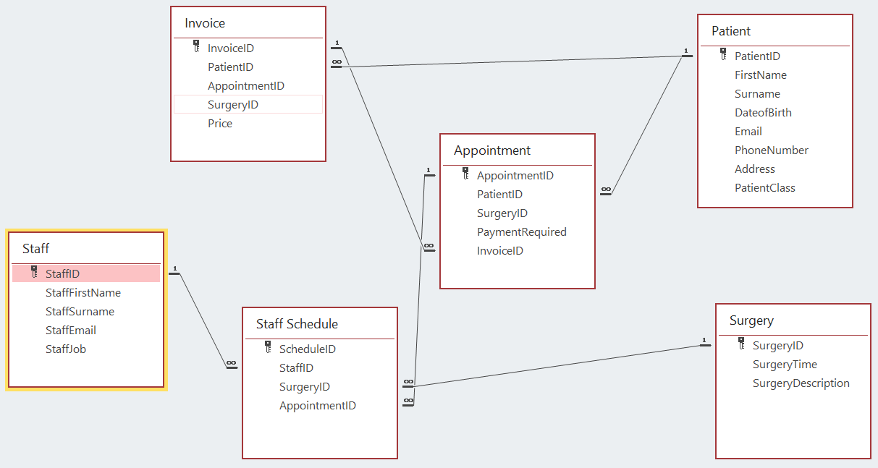

This is the entity relationship diagram that was created for the database. There are six tables in the diagram. The Patient table contains information about the patient. The primary key in the Patient table is linked to the Invoice and Appointment table.
The Staff table contains information about the staff. The primary key in the Staff table is linked to the Staff Schedule table.
The Surgery table contains information about the surgeries. The primary key in the Surgery table is linked to the Staff Schedule table.
The Invoice table contains information about the invoices. The primary key in the Invoice table is linked to the Appointment table.
The Appointment table contains information about the Appointments. The primary key in the Appointment table is linked to the Staff Schedule table.
Finally, the Staff Schedule table contains information about the surgeries that each staff member will be assigned to. The primary key is not linked to any other tables. These are all of the tables that are in the entity relationship diagram.

Indexes
There were six indexes which were created in the database. There was 1 index created for each table.
Patient Index:
This is the index that was created for the Patient table. An index was created on this table as it can help to make queries faster when searching for information about patients. These three columns were chosen to be a part of the index because the data in the columns does not change often. They were also chosen as it makes it easier to search for specific people and to check to see if they are a private patient or not.

Staff Index:
This is the index that was created for the Staff table. An index was created on this table because it can help to make queries faster when searching for information about members of staff. These columns were chosen to be a part of the index because the data in the columns does not change often. They were also chosen as it makes it easier to search for specific members of staff and to check what job they have.

Surgery Index:
This is the index that was created for the Surgery table. An index was created on this table because it can help to make queries faster when searching for information about the dates and descriptions of surgeries. These columns were chosen to be a part of the index because the data does not change often. They were also chosen as it makes it easier to search for surgeries that take place on certain dates. It also makes it easier to find out what the surgery is going to be.

Invoice Index:
This is the index that was created for the Invoice table. An index was created on this table because it can help to make queries faster when searching for a specific invoice. These columns were included in this index because the data does not change often. They were also chosen because it makes it easier to search for invoices for specific patients.

Appointment Index:
This is the index that was created for the Appointment table. An index was created on this table because it can help to make queries faster when searching for specific appointments. These columns were included in this index because the data does not change often. They were also chosen because it makes it easier to search for appointments for a specific patient.

Staff_Schedule Index:
Finally, this is the index that was created for the Staff_Schedule table. An index was created on this table because it can help to make queries faster when searching for information about a staff members schedule. These columns were included because the data does not change often. They were also chosen because it makes it easier to search for a specific staff members schedule.

Transaction
A transaction was created which books in a private patient for a new course of treatment.
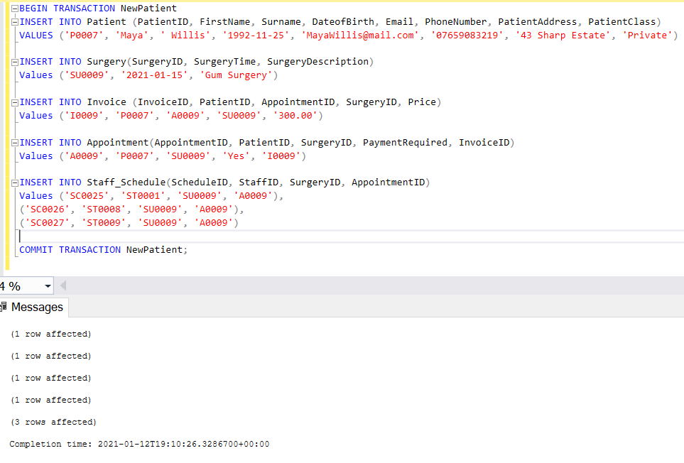
NewPatient Transaction:
This is the transaction that was created. First, ‘BEGIN TRANSACTION’ was written to start the creation of the transaction. Next, the private patients details were entered into the Patient table. The new treatment details were then inputted into the Surgery table. The patients invoice was then added to the Invoice table. An appointment was then made for the patient and it was added to the Appointment table. Finally, staff were assigned to the surgery and it was added to the Staff_Schedule table. This transaction is important as it allows you to easily execute a series of actions that add a new patient to the database. This can help to save a lot of time as you will not need to update each table individually.

