- Evaluate the advantages and disadvantages of both a divisional structure and a matrix structure. Within the evaluation, you should include the reasons underpinning each structure. (AC 1.1)
Divisional
Indeed.com (2024), Pros and Cons of Implementing a Divisional Structure, states that a divisional structure is an organisation that ‘segments its employees based on products or markets, as opposed to their job role’. Some advantages of a divisional structure, also highlighted through Indeed are that divisional structures can create ‘more accountability and transparency, gain local competitive advantage, improve company culture by allowing for unique perspectives and increases offerings efficiency’. The last point allows the organisation to expand and increase their markets by utilising employees from different regions or countries, due to an organisation having multiple bases across a country or the world. These views are further strengthened by an article from Wellhub (2025), Divide and Conquer: Definition, Advantages and Real-World Examples of Divisional Organizational Structures, which states that advantages are ‘Heightened visibility, improved product quality, increased local competitiveness and enhanced company culture’. Both websites cite the disadvantages of the use of a divisional structure are increased costs, use of the local economies scale, encourages rivalries and encourages a silo mentality of teams. The advantages of having regional knowledge and networks outweigh the disadvantages as an increased cost can be negated through an expanded market and healthy rivalries can produce better markets.

Matrix
Davies and Lawrence highlight in the Harvard Business Review that a ‘matrix organization can be identified by staff reporting to two bosses rather than a single boss’. Davies. M and Lawrence. P (1978). This is further supported by NIBusinessinfo.co.uk which states that a matrix structure ‘is a combination of two or more types of organisational structures, rather than in the traditional hierarchy’. The advantages of having a matrix structure according to NIBusinessinfo.co.uk can be improved decision making through having more than one approver, a ‘breaking down’ of traditional silo barriers, improved communication across a business through collaborative working and effective resource sharing. Davies. M and Lawrence. P (1978) lists that a matrix structure has several disadvantages, one disadvantage may occur is that there is that one manager can be recognised as a direct report to a staff member whereas the other manager may not be, which can lead to anarchy and confusion among staff members. This unclear hierarchy can then lead to power struggles within teams and management staff, this in turn, can lead to friction between teams. The matrix structure can benefit organisations through collaborative working and can benefit from easier communication due to colleagues working within the same relative space which can motivate employees to achieve a higher standard of work, however, hierarchy must be clear to prevent confusion or animosity between staff.

- Analyse the extent to which the organisational strategy in your organisation (or an organisation with which you are familiar) helps to ensure products or services meet customers’ needs. (AC 1.2)

Pembrokeshire County Council is a public organisation whose customer base is primarily the people living in Pembrokeshire and our ‘products’ are the services we provide to the people of Pembrokeshire. As a public body, our structure consists of a CEO and senior management team, however, we also have an elected cabinet who have the final say on organisational policies.
Pembrokeshire County Council’s vision statement, contained within Pembrokeshire County Council’s Wellbeing plan for Pembrokeshire (2023), outlines our organisational goal of ‘Working together, improving lives’, and aims for collaborative working across the organisation and with the people of Pembrokeshire, to ensure their needs and services provided are met. This vision statement is further supported by our cabinet's long-term goals that; ‘Pembrokeshire is a great place to live; our young people and vulnerable people are adequately supported; appropriate housing is available; Pembrokeshire County Council being a net zero carbon county; less families in poverty and thriving communities by making positive differences’. This vision statement outlines what Pembrokeshire Council are trying to achieve for the people of Pembrokeshire, through collaborative working with their employees and the community.

According to Pembrokeshire County Council’s strategy will ‘only be effective if it reflects Cabinet’s priorities in a coherent manner, and if organisational strategic objectives are embedded in what teams across the Council do on a day-to-day basis’, within Pembrokeshire County Council, this is known as the ‘Golden Tread’. The Golden Thread aims for ‘alignment between hierarchical plans and delivery across all levels of the organisation’ and emphasises the collaborative working that is required to meet the local authority’s vision.

The authority’s strategy is being developed continuously due to external factors, such as, government funding and financial pressures. Their strategy has been planned in advance but is reviewed every year once budgets are confirmed and elected members are consulted. Due to the nature of being a public body, with elected members, our strategy is both a planned one and an emergent one. The planned strategy is currently mapped out for the next five years, however, due to member decisions, the plan can change considerably should members wish to change their strategy due to budget and political pressures. This rapid change can mean that our strategy needs to be more reactive than planned, meaning that it will become an emergent strategy also.
As a public government body, their main goals should be the improvement in the quality of people’s lives and the local authority’s vision statement reflects the goals sufficiently due to outlining the expectations and behaviours of our employees and elected members when dealing with our customer base.

- Analyse the current impact of interest rates, inflation and one other external factor on your organisation (or one with which you are familiar). Identify organisational priorities arising from your analysis. (AC 1.3)

The Bank of England outlines that inflation is ‘when prices rise and how quickly they do so’, which is measured through the consumer price index. The Bank of England outlines the Consumer Price Index as a basket of goods that is measured every yearly. If the price of these goods increases after a year, then inflation has risen and if the price decreases, then so has inflation. According to the Bank of England, interest rates or lending rate is the amount you are charged for borrowing money, which is shown as a percentage, the higher the percentage, the more you pay back.
The Office of National Statistics (ONS) quoted through the Economics Observatory notes that the consumer price index increased by 10.4% between February 2023 to January 2024. According to ONS (No Date), inflation rose by a further 3.9% between 2024 to 2025. Economics Observation also notes that between 2023 – 2024. Within Pembrokeshire County Council, this means that if our budget were to remain the same year on year, we would have less money available to fund services due to a rise in costs not being met.
On top of this, Wages within Pembrokeshire County Council are paid through the National Joint Council (NJC) scale. NICVA highlights that he NJC scale are decided through negotiations between the employer and trade unions. agreed via trade unions through agreed increases to the National Joint Council (NJC) scale. Due to these negotiations, the NJC scale has increased yearly and the potential for an increase can occur on the next financial year, which would also will have an impact on the financial stability of Pembrokeshire County Council should budgets not increase with the rise in inflation. This external factor must be considered when finalising budgets for the next financial year ahead, due to the increase of wages and the effect it will cause for the overall budget within the local authority.
The yearly budget is supplied to us via the Welsh Government at the beginning of the financial year and currently, the impact of interest rates and inflation have led to a large funding gap within the organisation. Pembrokeshire County Council’s budget statement outlines that there is a funding gap of ‘£34.1m (net funding)’ which is then projected to widen in 2025 – 2026 to £64m. This funding gap is leading to cuts across the authority which can lead to redundancies and department closures. These redundancies will affect staff morale by adding workloads to remaining colleagues or work being stopped entirely, which will greatly impact service delivery to our customers. This funding gap has been created by a rise in borrowing costs due to the increase in interest rates and the rise in costs for goods needed to provide services to customers.
The Pembrokeshire County Council budget statement highlights that financial pressures have increased due to for several reasons including ‘An increase in the number of people needing our help with associated increased costs, particularly within our Schools Education, Children and Adult Social Care and Homelessness.’ Pembrokeshire County Council highlights that Pembrokeshire is considered the fourth oldest population within Wales and 35th oldest within the UK. With these facts in mind, the spending budget on Social Services will increase in the coming year, which will also impact our users and staff who provide essential care. be impacted by the rise in inflation, for example, on Personal Protective Equipment (PPE) and other supplies needed to provide our services.
In conclusion, Pembrokeshire County Council are forecasted to have a further funding gap in the year 2026 – 2027 and with this in mind, I would recommend planning to save costs where possible. For this year, the funding gap has led to redundancies across the authority due to services being cut to ensure core services remain, which may continue into the next financial year should inflation, interest rates and wages through the NJC scale continue to rise and the budget allocation not rise sufficiently to meet these costs.

Due to the increase in social care dependence on Pembrokeshire County Council, which accounts for an extensive part of our budget, and therefore is one of their main financial priorities which inflates every year, however, the council are not sustained by the government funding to allow for the appropriate increase in the budget which can cause detrimental effects to our education systems and hinder social care outcomes for the community.

Another priority for the local authority is the wellbeing of staff and to provide those who are facing redundancy due to decreased budgets within financially pressured areas with alternative job opportunities across the authority. Finding alternative roles within the local authority over redundancy is beneficial to both staff and the authority as it can provide ample opportunity to fill a vacancy quickly and to provide the staff member opportunity and growth within a different part of the organisation, as well as, utilising the experienced employee to a new department to allow for change, and new inspiration to increase efficient work flows throughout the department.

- In February 2024, Peter Cheese, current CEO of CIPD stated, “AI is transforming jobs, careers and workplaces. People professionals have a key role to play in encouraging safe experimentation and rapid learning, so that we can reap the benefits and mitigate the risks.” Assess the extent that AI is, or could be, used in your organisation (or an organisation with which you are familiar) and assess how AI impacts work. (AC 1.4)

Thomas, H Davenport and Ronanki. R (2018), through the Harvard Business Review, note that there are three main types of AI; process automation, cognitive insight and cognitive engagement. Businesses can take advantage of all three types through different mediums, according to the Harvard Business Review, process automation handles IT tasks such as transferring data from different systems, generating and reading documents, extracting information and providing summaries. This type of AI can be useful in the HR environment due to saving time in creating policies and identifying clearer procedures.
The Local Government Association gives some clear examples of how AI could be utilised within local government. These examples include, the use of public facing chatbots, AI assistants for caseworkers within social care, image recognition for littering and fly tipping, generative AI for creating images and documents, predictive analytics for falls and homelessness prevention, cleaning datasets and removing duplicates from programmes and threat monitoring for cyber security reasons.
Pembrokeshire County Council has created a chat bot for customers visiting our website. This bot can be used to find specific parts of our website or for customers to check when their bins are going to be collected. By using a chatbot, customers can benefit from quick answers to their queries and reduced waiting times to get answers from staff within our contact centre.
Pembrokeshire County Council also makes use of generative AI through Microsoft Copilot which helps with the creation of documents which are then proofread and amended as necessary. Staff can benefit from quicker turnaround and can focus on more pressing tasks.
The shortfall in utilising AI in business is the information that the AI is incapable of fact checking itself and can often provide inaccurate information or out-of-date information. This can occur due to the source material the AI has, for reference and if that information has been fact checked. AI also stores all data that is inputted for later reference so can cause a breach of confidentiality if used in the generation of sensitive documents or if the information inputted is sensitive. NIBusinessInfo’s article ‘Artificial Intelligence in Business’ underpins and adds to these concerns by highlighting other shortfalls of the use of AI. These shortfalls include ‘Algorithm bias, privacy and security concerns, high costs of integration and a shortage in data experts who can maintain AI systems’. This is further strengthened by
There are many benefits to using AI, however Forbes (2023) that outlines accuracy and accountability as possibly the largest risk in using AI within business. Forbes highlights that this is due to many AI applications being non-transparent and non-verifiable. Following this information, it was also highlighted that intellectual property rights can be infringed by AI due to the programme not recognising the legality of the content generated. This can lead to organisations being fined for breaching these rules. Forbes also strengthens NIBusinessInfo’s report by outlining that there is a skills gap within organisations and technical challenges, which can cause risks.
Forbes also outlines that the use of some AI software can cause legal risks around the use of intellectual property of software, art and music. Davies. C and Dennis. G notes that a ‘case has been raised to the high court by Getty Images that Stability AI has infringed on Getty Images property rights in both Stability AI’s image generation tool and the data input it uses’.
AI is a useful tool which can be utilised by organisations for a multitude of reasons, including document generation, policy writing and media generation. However, precautions need to be taken due to the risks AI pose’s regarding confidentiality, accuracy and AI’s source information. The precautions you can take are by using AI tools that give you the source information such as Microsoft Copilot or chat GPT where the source information can be easily found and by not uploading any confidential information to any AI tool.

- Explain Charles Handy’s model of organisational culture and explain David Rock’s SCARF theory. (AC 2.1)
HR Course Online (2024) outlines that Charles Handy’s model ‘helps leaders identify and shape the type of culture that will most benefit their organisation’ and that ‘By identifying and adapting to these cultural types, organisations and companies make more informed decisions, improve employee satisfaction, and enhance overall productivity’.
Charles Handy’s model splits organisational culture into four types; power culture, role culture, task culture and person culture. AQA’s teaching guide on Charles Handy’s model briefly explains the four cultures which are outlined in the following paragraphs.
- Power Culture is ‘A centralised culture which focuses on key decision makers. This type of culture depends on senior management or heads of the organisation to make important decisions which have an impact across the organisation. The advantage of a power culture is that there is little influence from a large group to determine the course of the organisation, however, this can lead to issues if the decision maker makes the wrong decision.
- Task Culture is dependent on ‘individuals, brought in to work on specific tasks when required, sharing ideas across functions. Task culture relies on specific people for specific tasks and encourages collaborative working to achieve their goals. An advantage of this type of culture is that the end goal is clear for those working on the task or culture, however, the decision makers may not be clear and could cause unnecessary friction between teams when different approaches clash.
- Role culture is a ‘more formalised culture with jobs having clear rules and procedures. This culture sees clear roles and responsibilities of employees, usually with clear reporting lines within their hierarchy. An advantage of this would be that decisions are often scrutinised by management teams to achieve the best outcome for the organisation
- Person culture sees employees have ‘considerable freedom to act independently’. An advantage of this kind of organisation is that decisions rest with the individual directly affected by an issue, however, this can also be a disadvantage due to there being no scrutiny check before a decision is made unless the individual seeks additional advice from colleagues.
Bitesize Learning highlights David Rock first introduced the SCARF model in 2008 and is inspired by neuroscience, particularly on the ‘theory of motivation’. David Rock’s SCARF model looks at five types of motivation; status, certainty, autonomy, relatedness and fairness and that we as individuals seek out these five things when it comes to our work.
The following graphic from Bitesize Learning showcases the model:
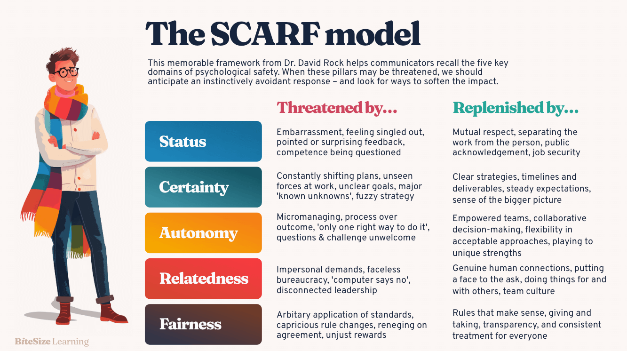

This graphic demonstrates each of the motivation types which can be threatened or replenished by certain emotions and actions. This model is particularly useful when an organisation is experiencing change due to highlighting the possible feelings of colleagues when their basic ideals are challenged but also notes how to possibly replenish one’s motivator. For example, as noted within the graphic, the feeling of embarrassment can threaten an individual’s feeling of status, however, if the individual is shown to be mutually respected, the feeling of status can be repaired. An alternate example is if a staff member is feeling micromanaged, their motivator for autonomy is then threatened. This can then be repaired if the manager works collaboratively with the employee rather than micromanaging them.

- Assess how employee selection or employee development impacts organisational culture and behaviour in your organisation (or one with which you are familiar). (AC 2.2)
Kassu. H (2023) via Forbes, references research by McKinsey & Company that ‘a lack of development or growth opportunities led around 60% of employees to leave their jobs’. This research shows that employee development opportunities are highly important to businesses as also noted by Kassu. H (2023) helps to ‘keep talent engaged and committed by improving a workers sense of wellbeing’. This statement is further supported by Ward (2023) Jobs for the future through LinkedIn’s report on ‘Building an Agile Future’ who argued that ‘learning is the key to resilience of an organisation'. This statement argues that employee development through an organisation’s Learning and Development team is a main driver for this change and can be achieved through a programme of course to upskill employees and provide them with the necessary information to prepare them for change.
Following on from the 2022 employee engagement survey, the Learning & Development Team have adopted using DISC profiles for teams who are having difficulties with working together through members completing a DISC survey, which then creates a profile for the individual outlining their preferred working style. Wiley (2019) notes that DISC was first proposed by William Moulton in 1928 to assess the ‘psychological phenomena which was observable through objective means’. DISC is an acronym for; Dominance, Influence, Support; and Conscientiousness, since the idea was founded, DISC has been adapted for use within business and its original headings have been changed slightly. We use this within our organisation to give individuals an overview of how their colleagues prefer to work and what their own colleagues’ strengths or weaknesses are. This also helps to give an understanding of what can cause friction between team members and help seek a resolution.
Within my organisation, the Learning and Development team have a huge impact on culture within the organisation through the creation of training packages that respond to staff and management needs effectively.

- An organisation is planning a change relating to hybrid working. Many employees moved to home working during the Covid-19 pandemic. Whilst this approach worked well at the time, the organisation now wants all employees to work at least two days a week on site. Explain how Kotter’s approach to managing change could be used to successfully implement this change. (AC 2.3)
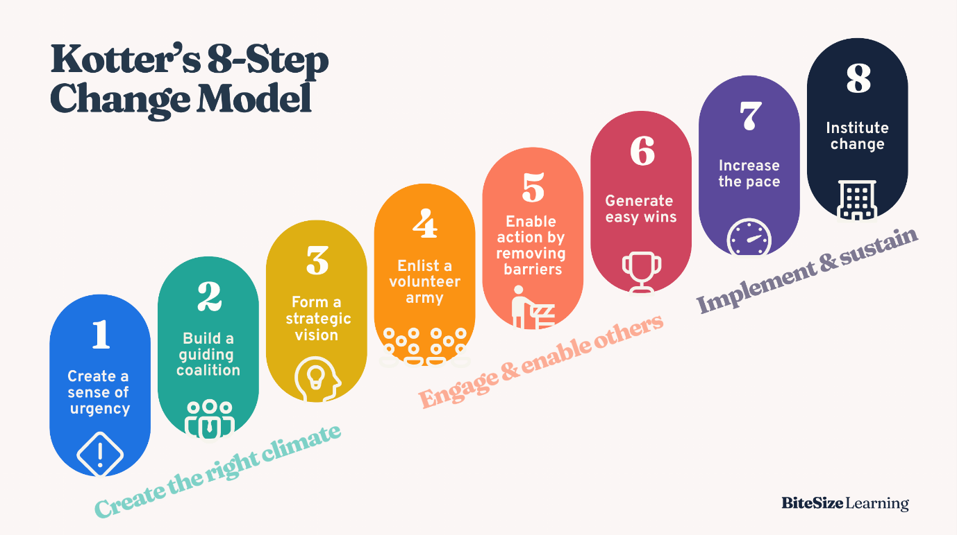
Kotter’s 8-Step Change Model – Bitesize Learning
Bitesize Learning explains that the eight-step change model ‘offers a structured approach to implementing lasting change’. The idea is that you would take the steps needed to successfully introduce a change in an organisation and if a step fails, you then start the whole process again. Kotter highlights that the ‘8 step change model’ can be utilised alongside Kotter’s 4 core change principles. Kotter inc. notes that the 4 core change principles were developed to ‘unlock the full power of the 8 steps’ and can otherwise be called accelerates. These accelerates are; Leadership + Management, Select few + Diverse Many, Have to + Want to, and Head + Heart.
Below is a diagram of the 4 Core Change Principles:
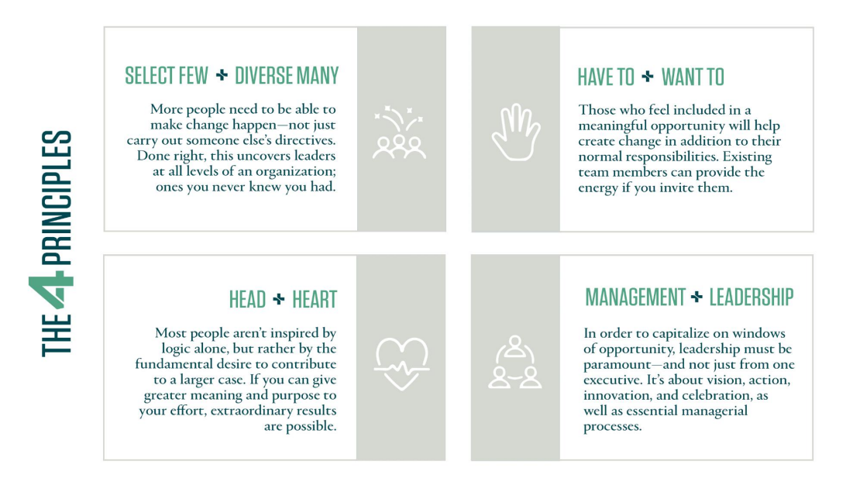

To implement the proposed change, the first step is to create a sense of urgency. Bitesize Learning explains that the first step is to help your team understand why this change is necessary and to share any gathered data with them. In relation to the proposed change in this question, the first step should see the proposer for change, share their data with management staff and employees to create an argument for the change to be implemented. Kotter inc. further supports this by noting that ‘your top leaders must describe an opportunity that appeals to heads and hearts’. This means that there are two Core Principles at play here; Leadership + Management; and Head + Heart. As outlined in the diagram, at this step, senior leaders will need to create a sense of urgency amongst staff (Leadership + Management) to create the buy-in for individuals (Head + Heart).

Step two is to build a coalition. This step would see the individual who introduced the idea of change Bitesize Learning notes that during this stage, you should collate a network of ‘influential people from different parts of the organisation’. These influential people can be those at a senior level or those who manage bigger teams, all of whom have different views of the organisation. Bitesize also notes that the individual views shared by these ‘influential people’ are crucial to driving change within an organisation. In this example, the next step would be to gather senior management, team managers and team members who have sway within the organisation to agree on the proposal and to start talking with their colleagues about the proposed change. During this stage, two principles are being addressed; Select Few + Diverse Many as more people are needed to make the change happen, and the Leadership + Management Principle through the addition of team managers collaborating with senior leaders.

After the coalition of ‘influential people’ has been formed, step three is to form a vision. This step would see the proposer then Bitesize Learning directs that you should ‘develop a clear, compelling vision of what success looks like after the change’. This would help create a plan of action to implement the change. In this example, the proposer would then create an action plan to help get employees back into the office for two days a week, so the end goal is clear. Kotter inc. further supports this by outlining during this stage, the ‘focus should be on actions and initiatives that will advance opportunity’.

Step four is to then enlist a volunteer army. Bitesize Learning notes that the proposer should now communicate their vision widely and then encourage questions and feedback which is further expanded on by Kotter inc. and notes that ‘large scale change can only occur when significant numbers of employees amass under a common opportunity’. In this instance, employee engagement events and a staff survey could be introduced to enable colleagues to express their concerns and be reassured.

Step five outlines the removal of barriers to the change and to enable action. Bitesize Learning outlines that this step is to ‘Identify obstacles, such as outdated processes, lack of resources and resistant individuals’, Kotter inc. states ‘by removing barriers such as inefficient processes and archaic norms, leaders provide freedom for employees to work across boundaries’ this means if employees are empowered to work outside of their ‘norms’ an impact can then be made towards the proposed change. For the hybrid change, I believe the main barrier would be resistant individuals. The reason for this is that some find working from home much easier than working in a busy office. With this, colleagues of the individual would need to be brought onside and reassured so the individual can talk about the change with their colleagues to see if a middle ground can be met.

Step six, seven and eight all coincide with each other. Step six is to celebrate quick wins. Bitesize Learning explains that, if celebrated, ‘these early successes will build momentum and keep people motivated’. Once the change has been introduced, this step would see the ‘influential people’ celebrate teams who comply with the new change, to help bring teams onside. Kotter inc. adds to this by saying ‘wins are the molecules for success’, meaning that if employees can see the value through wins, then change is more likely to be accepted by those who are still undecided on the change.

Step seven would see the change occur at a faster pace. Kotter inc. explains that during this step, you must ‘press harder’ and once initial successes have been celebrated, you can then be ‘relentless with initiating the change’. Within this step, the proposers for the change to hybrid working from home working can then be turned into policy. Bitesize Learning advises using these celebrations as credibility to tackle bigger changes.
Lastly, step eight is to institute the change by ‘anchoring them in your organisation's culture’. Kotter inc. adds to this by you will ‘need to communicate the connections between change and the organisations success’. Once the policy is in place, it is important for the organisation to advertise to staff the positive impact of hybrid working to ensure that it becomes the new ‘norm’.

- Using the Kubler-Ross change curve, discuss how change is experienced. (AC 2.4)
The change curve was first introduced by Elisabeth Kubler-Ross in 1969 which according to the Elisabeth Kubler-Ross foundation was first introduced as the ‘five stages of death’. This model was used to explain the emotions of someone who has experienced ‘change, loss or shock’. The ‘five stages of death’, outlined that an individual would experience are ‘denial, anger, bargaining, depression, and acceptance. This model and was later adapted to the change curve to showcase the emotions experienced when for example, a new process is introduced to an organisation. Malone, A, outlines that the Kubler-Ross Change curve in an organisation can be used for ‘business, innovation, work and employment to help a workforce adapt to change’.
Below is an example of the change curve that I have uplifted from the Elisabeth Kubler-Ross Foun Foundation:

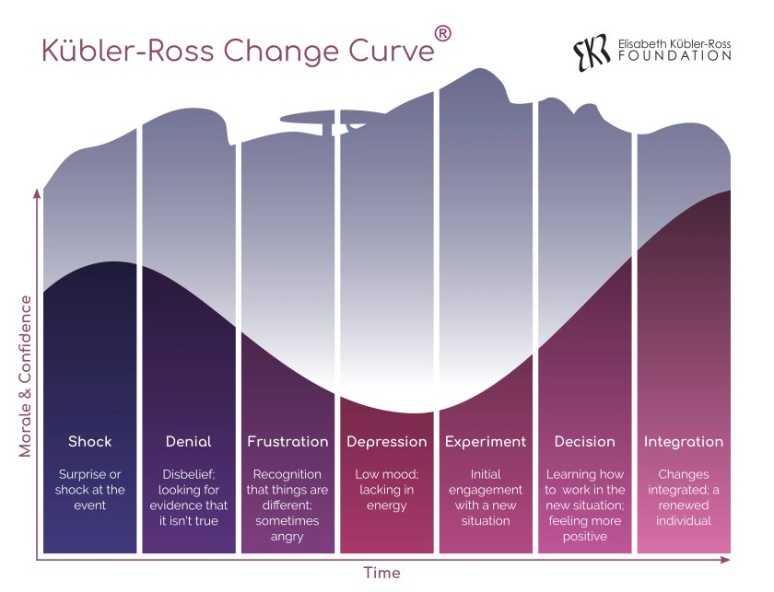
Kubler-Ross Change Curve – Elisabeth Kubler-Ross Foundation
The change curve showcases the possible emotions employees can process when a change is introduced into an organisation. An example of this being used in practice can be when a new, more efficient system is introduced by an organisation to a team that feel their old system was a perfect fit due to them having worked with the system for a few years. An employee will first experience the shock that the organisation is wanting to change a system that has been reliable over previous years. An employee will move to the denial stage where refusal of the change and the employee will become frustrated. The frustration stage may then lead to the team feeling depression. The depression stage is the lowest point of the change curve and if not addressed may encourage team members to look for employment elsewhere.
Once these first four stages have been processed, the employee will then start to accept the change which will then lead them to experiment with the new system. Once the employee has experimented with the new system, they can the decide on if the change is positive and them implement the new system. If the change is felt to not be positive, the employee may start the whole cycle again.

The starting point is shock, which can be felt when an employee feels that the organisation is on track to meet its goals and a change is then introduced to strengthen the process, which comes as a surprise to the individual. The staff member may then proceed to deny that this change would be introduced and frustration which may see the employee express their disappointment for the new change. Once frustration has been processed, this can often lead to depression which is the lowest point in the change curve. This feeling can lead an employee to lower their work standards due to them not feeling listened to. It is at this point that an employee will either start to accept the change and then experiment with the new process to find ways of integrating it within their daily work life, or, this is the point where an employee may feel that they are no longer satisfied with their employment and may seek to leave the organisation. After the employee has experimented with the new process, this point can then lead the individual to decide if the change is an appropriate one or if this change will have a negative impact. If the individual accepts the change, they will then integrate it within their daily processes, however, should the employee feel that the change in inappropriate, this can then lead them to experience all the previous emotions again.

While employees are experiencing emotions associated with the change curve, the HR function can ease the transition by hosting engagement events and undertaking a survey to give employees a chance to express their concerns and feel listened to. This would also give the decision makers vital information to reassure staff that the change is the correct one or to be able to adapt the change to suit any overriding concerns with their employees.

- The CIPD’s Health and wellbeing at work survey 2023 found the percentage of organisations that have a standalone wellbeing strategy has risen from 40% in 2018 to 53% in 2023. Although the percentage has increased, this means that 47% of organisations do not have a standalone wellbeing strategy. Assess the importance of wellbeing at work and assess how good work could impact wellbeing. (AC 2.5)

Suff. R (2024) via the CIPD factsheet on Wellbeing at Work notes that ‘an effective wellbeing at work programme can deliver benefit to people, organisations, economies and communities’. This article further explains that workplaces that provide a wellbeing environment for their staff, promotes contentment and enable individuals to flourish. An organisation who have a well-established wellbeing at work programme or policy may see less staff turnover due to employees feeling nurtured and looked after when compared to organisations that do not have a wellbeing programme. Wellbeing initiatives can also improve engagement with employees and provide them with more motivation to achieve the organisation's goals.
A consideration for the importance of wellbeing at work is the generational change in the workforce. Baker, T (2024) writes that ‘Generation-Z have changed the modern workplace through caring about the organisational values, having room to grow, flexible working and valuing mental health support, wellbeing initiatives and a healthy work-life balance.’ This showcases that when generational change occurs in the workforce, an individual’s priorities within their preferred working environment changes. Naber. A (n.d.) through Gettysburg College, estimates that the average time spent in work for an individual throughout their life is 90,000 hours. This equates to around one-third of a person's average life expectancy.

The CIPD Resourcing and Talent Planning Report (2024) also estimates that recruitment activity for an organisation can cost between £1500 - £3000. To avoid these costs, organisations should adapt to the needs of the younger workforce by introducing a comprehensive wellbeing at work strategy that addresses these needs. If this is not done, as new employees come into an organisation, they may not stay very long, which can impact the workloads of older employees and increase recruitment costs due to the increased turnover. With these facts in mind, I believe that a wellbeing at work programme can be pivotal to an organisation to drive down recruitment costs due to increased retention and for the mental and physical health of staff members.

- Provide a brief overview of the employee lifecycle and discuss people practice roles at the recruitment, development and separation stages of the lifecycle. (AC 3.1)
The Employee lifecycle according to Access PeopleHR (2023), has seven stages. These stages are; attraction, recruitment, onboarding, engagement, development, retention and exit, which are also outlined in the following graphic:
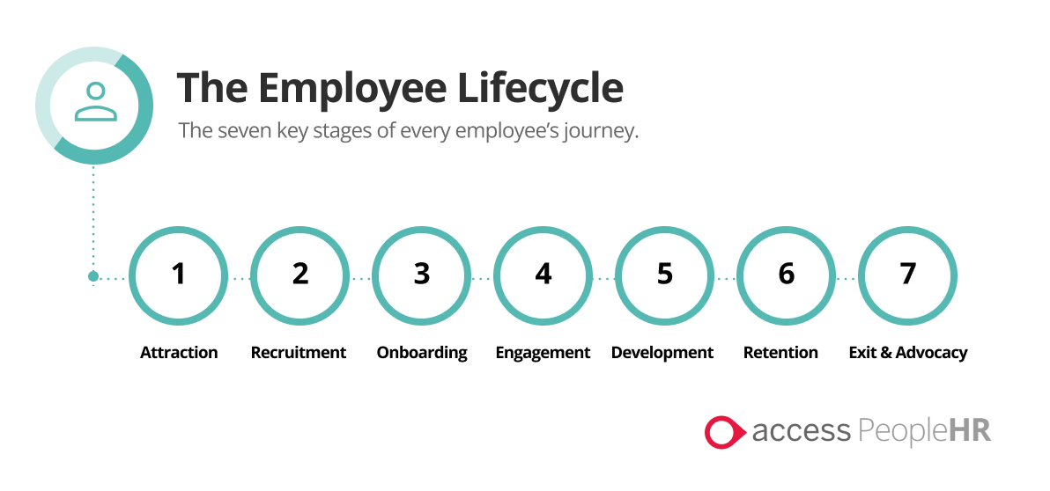
Indeed defines the employee lifecycle as the ‘different stages an employee goes through when joining the business, all the way through to leaving it’ and that the life cycle is at the heart of the employee experience for an organisation.
The attraction, recruitment, onboarding, and development stages usually involve specialised teams within the HR function of an organisation. At the attraction and recruitment stage, a specialised recruitment team undertakes project work to make the organisation an attractive place to work. This is done through effective advertising which can involve the use of career stories of current staff members, the benefits package for employees and any career or training pathways, should they be available. Once an identified role needs to be recruited, the recruitment team will then draft a job description and advertise the role through various mediums such as recruitment websites, social media, newspapers and other relevant platforms.
After applications have been received, interviews are then conducted. Interviews can could include panel members from the HR function, especially if the role advertised is at a senior level. During the interview process, an interviewer may ask questions relating directly to their own organisation, such as asking what the organisational goals, values and objectives are.
After this process, the successful candidate can then be onboarded. During this phase of the Employee Lifecycle, all pre-employment checks are undertaken before the new employee can start. During this process, the new employee can be reminded of the staff benefits they will receive for being part of the workforce and should be directed to any relevant training or policies they may need to complete or review before their start date.
During a colleague’s employment, the Learning and Development Team within the HR function can provide development opportunities to staff to strengthen their organisational knowledge and create pathways up the organisational ladder. As part of this development, the Learning and Development team can identify those who have qualities to be nurtured and give ample development opportunities to these individuals.
During the exit stage of the employee lifecycle, the HR function may undertake exit interviews to see why an individual is leaving the organisation and to gather feedback on what can be improved.

- Analyse how people practice supports organisational strategy through vertical integration and how people practice supports wider people strategies through horizontal integration. (AC 3.2)

AIHR defines vertical integration as the ‘integration of HR activities with the HR strategy, and the integration of the HR strategy with the business strategy’. Human resource professionals can utilise Strategic Human Resource Management (Strategic HRM) to align the management staff and employees to an organisation's goals. According to Peters. R via the CIPD Factsheet ‘Strategic Human Resource Management’, notes that ‘Strategic HRM provides a framework linking people management and development practices to long-term business goals and outcomes’. Strategic HRM can be used to create a framework for expected behaviours and cultures within an organisation with the organisation's goals in mind. Peters goes on to say that ‘Individual HR strategies may be shaped by the business strategy, but it’s too simplistic to suggest that strategic HRM simply follows on from business strategy – the two must inform one another’. This shows that Strategic HRM should be created alongside HR and business strategy and should complement one another.
Webster. J defines horizontal integration or ‘horizontal fit’ as ‘the alignment of HR practices with each other’. This means that HR policies should all collaborate and complement each other. The example Webster has given is that ‘recruitment policies should align with development programmes, performance management systems and compensation strategies. If horizontal integration is properly undertaken, then each policy should reference and complement each other rather than contradict each other.

- An organisation is planning to introduce a four-day working week. Discuss the processes the people function could use to consult and engage with managers and employees to understand their needs when moving from a five-day to four-day working week. (AC 3.3)

Tracey. H (2024) via the CIPD factsheet ‘Change Management’ explains that ‘People professionals have a significant role to play in any change management process. They often act as ‘stage directors of change’ playing a critical role behind the scenes.’ Tipton. T (2024) notes some common steps an HR function can take when introducing change; ‘assess the upcoming challenge, identify key stakeholders, pinpoint potential challenges, outline desired outcomes, create a communication plan, develop a training plan and implement a sponsor plan’. Alternatively, the HR function can utilise Kotter’s Eight Tier Model to identify the steps needed to introduce the change.
Once all these steps have been planned and communicated, the HR function can then host engagement sessions to give employees a chance to express their concerns or discuss the general policy. Evidence-based practice should also be implemented throughout the change process to aid the impact on the organisation, especially if this change has been highlighted as the best thing to do.
During the communications stage, HR can also send out an informational survey to gauge the needs of staff and managers should this change be introduced. This information can then be used to reassess what is required to help the organisation function and to reassure managers and staff that the change will be positive. Sharing Elisabeth Kubler-Ross’ change curve and David Rock’s SCARF model with staff and managers may provide them with an understanding of the emotions experienced while going through change. These models can help managers reassure those who are reluctant to change.
After the change has been implemented, the HR function can then regularly review if the change is having a positive impact by hosting engagement events and sending out employee engagement surveys. If the change is having a negative impact, then the HR function can revert to the evidence put forward when the change was proposed and amend the change where required.

Reference List:
Access PeopleHR (2023) 'What is the Employee Lifecycle?'. Available at: https://www.peoplehr.com/en-gb/resources/blog/what-is-the-employee-lifecycle/ (Accessed: 2nd February 2025).
AIHR (n.d.) 'HR Life Cycle'. Available at: https://www.aihr.com/blog/hr-life-cycle/#:~:text=Vertical%20integration%20is%20the%20integration,which%20leads%20to%20increased%20impact (Accessed: 2nd February 2025).
Barker, T. (2024) 'Gen-Z in the modern workplace: Mental health and well-being matters', Forbes Business Council, 20 March. Available at: https://www.forbes.com/councils/forbesbusinesscouncil/2024/03/20/gen-z-in-the-modern-workplace-mental-health-and-well-being-matters/ (Accessed: 21st March 2025).
Bank of England (2024) ‘What is inflation?’. Available at: https://www.bankofengland.co.uk/explainers/what-is-inflation (Accessed 18th March 2025).
Bank of England (2025) ‘What are interest rates?’. Available at: https://www.bankofengland.co.uk/explainers/what-are-interest-rates#:~:text=If%20you%20are%20borrowing%20money,more%20you%20must%20pay%20back. (Accessed 18th March 2025).
Bitesize Learning (n.d.) 'Kotter’s 8-Step Change Model'. Available at: https://www.bitesizelearning.co.uk/resources/kotters-8-step-change-model (Accessed: 1st February 2025).
Bitesize Learning (n.d.) 'SCARF Model: David Rock Explained'. Available at: https://www.bitesizelearning.co.uk/resources/scarf-model-david-rock-explained (Accessed: 2nd February 2025).
CIPD (2024) 'Resourcing and Talent Planning Report 2024'. Available at: https://www.cipd.org/globalassets/media/knowledge/knowledge-hub/reports/2024-pdfs/8662-resource-and-talent-planning-2024-report-web.pdf (Accessed: 2nd February 2025).
Davenport, T.H. and Ronanki, R. (2018) 'Artificial Intelligence for the Real World', Harvard Business Review. Available at: https://hbr.org/2018/01/artificial-intelligence-for-the-real-world (Accessed: 31st January 2025).
Davies, C.W, Dennis,G (2024). Getty Images v Stability AI: the implications for UK copyright law and licensing. [online] Pinsent Masons. Available at: https://www.pinsentmasons.com/out-law/analysis/getty-images-v-stability-ai-implications-copyright-law-licensing (Accessed 19 Mar. 2025).
Davies, M. and Lawrence, P. (1978) 'Problems of Matrix Organizations', Harvard Business Review. Available at: https://hbr.org/1978/05/problems-of-matrix-organizations (Accessed: 30th January 2025).
Elisabeth Kubler-Ross Foundation (n.d.) 'Change Curve'. Available at: https://www.ekrfoundation.org/5-stages-of-grief/change-curve (Accessed: 2nd February 2025).
Everything DiSC. (n.d.). History of DiSC Timeline. Retrieved from https://www.everythingdisc.com/EverythingDiSC/media/SiteFiles/Assets/History/Everything-DiSC-resources-historyofdisc-timeline.pdf (Accessed 21st March 2025).
HR Course Online (2024) 'Organisational Structures: Charles Handy'. Available at: https://hrcoursesonline.com/organisational-structures-charles-handy/#:~:text=Handy's%20model%20helps%20leaders%20identify,satisfaction%2C%20and%20enhance%20overall%20productivity (Accessed: 31st January 2025).
Indeed Editorial Team (2024) 'Pros and Cons of Implementing a Divisional Structure'. Available at: https://www.indeed.com/career-advice/career-development/divisional-structure (Accessed: 30th January 2025).
Kotter, J.P. (2018) 8 Steps to Accelerate Change in Your Organization. Available at: https://www.kotterinc.com/wp-content/uploads/2019/04/8-Steps-eBook-Kotter-2018.pdf (Accessed: 22nd March 2025).
Kotter, J.P. (2021) 4 Change Principles. Available at: https://www.kotterinc.com/wp-content/uploads/2021/01/Kotter-4-Change-Principles-eBook-new-1.pdf (Accessed: 22nd March 2025).
Local Government Association. (n.d.) Artificial Intelligence Hub. Available at: https://www.local.gov.uk/our-support/cyber-digital-and-technology/artificial-intelligence-hub (Accessed: 28th April 2025).
Malone, S (2018) ‘Models for Coaches/Mentors’ Retrieved from: https://pembrokeshire.bookboon.net/b/7bd39211-ab32-4ad2-8f64-fde7396779dd (Accessed 21st March 2025)
McKee, E. (2024) NJC Payscales for 2024-2025. Available at: https://www.nicva.org/article/njc-payscales-for-2024-2025#:~:text=The%20NJC%20payscales%2C%20which%20are,applicable%20from%2001%20April%202024 (Accessed: 28th April 2025).
Naber, A. (n.d.) 'How Much Time Do We Spend at Work?', Gettysburg College. Available at: https://www.gettysburg.edu/news/stories?id=79db7b34-630c-4f49-ad32-4ab9ea48e72b (Accessed: 2nd February 2025).
NIBusinessinfo.co.uk (n.d.) 'Matrix Organisational Structure'. Available at: https://www.nibusinessinfo.co.uk/content/matrix-organisational-structure (Accessed: 30th January 2025).
NIBusinessinfo.co.uk (n.d.) 'Risks and Limitations of Artificial Intelligence in Business'. Available at: https://www.nibusinessinfo.co.uk/content/risks-and-limitations-artificial-intelligence-business (Accessed: 31st January 2025).
Office of National Statistics (n.d.) ‘Inflation and price indices’. Available at: https://www.ons.gov.uk/economy/inflationandpriceindices (Accessed 18th March 2025).
Pembrokeshire County Council (2025) 'Budget Consultation 2025-26'. Available at: https://www.pembrokeshire.gov.uk/have-your-say/budget-consultation-2025-26#:~:text=Budget%20Context-,Funding%20Gap,increase%20in%20Welsh%20Government%20funding (Accessed: 31st January 2025).
Pembrokeshire County Council (2023) 'Corporate Strategy 2023 – 2028: Vision Statement'. Available at: https://www.pembrokeshire.gov.uk/cscorporatestrategy202328/csvisionstatement (Accessed: 31st January 2025).
Pembrokeshire County Council (2023) 'Corporate Strategy 2023 – 2028: The Golden Thread'. Available at: https://www.pembrokeshire.gov.uk/cscorporatestrategy202328/csgoldenthread (Accessed: 31st January 2025).
Pembrokeshire County Council (2023) ‘Vision Statement’. Available at: https://www.pembrokeshire.gov.uk/cscorporatestrategy202328/csvisionstatement (Accessed: 31st January 2025)
Pembrokeshire County Council (2023) ‘Pembrokeshire in Context’. Available at: https://www.pembrokeshire.gov.uk/cscorporatestrategy202328/cspembsincontext#:~:text=26%25%20of%20the%20population%20are,up%20from%2042.9%20in%202011. (Accessed 17th March 2025)
Peters, R. (n.d.) 'Strategic Human Resource Management', CIPD. Available at: https://www.cipd.org/uk/knowledge/factsheets/strategic-hrm-factsheet/ (Accessed: 2nd February 2025).
Practicus (n.d.) 'HR Strategy'. Available at: https://www.practicus.com/what-we-do/hr/hr-strategy (Accessed: 2nd February 2025).
Prosci (n.d.) 'HR Change Management Resources'. Available at: https://www.prosci.com/blog/hr-change-management-resources#:~:text=Create%20a%20Communications%20Plan%20to,supporting%20and%20communicating%20the%20change (Accessed: 2nd February 2025).
Raynovich, R.S. (2023) 'The top five real risks of AI to your business', Forbes, 22 June. Available at: https://www.forbes.com/sites/rscottraynovich/2023/06/22/the-top-five-real-risks-of-ai-to-your-business/ (Accessed: 19 March 2025).
Sameen, H. (2023) ‘How is the cost of living crisis affecting provision of social care?’, Economics Observatory. Available at: https://www.economicsobservatory.com/how-is-the-cost-of-living-crisis-affecting-provision-of-social-care (Accessed 18th March 2025).
Suff, R. (2024) 'Wellbeing at Work', CIPD. Available at: https://www.cipd.org/uk/knowledge/factsheets/well-being-factsheet/#what-is-wellbeing-at-work (Accessed: 2nd February 2025).
Tracey, H. (2024) 'Change Management', CIPD. Available at: https://www.cipd.org/uk/knowledge/factsheets/change-management-factsheet/ (Accessed: 2nd February 2025).
Wellhub Editorial Team (2025) 'Divide and Conquer: Definition, Advantages and Real-World Examples of Divisional Organizational Structures'. Available at: https://wellhub.com/en-us/blog/organizational-development/divisional-organizational-structure/ (Accessed: 30th January 2025).

