Emergent Leadership Skills in the Workplace

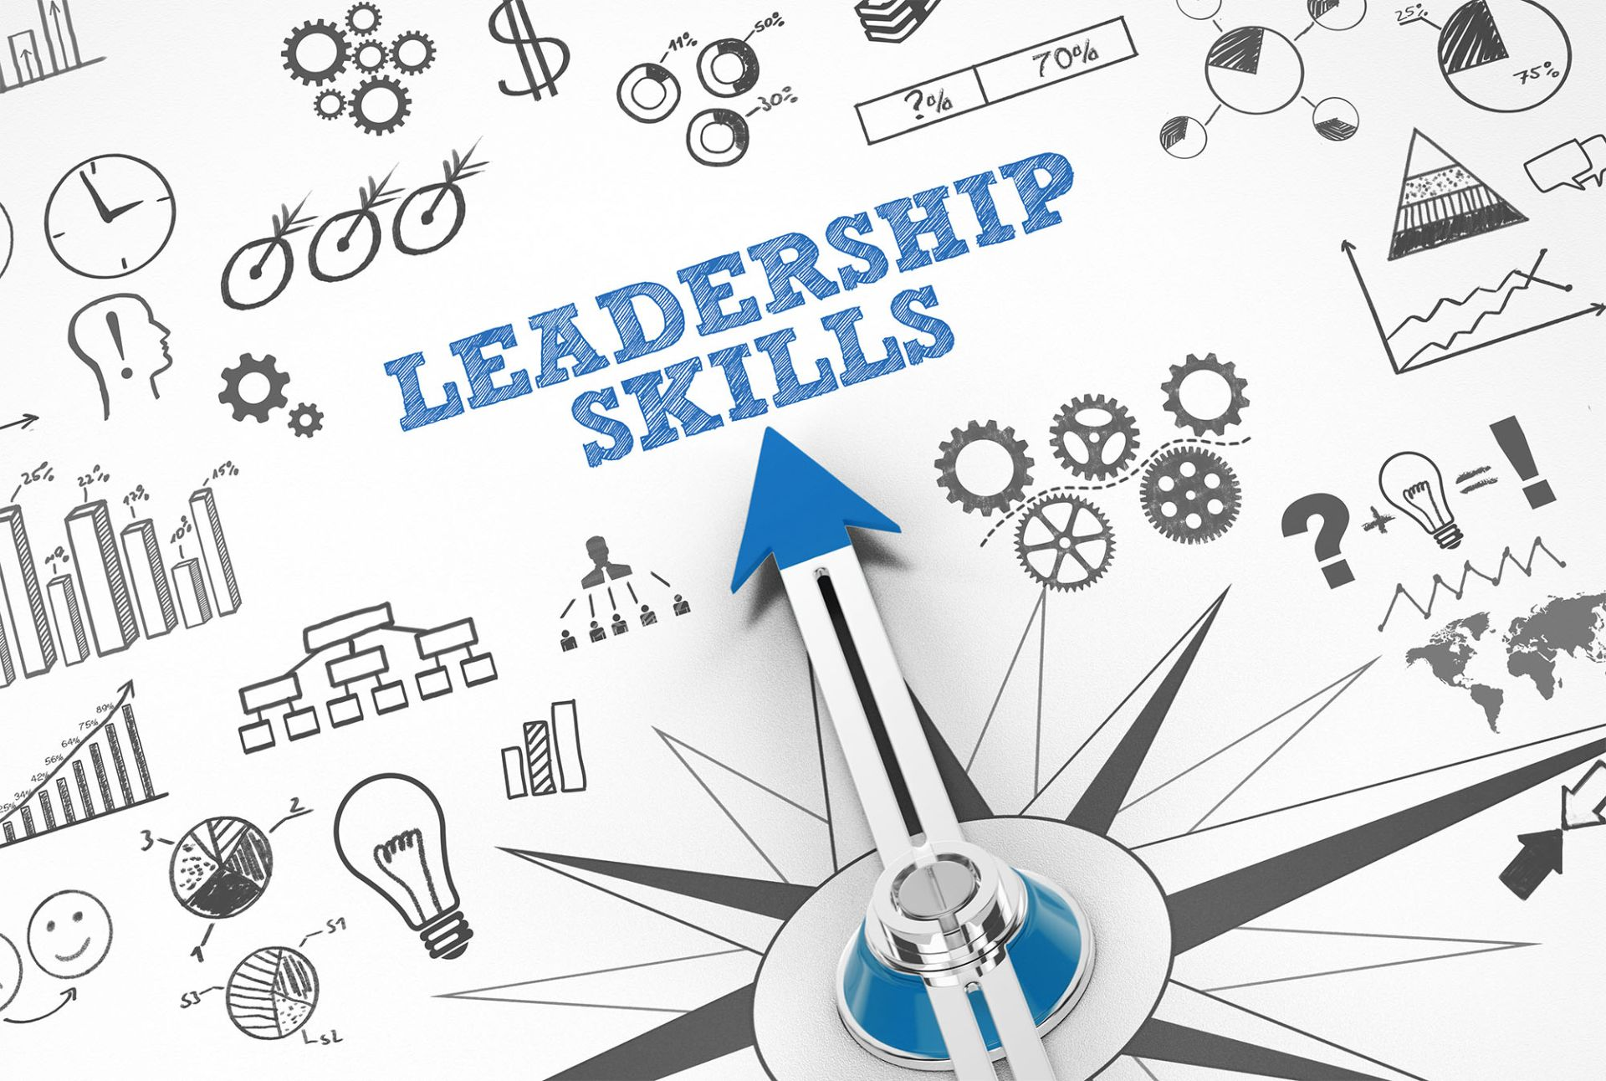

Name: Eltaf Mockbil
Module Code: BMSW6101
Lecturer: Rebecca Stewart
Student number: 1913491

Contents

- Introduction

- Difference between leadership & management

- Effective leadership styles

- Effective leadership skills

- Challenges to leadership in uncertain times

- Ethical leadership

- Conclusion

- References

Introduction

In recent years, every organisation has faced significant leadership issues. The intense pressure in the NHS has been blamed on a lack of staffing, increased service expectations, difficulty in fulfilling financial and operational targets, and a culture of blaming individuals and assigning blame. Being a leader in the NHS has grown increasingly complicated and challenging. To finalise this academic report, I will link back to an attached article summarising the fundamental difficulties in the NHS. As a result, I will review the article and create an academic report to analyse effective leadership in the NHS critically. Still, first, I will explore the difference between leadership and management as fundamental, practical leadership skills and styles, and finally, I will conclude my report by venturing into ethical leadership.

Difference between leadership and management

According to Abraham Zaleznik in a landmark article, the traditional understanding of management. Such an approach, he claimed, excludes key leadership elements such as creativity, ambition, and human passion—all of which drive business success. Managers and leaders constitute two different types.
Influence and inspiration distinguish leaders from managers, not power and control. Enable influential people to believe in the company's goal. Management is concerned with task management and the seamless execution of day-to-day activities. The difference is that leaders have followers, whilst managers have employees. Management and leadership are inextricably intertwined and mutually beneficial. Any attempt to separate the two within a company may cause more issues than it solves. A company's management must be competent in preparing, managing, and integrating its employees to succeed. Managers and leaders must grasp what they must accomplish, and to excel, they must understand the essential distinctions between them. Managers will use situational management to focus on setting, assessing, and attaining goals. Leaders will focus on inspiring others to achieve their goals.

Effective Leadership style

According to Douglas McGregor, an American management professor, leaders develop a style representing their personality, goals, and company culture. And each effective leader builds a leadership style based on their character, objectives, and organisational culture, choosing between three leadership styles: authoritarian, democratic, or laissez-faire. Douglas McGregor stated in 1960 that a manager's attitude impacts staff motivation. In his book, The Human Side of Business, McGregor developed two ideas for managers to understand and deal with employee motivation. He referred to these contrasting motivating strategies as Management Theories X and Y. Most firms profit from authoritarian leadership. Autocratic leaders make their decisions based primarily on their viewpoints and ideas. This promotes simplifying internal processes, which can help a company's long-term success. Theory X managers are known for their authoritarian leadership style and dominance. According to McGregor's Theory of Managers, individuals despise work and will take tremendous measures to avoid it. It also means that individuals need leaders' oversight and guidance. There is no need to seek approval from your team or other corporate sectors while making choices under autocratic leadership—just your opinion matters. With fewer decision-makers, structure and direction can be built more rapidly. Employees are frequently overloaded at work.

Google's democratic organisational structure is well-known. This type of leadership can be found in various situations, including corporations and educational institutions. Dr Paul Waldman says adopting a participative leadership style can be highly beneficial. According to Theory Y management, individuals want to work and are self-motivated, self-tolerant, and take personal responsibility.
Theory Y management may necessitate stricter controls, which can be relaxed as an employee progresses. It does not call for a gentle approach. An open debate encourages creativity and innovation. The more people who offer innovative ideas, the more established methods may be improved and updated. Some employees do less effectively under democratic leadership when choices are decided by a team rather than the leader.
Laissez-faire leadership is a management style in which managers step back and outsource decision-making to staff. Retail purchasing, for example, is a business that may thrive under laissez-faire leadership. The technique can be used in a variety of professional settings.
Many IT departments are also successful examples of laissez-faire leadership. Theory Z was an advancement over Theories X and Y, combining the best of Eastern and Western management practices. According to management expert William Ouchi, Western corporations can learn from their Japanese counterparts.
According to Theory Z, people desire to balance work and life. Also, workers may be trusted to accomplish their duties to the best of their ability. Long-term job commitments can be challenging for employers and employees, but Theory Z is not the definitive verdict on management.
Laissez-faire leadership, like other styles of leadership, has advantages. Because employers are so hands-off, employees have the option to be direct. This creates an environment that encourages growth and development. It allows for faster decision-making.

Referring to the article, leadership styles will be influenced by context, political environment, and societal concerns. The NHS's ability to offer safe, effective, high-quality care will be critical to this challenge. Amanda Pritchard, the Chief Executive of the NHS in England, must be highly adaptable in her leadership, employing a variety of leadership styles and techniques in practice.

Effective leadership skills

As stated by Warren Bennis, an American scholar, they are recognised as a founder of Leadership Studies. Leaders are formed, not born. He emphasised that leadership is a skill, more accurately, a collection of skills that can be acquired via challenging work. He compared it to a show. Leaders, like performers, need to embrace their characters.
Individuals' leadership abilities are the attributes and strengths they exhibit to help them monitor procedures, direct initiatives, and guide their staff towards goal achievement. Leadership abilities are required to drive others to execute a set of obligations on time, regardless of whether you are in a managerial capacity or supervising a project. Leadership is a group of talents that function in tandem. Communication, Creativity, Positivity, Problem Solving, Teamwork, Delegation, and Decision Making are among the most common leadership skills.
About the article, the NHS is intricate and powerful, requiring a diverse set of abilities to function correctly. Amanda Pritchard's capacity to lead successfully is vital to her success in her position. The ability to motivate and inspire others to influence change to provide high-quality care and a pleasant working environment for staff is necessary for modern healthcare services. To be an effective leader, Amanda must communicate effectively, motivate her team, manage, and allocate chores, listen to ideas, and solve problems in an ever-changing workplace. When uncertainty and time constraints underline the need for an almost immediate response, the importance of these skills increases considerably. Amber is expected to keep the Nhs's purpose and values in mind when making decisions and to stay loyal to the matters even when it is easier to abandon them. A strong vision based on long-held beliefs drives everyone to perform right, even when it goes against instincts.

Challenges to leadership in uncertain times

Leaders experience the same challenges regardless of industry. A review of the NHS industry found that leaders in the NHS sector face several challenges. Nevertheless, for this research, this report will address a few concerns.
The acute chief operating officer position has been the most challenging to fill in the NHS over 18 months to two years. Amanda Pritchard, NHS’s new Chief Executive, has taken control of leading the organisation through the stresses of the previous 18 months, including significant waiting lists in healthcare, a tired workforce, the COVID-19 outbreak, and strikes.
The Health Secretary, Sajid Javid, warned that waiting lists might exceed thirteen million people this year, signifying a decline in UK public health.
Concerning the article, the United Kingdom is struggling with several health issues that have long resulted from a lack of funding, destructive change, and a lack of behavioural and social factors that influence health.
To address these difficulties, the NHS requires a revised, long-term strategy to satisfy an ageing population's evolving physical and mental health demands, address worker welfare and staffing shortages, and reinforce the long heritage of clinical research. Pritchard is asked to have the bravery and commitment to see this plan through, and her main difficulty will be gaining the necessary political backing. The NHS has numerous merits, including handing out free healthcare to everyone, yet it has also revealed that it is no longer appealing to the overall population.
As an outcome of the research, Among the difficulties leaders face in the NHS, demand is constantly increasing, and there will always be more resources to meet that need. It isn’t easy to imagine that it took until about 2000 to develop a 10-year plan for the NHS. Policy and ideas frequently chop and shift for no apparent reason, making management more difficult.
Being in a leadership capacity in the NHS is a curious blend of great joy and frustration but always challenging. Aims and results support healthcare and healthcare-related organisations in improving leadership and performance.
This article has shown that Leaders in today's NHS work in a high-pressure environment. Staff shortages are frequent; there are widespread issues in fulfilling performance, and financial standards and service requirements remain high. The character of the difficulties that NHS trust leaders face has also shifted, with a stronger focus on joining forces as part of more integrated health and care sectors. Being a leader in the NHS is becoming more complex and demanding.
While discussing what may be done to improve leadership in the NHS, a recent federal assistance programme for aspiring directors of operations is a positive move that may be expanded with comparable offerings for directors of strategy, for example.
We need to make these jobs more appealing. We require leadership responsibilities that are challenging yet manageable. If we are to have a chance to turn things around, we will need national backing and air support for demanding jobs.
Nevertheless, the most prevalent proposal for strengthening future leader growth focused on the need for more robust regional employee engagement, previously supplied by strategic health authorities. Greater collaboration between NHS England and NHS Improvement will allow for rebuilding this labour and skills management role. Local Health trusts must also make investments in identifying and nurturing future leaders. This may involve regularly updating directors' resumes and looking at chances for less experienced staff members to engage in projects that would help them build board-level abilities.
Although much of the conversation surrounding leadership vacancies and tenure was presented as a problem to be solved, most leaders saw their employment as a calling and a privilege. Present NHS leaders classified themselves as "critical entrepreneurs," believing that the path through the problems of NHS leadership entailed them, as senior leaders, encouraging and showing the characteristics that would maintain their jobs appealing to future generations of leading figures.

Ethical leadership

Bill Grace is recognised for developing the 4-V Model of Ethical Leadership. He is one of the founders of Ethical Leadership. He thinks that ethical leaders can only operate successfully if they understand their fundamental principles and how they fit into the organisation’s larger mission.
Leadership that demonstrates and fosters normatively appropriate behaviour via personal acts and interpersonal ties" defines ethical leadership. When it comes down to it, ethical leadership is described as putting individuals in positions of management and leadership who will encourage and model good, ethical behaviour in their activities and workplace interactions.
In today's corporate environment, ethics is becoming a more critical component and topic of conversation. As a result, understanding, developing, and recognising ethical leadership is essential to the corporate world. To be a corporate leader, you must first comprehend ethical leadership. It is your obligation as a leader in an organisation to provide an excellent example of moral behaviour. You must have integrity, ethical behaviour, and ethics to be a good leader.
Treating people fairly, providing an excellent example for others, and actively managing morality are all examples of ethical leadership. Strong leadership is critical in the case study while caring for the most vulnerable. Ethical leadership is associated with a wide range of desirable behaviours in leaders and followers. It has been linked to increased leadership effectiveness, job devotion, satisfaction, and organisational commitment. It has also been related to improved work performance, corporate citizenship, and less unethical behaviour among members.

Conclusion

In summary, leaders should employ a hybrid of the four leadership and management paradigms. Some aspects influence which style may be used, such as how much time is available and whether relationships are built on trust, respect, or something else (Hersey 1984). While dealing with any crisis in the firm, the participative method allows executives to determine what action plan to implement. Instead of utilising penalties such as dismissal, warnings, or even days off to drive staff, positive leaders use rewards such as education. Leaders work through the positives, while bosses go through the negatives. My research on leadership ideas indicates a progression from a great man and characteristic theories to current leadership theories such as transformation and transaction theories. According to studies, each of these theories has advantages and disadvantages, and no perfect leadership philosophy exists. Some variables I identified throughout my research boost the power and effect of individuals, groups, and organisations.
Additionally, most people see how ethical action may benefit them daily. In the long term, all these occurrences benefit the company. They ultimately returned to the case study to compel or enforce successful change, even when it seemed impossible or exceedingly challenging. It involves developing exceptional leadership abilities, determining the right leadership style and philosophy, and choosing ethical leadership. Ultimately, this analysis demonstrates that leaders in the NHS confront several hurdles, with the critical chief operating officer role being the most difficult to fill. Amanda Pritchard has taken charge of steering the organisation through the rigours of huge healthcare waiting lists, a fatigued staff, the COVID-19 epidemic, and strikes. She will be successful in her efforts during these trying times.
To overcome these challenges, the NHS needs a redesigned, long-term strategy focused on meeting an ageing population's changing physical and mental health needs, addressing worker welfare and staffing shortages, and reinforcing the NHS's long history of clinical research. Demand is continually rising, and there will always be more resources to supply that need, complicating management.
NHS Improvement and the NHS are collaborating to enhance leadership and performance, particularly emphasising collaborating as part of more integrated health and care sectors. Today's NHS leaders operate in a high-pressure environment, with personnel shortages and difficulty meeting performance and budgetary criteria. National assistance programmes, regional employee participation, and investments in identifying and fostering future leaders are required to strengthen leadership. Current NHS leaders are considered essential entrepreneurs, promoting and demonstrating the attributes that will keep their professions desirable to future generations of leaders.

References

Herzberg Maslow. What are the similarities and differences between the theories of Maslow and Herzberg? 2022-11-08 (columbia.edu) accessed on 01.02.2023.

Blake, R. & Mouton, J. (1985). The managerial grid III: The key to leadership excellence. Houston: Gulf Publishing Co. accessed on 25.02.2023.

“Uzbekistan: Wicker Statement on Jackson Water Crisis.” MENA Report, Albawaba (London) Ltd., 1 Sept. 2022. accessed on 01.02.2023.

McGregor’s Theory of Motivation | The Enterprise World. https://theenterpriseworld.com/mcgregors-theory-of-motivation/ accessed on 01.02.2023.

The Power of Influence in Leadership Development. https://trainingindustry.com/articles/leadership/the-power-of-influence-in-leadership-development/ accessed on 01.02.2023.

What are the similarities and differences between the three ... - eNotes. https://www.enotes.com/homework-help/what-are-the-similarities-and-differences-between-581519 accessed on 01.02.2023.

Drysdale, L. and Gurr, D., 2017. Leadership in uncertain times. International Studies in Educational Administration, 45(2), pp.131-159. accessed on 01.02.2023.

Curson, J. and Parnell, H., 2010. Leading through uncertain times–dance in the rain: The experience accessed 03.03.2023.

Zhang, X. & Bartol, K.M., 2010, ‘Linking empowering leadership and employee creativity: The influence of psychological empowerment, intrinsic motivation, and creative process engagement’, Academy of Management Journal 53(1), 107–128. https://doi.org/10.5465/AMJ.2010.48037118 accessed on 01.02.2023

Cicero, L., Pierro, A. & Van Knippenberg, D., 2010, ‘Leadership and uncertainty: How role ambiguity affects the relationship between leader group prototypicality and leadership effectiveness’, British Journal of Management 21(2), 411–421. accessed on 03.03.2023.

Van Seters, D.A. and Field, R.H., 1990. The evolution of leadership theory. Journal of organizational change management, 3(3), pp.29-45. accessed on 03.03.2023.

Gandolfi, F. and Stone, S., 2018. Leadership, leadership styles, and servant leadership. Journal of Management Research, 18(4), pp.261-269. accessed on 03.03.2023.

Elmuti, D., Minnis, W. and Abebe, M., 2005. Does education have a role in developing leadership skills? Management decision. Accessed on 03.03.2023.

Hitt, W.D., 1990. Ethics and leadership. Columbus, OH: Battelle Press. accessed on 03.03.2023.

Ciulla, J.B., 2003. [Introduction to] The Ethics of Leadership. Wadsworth/Thomson Learning. Accessed on 03.03.2023.

Ham, C., Baker, G.R., Docherty, J., Hockey, P., Lobley, K., Tugendhat, L. and Walshe, K., 2011. The future of leadership and management in the NHS: no more heroes. London: The King’s Fund. Accessed on 20.02.2023.

Lumbers, M., 2018. Approaches to leadership and managing change in the NHS. British Journal of Nursing, 27(10), pp.554-558. accessed on 06.03.2023.

Why 'Miracle' Gene Therapy Is 'Blessing' and a 'Heartbreak' for Family. https://www.insider.com/toddler-first-uk-to-receive-miracle-drug-rare-fatal-disorder-2023-2 accessed on 05.03.2023

Examples of "Motivate" in a Sentence | YourDictionary.com. https://sentence.yourdictionary.com/motivate accessed on 05.03.2023.

Garcia, I., 2015. Emergent leadership: Is e-leadership important in the quality of virtual education? RIED: Revista Iberoamericana de educación a Distancia. Accessed on 5.03.2023.

