
APPENDIX GA36a

LEVEL 4 ASSESSMENT SPECIFICATION

Student name: |  | Student ID number:
Programme: | HNC Electrical and Electronic Engineering, HNC Instrumentation Engineering.
Module: | Industrial Measuring Systems
Module code: | PCEE4003 | Contribution to Overall Module Assessment (%): | 100%
Lecturer: | Anthony Howles | Internal Verifier: | Jason Pointer
Assignment Title: | Measurement systems | Word count (or equivalent): | 2000
Submission deadline: | 25/05/2022 | Return date of provisional marks & written feedback: | 08/06/2022
Submission method: | All written assessments, where practical and possible, must be submitted via Turnitin unless otherwise instructed by the Lecturer. (Please DO NOT put this assessment specification into Turnitin or it will match many similarities with other students’ submissions.)  Alternative submission method (if applicable):  Late submission of the assessment will result in a late penalty mark. Penalties for late submission: Up to one week late, maximum mark of 40%. Over one week late, 0%. Only the Extenuating Circumstances Panel may approve a change to submission dates.
Academic honesty / referencing: | Academic honesty is required. In the main body of your submission you must give credit to authors on whose research and ideas your work is based. Append to your submission a reference list that indicates the books, articles, etc. that you have used, cited or quoted in order to complete this assessment.

Module Learning Outcomes
(from module syllabus)
LO1, LO2.

TASK DESCRIPTION

Assignment Brief

For this assignment, you are required to complete six tasks that investigate sensor operation and characterisation, signal processing, signal transmission, open and closed loop control.

Task 1. Pressure sensor

To measure and indicate a process pressure value, analogue or digital systems could be used. For this task evaluate the two technologies with respect to an analogue bourdon tube pressure gauge and a digital pressure gauge employing a resistive strain gauge sensor (see figure 1). Compare and contrast these two instruments with respect to their principles of operation and their static and dynamic characteristics. Include any advantages and disadvantages for each of the measuring technologies in your answer.

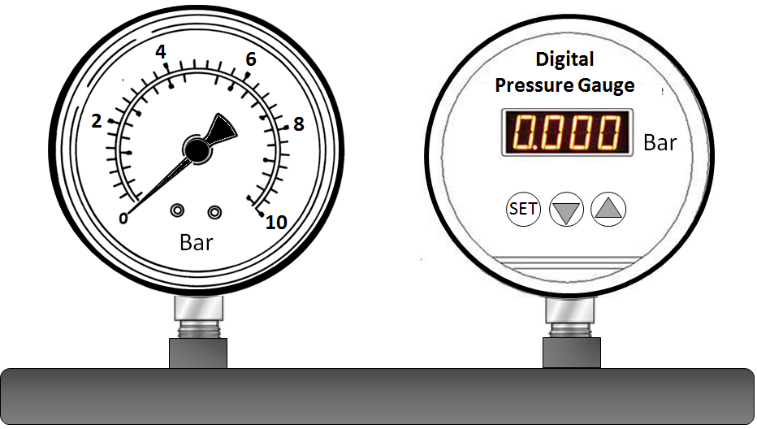

Figure 1. Analogue and Digital Pressure Gauges

Pressure Sensor(s):

Analogue pressure measurement device (Bourdon Tube) – A bourdon tube is an analogue measuring deivce that is used to measure pressure. It comprises of a tube, typically made of a thin flexible metal, this tube flexes when under pressure, essentially unravelling. The way that the tube works is that the more pressure within it, the more it flexes and unravels. A gearing mechanism is fastened to tube to give an analogue display of how much pressure there is. The more the tube flexes, the more the dial/needle on the display moves. Bourdon Tubes can be used to measure two types of pressures. These are direct pressure, this is where the device is used to measure absolute pressure of the system, and differential pressure, this is the difference in pressure between two pressurised systems.

Advantages:
1. They give accurate results.
2. Their design is simplistic, therefore they are easy and inexpensive to manufacture.
3. Due to their accuracy and their construction, they can be used to safely measure high pressure systems .
4. Their robust construction also gives them a high repeatability. This means they can give accurate readings over and over again, typically up to 1 million uses.

Disadvantages:
1. A Bourdan tube does not respond quickly to changes in pressure.
2. Due to the movement at the end of the bourdon tube being limited, a mechanism is needed to amplify this movement, so that it can be easily read using a scale/dial.
3. Although the results produced by the bourdon tube are accurate, it cannot be used for pressures which require precise readings.
4. Due to a thing called hysteresis, the Bourdon tube retracts slower when moving from a high reading to a low reading, therefore when the pressure is decreasing, the reading displayed on the bourdon tube is higher than what the actual pressure, although this is a miniscule difference, it still affects the readings produced.
5. Typically, most if not all bourdon tubes are calibrated to only reading within a particular medium, if this medium is changed, this can affect the readings produced by the bourdon tube resulting in an error.

Example of the construction of a Bourdon Tube:

Figure 1. Bourdon Tube Mechanical Layout
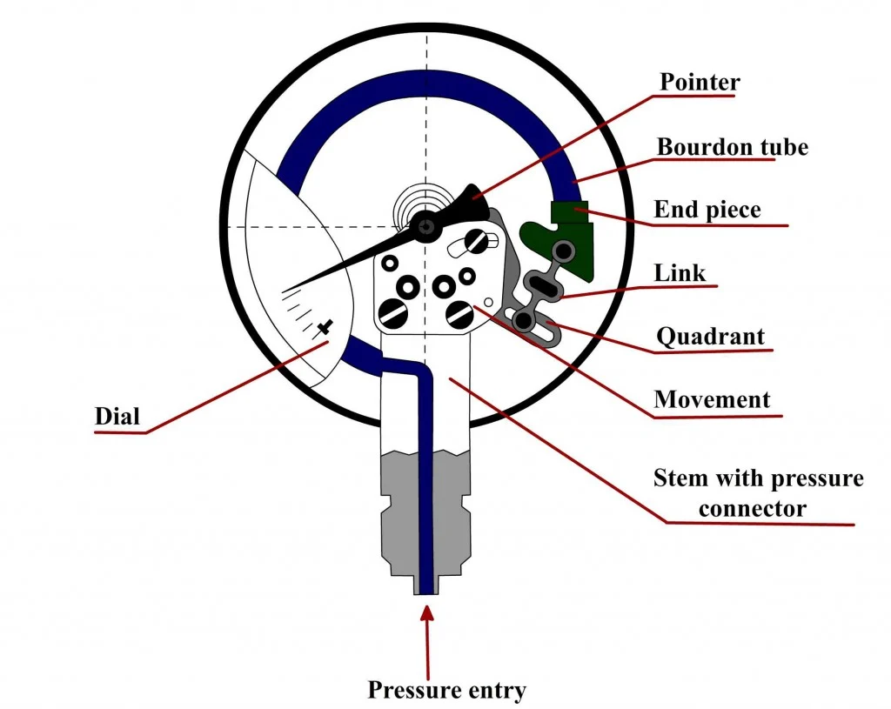

(Science ABC (2022). C-type. [Online Image] www.scienceabc.com. Available at: https://www.scienceabc.com/pure-sciences/what-is-a-bourdon-tube-gauge.html#what-is-a-bourdon-tube [Accessed 23 Mar. 2022].)

Digital pressure measurement device (Resistive Strain Gauge Sensor) –

A strain gauge is a sensory device which is used to detect and measure strain on an object. Strain covers the following measurements; pressure, force, weight and tension. The way a strain gauge works is that when strain/force is applied to it, the resistance of the strain gauge changes. This change in resistance will give different electrical outputs. These electrical outputs can then be converted into pressure measurements using a digital display. The reason for using a digital display is because analogue displays cannot respond to a change in resistance as it is an electrical output. Analogue displays use mechanical mechanisms to convert the pressure into a displayable form.
Multiple strain gauges can be placed together to increase the accuracy of the measurement. This is known as a wheatstone bridge. Using multiple strain gauges allows for even minute changes in pressure to be measured.

Advantages:
- A big advantage of a strain gauge is that there are no moving parts, this eliminates the need for maintenance as when the gauge fails a new one can be bought.
- The next advantage is that they are cheap and easily replacable.
- Due to theyre small size, they are easy to handle and easy to put in place.

Disadvantages:
- Strain gauge transducers have low output signal levels, therefore a signal booster might be needed or a digital device wich runs on lower signal levels might be needed.
- The frequency response of strain gauges is also limited. Therefore digital devices will have to run on a similar low frequency, or the frequency will needed to be increased.
- Strain gauges do not handle high voltages well, therefore the voltage going into the gauge will have to be low, this might require a step-down transformer if the control circuit voltages are 110V or higher.

Figure 2. Diargam of a Strain Gauge

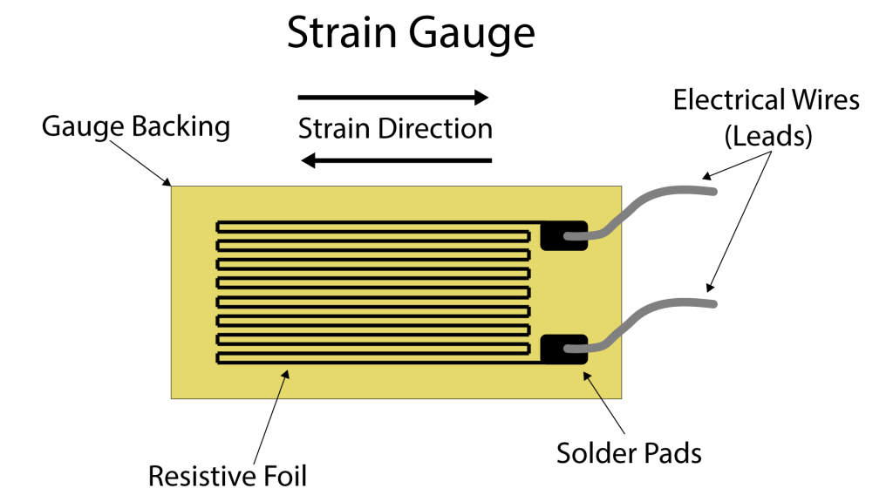

(Nachazel, T. (2020). Strain Gauge. [Online Image] www.michsci.com. Available at: https://www.michsci.com/what-is-a-strain-gauge/ [Accessed 6 Apr. 2022].)

To compare these thwo measuring instruments, it can be seen that Bourdon tube’s can be used to measure high pressure systems, a strain gauge typically would not be used to measure higher pressure. However, a bourdon tube would be obsolete when measuring systems with lower pressure as its mechanism would struggle to detect the miniscule changes in pressure. This is where a wheatstone bridge of strain gauges would have an advantage as they have the ability to detect extremely small changes in pressures. Both measuring instruments have their advantages and disadvantages. But when looking at these, it is clear to see that a bourdon tube is best suited to systems of higher pressure, and strain gauges suited to systems of lower presasure.

Task 2. Position sensors

- Identify a sensor that could be used to measure the angular velocity of an electric motor from 0 to 1000 RPM.

- Identify a sensor that could be used to measure the rotation of a 3-way ball valve through 180° operation. In addition, there is a requirement to indicate the operation of the valve from 0 to 100 % of its travel in both the forward and reverse action.

For both answers include an explanation of the sensor’s construction and its principle of operation. Include a data sheet for a commercially available sensor of the type you are proposing for each of the applications.

Position Sensors:

- Sensor used to measure angular velocity of a motor (from 0 to 1000 RPM) – The sensor which would most likely be used to measure the angular velocity of a motor would be a vibrating structure gyroscope (VSG). ‘The underlying physical principle is that a vibrating object tends to continue vibrating in the same plane even if its support rotates. The Coriolis effect causes the object to exert a force on its support, and by measuring this force the rate of rotation can be determined’.

User: AxelBoldt (2015). Vibrating Structure Gyroscope. [online] Wikipedia. Available at: https://en.wikipedia.org/w/index.php?title=Vibrating_structure_gyroscope&oldid=695709267 [Accessed 4 May 2022].

What this quotation is essentially saying is that the VSG utilises the Coriolis effect to determine the rate at which the object is roatating. This is either measured as RPM (Rotations Per Minute) or rad/s (Radians Per Second). The sensor would be mounted to the outer casing of the motor, so that the vibrations produced can be picked up easily.

The image below displays the simple layout of a Draper Laboratory gimbal gyroscope. This type of ‘gimbal’ gyroscope is one of the many subcategories of a VSG.

Figure 3. Draper Laboratory gimbal gyroscope Diagram

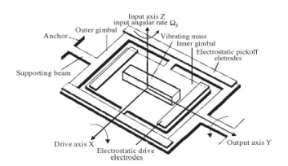
Xia, D., Yu, C. and Kong, L. (2014). The Development of Micromachined Gyroscope Structure and Circuitry Technology. Sensors, 14(1), pp.1394–1473. doi:10.3390/s140101394.

The following is a written review taken from ‘The Development of Micromachined Gyroscope Structure and Circuitry Technology’, it contains a description of how this specific gyroscope functions and what it contains:

‘During the period of operation, the inner gimbal is driven at constant amplitude and frequency by the electrostatic drive electrodes. In presence of an angular rotational rate normal to the device plane, the Coriolis force will cause the outer gimbal to oscillate around its output axis with a frequency equal to the driving frequency and amplitude proportional to the inertial input rate’

Xia, Dunzhu, et al. “The Development of Micromachined Gyroscope Structure and Circuitry Technology.” Sensors, vol. 14, no. 1, 14 Jan. 2014, pp. 1394–1473, 10.3390/s140101394. Accessed 6 May 2022.

The output that is produced by this gyroscope conists of electrostatic/capacitance. Due to the discharge voltage produced by the VSG being miniscule, a step up transformer would be needed to increase the voltage, so that better readings can be taken. Below is a data sheet of a basic gyroscope sensor.

Figure 4. Gyroscope Data Sheet

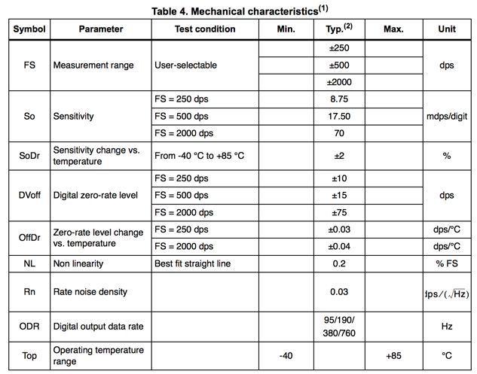

Adafruit Learning System. “Comparing Gyroscope Datasheets.” Adafruit Learning System, learn.adafruit.com/comparing-gyroscope-datasheets. Accessed 10 May 2022.

This data sheet provides a full scope of what is called the ‘zero rate error’ across all output ranges of this particular sensor which is labelled L3GD20. It can be seen that the higher the output range the more the zero rate error increases for example +/-500dps has a lower zero rate error than at +/-2000dps).

- Sensor used to measure 3-way ball valve through 180° operation (from 0–100% of its travel) – Below is an example of 3-way valve L-port with 180° degrees of travel. This would be the valve which the selected sensor would be used to measure.

Figure 5. 3-way ball valve 3-position(s) Diagram

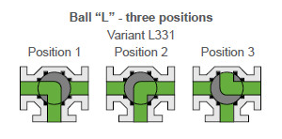
KE - ARM. “KE-ARM | Three-Way Ball Valve - 4 Seats, KM 93,” Www.kearm.eu, www.kearm.eu/products/three-way-ball-valves/three-way-ball-valve-4-seats-km-93.html. Accessed 6 May 2022.

The type of sensor which would be best suited to measure the 180° rotation of the 3-way ball valve would most likely be a Rotational Potentiometer. ‘Potentiometers work by varying the position of a sliding contact across a uniform resistance. In a potentiometer, the entire input voltage is applied across the whole length of the resistor, and the output voltage is the voltage drop between the fixed and sliding contact’. What this quotation is saying is that the voltage output from the potentiometer is directly proportional to where the sliding contact is located along the fixed resistive material.

DesignSpark. “Potentiometer Adjustable Voltage Divider Introduction,” Www.rs-Online.com, 11 Dec. 2020, www.rs-online.com/designspark/potentiometer-adjustable-voltage-divider-introduction. Accessed 10 May 2022.

Attatching the rotational potentiometer to the shaft of the 3-way ball valve would be the best way to measre its rotation through 180° and the 3 main different positions. By attatching the potentiometer to the shaft it would mean that the voltage output would be directly proportionat to the position of the valve. For example, if the 3-way valve were in position 1 (see Figure 5.) then the voltage output would be 10 volts. Then, moving from position 1 to 2, the voltage would slowly increase until the valve was completely in position 2 where it would be producing 20 volts, position 3 would then produce 30 volts.

The same can be said when the valve is in a closed position. For instance, when the valve is exactly between position 1 and 2, the voltage output would be 15 volts, between position 2 and 3 it would be 25 volts, etc.

The following is a diagram of the very basic layout of a rotational potentiometer.

Figure 6. Rotational Potentiometer Structure
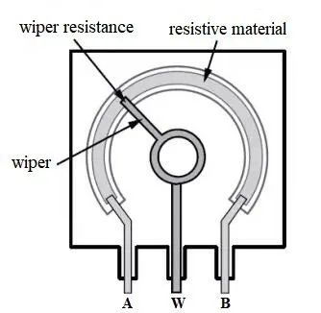

DesignSpark. “Potentiometer Adjustable Voltage Divider Introduction,” Www.rs-Online.com, 11 Dec. 2020, www.rs-online.com/designspark/potentiometer-adjustable-voltage-divider-introduction. Accessed 10 May 2022.

There are many different variations of roational potentiometers depending on what type is required, what voltage output is required and the companies which manufacture them. The following is a data sheet produced by ALPHA, which is a company that manufactuers rotational potentiometers. As can be seen, the value of the potentiometer will depend on the mouser stock number. As well as this, the dimensions of the potentiometer itself are included, along with its ‘Resistance tolerance’, ‘Maximum working voltage’ and its ‘Insulation resistance’ value.

Figure 7. ALPHA Potentiometer Data Sheet

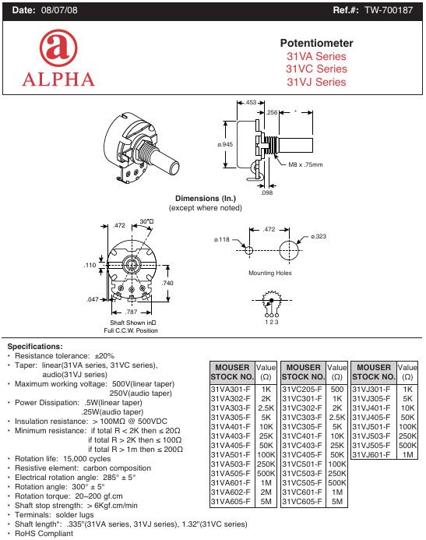

Mouser Electronics. “RV24AF-10-40R1-B10K Potentiometer Datasheet Pdf - Potentiometer. Equivalent, Catalog.” Datasheetspdf.com, 2014, datasheetspdf.com/pdf/866974/ALPHA/RV24AF-10-40R1-B10K/1. Accessed 10 May 2022.
Task 3. Temperature Sensor characteristics

A PT100 platinum type RTD is being used to measure the temperature of a process from 0 °C to 100 °C. The RTD being used has a temperature coefficient of resistance of 3.85 x10⁻³ ⁰C. For this task, use these values to answer the following questions.

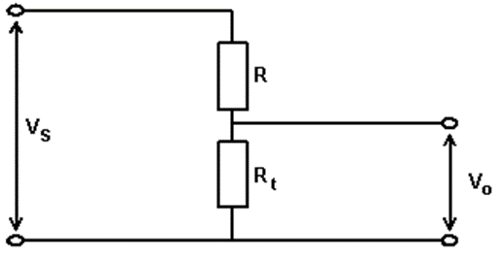

- Calculate the resistance of the sensor at 5°C intervals from 0 °C to 100 °C. You may use a table to collate your results but include all calculations in your answer.

Values:

a = 0.00385 RO = 100 VS = 10 R = 100

The formula used for Part a). RT = RO (1 + αt)

RT = 100 (1 + 3.85 x 10-3 t)

Temperature (℃) | Reistance (W)
0 | 100
5 | 101.925
10 | 103.850
15 | 105.775
20 | 107.700
25 | 109.625
30 | 111.550
35 | 113.475
40 | 115.400
45 | 117.325
50 | 119.250
55 | 121.175
60 | 123.100
65 | 125.025
70 | 126.950
75 | 128.875
80 | 130.800
85 | 132.725
90 | 134.650
95 | 136.575
100 | 138.500

- The platinum RTD is to be used in a voltage divider circuit (Fig 3.1 – Voltage Divider). If the supply voltage (V_{s}) is 10v, R = 100 Ω and R_{t} is the platinum RTD calculate the circuit output for the same range of temperatures in question 1a. You may add a separate column to your table to show these results but include all calculations in your report.

Vo = VS x RT / R + RT

Temperature (℃) | Vo (V)
0 | 5
5 | 5.05
10 | 5.09
15 | 5.14
20 | 5.19
25 | 5.23
30 | 5.27
35 | 5.32
40 | 5.36
45 | 5.40
50 | 5.44
55 | 5.48
60 | 5.52
65 | 5.56
70 | 5.59
75 | 5.63
80 | 5.67
85 | 5.70
90 | 5.74
95 | 5.77
100 | 5.81

- Assuming the input and output responses of the sensor are linear, determine the sensitivity of the circuit.

Sensitivity = Change in output / Change in input.

The temperatures which have been selected to determine the sensitivity of the circuit is between 30⁰C and 80⁰C.
The voltages that are between these temperatures range from 5.27V to 5.67V.

Sensitivity = $\frac{5.67-5.27}{80-30}$

Sensitivity = $8×{10}^{-3}$V / ⁰C

- The temperature sensor has a first order response with a time constant of 5ms. Plot the output response to a step change in input from 0 °C to 50 °C in 1ms steps until a steady state condition is achieved.

Symbol Key:

T = Output Temperature.
T0 = Final Temperature.
t = time (ms)
ȶ = time constant = 5ms

T = T0 (1 – e- t/ȶ)

Time (ms) | Temperature (℃)
0 | 0.00
1 | 9.06
2 | 16.48
3 | 22.56
4 | 27.53
5 | 31.61
6 | 34.94
7 | 37.67
8 | 39.91
9 | 41.47
10 | 43.23
11 | 44.46
12 | 45.46
13 | 46.29
14 | 46.96
15 | 47.51
16 | 47.96
17 | 48.33
18 | 48.63
19 | 48.88
20 | 49.08
21 | 49.25
22 | 49.39
23 | 49.50
24 | 49.59
25 | 49.66
26 | 49.72
27 | 49.77
28 | 49.82
29 | 49.85
30 | 49.88
31 | 49.90
32 | 49.92
33 | 49.93
34 | 49.94
35 | 49.95

Task 4. Indicators

- Explain the difference between an LCD and a LED seven segment display. Include in your answer advantages and disadvantages for each.

- Explain the operation of an analogue to digital conversion (ADC) process that could be used to turn a 4 to 20 mA signal into a digital indication. Include sensitivity, resolution quantization and quantization error in your explanation.

LCD and LED Seven Segment Display:

- A seven segment display is used to display ‘decimal numbers’, from 0 to 9. This type of display is very common in things such as calculators, digital clocks, electronic meters, and in car radios.

What is an LCD Display? – LCD stands for Liquid Crystal Display, ‘Liquid crystals are like a mixture between a solid and a liquid, where an electric current can be applied to change their state in order for a specific reaction to occur’. What this essentially means is that an LCD display contains these crystals which when different electrical currents are applied, results in a change of ‘state’, therefore creating different colours.

Facebook, Twitter and LinkedIn (2021). LCD Definition (Liquid Crystal Display). [online] Lifewire. Available at: https://www.lifewire.com/what-is-liquid-crystal-display-lcd-2625913 [Accessed 11 May 2022].

What is an LED Display? – LED stands for Light Emmiting Diode, these types of displays aren’t that different from the LCD’s. The only major difference is how the displays produce backlighting. Backlighting is essentially how the display can turn light on and off, this is specifically important when wanting to tell apart darker and lighter colours. The main advantages of an LED display are that they are very efficient and have a low energy consumption when compared to the LCD display. Also, LED displays provide a brighter and more intense light source.

Difference between them – To compare these two types of displays, an LCD display uses a ‘cold cathode fluorescent lamp (CCFL) for backlighting purposes, while LED screens use more efficient and smaller light-emitting diodes (LED's)’. The main difference therefore between these two types of displays is that the CCFL backlit displays cant ‘block’ all of the black and dark colours, therefore the contrast between dark and light coours isn’t as good as an LED display where the black and darker colours are displayed as much darker giving a better contrast between light and dark.

Facebook, Twitter and LinkedIn (2021). LCD Definition (Liquid Crystal Display). [online] Lifewire. Available at: https://www.lifewire.com/what-is-liquid-crystal-display-lcd-2625913 [Accessed 11 May 2022].

Analogue to Digital (ADC) Process:

Analogue to Digital Conversion – The ADC which could be used to convert 4-20mA of current into a digital singal would be a frequency transducer. A frequency transducer converts its input of AC current (4-20mA) into an output frequency. This frequency is directly proportionate to the input current and is expressed as kHz. This output frequency can be selected or changed depending on the required output signal. This output frequency can then be read from a digital display.

The frequency transducer in question would be the MINI MCR-SL-UI-F - 2864082. This device has an input range of 4-20mA, and an output of up to 10kHz. This frequency transducer has a very specific sensitivity where it calculates through ‘bits’, for example 12bits provides an output of between 977 and 1.9kHz, 10bits outputs 3.9 and 7.8kHz. The resolution of the frequency transducer means what is the lowest input it can read. For this specific transducer, the resolution of it is 0.2mA

‘Quantization is the process of mapping continuous infinite values to a smaller set of discrete finite values. In the context of simulation and embedded computing, it is about approximating real-world values with a digital representation that introduces limits on the precision and range of a value’. In relation to the frequency transducer, due to the output frequency being directly proportionate to the input current, as well as this the limits which are already set in the transducer provide a good quantization. This is because the limits and ranges are already stated on the data sheet and all values will be as stated.

TheMathWorks (n.d.). What Is Quantization? | How It Works & Applications. [online] uk.mathworks.com. Available at: https://uk.mathworks.com/discovery/quantization.html [Accessed 11 May 2022].

Task 5. Signal transmission

- Explain the advantages and disadvantages of current and voltage signal transmission.

Current and Voltage Transmission:

Current Transmission – The following are the advantages and disadvantages of using current signal transmission, specifically within the 4-20mA range.

Advantages
- Current signal transmissions can run over long distances with very little in losses when compared to voltage signal transmissions.
- A varying current loop load impedance or supply voltage will not significantly affect the signal as long as it does not exceed recommended component limits.
- Current is a rugged signal with low electromagnetic susceptibility.
- As current transmissions only need two wires/cables it saves on material.
- Live zero reading verifies sensor is electrically functional.
- Current signal transmission has a much higher resistance to electrical noise.

Disadvantages
- It has a high power consumption when compared to other types of analogue signal transmission types.
- Cuurent has an elevated output at zero reading.
- The supply does not have to be isolated from the output.
- Increasing the circuit load resistance, will reduce the supply voltage available to power the transmitter that is generating the 4-20mA signal.

Voltage Transmission – The following are the advantages and disadvantages of utilising voltage as a form of signal transmission.

Advantages
- When at much higher voltages, voltage signal transmission allows for less cable to be used.
- At higher voltages, transmissions are more efficient.

Disadvantages
- When transmitted over long distances, a lot of voltage is lost leading to the output voltage being much lower than the input. This could lead to errors in measurement and affect process.The voltage signal when transmitted over a long distance it causes a voltage drop in the wires.
- Generally is much less accurate than current signal transmission.

Overall, current signal transmission between 4 and 20mA is a much better way of transmission when compared to voltage.

- The output signal from a measurement system typically has to be processed in some way to make it suitable for the next stage of the process. Explain the operation and identify reasons why the five processes listed would be applied to a measurement signal:

- Conversion

‘Signal conversion is a fundamendal process to condition measurement signal or output signal from one device to another device for further processing. The conversion must be done if the measurement or the output signal does not meet input specification of the receving device’.

Mirzal, Andri. “Principles of Signal Conversion: A Brief Tutorial.” International Journal of Control and Automation, vol. 11, no. 1, 31 Jan. 2018, pp. 171–178, 10.14257/ijca.2018.11.1.16.

What this means is that a conversion of a signal is to change it from one output to a different input or vise versa. Signals are converted as not all input and output devices run off of the same signals. Therefore signal conversion is required to change signal to suit the specifications of the receiving devices.

- Amplification

Signal amplification is the process of increasing the strength of a signal. The main reson for signal amplification is because when transmissions are carried over a long distance, the strength of the transmission decreases. Therefore, when the transmission signal reaches its receiving device, the signal isn’t strong enough for the device to receive. By increasing the strength of the signal before it gets to the receiving device insures that it will be able to detect the transmission.

- Elimination

Elimination is also known as interference with regards to signal transmission. An interference is something which ‘modifies’ a signal in a way which disrupts it, as the signal travels between the output and input device through the communication line. Elimination/interference is often used to describe the addition of unwanted signals to a useful signal. The most common types of interference ‘in cellular networks are: self-interference, multiple access interference, co-channel interference (CCI) and adjacent channel interference (ACI)’.

Adediran, Y.A., et al. “Interference Management Techniques in Cellular Networks: A Review.” Cogent Engineering, vol. 4, no. 1, 16 Feb. 2017, 10.1080/23311916.2017.1294133.

- Manipulation

‘Manipulation is the sending of signals in a way that takes advantage of default receiver responses to such signals, to influence their behavior in ways favorable to the sender. Manipulative signals are often dishonest, and dishonest signals are often manipulative, though this not need be the case’.

Brusse, Carl. “Manipulation and Dishonest Signals.” Encyclopedia of Evolutionary Psychological Science, 2020, pp. 1–4, 10.1007/978-3-319-16999-6_3616-1. Accessed 16 May 2022.

What this means is that manipulation, with regards to signal transmission, is when a signal isn’t strong enough it is ‘dishonest’. Dishonest signals are much easier to manipulate which is when the signal itself is altered when moving between output and input devices. Signals which have been manipulated may affect things such as measurements and readings of receiving devices.

- Protection

Protection is anything that is put in place to protect the signal which is being transmitted. The purpose of protecting the signal is to ensure that the data that the receiving device receives isn’t corrupted or false, which could result in incorrect measrements and readings. Examples of how a signal might be protected could include the following;
- Using shielded cables
- Properly grounding electrical equipment
- Proper placement of sensors, cables and receiving devices
- Low-Pass Filters

‘Another solution can be to eliminate existing noise on a wire instead of preventing it at the beginning. A low-pass filter is a circuit combination of a resistor and a capacitor. The arrangement allows quick changes (high frequency) voltage changes to stop before the controller, while the slower deliberate changes from the actual sensor (the low frequency) are passed on to the input terminal’.

Peterson, David. “How to Reduce Electrical Noise on Sensors and Control Systems - Technical Articles.” Control.com, 4 Sept. 2020, control.com/technical-articles/how-to-reduce-electrical-noise-on-sensors/. Accessed 16 May 2022.

Task 6. Basic control systems

- Briefly explain open loop control systems. Include an application, one advantage and one disadvantage in your answer.

The brief descrition of what an open loop system is would be this. An open-loop system is a type of control system where the output of the control system completely depends on what the input of the system is. However, the input/controller of the system is independent from the output. These type of systems do not have any kind of feedback loop. Therefore, these systems are also known as non-feedback systems

A very good example of an open loop system which is used in every-day life would be a washing machine. The way a washing machine operates is very simple, it soak, washes, rinses and dries. All of these stages are completely time based depending on how long the user sets the wash time. The washing of the clothes does not depend on how clean or dry the clothes are, it is up to the user to set the wash time. Therefore, there is no feedback as when the wash has finished, the machine stops.

Advantages - The main advantages of an open look control system are:
- They are easy to maintainimple in construction and design
- Are simple in construction and design
- Generally stable
- Convenient to use as output is difficult to measure

Electrical4U. “Control System | Closed Loop Open Loop Control System | Electrical4U.” Electrical4U, 24 Feb. 2012, www.electrical4u.com/control-system-closed-loop-open-loop-control-system/. Accessed 16 May 2022.

Disadvatages
- The bandwidth of open loop control system is less
- The non-feedback system doesn't facilitate the process of automatio
- Open loop systems are inaccurate in nature and also unreliable

Src=’https://Secure.gravatar.com/Avatar/1b536d4070b94df597477afa574bbc4f?s=42, img Alt=’’, et al. “What Is an Open Loop System? Examples, Advantages, Disadvantages.” Electronics Hub, 23 Apr. 2021, www.electronicshub.org/open-loop-system/#:~:text=convenient%20to%20use.-. Accessed 16 May 2022.

- Draw a block diagram of a closed loop control system and describe the function of each element.

Below is an example of an open loop block diagram for a washing machine. As seen, each component has its own labelling, for example the ‘Desired Time’ is the firts In put as it is up to the user to set how long they want the wash to be on for. The ‘Timer’ of the washing machine is the control as depending on what the first in put is, the timer will set this and produce an output to go the the heating elements, etc.

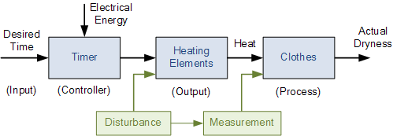

Reference List:

Reference 1 – Science ABC (2022). C-type. [Online Image] www.scienceabc.com. Available at: https://www.scienceabc.com/pure-sciences/what-is-a-bourdon-tube-gauge.html#what-is-a-bourdon-tube [Accessed 23 Mar. 2022].

Reference 2 – Nachazel, T. (2020). Strain Gauge. [Online Image] www.michsci.com. Available at: https://www.michsci.com/what-is-a-strain-gauge/ [Accessed 6 Apr. 2022].
Reference 3 – User: AxelBoldt (2015). Vibrating Structure Gyroscope. [online] Wikipedia. Available at: https://en.wikipedia.org/w/index.php?title=Vibrating_structure_gyroscope&oldid=695709267 [Accessed 4 May 2022].
Reference 4 – Xia, D., Yu, C. and Kong, L. (2014). The Development of Micromachined Gyroscope Structure and Circuitry Technology. Sensors, 14(1), pp.1394–1473. doi:10.3390/s140101394.
Reference 5 – Xia, Dunzhu, et al. “The Development of Micromachined Gyroscope Structure and Circuitry Technology.” Sensors, vol. 14, no. 1, 14 Jan. 2014, pp. 1394–1473, 10.3390/s140101394. Accessed 6 May 2022.
Reference 6 – Adafruit Learning System. “Comparing Gyroscope Datasheets.” Adafruit Learning System, learn.adafruit.com/comparing-gyroscope-datasheets. Accessed 10 May 2022.
Reference 7 – KE - ARM. “KE-ARM | Three-Way Ball Valve - 4 Seats, KM 93,” Www.kearm.eu, www.kearm.eu/products/three-way-ball-valves/three-way-ball-valve-4-seats-km-93.html. Accessed 6 May 2022.
Reference 8 – Max - Linquip Content Managment Team. “What Is Rotary Potentiometer? What It Does for Us.” Lingquip.com, 26 Apr. 2021, www.linquip.com/blog/what-is-rotary-potentiometer/. Accessed 10 May 2022.
Reference 9 – DesignSpark. “Potentiometer Adjustable Voltage Divider Introduction,” Www.rs-Online.com, 11 Dec. 2020, www.rs-online.com/designspark/potentiometer-adjustable-voltage-divider-introduction. Accessed 10 May 2022.
Reference 10 – Mouser Electronics. “RV24AF-10-40R1-B10K Potentiometer Datasheet Pdf - Potentiometer. Equivalent, Catalog.” Datasheetspdf.com, 2014, datasheetspdf.com/pdf/866974/ALPHA/RV24AF-10-40R1-B10K/1. Accessed 10 May 2022.
Reference 11 – Facebook, Twitter and LinkedIn (2021). LCD Definition (Liquid Crystal Display). [online] Lifewire. Available at: https://www.lifewire.com/what-is-liquid-crystal-display-lcd-2625913 [Accessed 11 May 2022].
Reference 12 – TheMathWorks (n.d.). What Is Quantization? | How It Works & Applications. [online] uk.mathworks.com. Available at: https://uk.mathworks.com/discovery/quantization.html [Accessed 11 May 2022].
Reference 13 – Mirzal, Andri. “Principles of Signal Conversion: A Brief Tutorial.” International Journal of Control and Automation, vol. 11, no. 1, 31 Jan. 2018, pp. 171–178, 10.14257/ijca.2018.11.1.16.
Reference 14 – Adediran, Y.A., et al. “Interference Management Techniques in Cellular Networks: A Review.” Cogent Engineering, vol. 4, no. 1, 16 Feb. 2017, 10.1080/23311916.2017.1294133.
Reference 15 – Brusse, Carl. “Manipulation and Dishonest Signals.” Encyclopedia of Evolutionary Psychological Science, 2020, pp. 1–4, 10.1007/978-3-319-16999-6_3616-1. Accessed 16 May 2022.
Reference 16 – Peterson, David. “How to Reduce Electrical Noise on Sensors and Control Systems - Technical Articles.” Control.com, 4 Sept. 2020, control.com/technical-articles/how-to-reduce-electrical-noise-on-sensors/. Accessed 16 May 2022.
Reference 17 – Electrical4U. “Control System | Closed Loop Open Loop Control System | Electrical4U.” Electrical4U, 24 Feb. 2012, www.electrical4u.com/control-system-closed-loop-open-loop-control-system/. Accessed 16 May 2022.
Reference 18 – Src=’https://Secure.gravatar.com/Avatar/1b536d4070b94df597477afa574bbc4f?s=42, img Alt=’’, et al. “What Is an Open Loop System? Examples, Advantages, Disadvantages.” Electronics Hub, 23 Apr. 2021, www.electronicshub.org/open-loop-system/#:~:text=convenient%20to%20use.-. Accessed 16 May 2022.

GUIDANCE FOR Students IN THE COMPLETION OF TASKS

NOTE: The guidance offered below is linked to the five generic assessment criteria overleaf.

- Engagement with Literature Skills
Your work must be informed and supported by scholarly material that is relevant to and focused on the task(s) set. You should provide evidence that you have accessed an appropriate range of sources, which may be academic, governmental and industrial; these sources may include academic journal articles, textbooks, current news articles, organisational documents, and websites. You should consider the credibility of your sources; academic journals are normally highly credible sources while websites require careful consideration/selection and should be used sparingly. Any sources you use should be current and up-to-date, mostly published within the last five years or so, though seminal/important works in the field may be older. You must provide evidence of your research/own reading throughout your work, using a suitable referencing system, including in-text citations in the main body of your work and a reference list at the end of your work.

Guidance specific to this assessment: You must provide evidence of individual research with respect to theory and operation and provide relevant referencing.

- Knowledge and Understanding Skills
At level 4, you should be able to demonstrate knowledge of the underlying concepts and principles associated with your area(s) of study. Knowledge relates to the facts, information and skills you have acquired through your learning. You demonstrate your understanding by interpreting the meaning of the facts and information (knowledge). This means that you need to select and include in your work the concepts, techniques, models, theories, etc. appropriate to the task(s) set. You should be able to explain the theories, concepts, etc. to show your understanding. Your mark/grade will also depend upon the extent to which you demonstrate your knowledge and understanding.

Guidance specific to this assessment: Your report should show you gained knowledge of measuring systems, operational characteristics and the application of instrumentation and control theory.

- Cognitive and Intellectual Skills
You should be able to present, evaluate and interpret qualitative and quantitative data, in order to develop lines of argument and make sound judgements in accordance with basic theories and concepts of your subject(s) of study. You should be able to evaluate the appropriateness of different approaches to solving problems related to your area(s) of study and/or work. Your work must contain evidence of logical, analytical thinking. For example, to examine and break information down into parts, make inferences, compile, compare and contrast information. This means not just describing what! But also justifying: Why? How? When? Who? Where? At what cost? You should provide justification for your arguments and judgements using evidence that you have reflected upon the ideas of others within the subject area and that you are able to make sound judgements and arguments using data and concepts. Where relevant, alternative solutions and recommendations may be proposed.

Guidance specific to this assessment: The report should show analysis of the experimental work and calculated values.

- Practical Skills
At level 4, you should be able to apply the basic underlying concepts and principles to evaluate and interpret these within the context of your area of study. You should be able to demonstrate how the subject-related concepts and ideas relate to real world situations and/or a particular context. How do they work in practice? You will deploy models, methods, techniques, and/or theories, in that context, to assess current situations, perhaps to formulate plans or solutions to solve problems, or to create artefacts. This is likely to involve, for instance, the use of real world artefacts, examples and cases, the application of a model within an organisation and/or benchmarking one theory or organisation against others based on stated criteria.

Guidance specific to this assessment: Correct theoretical and calculated outcomes have been achieved.

- Transferable Skills for Life and Professional Practice
Your work must provide evidence of the qualities and transferable skills necessary for employment requiring the exercise of some personal responsibility. This includes demonstrating: that you can communicate the results of your study/work accurately and reliably, and with structured and coherent arguments; that you can initiate and complete tasks and procedures, whether individually and/or collaboratively; fluency of expression; clarity and effectiveness in presentation and organisation. Work should be coherent and well-structured in presentation and organisation.

Guidance specific to this assessment: Your work should be well organised and presented in a professional manner.

Student FEEDBACK FORM

This section details the extent to which the assessment criteria are demonstrated by you, which in turn determines your mark. The marks available for each category of skill are shown. Lecturers will use the space provided to comment on the achievement of the task(s), including those areas in which you have performed well and areas that would benefit from development/improvement.

Generic Assessment Criteria | Marks available | Marks  awarded
1. Engagement with Literature Skills
.
Engagement with a wide range of literature, including sources retrieved independently. | 20 | 12
2. Knowledge and Understanding Skills

Limited knowledge and understanding of the basic underlying concepts and principles within the subject area. Some elements may be missing. | 20 | 9
3. Cognitive and Intellectual Skills

Ability to devise arguments using evidence to make mostly appropriate and valid judgements. | 20 | 11
4. Practical Application Skills

Clear appreciation of the context of the application.  Good evidence of different approaches to problem-solving in particular contexts and proposes mostly appropriate solutions. | 30 | 15
5. Transferable Skills for Life and Professional Practice

Work is coherent, very fluent and is presented professionally. | 10 | 7

Assessment Mark (Assessment marks are subject to ratification at the Exam Board. These comments and marks are to give feedback on module work and are for guidance only until they are confirmed. ) | Late Submission Penalties (tick if appropriate) |  | 54%
 | Up to 1 week late (40% Max) |  | 54%
 | Over 1 week late (0%) |  | 54%

GENERIC ASSESSMENT CRITERIA

Level 4
In accordance with the Framework for Higher Education Qualifications, at the end of Level 4 students will be expected to have demonstrated knowledge of the basic underlying concepts and principles of a subject, and an ability to evaluate and interpret these within the context of that area of study. They should be able to present, evaluate and interpret qualitative and quantitative data in order to develop lines of argument and make sound judgements in accordance with basic theories and concepts of their subject(s) of study. They will have learned how to evaluate different approaches to solving problems, and will be able to communicate the results of their study/work accurately and reliably, and with structured and coherent arguments. They will be able to undertake further training and develop new skills within a structured and managed environment and will have the qualities and transferable skills necessary for employment requiring the exercise of some personal responsibility.

Level 4 | FAIL | MARGINAL FAIL | SATISFACTORY  (3rd / Pass) | GOOD  (2.2 / Pass) | VERY GOOD  (2.1 / Merit) | EXCELLENT  (1st / Distinction) | EXCEPTIONAL  (1st / Distinction)
Category | 0-29% | 30-39% | 40-49% | 50-59% | 60-69% | 70-84% | 85-100%
Engagement with literature (including reading, referencing,  academic conventions and  academic honesty) | Little or no evidence of reading and/or reliance on inappropriate sources.  Views and findings mostly unsupported and non-authoritative.  Referencing conventions used incoherently or largely absent. | Poor engagement with essential reading. No evidence of wider reading. Reliance on inappropriate sources, and/or indiscriminate use of sources. Heavily reliant on information gained through class contact. Inconsistent and weak use of referencing. | Engagement with a limited range of mostly relevant and credible sources but with some reliance on information gained through class contact. Some omissions and minor errors.  Referencing conventions evident though not always applied accurately or consistently. | Engagement with an appropriate range of literature, including sources retrieved independently. Some over-reliance on texts rather than other sources. Referencing may show minor inaccuracies or inconsistencies. | Engagement with a wide range of literature, including sources retrieved independently.  Selection of relevant and credible sources. Generally sound referencing, with no/very few inaccuracies or inconsistencies. | Engagement with an extensive range of relevant and credible literature. Consistently accurate application of referencing. | Exceptional engagement with an extensive range of relevant and credible literature. High-level referencing skills consistently applied.
Knowledge and understanding (Knowledge of the basic underlying concepts and principles of a subject.) | Major gaps in knowledge and understanding of the basic underlying concepts and principles of the subject matter. Inclusion of irrelevant material. Substantial inaccuracies. | Gaps in knowledge of the basic underlying concepts and principles, with flawed or superficial understanding. Some significant inaccuracies and/or irrelevant material. | Limited knowledge and understanding of the basic underlying concepts and principles within the subject area. Some elements may be missing. | Knowledge of the basic underlying concepts and principles is accurate with a good understanding of the field of study but lacks depth and/or breadth. | Competent knowledge of the basic underlying concepts and principles. Exhibits very good understanding. | Excellent knowledge and understanding of the basic underlying concepts and principles of the subject. | Exceptional, detailed knowledge and understanding of the basic underlying concepts and principles
Cognitive and intellectual skills  (Evaluate underlying concepts and principles of a subject and interpret qualitative and quantitative data in order to develop lines of argument and make sound judgements.) | Wholly or almost wholly descriptive work. Little or no evaluation of the underlying concepts and principles.  Failure to develop arguments, leading to illogical or invalid judgements. Minimal or no use of  evidence to back up views. | Largely descriptive work, with superficial evaluation of the underlying concepts and principles. Weak interpretation of data, flawed development of arguments and judgements. Information accepted uncritically, uses generalised statements made with scant evidence and unsubstantiated opinions. Ideas sometimes illogical and contradictory. | Limited attempt at evaluation of the underlying concepts and principles, tending towards description.  Can interpret qualitative and quantitative data but with some errors. Some evidence to support emerging arguments and judgements but these may be underdeveloped or with a little inconsistency / mis-interpretation. | Good evaluation of the underlying concepts and principles. Can interpret qualitative and quantitative data, with minor errors.  An emerging ability to use evidence to support the argument.  Mostly valid arguments and logical judgements. | Sound evaluation of the underlying concepts and principles. Can interpret qualitative and quantitative data accurately. Ability to devise arguments using evidence to make mostly appropriate and valid judgements. | Excellent evaluation of the underlying concepts and principles. Can interpret qualitative and quantitative data accurately and with some insight. Excellent ability to devise arguments using evidence and make appropriate and valid judgements. | Exceptional evaluation of the underlying concepts and principles based evidence. Outstanding interpretation of qualitative and quantitative data.  Exceptional ability to devise arguments using evidence and make wholly appropriate and valid judgements.
Practical skills  (Different approaches to solving problems in particular contexts.) | Limited or no use of taught, basic methods, materials, tools and/or techniques.  Little or no appreciation of the context of the application.  Very weak evidence of different approaches to problem-solving in particular contexts. | Rudimentary application of taught, basic methods, materials, tools and/or techniques but without consideration and competence. Flawed appreciation of the context of the application.  Weak evidence of different approaches to problem-solving in particular contexts. | An adequate awareness and mostly appropriate application of basic methods, materials, tools and/or techniques.  Basic appreciation of the context of the application.  Can identify problems in particular contexts and propose basic alternative approaches or solutions though there may be errors. | A good and appropriate application of basic methods, materials, tools and/or techniques.  Clear appreciation of the context of the application.  Good evidence of different approaches to problem-solving in particular contexts and proposes mostly appropriate solutions. | A very good application of a range of basic methods, materials, tools and/or techniques.  Very good consideration of the context of the application. Very good evidence of different approaches to problem-solving in particular contexts and proposes appropriate solutions. | An advanced application of a range of taught, basic methods, materials, tools and/or techniques.  The context of the application is well considered, and insightful.  Excellent evidence of different approaches to problem-solving in particular contexts and proposes appropriate solutions. | Exceptional levels of application and deployment skills in particular practical contexts. Outstanding identification of problems in particular contexts and formulation of wholly appropriate, thoughtful solutions / different approaches.
Transferable skills for life and professional practice  (Communicate the results of their study/work accurately and reliably, and with structured and coherent arguments; the qualities needed for employment requiring the exercise of some personal responsibility within a structured and managed environment.) | Work is poorly structured, disorganised, inaccurate and/or confusingly expressed. Very weak use of language and/or very inappropriate style. Failure to work effectively individual or as part of a group. Little or no evidence of the skills for employment requiring the exercise of some personal responsibility. | Work is poorly presented in a disjointed manner. It is loosely, and at times incoherently, structured, with information and ideas often poorly expressed. Weak use of language and/or inappropriate style. Flawed approach to individual or group work, meeting only partial obligations to others. Limited evidence of the skills for employment requiring the exercise of some personal responsibility. | Mostly ordered presentation and structure in which relevant ideas / concepts are reasonably expressed. Work may lack coherence and/or accuracy in places. Can work as part of a group, meeting most obligations to others but perhaps with limited involvement in group activities.  Demonstrates the basic skills for employment requiring the exercise of some personal responsibility, with some areas of minor weakness. | Mostly coherent, organised and accurate work, in a suitable structure and is for the most part clearly expressed. Can work effectively independently and/or as part of a team, with clear contribution to group activities.  Demonstrates the skills for employment requiring the exercise of some personal responsibility, with some areas of strength and some of minor weakness. | Work is accurate, coherent, fluent, well-structured and organised.  Can work effectively independently and/or as part of a team, with very good contribution to group activities. Demonstrates very good skills for employment requiring the exercise of some personal responsibility, with just occasional minor weakness. | Work is coherent, very fluent and is presented professionally. Can work effectively independently and/or as part of a team, with an excellent contribution to group activities. Demonstrates excellent skills for employment requiring the exercise of some personal responsibility with an appetite for further development. | Work is accurate, exceptionally coherent, very fluent and presented well. Can work effectively independently and/or as part of a team, with an exceptional contribution to group activities. Demonstrates exceptional skills for employment requiring the exercise of some personal responsibility with an appetite for further development.

THIS DOCUMENT IS ALSO AVAILABLE IN WELSH

