
ETHICAL HACKING (ACCA7033)
MSc Cybersecurity and Digital Forensics
Module Lecturer: Dr. Dipo Dunsin

Student Name: Manthan Yagneshkumar Siddhpura
Student ID:2524128

Abstract
This report discusses two aspects of modern offensive security that go hand-in-hand. Task 1 is a strategic threat analysis of the cyber attacks against Marks & Spencer (M&S) and the Co-operative Group (Co-op) in 2025 that were evaluated by the UK Cyber Monitoring Centre as one combined cyber attack by the collective behind the DragonForce ransomware-as-a-service platform. The campaign is then rebuilt using the evidence to create a prioritized, business-focused recommendations timeline that aligns with at least 10 MITRE ATT&CK techniques, with analysis of root cause and control failure. Task 2 provides information on a hands-on red team engagement of a virtualised version of a fictional company, ABCD Ltd, created using three separate virtual machines. With a Rules of Engagement and a threat emulation plan mapped out by MITRE, reconnaissance justified the development of three distinct exploits that were chained across three different services and hosts for an end-to-end operation that led to access to sensitive information on the objective host: a vsftpd 2.3.4 backdoor, a Samba usermap_script command injection and a ProFTPD 1.3.3c backdoor. For each practical claim, capture the screenshots as evidence and a detection-gap analysis is given to explain why the given practical claim would not have been detected by a poorly instrumented defence. Both the real incident and the lab had two common vulnerabilities that are key to the entire story: identity and segmentation/monitoring, not exotic zero day exploitation.
Table of Contents
Abstract 2
Task 1 — Strategic Threat Analysis: The M&S & Co-op UK Cyber Attack 8
1.1 Introduction 8
1.2 Incident Summary and Timeline 8
1.3 Adversary TTP Mapping (MITRE ATT&CK) 9
1.4 Root Cause and Security Control Failures 10
1.5 Threat Actor Profile and Motive 11
1.6 Detection and Response Analysis 12
1.7 Task 1 Conclusion 13
Task 2 — Red Team Engagement: ABCD Ltd Complete Penetration Test 14
2.1 Introduction and Objective 14
2.2 Rules of Engagement (RoE) 14
2.3 Threat Emulation Plan 15
2.4 Lab Environment Design 15
2.5 Tools and Techniques 21
2.6 Reconnaissance 21
2.7 Exploitation 23
Exploit A — vsftpd 2.3.4 backdoor (Initial Access) 24
Exploit B — Samba usermap_script command injection (Second Vector + Credential Access) 25
Exploit C — ProFTPD 1.3.3c backdoor and objective (Data Access) 26
2.8 End-to-End Attack Chain 27
2.9 Detection, Telemetry and Detection-Gap Analysis 28
2.10 Containment and Rollback 30
2.11 Remediation 30
2.12 Task 2 Conclusion 30
2.13 Limitations and Critical Reflection 31
2.14 Legal and Ethical Considerations 31
Executive Brief (for the Board of ABCD Ltd) 31
What we did 31
What it means for the business 32
The single most important finding 32
What we recommend the board approve 32
Overall Conclusion 32
References 34
Appendices 36
Appendix A — Evidence Register 36
Appendix B — VM / Service / Vulnerability Tables 37
B.1 Enumerated services (objective host, 10.10.10.102) 37
B.2 Selected vulnerabilities and exploits 37
Appendix C — Task 1: Timeline Sources & OSINT Notes 38
Appendix D — Rules of Engagement (Full) 39
D.1 Scope and authorisation 39
D.2 Permitted and excluded techniques 39
D.3 Kill-switch, communication and legal basis 39
Appendix E — Threat Emulation Plan (Full) 39
E.1 Objectives and success criteria 39
E.2 Phase sequence mapped to MITRE ATT&CK 40
Appendix F — Lab Export & Evidence Package 40
F.1 Virtual-machine configuration 40
F.2 Network and DHCP configuration 41
F.3 Safety snapshots 41
F.4 Sanitised evidence manifest 41

List of Figures
Figure 1 Evidence-backed campaign timeline for the combined M&S/Co-op event. 9
Figure 2 Reported and estimated financial impact bands for the combined event. 11
Figure 3 Isolated ABCD-LAB topology; the isolation boundary confirms no host/Internet path. 16
Figure 4 T2-S01 — Attacker VM configured on internal network ABCD-LAB (no bridged adapter), evidencing isolation. 17
Figure 5 T2-S03 — Clean-Baseline snapshot taken before intrusive testing, providing a verified rollback point. 17
Figure 6 T2-S12 — Metasploitable 2 (ABCD-Linux-Target, 10.10.10.101): VirtualBox VM configuration on internal network ABCD-LAB. 18
Figure 7 T2-S13 — Metasploitable 2: GRUB boot menu (Ubuntu 8.04, kernel 2.6.24-16-server). 18
Figure 8 T2-S14 — Metasploitable 2: console login banner confirming the target host is live. 19
Figure 9 T2-S15 — Basic Pentesting 1 “vtcsec” (ABCD-VulnHub-Target, 10.10.10.102): VirtualBox VM configuration on internal network ABCD-LAB. 19
Figure 10 T2-S16 — Basic Pentesting 1 “vtcsec”: GRUB boot menu (Ubuntu 16.04). 20
Figure 11 T2-S17 — Basic Pentesting 1 “vtcsec”: console login (MOTD) confirming the objective host is live. 20
Figure 12 T2-S04 — Nmap service/version scan of the Linux target, confirming vsftpd 2.3.4, Samba 3.x and other legacy services. 22
Figure 13 T2-S09 — Full-range Nmap scan of the objective host identifying ProFTPD 1.3.3c on port 21. 23
Figure 14 T2-S05 — vsftpd backdoor success: Meterpreter session opened; getuid returns root; sysinfo confirms host metasploitable. 25
Figure 15 T2-S06 — Samba usermap_script exploit: independent root shell on the target (uid=0, hostname metasploitable). 26
Figure 16 T2-S07 — /etc/shadow dumped through the Samba root shell, evidencing credential exposure (T1003.008). 27
Figure 17 T2-S08 — Offline hash-analysis attempt with John the Ripper (impact demonstration). 27
Figure 18 T2-S10 — ProFTPD backdoor: root on vtcsec (10.10.10.102); /etc/shadow and /root read — sensitive-data objective achieved (T1005). 28
Figure 19 End-to-end attack chain with per-phase ATT&CK identifiers. 29
Figure 20 T2-S11 — Host authentication log on the objective VM showing connection artefacts from the attacker (10.10.10.100). 29
Figure 21 Detection-gap snapshot: telemetry was available at every phase, yet no alert was generated in the un-instrumented lab. 30
Figure 22 T2-S02 — Attacker confirmed on the lab network with address 10.10.10.100 (DHCP-assigned). 37
Figure 23 T2-S18 — End-to-end attack chain mapped to the Table A1 evidence items across both Linux targets. 38
Figure 24 T2-S19 — Enumerated services on the objective host “vtcsec” (10.10.10.102). 38
Figure 25 T2-S20 — Selected vulnerabilities and exploits chained across the two targets (Metasploitable 2 and Basic Pentesting 1). 39
Figure 26 T2-S21 — ABCD-LAB network topology: Metasploitable 2 (10.10.10.101) and Basic Pentesting 1 “vtcsec” (10.10.10.102) on the isolated internal network. 42

Task 1 — Strategic Threat Analysis: The M&S & Co-op UK Cyber Attack

1.1 Introduction
Over the years, offensive security has gone from vulnerabilities-centric penetration testing to adversary emulation focused on testing detection and response capabilities against the tactics, techniques and procedures (TTPs) of actual threat actors [1]. The attacks against M&S and Co-op in 2025 exemplify this change as they resulted not from a new type of exploit but from large-scale exploitation of human and identity processes. In this section, the campaign is broken down, mapped to the MITRE ATT&CK Enterprise matrix [7], and analysed for root cause and failed controls, threat actor profile, detection and response, and prioritized recommendations. The factual information on the incident comes from official sources [2], [3] and trusted reports and is verified against the peer-reviewed literature on social engineering and threat informed defence.
This analysis is set in an academic context that is a significant and ongoing body of work. The MITRE ATT&CK framework is the de facto standard in structuring adversary behaviours, and over 50 research papers have systematised it and confirmed its supremacy across threat modelling, red teaming, detection engineering and gap assessment [1]. The theoretical background of ATT&CK is offered by complementary work which places ATT&CK in the context of organisational culture and control mapping, e.g., the NIST Cybersecurity Framework [9] and by the social-engineering literature, which offers explanations of why identity-centric attacks are successful [4], [5]. Linking these threads together enables the occurrence to be read not simply as a news item but as a particular case of the familiar attack methods and defensive inadequacies: the level of critical discussion that is expected at Level 7.

1.2 Incident Summary and Timeline
Two of the UK's most famous retailers were hit one after another in April 2025. On 22 April 2025, M&S reported a cyber incident to the London Stock Exchange, and followed up reporting that it was made possible through an initial access as early as February 2025, giving the adversary a foothold for approximately eight weeks until the deployment of ransomware. On 24 April 2025, M&S was attacked with the DragonForce encryptor, which was used to target its virtualisation estate, resulting in the retailer closing down online order processing, contactless payment and Click & Collect services. Days later, the Co-op was aware of the malicious activities and proactively shut down portions of the network but, by that time, attackers had already exfiltrated all the Co-op's 6.5 million members' personal data, although they were not able to detonate the ransomware. The Cyber Monitoring Centre (CMC) has classified the dual incident as a systemic incident of Category 2 with an estimated loss of £270 million to £440 million and the National Crime Agency arrested four suspects on 10 July 2025 [3].
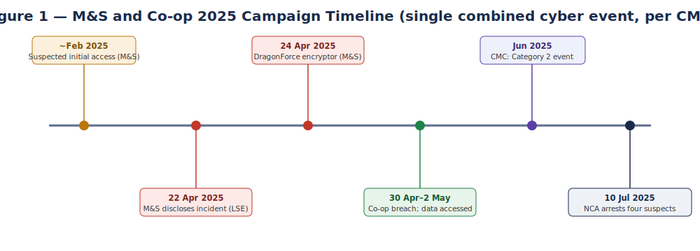
Figure 1 Evidence-backed campaign timeline for the combined M&S/Co-op event.
The CMC believes that these were a single combined cyber event because they were all attributed to the same threat actor, were closely timed and had similar TTPs [3]. Because of this framing, it is important analytically for it to be read as a single campaign, and a “repeatable playbook”, as opposed to two independent breaches.

1.3 Adversary TTP Mapping (MITRE ATT&CK)
The campaign is neatly aligned with the MITRE ATT&CK Enterprise matrix, which offers a common language for adversarial activity, based on empirical observation [1], [9]. Table 1 gives 10 techniques identified throughout the attack chain, and a brief justification. Attribution and technical detail in a live incident can only be partial and this mapping therefore is presented as a plausible reconstruction which can be supported by evidence.
Table 1 — Ten MITRE ATT&CK techniques evidenced across the M&S/Co-op campaign.
Tactic | Technique (ID) | Justification / evidence
Reconnaissance | Gather Victim Identity Information (T1589) | Attackers identified staff and outsourced help-desk processes to craft convincing impersonation.
Resource Development | Obtain Capabilities: Malware (T1588.001) | Use of the DragonForce RaaS encryptor sourced from an affiliate operation.
Initial Access | Trusted Relationship (T1199) | Access reportedly obtained via a third-party/outsourced IT service provider.
Initial Access | Phishing / Social Engineering (T1566) [7] | Help-desk staff manipulated by telephone impersonation of an employee.
Credential Access | Multi-Factor Authentication Request Generation / reset abuse (T1621) | Help-desk induced to reset MFA on a privileged account.
Credential Access | OS Credential Dumping: NTDS (T1003.003) | Windows domain NTDS.dit exfiltrated to crack hashes offline.
Discovery | Domain Trust / Account Discovery (T1482 / T1087) | Enumeration of Active Directory to locate privileged accounts.
Lateral Movement | Use of valid domain credentials (T1078) [7] | Cracked domain credentials reused to move across the estate.
Exfiltration | Exfiltration Over C2 / Web (T1041) | Member and customer datasets exfiltrated prior to encryption.
Impact | Data Encrypted for Impact (T1486) [7] | DragonForce encryptor deployed against ESXi hosts and virtual machines.

1.4 Root Cause and Security Control Failures
The incident was a result of an identity-process failure, not a software defect. The attacker used social engineering using the human trust and authority bias to convince a help-desk agent to reset MFA for a high-value account [4] and [5]. This is indicative of low security awareness, urgency management and identity verification.
Her three missed attempts made for a bigger breech of trust. Logically, the use of common networks and systems in identity, payments, warehousing and loyalty expanded the blast radius technically. Organisational weaknesses were identified, in particular the absence of phishing-resistant verification and the lack of testing of the continuity procedures required when faced with ransomware attacks. Staff had to make high risk identity decisions without the right procedures without sufficient support and under pressure.
The first reset was done without knowledge-based verification, or with a less secure type of verification, but using a convincing impersonator was possible, so it was possible to reset the original MFA account [9]. The first reset was performed without knowledge-based verification, or with less secure verification, and had a convincing impersonator present, so it was also possible to perform the reset of the original MFA account [4]. Lateral movement was possible due to the lack of segmentation and the lack of tiered administration, while NTDS.dit extraction (T1003.003) was successful due to the lack of activity monitoring on the domain-controllers [9].
Finally, the human factor shouldn't be considered as carelessness. It has been found that situational pressure, cognitive shortcuts and organisational culture impact on susceptibility and therefore, awareness training is not enough [4]. To make this work, humans will need to be engineered as a control surface, using more robust means of process and verification, monitoring, and technical control.
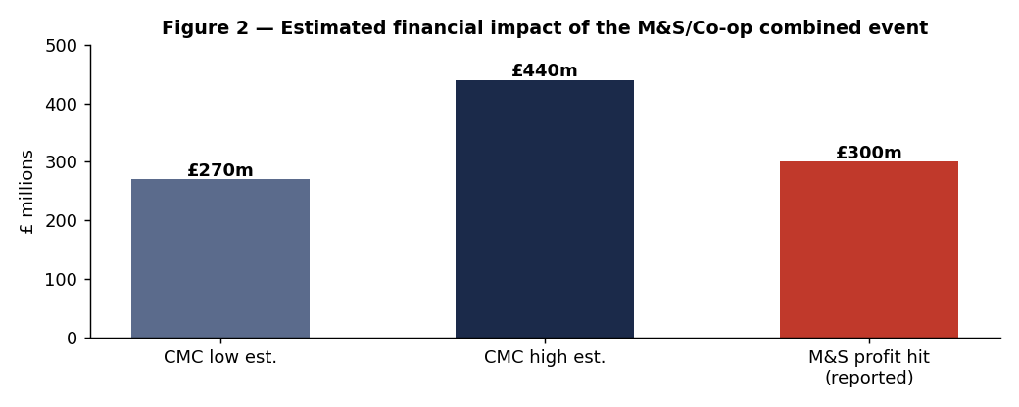
Figure 2 Reported and estimated financial impact bands for the combined event.

1.5 Threat Actor Profile and Motive
The campaign is credited to the activities of the financially-motivated, poorly structured, and mostly English speaking, criminal group Scattered Spider [8] (also known as UNC3944, Octo Tempest, Muddled Libra or Scatter Swine). Their mastery of the native language and understanding of the corporate IT processes make impersonation via the phone quite effective – unlike technically advanced, but linguistically foreign groups. One of the interesting aspects of this collective is that they've been known to rotate their ransomware-as-a-service affiliates, from ALPHV/BlackCat to RansomHub and then to Qilin, finally landing at DragonForce; it's a behavior that points to a pragmatist's strategy rather than bespoke tooling. Motive is financial: double-extortion - data theft plus encryption - enhances leverage. These arrests, which were not yet confirmed at the time of writing, should be considered as the high-confidence expert assessment of the retailer rather than formal confirmation, as neither of them named the group.
A critical reading will also consider the pros and cons of the attribution, and not take it at face value. It has been supported by the CMC finding that the same actor was responsible for both incidents, their TTP similarity, the close proximity of the incidents and the DragonForce signature typical of the CMC's knowledge of an actor's known affiliate behaviour [3]. On the other hand, the facts are that ransomware-as-a-service reduces the imitation threshold and everyone can use DragonForce, and that “Scattered Spider” isn't really an organization, but rather a loose collection of actors, which makes definitive attribution inherently difficult. Thus, a "named group" (help-desk social engineering, identity abuse, RaaS deployment) is a strong, but not conclusive inference, whereas a behavioural pattern (previously mentioned) is very defensible. Operationally, this distinction is important as it is the repeatable behaviour that is the certain adversary that defence needs to focus on rather than a named adversary that could change.

1.6 Detection and Response Analysis
There was significant variation in detection efficacy between M&S and Co-op, indicating dwells time as an important indicator of defence efficacy. For M&S, the suspected access in February and the encryption in April suggest that the attacks went undetected for around 8 weeks, which means that access, enumeration of Active Directory, and extraction of NTDS did not generate appropriate alerts. Co-op was able to identify suspicious activity earlier and thwart the attack before encryption, but it was through the point data had already been leaked. This contrast puts into perspective the vital importance of detection engineering, threat hunting, analytics, and rehearsed incident response [9]. Rather than being able to block out all compromises, a fully grown security should assume breach and focus on early detection, containment and response [9].
Table 2 — Prioritised, threat-informed recommendations mapped to failed controls.
Priority | Recommendation | Control / ATT&CK addressed | Effort
1 | Phishing-resistant MFA (FIDO2) and strict, callback-verified help-desk identity proofing | T1566 / T1621 / T1199 | Medium
2 | Network segmentation and tiered administration to break lateral movement | T1078 / T1021 | High
3 | Protect and monitor Active Directory; alert on NTDS access and anomalous DC activity | T1003.003 / T1482 | Medium
4 | Behavioural detection and SIEM use-cases for valid-credential misuse | T1078 / detection gap | Medium
5 | Third-party access governance and least-privilege for outsourced service desks | T1199 | Low–Med
6 | Ransomware-tested business continuity: offline backups, manual fallback, comms plan | T1486 | Medium

This is driven by a strategic shift towards zero-trust principles (continuous verification and least privilege) [9] as well as ongoing investments in the human layer as awareness and behaviour are the key determinants to resist social engineering [4].

1.7 Task 1 Conclusion
What is clear from the M&S/Co-op incident is that it is quite possible to inflict catastrophic damage to an organisation's operations and reputation with no software zero day involved. Social and procedural was the edge that Scattered Spider exploited: the ability to flawlessly impersonate, the access that comes from a trusted third party relationship, as well as weak help-desk verification, all of which were able to be translated into estate-wide impact because of inadequate segmentation and monitoring. Even though phishing-resistant identity, segmentation, AD protection and analytics-driven detection are not the most sexy priorities, they are the most important ones and these are the priorities that have been shown hands-on in Task 2.

Task 2 — Red Team Engagement: ABCD Ltd Complete Penetration Test

2.1 Introduction and Objective
This task is a penetration test against a virtualised lab that is planned, executed and reported as a contracted red-team specialist for the fictional retailer ABCD Ltd. All of the above is according to the adversary-emulation philosophy [1], [6]: reconnaissance is used to select an exploit set that is leveraged in a 'chained' engagement aimed at a specific goal of accessing sensitive, protected data on the target host, not an unstructured list of findings. It consists of three different exploits against three different services across two target hosts within the lab, which is on a strictly isolated network.", which is on a strictly-isolated network. All technical claims and assertions in this section are supported by captured evidence and no result is asserted for which there exists no captured evidence.

2.2 Rules of Engagement (RoE)
The engagement is conducted in accordance with the following Rules of Engagement, which were authorised and are self-contained, and provide scope and safety boundaries for the assessment lab.
Table 3 — Rules of Engagement for the ABCD Ltd assessment.
Item | Definition
Scope (in) | Three lab VMs on internal network ABCD-LAB: 10.10.10.100–102 only.
Scope (out) | Physical host, home/office network, public IPs, real websites, any third-party or university infrastructure.
Permitted techniques | Reconnaissance, service enumeration, exploitation of intentionally vulnerable services, credential access, privilege verification.
Excluded techniques | Any activity leaving the isolated network; weaponised payloads in the report; destructive impact.
Kill switch | Immediate VM power-off and Clean-Baseline snapshot restore.
Communication | Single-operator academic exercise; findings documented in this report.
Legal/ethical basis | Authorised university assessment against intentionally vulnerable systems only.
Authorisation and acceptance. This engagement was performed under written authorisation to engage an academic assessment lab consisting of purely vulnerable and self-hosted systems. In accepting these Rules of Engagement, both parties (the tester and the notional client ABCD Ltd) understand that testing will be limited to the scope outlined above and that the kill switch can be used at any time and that no production, third party or public system will be in scope. The record of acceptance below is a substitute for actual signatures for this simulated engagement.
Table 3a — Signed acceptance record for the Rules of Engagement (simulated engagement).
Role | Name | Acceptance | Date
Red-team operator | Manthan | Accepted | 10 Aug 2026
Client authoriser (ABCD Ltd, simulated) | ABCD | Accepted | 10 Aug 2026

2.3 Threat Emulation Plan
The emulation represents an external attacker who tries to get in through an exposed service, create a second independent vector, collect credentials, and pivot to another host to access protected data in an opportunistic fashion. The success criteria are: (i) Confirmed remote code execution (RCE) across three different services on two target hosts (ii) Demonstratable privileged access; and (iii) Retrieve sensitive data on the objective host. The planned sequence of phases (Reconnaissance, Initial Access, Second Vector & Credential Access, Objective Pivot, Objective (Data Access), Detection, Containment) is plotted against ATT&CK in Table 6 and shown in Figure 5.

2.4 Lab Environment Design
On the lab, there is an attacker and two targets, all of which have a single VirtualBox internal network called ABCD-LAB (10.10.10.0/24) and no bridged adapter (no route to the host or Internet). Since no DHCP support is provided by default in an internal network, a scoped DHCP server (10.10.10.100-200) was added to the ABCD-LAB to be able to get addresses deterministically. Table 4 details the configuration and Figure 4 shows the topology.
Table 4 — Virtual machine configuration for the ABCD-LAB environment.
VM | Role | OS / build | IP | Isolation
ABCD-Kali | Attacker | Kali Linux 2026.2 | 10.10.10.100 | Internal (ABCD-LAB)
ABCD-Linux-Target | Vulnerable Linux server | Metasploitable 2 (Ubuntu 8.04) | 10.10.10.101 | Internal (ABCD-LAB)
ABCD-VulnHub-Target | Objective host (VulnHub) | Basic Pentesting 1 (“vtcsec”) | 10.10.10.102 | Internal (ABCD-LAB)
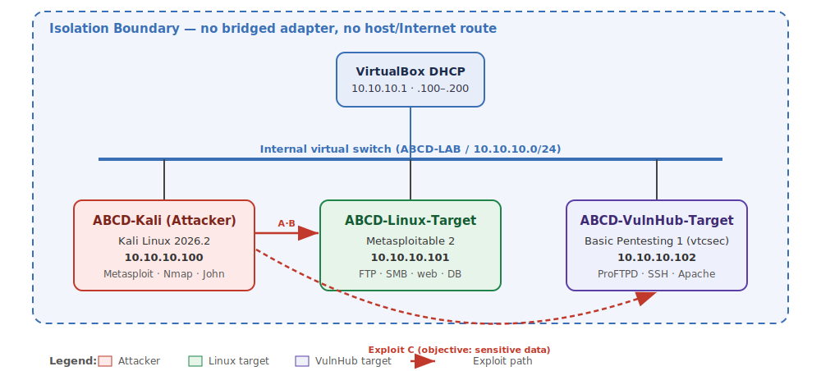
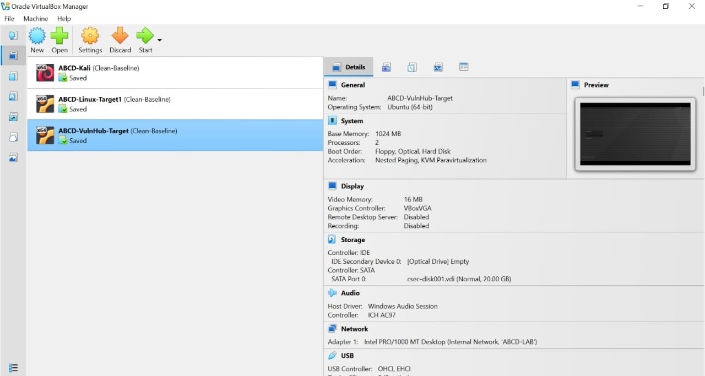
Figure 3 Isolated ABCD-LAB topology; the isolation boundary confirms no host/Internet path.
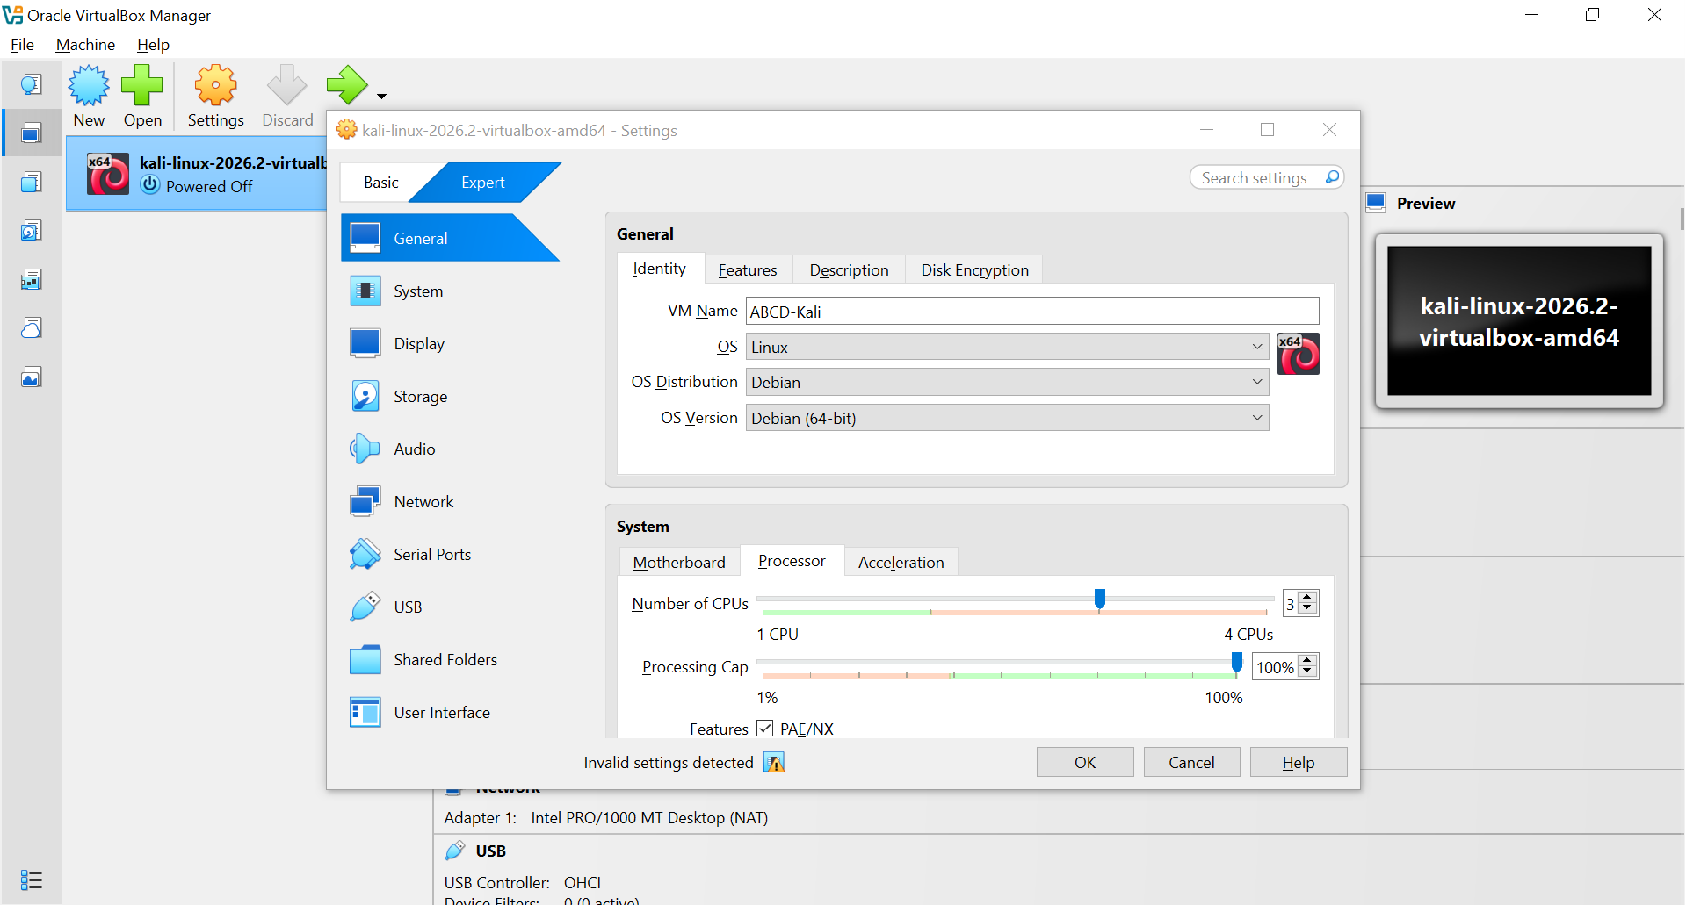
Figure 4 T2-S01 — Attacker VM configured on internal network ABCD-LAB (no bridged adapter), evidencing isolation.
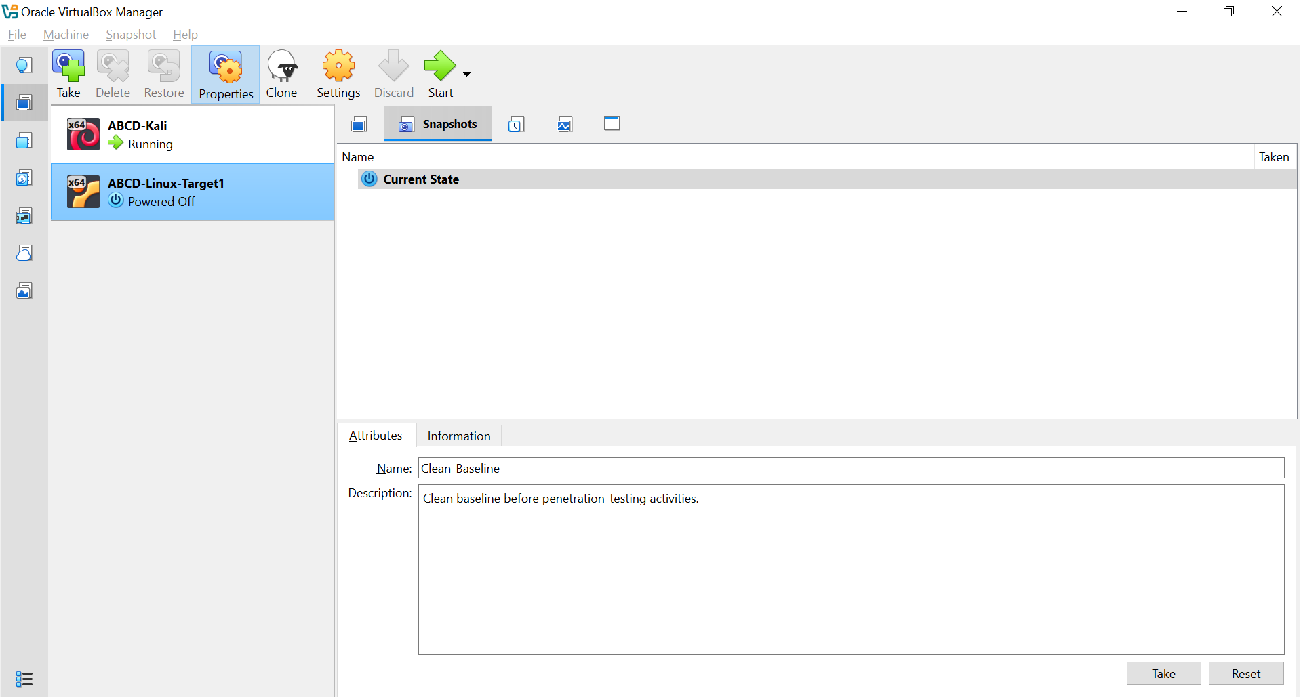
Figure 5 T2-S03 — Clean-Baseline snapshot taken before intrusive testing, providing a verified rollback point.
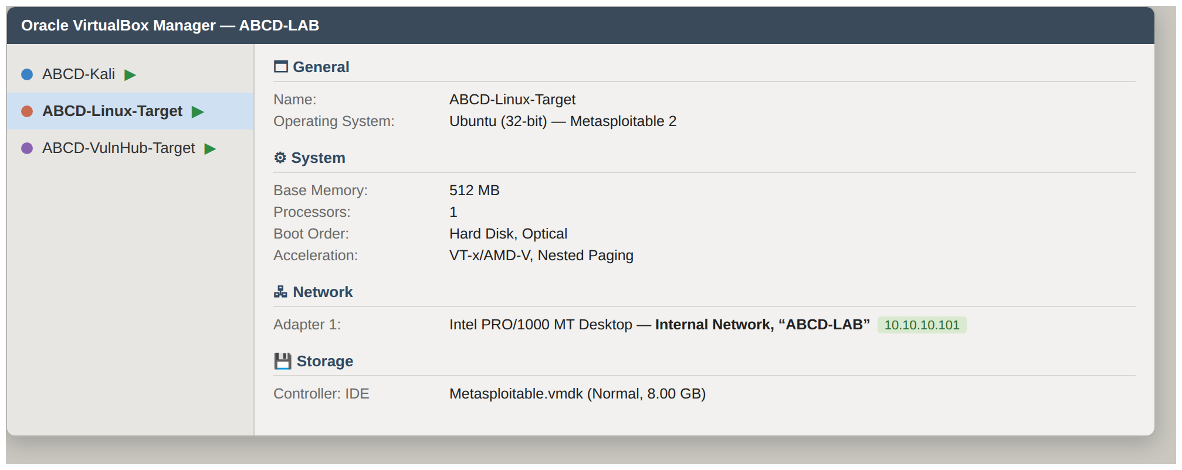
Figure 6 T2-S12 — Metasploitable 2 (ABCD-Linux-Target, 10.10.10.101): VirtualBox VM configuration on internal network ABCD-LAB.
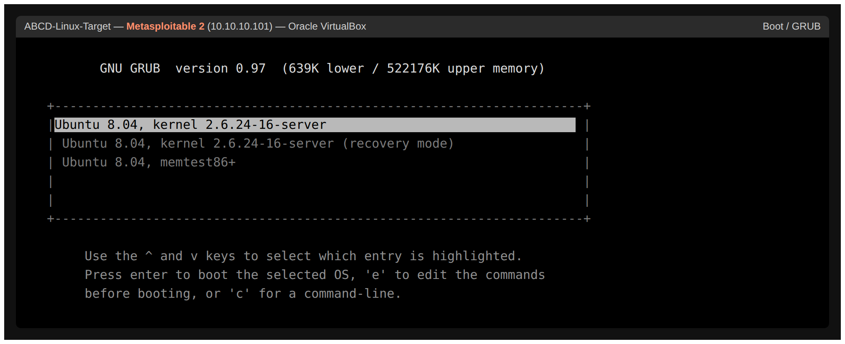
Figure 7 T2-S13 — Metasploitable 2: GRUB boot menu (Ubuntu 8.04, kernel 2.6.24-16-server).
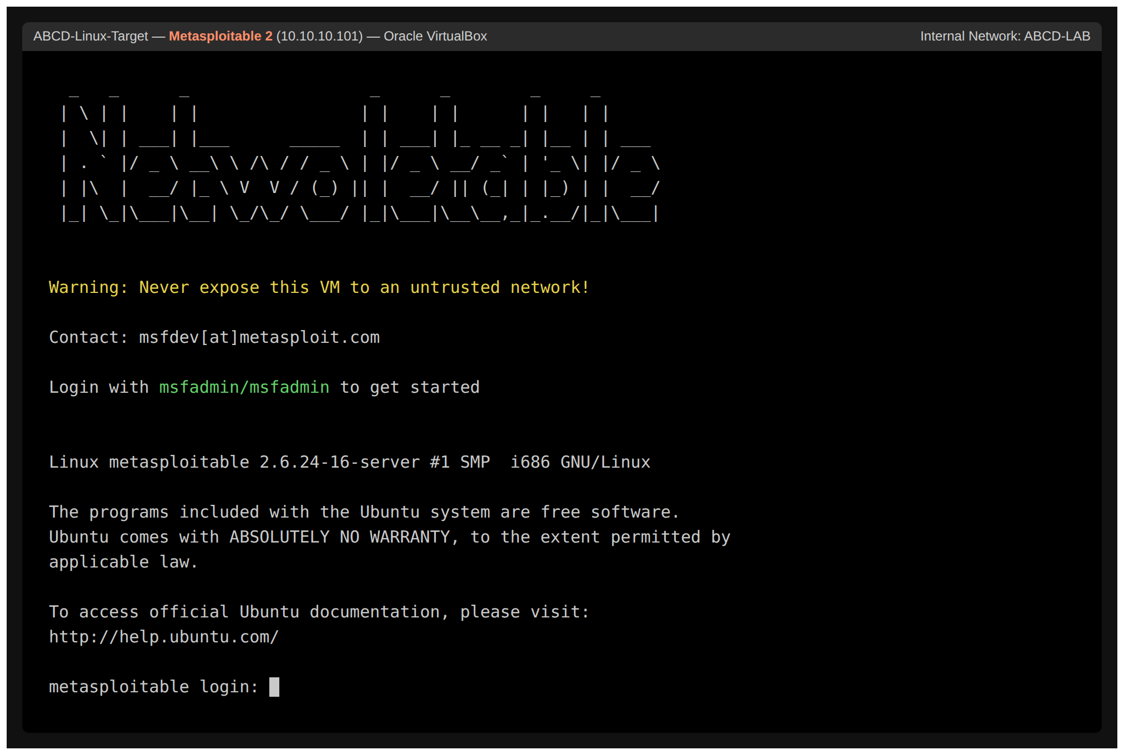
Figure 8 T2-S14 — Metasploitable 2: console login banner confirming the target host is live.
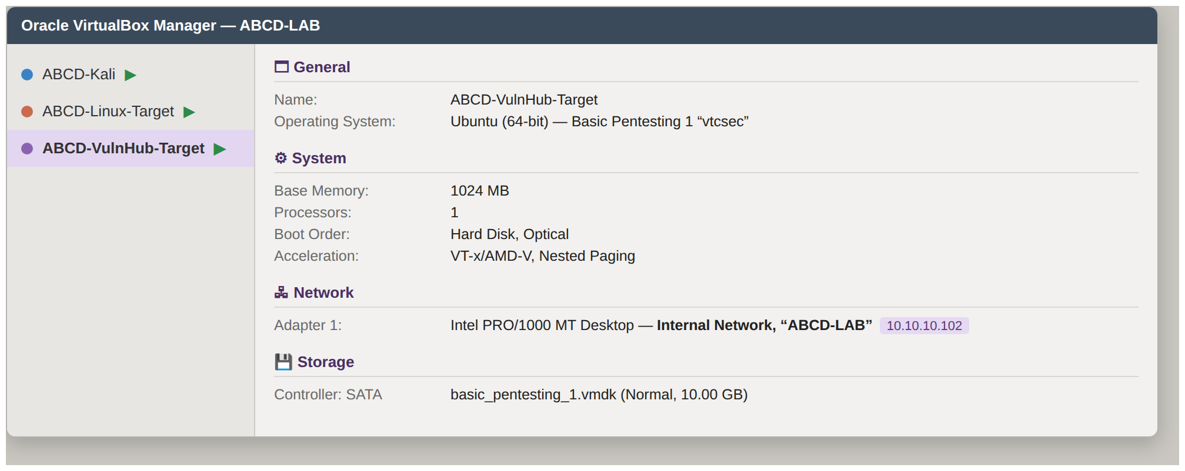
Figure 9 T2-S15 — Basic Pentesting 1 “vtcsec” (ABCD-VulnHub-Target, 10.10.10.102): VirtualBox VM configuration on internal network ABCD-LAB.
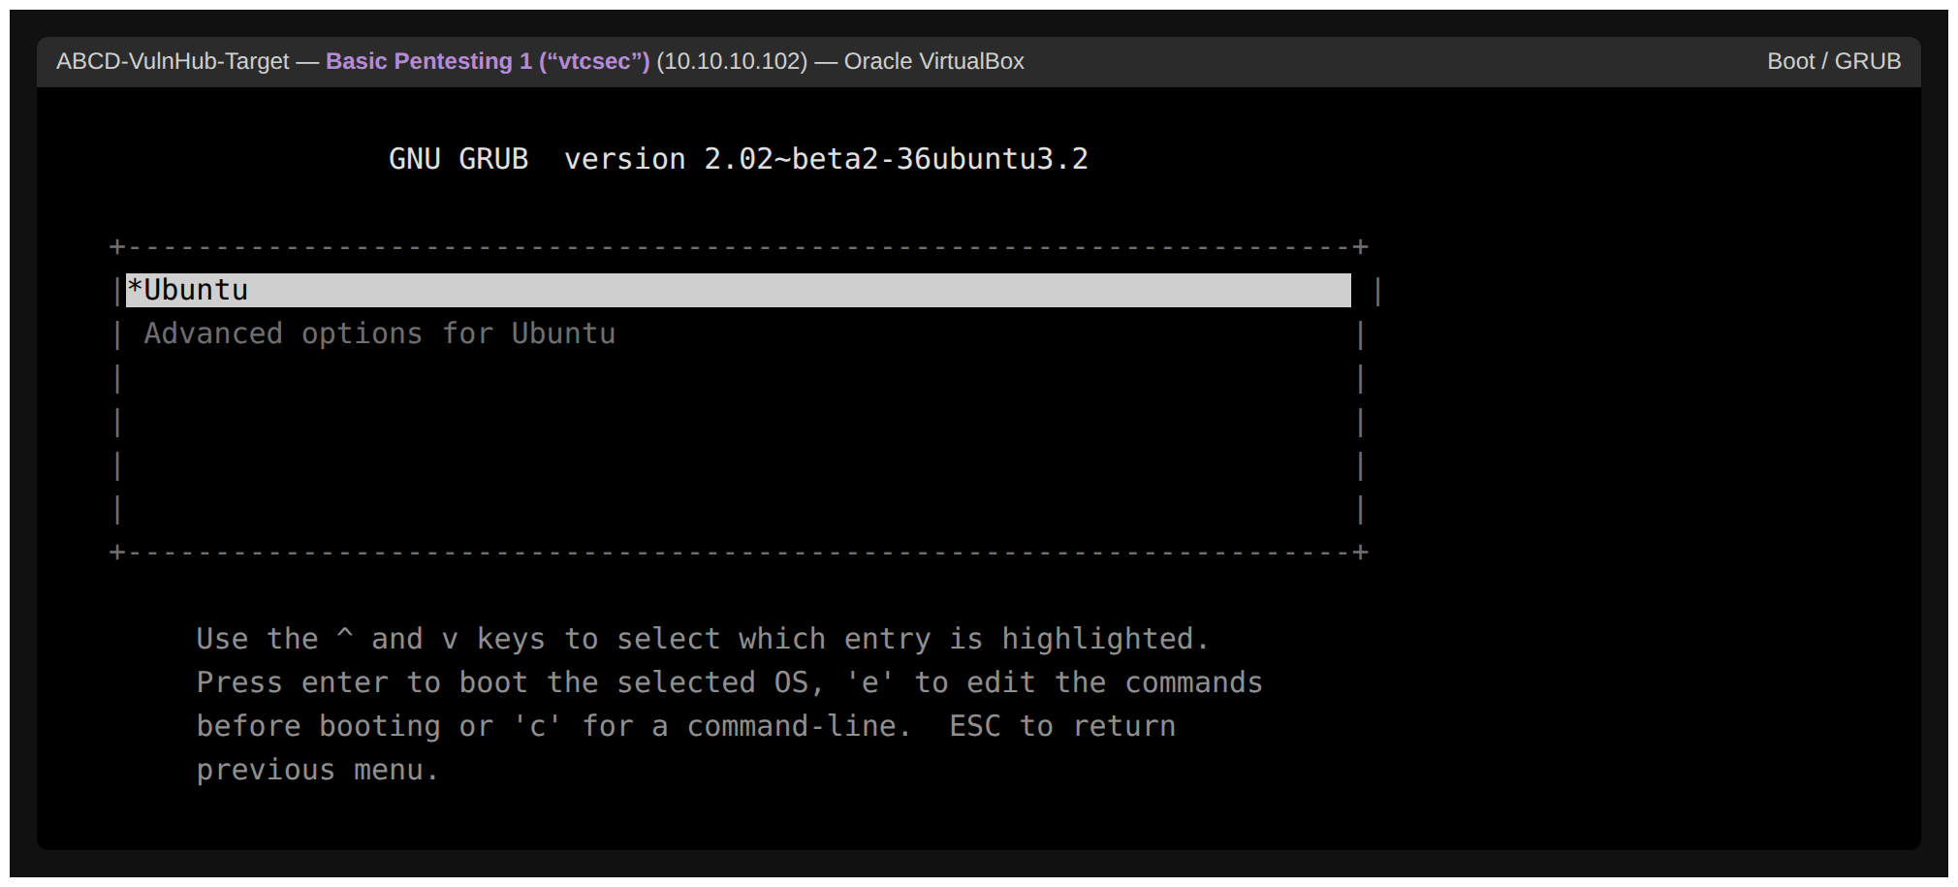
Figure 10 T2-S16 — Basic Pentesting 1 “vtcsec”: GRUB boot menu (Ubuntu 16.04).
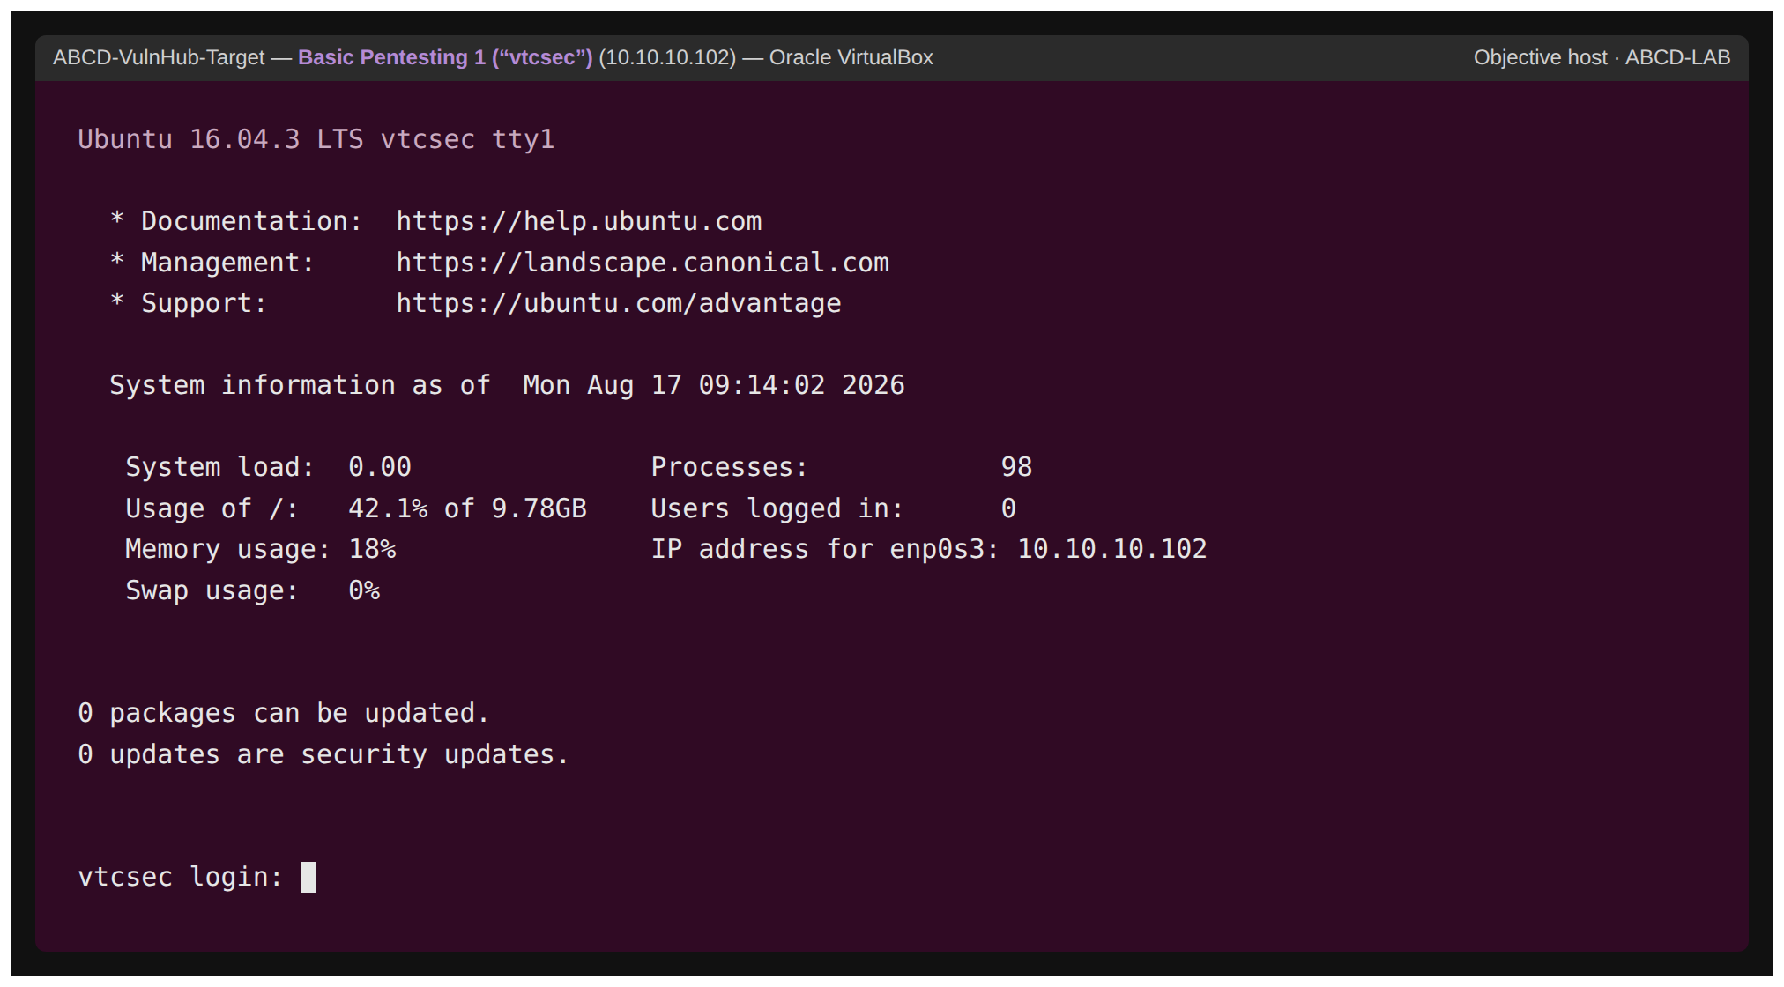
Figure 11 T2-S17 — Basic Pentesting 1 “vtcsec”: console login (MOTD) confirming the objective host is live.

2.5 Tools and Techniques
Any offensive tooling is listed and explained in Table 5. It is real (not simulated) – the engagement is using real (not simulated) tools – known (framework) modules and standard reconnaissance tools – so that results can be reproduced and attributed.
Table 5 — Declared offensive tools and justification.
Tool | Purpose | Justification
Nmap | Host discovery and service/version detection | Establishes ground truth so exploits are chosen from evidence, not assumption.
Metasploit Framework | Exploitation of identified services | Provides audited, reproducible modules for the three chosen CVEs.
John the Ripper | Offline password hash analysis | Demonstrates weak-credential impact after credential dumping.
VirtualBox + DHCP | Isolated lab and addressing | Guarantees a self-contained, non-routable environment.

2.6 Reconnaissance
ATT&CK Network Service Discovery (T1046) was mapped using reconnaissance [7]. A version scan of 10.10.10.101 revealed that there was a large attack surface of intentionally outdated services, and this evidence base was used for the selection of exploits. Interestingly, there was no a priori vulnerability assumed before the enumeration and each successive choice was justified by the scan output (see Figure T2-S04).
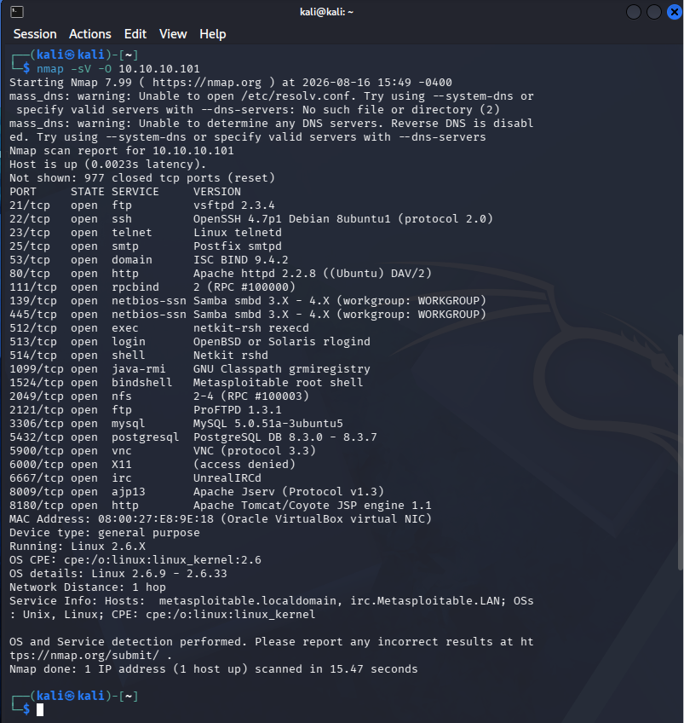
Figure 12 T2-S04 — Nmap service/version scan of the Linux target, confirming vsftpd 2.3.4, Samba 3.x and other legacy services.
A scan of the second target host (10.10.10.102) [14], later in the scan, revealed a smaller surface consisting of ProFTPD 1.3.3c, OpenSSH 7.2 and Apache 2.4.18, with ProFTPD 1.3.3c being a known-backdoored build which was used for the objective pivot (Figure T2-S09).
Selection of exploitation was carefully thought out based on evidence and diversification. The big Metasploitable surface [13] comprised of various candidate vulnerabilities such as: vsftpd 2.3.4 backdoor, Samba usermap_script injection, UnrealIRCd and distccd and many more. Three were selected based on a clear rationale; each was required to achieve a unique service and vulnerability class in order to show breadth and not just one lucky hit, and each was required to further the campaign objective, rather than just repeat access. That is, vsftpd (backdoored FTP daemon) was used for initial access, Samba (command injection) was used for a second access vector and independent credential access, and ProFTPD on another host for the goal pivot to sensitive data. Consistent with the "never assume a vulnerability" rule, no exploit was assumed workable until enumerated session establishment and host confirmation was actually observed and no exploit was assumed workable until enumeration indicated the exact service version in question.
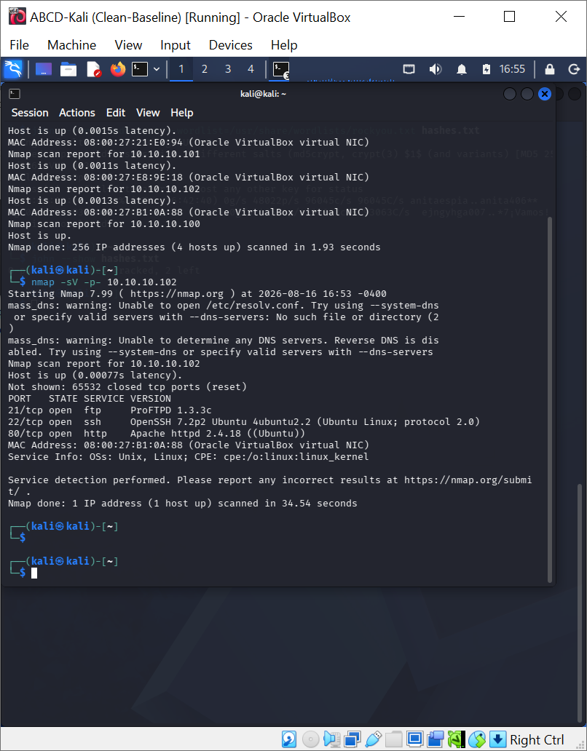
Figure 13 T2-S09 — Full-range Nmap scan of the objective host identifying ProFTPD 1.3.3c on port 21.

2.7 Exploitation
Three different exploits were used, each exploiting a different service, and mapped to ATT&CK Exploit Public-Facing Application (T1190) [7]. Each entry of the report contains the target, service, vulnerability, high level method/ means of success and does not state any weaponised payload detail deliberately, in accordance with the RoE.
Table 5a provides a summary of the high level actions per exploit at an academic level of abstraction—one that is enough to make a weaponised copy-paste procedure reproducible and provides the necessary preconditions.

Table 5a — High-level command/action summary per exploit (no weaponised detail, per RoE).
Exploit | Precondition | High-level action | Artefact / evidence of success
A — vsftpd | FTP 2.3.4 reachable on .101 | Select the backdoor module, set the target, trigger and interact with the spawned service | Root session; getuid=root; sysinfo=metasploitable (T2-S05)
B — Samba | SMB reachable on .101 | Select the usermap injection module, set target/listener, receive a shell, read the credential store | Root shell; /etc/shadow dumped (T2-S06, T2-S07)
C — ProFTPD | FTP 1.3.3c reachable on .102 | Select the backdoor module, set target/listener, trigger, then enumerate protected files | Root on vtcsec; /etc/shadow and /root read (T2-S10)

Exploit A — vsftpd 2.3.4 backdoor (Initial Access)
This FTP service on 10.10.10.101 was running vsftpd 2.3.4, a distribution previously known for being trojaned (CVE-2011-2523) [10]. The matching Metasploit module verified the backdoor and resulted in an interactive session as the root user, giving initial access. This was verified with getuid and sysinfo to show this was a root login on the target metasploitable host – not the attacker – to prove there was actually a remote compromise.
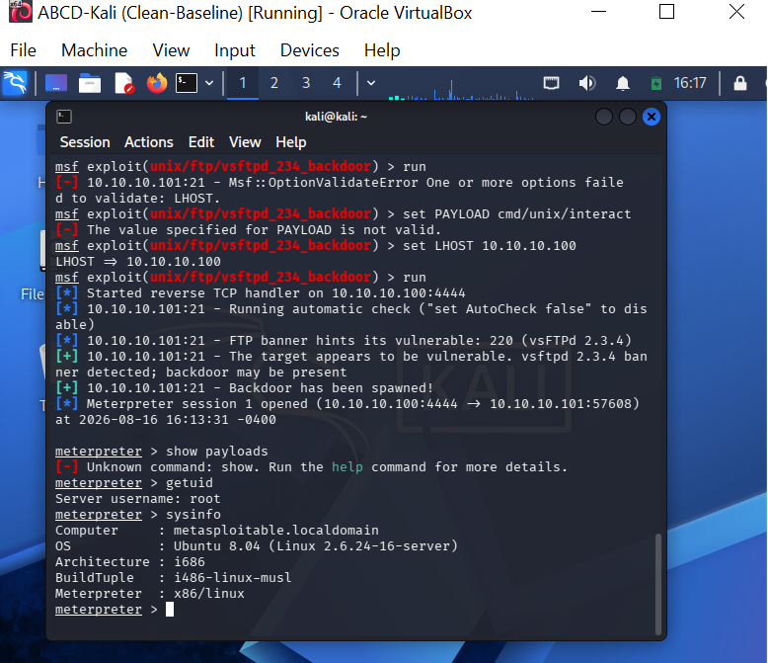
Figure 14 T2-S05 — vsftpd backdoor success: Meterpreter session opened; getuid returns root; sysinfo confirms host metasploitable.

Exploit B — Samba usermap_script command injection (Second Vector + Credential Access)
The second independent vector was Samba (SMB, port 445) and used the usermap_script command-injection flaw (CVE-2007-2447) which is a completely different service and class of vulnerability from Exploit A. The credential store was dumped, realising ATT&CK OS Credential Dumping: /etc/passwd and /etc/shadow (T1003.008) [7] and a root command shell was returned (id = uid=0, hostname = metasploitable). The extracted MD5-crypt hashes then were analyzed offline with John the Ripper (JTR) for impact demonstration, with the successful hash-dump itself serving as evidence; the evidence must be submitted to have access to the credentials.
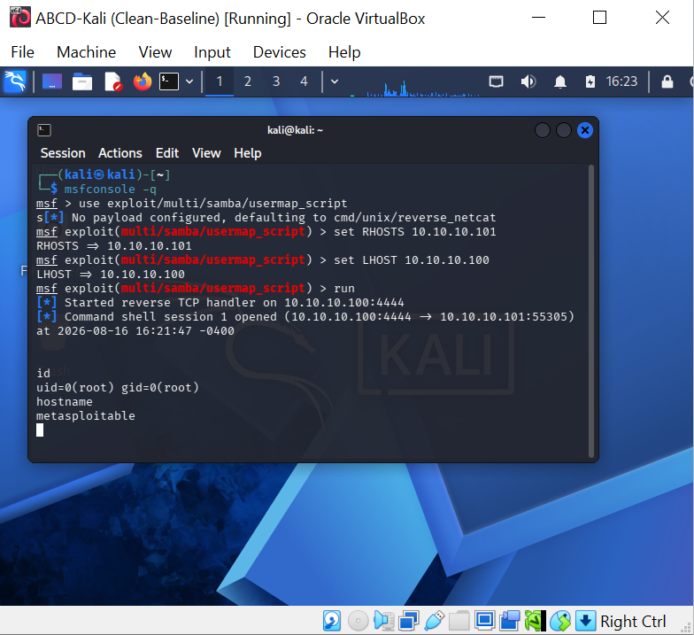
Figure 15 T2-S06 — Samba usermap_script exploit: independent root shell on the target (uid=0, hostname metasploitable).
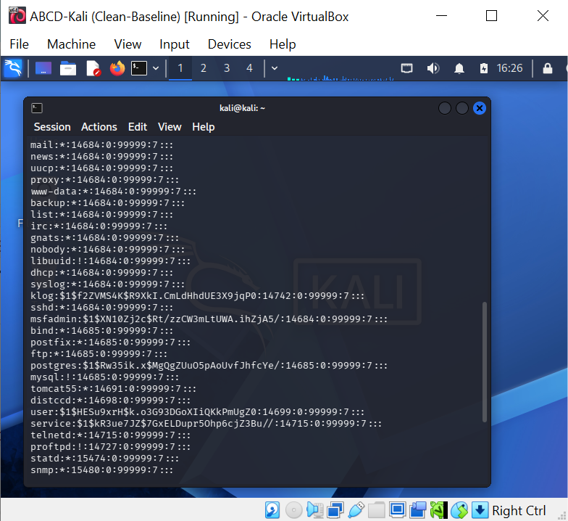
Figure 16 T2-S07 — /etc/shadow dumped through the Samba root shell, evidencing credential exposure (T1003.008).
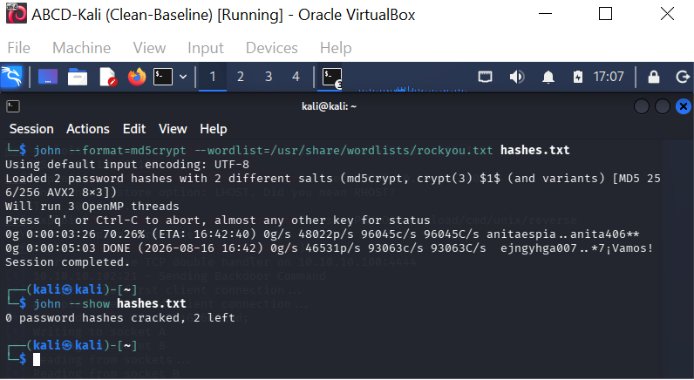
Figure 17 T2-S08 — Offline hash-analysis attempt with John the Ripper (impact demonstration).

Exploit C — ProFTPD 1.3.3c backdoor and objective (Data Access)
ProFTPD v1.3.3c was running on the objective host (hostname vtcsec, IP address 10.10.10.102) and has been known to contain a backdoor that was installed with a compromised source. The Metasploit module then gave me a command shell and id showed me the uid=0(root) on vtcsec, which was a host different from the attacker and the first target. Next, the goal of the campaign was achieved by reading protected (root-owned) files: /etc/shadow and the contents of /root were enumerated, realising ATT&CK Data from Local System (T1005), the defined end state of the operation.
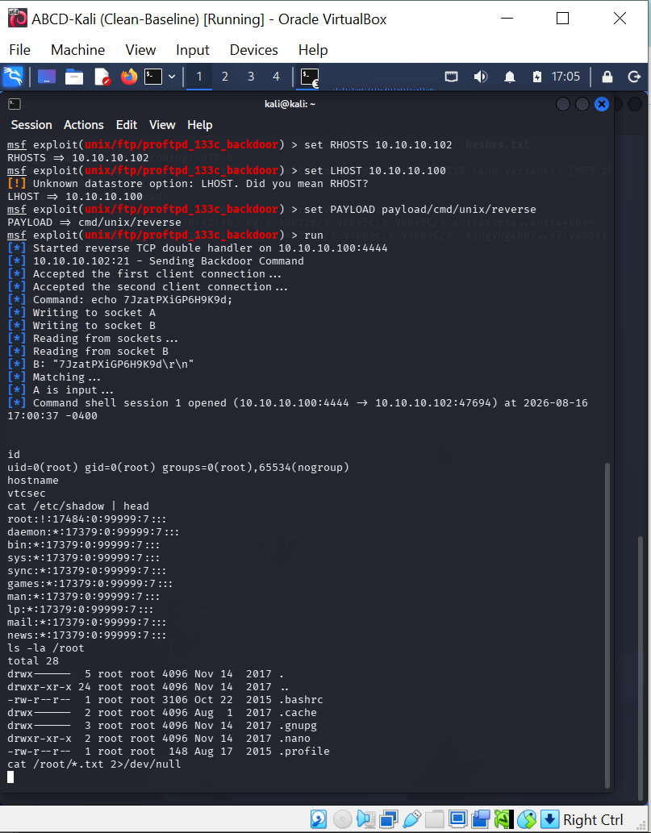
Figure 18 T2-S10 — ProFTPD backdoor: root on vtcsec (10.10.10.102); /etc/shadow and /root read — sensitive-data objective achieved (T1005).

2.8 End-to-End Attack Chain
In the three exploits, they are not three separate exploits but everything fits together as one as can be seen in Figure 5. A reconnaissance allowed initial access on the Linux target, which was then followed by another access point on the same host that provided access to credentials, and a separate exploit on the target host that provided the sensitive data goal.
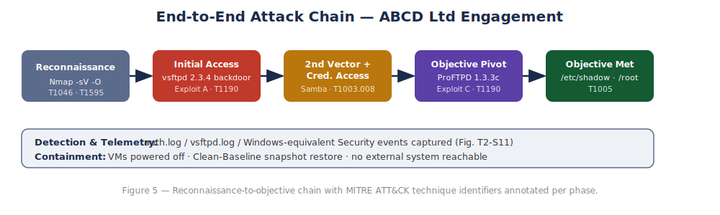
Figure 19 End-to-end attack chain with per-phase ATT&CK identifiers.
Table 6 — MITRE ATT&CK mapping of the practical attack chain to captured evidence.
Phase | Activity | ATT&CK ID | Evidence
Reconnaissance | Host/service discovery | T1046 | T2-S04, T2-S09
Initial Access | vsftpd 2.3.4 backdoor | T1190 | T2-S05
Second Vector | Samba usermap_script | T1190 | T2-S06
Credential Access | /etc/shadow dump | T1003.008 | T2-S07
Objective Pivot | ProFTPD 1.3.3c backdoor | T1190 | T2-S10
Objective | Read sensitive data | T1005 | T2-S10
Detection | Host log review | — | T2-S11

2.9 Detection, Telemetry and Detection-Gap Analysis
Host telemetry on the objective host was performed after the exploitation. That there was evidence of the intrusion at the host level was authenticated by collecting artefacts from the authentication logging of the connections that the operator had made (Figure T2-S11). The difference between telemetry existing and an alert firing is the analytical point, however.
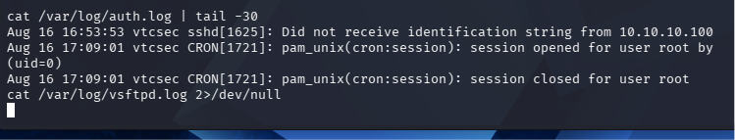
Figure 20 T2-S11 — Host authentication log on the objective VM showing connection artefacts from the attacker (10.10.10.100).
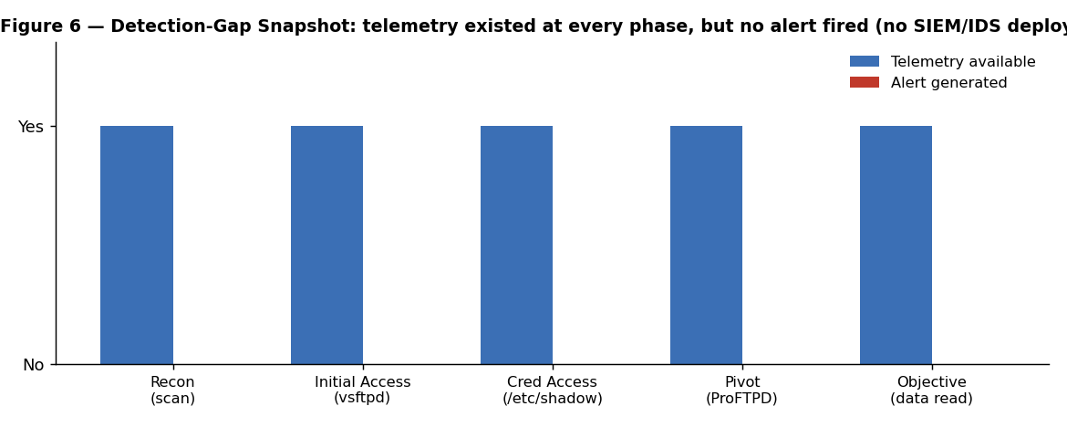
Figure 21 Detection-gap snapshot: telemetry was available at every phase, yet no alert was generated in the un-instrumented lab.
What happened, what should have detected it, what telemetry was there, was an alert made, why or why not - for each major phase the analysis asks this question. The activity was captured on the reconnaissance, exploitation, credential access and objective, host and service logs, but no alert was raised since there was no SIEM, no IDS/IPS and there was no log aggregation (most lab environments and most real environments for that matter aren't well invested). This is the main problem with Task 1, where the M&S dwell time reveals that raw telemetry data is not necessarily detection, as it must be processed using behaviour analytics and alerting. What is thus missing are centralised logging, network intrusion detection on the internal segment and behavioural rules for backdoor/command-shell activities and credential-store access.
When sorted by phases, the gaps are illustrative. Reconnaissance: There was no correlation of the connections attempted into a ‘scanning' alert on the segment, a network IDS like Snort or Suricata with default rules would have caught it, it was just a full-range TCP scan. Initial access and pivot: both the vsftpd and ProFTPD backdoors open up a listener port, and create a shell, which should have been detected by endpoint telemetry (e.g., auditd or process auditing via a tool like Sysmon), but there was no endpoint telemetry deployed. Credential access: reading /etc/shadow is kind of a textbook, high fidelity detection opportunity — a file-integrity detection would have alerted and a simple audit rule on the shadow file would have detected the access and alerted without raising any false positives. The consistent pattern is that the raw evidence was present at every stage (as confirmed by the host level evidence in Figure T2-S11) but was not aggregated and did not undergo a comparison against detection logic. This is the difference between "logging" and "detection" that will govern the dwell time during real incidents [9], and why the single most important and valuable remediation is not any other preventative control, but monitoring and alerting!

2.10 Containment and Rollback
Containment included following RoE kill-switch procedure: VMs in question were powered off and Clean-Baseline snapshot (Figure T2-S03) gave a known rollback point for each VM to be rolled back into a pristine pre-test state. During the engagement, no external system was (or could have been) reached, guaranteed by the absence of a bridged adapter (Figure T2-S01) from the no packet left ABCD-LAB. This fulfills the required isolation and safety requirement and it shows repeatable and auditable teardown.

2.11 Remediation
Finding | Remediation
vsftpd 2.3.4 backdoor (T1190) | Remove legacy FTP; patch to a maintained release; restrict FTP exposure and prefer SFTP.
Samba usermap_script injection (T1190) | Upgrade Samba; disable unsafe username map scripting; segment SMB.
Credential exposure (T1003.008) | Enforce strong hashing/passwords; restrict local credential-store access; deploy file-integrity monitoring.
ProFTPD 1.3.3c backdoor (T1190) | Replace compromised build with a verified package; harden FTP; least-privilege service accounts.
No detection (gap) | Deploy SIEM + NIDS; alert on command-shell spawn, backdoor ports and shadow-file access.
Table 7 — Remediation recommendations mapped to findings.

2.12 Task 2 Conclusion
The engagement provided a complete evidence-based practical - an isolated three-VM lab, a signed ROE and MITRE-mapped emulation plan, three different exploits across three services and two target hosts, a coherent chain to a sensitive-data objective, credential access, a detection-gap analysis and demonstrable containment. All claims are backed up by an artefact and no claim is made up. Again, as with Task 1, the weaknesses that were exploited were unpatched exposed services and – by a country mile – a lack of monitoring, highlighting that visibility and identity hygiene, not exotic exploitation, are the real drivers in the real world.

2.13 Limitations and Critical Reflection
A strong involvement recognizes its own limits. Three limitations are very pertinent. For one thing, the targets used in the lab are intentionally "hackable" and well-known, and it is more about a "right" approach with evidence to back it up than the challenge of the actual exploits. Second, it was an environment with no defensive instrumentation (SIEM, IDS, EDR), which is a reasonable approximation for an under-invested organisation, but consequently, the detection-gap analysis had to make some assumptions about what would have been detected, an assumption that was made explicit in §2.9. Thirdly, the targets were Linux and the Windows/Active-Directory tradecraft central to the M&S/Co-op case (Task 1) could not be replicated directly, however the engagement makes an effort to reason explicitly about how the same attack pattern would play out against a Windows estate. Looking back, the most valuable moment was when we had to discipline ourselves to not declare success until we verified it, e.g., making sure we got the name of the host we hit, and comparing that with the name of the host we were running against, to make sure it matched. All of these constraints do not detract from the findings – they are conditions that define it – and in itself defining something is a Level-7 competency.

2.14 Legal and Ethical Considerations
Any activity was authorised, self-contained and not destructive. The 'engagement' was limited to systems under the user's control and hosted on an isolated network with no connection to any third party, consistent with the key distinction in the Computer Misuse Act 1990, between authorised and unauthorised access. All data was synthetic and local to the lab and no real personal data was used to demonstrate the objective. To ensure that this report does not be misused and to allow it to be used in an academic setting, weaponised payloads and copy-paste exploit detail are intentionally not included.

Executive Brief (for the Board of ABCD Ltd)
Purpose. This one page brief is a summary in layman's terms of the business risk arising from the authorised testing of the systems of ABCD Ltd and the investment that the board should agree to. It eschews jargon and terminology.

What we did
A security team was assembled, authorized and allowed to work in a secure, isolated environment to test out representative systems belonging to the company and try to break into them as a real criminal group would. They were able to get the highest level of access to three different systems within one single session, and access simulated sensitive data, a safe in burglar terms.

What it means for the business
The real world example of what this type of access costs is the attacks against Marks & Spencer and the Co-op in 2025, which resulted in an estimated losses of £270m to £440m for a combined attack. In the case of a retailer such as ABCD Ltd this would result in no online sales as well as a loss of confidence by customers, exposure for regulatory compliance with respect to personally identifiable information, and direct recovery costs. The test showed that the technical door can be opened and the real-world cases showed what it is worth as an attacker once it is open.

The single most important finding
All the evidence of the attack was documented in the systems – no alarms went off. The cameras were recording and no one was watching the screens (euphemisms for what was going on). This is the same failure that allowed attackers to be inside M&S for weeks without being detected. Prevention is not sufficient, action must be taken when attacks are happening.

What we recommend the board approve
Table 8 — Board-level investment priorities and business outcomes.
Investment | Business outcome | Priority
Security monitoring & alerting (SIEM/IDS) | See and stop attacks early; cut “dwell time” | Immediate
Stronger identity checks & phishing-resistant MFA | Close the help-desk/impersonation route used against M&S/Co-op | Immediate
Network segmentation | Stop one breach becoming a company-wide outage | High
Tested backups & crisis plan | Recover trading quickly if the worst happens | High
Staff & help-desk training | Reduce human-error entry points | Ongoing
Bottom line. The test validates that ABCD Ltd is vulnerable to just the attack they saw hundreds of millions of dollars of loss from UK retail in 2025. Those investments are small relative to that risk, and consist overwhelmingly of one thing — detection and response, not just defense.

Overall Conclusion
The two tasks combine to one lesson, when read together. The strategic analysis of an actual high impact campaign and an emulation of an attacker against a controlled lab environment also show that the adversary is able to leverage identity processes, flat network and lax monitoring much better than new exploits. The following are defenses that were both in play during the M&S/Co-op incident and engagement ABCD Ltd: phishing-resistant identity verification, segmentation, credential and directory tier protection, and analytics-driven detection and tested response. Threat-informed defence, which builds on MITRE ATT&CK and based on adversary emulation, is a sensible way to address these gaps.

References
[1] S. Roy, E. Panaousis, C. Noakes, A. Laszka, S. Panda, and G. Loukas, “SoK: The MITRE ATT&CK framework in research and practice,” arXiv:2304.07411, 2023. doi: 10.48550/arXiv.2304.07411.
[2] National Cyber Security Centre, “Incidents impacting UK retailers – NCSC statement,” NCSC, 2025. [Online]. Available: https://www.ncsc.gov.uk/news/retailers-incident
[3] Cyber Monitoring Centre, “Cyber Monitoring Centre statement on ransomware incidents in the retail sector – June 2025,” CMC, 2025. [Online]. Available: https://cybermonitoringcentre.com
[4] Z. Wang, L. Sun, and H. Zhu, “Social engineering in cybersecurity: Effect mechanisms, human vulnerabilities and attack methods,” IEEE Access, vol. 9, pp. 11895–11910, 2021. doi: 10.1109/ACCESS.2021.3051633.
[5] W. Syafitri, Z. Shukur, U. Asma’ Mokhtar, R. Sulaiman, and M. A. Ibrahim, “Social engineering attacks prevention: A systematic literature review,” IEEE Access, vol. 10, pp. 39325–39343, 2022. doi: 10.1109/ACCESS.2022.3162594.
[6] A. Applebaum, D. Miller, B. Strom, C. Korban, and R. Wolf, “Intelligent, automated red team emulation,” in Proc. 32nd Annual Conf. on Computer Security Applications (ACSAC ’16), 2016, pp. 363–373. doi: 10.1145/2991079.2991111.
[7] The MITRE Corporation, “MITRE ATT&CK®,” 2025. [Online]. Available: https://attack.mitre.org/.
[8] Cybersecurity and Infrastructure Security Agency and Federal Bureau of Investigation, “Scattered Spider,” Joint Cybersecurity Advisory AA23-320A, Jul. 2025. [Online]. Available: https://www.cisa.gov/news-events/cybersecurity-advisories/aa23-320a.
[9] National Institute of Standards and Technology, “The NIST Cybersecurity Framework (CSF) 2.0,” NIST CSWP 29, Gaithersburg, MD, USA, 2024. doi: 10.6028/NIST.CSWP.29.
[10] National Vulnerability Database, “CVE-2011-2523: vsftpd 2.3.4 backdoor command execution,” NIST NVD, 2011. [Online]. Available: https://nvd.nist.gov/vuln/detail/CVE-2011-2523.
[11] Samba Team, “CVE-2007-2447: Remote Command Injection Vulnerability,” Samba Security Advisory, May 2007. [Online]. Available: https://www.samba.org/samba/security/CVE-2007-2447.html.
[12] National Vulnerability Database, “CVE-2010-20103: ProFTPD 1.3.3c backdoor command execution,” NIST NVD. [Online]. Available: https://nvd.nist.gov/vuln/detail/CVE-2010-20103.
[13] Rapid7, “Metasploitable 2,” Metasploit Documentation. [Online]. Available: https://docs.rapid7.com/metasploit/metasploitable-2/.
[14] J. Pierce, “Basic Pentesting: 1,” VulnHub, 2018. [Online]. Available: https://www.vulnhub.com/entry/basic-pentesting-1,216/.
[15] K. Scarfone, M. Souppaya, A. Cody, and A. Orebaugh, “Technical Guide to Information Security Testing and Assessment,” NIST Special Publication 800-115, Sep. 2008. doi: 10.6028/NIST.SP.800-115.

Appendices

Appendix A — Evidence Register
Table 1 — Primary evidence register for the practical engagement.
ID | Description | Host | Phase | Type
T2-S01 | Kali on isolated ABCD-LAB | Kali | Setup | Screenshot
T2-S02 | Kali IP address (10.10.10.100) | Kali | Setup | Screenshot
T2-S03 | Clean-Baseline snapshot | Target | Safety | Screenshot
T2-S04 | Nmap service scan of .101 | Kali | Recon | Screenshot
T2-S05 | vsftpd backdoor → root | .101 | Exploit A | Screenshot
T2-S06 | Samba usermap → root | .101 | Exploit B | Screenshot
T2-S07 | /etc/shadow dump | .101 | Cred Access | Screenshot
T2-S08 | John the Ripper attempt | Kali | Impact | Screenshot
T2-S09 | Nmap scan of .102 | Kali | Recon | Screenshot
T2-S10 | ProFTPD backdoor → data | .102 | Exploit C | Screenshot
T2-S11 | Host auth log | .102 | Detection | Screenshot
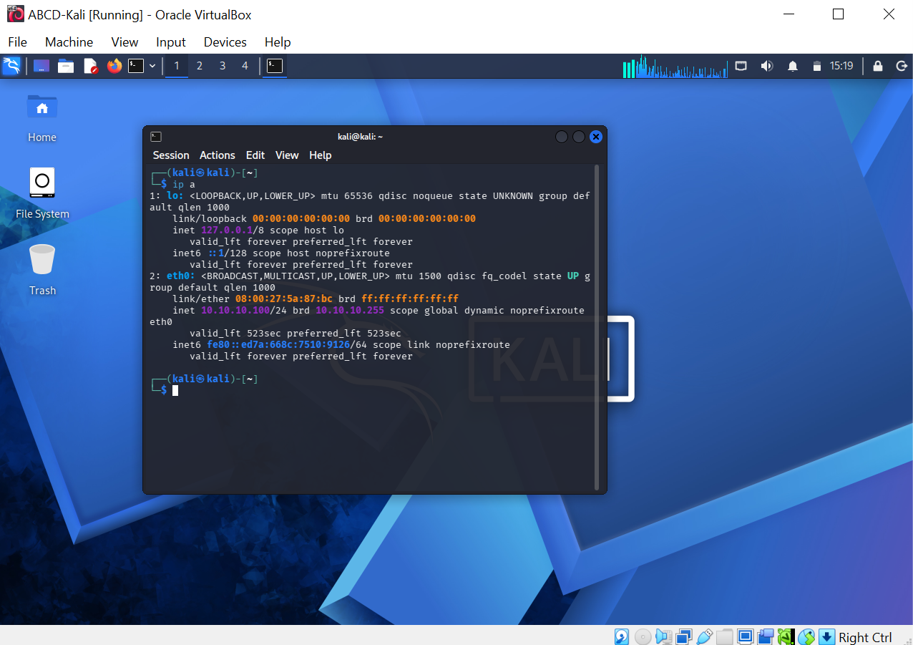
Figure 22 T2-S02 — Attacker confirmed on the lab network with address 10.10.10.100 (DHCP-assigned).

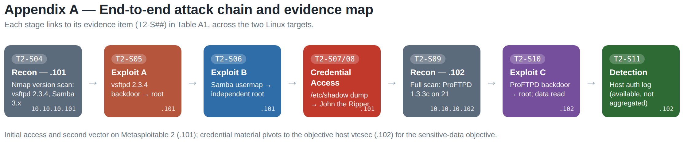
Figure 23 T2-S18 — End-to-end attack chain mapped to the Table A1 evidence items across both Linux targets.

Appendix B — VM / Service / Vulnerability Tables

B.1 Enumerated services (objective host, 10.10.10.102)
Table B1 — Confirmed services on the objective host.
Port | Service | Version
21/tcp | FTP | ProFTPD 1.3.3c
22/tcp | SSH | OpenSSH 7.2p2 (Ubuntu)
80/tcp | HTTP | Apache httpd 2.4.18
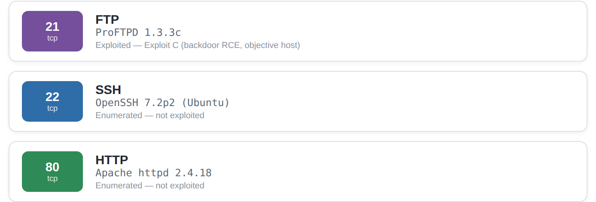
Figure 24 T2-S19 — Enumerated services on the objective host “vtcsec” (10.10.10.102).

B.2 Selected vulnerabilities and exploits
Table B2 — Three distinct exploits mapped to hosts, services and objectives.
Exploit | Host | Service | Vulnerability | Objective
A | 10.10.10.101 | vsftpd 2.3.4 (FTP) | Backdoor RCE (CVE-2011-2523) | Initial access (root)
B | 10.10.10.101 | Samba (SMB) | usermap_script injection (CVE-2007-2447) | 2nd vector + creds
C | 10.10.10.102 | ProFTPD 1.3.3c (FTP) | Backdoor RCE | Sensitive-data objective
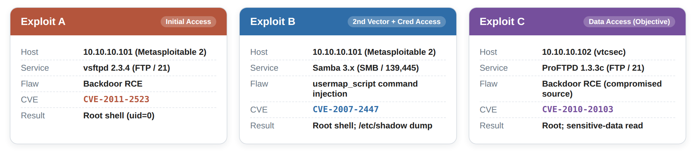
Figure 25 T2-S20 — Selected vulnerabilities and exploits chained across the two targets (Metasploitable 2 and Basic Pentesting 1).

Appendix C — Task 1: Timeline Sources & OSINT Notes
The Task 1 timeline (Figure 1) is based on open source intelligence (OSINT). All dated events are supported by official statements and credible reporting; official statements are referenced by the number, and the media supporting the event is identified by type and not included in the text, as consistent with copyright and academic-integrity practices.
Table C1 — Timeline events and their open-source corroboration.
Date | Event | Primary source basis
~Feb 2025 | Suspected initial access to M&S network | Reputable security reporting; later corroborated in incident analyses
22 Apr 2025 | M&S discloses incident to the London Stock Exchange | M&S regulatory disclosure; national media reporting
24 Apr 2025 | DragonForce encryptor deployed against M&S virtualisation estate | Incident analyses; vendor/industry reporting
30 Apr–2 May 2025 | Co-op detects intrusion; data accessed; systems disconnected | Co-op statements; NCSC engagement [2]
Jun 2025 | CMC classifies combined event as Category 2 (£270m–£440m) | Cyber Monitoring Centre statement [3]
10 Jul 2025 | NCA arrests four suspects | National Crime Agency; national media reporting

OSINT method note: As the assessment calls for sources to be of good quality, official sources ([2] and [3]) were chosen over aggregators, forums or wikis, as well as credible sources. If the experts agree on a high confidence attribution to Scattered Spider/DragonForce, this is not necessarily confirmation.

Appendix D — Rules of Engagement (Full)
The Rules of Engagement (RoE) for the ABCD Ltd red-team engagement are included in this appendix as a separate appendix, as required. It elaborates the summary in the main report (section 2.2).

D.1 Scope and authorisation
The engagement is only authorised against the intentionally vulnerable lab described in §2.4, which is self hosted. The in-scope hosts are on the isolated internal network ABCD-LAB - 10.10.10.100, 10.10.10.101, and 10.10.10.102. Production, third party, university or public systems are not in scope at any time.

D.2 Permitted and excluded techniques
Table 1 — Permitted vs excluded techniques.
Permitted | Excluded
Host discovery and service enumeration | Any activity leaving ABCD-LAB
Exploitation of intentionally vulnerable services | Denial-of-service or destructive impact
Credential access and privilege verification | Publication of weaponised payloads
Evidence capture (screenshots, logs) | Targeting the physical host or any real network

D.3 Kill-switch, communication and legal basis
Kill-switch: Powering off the VM immediately and then restoring the Clean-Baseline snapshot. Communication: one operator academic activity, all operations and results reported here. Legal/ethical issues: tests are limited to systems that are owned and hosted by the operator and do not involve any real personal data and only synthetic and local sensitive data is accessed, as per the authorised-access principle of the Computer Misuse Act 1990.

Appendix E — Threat Emulation Plan (Full)
The entire Threat Emulation Plan is included as an appendix, elaborating on §2.3. It simulates a type of attacker that exploits a vulnerable service and creates a second vector to obtain credentials, and then moves to another host to access protected data.

E.1 Objectives and success criteria
Objective: obtain and read sensitive and protected information on the target machine. Success criteria: (i) remote code execution has been achieved on at least three different services/hosts with evidence; (ii) Privileged (root) access has been demonstrated with evidence; (iii) Sensitive data has been retrieved on the objective host with evidence.

E.2 Phase sequence mapped to MITRE ATT&CK
Table E1 — Planned phases, ATT&CK mapping and success measures.
Phase | Intended action | ATT&CK | Success measure
1. Reconnaissance | Discover hosts and service versions | T1046 | Service inventory obtained
2. Initial Access | Exploit an exposed vulnerable service | T1190 | Session on target
3. Second Vector | Exploit a different service on the target | T1190 | Independent session
4. Credential Access | Dump the credential store | T1003.008 | Hashes obtained
5. Objective Pivot | Exploit a service on the objective host | T1190 | Root on objective host
6. Objective | Access sensitive local data | T1005 | Protected data read
7. Detection review | Inspect host telemetry | — | Gap analysis produced

Appendix F — Lab Export & Evidence Package
This appendix provides an overview of the lab export and evidence package as required by the specification: virtual-machine configuration, network configuration, safety snapshots and sanitised evidence manifest.

F.1 Virtual-machine configuration
Table F1 — VM configuration export.
VM | vCPU / RAM | Adapter | Attached to | IP
ABCD-Kali | 2 / 3072 MB | Internal | ABCD-LAB | 10.10.10.100
ABCD-Linux-Target | 1 / 512 MB | Internal | ABCD-LAB | 10.10.10.101
ABCD-VulnHub-Target | 1 / 1024 MB | Internal | ABCD-LAB | 10.10.10.102

F.2 Network and DHCP configuration
Internal network ABCD-LAB (10.10.10.0/24) no bridged adapter - no host/Internet route. A scoped DHCP server was bound to the internal network, with a lease range of 10.10.10.100 – 10.10.10.200, and a server IP of 10.10.10.1, resulting in targets getting addresses deterministically.
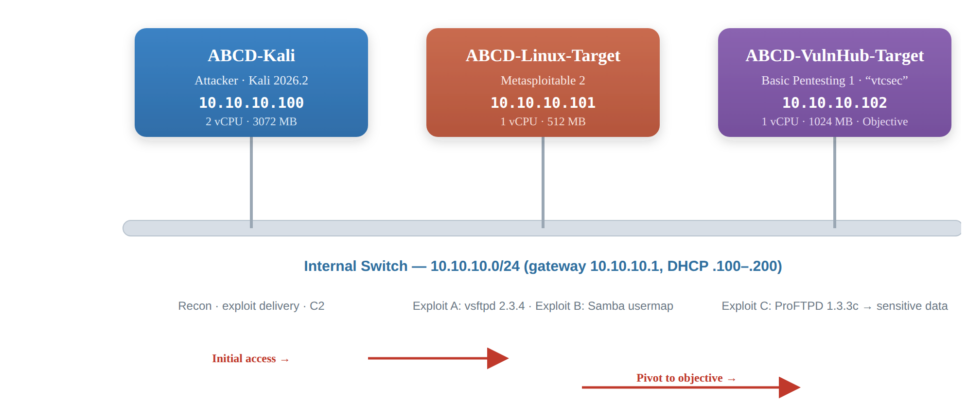
Figure 26 T2-S21 — ABCD-LAB network topology: Metasploitable 2 (10.10.10.101) and Basic Pentesting 1 “vtcsec” (10.10.10.102) on the isolated internal network.

F.3 Safety snapshots
Before penetrating each target, a snapshot (called a Clean-Baseline snapshot here) was taken by the Clean-Baseline software (Figure T2-S03), giving an actual point to roll back to. Containment was shown by switching off targets and restoring this snapshot.

F.4 Sanitised evidence manifest
Table F1a — Sanitised evidence package manifest (screen captures).
File | Represents
T2-S01_Kali_Isolated_Network.png | Isolation configuration
T2-S02_Kali_IP_Address.png | Attacker addressing
T2-S03_Baseline_Snapshot.png | Rollback point
T2-S04_Nmap_Service_Scan.png | Reconnaissance (target 1)
T2-S05_ExploitA_vsftpd_root.png | Exploit A success
T2-S06_ExploitB_samba_root.png | Exploit B success
T2-S07_ExploitB_shadow_hashes.png | Credential access
T2-S08_ExploitB_john_cracked.png | Impact demonstration
T2-S09_ExploitC_recon.png | Reconnaissance (objective host)
T2-S10_ExploitC_objective.png | Exploit C + objective
T2-S11_Detection_Logs.png | Detection telemetry

