Master of Business Administration
International Business pathway

Contemporary employability skills
Assessment 1: Individual report. Weight: 100%
Module name: Strategic Management
Module code: LCMB7003
Lecturer name: Tutors Name: Amare Desta and Ghulam Mujtaba
Student Name: Md Ismail Hossan
Student ID: 2521543

Word count: 5173

Submission date: 11-08-2026

Table of Contents
Section 1 5
Introduction 5
1. Organisational Context and Overview 5
1.1 Background of Adidas 5
1.2 Industry Context and Market Position 7
2. External and Internal Analysis 9
2.1 External Analysis: PESTLE Framework 9
2.2 Internal Analysis: VRIO Framework 12
2.3 SWOT Analysis 14
3. Comprehensive and Holistic View of Adidas 15
3.1 CSR Strategy and Alignment with Business Objectives 15
3.2 Balanced Scorecard Analysis 17
4. Strategic Choices and Implementation 19
4.1 Business-Level Strategic Options 19
4.2 Identification of the Most Appropriate Strategy 21
4.3 Strategic Benefits and Implementation Plan 23
4.4 Implementation Challenges and Mitigation Strategies 23
Conclusion 25
Section 2 26
Reflective Account Using Gibbs' Reflective Cycle 26
5.1 Description 26
5.2 Feelings 27
5.3 Evaluation 27
5.4 Analysis 27
5.5 Conclusion 28
5.6 Action Plan 28
References 30

Tables and Figures
Table 1: Balanced Scorecard for Adidas Ultraboost UK 17
Table 2: Implementation roadmap and principal risks 22
Table 3: Action Plan 27

Figure 1: The Adidas performance and lifestyle brand marks 4
Figure 2: Adidas business model overview 5
Figure 3: Adidas net sales share by product division in 2025 6
Figure 4: Adidas gross margin development from 2021 to 2025 7
Figure 5: PESTLE Framework 7
Figure 6: UK clothing and footwear inflation, April 2016 to April 2026 8
Figure 7: Strategic resources and capabilities as drivers of performance 10
Figure 8: VRIO Framework 11
Figure 9: SWOT Analysis 12
Figure 10: The four perspectives of the Balanced Scorecard 15
Figure 11: The Strategy Clock and routes to competitive positioning 18
Figure 12: Adidas global sales mix by market in 2025 19
Figure 13: SAFe Framework 20
Figure 14: Adidas sales channel mix in 2025 20
Figure 15: Adidas sourcing volumes by country and product category in 2025 21
Figure 16: Gibbs' Reflective Cycle 24


AI use acknowledgement

Section 1

Introduction
Strategic management is the adjustment of resources to changes in the environment and an invulnerable foundation of value creation. Digital transformation is strategic when technology is used for the benefit of business purpose, governance and customer outcomes, according to Cöster et al. (2023). This report is for the Board acting as a consultant and aims to assess the UK strategy adopted by Adidas Ultraboost and to determine its positioning and value proposition for the market as well as recommend a viable way to move forward in an implementable way for the company in order to gain a stronger advantage in the UK market. The product and market focus allows testing of claims on identifiable consumers, opposition, regulation and operating decisions.

1. Organisational Context and Overview

1.1 Background of Adidas
Adidas was established in 1949 by Adolf Dassler in Germany and has grown to become a global performance and lifestyle company (Adidas, 2026). Its brand architecture as shown in Figure 1 is a fusion of the performance side with the lifestyle side represented by 3-Bar and Trefoil respectively, allowing the company to take on the competition in both sport and lifestyle/fashion/everyday wear. Its mission is to become "the world's best sports brand" and its purpose is founded on the conviction that "sport can change lives. But instead of producing a traditional vision statement, Adidas states it is going to be a “global brand with a local mindset”.

Figure 1: The Adidas performance and lifestyle brand marks
Source: (Adidas, 2026)
Figure 2 illustrates a consumer centric business model, where there are four interdependent activities: product and marketing, markets and sales channels, sourcing and supply chain, and people and culture, which will be used to transform financial, intellectual, manufactured, natural, human and social and relationship capital. These activities result in products, market delivery, employee ability and supplier relationships. The model also takes into account negative issues such as emissions, resource consumption, human rights risks, reputational damage. Value creation is thus not only dependent on sales but also on the effectiveness in which Adidas manages its operating system and the impacts on the stakeholders.
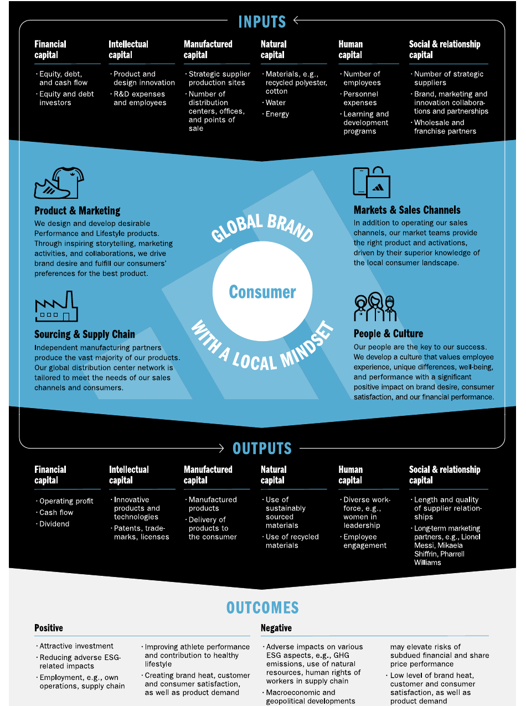
Figure 2: Adidas business model overview
Source: (Adidas, 2026)

1.2 Industry Context and Market Position
Boost cushioning was added to Adidas' lineup in 2013 and Ultraboost was introduced in 2015. The cool factor and comfort of it sits in between technical footwear and high-end athleisure, while still delivering performance. The study by Chi et al. (2021) demonstrates that sustainable consumption of Athleisure is not just an environmental one. Ultraboost thus needs to make its comfort and performance case in the first place – the design and responsible materials are the icing on the cake.
As shown in figure 3, footwear is a key business with Adidas sales from this segment accounting for 57% of net sales in 2025, which is 35% for apparel and 7% for accessories (Adidas, 2026, p. 58). Competitors include Nike, ASICS, New Balance, Hoka, On and Puma.
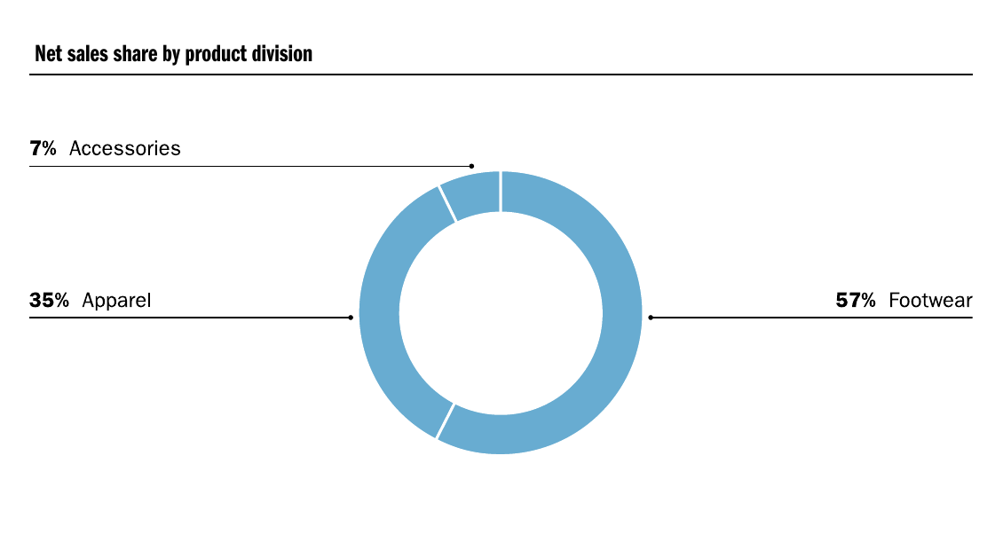
Figure 3: Adidas net sales share by product division in 2025
Source: (Adidas, 2026)
The gross margin of Adidas has improved from 47.3% in 2022 to 51.6% in 2025, suggesting a more favourable product mix and better full price sell (Adidas, 2026, p. 81) as seen in figure 4. But due to the lack of public UK market-share figures (which have not been audited) the franchise is more defensibly seen as a premium challenger than a market leader. What makes this stand out is that it offers ‘in constant use performance comfort from running to everyday life' based on design that has been recognised, is available in multiple channels and can be backed by claims of responsible materials.
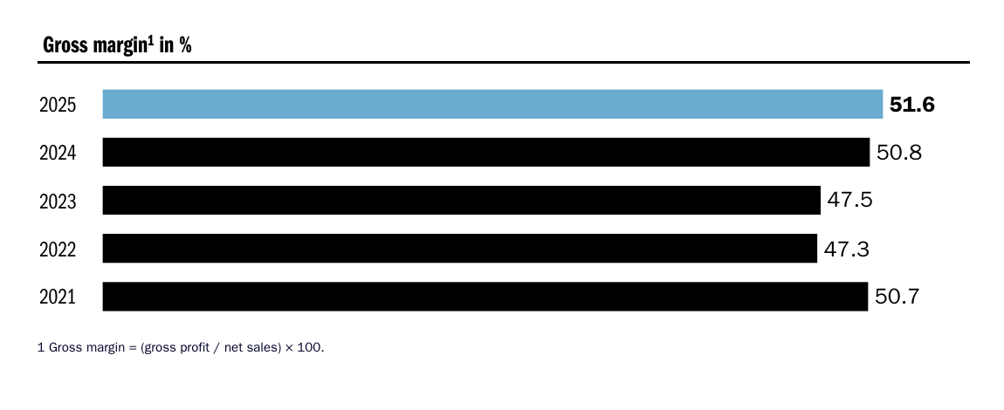
Figure 4: Adidas gross margin development from 2021 to 2025
Source: (Adidas, 2026)

2. External and Internal Analysis
This section identifies forces that drive the attractiveness of markets and that influence the ability of Adidas to respond favourably in comparison to its competitors. PESTLE analyses for opportunity and threat in materials, while VRIO is used to analyse the implication in terms of competitive consequences and SWOT analyses are used to combine the results. Yu (2021) warns that frameworks are tools to make decisions, not to replace judgment. PESTLE can turn into a non-specific list and VRIO can assume what is known as an asset is rare, so only demand, cost, legitimacy or execution factors are stressed.

2.1 External Analysis: PESTLE Framework

Figure 5: PESTLE Framework
Source: (Athuraliya, 2026)
Political Factors: This involves a combined political setting. The United Kingdom is an environment of open retail competition and with more expectations for the supply chain in the post-Brexit world, the value of traceability grows. The guidance set out by Home Office (2025) requires large businesses to carry out an assessment of modern slavery risk, and report action taken and measurable progress, rather than simply publishing a compliance statement. Adidas has the potential to transform trustworthy due diligence into retailer and consumer confidence. Especially the risk of labour, customs, and disruption, which can not credibly be dissociated from the rest of the value chain, is something that can not be excluded in outsourced production, as is the threat.
Economic Factors: Economic pressures are exerted on a prestige shoe that can be postponed. For example, in clothing and footwear, prices increased by 0.7 per cent in year-to-April 2026 after a drop in the previous month, reflecting discount and price impacts which were not consistent with inflation (ONS, 2026). Household caution enhances comparison and boosts proof asked for premium value. Broad discounting would affect reference price, so Adidas is advised to use clear product tiers, member benefits, controlled bundles while showcasing meeting the test of time and comfort in running and use beyond.
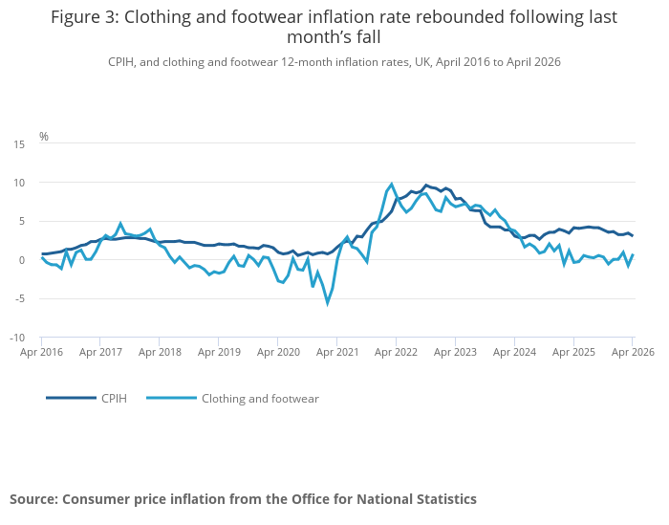
Figure 6: UK clothing and footwear inflation, April 2016 to April 2026
Source: (Office for National Statistics, 2026)
Social Factors: There's a positive social signal at the intersection of running/walking, wellbeing and athleisure, though one may not necessarily translate into premium footwear. Sport England (2026) identifies there being a large, diverse and active population, which contributes to the community activation beyond elite sport. Use occasion and confidence should be the only two consumers to be segmented, not age. New runners require comforting and education, more advanced runners hope for authenticity in comparison, and casual users want flexibility. Liu (2022) also demonstrates that influencer campaigns also influence intentions to buy, and local influencers should aim for more than just face value.
Technological Factors: This occurs because technology affects the product and the buying process. Digital fitting, membership data and mobile commerce and content can alleviate size, feel and use uncertainties. According to Both and Steinmann (2023), the omnichannel experience is not about having several channels but about integrating them together. Adidas has already merged wholesale, retail and ecommerce and breadth endangers the consistency. A centralized product record, fit profile and service promise can optimize conversion, while disjointed stock, unintentional advertising and inhibiting customer data can drive returns and erode trust.
Environmental Factors: Commercial Pressure: footwear is made of mixed materials, produced and packaged all over the world. In short, Saha et al. (2024) find coordinated design, collection, sorting, recycling and business model change necessary for circularity. Recycled input claims are thus helpful, but not sufficient. Management commitment, stakeholder collaboration and workforce capability are key implementation conditions identified by Akash et al. (2025). Adidas should try testing durability, materials identification, take back and credible pathway for materials recovery and make it clear about limitations. The opportunity is differentiated resource productivity and the threat is cost and lack of participation and reputational risk of exaggerated claims.
Legal Factors: This is particularly crucial when sustainability is a marketing strategy. The CMA (2021) calls for environmental claims to be truthful, clear, substantiated, complete and thought through throughout the product lifecycle. ASA and CAP (2023) also state that a positive initiative can mislead by overly promoting the environmental performance of the business. Ultraboost marketing should understand what exactly the component, percentage, boundary and comparison of each claim is. This discipline is one that infringes on short-term creative freedom, but safeguards trust, and sustainability is not an easy target.

2.2 Internal Analysis: VRIO Framework
The resource-based view assesses if a firm has resources and capabilities that are valuable, rare, difficult to imitate, and organisationally supported. As in Figure 7, there is no direct connection between resources and performance. Before financial, human and relational resources can be translated into organisational capabilities, there are management systems, research and development, manufacturing and marketing and decision making processes.
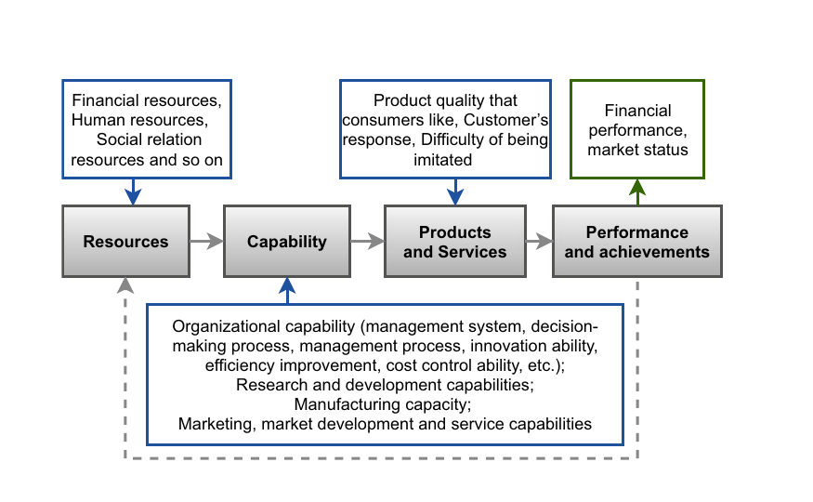
Figure 7: Strategic resources and capabilities as drivers of performance
Source: (Yu, 2021)
These capabilities then produce products and services that customers value to produce financial performance and market status. The figure also shows a feedback loop, which suggests that performance can be used to fund future performance and resource/capability development (Yu, 2021, p. 144). Instead, Jevnaker and Olaisen (2022) state that sustainable advantage is based on interacting knowledge, relationships and renewal processes, but not on isolated assets.
Valuable: Adidas brand equity is valuable as it ensures low purchasing risks, draws business relationships and enables high prices. Another aspect of how Boost and Ultraboost are valuable is the cushioning effect and comfort they provide. Omnichannel distribution, sustainability systems and customer data ensures the availability of products, regulatory readiness and customer understanding. But these resources are of no value if they are not converted into quality product and service.
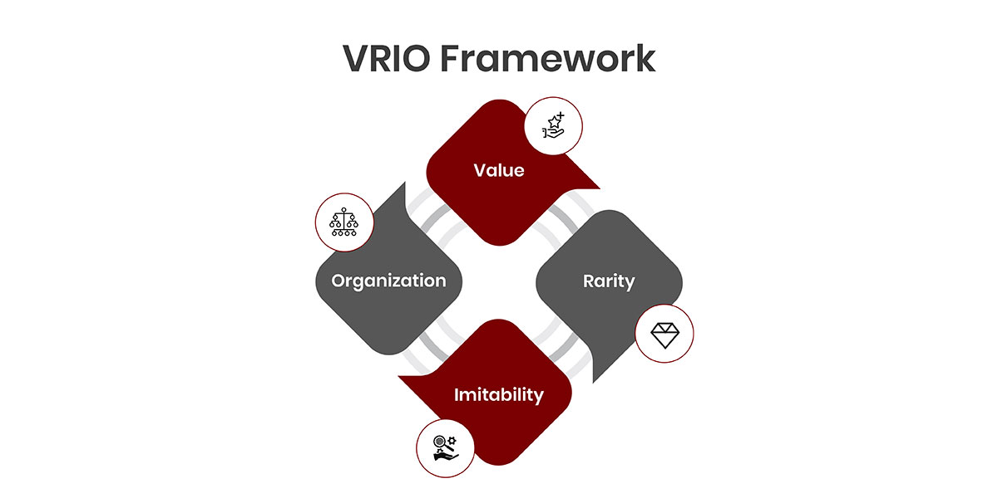
Figure 8: VRIO Framework
Source: (The Strategy Institute, 2024)
Rare: Adidas has a unique brand history that few brands can match and is one of the few things that sets them apart. The unusual nature of the athlete/ cultural connections also stems in part from long-term partnerships. Authenticity can enhance ewom as mediated by self-brand connection (Xu et al., 2021). In contrast cushioning technology and omnichannel distribution aren't completely novel, with Nike, ASICS, Hoka and On having been able to do similar things.
Difficult to imitate: Brand heritage is path dependent and cannot be easily reproduced. Retailer relationships and community partnerships can also help to make a UK market uncopyable, along with consumer data and routines of learning. Visible product technologies are more likely to be imitable. Okorie et al. (2023) state that technology influences the creation of greater advantage in conjunction with broader capacities in the organization. Technology, therefore, on its own, could offer only a fleeting edge, but with fit data, design know-how, and local learning, it's a much more sustainable tool.
Organised: Adidas is organised to leverage brand equity via its performance 3-Bar and lifestyle Trefoil architecture, product-development systems and international distribution. The organisation of sustainability capability is less developed. Adidas has decarbonisation, circularity and responsible sourcing material programmes, reporting systems and priorities, but governance and recovery infrastructure need to be strengthened. According to Liang et al. (2022) dynamic capabilities will be the link that connects the ESG strategy and organisational performance. Likewise, local responsiveness will only result in advantage if the UK teams have shared data, decision authority and cross-functional coordination (Lu and Shaharudin, 2024).
Brands, generally, offer the greatest long-term benefit in global brand equity. Expertise, sustainability, and athlete relationships provide only limited benefit, and omnichannel distribution brings parity. The best opportunity for long-term benefits lies in institutionalised UK learning.

2.3 SWOT Analysis
The SWOT analysis combines the external and internal findings to highlight the most strategically relevant issues for Adidas Ultraboost in the United Kingdom. Unfortunately, some decision-making processes and relationships with stakeholders have been separated from what could be described as responsible strategy, making it an activity instead of part of the core decision-making process (Ditlev-Simonsen, 2022).
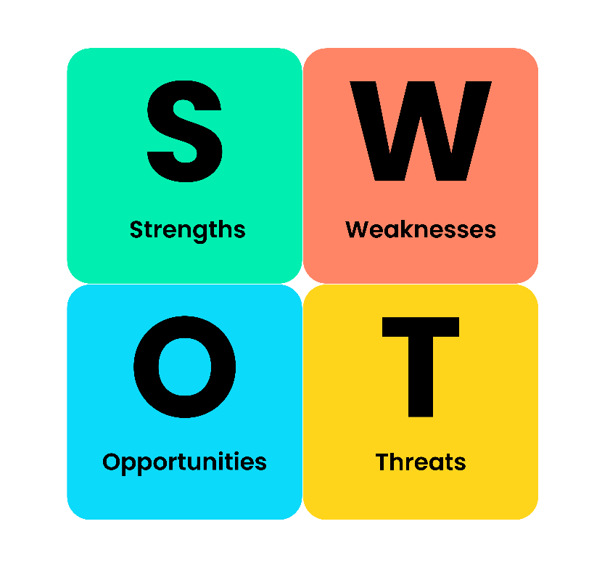
Figure 9: SWOT Analysis
Source: (BusinessBalls, 2023)
Strengths: Adidas enjoys high brand awareness worldwide and has a successful product development, a long history of wholesale and retail distribution. Performance credibility isn't its only thing, Ultraboost is also appealing to runners, casual users and the athleisure buyer, too. These strengths are used to support the premium pricing and can be used to offer differentiated customer experiences.
Weaknesses: Ultraboost is vulnerable to price sensitivity, especially when households are under financial strain. Competitors can also mimic its cushioning and design features which reduces the product-sustained benefit for an extended period. Outsourcing supply chain poses risks for operations and reputation, inconsistent channel pricing, stock and service may erode customer trust.
Opportunities: Growth in running, walking and active lifestyles that are driving demand for versatile footwear. Personalised product recommendations and customer data via digital fitting can minimise purchase uncertainty and returns. Greater differentiation can also be achieved by means of verified durability claims, chosen take-back services, community-running partnerships and product education.
Threats: Nike, ASICS, New Balance, Hoka, On and Puma remain to be intense competitors. Online price comparison increases buyer power and low switching costs make it possible. Labour concerns, logistics challenges, supply risks, legal and reputational risks from increased enforcement of environmental claims – impacts on availability and credibility.
In the overall, Adidas should build an integrated UK service and circular-performance system with the strengths of its brand, product and channel. Celebrity visibility and/or claims of recycled content would not be defensible alone.

3. Comprehensive and Holistic View of Adidas

3.1 CSR Strategy and Alignment with Business Objectives
Adidas's CSR strategy is strategically relevant given that the impacts of Adidas on the environment and society are primarily linked to materials and manufacturing partners, logistics and end-of-life management of products. Karaosman et al. (2022) outline governance, supplier relations, purchasing and traceability as important obstacles to sustainable sourcing in the fashion sector. Adidas has stepped away from single-purpose philanthropy and towards setting sustainability targets for sourcing, running the business and corporate reporting. CSR is most closely associated with business objectives where responsible practices lead to better product quality, more resilient supply chains, regulatory preparedness and stakeholder trust. The alignment is weaker if there are no specific, measurable benefits, suppliers' actions, or products associated with the company-wide commitments.
Environmental responsibility and circularity: Adidas shows signs of improvement, but there are inherent structural constraints. 60% of the materials and packaging used in 2025 were recycled or composed of sustainably sourced renewable (Adidas, 2026). But using alternative materials is not a circular business model. Circular supply chains need to be a systemic redesign, Montag (2023) writes, and not merely linear flows turned the other way. The next step for Ultraboost should thus be product durability testing, identification of materials and take back logistics and recovery quality testing. Product life extension can make a significant contribution to customer value and environmental impact, if it is technically possible and economically credible (the added value of the other route to recovery).
Social responsibility and supplier management: Deeper connections between the purchasing decisions made by Adidas and the outcomes of workers are needed for social responsibility. International sourcing introduces efficiencies and access to specialist manufacturing at the expense of potentially shifting sourcing pressure if there are fluctuations in order volumes, forecasts, lead times or prices. Effective remediation and year-on-year improvement, along with meaningful stakeholder engagement is a focus of the guidance provided by The Home Office (2025) It is therefore recommended that Adidas link the planning of United Kingdom Ultraboosts with responsible purchasing indicators and grievance evidence, and supplier capacity. These are not ‘promotional’ but ‘operational' actions which preserve continuity of supply, reputation and the organisation's licence to operate. The Board should therefore take a look at social responsibility as a capability of the supply chain and not only issue of compliance.
Brand authenticity and green claims: CSR also has an impact on brand reliability and customers' trust. Lee and Jeong (2022) identify that brand trust and the sustainability-management outcomes are enhanced by compatibility and perceived authenticity. It is therefore important that environmental communication is directly linked to the function, materials and identity of Ultraboost and avoids using general sustainability terms. As perceptions of greenwashing have a negative effect on green purchase intention, transparency is of commercial significance, as shown by Lu et al. (2022). To be clear, Adidas should reveal any trade-offs, not show a partial improvement of materials as proof of the shoes sustainability and only include independent standards when they directly apply to the claim.
Although, CSR is aligned to Adidas' strategy of differentiation, it is not yet enough to provide a continuous competitive edge. However, circular transition is a process that needs coordination along the value chain and consideration of power dynamics between the organisations involved (Mahanty & Domenech, 2024). The proposed United Kingdom pilot should thus include return rates, shoe condition, yield of shoes recovered, customer response and cost per recovered shoe. The learning should shape the knowledge that will impact design, sourcing and channel decisions in the future. This would take CSR beyond target reporting, and build it up into a 'living capability', generating a greater capacity for innovation, resilience and trust and pinpointing symbolic activities of no benefit to customers or environment.

3.2 Balanced Scorecard Analysis
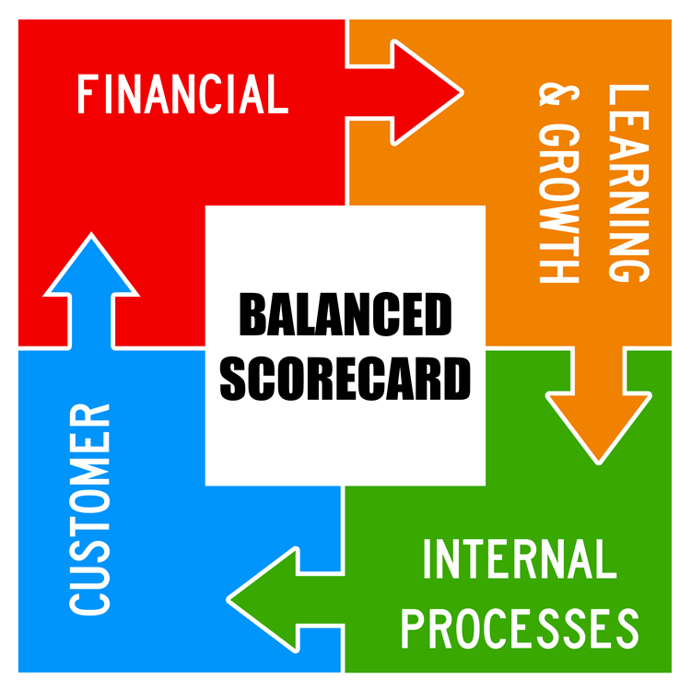
Figure 10: The four perspectives of the Balanced Scorecard
Source: (Barthold, 2021)
The Balanced Scorecard is the discipline that transforms strategy into a chain of interrelated, financial and non-financial objectives. Fig. 10 shows the linkages among its four perspectives – learning and growth, internal processes, customer, and financial performance. These perspectives are interrelated, connected by causal arrows which indicate that they are not isolated measurement categories. Employee knowledge and digital capability and organisational learning leads to better internal processes; better processes leads to better customer experience; better customer experience leads to better revenues and profitability.
Gazi, Atan and Kılıç (2022) conclude that sustainability indicators when integrated in financial and non-financial dimensions are more effective. Similarly, Eifert and Julmi (2022) highlight that, if too many indicators are included in a scorecard without understanding of their causality, they are ineffective. Ultraboost UK: Proposed sequence starts with employee capability and evidence governance, that enhance the omnichannel and circular processes. These enhancements should boost customers' trust and loyalty even before promoting monetary benefits.
Perspective | Objective and KPI | Target by end of 2027 | Priority initiative
Financial | Increase profitable premium sales; full-price revenue and gross margin | 8% full-price revenue growth while maintaining margin | Member-led launches and controlled markdowns
Customer | Increase confidence and loyalty; repeat purchase rate, NPS, return rate. | Repeat purchase rate up 5 percentage points and reduce fit-related returns by 10% | Digital fit profile and community trials.
Internal processes | Improve stock accuracy; maximize take back rate and maximize recovery yield of selected-store take-backs | 95% stock accuracy; 5% of eligible pilot sales returned | Central product information in store; take-backs of selected stores
Learning and growth | Build local insight and claims governance; training and learning cycles | 100% of campaign teams trained; quarterly experiments completed | Crossfunctional UK Ultraboost team and evidence library.
Table 1: Balanced Scorecard for Adidas Ultraboost UK
The Board must make a causal reading of the measures. Only with improved customer confidence, reduced returns and reliable processes will there be credibility around financial improvement. The convenience and functional value of take back participation is essential, as reported by Hasbullah et al., (2022) that motivation, opportunity and ability influence sustainable apparel purchase intention. Leading indicators should be evaluated every quarter and financial outcomes evaluated after 6 and 12 months. Non-value-adding activitiesthat create awareness should be reconsidered or eliminated.

4. Strategic Choices and Implementation

4.1 Business-Level Strategic Options
Cost leadership: Inappropriate in the case of Ultraboost, since the franchise is designed with a premium system, and the franchise are not competing based on the lowest price. From Figure 11 Strategy Clock, it is evident that low-price positions tend to be lower perceived value or a hybrid offer. Such a shift toward these categories would endanger the margins and brand for Ultraboost, which already has reachable shoes in other categories in the brand's portfolio. Rivalry and buyer power are high, online comparison is easy and lower-priced substitutes are widely available.
Focused differentiation: A limited appeal to hard-core joggers would certainly offer technical clarity yet would not make use of the crossover for running and everyday wear that Ultraboost offers. Experts like ASICS, Hoka, and On may also be more credible in the subcategories of running. Hence a focused differentiation, along the use occasion perspective, is more helpful: novice runners could be given reassurance, lifestyle consumers could be offered versatility.
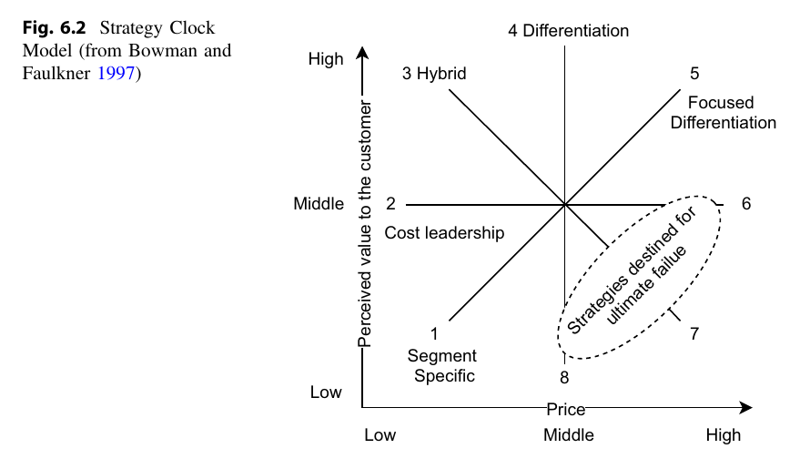
Figure 11: The Strategy Clock and routes to competitive positioning
Source: (Yu, 2021)
Differentiation: The best option is differentiation. Figure 11 illustrates that differentiation and focused differentiation are positioned at higher perceived values, in line with Ultraboost's premium brand identity. As Yu (2021) points out, however, differentiation requires more than the price: superior perceived value. To uphold its premium, Adidas needs to provide proof of its fit, security, service, community credibility, and responsible product.
Porter’s Five Forces: This is reinforced by Porter's model. The rivalry is high, the power of buyers is high, the power of suppliers is moderate (due to scale but relying on specialist materials and focused production), substitutes are very easy to get and niche entry is still possible. The forces align with decreasing direct comparability via service and evidence as opposed to mimicking competitors prices (Yu, 2021).
Ansoff’s Matrix: The best growth avenue is through product/service development in the current UK market. More promotion can cause a margin reduction, but market development is not necessarily in selected geography and diversification would create extra risk. Lin and Chen (2022) demonstrates that Sustainable Apparel Intention is influenced by Knowledge, Perceived Value and Environmental Concern. A digital proposition can describe performance, can help align variants with what customers need and can provide a realistic circular path.
Europe accounted for 33% of Adidas' net sales in 2025, followed by North America (21%), Emerging Markets (15%), Greater China (14%), and Latin America (12%) and Japan/South Korea (6%), as illustrated in Figure 12 (Adidas, 2026, p. 65). Europe therefore has strategic importance, but it doesn't set any UK-specific Ultraboost performance.
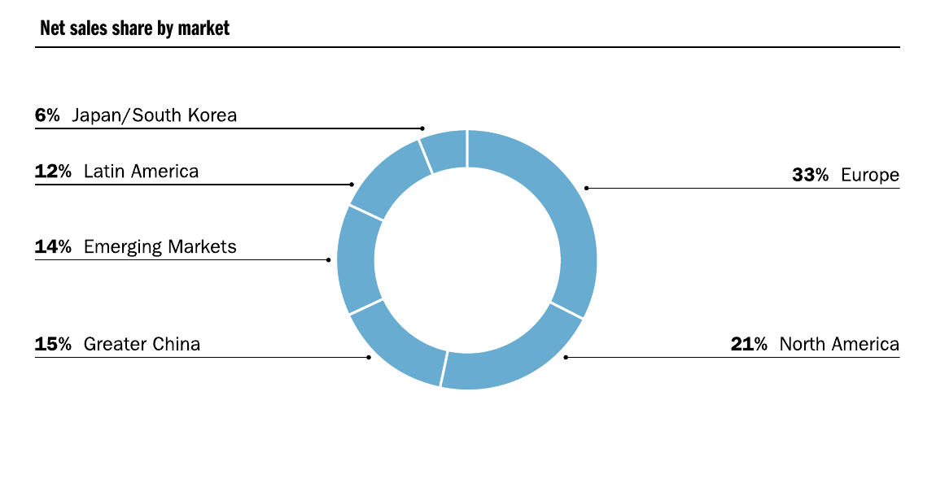
Figure 12: Adidas global sales mix by market in 2025
Source: (Adidas, 2026)

4.2 Identification of the Most Appropriate Strategy
The recommended approach is localised sustainable differentiation which is a combination of community trials, control take-back pilot, transparent performance and durability evidence, and the persistence of the UK fit profile. Digital capability, coupled with business-model innovation oriented to the market, are explained to pave the way for a sustainable performance (Chen, Li and Shahid, 2024). Chung et al. (2022) also conclude that credible communication positively effects the reliability and purchasing intention under sustainability. It is not about campaigns that bear no relationship to one another that would be advantageous, but about integration.
Suitability: The strategy considers Adidas' current brand and product strengths, pressure on premium value, digital expectations and green-claims risk. It combines fit support, evidence and local service to lessen the direct price comparison.
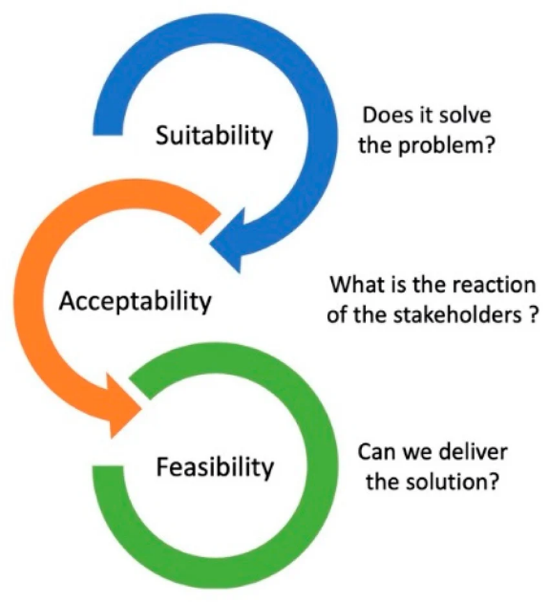
Figure 13: SAFe Framework
Source: (Lemay and Moreau, 2020)
Acceptability: Functional value is delivered to customers prior to asking for customer participation in circular behaviour. Retailers have the potential to better leverage conversion – but may not want to take customer data. Wang and Walker (2023) demonstrate that restoration of trust after greenwashing needs to be backed up by credible action and communication. Joint incentives, clear claims, written consent arethus required.
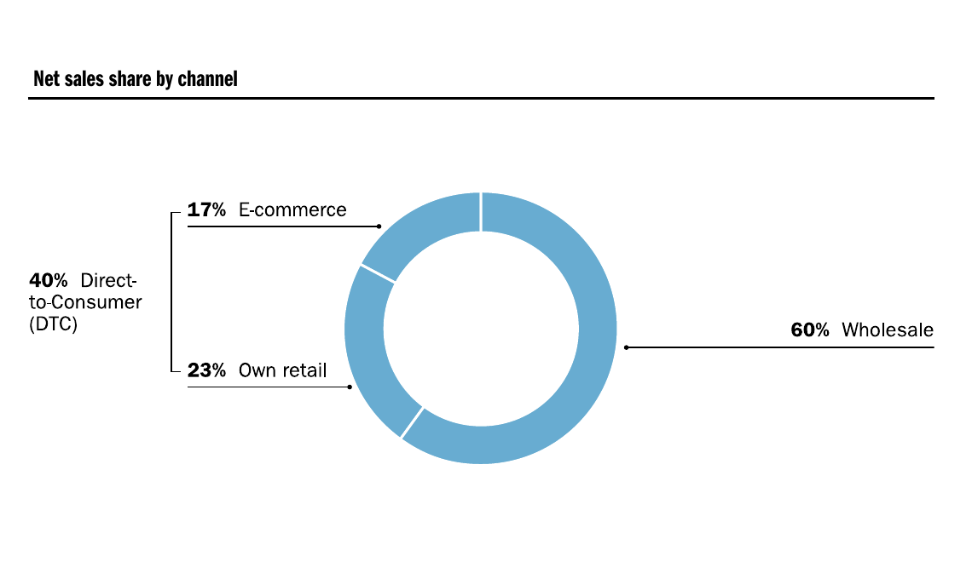
Figure 14: Adidas sales channel mix in 2025
Source: (Adidas, 2026)
Feasibility: Wholesale sales accounted for 60% of 2025 sales, with direct-to-consumer channels accounting for 40% of sales, consisting of 23% own retail and 17% ecommerce (Adidas, 2026, p. 65). This reach provides for delivery and poses a channel-integration challenge. The approach is possible using existing assets, if the UK Ultraboost team has one roadmap, evidence library and scorecard.

4.3 Strategic Benefits and Implementation Plan
Implementation should start with a 12-month pilot in London, Manchester and in one digitally served comparison region. The first phase establishes baselines, claim rules, retailer agreements and the common fit profile. The second involves community trials, service content and take back is selected. The third only considers components that affect full price conversion, loyalty or recovery performance. Alojail and Khan (2023) highlight the importance of stakeholder involvement and resource allocation and support in digital transformation. Thus, executive sponsorship, product ownership, and exception reporting on a monthly basis are required for the programme, and not a loose sustainability committee.

4.4 Implementation Challenges and Mitigation Strategies
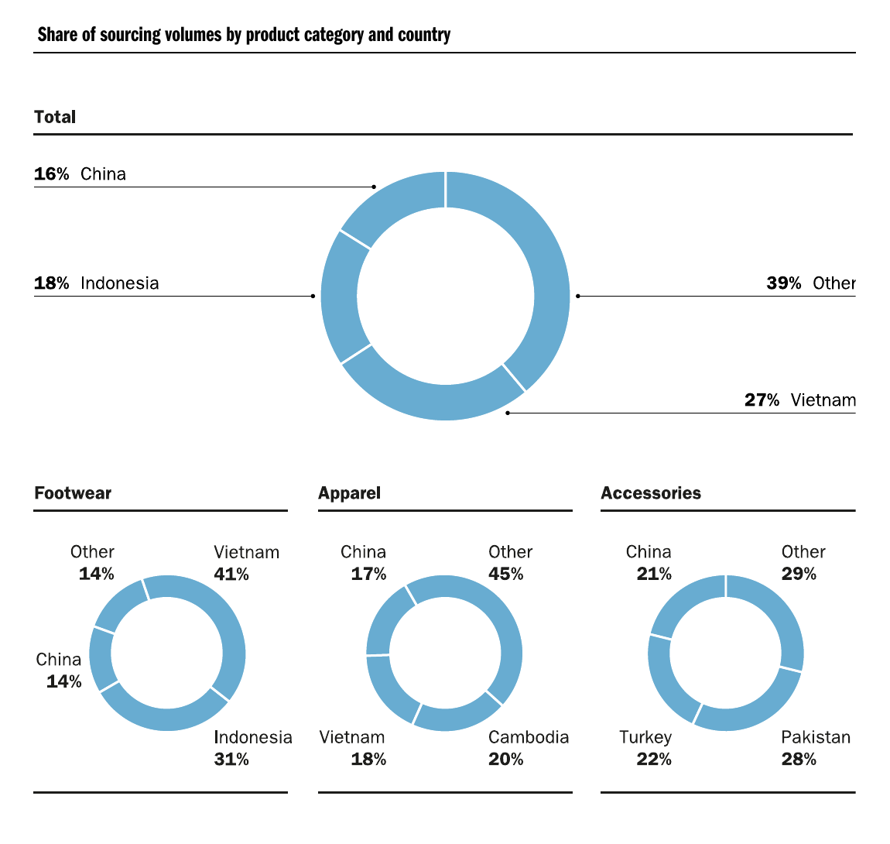
Figure 15: Adidas sourcing volumes by country and product category in 2025
Source: (Adidas, 2026)
The key challenges are reverse-logistics cost, shoe condition variability, privacy, retailer conflict, and sourcing disruption. As revealed in Figure 15, the sourcing volume from Vietnam accounted for 27%, Indonesia 18%, and China 16%. Footwear sourcing was more concentrated, with 41% sourced from Vietnam, 31% from Indonesia, 14% from China and 14% elsewhere (Adidas, 2026, p. 68). This level of concentration exposes its member states to “logistics, labour and geopolitical disruption.”
Sarker et al. (2024) list technology, collaboration and management commitment as enabling factors for footwear-circularity. Strategies for mitigation should include: restricted eligible range, QR identification, explicit consent, specialist recovery partners, retailer incentives, separate pilot accounting.
Timing | Action | Owner | Success signal | Risk control
Months 1 to 3 | Baseline, evidence standards, partner design and data governance | UK General Manager and Product Lead | Approved business case and shared baseline | Legal review and limited pilot scope
Months 4 to 6 | Launch fit profile, community trials and selected take back | Digital, Retail and Sustainability Leads | Conversion uplift and participation data | Consent controls and retailer incentives
Months 7 to 9 | Optimise content, stock and recovery process | Cross functional Ultraboost squad | Lower fit returns and improved recovery yield | Weekly exception review
Months 10 to 12 | Independent evaluation and scale decision | Board Strategy Committee | Positive customer economics and verified claims | Stop, redesign or scale by evidence
Table 2: Implementation roadmap and principal risks

Conclusion
Differentiation is appropriate but is not strongly enough reflected in the existing curriculum. Going forward, Adidas needs to maintain their performance and lifestyle status quo and transfer United Kingdom insight, digital service and verified circular practice into an offering that is not easy to replicate. According to Sahimaa et al. (2024), there is a need to shift fashion sustainability from a simple product claims model to systemic change. There will only be measurable customer, financial and recovery results when the elements of the localised sustainable differentiation result in advantage.

Section 2

Reflective Account Using Gibbs' Reflective Cycle
This section uses Gibbs' Reflective Cycle to reflect on my approach, feelings, evidence used, analytical judgement and learning. It highlights strengths, limitations and tangible actions to enhance future consultancy work, decision making and professional communication (Channell, 2025).
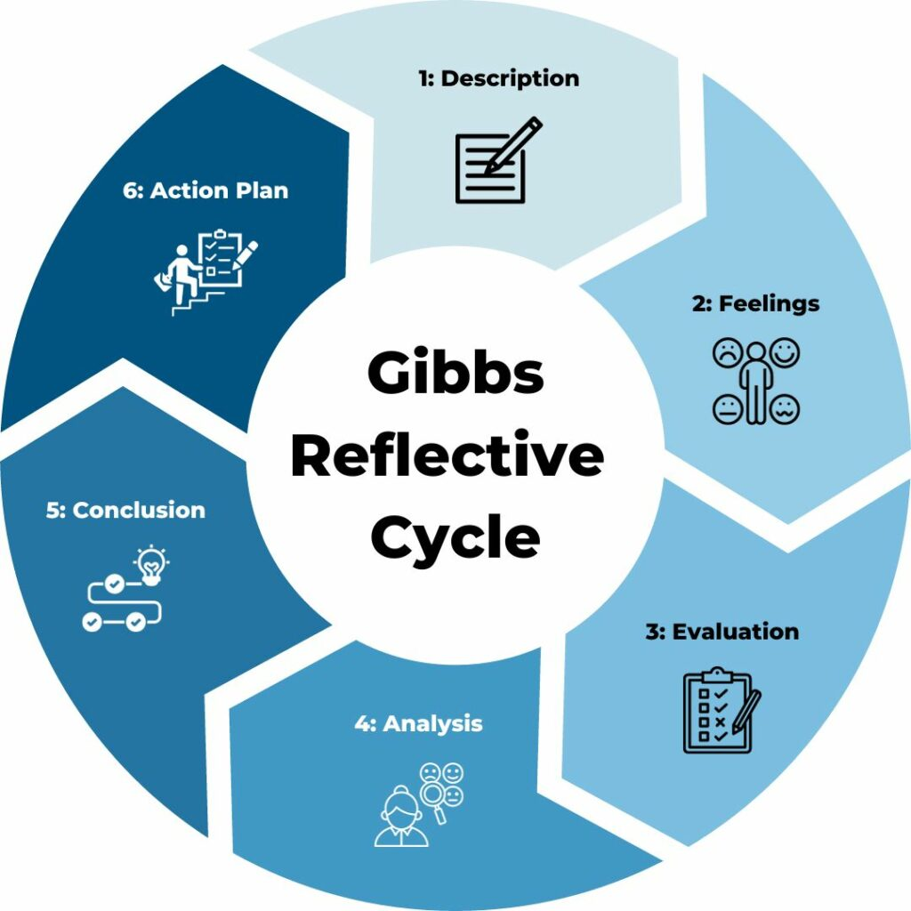
Figure 16: Gibbs' Reflective Cycle
Source: (Channell, 2025)

5.1 Description
I treated it as a consultant to give advice to a Board, not a student writing down tools for strategies. I verified the organisation, product and market, and then created an evidence map of the context, external forces, internal capabilities, CSR, performance measures, strategic choice and implementation from the brief. Klos et al. (2022) demonstrates that information is needed along organisational boundaries for life cycle management. This made me think about linking the product to the sourcing, the customer and end of life evidence rather than having an alternative descriptive part about sustainability.

5.2 Feelings
I was optimistic about it, as Adidas is familiar, however, I didn't want to hope for it since it is mostly reported at group level and not specifically Ultraboost in the UK. Another risk was the addition of a multitude of frameworks, making it seem comprehensive without being selective. Samans and Nelson (2022) stress the importance of enterprise value based on coherent outcomes for business and stakeholders. I developed a new way of looking at the models and started becoming familiar with excluding models that didn't test the recommendation, focusing on the number of models that supported a decision.

5.3 Evaluation
My strongest aspect of my process was triangulating the company disclosures, regulation, market data and academic research. Official Adidas numbers provided an organising measure of scale, and journal articles refuted the notion that recycled materials will necessarily lead to greater intention to buy or a competitive edge. La Rosa and Jorgensen (2021) demonstrate that attitudes, social influence and convenience influence sustainable apparel behaviour, indicating that take-back schemes should be convenient and associated with functional value. Proposed targets have to be baseline validated however as UK Ultraboost profitability has not been audited and there is no data consisting of customer cohorts.
I excluded promotional materials and looked for each source to directly address the respective claim, using peer reviewed research and official reporting. Cöster et al. (2023) focus on governance and decision clarity with separation between verified facts, analytical inferences and proposed targets. This lowered the number of unsupported claims and acknowledged that product-level uncertainty will remain even if group-level assurance is provided.

5.4 Analysis
I found out that strategic models have a different function. PESTLE (Political, Economic, Social, Technological, Legal and Environmental factors) identified external conditions, but could not determine if Adidas could exploit them. VRIO was used to evaluate internal resources, with value based on external evidence. These analyses made SWOT meaningful and the Balanced Scorecard turned the recommendation into connected performance measures. Gazi et al., 2022 agrees that sustainability should be reflected throughout the entire scorecard and not just as a separate environmental issue. This translated to customer confidence, organisation learning and internal processes and financial results.
I also looked at conflicting evidence. Brand scale builds trust and reach, but can lead to scrutiny, and wholesale drives volume but risks to silo of customer information. Recycled materials can decrease dependence on virgin resources but might be easily copied and be greenwashing subject of criticism. Sun and Shi (2022) demonstrate that the sense of greenwashing can undermine trust, leading to diminished purchasing intentions. So I recommended local pilots, specific evidence and staged investment, which means that it's possible to make a balanced judgement without having a complete set of information.

5.5 Conclusion
The process helped me to improve my capacity to go from description to synthesis. So, I learned that when a recommendation includes what we should do, why it's a fit for the evidence, who is responsible for it, and how we will know when we've done enough, the recommendation carries more credibility. Cardona&Rey (2022) link mission to management&tangible contribution. The purpose Adidas places on an operational proposition instead of as introductory language. What I would have done to enhance the work is to have some primary customer interviews, retailer insight and product level cost data.

5.6 Action Plan
Action | Intended outcome
Define decision questions before research | Improve focus and relevance.
Maintain a source-quality log and evidence matrix | Separate facts, assumptions and recommendations.
Record contradictory evidence | Strengthen balanced judgement.
Consult customers, retailers and internal functions | Validate recommendations and targets.
Model expected and downside scenarios | Identify risks, controls and stop-or-scale criteria.
Use fewer measures with clear causal links | Improve accountability and implementation.
Test measures through pilot data | Confirm feasibility before wider investment.
Table 3: Action Plan
Eifert and Julmi (2022) emphasize that poor clarity of priorities and organisational obstacles undermine the implementation of a scorecard. The activities will help me become more disciplined in my analysis and more open and honest in my professional communication.

References
Adidas (2025) Our targets. Available at: https://www.Adidas-group.com/en/sustainability/our-gameplan/our-targets.
Adidas (2026) Annual Report 2025. Available at: https://report.Adidas-group.com/2025/en/_assets/downloads/annual-report-Adidas-ar25.pdf.
Advertising Standards Authority and Committee of Advertising Practice (2023) Update to CAP and BCAP guidance on misleading environmental claims. Available at: https://www.asa.org.uk/news/update-to-cap-and-bcap-guidance-on-misleading-environmental-claims.html.
Akash, M.H., Aziz, R.A., Karmaker, C.L., Bari, A.B.M.M., Kabir, K.M.A. and Islam, A.R.M.T. (2025) ‘Investigating the attributes for implementing circular economy in the textile manufacturing supply chain: implications for the triple bottom line of sustainability’, Sustainable Horizons, 14, article 100129. Available at: https://doi.org/10.1016/j.horiz.2024.100129.
Alojail, M. and Khan, S.B. (2023) ‘Impact of digital transformation toward sustainable development’, Sustainability, 15(20), 14697. Available at: https://doi.org/10.3390/su152014697.
Athuraliya, A. (2026) ‘What is a PESTLE analysis: definition, purpose, and core concepts’, Creately, 3 January. Available at: https://creately.com/guides/what-is-a-pestle-analysis.
Barthold, B. (2021) ‘How to use the Balanced Scorecard approach to achieve world-class service desk performance’, Giva, 23 July. Available at: https://www.givainc.com/blog/what-is-the-balanced-scorecard-approach-example-template-itsm/.
Both, A.D. and Steinmann, S. (2023) ‘Customer experiences in omnichannel retail environments: a thematic literature review’, The International Review of Retail, Distribution and Consumer Research, 33(5), pp. 445–478. Available at: https://doi.org/10.1080/09593969.2023.2256491.
BusinessBalls (2023) ‘SWOT: Strengths, weaknesses, opportunities, threats’. Available at: https://www.businessballs.com/strategy-innovation/swot-analysis/.
Cardona, P. and Rey, C. (2022) Management by Missions. Cham: Springer. Available at: https://doi.org/10.1007/978-3-030-83780-8.
Channell, M. (2025) ‘Gibbs Reflective Cycle: a practical guide’, TSW Training, 11 January. Available at: https://www.tsw.co.uk/insights/gibbs-reflective-cycle/.
Chen, A., Li, L. and Shahid, W. (2024) ‘Digital transformation as the driving force for sustainable business performance’, Heliyon, 10, e29509. Available at: https://doi.org/10.1016/j.heliyon.2024.e29509.
Chi, T. et al. (2021) ‘Understanding perceived value and purchase intention toward eco-friendly athleisure apparel’, Sustainability, 13(14), 7946. Available at: https://doi.org/10.3390/su13147946.
Chung, T., Lee, K.Y. and Kim, U. (2022) ‘The impact of sustainable management strategies of sports apparel brands on brand reliability and purchase intention’, Sustainability, 14(12), 7076. Available at: https://doi.org/10.3390/su14127076.
Competition and Markets Authority (2021) The Green Claims Code checklist. Available at: https://www.gov.uk/government/publications/green-claims-code-making-environmental-claims/green-claims-and-your-business.
Cöster, M., Danielson, M., Ekenberg, L., Gullberg, C., Titlestad, G., Westelius, A., & Wettergren, G. (2023). Digital transformation: Understanding business goals, risks, processes, and decisions. Open Book Publishers. https://doi.org/10.11647/OBP.0350.
Ditlev-Simonsen, C.D. (2022) A Guide to Sustainable Corporate Responsibility. Cham: Palgrave Macmillan. Available at: https://doi.org/10.1007/978-3-030-88203-7.
Eifert, A. and Julmi, C. (2022) ‘Challenges and how to overcome them in the formulation and implementation process of a sustainability balanced scorecard’, Sustainability, 14(22), 14816. Available at: https://doi.org/10.3390/su142214816.
Gazi, F., Atan, T. and Kılıç, M. (2022) ‘Assessment of internal indicators on the balanced scorecard measures of sustainability’, Sustainability, 14(14), 8595. Available at: https://doi.org/10.3390/su14148595.
Hasbullah, N. N., Sulaiman, Z., Mas’od, A., & Ahmad Sugiran, H. S. (2022). Drivers of sustainable apparel purchase intention: An empirical study of Malaysian millennial consumers. Sustainability, 14(4), Article 1945. https://doi.org/10.3390/su14041945.
Home Office (2025) Transparency in supply chains: a practical guide. Available at: https://www.gov.uk/government/publications/transparency-in-supply-chains-a-practical-guide/transparency-in-supply-chains-a-practical-guide-accessible.
Jevnaker, B.H. and Olaisen, J. (2022) Reimagining Sustainable Organization. Cham: Palgrave Macmillan. Available at: https://doi.org/10.1007/978-3-030-96210-4.
Karaosman, H. et al. (2022) ‘Barriers to sustainable sourcing in the apparel and fashion luxury industry’, Sustainable Production and Consumption, 31, pp. 220–235. Available at: https://doi.org/10.1016/j.spc.2022.02.007.
Klos, Z.S., Kalkowska, J. and Kasprzak, J. (eds.) (2022) Towards a Sustainable Future: Life Cycle Management. Cham: Springer. Available at: https://doi.org/10.1007/978-3-030-77127-0.
La Rosa, A. and Jorgensen, J.J. (2021) ‘Influences on consumer engagement with sustainability and the purchase intention of apparel products’, Sustainability, 13(19), 10655. Available at: https://doi.org/10.3390/su131910655.
Lee, S.H. and Jeong, G.Y. (2022) ‘The effect of corporate social responsibility compatibility and authenticity on brand trust and corporate sustainability management’, Frontiers in Psychology, 13, 895823. Available at: https://doi.org/10.3389/fpsyg.2022.895823.
Lemay, J. and Moreau, P. (2020) ‘Managing a curriculum innovation process’, Pharmacy, 8(3), article 153. Available at: https://doi.org/10.3390/pharmacy8030153.
Liang, Y., Lee, M.J. and Jung, J.S. (2022) ‘Dynamic capabilities and an ESG strategy for sustainable management performance’, Frontiers in Psychology, 13, 887776. Available at: https://doi.org/10.3389/fpsyg.2022.887776.
Lin, P.H. and Chen, W.H. (2022) ‘Factors that influence consumers’ sustainable apparel purchase intention’, Sustainability, 14(14), 8950. Available at: https://doi.org/10.3390/su14148950.
Liu, M. (2022) ‘Determining the role of influencers’ marketing initiatives on fast fashion industry sustainability’, Frontiers in Psychology, 13, 940649. Available at: https://doi.org/10.3389/fpsyg.2022.940649.
Lu, H. and Shaharudin, M.S. (2024) ‘Role of digital transformation for sustainable competitive advantage of SMEs’, Cogent Business & Management, 11(1), 2419489. Available at: https://doi.org/10.1080/23311975.2024.2419489.
Lu, X., Sheng, T., Zhou, X., Shen, C., & Fang, B. (2022). How does young consumers’ greenwashing perception impact their green purchase intention in the fast fashion industry? An analysis from the perspective of perceived risk theory. Sustainability, 14(20), Article 13473. https://doi.org/10.3390/su142013473.
Mahanty, S. and Domenech, T. (2024) ‘Working along the value chain for circular economy transitions in fashion textiles’, Journal of Cleaner Production, 465, 142627. Available at: https://doi.org/10.1016/j.jclepro.2024.142627.
Montag, L. (2023) ‘Circular economy and supply chains: definitions, conceptualisations and research agenda’, Circular Economy and Sustainability, 3, pp. 35–75. Available at: https://doi.org/10.1007/s43615-022-00172-y.
Office for National Statistics (2026) Consumer price inflation, UK: April 2026. Available at: https://www.ons.gov.uk/economy/inflationandpriceindices/bulletins/consumerpriceinflation/april2026.
Okorie, O., Russell, J. J., Cherrington, R., Fisher, O., & Charnley, F. (2023). Digital transformation and the circular economy: Creating a competitive advantage from the transition towards net zero manufacturing. Resources, Conservation and Recycling, 189, Article 106756. https://doi.org/10.1016/j.resconrec.2022.106756.
Saha, K., Dey, P.K. and Kumar, V. (2024) ‘A comprehensive review of circular economy research in the textile and clothing industry’, Journal of Cleaner Production, 444, 141252. Available at: https://doi.org/10.1016/j.jclepro.2024.141252.
Sahimaa, O., Miller, E. M., Halme, M., Niinimäki, K., Tanner, H., Mäkelä, M., Rissanen, M., Härri, A., & Hummel, M. (2024). From simplistic to systemic sustainability in the textile and fashion industry. Circular Economy and Sustainability, 4, 1115–1131. https://doi.org/10.1007/s43615-023-00322-w.
Samans, R. and Nelson, J. (2022) Sustainable Enterprise Value Creation. Cham: Palgrave Macmillan. Available at: https://doi.org/10.1007/978-3-030-93560-3.
Sarker, M. R., et al. (2024). Circular economy strategies in footwear manufacturing using fuzzy DEMATEL. Discover Sustainability, 5, Article 260. https://doi.org/10.1007/s43621-024-00484-z.
Sport England (2026) Active Lives. Available at: https://www.sportengland.org/research-and-data/data/active-lives.
Sun, Y. and Shi, B. (2022) ‘Impact of greenwashing perception on consumers’ green purchasing intentions’, Sustainability, 14(19), 12119. Available at: https://doi.org/10.3390/su141912119.
The Strategy Institute (2024) ‘VRIO framework: unlocking competitive edge for your business’, 23 December. Available at: https://www.thestrategyinstitute.org/insights/vrio-framework-unlocking-competitive-edge-for-your-business.
Wang, D. and Walker, T. (2023) ‘How to regain green consumer trust after greenwashing’, Sustainability, 15(19), 14436. Available at: https://doi.org/10.3390/su151914436.
Xu, Y., Du, J., Shahzad, F., & Li, X. (2021). Untying the influence of green brand authenticity on electronic word-of-mouth intention: A moderation–mediation model. Frontiers in Psychology, 12, Article 724452. https://doi.org/10.3389/fpsyg.2021.724452
Yu, X. (2021) The Fundamental Elements of Strategy. Singapore: Springer. Available at: https://doi.org/10.1007/978-981-33-4713-7.

