Managing Change Within Tourism Organisations
(BMMB7011)
Assignment 2
Steffan Treharne
Student number: 1705128
03/06/2021

Table of Contents
Executive Summary 3
Introduction 3
Introduction to Uber 4
Main Body 4
What change did uber introduce? 4
Implementing Mission Statement 5
Clean Air Plan 5
Lewin’s force field for Uber 6
Porters five forces 6
Customer Value of money / competition 7
Range of services by Uber / Business growth 8

Executive Summary

Introduction
In the tourism sector change is inevitable and organisations must be able to adapt to an ever-changing environment. One threat within the tourism sector is potential of a sharing economy, according to Investopedia.com (2020) “The sharing economy is an economic model defined as a peer-to-peer (P2P) based activity of acquiring, providing, or sharing access to goods and services that is often facilitated by a community-based online platform”. Examples of a sharing economy are companies such as Expedia and Uber, these companies invade existing sectors such as tourism sectors and provide a similar service or product that exists but for a lower price through the use of apps or online which reduces the overall cost. This report will be looking at a company within the sharing economy, which is Uber. This report will be using a “change agent” to analyse and evaluate Uber and its business practises whilst using theoretical concepts and reasons for change. A change agent is according to Burnes. (2014) is someone who directs, organises and facilitates change within an organisation. The biggest change Uber has had in the last few years has been its idea of car sharing / Pooling, this concept is for consumers to share the same driver within their journey and will be looking at how Covid 19 has impacted this. By analysing how the change has been impacted by Covid the report will link theory for example undertaking stakeholder analysis mapping and Lewin’s force field with practise and present evidence to support the overall conclusion.

Introduction to Uber

Uber.com(2021) explains that the company was created back in 2008 with its creators Travis Kalanick and Garrett Camp who were in Paris and could not get a taxi and had the basics idea of Uber, in 2009 Uber started operations in San Francisco. Uber as of 2021 according to worldpopulationreview.com (2021) now operates in 85 countries where previously mentioned in the presentation Uber only operated in 21 countries this could possibly down to Covid 19. According to uber.com (2021) Uber is a digital platform that connects consumers to drivers through an app, within the app the consumer can chose a starting location to an ending location for the journey and then a driver will accept the request. The idea of Uber has impacted the services of the original taxi drive, Uber has managed this by not only providing the same service but a choice of product within the service. Within the Uber app there are options to select a variant of products which are the types of vehicles used from an everyday vehicle to very high-end luxurious vehicles. As previously mentioned in the presentation the cost difference for the services provided by taxis and Uber on average in London according to finder.com (2020) Uber fairs are roughly 79% cheaper that the average taxi per km.

Main Body

What change did uber introduce?
In a case study by Lo. J. (2018) on Uber, the case study examines Uber’s introduction to change with carpooling which was created in 2014. It was created to make it easier for people who were traveling in the same direction to share the same journey. There were considered beneficial factors for consumers such as lower prices and in return for the drives possibly more overall fairs. Other factors that are not mentioned but is something Uber.com (2021) is trying to support which is sustainability as it is part of their mission statement.

Implementing Mission Statement

Clean Air Plan

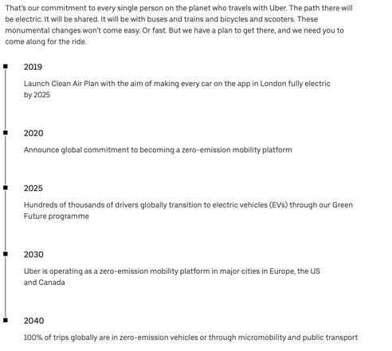
Uber (2021) explain that to become sustainable they have created a “Clean air plan” which is on the left-hand side and shows the focus points of the plan including producing zero emissions in London by 2025, and all trips zero emissions by 2040. The change was brought in according to Lo. J. (2018) as a fundamental objective to promote sustainable efficiency from services provide by Uber such as car -pooling, in theory this would mean filling as many vehicles as possible and possibly promoting use of electric vehicles. Overall, this would reduce the amount of CO2 being produced by the company. On the other hand, transportenvironment.org (2020) explains that uber is contributing 69% more Co2 that the conventional taxi, this shows that Uber are not focusing clearly on their mission statement which will impact their business plan. Uber.com (2021) response to this is to introduce a Green future program that helps drives make the switch to EV’s by 2025 by investing $800 million to help drivers and the service provided such as car - pooling. The strategic business plan by Uber to be more aware of sustainability which makes Uber according to powersresourcecenter.com (2017) a catalyst Leader which means Uber can jump start the process of a new idea of a product such as car – pooling and the vehicles it uses, and effect change of others by investing millions to make the changes needed for the company.

Sustainability 2030 & 2050 Agendas

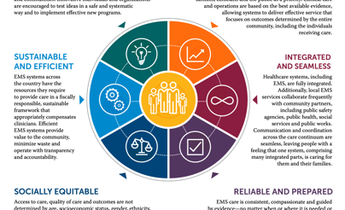
Uber shows Transformational Leadership according to verywellmind.com (2020) as it trying to inspire positive changes through its services for a more sustainable and eco-friendly future which correlates to the 2030 agenda. According to SDGS.un.org (2021) the 2030 agenda was created to resolve several issues such as poverty and hunger, battle inequalities within countries, promote sustainability to protect the planet and its natural resources. With this concentration on sustainability this shows that Uber is a strategic leader in the way it has reacted by offering car – pooling in hybrid or EV cars. According to McShane & Von Glinow (2018) this shows a motivator leadership quality from Uber as it’s based on goal – oriented characteristics with one of its main goals is to be sustainable. Uber also mixes motivator with the implementer which is based on a strategic approach created by influential behaviours mainly on consumers which can be broken into several segments such as the tourism sector consumers, these types of tourists are one of Ubers biggest consumer markets in major cities. Within tourism there is a segment called green tourism which means that tourists will travel but with minimal environmental impacts according to Sung-kwon et al. (2003). This a new segment where Uber can fully immerse itself and to begin expanding the business.

Lewin’s force field for Uber
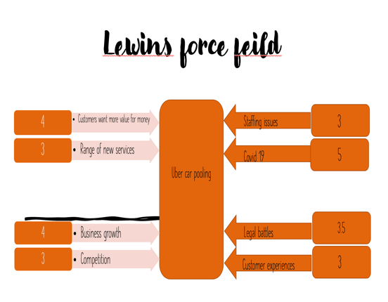
Lewin. K. (1951) uses a force field model which is shown on the left for Uber and the change that has happened with its business which is Car Pooling. As shown there are four forces which pushes against and four forces trying to push the car-pooling forward. First of all, the report will look at forces that are pushing for the recent change and using Porters five forces to explain how each positive has an impact on Uber.

Porters five forces
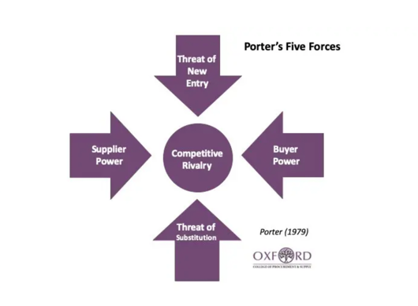
Porter. M, E. (1989) model of Porters five forces which according to investopedia.com (2020) explains consumers and suppliers create the service provided by Uber and will identify the forces weaknesses and strengths by understanding segmentation of the economy for Uber’s carpooling service. Porters five forces links to Lewin’s force field model and explains the pushes for and against, but also how do consumers have an effect on Uber as a positive push which in turn creates business growth, healthy competition which creates value for consumers from introducing new products from the supply and demand point of view.

Customer Value of money / competition

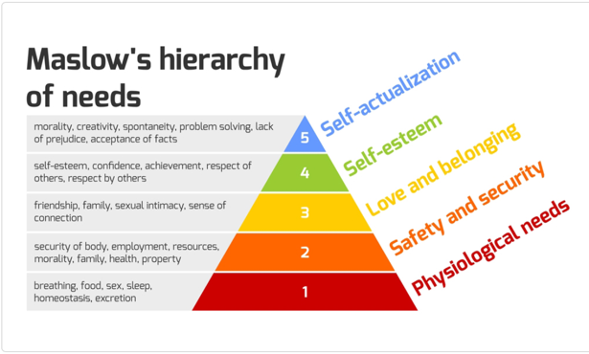
With customers wanting more value for money especially within major cities like London, the natural go to would be the use of Black cabs. According to taxi – calculator.com (2021) explains that the basic fee is £3, then each kilometre is around £2.30 afterwards for black cabs. This correlates to Maslow’s hierarchy for peoples need, Mullins (2010) explains that Maslow’s theory of people’s needs can relate to most things that people need, whether it’s to stay alive or reach a point of self -actualisation. According to opentextbc.ca (2021) Maslow’s first three tiers are where the report finds that money plays an important role for consumers. It also explains that with consumers exploring the different tiers and focusing on several aspects such as friendships and jobs they need a service that they can use, that is fair for the amount of disposable income available to satisfy these needs. In turn this means possibly choosing a lower cost fare within London which would be Uber. Uber (2021) explain that they use a model called “dynamic pricing model” which means that the model uses an algorithm which adjusts the price based on a number of variables. This links to porters five forces as it explains that consumers dictate the price of services and products, which creates competition not only from current competitors such as Black Cabs. According to Time.com (2019) there are plenty of opportunities created for new threats from new entrants which can provide a new substitute for the service already provided from companies like Bolt, Kapten and so on which provide a similar product to Uber. Overall Uber seems to be the choice for many as it’s the most well - known company that is based around the “Shared Economy”.

Range of services by Uber

when looking at the buying power the consumer has the power over Uber which in turn Uber reacted by creating Uber Pooling with several features which included the type of car luxury such as Uber Lux, Uber exec that could be obtained and also access to to meet the demands of different type of customers. Uber have also expanded their service types which correlates to sustainability by offering car – pooling with EV’s and hybrid due to consumer demand. So far according to engadget.com (2021) Uber have expanded EV’s from 100 to 1,600 in London by investing £125 million. According to innovationtactics.com (2018) explains that buyers are more powerful which means Uber’s profits could reduce over time if the business does not respond to such things as sustainability once again this links to consumer power in porters five forces, hence why the introduction of new services, features and quantity which corelates to introduction of carpooling. The range of services provided by Uber are explained simply by consumers and their needs and wants which links to Maslow’s hierarchy. This is where the report will see an adaption and further needs and wants but dictated by an online society which creates latest trends such as sustainability for consumers. By introducing a greener way of travelling for society who are becoming more knowledgeable, Uber become a leader in the shared economy for sustainability and becomes more attractive to grow the business overall.

Business Growth

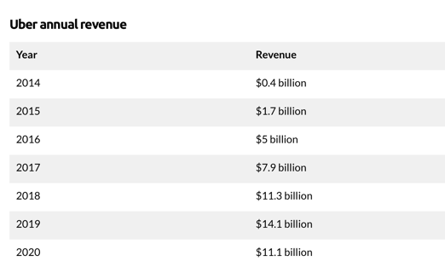
By comparing figures for Uber since the introduction of car - pooling its revenue according to businessofapps.com (2021) have surged since the introduction back in 2014 from $0.4 billion to $11.1 billion in 2020, this is partially down to car - pooling. Uberpool is holistically and strategically important for Uber’s business growth as it provides a greater scale of service overall through promoting lower costs for consumers and more fairs for drivers. The Link between business growth for Uber with sustainability promotes services that are affecting the world on a global scale Uber needed to react with both agendas previously mentioned the best they can and that is why Uber have introduced the green future program. Overall, this would promote collaborative leadership as it would bring employees, business and consumers to reinforce sustainability through car-pooling not only sharing fares, but the type of vehicle used also. If Uber can keep to their program, they could possibly share a projection worth of $36.6 billion within the sustainability segment by 2025 according to globenewswire.com (2020). This would expand the growth of business for Uber as invest more into Sustainability by expanding their service of car – pooling.

Employees

On the other hand, when looking at employees their needs are different as they would need a fair wage that can supply them with the basic needs according to Maslow.

