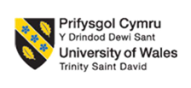
Programme: Master of Business Administration

Name: Jay Shaileshbhai Patel
Student ID: 2529400
Lecturer name: Gladius Kulothungan

Module: International Business Concepts
Module code: LCMB7034
Words: 5380
Chosen Company: Exide
Target Country: Morocco

Table of Contents
Introduction 3
Section 1 3
1. Organisational Classification and Global Strategy 3
1.1 Strategic Categorization (Bartlett and Ghoshal’s model) 3
1.2 Global Configuration 6
2. Macro-Environmental Appraisal and Market Attractiveness 7
2.1 Host Country Analysis 7
2.2 Market Entry using OLI Framework 13
3. Entry Mode Strategy and Strategic Synthesis 16
3.1 Historical Pattern Recognition 16
3.2 Strategic Fit & Justification 17
3.3 Conclusion & Recommendations 18
Section 2 20
2.1 Reflective Account (Gibbs Reflective Cycle) 20
References 24

Introduction
The report analyses Morocco's availability as a target market for the Exide industry to expand abroad. It evaluates the external environment, strategic opportunities, and market entry opportunities using established international business frameworks, such as the Bartlett and Ghoshal strategy model and resource dependence theory. On this basis, the report suggests a proper market entry strategy and, therefore, talks about its consequences for Exide in its future international development.

Section 1

1. Organisational Classification and Global Strategy

1.1 Strategic Categorisation (Bartlett and Ghoshal’s model)
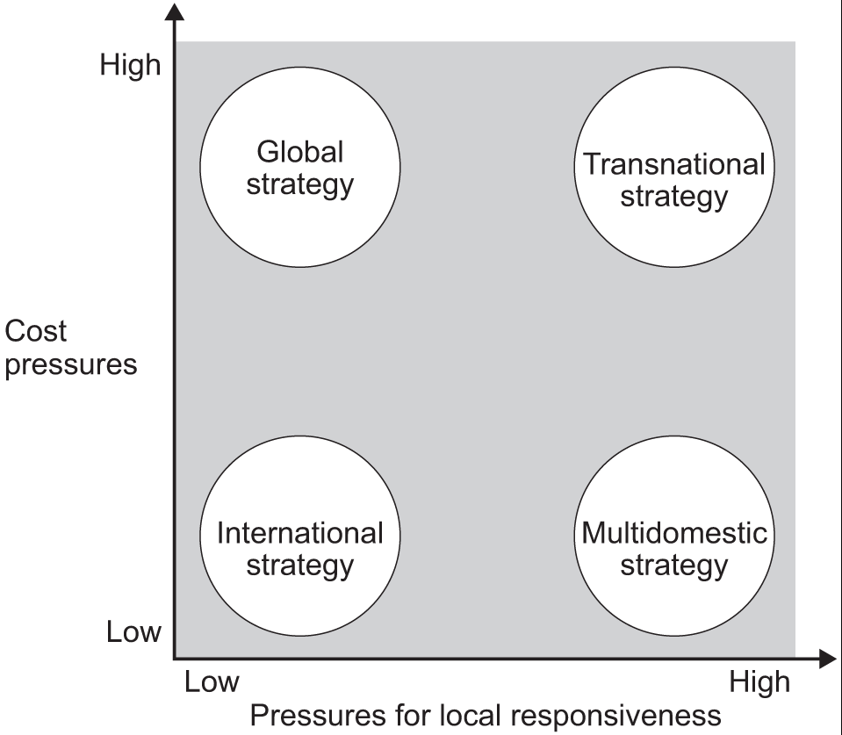
Figure 1: Bartlett and Ghoshal’s Matrix
(Source: Bartlett and Ghoshal, 1989)
Strategy | Pressure for Global Integration | Pressure for Local Responsiveness | Key Characteristics | Application to Exide Industries
International Strategy | Low | Low | Ships goods that were designed in the home country with minimal localisation. | Not applicable, since Exide manufactures, subsidiaries and distribution aids in most of the foreign markets.
Multi-Domestic Strategy | Low | High | There is lots of customisation of products and operations to each country and decentralised decision-making. | Inappropriate since Exide adheres to the standard product platforms and decentralised technology development based in India.
Global Strategy | High | Low | A high level of cost efficiency and coordination worldwide, centralised production and standardised products. | Exide produces standardised manufactured lead-acid batteries, industrial batteries, and energy storage systems with integrated production, research and development and supply chain management located in India (Bartlett and Ghoshal, 1989). The firm is also exporting to over 60 countries and equally its quality has been maintained in the various markets.
Transnational Strategy | High | High | Brings together both international effectiveness and a wide local adaptation and decentralised innovation. | Partially relevant because Exide localises a chosen product according to regional rules.
Table 1: Bartlett and Ghoshal’s model
(Source: Self-created)
According to Bartlett and Ghoshal (1989), although Bartlett and Ghoshal present an effective strategic typology, Selma and Faisal (2025) argued that the model is a simplistic technique of multinational strategies and fails to incorporate a complete picture of the fast technological dynamics that battery producers face in Exide in Morocco.

1.2 Global Configuration
Exide Industries has established an effective international geographic presence that enhances its competitive edge and value creation over the long term. The company has had a global presence, though its manufacturing base has been centralised in India by exporting its batteries and energy storage solutions to over 60 countries in Asia, Africa, Europe, the Middle East and Latin America (Exide Industries, 2025). Exide mainly relies on exports, regional subsidiaries, distributors and commercial representatives, instead of the costly option of overseas manufacturing plants, to reach international customers effectively. This is an asset-light international structure which allows the company to go global with less capital outlay and more control over its operations (Zahra et al. 2022).

The international business provides a competitive edge to the company in the form of economies of scale and centralised production. The production is based in India, where there is a well-established network of suppliers, low cost of labour and integrated production lines which minimise operating costs and produce consistent products. Another strength that Exide can leverage to set up advanced battery technologies in various foreign markets with a universal technology platform is the good research and development capability that it has. In FY2025-26, Exide realised operations revenue of INR 17,269 crore (about US$2billion), which indicates a further increase despite the uncertainties caused by the economic environment across the globe (Exide Industries, 2026). According to Turner (2024), another significant investment that the company has made is in Exide Energy Solutions to create the first large-scale lithium-ion cell production plant in India, which will boost future competitiveness in EVs and stationary energy storage.

As argued by Massa et al. (2023), the current export sales add up to approximately 8% of total turnover, and the management expects to enhance this percentage by getting into new international markets and cashing in on favourable trade terms in Europe and North America.

2. Macro-Environmental Appraisal and Market Attractiveness

2.1 Host Country Analysis
External Factors | Description | Impact
Political | - Constitutional monarchy and good political environment.  - World Bank Governance Indicators demonstrate the increase in government effectiveness.  - Over 60 Free Trade Agreements with circa 2.5 billion consumers.  - The Industrial Acceleration Plan provides strong governmental backing of electric vehicles and renewable energy.  - Central location between Europe, Africa and the Middle East. | Positive
Economic | - GDP (2026): US$194.33 billion.  - GDP growth (2026): 4.9%.  - GDP per capita: US$5,107.  - Population: 38.76 million.  - New large automotive production centre consisting of Renault.  - Making more investments in renewable energy and battery chains. | Positive
Legal | - Foreign investors: 100% ownership in most manufacturing options permitted.  - Tax incentives and financial support are offered through  Investment Charter.  - Excellent protection of intellectual property in line with WTO and WIPO.  - Free Trade Agreement with the European Union helps in exports.  - Environmental policies promote sustainable production and recycling of batteries. | Positive
Cultural | - Power Distance: 70.  - Individualism: 24.  - Masculinity: 53.  - Uncertainty Avoidance: 68.  - Long-Term Orientation: 25.  - Indulgence: 25. | Positive
Table 2: Country Analysis of Morocco
(Source: Self-created)

2.1.1 Political Analysis
The political environment of Morocco offers a tremendous competitive advantage to Exide Industry since political stability has a direct effect on decisions to invest in foreign markets, continuity of their operations and long-term business growth. According to Meyer et al. (2023), Morocco has enjoyed a stable constitutional monarchy under King Mohammed VI as opposed to a number of North African nations, which are still faced with political uncertainty. As argued by Jiang et al. (2023), this mitigates long-term risk in investment in the proposed manufacturing plants by Exide and enhances capital recovery forecast. But reliance on government incentives for its industries may open Exide to the possibilities of changes in policy in case of a change in fiscal priorities. This stability in politics has helped the government to make long-term industrial and economic reforms, which have helped to provide a foreseeable climate of investment. The World Bank (2026) indicates that Morocco has always been enhancing its governance and performance of the public sector, building on investor trust and minimising political risks. In the case of the now battery-making company based in India (Exide Industries), where a significant capital outlay and many years of planning are needed, that kind of political stability reduces the uncertainty of business activity and leads to sustainable business development (World Bank, 2026).

According to Pereira et al. (2022), the investment attractiveness of Morocco is further enhanced by the policies adopted by its government in industry. However, Turner (2024) argued that it has signed more than 60 Free Trade Agreements (FTAs), and this offers preferential access to markets for more than 2.5 billion consumers, the European Union, the United States and a few African economies. Such a vast network of trade also provides Exide Industries with an opportunity to set up manufacturing or assembling facilities in Morocco and sell the batteries to other international markets with fewer tariff restrictions. As a result, Morocco might become a domestic and export hub in Europe and Africa.

Exide has a long-term strategy favoured by political commitment towards renewable energy and sustainable industrialisation. Morocco plans to use renewable energy to produce half of all the installed electricity capacity, which puts large-scale renewable energy sources under severe pressure to provide solar and wind-generated energy storage by using large-scale industrial-sized batteries and energy storage systems (International Energy Agency, 2025). As Exide continues to grow its lithium-ion battery operations around the world, these national initiatives form excellent strategic congruence between national policy and the company's future product portfolio.

2.1.2 Economic Analysis
The economic conditions in Morocco offer attractive opportunities to Exide Industries since the long-term economic growth, industrialisation and growing number of automotive manufacturing will provide a favourable market for battery producers. The nominal GDP of Morocco was US194.33 billion, with an economic forecast of 4.9% in 2026 (Worldometers, 2026). The GDP per capita is also on the rise to about the US$5,107 mark, signifying an annual growth of 5.5%, which shows slow consumer buying power (IMF, 2026). Figure 1 shows that the GDP trend has seen a consistent and positive trend that has had a consistent increase in Morocco despite short-term fluctuations due to global inflation and supply chain issues.
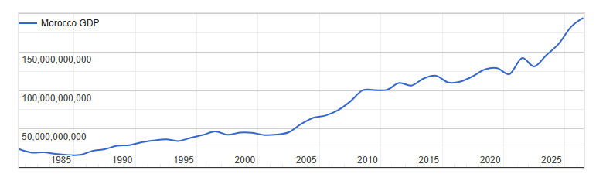
Figure 2: GDP of Morocco
(Source: Worldometers, 2026)
One economic strength that is critical is the fastest-developing automotive industry in Morocco. The nation has emerged as the automotive manufacturing centre of Africa, with over 700,000 vehicles being transported every year by multinational automobile manufacturers like Renault. Automobile exports are the largest export in Morocco, with the contribution being about 22% of national exports (Worldometers, 2026). This type of industrialisation greatly enhances the demand for automotive batteries, replacement batteries and storage of energy. Thus, Exide Industries had access to both original equipment manufacturers (OEMs) and the booming aftermarket battery market.
The strategic geographical location serves to strengthen economic competitiveness in Morocco. Morocco borders Spain by only 14 kilometres on the other side of the Strait of Gibraltar, offering direct access to European, African and Middle Eastern markets with modern logistics infrastructure, including the Tanger Med Port, which is one of the largest container ports in Africa (World Bank, 2026). Availability of efficient transport infrastructure will minimise the cost of logistics, enhance the efficiency of the supply chain and enhance competitiveness in exports.

2.1.3 Legal Analysis
The laws of Morocco offer a conducive environment for foreign direct investment and enhance the competitiveness of the country to international manufacturers. According to Witt et al. (2023), the Moroccan Investment Charter is the boosting regime of industrial investment by financial incentives, whereas Meyer et al. (2023) argued that simplification of administrative procedures and mechanisms of assistance for investment. In the majority of the manufacturing sectors, foreign investors are allowed to enjoy 100% ownership to allow Exide Industries to have full managerial and operational control of the manufacturing facilities without jeopardising its proprietary manufacturing technologies (Witt et al. 2023). Belonging to the “World Trade Organisation (WTO)” and the “World Intellectual Property Organisation (WIPO)” has also helped Morocco to provide its intellectual property with better protection. These global obligations enhance legal clarity and minimise the chance of imitation of technology, which is crucial to investments enabled by Exide in modern battery technologies and lithium-ion cell development (WIPO, 2026).

2.1.4 Cultural Analysis
The cultural factors also have a great impact on the performance of international business since they impact negotiation and organisational behaviour, leadership and communication. Morocco has a Power Distance of 70, which means that subordinate-superior organisation structure and respecting authority are highly valued (Theculturefactor, 2026). This cultural trait favours the organisational management style of Exide Industries, whose decision-making is highly centralised and organisational roles are well spelt out.
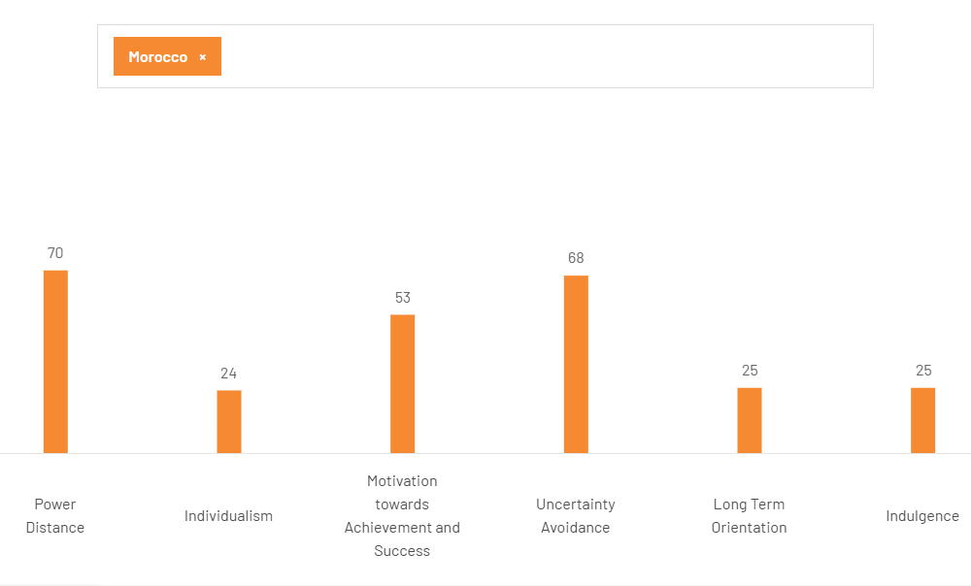
Figure 3: Cultural dimensions of Morocco
(Source: Theculturefactor, 2026)
The Individualism score of Morocco is 24, which is indicative of a highly collectivist society, where trust, long-term relations and the allegiance of the group have a very strong impact on business. Therefore, in creating strategic alliances with its local partners in distribution, suppliers and government agencies as opposed to a transactional business relationship, Exide Industries would have a better acceptance in the market (Theculturefactor, 2026).

According to Pereira et al. (2022), the Uncertainty Avoidance score of the country stands at 68, which allows predicting the preference towards organised processes, formal agreements and known business activities. As argued by Jiang et al. (2023), this cultural attribute is quite consistent with the focus of Exide, which is on quality management, safety standards and standardised production systems. Risk aversion, however, could be higher, which will prolong negotiation and postpone the decision-making process of investment when entering the market.

Morocco has a Masculinity score of 53, or moderate achievement and business performance, whereas the Long-Term Orientation score is 25, indicating that tradition and short-term planning are more important to them. Another indicator to note is the score of Indulgence of 25, which indicates a reserved culture where strictness and social responsibility hold a high priority over personal fulfilment (Theculturefactor, 2026). The above cultural attributes indicate that Exide needs to contrast its position using the quality of products and the dependability and long-term corporate responsibility instead of intense promotional campaigns.

Even though cultural differences can pose some managerial problems at the onset, Lu et al. (2022) stated that similarities between the Indian and the Moroccan relationship-oriented cultures of business minimise the risk of a significant cultural clash, whereas Witt et al. (2023) argued that proper cross-cultural training, local recruitment, and stakeholder mobilisation can turn the cultural differences into a sustainable competitive advantage.

2.2 Market Entry using OLI Framework
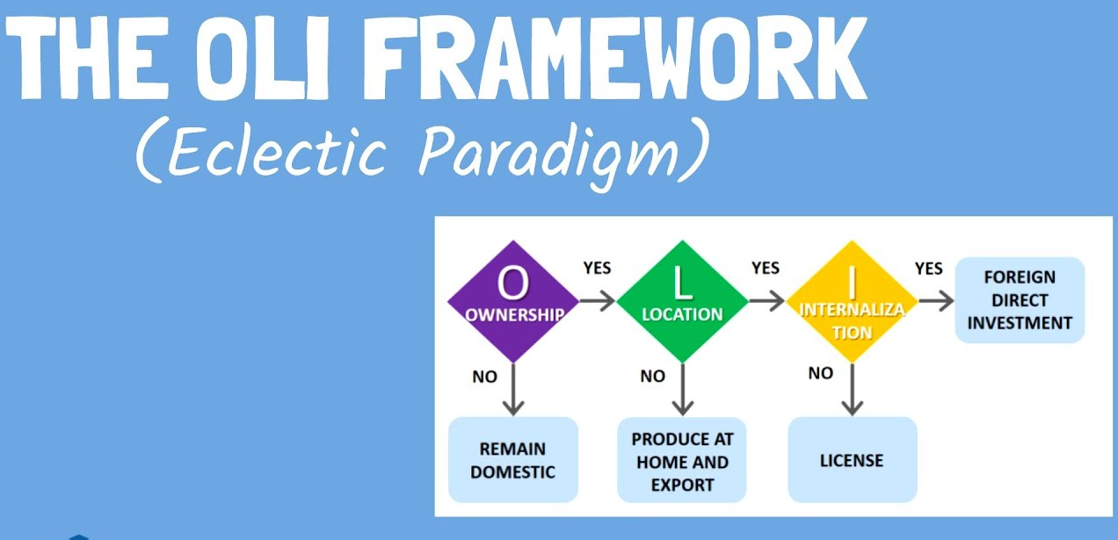
Figure 4: OLI Framework
(Source: Selma and Faisal, 2025)

2.2.1 Ownership (O) Advantages
Dunning claims that based on his Ownership (O) advantage, firms internationalise once they have exceptional resources and capabilities which their competitors cannot easily imitate. Exide Industries has positive ownership benefits, which justify its planned expansion to Morocco. The company is the biggest producer of lead-acid storage batteries in India and has built a diversified enterprise into automotive, industrial and energy storage applications (Selma and Faisal, 2025). Exide is further enhancing its technological capacities by investing about INR 3,602 crore (approximately US$420 million) in its wholly owned company, Exide Energy Solutions, to build a 12 GWh lithium-ion cell manufacturing plant, which would place the company at the forefront of the rising global electric vehicle and energy storage markets (The Times of India, 2025).

The technological skills and financial prowess of Exide are another major asset of ownership. In Q4 FY2025-26, the company realised a 9.4% year-on-year growth in revenue and 22.6% growth in after-tax profit, indicating good performance in its operations, despite the rising market competition in the battery segment (Exide Industries Ltd, 2026). Additionally, Exide has been growing into international markets through the introduction of new technology products in batteries and exporting to new markets, whereby the management believes they can increase the percentage of exports to more than the current 8% of total turnover (Meyer et al., 2023).

2.2.2 Location (L) Advantages
The Location (L) advantage is an argument by Dunning that firms invest in those countries which have better economic, industrial and strategic conditions than their home country. According to Welch et al. (2022), Morocco offers various location-related benefits that will enhance the viability of the market entry of Exide Industries. The greatest positive feature is that the nation is quickly turning into an electric vehicle (EV) and battery manufacturing centre. As argued by Ochuba et al. (2024), in 2024, BTR New Material Group obtained Moroccan governmental approval of a 3 billion Moroccan dirham (equivalent to about US$300 million) investment to locate a cathode production facility with a production capacity of 50,000 tonnes/year. This is in addition to another strategic plan with Gotion High-Tech being a 12.8 billion Moroccan dirham (equivalent to about US$1.3 billion) gigafactory, employing approximately 17,000 direct, indirect and induced jobs (Reuters, 2024). These investments indicate the development of Morocco as a regional battery production ecosystem and not just a place of automotive assembly.

Exide Industries also gains location advantages because of the industrial ecosystem in the country. Electric vehicle investment in Morocco has emerged as one of the emerging destinations in the world due to its export-oriented industries, specialisation in training its workforce and well-established supplier networks (UNCTAD, 2026). Moreover, the battery and green mobility industry of Morocco keeps growing, and other investments of 6 billion Moroccan dirhams have been announced to implement the projects of cathode and anode manufacturing that are likely to create over 1,150 direct jobs (Welch et al., 2022).

2.2.3 Internalisation (I) Advantages
The Internalisation (I) advantage by Dunning is that in companies, ownership and control over strategic activities provide higher value than licensing technology or external partners. In the case of Exide Industries, internalisation is especially significant since manufacturing of the batteries relies on proprietary technology, quality standards and integrated supply chain management. The firm has already invested ₹4,802 crore (about US$600 million) in its lithium-ion battery business, as commercial production will be implemented via wholly owned enterprises, as opposed to licensing technology (Exide Industries Ltd 2026).

The internalisation is also enhanced with the vertically integrated recycling and procurement system at Exide. The company has a battery recycling business of 346,000 metric tonnes/annum capacity that enables it to refine about half of its lead and lead alloy needs using recycled materials (Cumming et al. 2023). Moreover, the recyclability of lead is more than 99% and less reliance on outside vendors and better cost efficiency are achieved (Tolstoy et al. 2022). According to the reports made by Exide, the overall emissions decreased by 11.6% annually, which indicates that the internal controls strengthen the sustainability of operations and compliance with the regulations (Exide Industries Ltd, 2025).

2.2.4 Critical Evaluation of OLI Framework for Exide's Entry into Morocco (Foreign Direct Investment)
According to Selma and Faisal (2025), the proposed OLI framework offers a powerful theory in assessing the proposed entry of Exide Industries into Morocco since the company has distinct ownership, location and internalisation advantages. The technological capability, manufacturing skills and financial investment of Exide enhance the Ownership advantage, whereas the growing battery system in Morocco and the Industrial policies play up the Location advantage. As argued by Amicarelli et al. (2026), Internalisation is another reason that supports the concept of “Foreign Direct Investment” because it allows Exide to ensure its proprietary technology and product quality. Nevertheless, the framework is limited in the sense that it only describes the reasons that lead to the internationalisation of firms and not whether the success will be realised in the long-term. As stated by Ochuba et al. (2024), the company may face threats to its competitive position given that there is a high level of market uncertainty, a high rate of technological advancement in the chemistry of batteries, fluctuation of raw material prices and rising competition from Chinese-based battery makers, all through their operations in Morocco, yet meets the OLI requirements. Thus, Polishchuk (2024) demonstrated that successful market entry of our Exide, as powerful as it is offered by the OLI framework, will end up being reliant on effective implementation, unceasing innovation and the capacity to adapt to the evolving competitive and market environments. According to Cumming et al. (2023), a wholly owned subsidiary is superior to exporting since it will lead to less reliance on logistics and enhanced responsiveness. As argued by Tolstoy et al. (2022), it is superior to licensing as Exide will still have ownership of proprietary technology, production quality and intellectual property. As stated by Meyer et al. (2023), it will offer more control over management and prevent clashes of strategic decisions as compared to joint ventures, but Jiang et al. (2023) argued that Morocco encourages the entry mode due to its 100% foreign ownership laws and its developing battery ecosystem, although requiring increased investment levels.

3. Entry Mode Strategy and Strategic Synthesis

3.1 Historical Pattern Recognition
Exide Industries has been practising a “low-risk and slow international expansion strategy” which has mostly depended on exports, overseas subsidiaries and strategic business partnerships and not through setting up a manufacturing unit in foreign markets. This trend in history has helped the company to intensify its global operations while maintaining centralised production, control over technology and cost-effective production in India. As stated in the Annual Report of Exide Industries, the company now exports batteries and energy storage products to over 60 countries, with exports accounting for up to 8% of the overall revenue during FY2024-25 (Dana et al. 2022).
The financial results of the company indicate that this export-based strategy has provided sustainable overseas development. Standalone revenue will grow by an average of nearly 27.6% over 4 years, between FY2021-22 and FY2025-26, to be between ₹13,538 crore (US$1.58 billion) and ₹17,269 crore ($2.02 billion) (Dziubaniuk et al. 2023). During the same time span, Exide was enjoying a zero-debt balance sheet and it was investing approximately INR 4802 crore (about $560 million) in Exide Energy Solutions to solidify its lithium-ion battery business. These numbers show that the company has favoured taking steps to enhance technological capacity and financial stability, and only then does it proceed to make grand-scale international investments related to manufacturing.
In the past, Exide, too, has been able to grow by discriminating overseas subsidiaries and joint ventures rather than pursuing hostile takeovers. This has minimised the financial risk and has also allowed the company to get back to learning the conditions of the foreign markets before making expensive commitments (Stănciulescu, 2023). Its reliance on exporting can lower its capability to respond to the needs of local customers, and the firm will also be exposed to transportation expenses, fluctuations in the exchange rate and almost all forms of international trade shocks. Local competitors who have their own manufacturing plants are often better able to react faster to the demands of the market and enjoy a cheaper logistics operation.

In the end, the history of the Exide business development process reveals that it follows the export-led market entry strategy backed by the investment of strategic resources and a progressive international engagement process. Whereas such an approach has brought about predictable financial growth and increased competitive capacities in the global arena, it is possible that the battery ecosystem growing rapidly in Morocco demands a greater degree of dedication to local markets that Exide has perpetually been implementing.

3.2 Strategic Fit & Justification
Exide Industries' historical approach of export-led entry strategy is a good point to start entry to Morocco, but it might not ensure maximisation of long-term competitive advantage with the sole strategy. According to Tuominen et al. (2023), the international expansion that the company has achieved so far has been successful due to the low financial risk involved in exportation, minimal capital investment and the ability of the management to test the markets and determine the demand before investing a lot of resources. However, Welch et al. (2022) argued that with the quickly maturing battery and electric vehicle ecosystem in Morocco, a more aggressive market approach compared to typical practice with Exide is needed. Hence, a “wholly owned subsidiary” company that already has local assembly but is initially assisted by exports in India would be a better introduction strategy compared to just exports alone.

The strategy proposed has a better strategic fit since Morocco has developed into a manufacturing hub of electric vehicles and battery materials in the region. Stănciulescu (2023) stated that significant investments made by international battery suppliers have hastened the process of building local supply chains that have added competition and offered new possibilities to cooperate with car manufacturers. Therefore, Dziubaniuk et al. (2023) argued that the export-only plan would have lowered Exide's capacity to compete with firms which are already established in Morocco.

Risk-wise, a “wholly owned subsidiary” has a higher financial input as compared to exports. First cost of investment, cost of recruiting and adhering to regulations would raise costs of operation. But Morocco has a relatively stable political climate, incentives to invest and developing industrial infrastructure, decreasing the risk of investments in the long-term perspective. Such a positive environment does warrant a greater commitment of resources than Exide has shown thus far in most of the foreign markets (Ochuba et al. 2024). The strategy proposed also ensures a higher level of managerial control. The production of batteries relies on the quality of the products, technological capacity and intellectual property rights. According to Welch et al. (2022), a “wholly owned subsidiary” allows Exide to have direct control over production standards, customer service and technological processes, besides preserving proprietary battery technologies. Licensing or joint ventures would lead to lower investment costs but could strip Exide of quality control and expose it to a higher chance of technology transfer to the competitive environment.

As influenced by Tolstoy et al. (2022), the discussions on strategy in the long term would consider the proposed entry mode as more strategic to Exide's transition to lithium-ion batteries and hi-tech energy storage systems. As argued by Polishchuk (2024), the opportunities in both the short-term and the long-term are more than merely increasing exports in the short term, with Morocco developing its renewable energy sector and growing its auto industry and strategic access to the European and African markets. Thus, although the company’s historical export-led strategy has helped the company pursue the internationalisation strategy, the strategy does not entirely fit the new industrial environment in Morocco.

3.3 Conclusion & Recommendations
It is concluded that the findings have shown that Morocco will offer Exide Industries a good international expansion opportunity due to its political stability, emerging automotive industry, strategic location and emerging battery ecosystem. The OLI analysis reveals that Exide has been enjoying excellent ownership advantages in terms of technology, financial ability and manufacturing experience, whereas Morocco has great location advantages. Internalisation will then be fundamental in safeguarding technology and ensuring a quality operation (Ochuba et al. 2024). The recommended “wholly owned subsidiary” will be more appropriate, compared to exclusive exporting, licensing or joint venture. Exporting will reduce local responsiveness and logistics vulnerability, and licensing will dilute control of Exide over proprietary technology (Stănciulescu, 2023). A joint venture will give local expertise and decrease managerial authority and pose a risk of technology sharing. A wholly owned subsidiary will need more investment. However, it will give it good control, protection of technology, consistency and flexibility of operations in the long-term strategies.

The stability in the political context of Morocco, the sheer amount of free trade agreements and increasingly active EV ecosystem all contribute to a convenient base of production in the region, which implies that Exide will be better off concentrating on local production than its exclusive focus on the export-driven approach (Dziubaniuk et al. 2023). According to Tolstoy et al. (2022), the free trade agreements of Morocco are widespread and minimise the barriers to exports and favour the expansion strategy of Exide in the region. However, Dziubaniuk et al. (2023) argued that this reliance on trade agreements exposes companies to future geopolitical or regulatory shifts and indicates that Exide needs to keep up with the flexibility of its supply chains.

Section 2

2.1 Reflective Account (Gibbs Reflective Cycle)
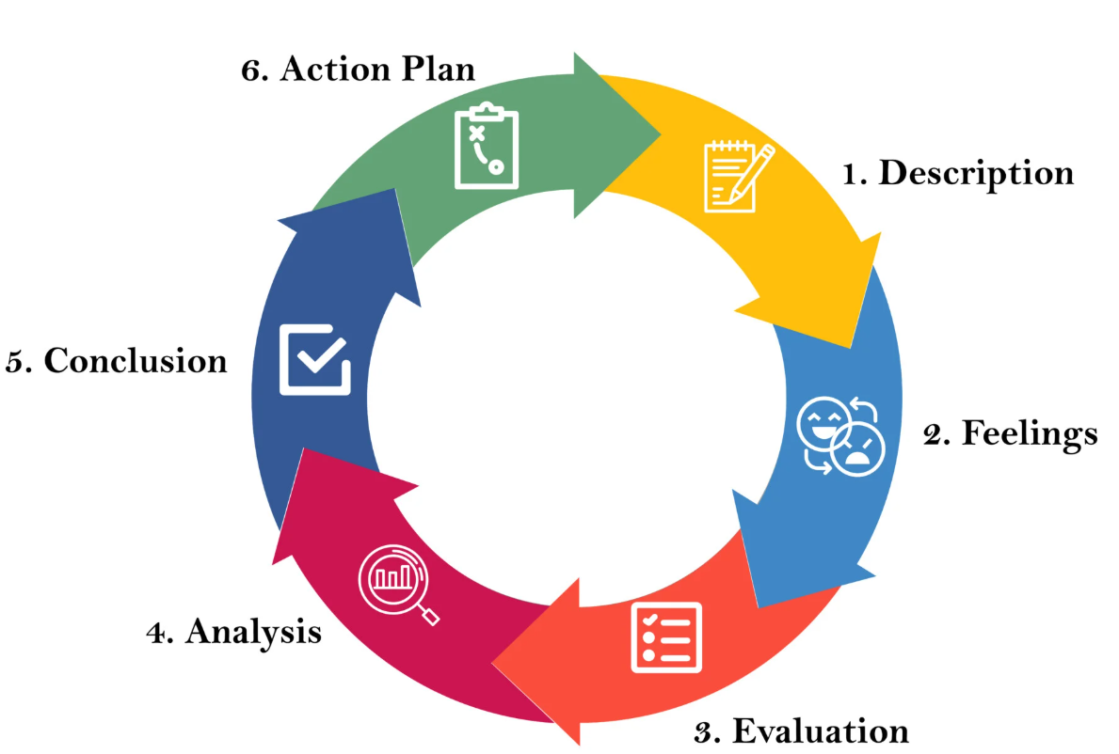
Figure 5: Gibbs’ Reflective Cycle
(Source: Galli and New, 2022)
Description
To tackle this evaluation, I used Gibbs Reflective Cycle to critique the way in which I did my research, analysis and formulation of the international market entry plan to be used by Exide Industries in their proposed expansion to Morocco. I started the assessment by ensuring that I went through all the requirements of the assignment to get a clear picture of how it should be structured, the analytical frameworks and learning outcomes.

To complete the assessment, I used primary sources that contain trustworthy data such as annual reports of Exide factories, data from the “International Monetary Fund (IMF)”, the World Bank, UNCTAD, Reuters, government publications and written literature. I also used some of the major international business models such as the Global Strategy Model suggested by Bartlett and Ghoshal, the OLI Framework and macro-environmental analysis of Dunning to analyse Morocco as the target market. This methodological tool helped me to systematise the data and work on evidence-based suggestions (Galli and New, 2022).

Feelings
First, I was confident since I was aware of the general concepts of international business. Nevertheless, I also understood that it would prove more difficult to choose the right evidence and use the models of the theory critically than merely describe them. My interest was especially to make sure that all the recommendations were backed up with the latest statistics, financial numbers and scholarly theory instead of subjectivity. My confidence had been boosted as the research went on. I felt more at ease in deciphering company reports and international economic statistics, and how various frameworks were used to complement each other. I also realised that decisions to enter the international market need to be made by balancing opportunities and any risks that they may come with rather than concentrating on positive market features.

Evaluation
My research process had a number of successes, as several reliable sources contributed to achieving the great credibility of the information and less reliance on one publication. The annual reports of the company included detailed information on the financial performance and strategic priorities, and international organisations helped with familiar economic and political indicators. The integration of these sources was helpful in enhancing the overall quality of the analysis. A good thing was the application of theoretical framework complements. The model developed by Bartlett and Ghoshal described why Exide Industries has a global strategic orientation, whereas the Dunning OLI Framework turned out to be the reason to enter the foreign market. These models helped to relate theoretical knowledge to the business decisions rather than discuss them independently.

Although there were such strengths, the assessment was faced with several challenges. One of the challenges was finding up-to-date and pertinent information on the specific expansion of Exide Industries to international markets since the firm is mainly oriented towards the Indian market. Reporting on the battery industry of Morocco was also found all over in various reports and government announcements (Galli and New, 2022). Moreover, a few statistical data points were slightly different in various organisations due to the publication dates and methods used in reporting the data.

Analysis
The analysis greatly helped to comprehend how the concepts of international business can be translated into practical business case scenarios (Meletiadou, 2022). In the process of conducting the research, I realised that organisational capabilities coupled with host country conditions and strategic objectives interact to create success in undertaking international expansion. Using the framework of Bartlett and Ghoshal showed that Exide Industries uses a more global-based approach since it is based on standardised production, technological acumen and centralised management. I also got to know that knowing a strategic orientation of a firm can serve as a strong basis for assessing the future growth prospects.

The use of the OLI Framework by Dunning also contributed towards strengthening my knowledge of foreign direct investment decisions. I came to realise the idea of ownership benefits is not sufficient to warrant international expansion. There should also be location-specific benefits and internalisation of operations to enable the sustainability of competitive ability in the long run. Seeking growth in the battery ecosystem, industry policies and strategic geographic location made Morocco an attractive destination since it would be an addition to the current technological and manufacturing strength of Exide Industries (Meletiadou, 2022). My critical thinking was also enhanced with the macro-environmental analysis. Initially, I thought that political stability and economic growth were going to be the most critical determinants of market attractiveness. But I also came to understand that legal regimes, cultural attributes, industrial policy, and infrastructure logistics can be equally as influential in determining success in international business. The examination of these interwoven factors has helped me to step out of the descriptive discourse and create a more balanced judgment.

This assessment was also greatly contributed to by course learning. Academic readings, lectures, classroom discussions and practical examples enhanced my knowledge of international strategy, foreign direct investment, competitive advantage and global market expansion. Such learning tasks stimulated me to think critically about business decisions and not to accept theoretical models as they are without asking about their shortcomings.

Conclusion
This reflection has shown that the process of an international market entry analysis would take systematic research to accurately analyse, apply and promote business theories. I gained a clearer insight into the approaches to international expansion by combining theoretical frameworks with the existing evidence in the industry. Despite difficulties in data collection and analysis, the quality of my findings was enhanced by a careful comparison of credible sources.
Action Plan
Development Area | Action Plan | Timeframe
Improve research skills | Read more global corporate magazines, corporate annual reports and sector magazines weekly. | 3 months
Strengthen theoretical application | Experience in using international business models in various multinational firms and industries. | 4 months
Enhance data analysis | Periodically analyse financial reports, economic indicators and reports of international organisations. | 6 months
Develop academic writing | Keep on writing reflective and analytical reports and getting feedback on these reports with lecturers and peers. | 8 months
Build international business knowledge | Track business news, trends in foreign investment and trade all across the globe. | 11 months
Table 3: Action Plan
(Source: Self-created)

References
Amicarelli, V., Bux, C., Del Chicca, A., Giungato, P., Tarabella, A. and Tricase, C. (2026). Toward a Business‐Oriented Concept of Natural Capital and Its Measurement in Organizations. Business Strategy and the Environment, 35(2), pp.2482-2501. DOI: https://doi.org/10.1002/bse.70310
Bartlett, C.A. and Ghoshal, S. (1989) Managing Across Borders: The Transnational Solution. Boston: Harvard Business School Press.
Cumming, D., Johan, S., Khan, Z. and Meyer, M. (2023). E-commerce policy and international business. Management International Review, 63(1), pp.3-25. DOI: https://doi.org/10.1007/s11575-022-00489-8
Dana, L.P., Salamzadeh, A., Mortazavi, S. and Hadizadeh, M.(2022). Investigating the impact of international markets and new digital technologies on business innovation in emerging markets. Sustainability, 14(2), p.983. DOI: https://doi.org/10.3390/su14020983
Dziubaniuk, O., Ivanova-Gongne, M. and Nyholm, M.(2023). Learning and teaching sustainable business in the digital era: a connectivism theory approach. International journal of educational technology in Higher education, 20(1), p.20. DOI: https://doi.org/10.1186/s41239-023-00390-w
Exide Industries Ltd. (2025) Integrated Annual Report 2024–25. Available at: https://www.exideindustries.com/investors/annual-reports.aspx (Accessed: 3 August 2026).
Exide Industries Ltd. (2026) Integrated Annual Report 2025–26. Available at: https://www.exideindustries.com/investors/annual-reports.aspx (Accessed: 3 August 2026).
Galli, F. and New, K.J., (2022). Gibbs’ cycle review. Emotions as a part of the cycle. E-Motion: Journal of Education, Motor Skills, and Research, (19), pp.92-101. DOI: https://doi.org/10.33776/remo.vi19.7224
Hofstede Insights (2026) Country Comparison: Morocco. Available at: https://www.hofstede-insights.com/country-comparison/morocco (Accessed: 4 August 2026).
International Energy Agency (2025) Morocco Energy Profile. Available at: https://www.iea.org (Accessed: 4 August 2026).
International Monetary Fund (2026) World Economic Outlook Database: Morocco. Available at: https://www.imf.org (Accessed: 4 August 2026).
Jiang, H., Luo, Y., Xia, J., Hitt, M. and Shen, J., (2023). Resource dependence theory in international business: Progress and prospects. Global Strategy Journal, 13(1), pp.3-57. DOI: https://doi.org/10.1002/gsj.1467
Lu, J.W., Ma, H. and Xie, X., (2022). Foreignness research in international business: Major streams and future directions. Journal of International Business Studies, 53(3), pp.449-480. DOI: https://doi.org/10.1057/s41267-021-00465-8
Massa, S., Annosi, M.C., Marchegiani, L. and Messeni Petruzzelli, A. (2023). Digital technologies and knowledge processes: new emerging strategies in international business. A systematic literature review. Journal of Knowledge Management, 27(11), pp.330-387. DOI: https://doi.org/10.1108/JKM-12-2022-0993
Meletiadou, E. (2022). Using educational digital storytelling to enhance multilingual students’ writing skills in higher education. IAFOR Journal of Education, 10(2), pp.111-130. DOI: https://doi.org/10.22492/ije.10.2.06
Meyer, K.E., Fang, T., Panibratov, A.Y., Peng, M.W. and Gaur, A. (2023). International business under sanctions. Journal of World Business, 58(2), p.101426. DOI: https://doi.org/10.1016/j.jwb.2023.101426
Meyer, K.E., Li, J., Brouthers, K.D. and Jean, R.J.B. (2023). International business in the digital age: Global strategies in a world of national institutions: Klaus E. Meyer et al. Journal of International Business Studies, 54(4), pp.577-598. DOI: https://doi.org/10.1787/7c542c16-en
Ochuba, N.A., Usman, F.O., Amoo, O.O., Okafor, E.S. and Akinrinola, O. (2024). Innovations in business models through strategic analytics and management: conceptual exploration for sustainable growth. International Journal of Management & Entrepreneurship Research, 6(3), pp.554-566. DOI: 10.51594/ijmer.v6i3.844
Pereira, C.S., Durão, N., Moreira, F. and Veloso, B. (2022). The importance of digital transformation in international business. Sustainability, 14(2), p.834. DOI: https://doi.org/10.3390/su14020834
Polishchuk, S. (2024). Conceptual Foundations and International Experience of Implementing the Safe Harbour Regime in Transfer Pricing. Економіка розвитку систем, 6(2), pp.130-138. DOI: https://doi.org/10.32782/2707-8019/2024-2-18
Reuters (2024) China EV battery maker BTR to build cathode plant in Morocco. Available at: https://www.reuters.com/business/china-ev-battery-maker-btr-build-cathode-plant-morocco-2024-03-29/ (Accessed: 4 August 2026).
Selma, Y. and Faisal, Z. (2025). Moroccan firms in Sub-Saharan Africa: a strategic partnership for win-win cooperation. African Scientific Journal, 3(28), pp.1197-1197. DOI: https://doi.org/10.5281/zenodo.15025863
Stănciulescu, G.D. (2023). A critical view on defining the concept of family business in Romanian, European and international context. In International Conference of Management and Industrial Engineering (Vol. 11, pp. 92-99). DOI: https://doi.org/10.56177/11icmie2023.34
The Times of India (2025) Exide bets on innovation, expansion to boost exports. Available at: https://timesofindia.indiatimes.com/city/kolkata/exide-bets-on-innovation-expansion-to-boost-exports/articleshow/122960895.cms (Accessed: 4 August 2026).
Theculturefactor (2026) Cultural dimensions of Morocco. Available at: https://www.theculturefactor.com/country-comparison-tool?countries=morocco (Accessed: 4 August 2026).
Tolstoy, D., Nordman, E.R. and Vu, U.(2022). The indirect effect of online marketing capabilities on the international performance of e-commerce SMEs. International Business Review, 31(3), p.101946. DOI: https://doi.org/10.1016/j.ibusrev.2021.101946
Tuominen, S., Reijonen, H., Nagy, G., Buratti, A. and Laukkanen, T.(2023). Customer-centric strategy driving innovativeness and business growth in international markets. International marketing review, 40(3), pp.479-496. DOI: https://doi.org/10.1108/IMR-09-2020-0215
Turner, C. (2024). International business: Themes and issues in the modern global economy. Abingdon: Routledge.
UNCTAD (2026) World Investment Report 2026: Morocco's growing role in electric vehicle value chains. Available at: https://maroc.ma/en/news/unctad-highlights-moroccos-growing-role-electric-vehicle-value-chains (Accessed: 4 August 2026).
Welch, C., Paavilainen-Mäntymäki, E., Piekkari, R. and Plakoyiannaki, E. (2022). Reconciling theory and context: How the case study can set a new agenda for international business research. Journal of International Business Studies, 53(1), pp.4-26.
Witt, M.A., Lewin, A.Y., Li, P.P. and Gaur, A. (2023). Decoupling in international business: Evidence, drivers, impact, and implications for IB research. Journal of World Business, 58(1), p.101399. DOI: https://doi.org/10.1016/j.jwb.2022.101399
World Bank (2026) Morocco Overview. Available at: https://www.worldbank.org/en/country/morocco (Accessed: 4 August 2026).
World Intellectual Property Organization (2026) Morocco Intellectual Property Profile. Available at: https://www.wipo.int (Accessed: 4 August 2026).
Worldometers (2026) GDP of Morocco. Available at: https://www.worldometers.info/gdp/morocco-gdp/ (Accessed: 4 August 2026).
Zahra, S.A., Petricevic, O. and Luo, Y., (2022). Toward an action-based view of dynamic capabilities for international business. Journal of international business studies, 53(4), pp.583-600. DOI: https://doi.org/10.1057/s41267-021-00487-2

