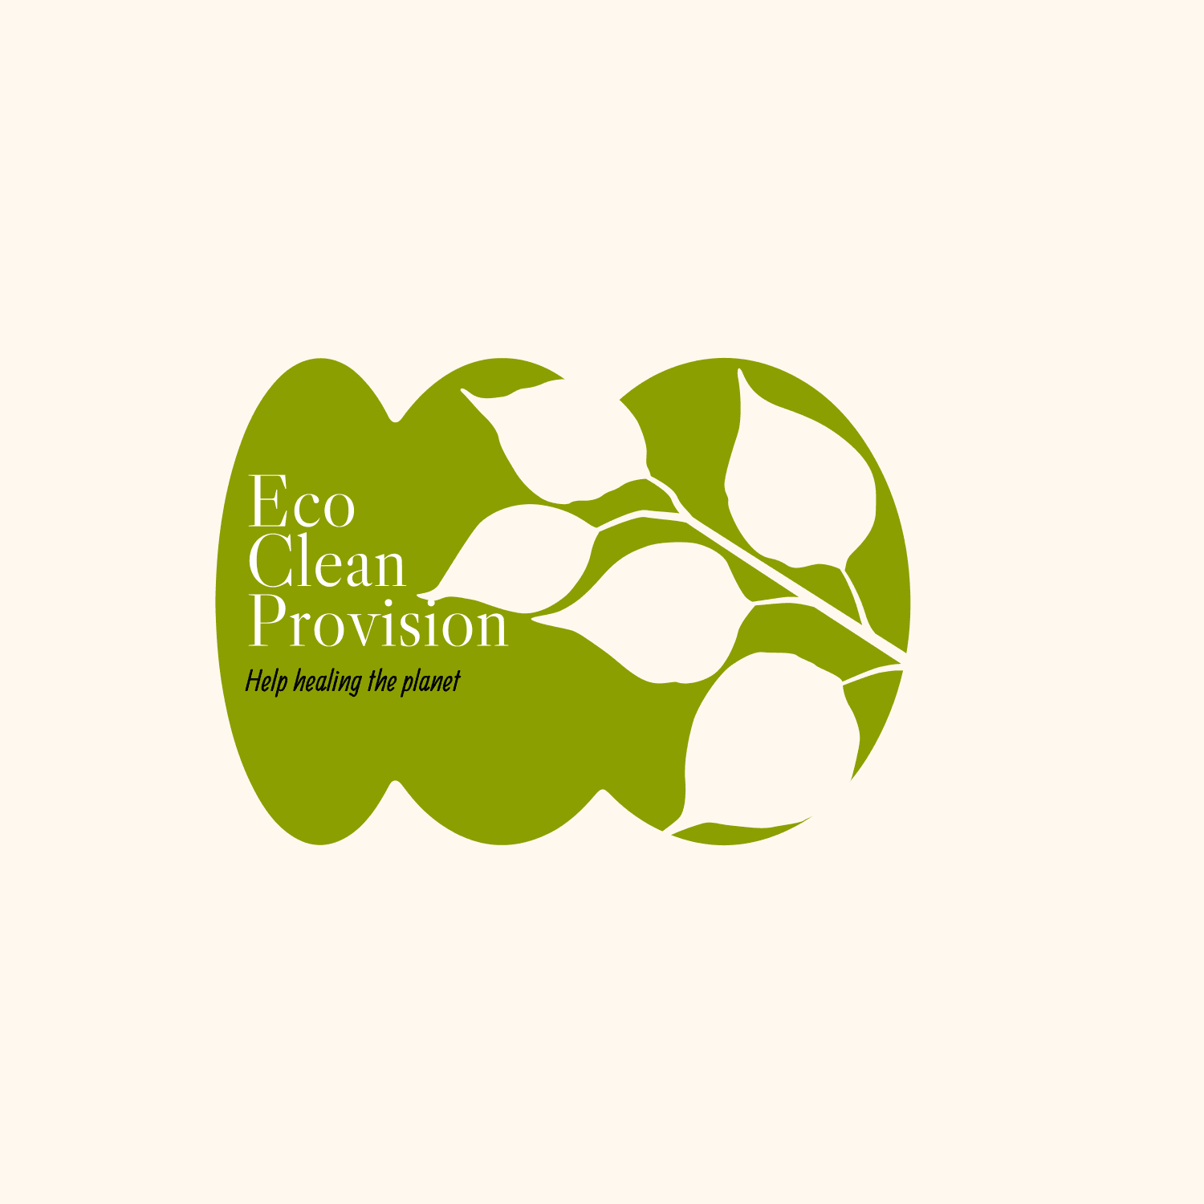  Portfolio  December 6th 2024 | Module code: BMSW4008  Lecturer: Philippa Fitzgerald  Mariela Hidalgo (2318489)  Digital Skills for Personal and Professional Growth

Task 1.

Questionary Analysis

Finding out what your customers are doing and why they are doing it can be done with great accuracy using survey data. As a result, businesses can create consumer journey maps and data-driven buyer personas that serve as the cornerstone of genuinely innovative, tailored marketing. (Saharawat, 2024).

These are the questions I base my analysis on:
1.- What do people think about using environmental products for a cleaning service?
Where are more businesses and consumers choosing environmentally friendly cleaning products, the cleaning industry has seen a noticeable shift towards sustainability. Increased knowledge of the negative effects that traditional cleaning agents have on the environment and human health is what is driving this trend. Because traditional cleaning products contain harmful ingredients that can cause skin irritation, respiratory problems, and other health issues, consumers are growing more aware of these ingredients. This heightened consciousness is driving the need for goods that are safe for consumers and the environment in addition to being effective. (Kuusk, 2024).

2.- Would you do business or require an eco-friendly cleaning service as an option when you search for a cleaning company?
When looking for a cleaning company, more than 60% of people will select an eco-friendly option if they need or perform business cleaning. You are not only enhancing the atmosphere in your house or place of business when you hire a cleaning service that uses environmentally friendly cleaning techniques, but you are also helping the planet. The world outside your front door is just as important to your eco-friendly cleaning services as the security of your family and pets. Investing in this kind of cleaning will result in a sustainable approach to the whole process. (Greenmaids, 2012)

3.- Are people prepared to pay a little bit more for environmentally friendly cleaning services?
According to reports like Nielsen Insights, nearly half 46% of consumers would switch to environmentally friendly products, and the majority 73% would alter their consumption patterns to lessen their impact on the environment. Mortimer, 2020).
This discrepancy between purchase intentions and behaviours has been repeatedly noted in academic research. As a result, consumers' attitudes toward sustainability and green products have changed despite environmental concerns. In the end, there has been conflicting research on consumers' willingness to pay more for environmentally friendly products. Mortimer, 2020). The purpose of nudge theory is to better understand human thought, decision-making, and behaviour, it can be applied to help people think and make better decisions.

4.- Does using eco-friendly cleaning services benefit the environment?
Nowadays, sustainable cleaning is a need rather than an option. In order to ensure a healthier environment without sacrificing cleanliness. (Montez, 2024)

More than ever, today's consumer is knowledgeable and concerned about the environment. As part of their dedication to sustainable living, an increasing number of people are actively looking for eco-friendly goods and services, such as green cleaning. Demand for cleaning services that put environmental and health concerns first has increased as a result of this increased awareness. (Voolt, 2024).
Companies all over the world are adopting sustainability as a fundamental principle, in part because of growing awareness of corporate social responsibility and in part because of consumer demand. Companies are keen to show their dedication to environmental stewardship, and green cleaning services have emerged as a crucial part of larger corporate sustainability initiatives. (Voolt, 2024).

Screenshot of Questionary

1.-

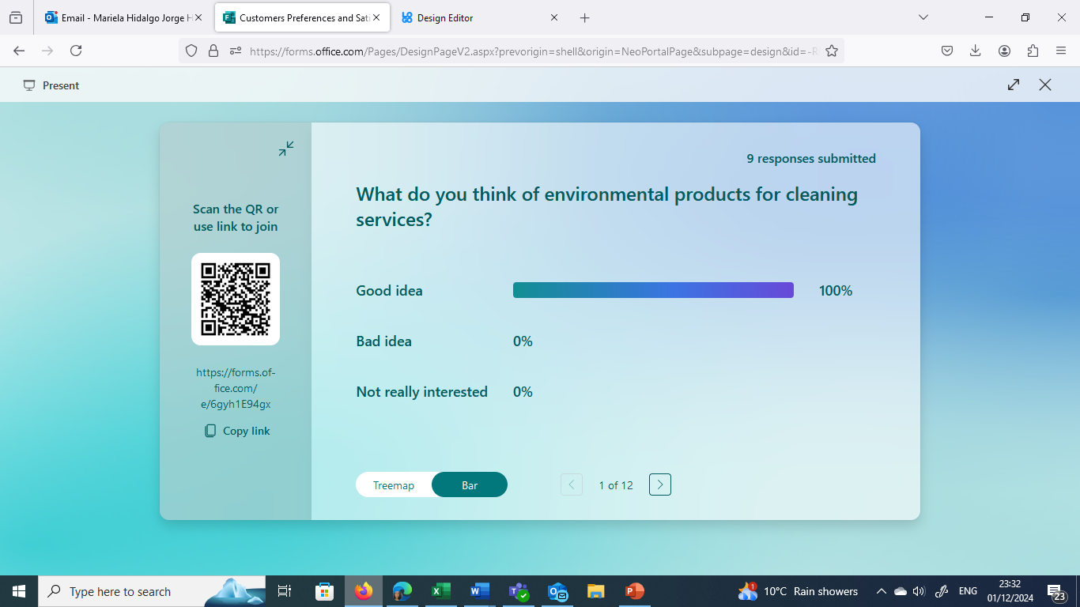

2.-
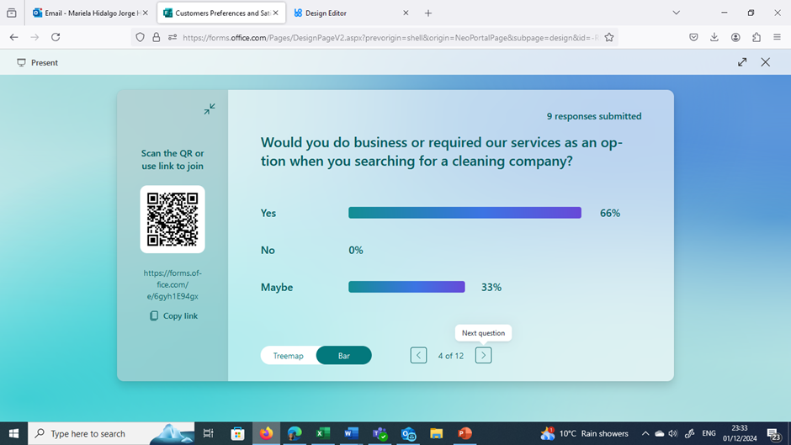

3.- 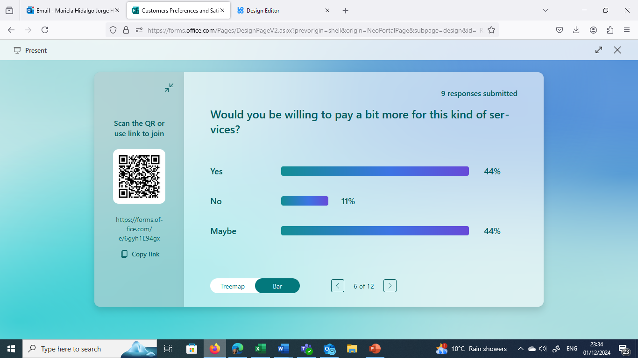

4.-
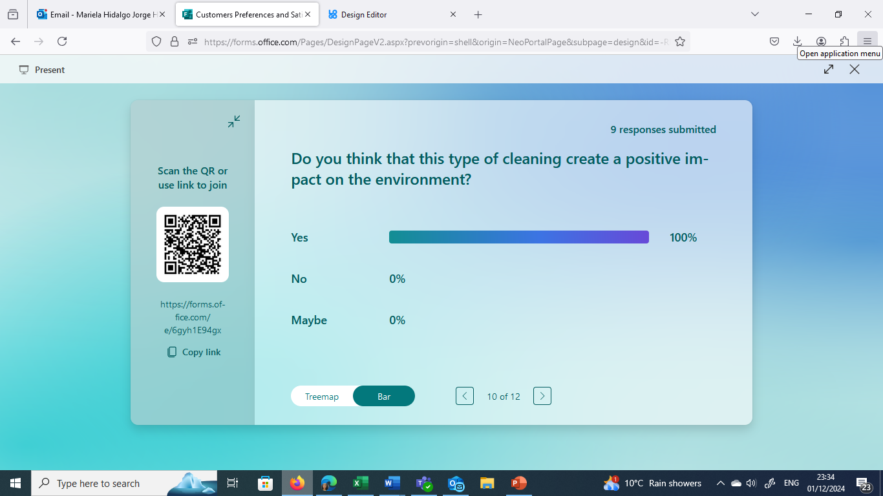

Findings I can used to shape and enhance my business Idea.

It is evident from these environmental concerns that conventional cleaning methods are not long-term viable. Therefore, it is essential to investigate alternate strategies that minimize adverse environmental effects while upholding superior standards of hygiene and cleanliness. (Nguyen, 2023).
Your company can actively lessen its impact on the environment, conserve natural resources, use less energy, and minimize pollution by implementing green cleaning practices. Additionally, these environmentally friendly initiatives could improve workplace productivity, lower operating expenses, and enhance your business's reputation—a situation that benefits both your company and the environment. (Acies, 2023).
The idea of making an organization more environmentally friendly is no longer something that companies can overlook. Governments are implementing it in response to consumer demand, and the advantages now greatly exceed the disadvantages. Considering this, it is demonstrated that going green improves business. For companies that invest in green technologies to lower carbon emissions or improve energy efficiency, funding opportunities will be given. (GOV.UK, 2021)

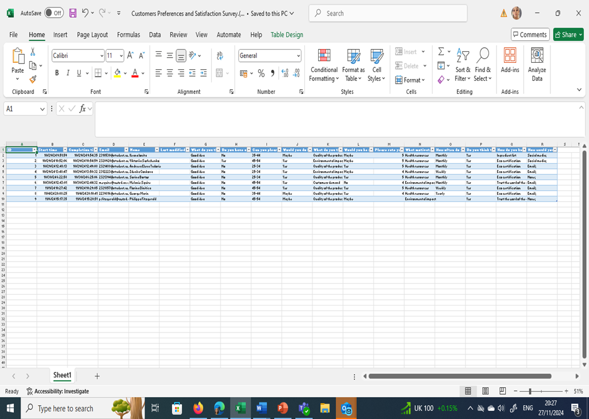

Task 2.- Design of website and Marketing materials

Segmentation: To find a target market that is sufficiently detailed, you can employ one of four main types of segmentation.
Geographic: Localized campaigns that concentrate on regions with a high density of environmentally conscious consumers.

Demographic: 20–40-year-old, eco-aware consumer, busy professional with the means to pay more, and enthusiastic about supporting small businesses and purchasing goods made sustainably. Reacts favourably to messaging that highlights our collaboration with a nearby tree-planting initiative and the use of sustainable materials in our gifts. (Bremner, 2024).

Psychographic: Finding a target market has several advantages, especially for smaller retailers. The following are a few of these: Concentrate marketing efforts on the target audience most likely to buy your goods or services and avoid taking on marketing initiatives that are unlikely to yield a profit. Educate yourself on buyer personas. Take advantage of market gaps while your company is still adaptable. Seek out fresh business prospects to create goods or services that more closely match the demands of your target market. Use messaging to increase customer loyalty and enhance customer support. Knowing how to choose a target market early on will help you keep your business running as efficiently as possible and get past some of the typical marketing obstacles that new business owners encounter. (Bremner, 2024).

Behaviour: In this study, a survey has been used to gather data from a sample of participants using a structured questionnaire. Sustainability awareness, consumer desire for eco-friendly products, and factors influencing purchase decisions will all be measured by the questionnaire. Eco-friendliness, environmental concerns, and the absence of chemicals and preservatives seem to be the main factors influencing consumer choice for eco-friendly products. This is encouraging because it demonstrates that more people are acting to create a more sustainable environment and are becoming conscious of how their consumption habits impact the environment. Consumers in the modern era consume a great deal of the different products that are available on the market, and they typically make purchases in the modern market that is close to their homes. (Tamboli et al., 2023)

Nevertheless, are we aware that the products we consume are safe for consumers and do not harm the environment? It's interesting to note that a product's market availability is inextricably linked to its captivating design, extensive communication, and excellent product quality. The pre-survey, which consists of direct interviews with customers, can reveal the phenomenon of consumers using environmentally friendly products. Smart consumers should purchase a variety of everyday necessities. A variety of widely disseminated information regarding the calibre of the products available frequently helps consumers. Customers are encouraged to select goods that are not only practical for fulfilling needs and meeting guidelines for feasible consumption, but also have an eco-friendly manufacturing process. Based on the current situation, this study looks at how the market is attempting to create environmentally friendly preferences and the calibre of eco-friendly products, which will in turn affect customer satisfaction and, of course, benefit the modern market. A strategy known as "green marketing" was developed by marketers in response to consumers' growing environmental concerns. Generally speaking, green marketing entails: (1) creating products that are less harmful to the environment in terms of production, use, or disposal than their conventional counterparts; and (2) creating products that promote environmental sustainability. (Soegoto, 2018)

The survival of present and future generations depends on us taking care of the planet. If we all do our part to lessen our personal environmental footprints, the world can be a better place for everybody. We can reduce our environmental impact and preserve natural resources by switching to eco-friendly products. Using these products results in less waste, less pollution, and greater conservation of precious resources. (Tamboli et al., 2023)

SEO: Description of how to optimize a website and marketing materials as search engines.

Consumer motivations, customer behaviour, and demographics are the three types of customer data that Digital Marketing Strategy suggests gathering. Details about customers' demographics, such as their age, gender, occupation, lifestyle, and interests, can be particularly helpful when drawing unspoken conclusions about them. Marketing strategy can be developed and implemented with the help of your customers' personal information. But gathering it is a challenge for many marketers. Less than half of marketers are aware of their audience's interests and pastimes, while 42% are aware of their demographics, according to HubSpot.

Consumer behaviour is another way to identify your target market is to examine consumer behaviour. In contrast to lifestyle and preference data, this category focuses on behaviour associated with your goods or services. in this instance, emphasizing the benefits of eco-friendly cleaning services. Purchase history, frequency, email marketing open rates, and website interaction patterns are a few examples of customer behaviour. By looking at these behaviours, you can learn much about your target audience and how to best engage them with blog posts, online advertisements, and email marketing.

Customer Motivations The last strategy for determining your target market is to concentrate on the main reasons why customers buy, which frequently entails asking, “What are they searching for?” In the case of products, consumers frequently look for: Convenience Value Status By employing focus groups and surveys to collect data, you can categorize your customers and comprehend why they buy. (Gibson, 2024)

The creation of content is essential. For your brand to have a successful free or organic traffic program, you must have a strong content team that can produce content fast and efficiently. As we'll discuss later, content is essential for attracting organic traffic and essentially creates your free traffic footprint. Consider content to be a fishing net. Your chances of catching more fish increase with its size. It's no secret that news websites typically receive the most traffic due to their consistent release of fresh content and effective content discovery and promotion strategies. All these factors aid in attracting the freest traffic possible to websites with a lot of content and web pages. These were formerly known as "content farms," but many of those poor-quality content farms have since dispersed, and high-quality websites that provide a wide range of high-quality content now tend to draw the most visitors. (Papagiannis, 2020).

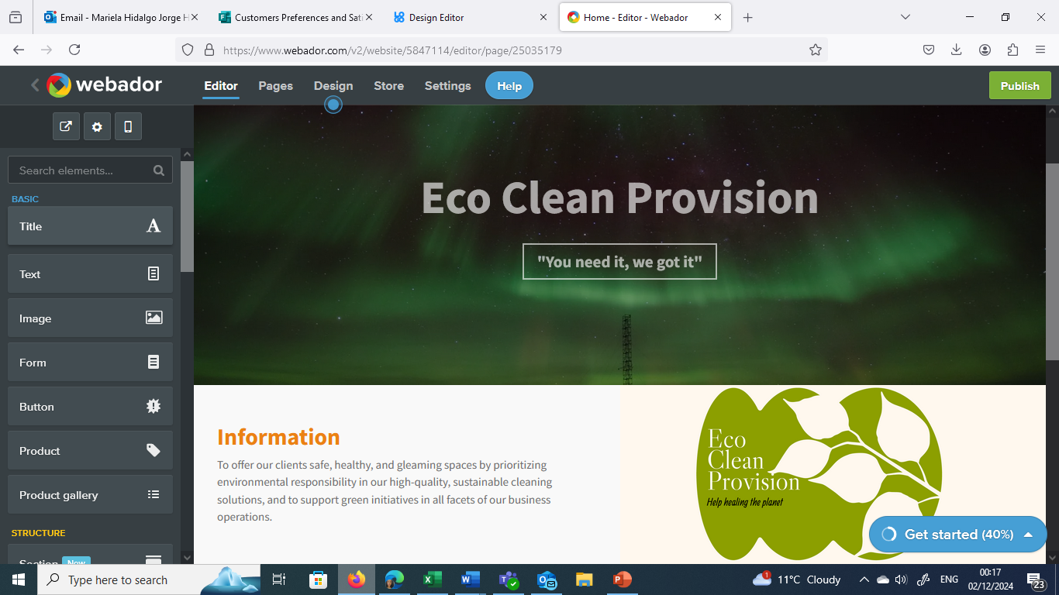

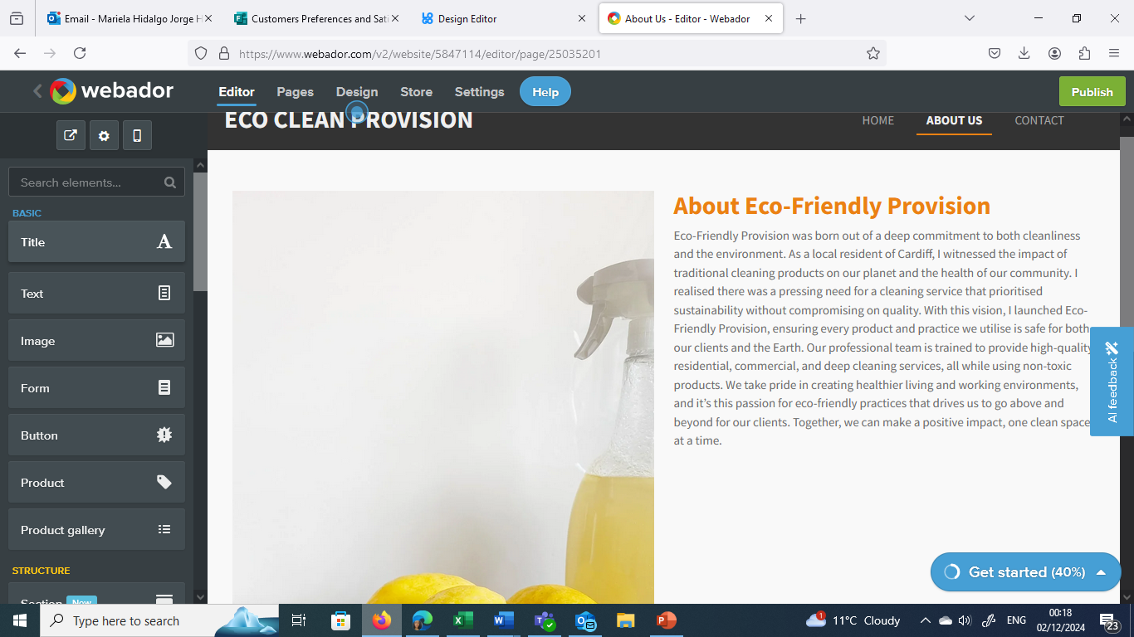
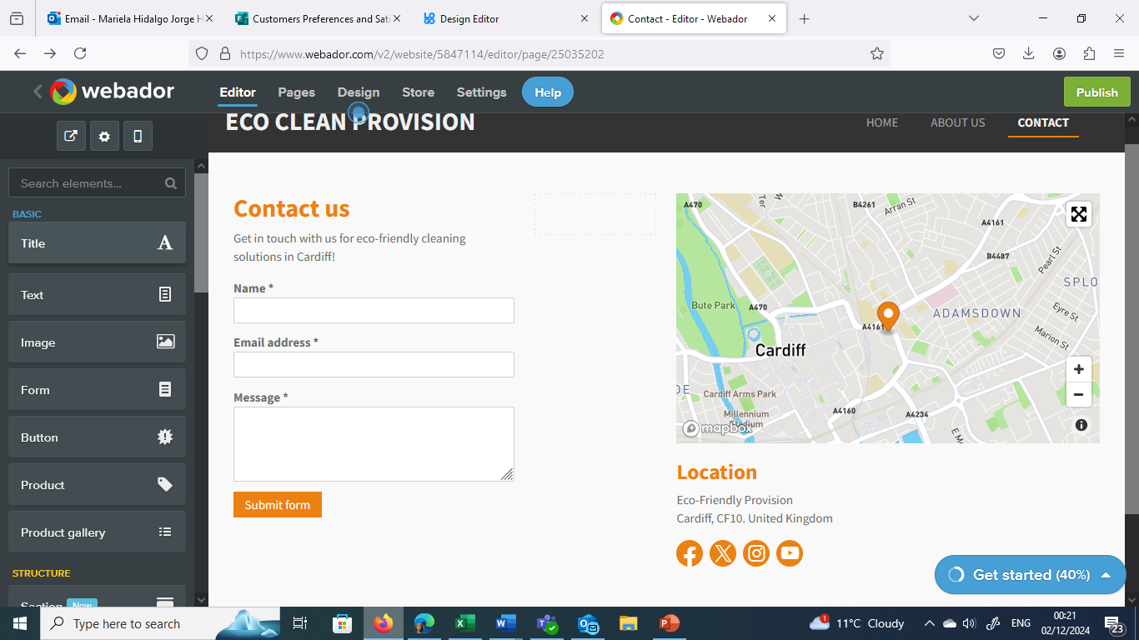

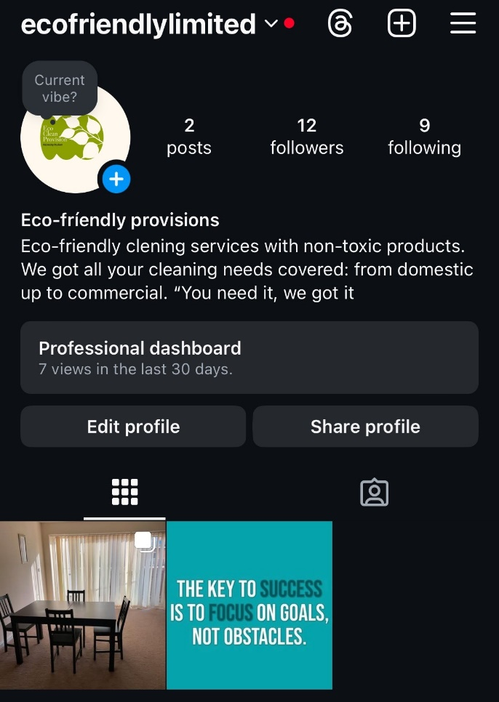



Task 3.- Excel's significance in the digital age.

In the current digital age, Microsoft Excel is an effective tool for data analysis. Millions of people use it in every industry. Artificial intelligence, a technology that accelerates, improves and simplifies data analysis, has been added to Excel's capabilities. Since its introduction in 1985, Excel has transformed from a simple spreadsheet to an AI-powered tool (ElHady, 2024). Started as a simple spreadsheet for arithmetic and tabular data. It soon became the tool of choice for professionals in the business world. The need for increasingly sophisticated data analysis grew as the business world changed. Excel has evolved from a simple calculation tool to a powerful data analysis tool. Thanks to AI integration, demanding tasks can now be carried out. The way we analyze data has completely changed with the integration of AI in Excel. Excel will remain a useful tool for data enthusiasts, businesses and researchers. It enables them to make effective decisions based on data. Excel's AI is more than just a new feature. It is a step towards a data-driven future. (Yates, 2024). Staying ahead of today's rapidly changing business environment requires leveraging tools that improve productivity, teamwork, and data-driven decision-making. Let's introduce cloud-based Excel and its powerful AI partner. Combined with artificial intelligence (AI), seamless Excel web applications transform business operations and enable unprecedented levels of productivity. The strength of Excel lies in its ability to organize, calculate and evaluate complicated data. However, when it comes to real-time collaboration, cross-platform accessibility, and integration with other cloud-based technologies, the traditional desktop version of Excel can sometimes have limitations. This is where Excel web applications really come into their own. Real-time co-authoring capabilities allow multiple team members to work on the same spreadsheet at the same time, promoting collaboration and speeding up processes. (Nieburg, 2024).

Microsoft Excel is an important part of the modern digital environment. Data Management and Organizational Excellence: Its ability to act as a solid foundation for managing and organizing data with unparalleled effectiveness. From simple lists to complex data sets, Excel provides an organized environment that allows both individuals and businesses to manage information in an organized and easily accessible manner. Enabling users to easily perform complex data analysis is called Empowering Data Analysis and Visualization. Pivot tables, functions and formulas provide quick insights, and graphs and charts help visualize patterns and trends. From marketing to finance, this analytical capability elevates Excel beyond the status of a traditional spreadsheet application and is critical in decision-making processes across a variety of industries. Mastering financial management: Excel allows you to create detailed financial reports, track expenses, and create budgets. With features like SUM, IF, and VLOOKUP that make complex calculations easier, Excel is an essential tool for financial analysts, accountants, and business owners grappling with the complexities of tax responsibilities. (Alton, 2020). Flexibility in project planning and monitoring: Excel's flexibility carries over to project management, offering tools like schedules, Gantt charts, and project tracking templates. These tools allow both individuals and groups to plan, track, and evaluate progress efficiently.
Improves overall project management in the busy business world by ensuring resources are distributed effectively and deadlines are met. Easy sharing and collaboration: The ability to work with cloud services like SharePoint and OneDrive makes sharing and collaboration easier. The ability for multiple users to collaborate on the same spreadsheet at the same time improves teamwork and guarantees real-time updates. This collaboration feature, which eliminates geographic barriers and promotes a unified approach to data-driven decision making, is particularly important for companies with distributed teams. Education and Personal Development Hub: It is an important resource for teachers, learners and people seeking personal development. Its use in skills development, statistical analysis and scientific research supports a well-rounded education. Excel enables people to become more comfortable with data-related tasks, preparing them for success in an increasingly data-driven world. Excellent software integration creates a unified digital environment through integration with other Microsoft Office programs. (Nechvatal, 2023). Although the study and understanding of digital transformation is a global focus, there is currently no accepted definition of the term and the possible terms that could be used for it are still unclear. Existing explanations cover, among other things, different business contexts and digital technologies. (Kraus et al., 2021). Digital transformation is the use of technology to significantly increase the performance or reach of a company. Westerman G, Calméjane C, Bonnet D, Ferraris P, McAfee A (2011).





Task. - 4. Techniques use in a video advertisement

Video collaboration is essential for every business, but it's especially important for the growing number of companies that employ people around the world. Making a collaborative workforce as productive and efficient as possible requires the use of a video conferencing solution that is both reliable and provides an excellent user experience. (Kennedy, 2018) TikTok has become a very popular social media platform around the world, especially among younger generations. With the help of this app, users can create and distribute entertaining short videos ranging from a few seconds to a minute in length. The focus on user-generated content, cutting-edge tools, and a highly engaging and entertaining interface are what make TikTok so special. This personalized feed makes it easy to find new artists and trends as it presents users with a diverse range of content and keeps the platform attractive. (Anderson, p. 2024). For content creators focused on creating YouTube content, Descript is an obvious choice because it requires the right tools to create engaging YouTube videos. Two essential elements of a strong video are great audio and video quality. Although audio quality is equally crucial, post-production can improve sound quality. (Dopson, E. 2023).

References

Acies (2023). How Eco-friendly Cleaning Services Benefit Your Business. [online] Acies Cleaning & Support Services. Available at: https://aciescleaning.co.uk/eco-friendly-cleaning-services-business-benefits/.

Alton, L. (2020). In The Age Of Big Data, Is Microsoft Excel Still Relevant? [online] SmartData Collective. Available at: https://www.smartdatacollective.com/in-the-age-of-big-data-is-microsoft-excel-still-relevant/ [Accessed 5 Dec. 2024].

Anderson, S. (2024). How to Make a TikTok Video: An A to Z Guide for Beginners. [online] Social Champ. Available at: https://www.socialchamp.io/blog/how-to-make-a-tiktok-video/ [Accessed 5 Dec. 2024].

Bremner, M. (2024). How to Identify a Target Market as a Small Business. [online] SumUp - a better way to get paid. Available at: https://www.sumup.com/en-gb/running-business/marketing/how-to-identify-target-market/?path=%2F [Accessed 5 Dec. 2024].

Dopson, E. (2023). How to Make a YouTube Video in 10 Easy Steps. [online] www.descript.com. Available at: https://www.descript.com/blog/article/how-to-make-youtube-video.

ElHady, H. (2024). The Importance of Excel in Business (+ Examples). [online] 10XSheets. Available at: https://www.10xsheets.com/blog/importance-excel-business.

Gibson, K. (2024). Why Identifying your target audience is important to your marketing strategy. [online] Business Insights Blog. Available at: https://online.hbs.edu/blog/post/target-audience-in-marketing.

GOV.UK (2021). Find funding to help your business become greener. [online] GOV.UK. Available at: https://www.gov.uk/guidance/find-funding-to-help-your-business-become-greener.

Greenmaids (2012). Why Is It So Important to Use Eco-Friendly Cleaning Services? [online] greenmaids.com. Available at: https://greenmaids.com/why-is-it-so-important-to-use-eco-friendly-cleaning-services/ [Accessed 1 Dec. 2024].

Harfield, J. (2022). eco-friendly business ideas that make a difference. [online] Pipedrive. Available at: https://www.pipedrive.com/en/blog/eco-friendly-business-ideas [Accessed 2 Dec. 2024].

Kraus, S., Jones, P., Kailer, N., Weinmann, A., Banegas, N.C. and Tierno, N.R. (2021). Digital Transformation: an Overview of the Current State of the Art of Research. SAGE Open, [online] 11(3), pp.1–15. doi:https://doi.org/10.1177/21582440211047576.

Kuusk, G. (2024). The Impact of Sustainable Cleaning Products on Health and Environment. [online] Clean Chaps. Available at: https://cleanchaps.com/blog/the-impact-of-sustainable-cleaning-products-on-health-and-environment.

Montez, M. (2024). The Definitive Guide to Sustainable Cleaning Practices - TRAX Analytics |. [online] TRAX Analytics |. Available at: https://traxinsights.com/2024/01/11/cleaning-and-maintenance-to-support-sustainable-practice/.

Mortimer, G. (2020). Climate explained: are consumers willing to pay more for climate-friendly products? [online] The Conversation. Available at: https://theconversation.com/climate-explained-are-consumers-willing-to-pay-more-for-climate-friendly-products-146757.

Nechvatal, J. (2023). Immersion Into Noise. Excel: Transforming Digital Landscapes Through Efficiency and Collaboration. [online] doi:https://doi.org/10.3998/ohp.9618970.0001.001.

Nguyen, V. (2023). Cleaning Up the Industry: How Sustainable Cleaning Is Transforming the Cleaning Industry. [online] The Business Magazine. Available at: https://thebusiness-magazine.co.uk/cleaning-up-the-industry-how-sustainable-cleaning-is-transforming-the-cleaning-industry/.

Nieburg, M. (2024). Excel’s evolution: how cloud and AI are transforming the digital workplace. [online] TechRadar. Available at: https://www.techradar.com/pro/excels-evolution-how-cloud-and-ai-are-transforming-the-digital-workplace [Accessed 5 Dec. 2024].

Papagiannis, N. (2020). Effective SEO and content marketing : the ultimate guide for maximizing free web traffic. Indianapolis, Indiana: Wiley.

Saharawat, V. (2024). Analysis Of Survey Data: Methods & Examples. [online] Skills. Data Analyst. Available at: https://pwskills.com/blog/how-to-analysis-of-survey-data/.

Soegoto, D.S. (2018). Analysis of eco-friendly Preference and eco-friendly Product quality; Their Implications to Customer Satisfaction. IOP Conference Series: Materials Science and Engineering, 434(1), p.012164. doi:https://doi.org/10.1088/1757-899x/434/1/012164.

Tamboli, A.S., Ohol, A., Haque, M. and Jojare, Y. (2023). Consumer Preference for Eco-Friendly Products in Relation to Sustainability Awareness. Journal Of Advanced Zoology, pp.44(S6):87-93. doi:https://doi.org/10.17762/jaz.v44iS6.1990.

Voolt (2024). The Benefits of Green Cleaning Services - Voolt Blog. [online] Voolt Blog. Available at: https://blog.voolt.com/categories/business-tips-for-success/benefits-green-cleaning-services/ [Accessed 1 Dec. 2024].

Westerman G., Calméjane C., Bonnet D., Ferraris P., McAfee A. (2011). Digital transformation: A roadmap for billion-dollar organizations (pp. 1–68). MIT Sloan Management, MIT Center for Digital Business and Capgemini Consulting.

Yates, E. (2024). Excel in the Age of AI: How Artificial Intelligence is Transforming Data Analysis. [online] Excel Tip. Available at: https://www.exceltip.com/technology/excel-in-the-age-of-ai-how-artificial-intelligence-is-transforming-data-analysis.html [Accessed 5 Dec. 2024].

