
HTML & CSS Web Development
Harry Roberts: 1802886

January 15, 2020

Contents
Introduction 2
Requirements section: 2
Screenshots of the website 2
Validation 4

Introduction
Here is a short summary of what the contents in this report will contain. It will contain the requirements of the target audience and its relevant as well as images of the website itself. It will also consist of validation of the HTML and CSS and the corrections of any errors if possible. It will also include an evaluation section based on what website usability and accessibility. It will then include an evaluation of the website including usefulness which will consist of usability and utility, search engine optimisation and accessibility.

Requirements section:
The target audience of my website is anyone who is looking to be introduced to video gaming and wants a brief overview of the game. The relevance of this website is quite large in the sense of advertisement as it will give the audience some form of insight on the game and a piece of relevant content. The subject matter in gaming is a very crucial point as bolstering the number of new players is something almost every games company would want. It would be considered relevant depending on the opinion of the audience themselves.

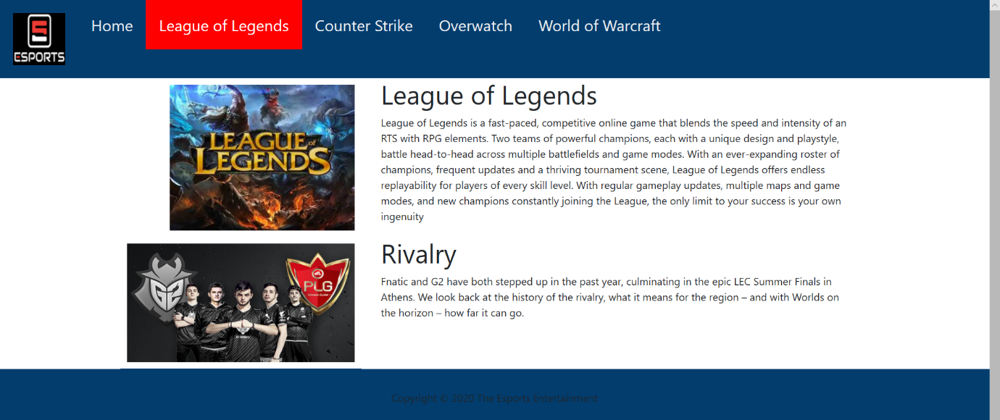
Screenshots of the website



