This image commentary will focus on one manuscript, Peniarth MS 28, and some of the images contained therein. Peniarth MS 28 is housed in the National Library of Wales’ collections and has been digitised, to make it widely accessible. Even before the days of digitalisation, the illustrations had already been popularised, through being available in pamphlet form through the National Library for several decades.
Peniarth MS 28 is a Latin version of the Welsh Laws, also known as the laws of Hywel Dda. It belongs to what is thought of as the first generation of surviving Welsh law books, and is similar to the others in this generation in that it was produced in roughly the same period – the mid-13th century – and contains much of the same material. Where it differs from the others is that it is larger, and contains the aforementioned illustrations. Its use of Latin is not unusual, as other Latin texts survive, but Welsh is the more usual language, not surprisingly.
The smaller size of most medieval Welsh lawbooks indicates that they were designed to be carried by lawyers, and were made for practical use. Peniarth MS 28, on the other hand, with its larger size, use of Latin and illustrations, seems to have been designed as a presentation copy. It has been suggested that it was presented to, and used by, none other than John Pecham, Archbishop of Canterbury (1279-1292), who is infamous in Welsh history for his denunciation of the Welsh laws.
The manuscript is vellum, with the lettering being black ink, with some red and green lettering as well. The illustrations appear to be in the same ink as the text, using black, green and red primarily, but also occasionally thin yellow and brown, and once a ‘thin reddish flesh colour’. Daniel Huws suggests that the scribe may have also been the artist. He also notes that the green is corrosive, and has eaten through the pages. This can be seen quite clearly on the digital copy, though some of the other colours can be spotted showing through, as well, such as the brown of one of the men’s gowns at f.15^{v} shows at f.15^{r}.
There are about 30 drawings in all, and most are either of people or animals. All are interesting, but for the purposes of this commentary, only a few will be focused on. These will be the king, the judge and the two depictions of women. These have been chosen for being the ones most likely to yield more interesting observations, given the brevity of this commentary.
The King
The image of the king comes at the beginning of the manuscript, at folio 1^{v}. It appears to sit within the columns dealing with the royal household, basing this on what can be read of the manuscript (and this writer’s limited Latin), and the knowledge that this version of the laws, like many others, begins with a prologue and then moves directly into discussing the laws of court.
The king is seated on a low throne, crown on his head, sceptre in his left hand, right hand showing one long finger pointing outwards. He has long hair and a beard, and wears robes of green and brown.
It has been suggested that this drawing owes its origins to more sophisticated illustrations of the stereotyped image of the king that was current in the twelfth and thirteenth century, and is the only one of the illustrations in the manuscript to do so. Certainly the drawing is more elaborate than the ones that follow it, and following schemata was typical of that era.
However, looking through various contemporaneous images of the king, using those available from the British Library, some observations can be made about the choices the artist made with this particular image. The basic posture and clothing of the king are very similar to those shown elsewhere. Many of them hold sceptres, as this king does. Frequently, though, they hold a sword, instead, which this king notably does not. Interestingly, the one image in the admittedly small sample this commentary is drawing on where the right hand posture is very similar to that of the Peniarth MS 28 king is that of a king dictating the law.
All of these choices made, even if working from a schemata, suggest that the artist may have had one particular king in mind, the Hywel Dda who is associated with the laws. Whilst there is no evidence that he actually caused the laws to be written down, each of the prologues to the various texts asserts that he called an assembly to set the law down in writing. His reign in the latter part of the tenth century was known to be a peaceful one by the standards of the time, which might account for the king in the manuscript only holding a sceptre, and not a sword. His finger pointing out suggests that he is setting out the law, for someone else to write down.
All of this suggests that the scribe/artist of this text, which might have been being prepared in the hopes of favourably influencing Archbishop Pecham, was wanting to emphasise the legitimacy of these laws, by using an image that was both familiar and particular. The text further emphasises this legitimacy, as the prologue, like many of the others, says that Hywel Dda called the others of Wales together at ‘Ty Gweyn ar Taf’, which is the Welsh for Whitland – Whitland Abbey being the motherhouse of the Welsh Cistercians, and thus lending religious authority to these laws, as well.

The Judge
The judge is found at folio 4^{r}, in the right-hand column. Like the king, he has long hair, beard and robes, though his robes are simpler, and simply coloured green. He sits in a chair, and like the king, his right hand is stretched out, finger pointing in judgement, which emphasises once again that the king in the above description was a law-giver, whether intended to be Hywel Dda, or not. Whilst the judge has simpler robes than the king, understandably, his chair is quite ornate, with decorative sides and top, which suggests that he was seen as quite high status. Most interestingly for the purposes of this commentary, he holds his law-book in his left hand, and it is of a size that looks similar to the other more typical law books. This is law in action, showing how these laws were generally intended to be used.

The Women
As mentioned above, Archbishop Pecham was not a fan of the Welsh Laws (nor of the Welsh), and one of the reasons that he criticised them was that they were more equitable in regards to divorce and to illegitimate children, both of which topics involve women, if indirectly in the latter. One of Huws’ reasons for thinking this might be the very copy of the laws that Pecham used in forming this opinion is the heavy marking found near the pages where these matters are discussed. Whilst it has been shown that women in the Welsh Laws were considered to be less than the men, they nonetheless had, in many ways, greater status than their contemporaries in England. And the two illustrations of women, to a certain extent, show that. The first woman is to be found at folio 5^{r}, in the second column, and Daniel Huws suggests that she and her partner are intended to illustrate the section on the duties of the servant and maidservant of the chamber. They are clearly not about their duties in the illustration, however, as they are embracing and sharing a kiss. Both are robed, the man in a green, slightly shorter robe, and the woman in a brown one. He seems to possibly be the instigator of their embrace, given the smile he’s wearing, and that he seems more solid in his posture, whereas she seems slightly off-balance, as if he has pulled her into his arms. She appears to be the taller of the two, however, and is possibly also enjoying the experience, if her hands are to be interpreted as embracing him, and not strangling him (both seem possible). Her height and posture do seem to suggest that she is of fairly strong character.
The second woman is found at folio 17^{v}, again in the second column, directly under the words ‘de lege puellae et feminae’, ie, the laws of girls and women. She has long brown hair, a long green gown, and holds a dish. Like the king and the judge, she, too, is gesturing with one hand, finger extended, though this time it is her left hand. Is she, then, the head of her household, perhaps laying down the (domestic) law to her servants? She seems older than the first woman, and again is of strong character, with a firm expression and a jutting chin. This indicates that, whilst the women may have been of lower status in the laws, the artist at least still saw them as strong actors within their own spheres, and as individuals.
As mentioned above, Daniel Huws has suggested that only the king was based on a schemata, and that the rest of the illustrations were the scribe (or artist, if he was a separate individual)’s original work. This may well be so, as the rest of the drawings are simpler, and show more character (though the artist also seems to have struggled with drawing chins, which may be why they all seem to have strong jaws). However, he also seems to have followed conventions in the hand posture of the judge and the older woman, with their law-giving fingers, perhaps unconsciously following the patterns he had established in his first drawing. It has been suggested that Archbishop Pecham was the intended audience for this manuscript, and if the intention was to soften his views on the Welsh and their laws, it clearly failed to do so. But the Archbishop was not the only audience of this manuscript. In the fourteenth and fifteenth century, it was in the library at Canterbury, but by the seventeenth century, Robert Vaughan of Hengwrt had acquired it. The Hengwrt collection has been called ‘the finest collection of Welsh manuscripts ever assembled by an individual’. It was largely this collection (with the addition of the Peniarth collection, which it had been added to) that led to the establishment of the National Library of Wales. Robert Vaughan’s hand can be seen at the beginning of the manuscript, at folio iv^{v}, and at the end of the manuscript, at folio 27^{v}, there are notes by J. Gwenogvryn Evans, dated December 1893. Evans was not only an important early scholar on the Welsh Laws, but he also was instrumental in ensuring that the Hengwrt-Peniarth collection was purchased, leading to the creation of the National Library at Aberystwyth.
The manuscript, the illustrations and, indeed, the handwriting of two instrumental figures in Welsh history, all have their place in the creation of Welsh identity. Whilst the text and drawings may not have softened the stance of the original audience, they have been instrumental over the years to helping create a sense of self amongst the Welsh. A proposal earlier this century to the Royal Mail, asking them to create a Welsh stamp, included two of the illustrations from Peniarth MS 28, that of the king and that of the judge, in its design. Its audience has been far wider than its original scribe and artist could have imagined.

Word Count (not including footnotes or bibliography) - 1917

Bibliography
Books
Backhouse, J., The Illuminated Manuscript (Oxford: Phaidon, 1979)
Howells, R., Visual Culture (Cambridge: Polity, 2003)
Huws, D., Peniarth 28: Darluniau o Lyfr Cyfraith Hywel Dda, (Aberystwyth: National Library of Wales, 1988)
Jenkins, D. and M. E. Owen, (eds.), The Welsh Law of Women, (Cardiff: University of Wales Press, 1980)
Woods, K. (ed), Art and Visual Culture 1100-1600: Medieval to Renaissance (London: Open University, 2012)
Journal Articles
Chapman Stacey, R., ‘Law and Lawbooks in Mediaeval Wales’, History Compass, 8.10 (2010), 1180–90
Davies, R.R., ‘The Twilight Of Welsh Law, 1284–1536’, History, 51.172 (1966), 143–64
Huws, D., 'Leges Howelda at Canterbury', National Library of Wales Journal, XIX (1976), pp. 340-4

The Images:
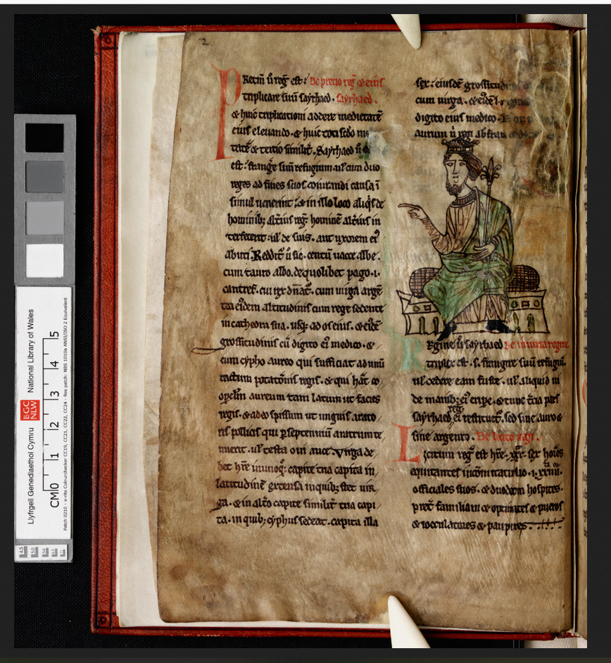

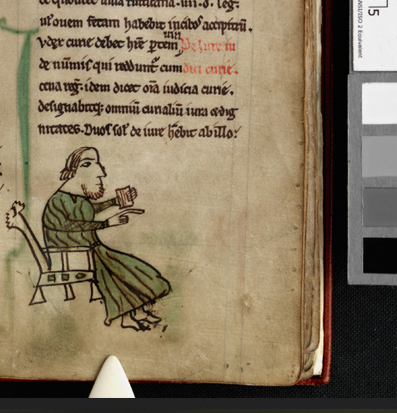

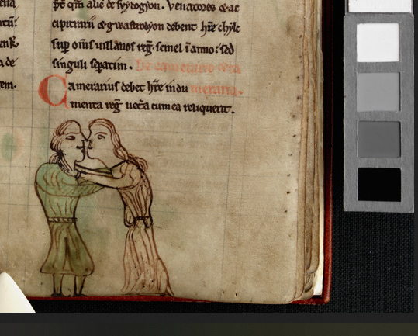

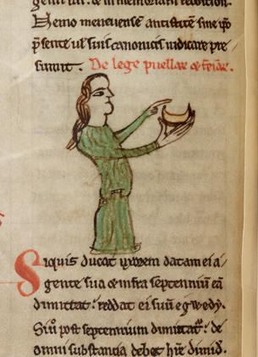

Available at https://www.library.wales/discover/digital-gallery/manuscripts/the-middle-ages/laws-of-hywel-dda#?c=&m=&s=&cv=12&xywh=-705%2C-317%2C5207%2C4793, last accessed 12 December 2012.
Daniel Huws, Peniarth 28: Darluniau o Lyfr Cyfraith Hywel Dda, (Aberystwyth: National Library of Wales, 1988).
The best place starting place for information on Welsh medieval law is here: http://cyfraith-hywel.cymru.ac.uk/en/canllaw-croeso.php.
Daniel Huws, ‘Peniarth 28: illustrations from a Welsh Lawbook’ https://www.library.wales/discover/digital-gallery/manuscripts/the-middle-ages/laws-of-hywel-dda/daniel-huws-article-peniarth-28-illustrations-from-a-welsh-lawbook (possibly the text of the English version of fn 1), last accessed 12 December 2021.
ibid.
ibid, also Daniel Huws, 'Leges Howelda at Canterbury', The National Library of Wales Journal, XIX (1976), pp. 340-4.
Daniel Huws, 'Leges Howelda at Canterbury', The National Library of Wales Journal, XIX (1976), pp. 340-4.
Huws, fn. 4.
ibid.
ibid.
Fn 1.
At times two illustrations are placed close together, and one drawing, of a cat, has disappeared, so an exact count is not entirely possible.
H.D. Emanuel, ‘The Latin Texts of the Welsh Laws’, Welsh History Review Special Number: The Welsh Laws (1963), 25-32. See also the website listed at fn. 3.
Huws, fn 4.
As Visual Culture terms it.
See, for some examples, the British Library blog posts, searching ‘kings’ and ‘law’, primarily - https://blogs.bl.uk/digitisedmanuscripts/index.html
London, British Library, Royal MS 11 D IX, f. 6r, available at ‘The Anglo-Saxon Origins of Medieval Justice’, British Library Blog Post, 29 March 2015, https://blogs.bl.uk/digitisedmanuscripts/2015/03/the-anglo-saxon-origins-of-medieval-justice.html accessed 12 December 2021.
Multiple sources, see in particular the website at fn. 3.
Folio 1^{r}, about halfway down.
See the two other law books offered in digital form by the National Library of Wales - NLW MS 20143A, available at https://www.library.wales/discover/digital-gallery/manuscripts/the-middle-ages/a-welsh-text-of-the-laws-of-hywel-dda#?c=&m=&s=&cv=&xywh=-764%2C0%2C4183%2C2917 and NLW MS 24029A (the Boston Manuscript), available at https://www.library.wales/discover/digital-gallery/manuscripts/the-middle-ages/the-boston-manuscript-of-the-laws-of-hywel-dda#?c=&m=&s=&cv=&xywh=-241%2C-1%2C4352%2C3036, both last accessed 12 December 2021.
R. R. Davies, ‘The Twilight Of Welsh Law, 1284–1536’, History, 51.172 (1966), 143–64.
Huws, fn. 7.
Quite literally, as the price owed for insulting them or for killing them was half that which was due for men of equal social status.
Dafydd Jenkins and Morfydd E. Owen, (eds.), The Welsh Law of Women, (Cardiff: University of Wales Press, 1980).
Huws, fn 4.
Text accompanying fn 14.
‘Laws of Hywel Dda’, National Library of Wales, https://www.library.wales/discover/digital-gallery/manuscripts/the-middle-ages/laws-of-hywel-dda#?c=&m=&s=&cv=&xywh=-1413%2C361%2C5430%2C3787 last accessed 12 December 2021
ibid.
E.D. Jones, (1959). VAUGHAN, ROBERT (1592? - 1667), antiquary, collector of the famous Hengwrt library. Dictionary of Welsh Biography. Retrieved 12 Dec 2021, from https://biography.wales/article/s-VAUG-ROB-1592.
E.D. Jones, (1959). EVANS, JOHN GWENOGVRYN (1852 - 1930), palaeographer. Dictionary of Welsh Biography. Retrieved 12 Dec 2021, from https://biography.wales/article/s-EVAN-GWE-1852
Robin Chapman Stacey, ‘Law and Lawbooks in Mediaeval Wales’, History Compass, 8.10 (2010), 1180–90.

