Business Report - Comparison of Two Hospitality Organisations

Student Name: Alina Maria Cimpian
Student ID: 2207461

Module Leader: Tristan Hawkins
Word Count: 2038

Executive Summary

Shangri-La Hotels and Travelodge Hotels are two key industry bigwigs with chains in luxury and budget categories. Shangri-La is the epitome of a brand delivering a luxury experience with a solid global presence. At the same time, it is well-famed for maintaining a strong commitment to sustainability factors, which has driven the brand to hold a solid position in luxury hospitality.
On the other hand, Travelodge's focus on affordability, broad access, and sustainability is a good match with the requirements of budget-minded travellers, so it became a leader in the UK budget hotel market. Both companies have succeeded in satisfying the needs of different travellers' preferences.
All these unique strengths, innovating guest services, strategic growth, and sustainability, will translate to strong financial performance. The report details these financial management strategies and growth potentials, and recommendations will be made to continue with success in their respective niches in the dynamic hospitality world.
Contents
Executive Summary 2
Introduction 4
Shangri-La Hotels: Company Profile 4
Shangri-La Hotels: Revenue 4
Market Position of Shangri-La Hotels 5
Growth Potential of Shangri-La Hotels 6
Commitment for Sustainability 7
Recommendations 7
Travelodge Hotels: Company Profile 7
Travelodge Hotels: Revenues 7
Market Position of Travelodge Hotel 8
Growth Potential of Travelodge Hotel 9
Sustainability Report: Travelodge Hotel 10
Recommendations 10
Comparative Analysis of Shangri-La Hotel and Travelodge Hotel 10
Conclusion 11
References 12

Table of Figures
Figure 1: Shangri-La Cash Flow Performance of 2022 5
Figure 2: Shangri-La's Business Presence 6
Figure 3: Revenue Comparison of Travelodge 2019-2022 8
Figure 4: Brand Profile of Travelodge 9

Introduction
Financial management is all about full provision for the financial transactions of an organisation, where special care is taken to provide information that is indispensable for the top management in helping them make the right business decisions (Madura, Hoque and Krishnamurti, 2018). It ensures an organisation has enough financial resources to carry out its operations effectively and meet its commitments. Financial management involves efficiently utilising and distributing resources, managing costs, and handling revenues (Drury, 2020). In other words, financial management provides the foundation for organisational organisational sustainability by making prudent financial decisions and stewardship of resources. This report elaborates on a comparative analysis of two high-end hotels, Shangri-La Hotels and Travelodge Hotels, based in Asia and the UK. The focal point will be researching their future revenue streams, market positions, and growth avenues. Comparing such reputed organisations will provide insight into their financial status and areas where they can work further. Therefore, the study will explain the recommendations to enhance their financial performance.

Shangri-La Hotels: Company Profile

Founded in 1971, Shangri-La Hotels & Resorts has established itself as a premier global hotel brand renowned for its luxury and hospitality. The inception of this prestigious brand began with the opening of the Shangri-La Hotel in Singapore, setting a high standard for elegance and superior service. Presently, Shangri-La Hotels & Resorts boasts over 100 properties located in major cities and resort destinations across Asia, Europe, the Middle East, and North America (Shangri-La, 2023b). This esteemed brand is distinguished by its unique blend of Asian hospitality, local heritage, and global standards. Committed to sustainable development, Shangri-La has received numerous awards for its eco-conscious practices and community engagement (Shangri-La, 2023a). Guided by strong leadership, Shangri-La has continually expanded its portfolio while upholding its esteemed reputation. The company's vision of creating and delivering unforgettable experiences is realised through the strategic and progressive growth overseen by its executive leadership team, ensuring a diverse and dynamic portfolio of hotels and resorts.

Shangri-La Hotels: Revenue

Latest available reports show Shangri-La Hotels & Resorts hit a high of $2.8 billion in 2023—46.5% over the 2022 level—and that number had rebounded by 95% from 2019, underpinning the group's clear leadership in the luxury hospitality branding market. Shangri-La consistently makes huge turnovers by selling rooms, providing food and beverages, arranging events, and using spas and other facilities (Shangri-La, 2023b). The financial performance of the Cash Flow of Shangri-La Hotel also shows significant stability, which can be seen from the picture below
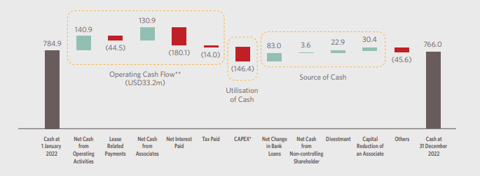
Figure 1: Shangri-La Cash Flow Performance of 2022
Source: (Shangri-La, 2023a)
Shangri-La's revenue growth has been consistently steady over the years, with the only significant setback occurring during the COVID-19 pandemic. This resilience underscores the brand's capacity to adjust to shifting market dynamics, extend its international footprint, and affluent travellers searching for luxurious accommodations and exceptional experiences (Li, 2023). The revenue growth at Shangri-La Hotels & Resorts highlights strategic initiatives in property expansion, brand partnerships, and innovations in guest services (Oh, 2024).

Market Position of Shangri-La Hotels

Shangri-La Hotels & Resorts is one of the world's top 100 luxury hotel companies, with over 100 properties in 22 countries worldwide.
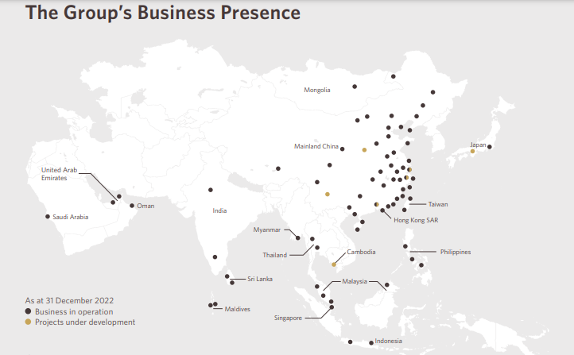
Figure 2: Shangri-La's Business Presence
Source: (Shangri-La, 2023a)
Shangri-La is renowned for its exceptional hospitality and luxurious experiences. In the highly competitive luxury hospitality industry, Shangri-La combines Asian traditions with modern luxury. Their focus on personal service, attention to detail, and top-notch amenities make them a top choice for travellers seeking comfort and indulgence. Shangri-La's portfolio includes some of the best hotels in Asia, Europe, the Middle East, and North America, offering guests unparalleled luxury and sophistication (PR Newswire, 2024). Additionally, Shangri-La's commitment to sustainability and social responsibility appeals to environmentally conscious travellers, enhancing its market position. With its strong brand reputation, global presence, and dedication to excellence, Shangri-La leads the way in luxury hospitality, attracting travellers seeking exceptional experiences worldwide.

Growth Potential of Shangri-La Hotels

It has a good potential for growth, evidenced by strategic plans for expansion, a commitment to innovation, and a focus on delivering excellent guest experiences. With a good brand reputation and properties in key global markets, Shangri-La is well-placed to harness emerging travel trends and steal a march on market share in the luxury hospitality sector. These follow the footprint of expanding into property development, brand enhancement, and guest satisfaction initiatives and continue to underline the ability of the company to support long-term growth and thus command a leadership status in the industry (HospitalityNet, 2021). The company has been rapidly growing since it recovered from the losses caused by COVID-19, as it registered a huge EBITA at 31.5%, the highest in history (Shangri-La, 2023b).

Commitment for Sustainability

Shangri-La Hotels will continue to be committed to sustainability in terms of environmental stewardship, community engagement, and excellence in governance. In 2022 alone, the company dedicated 26,000 volunteer hours toward relief work from COVID-19, reduced single-use plastics and established the ESG division to reinforce sustainability goals (Shangri-La, 2022). Through the leadership oversight of the Board of Directors and the Audit & Risk Committee, Shangri-La consistently ensures effective operations, responsible engagement with suppliers, and positive contributions to communities through various educational and health programs (Purnell, 2023).

Recommendations

Shangri-La Hotels should continue with strategic expansions, innovations in guest service, and pursuing sustainability. It is a company with a strong brand reputation and excellence based on the emerging travel trends that the luxury hospitality industry will be able to enhance, market more, and move forward with an expanded share.

Travelodge Hotels: Company Profile

Travelodge Hotels is a UK-based budget hotel brand established in 1935; it is known to provide comfortable and affordable accommodation. Travelodge was founded in California as the "Sleepy Bear Motel" in 1939 but moved to the UK in 1985, where its no-frills but reliable lodging options quickly gained prominence. Travelodge has over 600 hotels in prime locations throughout the UK: city centres, popular urban sites, and transport hubs. This position has enabled the group to reach a large audience, from business professionals to travelling families and tourists, by providing basic amenities at a low cost. These hotels are run by core teams of hospitality professionals who ensure that Travelodge concentrates on value-engineered experiences and standards in cleanliness and customer service. The company's leadership focuses on the effectiveness of operations and continuous improvement to satisfy guests and grow the business.

Travelodge Hotels: Revenues

Travelodge Hotels is one of the largest budget hotel brands in the UK; it has consistently accrued high revenues from its several revenue streams, amounting to over £909.9 million in 2022.
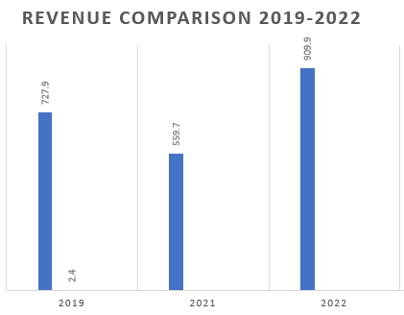
Figure 3: Revenue Comparison of Travelodge 2019-2022
Source: (Travelodge, 2023c)
Travelodge accrues its revenues from room bookings, sales of food and beverages, and hosting of conferences and events, among other services required by the guests. Over time, Travelodge has had stable revenue growth. In 2022, Travelodge enlarged by 16.7%, which shows the brand's ability to adapt to the changing market demand and to extend the hotel portfolio to include the budget-classed traveller in the category of those who appreciate low prices, not to the detriment of quality (Travelodge, 2023c). Travelodge maintains its revenue growth based on three strategies: operational efficiency, cost-effective management practices, and strategic expansion initiatives.

Market Position of Travelodge Hotel

Travelodge Hotels is one of the UK's largest budget hotels, offering straightforward, quality accommodation for business and leisure travellers nationwide. It is the second-largest chain of budget lodging houses in the UK, operating in significant locations within critical cities, airports, and other top destinations (Kunst, 2023).
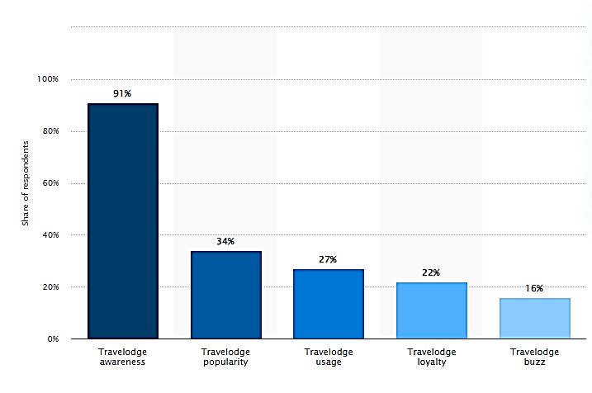
Figure 4: Brand Profile of Travelodge
Source: (Kunst, 2023)
Travelodge provides straightforward amenities and comfortable accommodations to travellers at reasonable prices. With over 600 hotels all around the country, Travelodge is the best and most convenient choice for every individual or family in search of affordable accommodation without compromising on quality. They plan to add 300 more hotels more hotels to the UK market (Taiwo 2023). Travelodge competes in the UK budget hotels market and with major brands such as Premier Inn, ibis Budget, and Holiday Inn Express. However, amidst great competition in the budget hotel market, Travelodge remains distinct due to its vast network of properties throughout the land, its high and dependable standards of service, and its commitment to price competitiveness. Travelodge's position on the market is further consolidated by its strategic pricing, operational efficiency, and focus on satisfying demand from budget-conscious travellers in the UK, hence the market-leading title for inexpensive lodging. Also, Travelodge plans to expand more in Spain by acquiring six more new properties, which shows the brand has a strong presence in the European region (Travel Wires, 2024).

Growth Potential of Travelodge Hotel

Travelodge Hotels has strong growth prospects in the UK's budget hotel industry. As an established brand with numerous properties, Travelodge is well-positioned to meet the rising demand for affordable accommodation (Travelodge, 2024). The company has seen a 16.7% increase in revenue, reflecting a growing preference for budget-friendly hospitality (Travelodge, 2024b). With strategic expansion efforts, competitive pricing, and a focus on quality service, Travelodge has the opportunity to further penetrate the market and boost its revenues. As the hospitality industry evolves and consumer preferences shift towards value-driven experiences, Travelodge's consistent and accessible lodging options position it well for continued success and expansion in the UK market.

Sustainability Report: Travelodge Hotel

Travelodge's second Sustainability Report highlights its commitment to a "Better Future," emphasising inclusivity, care, and environmental responsibility. The company aims to achieve net-zero emissions by 2050, promote social mobility, and reduce water consumption (Travelodge, 2022). Travelodge engages with stakeholders to ensure its initiatives are relevant and transparent. The report acknowledges current challenges in the hospitality industry while showcasing the company's strong financial performance and key sustainability goals. Notable achievements include promoting gender diversity in senior roles and providing CPR training to over 1,000 people. Travelodge is dedicated to continuous improvement for a better future (Travelodge, 2023a; Travelodge, 2023d).

Recommendations

Travelodge should ensure the strategic expansion of its properties in prime locations, competitive pricing, and prioritise sustainability issues through its operations. Travelodge can thus become a leading choice for budget-conscious travellers, add positivity to the environment, and make society flourish further by letting people get a standard guest experience with an inclusivity motto and by putting minimal environmental impacts.

Comparative Analysis of Shangri-La Hotel and Travelodge Hotel

Shangri-La Hotels and Travelodge Hotels serve distinct segments of the hospitality industry. Shangri-La is known for its luxurious experiences and global presence, attracting wealthy travellers with its premium offerings. On the other hand, Travelodge is known for being affordable and widely available, especially in the UK. Shangri-La's growing revenue, expected to reach $2.8 billion in 2023, highlights its appeal to high-end travellers seeking top-notch experiences. In contrast, Travelodge has grown its revenues to reach £909.9 million in 2022, capturing the cost-conscious market. As Shangri-La positions itself on the luxury front, sustainability, and excellent customer service, Travelodge positions itself in a no-frills space with the best deal for a broad population. Both are very strong in terms of sustainability, though this is often tied to their luxurious positioning, as in the case of Shangri-La. At the same time, Travelodge is more about making it relevant to its cost-conscious demographic. Finally, both Shangri-La and Travelodge have attested success in their respective niches with their applied unique strategies and holding market leadership, turning their hands to variously formulated customer needs in the hospitality industry.

Conclusion

In conclusion, the comparative analysis of Shangri-La Hotels and Travelodge Hotels highlights their distinct positions within the hotel industry. Shangri-La excels in providing luxury experiences, boasts a global presence, and prioritises sustainability. These factors have propelled it to the forefront of the luxury hospitality market with substantial revenue growth. In contrast, Travelodge focuses on affordability, extensive availability, and sustainability, catering effectively to budget-conscious travellers, and establishing it as a leading budget hotel chain in the UK. Both companies have thrived in their respective niches by addressing diverse customer needs uniquely. Moving forward, Shangri-La and Travelodge can enhance their financial performance by leveraging their distinct strengths, innovating guest services, expanding strategically, and emphasising sustainability in their operations. This analysis offers valuable insights into their financial management strategies and future growth potential, underscoring the strengths of these prominent hotel brands.

References

Berger, A., (2022). The Evolution of Budget Hotels: A Case Study on Travelodge.Hospitality Management Review, 2(3), pp. 233-246.
Drury, C. (2020) Management and Cost Accounting.Springer
Dutta, R. (2023). Innovative Marketing Strategies in the Hospitality Industry. Journal of Marketing Research 27(2), pp. 123-136.
Garrison, R. H., Noreen, E. W., & Brewer, P. C. (2020). Managerial Accounting (17th Ed.). McGraw-Hill Education
HospitalityNet, (2021). Shangri-La Steps Up Hiring in Line with Expansion Plans In Asia And Middle East, Finds Global Data Hospitality Net Available at: https://www.hospitalitynet.org/news/4104417.html (Accessed 29 April 2024).
Kunst, A. (2023) Travelodge brand profile UK 2022, Statista. Available at: https://www.statista.com/forecasts/1335657/travelodge-hotels-brand-profile-in-the-uk (Accessed: 29 April 2024).

Li, X. (2023) Shangri- La Hotels: A Paradigm of Luxury Hospitality. Journal of Hotel Management, 35 (4) pp 45-49

Madura, J., Hoque, A. and Krishnamurti, C. (2018) Financial management Theory and Practice Andover: Cengage Learning.

Marshall, T.(2023). Travelodge's Expansion into the European Market. International Hospitality Management 36(2), pp. 45-60.
Oh, S. (2024) Strategic Growth in Luxury Hospitality:The case of Shangri-La Hotels.International Journal of Tourism Management, 48(1)pp 15-29

Jones, R.(2023). Sustainability in Budget Hotels: The case of Travelodge. Journal of Sustainable Tourism, 31(1) pp 70- 85

Purnell, K. (2023) Makati Shangri-La reopens with sustainability focus | Philstar.com, www.philstar.com. Available at: https://www.philstar.com/lifestyle/business-life/2023/08/10/2287427/makati-shangri-la-reopens-sustainability-focus (Accessed: 05 May 2024).

Shangri-La (2022) SUSTAI NABILITY REPORT 2022, Shangri-La. Available at: https://sitecore-cd.shangri-la.com/-/media/Project/Shangri-La-Group/Investor/Files/Corporate-Governance-and-CSR/Sustainability-Reports/2022_SLA_Sustainability-Report_EN.pdf (Accessed: 05 May 2024).

Shangri-La (2023a) Cover Photos: 1. JEN Shenzhen Qianhai by Shangri-La 2. Kerry Hotel. Available at: https://sitecore-cd.shangri-la.com/-/media/Project/Shangri-La-Group/Investor/Files/Public-Disclosures/Latest-Top-Publications/e0069_230418_AR.pdf (Accessed: 05 May 2024).

Shangri-La (2023b) Shangri-La Corporate Profile, Shangri-la.com. Available at: https://www.shangri-la.com/group/investors/corporate-profile#:~:text=Shangri%2DLa%20Asia%20Limited%20is (Accessed: 05 May 2024).

Shangri-La, (2023c). Shangri-La Group. Shangri-La Available at: https://www.shangri-la.com/group/media/media_post?post=Shangri-La%20Group%20Releases%202023%20Full%20Year%20Results (Accessed 29 April 2024).
Singh, V., (2024). Financial Performance Analysis of Global Hotel Chains.Journal of Financial Studies 50(1), pp. 98-110.
Taiwo, I. (2023). Travelodge to open 300 more UK hotels following record first half.Hospitality Investors Available at: https://www.hospitalityinvestor.com/brands/travelodge-open-300-more-uk-hotels-following-record-first-half (Accessed 29 April 2024).

Travelodge (2022) Travelodge | Travelodge launches its new sustainability plan - ‘Better Future’, www.travelodge.co.uk. Available at: https://www.travelodge.co.uk/press-centre/press-releases/Travelodge-launches-its-new-sustainability-plan-%E2%80%98Better-Future%E2%80%99 (Accessed: 05 May 2024).
Travelodge (2023a) Sustainability Reports Travelodge. Available at: https://www.travelodgesustainability.co.uk/wp-content/uploads/sites/2/2023/05/Better-Future-Report-2023.pdf (Accessed: 05 May 2024).

Travelodge (2023b) Home – Annual Report, Travelodge Corporate Website. Available at: https://travelodge.co.uk/our-business/#:~:text=visitors%20each%20year.- (Accessed: 05 May 2024).

Travelodge (2023c) Financial Report, Travelodge. Available at: https://www.travelodge.co.uk/blog/news/travelodge-trading-record-results-2022-2023/ (Accessed 05 May 2024).

Travelodge (2023d) Travelodge reveals 2023 plans for its sustainability programme ‘Better Future’, Travelodge Corporate Website. Available at: https://www.travelodge.co.uk/our-business/blog/2023/06/15/travelodge-reveals-2023-plans-for-its-sustainability-programme-better-future/ (Accessed: 05 May 2024).

Travelodge (2024) Strategic Expansion and Marketing Position. Available at: https://travelodge.co.uk/our-business/blog/press_release/record-full-year-performance-with-travelodge-well-positioned-for-long-term-growth/ (Accessed: 05 May 2024).

