The Global Business Environment-Environmental Analysis of Automobile Industry

Penka Murdzheva
Student ID:2122606
Module code:LCBB4005
Lecturer:Alfred Mensah and Nadeem Mirza

Table of Contents
Introduction 3
Main body 3
External analysis 3
Political factors 3
Economic factors 4
Social factors 5
Technological factors 6
Environmental factors 7
Legal factors 7
Summary 8
Industry analysis 8
Bargaining power of suppliers 8
Bargaining power of buyers 8
Threat of new entrants 9
Threat of substitutes 9
Existing rivalry 9
Summary 9
Internal analysis of Tesla 10
Conclusion 12
References 13

Introduction
The global automobile industry has a total size in term of revenue reaching $3.8 trillion (IBIS World, 2021). The sector experiences a major decline by 18% during the pandemic 2020 but recovery is taking place at the current stage of development by achieving 16% revenue growth in 2021 and 5% in 2022 (Economist Intelligence Unit, 2020; IBIS World, 2021). Given the size and importance of the sector, as well as the turbulent developments in the last several years, it is quite relevant to analyse the factors which influence the trends in the industry. In this relation, the report aims at exploring the major external opportunities and threats, as well as the specific features of the industry affecting its performance.
The selected organisation is Tesla. It is a popular automobile brand with specialisation in the electric segment (Reuters, 2022). Tesla designs, develops, manufacturers, sells and leases fully electric vehicles and energy storage systems. The success of the organisation is seen by its market capitalisation approaching $942 billion (Reuters, 2022). The analysis of the company is included in the report as a way of exploring the interactions between Tesla and the industry as a whole.

Main body

External analysis
The external environment considers the PESTEL model as a road map in understand the effects of different political, economic, social, technological, environmental and legal variables producing opportunities and threats to the companies in the automobile sector (Worthington and Britton, 2015). Each of the six variables is analysed by including the most important evidence from a global perspective.

Political factors
Political factors determine the quality of the business environment (Worthington and Britton, 2015). The data from the corruptions perceptions index by Transparency International (2021) shows the existence of different political systems around the world in terms of efficiency of public institutions and rule of law. The lighter areas indicate countries with stable political systems, transparent and efficient public institutions, which support business development, whereas darker countries pose political challenges for automobile companies due to instability, corruption and lack of efficient institutional framework (Transparency International, 2021).
Figure 1 – Corruption levels around the globe
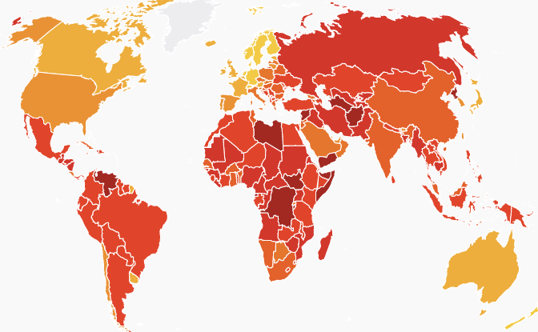
Source: Transparency International (2021)
In addition to the corruption problem and political instability in many regions, the global political environment is also worsened by the conflict in Ukraine and the corresponding geopolitical instability which worsens the conditions of doing business by multinational automobile companies.

Economic factors
The economic conditions are also challenging. The world economy experienced a global recession in 2020 (World Bank, 2022). The decline in the GDP level exceeded 3% and surpassed the recession during the global financial crisis of 2008/09, as shown below (World Bank, 2022). As a result, consumers’ purchasing power and confidence are reduced, despite the positive impact of the recent post-pandemic economic recovery.
Figure 2 – Global economic growth rate (%)
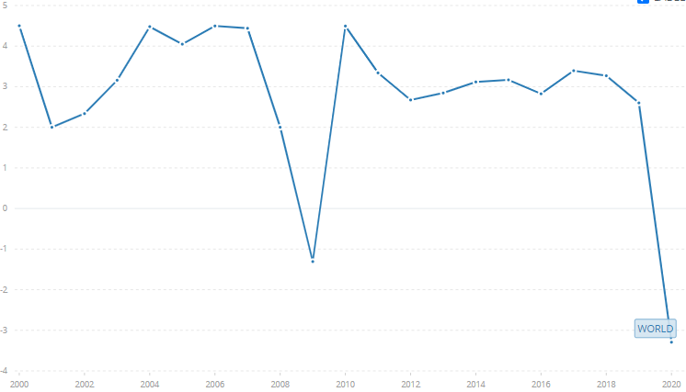
Source: World Bank (2022)
Another negative economic factor at global scale refers to the escalating inflation rates. As explained by DiCamillo (2022), global inflation rate already exceeds 6% due to rising energy, food and other costs. This level of price increase is quite high by historical standards and causes uncertainty among consumers together with a meaningful reduction in the purchasing power, as more income is dedicated towards the acquisition of basic products, such as shelter, food and energy (DiCamillo, 2022).

Social factors
Socio-demographic trends also determine the nature of demand (Worthington and Britton, 2015). The main consumer trends express the increasing interest in electric vehicles. As shown below, the total stock of electric vehicles around the world has exponentially increased in the last decade by exceeding 11 million units (Knoema, 2021). Interestingly, the growth in the segment was not interrupted during the pandemic 2020 which clearly demonstrates the resilience and impact of the trend towards electrification (Knoema, 2021). Thus, social factors have to recognise the growing importance of sustainability among the buyers of automobiles.
Figure 3 – Global stock of electric vehicles
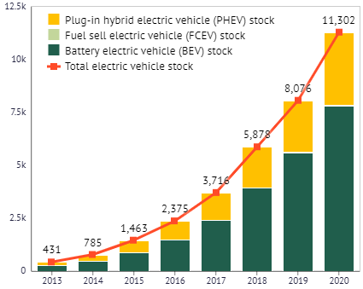
Source: Knoema (2021)
Another key social factor, which determines the long-term growth of the industry, refers to demographic trends. According to Worldometers (2022), global population is approaching 8 billion people and expectations are for continuous growth; thereby, supporting demand for vehicles in the future.

Technological factors
The technological intensity of the automobile sector also determines its dependence on the implementation of new technologies and process as drivers for innovation and improved output. According to StartUs (2022), there are ten major technological trends with a positive impact on the sector. Each of the areas is quantified according to the level of importance. As shown below, the development of autonomous vehicles, as well as electric ones is a key industry trend (StartUs, 2022). The use of 3D printing, Big Data analytics, artificial intelligence, enhanced connectivity and shared mobility are also recognises as key technological drivers for progress (StartUs, 2022).
Figure 4 – Key technological trends in the global automobile industry
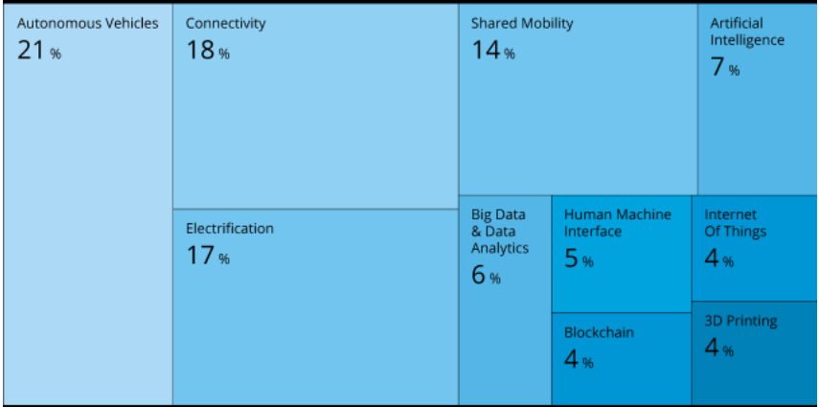
Source: StartUs (2022)
In this relation, the innovation and productivity improvement in the automobile sector are supported by the emergence and implementation of numerous technologies.

Environmental factors
From an environmental point of view, the automobile sector is a subject of increased regulation given the negative impact on the environment. Automobile companies are required to comply with stricter standards in terms of safety, fuel efficiency, as well as reduction of carbon dioxide and other emissions (Boyle, 2021). The increased regulatory pressure supports innovation, but also causes extra costs for automobile manufacturers.

Legal factors
Finally, the legal aspects of doing business at a global scale are discussed. Typically, automobile manufacturers face a complex environment due to the need to comply with specific laws and regulations in each country or origin of operations. Without doubt, the necessity to adjust processes towards the requirements in each geographic market could be seen as a source of extra expenses.

Summary
The external environment is mixed. Opportunities emerge from changing consumer trends and technological progress. Nevertheless, automobile producers have to cope with political uncertainty, economic challenges related to the pandemic and high inflation, as well as complexities of addressing environmental and legal regulations. The analysis continues with an exploration of the specific industry-level trends.

Industry analysis
The model by Porter (1979) is of significant importance in analysing the developing trends in the industry. Porter’s Five Forces framework emphasises on the importance of evaluating the bargaining power of suppliers and buyers as key factors of supply and demand. Market structures are also assessed by focusing on the potential threats of new entrants, substitute products and existing rivalry (Porter, 1979). Each of these five factors is analysed in an attempt to understand the level of industry profitability.

Bargaining power of suppliers
The restricted supply of chips and other essential components is a key challenge for automobile producers (Jim, 2022). Chip suppliers are just several large producers and they cannot be replaced; hence, there are meaningful delays in the manufacturing process, as well as higher costs due to the supply shortage which is expected to last for a continuous period of time (Jim, 2022). These considerations demonstrate the currently high bargaining power of suppliers.

Bargaining power of buyers
The bargaining power of buyers is also quite high. This is explained by the fact that consumers can choose between many brands in the marketplace without facing high switching costs (Ashraf, 2019). The challenging inflationary environment has also made buyers more price-sensitive; hence, price bargaining is more likely and it reduces profit margins 9Ashraf, 2019; DiCamillo, 2022).

Threat of new entrants
The threat of new entrants is limited. This is explained by the fact that the industry is capital intensive. There are significant capital requirements to develop global manufacturing, supply chain and distribution facilities (Ashraf, 2019). Moreover, existing car manufacturers have established brands and reputation in the marketplace – key factors for discouraging potentially new entrants (Ashraf, 2019).

Threat of substitutes
The threat of substitutes is high due to the existence of numerous alternative transportation modes. Often, the existing alternatives, such as public transportation, motorcycles, bikes and others, deliver low costs and more environmentally-friendly options which are preferred by a higher number of sustainable consumers (Ashraf, 2019).

Existing rivalry
The existing rivalry is quite intense; thereby, having a negative impact on profitability. As explained by IBIS World (2021), the annualized growth rate of the global automobile industry for the 5-year period between 2017 and 2022 is negative: -0.4%. This means that the industry is mature and perhaps entering in a decline stage. In this relation, global automobile manufacturers do not have new revenue sources (expect for the electric vehicle segment) which intensifies the competition for a shrinking consumer demand.

Summary
Considering all, the automobile sector faces low profitability prospects as a result of the combination of intensive rivalry, restricted supply and demand and alternatives. Despite being protected against new entrants, the industry is quite competitive which requires constant innovation and improvement by existing brands in order to sustain the positions and profitability in a challenging marketplace.

Internal analysis of Tesla
The strengths of Tesla can be seen in many areas of the value chain – a model showing the primary and secondary areas of value creation (Porter, 1990).
Figure 5 – Value chain model
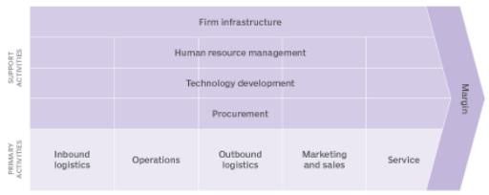
Source: Chai (2022)
The operational efficiency of Tesla can be seen by the ability of the brand to continuously decrease product prices. For example, Model 3 costs only $39,000 which shows enhanced cost control and productivity (Lambert, 2019). The outbound logistics is quite innovative, as Tesla does not use dealerships; instead, only online-based sales channels for direct selling to customers are incorporated (Zucchi, 2021). The success of the marketing and sales process is not only driven by the focus on online channels, but also given the leading market position of the brand. Tesla occupies 14% of the electric vehicle segment (Patton, 2022). The service level is also perceived as being high-quality (Zucchi, 2021). In this light, the high brand value of $46 billion (ranking on the 3rd position) clearly shows the marketing and service quality of Tesla (Brand Finance, 2022).
There are also strengths in respect to some secondary activities. For example, the firm infrastructure has been expanded by having assets exceeding $62 billion, as well as global distribution network (Reuters, 2022). The brand is also popular with its innovative culture, product development and ability to continuously change – key features of the tech-driven approach to business (Tesla, 2019). Nevertheless, for the purpose of the critical analysis, it should be noted that Tesla has experienced product delivery delays and quality issues requiring product recalls (Rudgard, 2019). Thus, procurement and supply management issues are present which erode the generated value to customers.
The purpose of the SWOT analysis is to selectively present the main internal and external factors affecting a given company (Worthington and Britton, 2015). In this way, it is possible to better develop future strategies on the basis of internal strengths/weaknesses and external opportunities/threats (Worthington and Britton, 2015). The report already explored the external and industry environment; thereby, being able to identify relevant opportunities and threats on the basis of the research findings. The key remarks about Tesla’s value chain performance also deliver relevant strengths and weaknesses to be considered as a part of the SWOT analysis.
Table 1 – SWOT analysis of Tesla
Internal factors
Strengths  - Solid financial resources.  - Strong brand value.  - Innovative organisational culture.  - Operational excellence and competitive prices.  - Large market share and elimination of dealerships. | Weaknesses  - Supply chain issues leading to delays in the product delivery.  - Technical issues requiring product recalls and extra costs.
External factors
Opportunities  - Technological progress stimulating innovation and competitiveness.  - Strong consumer preferences for electric vehicles. | Threats  - Global political uncertainty.  - Economic challenges restricting demand.  - Environmental and legal compliance costs.  - Intensive industry rivalry.  - Supply chain issues.

The SWOT analysis demonstrates the key strengths of Tesla which support future expansion in the marketplace. The company should incorporate its strengths in order to benefit from the existing opportunities in the marketplace, especially increasing consumer preferences for sustainable products. Future success; however, strongly requires the elimination of existing internal weaknesses which inhibit growth and development. Moreover, as a global company, Tesla has to adapt to external challenges which may restrict trade and cause direct financial losses. Although beyond the control of the organisation, external threats deserve special attention as a part of a risk management strategy.

Conclusion
In the context of research findings, the global automobile industry experiences a difficult period where the cascading effects of the pandemic, economic recession and geopolitical instability have negatively impacted the sector. Such dynamism requires extensive innovation and risk management in order to sustain competitive advantage in the marketplace. The case of Tesla is one of the few success stories in the industry; however, the company should not be complacent. Instead, continuous improvement and adaptation to external and industry trends remain necessities to stay competitive in a competitive environment.

References
Ashraf, R. (2019) Porter’s Five Forces of the Automotive Industry, [online] Available: https://www.linkedin.com/pulse/porters-five-forces-automotive-industry-rizwana-ashraf-1c/ [Accessed: 3 May 2022]
Boyle, M. (2021) What Regulations Affect the Automotive Sector? [online] Available: https://www.investopedia.com/ask/answers/042015/how-much-impact-does-government-regulation-have-automotive-sector.asp [Accessed: 3 May 2022]
Brand Finance (2022) Tesla Shows No Intention of Hitting Brakes, [online] Available: https://brandfinance.com/press-releases/tesla-shows-no-intention-of-hitting-brakes#:~:text=The%20brand's%20impressive%20growth%20continued,see%20significant%20growth%20this%20year [Accessed: 3 May 2022]
Chai, W. (2022) Value chain, [online] Available: https://www.techtarget.com/searchcio/definition/value-chain [Accessed: 3 May 2022]
DiCamillo, N. (2022) Inflation rates are rising around the world, [online] Available: https://qz.com/2153852/inflation-rates-are-rising-around-the-world/ [Accessed: 1 May 2022]
Economist Intelligence Unit (2020) The global automotive sector to see double-digit growth in 2021, [online] Available: https://www.eiu.com/n/the-global-automotive-sector-to-see-double-digit-growth-in-2021/ [Accessed: 30 April 2022]
IBIS World (2021) Global Car & Automobile Sales - Market Size 2005–2027, [online] Available: https://www.ibisworld.com/global/market-size/global-car-automobile-sales/ [Accessed: 30 April 2022]
Jin H. (2022) Automakers, chip firms differ on when semiconductor shortage will abate, [online] Available: https://www.reuters.com/business/autos-transportation/automakers-chip-firms-differ-when-semiconductor-shortage-will-abate-2022-02-04/ [Accessed: 2 May 2022]
Knoema (2021) Global Automotive Industry Overview | Data and Analysis, [online] Available: https://knoema.com/infographics/gdwntfe/global-automotive-industry-overview-data-and-analysis [Accessed: 2 May 2022]
Lambert, F. (2019) Tesla Model 3 Takes Over the UK With a Record Quarter, [online] Available: https://electrek.co/2019/10/09/tesla-model-3-uk-record-quarter/ [Accessed: 3 May 2022]
Patton, M. (2022) Competition Heats Up For Tesla In EV Market, [online] Available: https://www.forbes.com/sites/mikepatton/2022/03/30/competition-heats-up-for-tesla-in-ev-market/ [Accessed: 3 May 2022]
Porter, M. (1979) How Competitive Forces Shape Strategy, Harvard Business Review, Vol. 57, pp. 86-93.
Porter, M. (1990) The Competitive Advantage of Nations. Free Press
Reuters (2022) Tesla Inc., [online] Available: https://www.reuters.com/companies/TSLA.OQ [Accessed: 1 May 2022]
Rudgard, O. (2019) Tesla Drivers in UK Claim They Wait Months For Parts, [online] Available: https://www.telegraph.co.uk/technology/2019/08/11/tesla-drivers-uk-claim-wait-months-parts/ [Accessed: 3 May 2022]
StartUs (2022) Top 10 Automotive Industry Trends & Innovations in 2022, [online] Available: https://www.startus-insights.com/innovators-guide/automotive-industry-trends-10-innovations-that-will-impact-automotive-companies-in-2020-beyond/ [Accessed: 2 May 2022]
Tesla (2019) Tesla’s mission is to accelerate the world’s transition to sustainable energy, [online] Available: https://www.tesla.com/about [Accessed: 3 May 2022]
Transparency International (2021) Corruption Perceptions Index, [online] Available: https://www.transparency.org/en/cpi/2021 [Accessed: 1 May 2022]
World Bank (2022) GDP growth (annual %), [online] Available: https://data.worldbank.org/indicator/NY.GDP.MKTP.KD.ZG [Accessed: 1 May 2022]
Worldometers (2022) Current World Population, [online] Available: https://www.worldometers.info/world-population/ [Accessed: 1 May 2022]
Worthington, I. and Britton, C. (2015) The business environment. 7th edition, Harlow: Pearson Education
Zucchi, K. (2021) What Makes Tesla's Business Model Different? Available: https://www.investopedia.com/articles/active-trading/072115/what-makes-teslas-business-model-different.asp [Accessed: 3 May 2022]

