Patisserie Valerie

STUDENT NAME: MOHAMMADJUNAID KHWAJA
STUDENT NUMBER: 1711085
MODULE CODE: LCMB7001 ASSESSMENT-1
MODULE TITLE: MARKETING MANAGEMENT
LECTURER: RICHARD SMALL

Contents
1.0 Introduction 3
2.0 Background of the company 3
3.0 Market analysis………………………………………………………………………………..4
3.1 PESTLE analysis 4
3.2 Segmentation, Targeting and Positioning 5
3.3 SWOT analysis 6
4.0 Marketing Mix 7 P’s 7
5.0 Brand Equity 10
5.0.1 Adoption lifecycle process…………………………………………………………………11
5.1 Customer Journey Map and Touch points 11
5.1.2 Brand Relationship…………………………………………………………………………14
5.2 Evaluation of Critical Success Factor 15
5.2.1 Gap model………………………………………………………………………………….17
5.3 Porters Five Force Analysis 18
5.3.1 Consumer Decision Making Model for Patisserie Valerie………………………………...19
6.0 Recommendation 20
7.0 Conclusion 20
After in store experience some questionnaire -answers……...…………………………………..21
Reference 23

Introduction
The company Patisserie Valerie is mainly a chain of café located in the United Kingdom where the company highly specializes in continental breakfasts, handmade cakes, coffees, teas and lunches.The company Patisserie Valerie was first opened in the year 1926 in Central London near,Frith,Street.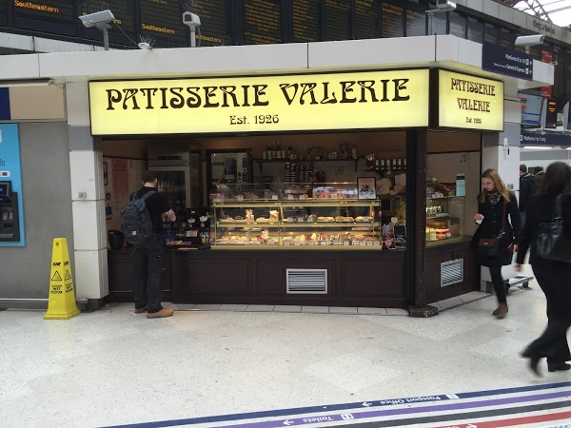

Background of the company
Due to the bombing in World War 2, the store was destroyed and they have to move to Old Compton Street. The main headquarter of Patisserie Valerie is located in Hall Green which falls under the state of Birmingham, and the founder of the company is Madam Valerie. From the year 2006, it could be found that the chain of Patisserie Valerie is expanding their business since 2006, which was from eight shops to 192 shops in the year 2017. The company is now operating 206 outlets, and total numbers of employees in the Patisserie Valerie shop are approx 3000 (thisismoney.co.uk, 2018). The company Patisserie Valerie is announcing plans for raising a fund of about 35 million pounds on London Alternative Investment Market and the companies are facing fraudulent accounting irregularities with two unauthorized drafts that mainly lead to misstatement for the company with an amount of 20 million pounds.

3.0 Market Environment analysis

3.1 PESTLE analysis
Political | - Political Stability is very high in UK  - Brexit are creating many political debates and uncertainty  - As said by Peattieand Belz (2013), the Brexit either can create opportunities for the country or can bring chaos to their political system.  - One of the most popular destinations for FDI or foreign direct investment is UK.
Economy | - The country UK has 5th largest economy according to their nominal GDP  - The minimum wage for people whose age is 25 is about 7.5 pounds per hour and the wage is increasing for about 7.9 pounds by April 2018.  - The rate of inflation is rising for about 3.1 percent in the year 2017
Social | - As said by Peattieand Belz (2013), the country UK has vast consumer market, the numbers of populations are increasing everyday, and it will reach 74 million by the year 2039.  - Many companies’ ahs able to benefited in their business with the help of local consumers.  - The population is multicultural and has high standard of living.
Technological | - UK is high advanced with their technology  - London is great hub for both technological and financial institutions.  - The country are developing new technologies for offering the best solutions for their customers
Legal | - The employment Act 1996 protects rights of all employees  - Equality Act 2010 helps the people to protect people from any kind of discrimination
Environmental | - The percentage of pollution is less in United Kingdom  - The country are trying their best to bring awareness to people for the protection of environment
Table 1: PESTLE analysis

3.2 Segmentation, Targeting and Positioning
The market segmentation is the process of dividing the market into many distinctive groups for buyers with different behavior, characteristics or needs that require separate marketing programs or products is called segmentation. As said by Sargeantand MACQUILLIN (2016), the café Patisserie Valerie is mainly based on Socio-Economic segmentation that highly concentrates on the social class where the business class people are high in one of the major cities of UK where the people always wanted to have a cup of coffee with excellent facilities and atmosphere. The café Patisserie Valerie has segmented their market both demographically and geographically by selecting proper stores where they can able to find the appropriate class of people and people who love to baked items with a cup of coffee.
After the company, Patisserie Valerie was able to define their market segments they must make proper decisions for targeting the right group of customers with the help of strong philosophy of the market. As said by Zimmermanand Blythe (2013), the company Patisserie Valerie must target segments where it can generate a huge amount of profit and the target segments to make a significant amount of value for their customers and sustain their business for future. The company PAtissare Valerie needs to develop more relationship that is reputable for all the customers for entering a new market in the United Kingdom. The company Patisserie Valerie must target their parents and the young children. The company Patisserie Valerie is also targeting their many teenage people who are studying in school and college.
The market positioning is arranging for the entire product to occupy a desirable, distinctive and transparent place to compete for the products for targeting customers. The positioning of the product holds the competitors in the consumers' mind and the company Patisserie Valerie is gaining a unique market position for all of their products to the consumer the market. As said by Villeneuve and Pasquier (2017),the company Patisserie Valerie has always positioned them to provide a highly reputed brand to plan the positioning to gain great reputation in the market. The company Patisserie Valerie has planned their positioning to distinguish their products with other most competitive brands. As said by Weinsteinand Pohlman (2015), the positioning strategy of the company Patisserie Valerie is mainly based on the customers and provides an excellent facility regarding furniture, music, interior, layout and satisfaction of the employee. The company Patisserie Valerie always makes the employees to be their partners and provides personal security to provide great freedom for participating in every decision.

3.3 SWOT analysis
Strength  - Has great strength in their overall cash flow  - Performance is high in new markets  - The workforce are highly skilled  - The low cost structure to produce low price products and low cost  - The company are investing extensively to train their employees that results in employment  - High quality baking products  - Strong presence in the social media | Weakness  - Research and Development team needs to be improved to provide proper quality of baking products according to the provided price.  - Some of the properties are rented and for this reason majority of their products are high priced  - As said by Hutchinsonet al.(2015), they are facing great problem in their cash flows and backgrounds of the workers is less who has less training  - The company has less control on their quality according to their budget and provided price
Opportunity  - Due to increase of internet users the company has huge opportunity to gain feedback from the customers and expand their presence online  - E-commerce are rising as the growth and trend in their sales about their products to open online stores  - As said by Peñalozaet al.(2013), social media are attracting many users with the help of various platforms like Instagram, Facebook and Twitter | Threat  - There are competitors who are opening new baking stores  - The bargaining power of suppliers are increasing at huge rate  - As said by Vitouladiti (2014), there are many cafes like Starbucks who are also providing baking products with their coffee products to their customers
Table 2: SWOT analysis

4.0 Marketing Mix
4.0.1 Product
The product of Patisserie Valerie is perishable, heterogeneous and intangible where the consumption and production are highly inseparable. The Patisserie Valerie is one of the different outlets in the United Kingdom. The Patisserie Valerie sells coffee as their main products and offers lots of flavors and variants in their coffee products. One of the most famous coffee products are Patisserie Valerie are Latte, Cappuccino, Americano, Flat white, Expresso, Mocha etc. As said by Banterleet al.(2014), the café also has separate ice blended products which offer Patisserie Valerie are Mocha cream, coffee cream, Lemonade, Frostino etc. The company PAtissare Valerie sells their products in their business and caters with their vending machines for all the colleges and corporate offices under the brand name of Patisserie Valerie. The company is highly popular with their varieties of cakes like vanilla cake, pastries, plum cake, cheese cake and snacks like the sandwich, pizza etc.
4.0.2 Place
The total number of outlets that the company Patisserie Valerie has 192 outlets in the UK and the outlets are targeting mainly the rich people and upper middle class in the country UK. The Company has the enormous amount of opportunity in the country UK because the majority of the people can afford to buy snacks and coffee from the café (Ft.com, 2018). The companies Patisserie Valerie are mainly targeting various airport, stations, shopping malls, sports stadium and famous streets to open the outlet in the UK. The company Patisserie Valerie also modifies their menu according to the preference of their customers to gain stronger customer base in the UK.
4.0.3 Pricing
The Patisserie Valerie has diverse price offering in their coffee and baking products that influence the competition. Patisserie Valerie offers the products at premium range due to their high quality and value to their brand. The Patisserie Valerie always believes that price is secondary for focusing on delivering excellent quality products and their customers. As said by Coombesand Nicholson (2013), the company provides two types of variants in their beverages as if large and small size coffee products that are directly proportionate according to the quantity that is being ordered. The company Patisserie Valerie sells their coffee with the help of their vending machine and price is competitive to all the competitors Starbucks, Costa Coffee etc.
4.0.4 Promotions
The patisserie Valerie does not rely on print media and TV advertisement very much for the promotion of their stores and products. The company provides the promotional strategy for al new products with their free samples for their customers to gain positive review about their products and purchase intention. The company must always focus on the digital media for the promotion of their products and campaigns to increase proper connection from their customers. As said by Aghazadeh (2015), the company must run a separate loyalty program that will help infrequent visits of the customers to gain more discounts on their products, and they can separate points for every purchase of their products from any PatisserieValerie outlet. The company lacks a strong campaign that will help to promote the coffee and baking products to their customers, and they must use a proper logo to attract customers.
4.0.5 People
The company Patisserie Valerie mainly focusing on their customers and employees to gain growth in their business. The employees of the Patisserie Valerie are highly trained to provide polite and professional behaviour to their customers. As said by Aghazadeh (2015), each Patisserie Valerie treats all of their customers with an overall experience of their baking products and coffee products that are highly dependent on their employees. The company uses a considerable range of machines to process various fee from their customers like online payment, cash payment or debit/credit cards etc.
4.0.6 Process
The baking products and coffee products of the Pattisare Valerie follows the standard procedures like other competitors. Some of the outlets of Pattisare Valerie have sitting arrangements and majority of the outlets has takeaway service with less number of seats.
4.0.7 Physical Evidence
The outlets of PAttisare Valerie are one of the physical evidence for the company, and it has chain outlets all over the UK with the total number of 192 outlets. The significant parts of the business are established in London, Birmingham, Ireland etc. in the UK. The products that are being offered by Pattisare Valerie are with their attractive packaging and sells small merchandise like the branded cup to the customers.

5.0 Brand Equity
The brand equity refers to the premium value where the company able to generate from their products through which the company can able to recognize the name of the company. The customers of Patisserie Valerie are all over the social networks and web about their presence to gain a proper brand engagement on the website Patisserie Valerie, and the website provides excellent use of their website and social media page for tough conversations from their customers to gain feedback about their products and services provided to them. As said by Maglioand Spohrer (2013), the consumer-brand relationship is significant for the company Patisserie Valier that helps proper engagement among the seller and buyers for the creation of a long-term relationship with the help of relationship builder.
The company Patisserie Valerie must provide unique brand experience for their customers to create a solid customer-brand relationship because the companies are lacking a proper strategy to attract an ample amount of customers with their approach. Brand satisfaction is one of the most important factors that provide a huge effect on the loyalty of the brand, and the brand satisfaction will produce positive experience on their brand. The customer returning to the shop for buying the same products increases the overall brand loyalty. As said by Möller (2013), the company must gain opinions from their customers from their online websites or social media to understand what do they lack in their business that reducing the growth of their business. Patisserie Holdings has the total number of five brands, which are Lurkers, Patisserie Valerie, Philpotts, Spice and Flour Power city and Baker and Spice.
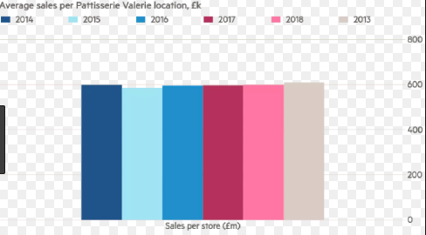
Figure 1: Average Sales per Patisserie Valerie
(Source: https://ftalphaville.ft.com/2018/10/16/1539662400000/Too-smooth--the-red-flag-at-Patisserie-Valerie-which-was-missed/)
5.0.1 Adoption lifecycle process
The adoption lifecycle process mainly explains the acceptance or adoption of the innovation or product process where the new product is primarily known as innovators, which mainly is being followed by the early adopters. After the early adopters come to the late majority and old majority and the final group is known as Phobics. The product adoption cycle must be followed by the company Patisserie Valerie to improve their products according to the price they are providing to attract their customers.
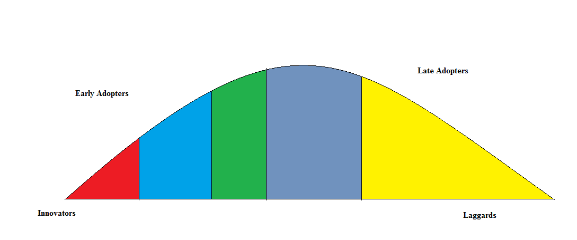
Figure2: Adoption Process Cycle for Patisserie Valerie
From figure 1, it could be found that for the first stage of the company Patisserie Valerie that is innovators are mainly adopting with the innovation of the baking products. In this stage, the innovation process is high for attractive pastries and snacks that will attract the customers it can be found out that the innovators in the adoption lifecycle process of Patisserie Valerie are ruling about 2.5 per cent. The innovators are mainly the chefs in the patisserie Valerie who are primarily the creator of all quality pastries and sandwiches. The innovators of the patisserie Valerie has the highest social class and have an enormous amount of financial transparency to every interaction with other employees who are mainly interacting with their customers. About 13.5 per cent is the early adopters, which fall primarily under second fastest individuals who provide innovative ideas for attracting new customers in the market. The early adopters of the company Patisserie Valerie are mainly advanced in education and higher in social status. About 34 per cent of the individuals are mostly majority who mostly able to adopt the marketing strategy provided by the Patisserie Valerie, and the process tends to be slower. For example, change in the pricing in approach for Patisseries Valerie will make the process lower. About 34 per cent of the market strategy for the Patisserie Valerie that are being adopted by the customers. About 16 per cent are Laggards are the last group who are being selected with the innovation that has very little opinion leadership.

5.1Customer Journey Map
The customer journey provides the visual representation of the experience of all the customers they have with the company Patisserie Valerie and helps to provide detailed information about the experience of the customers with the brand. It helps the company like Patisserie Valerie to approach their customers and understand their perspectives for every customer. As said by Ingenbleeket al.(2015), it helps the company Patisserie to focus their business according to the needs of the customers at various stages and provides an outside perception to their sales process and pricing strategy. It also reveals the necessary gaps between the customers and the company so that the Patisserie Valerie can gain higher conversion rates.
 | Cake and pastries | Snacks | Coffee Products | Service | Packaging
Touch points | 1. Some of the cake are very delicious mainly the vanilla, plum and fruitcake.  2. All the cakes are being baked with great quality of raw materials  3. All the pastries are highly attractive for the customers | 1. One of the famous snacks is Pizza, patties, croissants.  2. As said by Fernandezet al.(2014), there are many food craving snacks that can fill up people when they are shopping or in airports | 1. Thecompany provides one of the best cappuccino, mocha, frappe with a free cookie  2. The blended coffee used by the company is very good | 1. All the staff knew what the customers required.  2. All the staffs are not confused with the customers’ demands  3. They were friendly and polite. | 1. The packaging is highly attractive  2. The packaging has very attractive color and logo in it.
Thinking and Feeling | 1. The cost of pastries is very for the people because other competitors at cheaper price are providing same qualities of pastries.  2. Lack of proper decoration and taste in the cake according to the provided price | 1.The cost of the snacks is overpriced and many people do not buy snacks  2. As said by Järvinenand Taiminen (2016), majority can buy the same snacks at low price at other café who provides the same quality. Price needs to be checked | 1.ThePatisserie Valerie has the best quality products that are being provided to the customers.  2.However, the Starbucks coffees are best and much cheaper than Patisserie Valerie. | 1. There is no problem with the employees because the service person provides the best quality service to their customers. | 1. The packaging provided by the company is highly attractive for the people.  2. Many people can able to identify the brand by looking at packaging box.
Ideas of improvement | 1. The company must analyse their product quality they are providing according to the offered price.  2. It is because many customers are not at all satisfied with the taste according to the amount of food. | 1. As said by Brown (2016), it is similar like cakes and pastries the company must revise their quality of food they are providing to their customers, and  2. They must also change the prices properly to attract more customers. | 1. The company must analyse the various strategies used by other competitors like Starbucks who are providing the best value coffee at high prices. | 1. Proper training needs to be provided to all the employees to provide best services to their customers. | 1. The amount invested in the Packaging must be reduced a bit to revise the prices of their food and coffee products.

Table 3: Customer Journey Map of Patissare Valerie
5.1.2 Brand Relationship
The brand relationship is significant for the customers and the company Pattiserie Valerie to bring positive feelings and perceptions among the customers. The strong brand relationship helps to build a proper trust that helps to endure great relationship and leaves a very strong correlation to all the new and existing customers. For this reason, there is the requirement of repeated interactions among the customers to reflect strong characteristics in their products even if their prices are high for the customers.
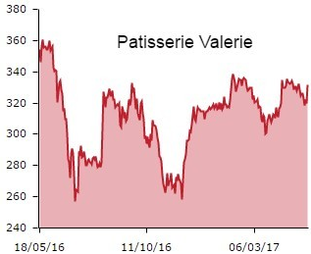
Figure 2: Performance of Patisserie Valerie
(Source: https://socialsteve.wordpress.com/tag/brand-relationships/)
From the analysis of figure 2, it has been found the company Patisserie Valerie was highly demanded by the customers in the year 2016 than in the year 2017 and later. The performance is much higher in the year 2016, but the execution was bit lower in October 2016, but it raised in the year 2017. The main reason for dropping in the number of customers is the high price in their products. Many competitors in the UK are providing the same quality baking products at a low price.

5.2 Evaluation of Critical Success Factor
The number of areas in the company Patisserie Valerie is limited gets satisfaction to ensure positive competitive performance for the café and pastries stores. Some of the major cities the company Patisserie Valerie needs to identify and analyse the right areas for flourishing their business in future to attract more customers. The company Patisserie Valerie needs to make an effort for receiving careful and constant attention in their management and business strategy. As said by McDonaghand Prothero (2014), all the staffs and management must work hard with the variables so that they can correlate with outcomes and have the more casual effect. The identification of the critical success factor helps to analyse the result of the exploration and research. The managers of the company Patisserie Valerie must identify the measurement that translates their actions into meaningful indicators about the effectiveness of business and training time.
Logistics | Marketing
Employees | Expenses
Table 4: Success Factor for Patisserie Valerie
The main success factor for the company Patisserie Valerie is the logistics because the competition mainly includes grocery stores, other bakeries, big-box retailers, specialty shops and café like Starbucks. Expansion of the business comprises mostly corporate delivery service to the major areas like near office, shopping malls, near schools or colleges and other attractive places where the company will receive potential customers. As said by Raza-Ullahet al.(2014), the next success factor for the company Patisserie Valerie is marketing that differentiates themselves from other bakeries because with proper promotions they can attract right targeted customers. For example: If the baked goods of Patisserie Valerie are made up of all natural resources they must announce it so that all the customers know the difference in their baked products. If the baked products of Patisserie Valerie are certified, vegan, kosher or made with great ingredients that are costly and they must include it in the market materials.
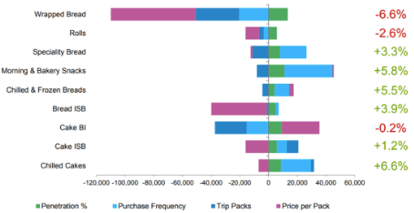
Figure 3: Patisserie Valerie purchase segment
(Source: Raza-Ullahet al. 2014)
From the figure 3, it could be found that major demanded products for the customers is the bakery snacks and the frozen breads that are highly popular in Patisserie Valerie. However, the performance is very low for cake in Patisseries Valerie. Majority of the customers are mainly fond of chilled cakes and specialty breads in Patisserie Valerie. The company must ensure their web presence that reflects unique value of their brands, benefits and products. The company must engaged with their potential customers with the help of social media to understand what do they lack in their products and service. As said by Šimberová (2014), the company Patisseries Valerie will also be able to know why people do not like their baked products and why their baked products are overpriced for many people. The employees of the bakery can lead their business to the failure of success because without proper chefs and staffs the company will not grow successfully and cannot provide unique taste to their baked products. F
5.2.1 Gap model

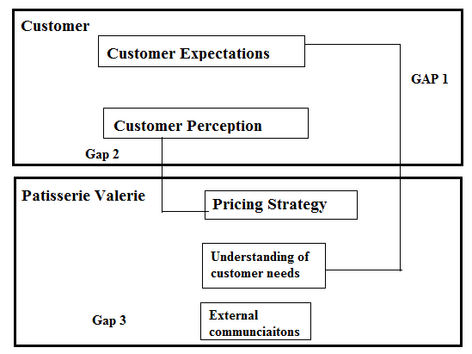
Figure4: Gap model
From the overall analysis of figure 4, it could be found that there are mainly gaps that had been recovered from the model that there are mostly three gaps. The customer expectations are the first most important thing for the company Patisserie, Valerie, to focus on because the quality of the baking product they are providing to the customer must be worth of the price they are charging to their customers. The cakes and snacks in Patisserie Valerie are highly expensive for many customers because same quality cakes can be found at other stores at a much lesser price. For this reason, it is crucial for the company Patisserie Valerie to understand the needs of customers because some of the customers think that Patisserie Valerie is not providing the product that can attract the customers with high prices as if Starbucks maintain their quality with the high prices they are contributing to the customers. The second gap is between the pricing strategy and customer perception, which is essential for the company Patisserie Valerie to maintain their customer base and quality. External communication is necessary for patisserie Valerie because they provide all the critical details to the company about the changes that are being made by other major competitors to gain back more customers.

5.3 Porters Five Force Analysis
Threat of New Entrants | The threats of new entrants are gaining massive rivalry in the competition, and the overall force is highly moderate because opening a branded a café and pastry shop requires the huge amount of promotions and attraction of the customers. The cost of business is highly reasonable.
Bargaining Power of suppliers | As said by Calderet al.(2016), the companies Patisserie Valerie are facing a weak force among the bargaining of suppliers because the suppliers are aiming to gain more amount of revenue by supplying more materials to the company. There are many suppliers of raw materials for baking, coffee, tea etc. in the UK.
Bargaining power of buyers | The bargaining power of the company Patisserie Valerie is experiencing a strong force in the bargaining power of the customers. As said by Guercini et al. (2014), the energy is mainly based upon the influence of groups or individuals customers in UK business environment.
Industry Rivalry | The industry rivalry has a powerful force because the number of baking firms is high in the UK. The switching cost is very low in this industry because of availability of many shops.
Threat of substitute | The threat of substitute of this industry is moderate for the companyPatisseriesValerie because there is no company that can substitute the baking industry.
Table 4: Porters Five Force Analysis

5.3.1 Consumer Decision Making Model for Patisserie Valerie
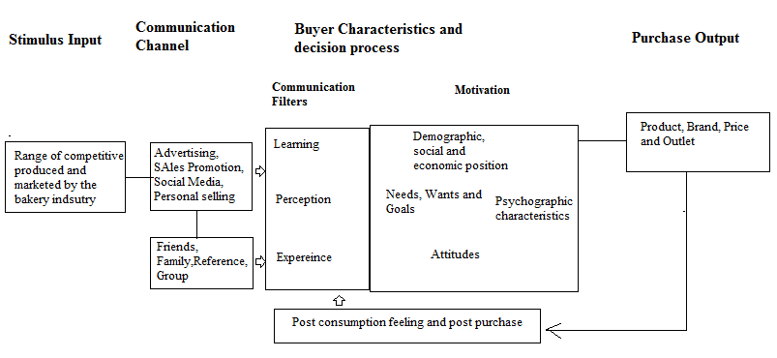
Figure 4: Consumer Decision Making Model for Patisserie Valerie
The consumer decision-making model will be highly reliable for the Patisserie Valerie to approach the customers to improve their customer base. The first most crucial stage of the consumer decision-making model is the stimulus input that helps the company Patisserie, Valerie, to identify the range of competitive products and marketed by other competitors compared to Patisserie Valerie. The next most crucial stage for Patisserie Valerie is Communication Channel from which they can gain feedback and can approach many customers through advertisement, sales promotion and social media. The social media is plating one of the major roles for the development of the bakery products online for the customers. The third stage is crucial for PAttiserie Valerie because it is essential for them to understand the decision process and buying characteristics. In the case of communication filters, three types need to be concentrated learning, experience and perception. For gaining motivation, it is essential to choose the right demographic, location for obtaining the right customers for the company. The final stage is where the company will understand whether their decision has gone well or not according to their input in the first stage.

6.0 Recommendation
The company must select the right location that mainly includes population density, climate and region where they will gain potential customers. Opening stores in shopping mall, other luxury area and airports will provide huge amount of profit to the business. The main targeted customers are the people from upper class and young teenagers who are mainly from school and college. The lifestyle of the people are changing with time that includes perceptions and attitudes of the people who requires high fiber rolls and breads and mainly good quality food.
The company Patisserie Valerie must invest their money more on promotions and their products to provide more unique cakes with new types of taste to attract customers. The Patisserie Valerie must build their client base more actively with proper promotions in the social media pages like Facebook, Instagram, and Twitter etc. The company can able to connect their customers with the help of social media to gain right feedback from their customers. Proper collaboration with community is very important for the company Patisserie Valerie to gain more attraction of the customers like providing discount coupons to the students and providing discounts to the university students if they shows their own ID card.

7.0 Conclusion
From the overall analysis of the market environment of the company Patisserie Valerie, it could be found that there is definitely management negligence and the cash position of the company Patisserie Valerie had a significant impact because of accounting regularities. For this reason, the overall management in the finance department gone wrong and the company cannot be able to make an active strategy to overcome the gap in their business. The successful bakery provides strong strategic planning to increase their overall profitability to decrease any expenses that can affect the quality products at any cost. The company must know the best time to purchase their required supplies from right suppliers at right when the cost of goods is low. According to experience in the store, it has been identified that the company Patisserie Valerie needs to provide more innovative products to gain more customers and the most important thing is increasing the presence of the brand in the online media. The internet has become one of the core channels through which the company can able to gain right feedbacks and requirements of customer very easily from various social media channels like Instagram, Facebook, Youtube etc. Moreover prices of some products need to be lower down or offers and promotions must be done as there is lot of competitive stores with lower price products. From in store experience it can be clearly stated that because of over crowded area like Victoria station staff didn’t serve or focus on each and every customer nicely so they need to improve the customer service and satisfactory service should be provided as they are always in rush. Company needs to provide excellent training to staff and busy shops should have more experienced staff to improve the services and sales.

After in store experience some questionnaire answers

*why they haven't reached me?
The main reason the company was not able to achieve is the lack of promotions provided by the company. It is essential for the company to show their presence to the customers with various media channels and digital marketing are rising at a considerable rate. It is an excellent opportunity for every company to gain proper presence through patisserie Valerie. And because of high priced products.
*if this was my business where would I put my money in?
First I will consider factoring where the company can able to sells their receivables at proper discounts to gain more cash up front. The next thing I will put on my money is creating the best quality cakes and pieces of bread according to the price provided by the company. Crowdfunding is a significant way to raise money at a very less cost. I will give free stall in some places to make people taste our baking products to provide feedback that will help in the branding process.
Educated staff and focusing on customer satisfaction.

The transformation process is essential for me to understand the best way to figure out what I am lacking. I must provide constant cross-media stimulus so that the customer can able to experience memorable and fulfilling experience when they are visiting the store. The proposition of the personalised solution in real time is fundamental for me to provide the best customer experience.
*they haven't done very well as they should have targeted customers like me and that should be the keen target
The primarily focused customer of the Patisserie Valerie is mainly the upper class, upper middle class and middle class who can able to afford the high price bakery products for the related story.

Majority of the customers who visit the bakery store represents multiple attempts to clarify the information of the product and to gain a proper fix in the problem that they had ordered or confusion on the bill creates the vast problem.
*inspection in the store whether this is the real luxury or am I be taken?
Majority fo the main store of Patisserie Valerie provides luxury designed cakes for their customers than the small stores that are presented in some regions like small shopping centres where they keep limited products. The cake products and the providing orders for birthday and marriage is highly demanding due to their best design in the cake but customers like me or students feels like its not a genuine luxury for us in fact we are taken. Was not a good experience overall.

*customer relationships suspects the question
who are these customers facing issues?
The primary customers who are having trouble with the baking products are the middle class and upper-middle-class people.
What do they feel?
They are feeling that Patisserie Valerie is providing baking products at a very high price and instead of real luxury they are just been taken. For this reason, the majority of the customers moves to another store due to high prices in Patisserie Valerie. But some of the customer still visit there because of the brand name.
Why did they want to go there?
There is the rise of many competitors in the UK market who are providing new types of bakery goods that are much cheaper than patisserie Valerie. But they want to get recognised with whom they are associated with so they still go there.

Reference
Aghazadeh, H., 2015. Strategic marketing management: Achieving superior business performance through intelligent marketing strategy. Procedia-Social and Behavioral Sciences, 207, pp.125-134.
Banterle, A., Cavaliere, A., Carraresi, L. and Stranieri, S., 2014. Food SMEs face increasing competition in the EU market: marketing management capability is a tool for becoming a price maker. Agribusiness, 30(2), pp.113-131.
Brown, S., 2016. Postmodern marketing: dead and buried or alive and kicking?. In The Marketing Book (pp. 43-58). Routledge.
Calder, B.J., Malthouse, E.C. and Maslowska, E., 2016. Brand marketing, big data and social innovation as future research directions for engagement. Journal of Marketing Management, 32(5-6), pp.579-585.
Coombes, P.H. and Nicholson, J.D., 2013. Business models and their relationship with marketing: A systematic literature review. Industrial Marketing Management, 42(5), pp.656-664.
Fernandez, A.S., Le Roy, F. and Gnyawali, D.R., 2014. Sources and management of tension in co-opetition case evidence from telecommunications satellites manufacturing in Europe. Industrial Marketing Management, 43(2), pp.222-235.
Ft.com. (2018). Top Patisserie Valerie bosses made £2.9m from bonus scheme shares | Financial Times. Available at: https://www.ft.com/content/22214d1c-d3b3-11e8-a9f2-7574db66bcd5 [Accessed 16 Dec. 2018].
Guercini, S., La Rocca, A., Runfola, A. and Snehota, I., 2014. Interaction behaviors in business relationships and heuristics: Issues for management and research agenda. Industrial Marketing Management, 43(6), pp.929-937.
Hutchinson, K., Donnell, L.V., Gilmore, A. and Reid, A., 2015. Loyalty card adoption in SME retailers: the impact upon marketing management. European Journal of Marketing, 49(3/4), pp.467-490.
Ingenbleek, P.T., Meulenberg, M.T. and Van Trijp, H.C., 2015. Buyer social responsibility: A general concept and its implications for marketing management. Journal of Marketing Management, 31(13-14), pp.1428-1448.
Järvinen, J. and Taiminen, H., 2016. Harnessing marketing automation for B2B content marketing. Industrial Marketing Management, 54, pp.164-175.
Maglio, P.P. and Spohrer, J., 2013. A service science perspective on business model innovation. Industrial Marketing Management, 42(5), pp.665-670.
McDonagh, P. and Prothero, A., 2014. Sustainability marketing research: Past, present and future. Journal of Marketing Management, 30(11-12), pp.1186-1219.
Möller, K., 2013. Theory map of business marketing: Relationships and networks perspectives. Industrial Marketing Management, 42(3), pp.324-335.
Peattie, K. and Belz, F., 2013. Sustainability marketing: A global perspective. John Wiley and Sons.
Peattie, K. and Belz, F., 2013. Sustainability marketing: A global perspective. John Wiley and Sons.
Peñaloza, L., Toulouse, N. and Visconti, L.M. eds., 2013. Marketing management: A cultural perspective. Routledge.
Raza-Ullah, T., Bengtsson, M. and Kock, S., 2014. The coopetition paradox and tension in coopetition at multiple levels. Industrial Marketing Management, 43(2), pp.189-198.
Sargeant, A. and MACQUILLIN, I., 2016. Marketing for nonprofit organisations. In The Marketing Book (pp. 555-576). Routledge.
Schultz, D., Patti, C.H. and Kitchen, P.J. eds., 2013. The evolution of integrated marketing communications: The customer-driven marketplace. Routledge.
Šimberová, I., 2014. Company strategic marketing management–synergic approach and value creating. Acta Universitatis Agriculturae et Silviculturae Mendelianae Brunensis, 58(6), pp.543-552.
thisismoney.co.uk (2018). Patisserie Valerie finance boss quits as more write-downs loom. Available at: https://www.thisismoney.co.uk/money/markets/article-6317431/More-trouble-Patisserie-Valerie-write-downs-threaten-blow-hole.html [Accessed 13 Dec. 2018].
Villeneuve, J.P. and Pasquier, M., 2017. Marketing management and communications in the public sector. Routledge.
Vitouladiti, O., 2014. Content analysis as a research tool for marketing, management and development strategies in tourism. Procedia Economics and Finance, 9, pp.278-287.
Wagner, S.M. and Eggert, A., 2016. Co-management of purchasing and marketing: Why, when and how?. Industrial Marketing Management, 52, pp.27-36.
Watrobski, J., Jankowski, J. and Ziemba, P., 2016. Multistage performance modelling in digital marketing management. Economics & Sociology, 9(2), p.101.
Weinstein, A. and Pohlman, R.A., 2015. Customer value: a new paradigm for marketing management. In Proceedings of the 1997 Academy of Marketing Science (AMS) Annual Conference (pp. 132-133). Springer, Cham.
Zimmerman, A. and Blythe, J., 2013. Business to business marketing management: A global perspective. Routledge.

