
Skills for the Workplace
Module Assignment Submission
Student Name: | Andrew McKay
Student Number: | 2014519
Module No: | BMSK4004
Module Title: | Problem Solving and Decision Making

Statement of Confirmation of Authenticity
By the act of making this submission, the student declares that this is the work of the student named above. The work has not, in whole or in part, been knowingly presented elsewhere for assessment, or where assessment has been built on a previous assessment, this has been identified. Where materials have been used from other sources it has been properly acknowledged. If this statement is untrue, the student acknowledges that an assessment offence has been committed.
Attention is drawn to the plagiarism and unfair practice policies of UWTSD.

Table of Contents
Introduction 3
The problem 4
Desccription and analysis of the problem 4
Possible solutions to the problem 5
Decision making techniques to evaluate the possible solutions 9
Plan for implementing the solution 12
Communication the plan to stakeholders 13
Monitoring and review techniques to ensure successful implementation of the plan 14
Conclusion 15
References 16
Appendices 18

Introduction.
Stottler W. (2021) describes problem-solving as “the process of observing what is going on in your environment; identifying things that could be changed or improved; diagnosing why the current state is the way it is and the factors and forces that influence it; developing approaches and alternatives to influence change; making decisions about which alternative to select; taking action to implement the changes; and observing impact of those actions in the environment.”
Kanbanize (2021) suggests that problems will from time to time arise in work and that in order to address these problems you really need to dive down to the root causes of that problem. In order to do that you should consider using the 5 whys as it helps you to focus on the problem and not simply address it but tackle it properly. “The 5 Whys technique is one of the most effective tools for root cause analysis in the Lean management arsenal.” The article goes onto to suggest that those best placed to tackle this problem are those with “practical experience” as these individual people or groups can offer the most valuable information. Finding and eliminating the root causes of any problem will stop that problems reoccurrence.
Within the body of this work the analysis of the 5 whys will be captured, however, once again as suggested within Kanbanize (2021) it is beneficial and widely recognised that the process will source the real causes of the problem and that you may ask more than 5 whys, without losing sight of identifying the root cause. Further steps identified within this process is to form a “cross functional team” in order to collate information which will contain “unique points of view” (brainstorming), identifying the problem and developing a “clear problem statement” with the purpose of finding “an effective solution”. One person should lead, keep the team on track and base everything on facts and data and not feelings. Having established the root cause or in this case ways to address the problem the team then needs to take action by applying processes to make the right decision. The team must meet regularly to ensure that the correct process is underway and that the outcomes are being achieved in line with the plan. Once completed it is good practice to share with the stakeholders the process and problems that were encountered in resolving the problem.

To summarise the 5 whys technique is recognised as an effective team tool for problem solving. It addresses the root causes of the problem, allowing every team member an opportunity to feed into it therefore reducing a culture of blame. It also gives the team confidence to go on and solve other problems.

The Problem.
Our organisation is a community-based children and youth provider of services and activities. We have worked within our electoral ward for approximately 16 years. During those years we have worked out of community buildings and within community settings never owning or leasing our own community space. We currently work out of terraced house, having an office upstairs and delivering activities in a downstair sitting room type area. We have been asked to look at seeking an alternate premises because the Landlord (a social housing organisation) believes we have “outgrown” the building. Their agent (local community group) has been asked to increase footfall into the building with activities and services for older members of the community. The application of the 5 whys (Kanbanize, 2021) to this problem is as follows;
Problem – BAD Bikes needs a new premises
- Why do BAD Bikes need a new premises? The landlord wants the organisation to leave.
- Why does the landlord want the organisation to leave? Not enough space.
- Why isn’t there enough space? Too many beneficiaries.
- Why are there too many beneficiaries? 18 years serving the local community
- Why such a long time in the community? Because there are no other facilities or sources of support for the community

Description/The Analysis of the problem
The problem is there are not enough community buildings in our immediate area of a standard or capacity to meet our needs. Moving out of area would possibly erode any relationships we have with our children and young people and other service users, besides having an impact on the workers who would need extra support to step in and out of our area to work. Coming and going would causes some upset and questioning amongst our children and young people as they are used to seeing us in the area throughout the day. They also call to our office for information or to simply pop in to see us. All of this type of connectivity with our client groups is important in establishing bonds between both parties for future working and community cohesion.
For the wider community if we did not have a local office, they would lose a facility that offers advice, support and signposting for employment, training or volunteering opportunities, use of a printer and phone, or a safe neutral meeting point.
We have learnt that having a community-based building of our own would increase the profile of the organisation and potentially create an income path and allow us to work more effectively. We have recognised through reflection the issue of not being able to flourish or have the freedom to develop further or earn and income because we stood by a philosophy of supporting and using community owned/run buildings. One problem that we have long tolerated in order to deliver services is that our activities have to be planned in line with the organisation managing the building., recorded and communicated several times, each in a different way i.e. emails, text, phone, written displayed and recorded on white boards or diaries to different members of whichever committee run that building. This in itself is both time consuming and energy sapping.

This problem could well be described as a strategic problem given that it could be long term in securing both premises and funding for the organisation to continue. During our discussions the question did arise about not recognising or seeing this problem arise. Nijssen, Edwin, Frambach and Ruud (2001) describe a strategic problem as not appearing overnight because workers usually close to the problem and aware of some issues, do not recognise them until everything finally surfaces. Workers would then need to define the problem and feed back to the management for them to deal with the problem.

Possible solutions to the problem.

In order to come to a decision about how we overcome our problem we intend to look at our options, and then adopt and demonstrate processes that allow us to explore and evaluate those problems, develop and implement a plan, communicate the plan to our stakeholders and finally monitor and review to make sure there is a successful implementation of the solution.
Option 1. We could continue to work within the same premises and wait to be told to leave or given a date to leave the building.
Option 2. We could explore finding alternative office space outside of the area, but keep a presence with our activities in the immediate area.
Option 3. There is a social club in the area that is very run down and only opens on a Sunday morning/afternoon.
Option 4. There is a large type playing area that is controlled by our local authority who would consider a Community Asset Transfer (CAT) of the ground.
A solution we used to share ideas and come up with possible answers to our problem was Brain storming. There is a photo of our session in appendix 1, however more detail and possible solutions has been captured in the body of this assignment and follows after a brief explanation of Brain storming as suggested by TWI (2021). “When planning a brainstorming session, it is important to define clearly the topic to be addressed. A topic which is too specific can constrict thinking, while an ill-defined topic will not generate enough directly applicable ideas. The composition of the brainstorming group is important too. It should include people linked directly with the subject as well as those who can contribute novel and unexpected ideas. It can comprise staff from inside or outside the organisation. Brain Storming is a method of generating ideas and sharing knowledge to solve a particular commercial or technical problem, in which participants are encouraged to think without interruption. Brainstorming is a group activity where each participant shares their ideas as soon as they come to mind.” (TWI, 2021) They go on to suggest that “rules” allow “novel and innovative ideas, however odd they may first appear. the quantity of ideas is more important than quality” that everyone should, “Build on the ideas put forward by others, every person and every idea has equal worth” and that “Each idea generated belongs to the group rather than the individual who thought of it” (Appendix 1). Another option that we recognised as a solution to help solve the root cause of our problem was that of the “Fishbone” which according to CMS (2021). “Compliments the brainstorming exercise in an attempt to recognise the causes and effect of the problem...The value of using the fishbone diagram is to dig deeper, to go beyond the initial incident report, to better understand what in the organization’s systems and processes are causing the problem, so they can be addressed.” At the head of the fish diagram would be the problem, with possible causes making up the (smaller) bones under major categories associated with the problem. It is important to recognise to leave room within the diagram to add minor detailed causes (when identified) under the major categories’ headings (Appendix 2). Once again contributions should be asked from all members of the team. The fishbone model should drive the team to concentrate on the causes of the problem instead of the symptoms.
Having completed our fishbone model (appendix 2), and talked in some depth exploring the how’s, why, and what’s we feel we have been able to identify three re-recurring themes and possible solutions to our predicament, these are:
- Income generation: Without our own premises we are unable to generate a regular income. The organisation has identified several possible income streams that we would like to explore. We feel our position in the market place makes us well placed to create that income
- Sustainability: Research by Brady. C (2020) suggests that there are five questions to ask yourself in order to create that sustainability, these are: “Are you delivering a product and/or service offer that helps your customers? What are the mega or future trends that will impact your business model? What’s the long-term legacy of your purpose? How can articulating your purpose mobilise and inspire your customers? How does your purpose marry short-term needs for profitability and survival post covid-19, with creating long-term sustainable outcomes? This research undertaken in sustainability, as a result of the fishbone model has driven and inspired us to look at creating a model/policy around sustainability something that has been overlooked in the past but will be a cornerstone for growth and development in the future.
- Lack of appropriate venue: Ironically the C19 pandemic seems to have played its part in the demise of our use of a community building. Initially we acted on protecting the venue for our community, however someone or something has taken exception to us producing in collaboration with the agent the following: risk assessment, sanitising stations, general notices, and undertaking C19 training, all in the interest of our community and their use of the building. It’s not hard to recognise that no communication took place between the landlord and the agent. It would appear that the landlord needs the agent to take control of the running of the premises. In addition, the landlord and some other providers have agreed a timetable for activities and as a result of these some extra cupboards and equipment have been placed into the main room cutting down the space to deliver activities and making the room inappropriate to work with children and young people.
Option1. As part of an exit strategy, we would continue to support the agent to develop their skills. However, our trustees now feel this is an area that should be supported by the Landlord. We recognise that our resources would be stretched if we maintain our support whilst exploring other avenues for office space. The trustees also recognised that there is a cost to this type of support. We also recognise that despite our best intentions this work deflects from our actual funding for working with children and young people. Being directed when to leave could sour our relationship with the Landlord who has in the past supported us. We feel it would be beneficial to continue to keep them informed of our plans in order to develop a timeline of our possible exit.
Option 2. Resources, time and energy levels do not allow us to pursue this avenue. New working relationships would take time to establish, we would have to inform our current funders as we are not in keeping with our original funding bid of being directly based in our area. All our equipment is based within our ward, and travelling between areas would increase transport costs, and potentially reduce our working hours to our core group. Extra funding would need to be sought to address these issues.
Option 3. Explore with the local social club if we could hire their main hall during the day because it is no longer in use, for workshops and activities. We are however unaware of the condition of the premises and they may not be fit for purpose. The advantages are: We may be able to place a container on their car park for storage. Therefore, some of our equipment would be at hand. We would need to create an office type environment within the premises. Funding would be crucial in developing our interests.
Option 4. Failing all of the above, we can pursue our interest in a Community Asset Transfer (CAT) of that open green space. We would require funding to create an office space. However once funding is secured, we would have a purpose-built modern facility with ample area to store our equipment. This opportunity will potentially create a much-needed income for the organisation.

Decision making techniques to evaluate the possible solutions.
In order to make a decision on which option to pursue we will need to evaluate all the options using a variety of formulas. To start I will use a SWOT analysis to highlight the current situation as it is, then other SWOT analysis for each of the options. These will be shared for opinions, however, if not conclusive we will consider other options to finally decide which option to pursue.

After consideration we decided that options 3 and 4 were what we would like to pursue, however, both have strengths and weaknesses and further consideration would have to be taken to finally determine the path we take.
Option 1. We had no control over as outside factors and people would ultimately decide our future. We cannot wait for others to make up their minds and have decided to ignore this option on that basis.
Option 2. Although this is was an option upon discussion, we felt this could be a short-term measure to our ultimate solution. Directly we felt that the pressure on staff and volunteers’ long term would be detrimental to the project over a long term.
Option 3. Much discussion between the workers and trustees has taken place over this option, however we have been unable to open a dialogue with the club committee. An excellent option especially if the club could be persuaded to sell as there is a central government fund available that allows community groups / charities to purchase buildings that will be lost to communities, and we feel that unfortunately this could be so with this building? A central base for our activities, hold meetings, and an ideal opportunity to create a community space where parties could be held this is an ideal contender with potential to earn some income for the charity. However, the building is not in great shape and will need a considerably large amount of money to bring it up to scratch. We feel this project is far to big for ourselves and could potentially be a role for an employee purely to find the funding and undertake the management of the works needed for it to rise to a very reasonable standard.
Option 4. Favoured by the workers, but the trustees have concerns around the level of responsibility that they may have to undertake. The trustees are currently undertaking that risk assessment and any other changes we may have to make? In the mean-time the workers have been given permission to contact BCBC CAT team to explore what would be required for a CAT. The workers have been in dialogue with the CAT team and are awaiting a date for an on-site meeting with the CAT worker. Between all these activities a visual plan of what could be developed on the site has been produced and presented to the trustees (Appendix 3). The trustees like the ideas and we all agree that there would need to be several stages to the development of the site with a time scale for full development of around 5-7 years. There was agreement between the trustees and workers that the potential site map could be shared initially with community members to gather their thoughts, however, we all feel that a consultation should be undertaken by a neutral consultant with a full report brought back to us for sharing with the CAT team, funders and other interested parties.
In order to establish without prejudice which option to continue with we have agreed to use a weighted grid analysis (Appendix 4). We have agreed the most important factors which will be assigned in the column and options will be in the row. We will then look at our factors and put a number to their value (0-5) with the 5 being the most important, we will repeat this within weighting the importance. Once the factor score has been established, we can the multiply this by the score awarded within the weight. IE: A score of (1) within the factors is multiplied by score in the weighting (5) 1 x 5 =5. The highest score indicates your favoured option.

Plan for implementing the solution.
It’s important that your stakeholders are kept informed of your plans. In order to do that you would need to recognise your stakeholders and then put them in order of who actually needs what levels of information. In order to do this, we would produce an Influence-Interest matrix in order to understand who goes where. It would be beneficial at this point to recognise factors such as your duty, morally or legally to keep all stakeholders happy. i.e.: Trustees would require all legal information regarding the CAT, however this information, would not necessary be of importance to other stakeholders, i.e. Young People.
Another tool used to plan and monitor our progress is the use of a Gannt chart. The Gantt chart offers everyone involved in the project a timescale from the headed projects, plus those responsible for carrying out those duties. A completed Gantt Chart is available in Appendix7. The author has generalised those delegated those tasks as opposed to naming them as suggested by Project Manager (2021).
The reason for this is that within the organisation, people come and go and rather than put individuals under pressure this Gantt chart immediately identifies the role of individuals and what their responsibilities would be. Support and training will be offered to everyone tasked with taking on their roles within the Gantt chart.
Another consideration would be that of regular communication and general updates, actions or progress at meetings between Trustees and workers in order to maintain momentum and progress on target.

Communicating the plan to stakeholders.

O’ Berry (2020) suggests that the better way to conduct a communication plan is not by locking yourself away in an office, but by identifying and communicating with all the stakeholders in order to ensure the plan is inclusive and comprehensive. They go onto suggest that a high-level description of the plan, why it exists and a general idea of how you will implement the plan on your project” They continue by identifying that stakeholder will have a broad range of interests and influences regarding the project and will need to be communicated through a series of methods, (having identified the best way of communication for them). Understanding who your stakeholders are and their preferred method of communication should be shared with the whole project team to ensure a successful outcome to your project as can been seen in a completed Communication Action Plan, template from Project Management Docs (2021) (Appendix 5).
O’ Berry (2020) further states that educating and updating anyone impacted by the project increases their knowledge and importance of the project and in some cases will prove vital in changing the minds of those opposed to the idea or changes. Communication is a two-way process with those stakeholders offered the opportunity to feedback. Further suggestion regarding communication are that one person should not be entirely responsible for it all and is a shared responsibility, however as identified in appendix 5 a range of communication methods should be used and not filtered down to solely one. If necessary, stage some formal and informal meetings either in person or on Teams etc, be prepared to communicate with groups and individuals, display some posters or produce a newsletter, hire an independent consultant to undertake a door-to-door survey and complete a report, or interact through the internet on a dedicated Web page.

Monitoring and review techniques to ensure successful implementation of the solution.

A cost-benefit analysis was one of the tools chosen to help if the project was worth pursuing. As Thompson 2019 states “A cost-benefit analysis is the simplest way of comparing your options to determine whether to go ahead with a project.” They further suggest a cost-benefit analysis looks at the benefits, course of action or investment, investigating the associated costs in an objective manner. To summarise they state: “Many businesses have suffered badly because they invested in a project that sounded good in the boardroom, but ultimately didn't generate any returns. A cost-benefit analysis can bring your ideas into the real world, effectively asking the question "Is it worth it?" (Thompson, 2019). The writer undertook a Cost analysis for Option 4 as can be seen in appendix 6. The cost analysis shows that at the moment BAD Bikes is currently spending £2750 of its reserves every year with no option for generating income. Although option four would take considerable investment and increase the organisation's outgoings, it also shows that it would allow for income to be generated with ironically a possible profit of £2750 per year after set up. This is based on undertaking work from Pupil referral unit (PRU,) local comprehensive school and the Youth Offending Team (YOT) that is currently being turned away due to lack of appropriate facilities. If BAD Bikes were to work with 10 young people per week throughout the school terms there would be an income of £14400 per year. There are additional possibilities of room hire and charging for refreshments such as tea and coffee. Plus, the potential of creating a near like facility for users of the nearby national cycle route 4 that could generate further income in the future.
Conclusion:
A great module with tools that can be used daily in order to look at and address any problem. Initially we looked at a SWOT analysis to address our problem. By using the SWOT, we were able to dismiss both Options 1 and 2, however looking at Options 3 and 4 they looked quite close. In order to define which option was better we used the weighted grid analysis for all four despite our findings. The result was quite astounding and firmed up in everyone’s view that option 4 would be the option we would pursue.

References

Brady, C. 2020 One planet living, sustainable business. Bioregional.com Available at: https://www.bioregional.com/news-and-opinion/creating-a-sustainability-strategy-five-questions-to-define-business-purpose?gclid=EAIaIQobChMIv-XpnvvL8gIVFIBQBh1s1wMJEAAYBCAAEgIC6fD_BwE Last accessed: 29/08/2021
CMS. 2021. How to use the fishbone tool for root cause analysis. Centers for Medicare & Medicaid Services. Available at: https://www.cms.gov/medicare/provider-enrollment-and-certification/qapi/downloads/fishbonerevised.pdf Last accessed: 22/08/2021
Kanbanize. 2021 5 Whys: The Ultimate Root Cause Analysis Tool. Kanbanize. Available at: https://kanbanize.com/lean-management/improvement/5-whys-analysis-tool Last accessed: 18/08/2021

Nijssen, Edwin J., Frambach, Ruud T. 2001. Springer Science and Business Media. Creating Customer Value Through Strategic Marketing Planning. A management Approach. Available at: https://www.springer.com/gp/book/9780792372721 Last Accessed: 10/08/2021

O’ Berry, D. 2015 How to create a project communication plan Available at: https://www.quickbase.com/blog/how-to-create-a-project-communication-plan Last Accessed: 12/08/2021

Project Management Docs. 2021 Communications Management Plan Template. Project Management Docs. Available at: https://www.projectmanagementdocs.com/template/project-planning/communications-management-plan/#ixzz73KOEvXdD Last Accessed 15/08/2021
Project Manager. 2021. Project Manager. The Ultimate Guide… Gantt Chart. Available at: https://www.projectmanager.com/gantt-chart Last Accessed: 30/08/21
Stottler, W. 2021. What is problem solving and why is it important? Kepner-Tregoe. Available at: https://www.kepner-tregoe.com/blog/what-is-problem-solving-and-why-is-it-important/ Last accessed: 08/08/2021

Thompson, Jayne. 2019. CHRON. What Makes Cost Benefit Analysis Important? Available at: https://smallbusiness.chron.com/cost-benefit-analysis-important-75211.html Last Accessed: 30/08/2021
TWI. 2021 What is brainstorming? TWI. Available at: https://www.twi-global.com/technical-knowledge/faqs/faq-what-is-brainstorming Last accessed: 08/08/2021

Appendix 1 – Brainstorming

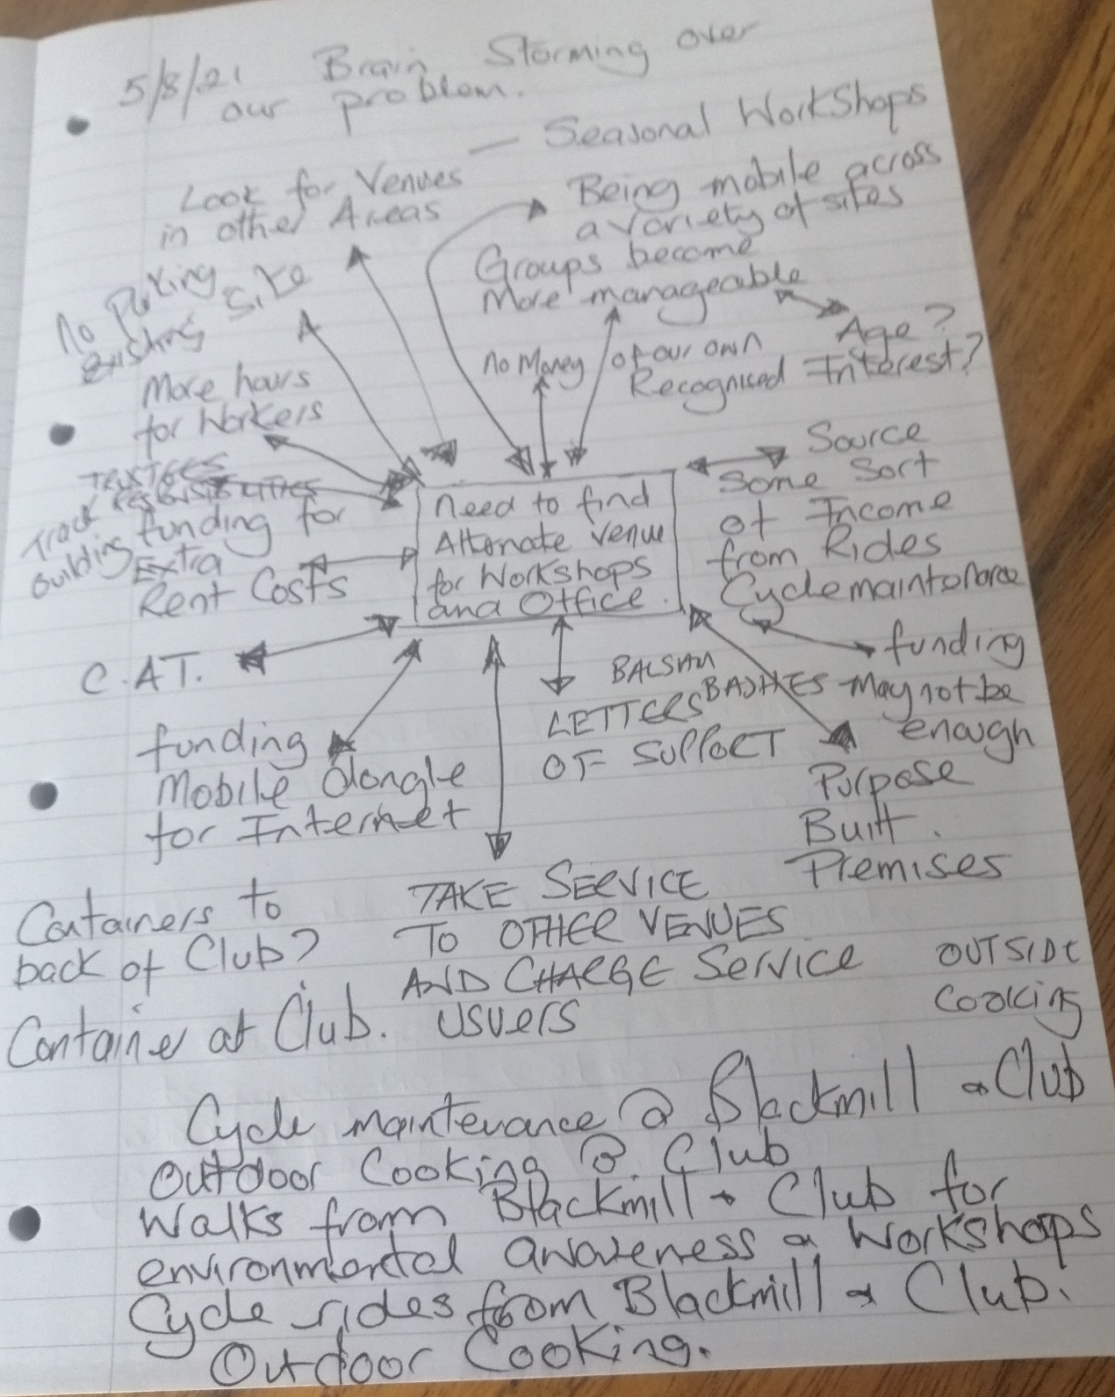

Appendix 2 – Fishbone model

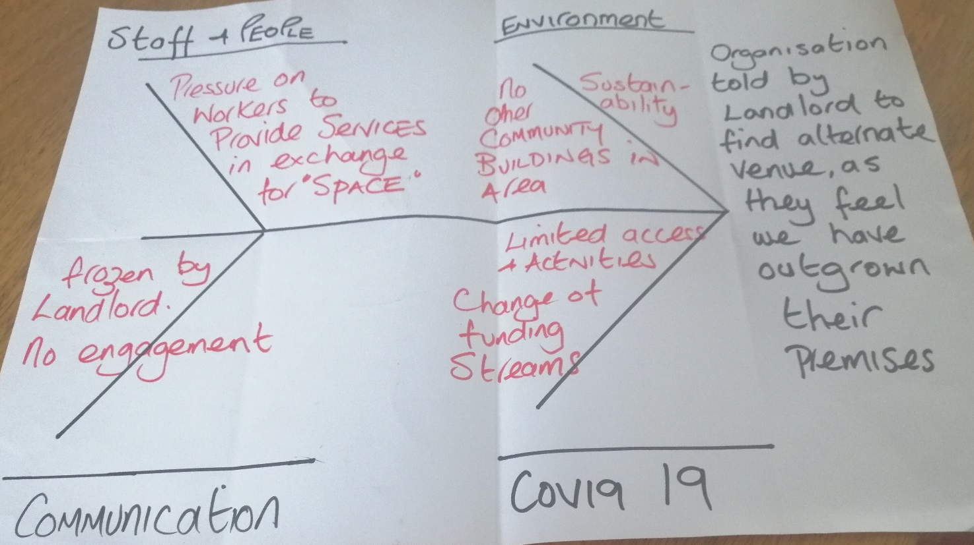

Appendix 3 – Visual Idea
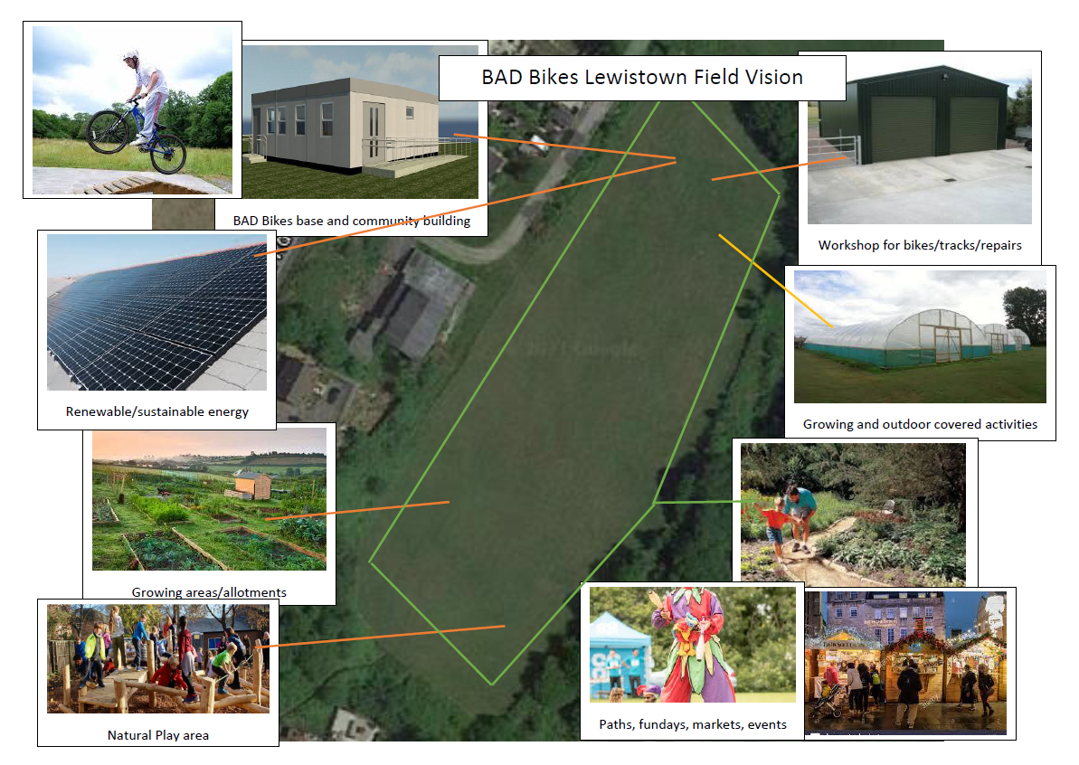

Appendix 4 – Weighted Grid Analysis
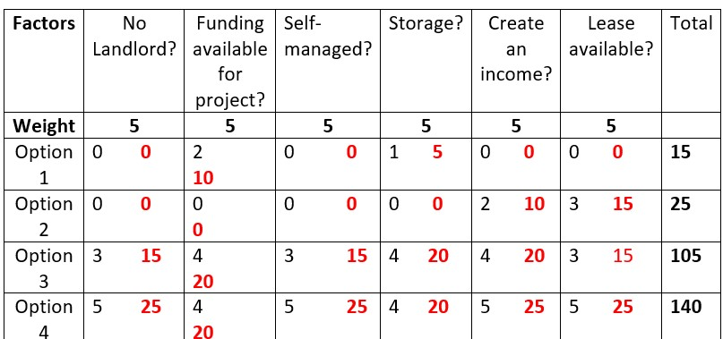

Appendix 5 – Communication to Stakeholders
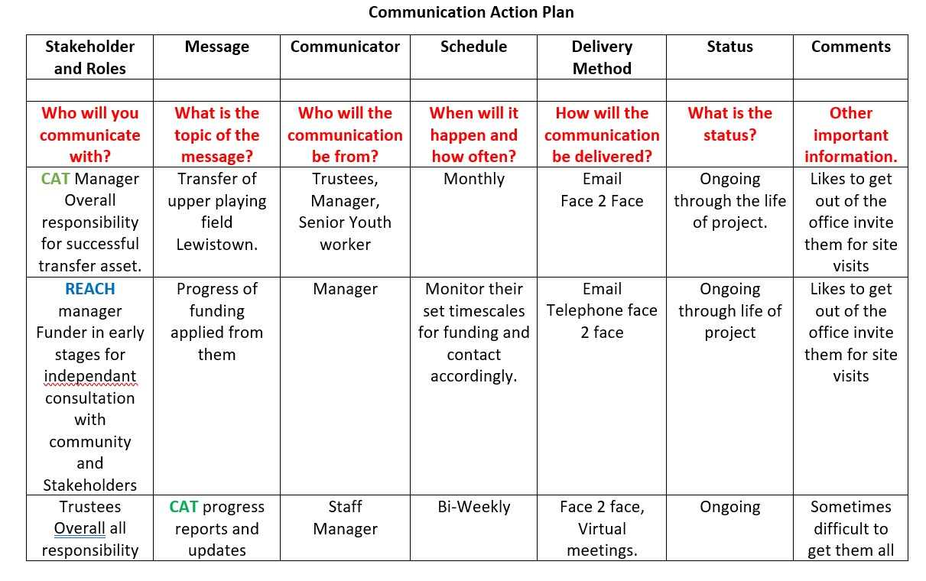
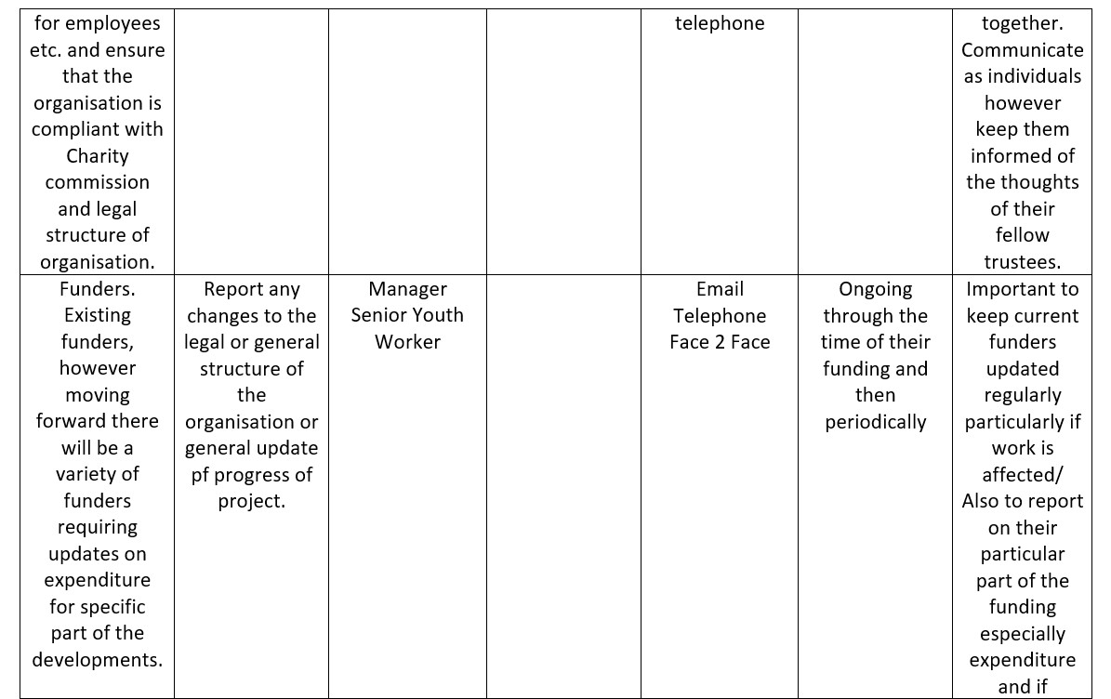
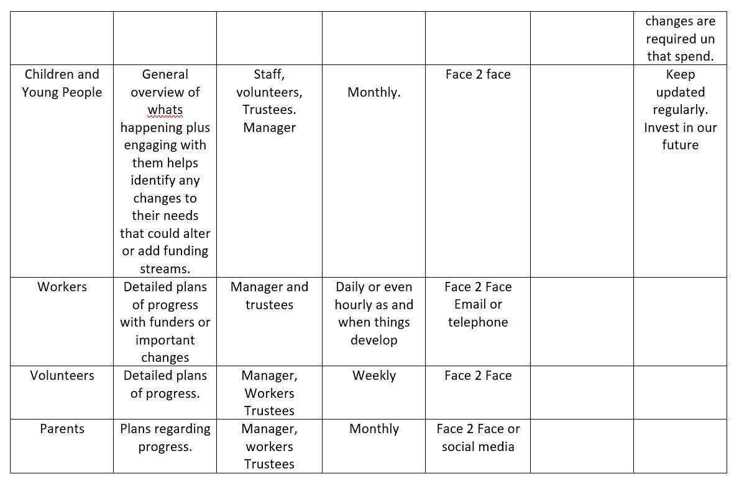
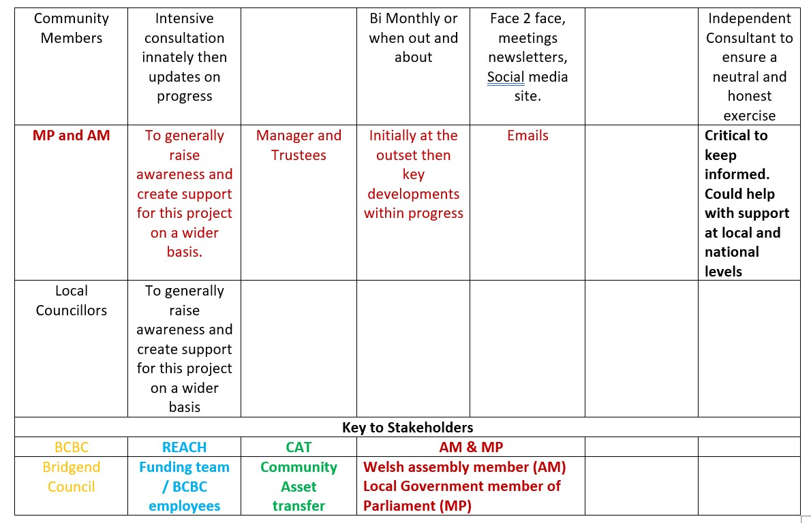

Appendix 6 – Cost Analysis
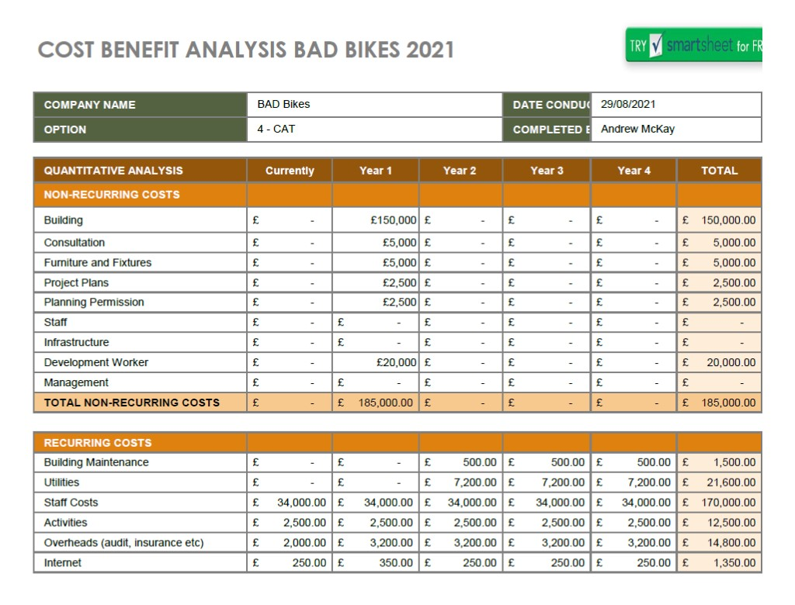
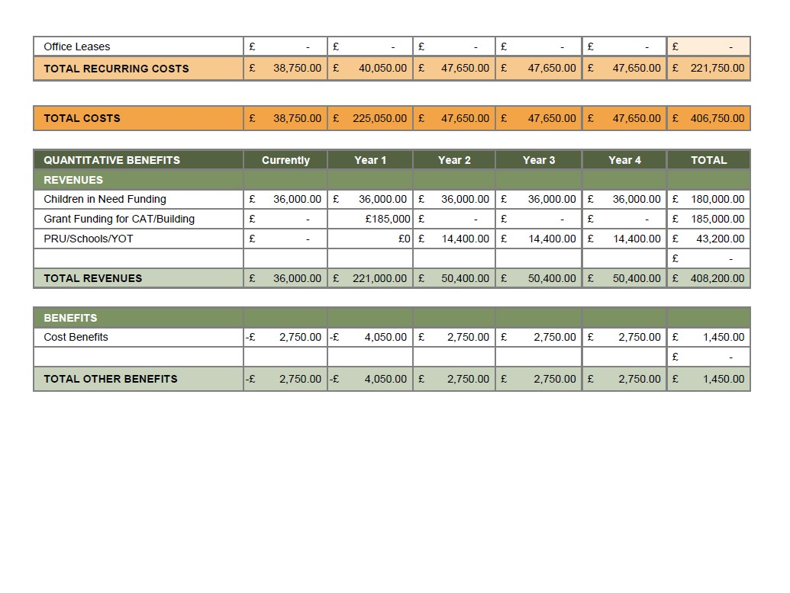

Appendix 7 – Gantt Chart

