

Student Name: Mercy Reoja Fiel
Student ID: 2427852

Module name: Introduction to Physiology
Module code: BMHP5023
Lecturer name: Shaila Hussain

Assessment: Component 1: Written Assignment (Case Study Report)

Contents
1.0 Introduction 3
2.0 Blood Sugar Regulation 4
3.0 Cellular Metabolism 5
4.0 Recording and tracking blood sugar levels for type 2 diabetes 6
5.0 Recommendations 8
6.0 Conclusion 10
References 11
Appendix 13
Appendix 1. Glucose Monitoring 13
Appendix 2. Guidelines for Self-Blood Glucose Monitoring 14
Appendix 3. Principles and recommendations of diet and nutrition for adult diabetics 15

1.0 Introduction
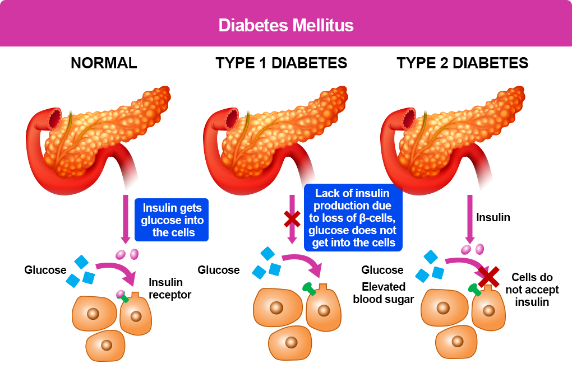
Figure 1: Diabetes Mellitus
Source: (Diabetes UK, 2017; NICE, 2022)
Diabetes mellitus is a long-term metabolic disorder resulting in inadequate management of blood glucose due to a malfunction of insulin secretion or action, or both (Diabetes UK, 2017). It is typically divided into Type 1 diabetes, an autoimmune condition which results in absolute insulin deficiency, and Type 2 diabetes, which is largely associated with insulin resistance and relative insulin insufficiency, and the objective of this report (NICE, 2022). To maintain glucose balance, diabetes is an endocrine disorder that is defined by the interference of the pancreas, including the islets of Langerhans, where the beta-cells secrete insulin and alpha-cells secrete glucagon (Hall, 2021). Diabetes type 2 is likely to be associated with obesity, sedentary lifestyles, poor dieting, genetic predisposition, ageing, and certain ethnicities such as South Asians (WHO, 2024). This report will explain the regulation of blood glucose, how the cell works, the importance of monitoring, and how Type 2 diabetes can be managed evidence-based.

2.0 Blood Sugar Regulation
The maintenance of blood sugar and a stable internal system where the cells work is orchestrated by the endocrine control. The pancreas is among the key endocrine tissues, with its beta cells secreting insulin and alpha cells secreting glucagon (Hall, 2021). These endocrines are antagonistic to each other in such a way as to keep the blood sugar inside in a very insufficient physiological scale. The secretion of insulin is triggered by the increase in blood sugar after consuming food. Insulin reduces glucose level by stimulating glucose uptake into muscle and fat tissues through the glucose transporters and increasing glycogen synthesis in the liver, where excess glucose is stored to be utilised in the future (American Diabetes Association, 2023).
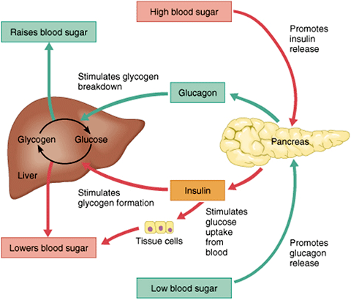
Figure 2: Blood Sugar Regulation
Source: (Röder et al., 2016)
Conversely, when a person is fasting or in a low-glucose environment, glucagon is secreted to rise the amount of sugar in the blood. It triggers the degradation of glycogen (glycogenolysis) and the release of glucose (out of the liver) into the bloodstream to ensure that the body organs (including the brain) are constantly supplied with energy (Röder et al., 2016). It is a reciprocal relationship between insulin and glucagon, which enables homeostasis so that the body is able to respond to the differing demands of the metabolic needs. An example is that after a meal, the insulin activity is dominant, and during the night, glucagon activity increases to prevent hypoglycaemia.
Type 2 diabetes influences this regulatory system. The peripheral tissues (particularly muscle and adipose tissue) react to insulin by diminishing when there is insulin resistance that suppresses the uptake of glucose. In addition, it is dysfunctional, which leads to the inadequacy of insulin release by the beta-cells of the pancreas (Mayorov, 2017). This causes accumulation of glucose in the bloodstream that will cause incessant hyperglycaemia. This maladaptation of normal endocrine functions increases the risk of developing complications during the longer term, including cardiovascular disease, neuropathy, and nephropathy. Therefore, the most effective blood glucose treatment relies on a complex of the functional activity of pancreatic hormones, as well as the pathophysiology of Type 2 diabetes, which is founded on the ineffectiveness of this mechanism.

3.0 Cellular Metabolism
Cellular metabolism is the operation by which cells decompose glucose to obtain energy that can be utilised. Digestion of carbohydrates produce the absorption of sugar into the bloodstream (DeBerardinis and Thompson, 2016). It is then the insulin that mediates the consumption of glucose into insulin-sensitive tissues, specifically the skeletal muscle and adipose tissue, due to which the glucose can be moved out of the blood to the cells so that it can be utilised or stored as energy. Lack of effective insulin activity means that the glucose will not be used by the body tissues, but instead will be deposited in the bloodstream (NHS, 2025).
Upon the entry of glucose into the cell, it is metabolised mainly via aerobic respiration, occurring in the mitochondria to a significant degree. It is a process that requires the presence of oxygen, which is supplied to tissues by red blood cells, as oxygen is the ultimate electron acceptor in an oxidative phosphorylation process. Glycolysis, the citric acid cycle, and the electron transport chain release the chemical energy of glucose and convert it to the initial energy of the cell, adenosine triphosphate (ATP) (Antonioli et al., 2015). ATP is a crucial component in the normal body processes such as muscular contraction, nerve conduction, active transfers and protein synthesis. This is illustrated by the muscle cells, which need ATP to contract during walking, and the neurons, which need ATP to produce membrane potentials and transmit impulses.
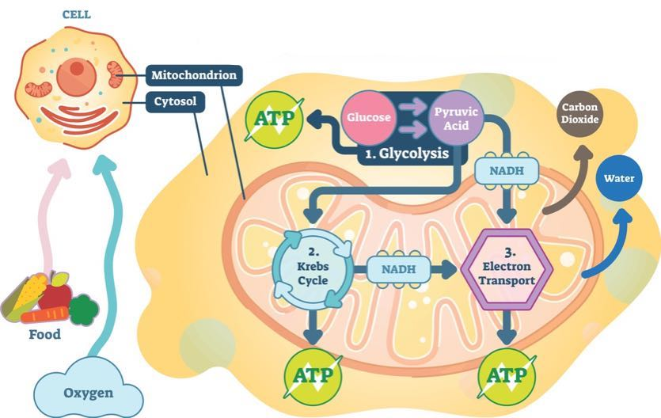
Figure 3: Cell Metabolism
Source: (DeBerardinis and Thompson, 2016)
In healthy metabolism, the liver also has a significant role in balancing fuel because it stores the excess glucose, which is glycogen and releases it when the body requires it. This response to insulin, combined with oxygen delivery and mitochondrial formation of ATP, enables the cells to meet short-term energy needs without reducing the overall metabolic homeostasis in tissues. In Type 2 diabetes, it is an inefficient process. Insulin resistance lowers the concentrations of glucose uptake into the cells and, therefore, in the case of hyperglycaemia, the tissues may not efficiently utilise glucose (Wu et al., 2022). This creates an imbalance in energy and results in fatigue, poor healing and performance of the cells. Therefore, diabetes not only affects the functionality of the body because of the increased percentage of sugar, but also the fact that the body cannot process glucose at the cellular level efficiently.

4.0 Recording and tracking blood sugar levels for type 2 diabetes
Recording and tracking of blood sugar levels is a required feature of treating Type 2 diabetes and is reflected in normal data collection in the health and social care domain. Self-monitoring of blood glucose (SMBG) is usually done via the utilisation of a glucometer that allows people to scan capillary blood glucose at different times of the day, e.g. before and after a meal or during symptoms (American Diabetes Association, 2023). Regular tracking provides a time-based record of glycaemic patterns, as they assist individuals and health professionals to assess time management. Monitoring is also important because it can identify instances of hyperglycaemia and potential trends of hypoglycaemia; otherwise, they would not be reported (Janapala et al., 2019). As an example, high postprandial readings could indicate bad dietary practises or ineffective drugs, and low readings could indicate that an individual consumes a lot of medication or abstains from eating (NICE, 2022). The information enables the evidence-based change of medication, dietary intake, and physical activity to incorporate individualised and safe management.
Furthermore, regular check-ups will improve glycaemic control based on self-knowledge and readiness to become an active participant in its management. It may also contribute to clinical decision making relating to health care review to allow a professional to evaluate the effectiveness of treatment and change the care plans depending on the outcomes (Diabetes UK, 2017). Examples of the indicators of dynamics in the recorded information can assist in adjusting the dosage of medication, such as Metformin or insulin. Without frequent glucose level monitoring, the inability to regulate the situation may go unnoticed, and hyperglycaemia may continue. This has a long-term significant effect on long-term risks of complications, including neuropathy, nephropathy, retinopathy, and cardiovascular disease (Ripsin et al., 2019). Therefore, routine check-up is needed not only to ensure immediate safety but also to prevent severe complications and improve the future health status of individuals with Type 2 diabetes.

5.0 Recommendations
Diet management: A more fibre-based, low-calorie diet with less free sugar and refined carbohydrates and higher glucose post-meal spikes would be better at lowering the rapid elevations in glucose following meals and healthier weight management, thereby improving glycaemic control in Type 2 diabetes (Mann and Chisholm, 2015). The particular recommendation to prevent the high level of sugar and salt in highly processed foods, proposed by the NHS, identifies eating well as one of the first methods of treatment (NHS, 2025; Diabetes UK, 2017).
Physical activity: Exercise also increases insulin sensitivity, or the capacity of body cells to acknowledged better to insulin and to take in glucose in the blood more effectively (Hayes and Kriska, 2018). This decreases the circulating glucose and assists in sustaining metabolism with the passage of time, which is why exercise is a mandatory concept of lifestyle change, along with diet and medication.
Weight management: Weight loss is advised because insulin resistance is closely intertwined with obesity. Weight loss can also improve the body and, in some people, greatly reduce the amount of blood glucose and even remit Type 2 diabetes (Van Gaal and Scheen, 2015).
Medication adherence: Prescription medication should be taken regularly. As NHS information states, metformin is generally the first medication administered in Type 2 diabetes; it helps decrease the concentration of glucose and is frequently combined with other treatments in case of failure to reach a target (NHS, 2025).
Blood glucose monitoring: Regular blood glucose checks enable an early response to be taken, in the event of consistently high blood glucose levels, or in the event of hypoglycaemia. The other advice provided by NICE concerns the fact that the real-world data and consistent glucose monitoring are important to improve glycaemic control of a specific group of adults with Type 2 diabetes who are treated with insulin (NICE, 2022).
Smoking cessation: Smoking cessation is a useful health-promotion process, which reduces the risk of cardiovascular disease, especially where diabetes is a common condition, in which vascular complications are common. In NICE, quitting smoking is also listed among the healthy living recommendations for long-term diabetes management (NICE, 2022).
Regular check-ups: Frequent check-ups, including HbA1c levels, kidney test, foot test, blood pressure, cholesterol, weight check, and eye screenings, will assist in the early detection of complications symptoms and timely treatment (NHS, 2025).
Patient education and support: Structured education improves self-management, self-confidence, and long-term behaviour change. According to the NHS, a course on diabetes should be administered to all individuals with Type 2 diabetes within the initial year of diagnosis, and this course helps such individuals to learn about diet, medication, and self-monitoring, as well as mitigating the risk (NHS, 2025). This additionally promotes shared decision making in health and social care that improves compliance, safer self-management and long-term quality of life to a number of persons and reduces unnecessary hospitalisation and lifetime spending to a large extent.

6.0 Conclusion
Diabetes mellitus is a long-lasting aberration of glucose regulation whereby the endocrine system, especially the pancreas, plays an important role in the administration of glucose in the bloodstream. The inability to sustain normal blood glucose levels is caused by insulin resistance or insulin deficiency, leading to persistent hyperglycaemia. This is essential to the metabolism of the cells as glucose and oxygen are required to generate energy via ATP, and this is disrupted in Type 2 diabetes patients. Monitoring of blood glucose thus becomes important as it would enable the detection of imbalances at an early stage, and safe and effective management of the condition. Also, as lifestyle changes, a healthy diet, physical exercise, and treatment compliance are evidence-based and should be implemented to optimise glycaemic control and reduce the risks of difficulties. Generally, physiological knowledge and practical application in the management of diabetes also form a base for ensuring health and wellness in the long-term perspective.

References
American Diabetes Association (2023). American diabetes association releases 2023 standards of care in diabetes to guide prevention, diagnosis, and treatment for people living with diabetes | ADA. [online] diabetes.org. Available at: https://diabetes.org/newsroom/american-diabetes-association-2023-standards-care-diabetes-guide-for-prevention-diagnosis-treatment-people-living-with-diabetes [Accessed 23 Mar. 2026].
Antonioli, L., Blandizzi, C., Csóka, B., Pacher, P. and Haskó, G. (2015). Adenosine signalling in diabetes mellitus—pathophysiology and therapeutic considerations. Nature Reviews Endocrinology, [online] 11(4), pp.228–241. doi:https://doi.org/10.1038/nrendo.2015.10.
DeBerardinis, Ralph J. and Thompson, Craig B. (2016). Cellular Metabolism and Disease: What Do Metabolic Outliers Teach Us? Cell, 148(6), pp.1132–1144. doi:https://doi.org/10.1016/j.cell.2012.02.032.
Diabetes UK (2017). Diabetes: the basics. [online] Diabetes UK. Available at: https://www.diabetes.org.uk/about-diabetes [Accessed 22 Mar. 2026].
Hall, J.E. (2021). Guyton and Hall textbook of medical physiology. St. Louis: Saunders.
Hayes, C. and Kriska, A. (2018). Role of Physical Activity in Diabetes Management and Prevention. Journal of the American Dietetic Association, [online] 108(4), pp.S19–S23. doi:https://doi.org/10.1016/j.jada.2008.01.016.
Janapala, R.N., Jayaraj, J.S., Fathima, N., Kashif, T., Usman, N., Dasari, A., Jahan, N. and Sachmechi, I. (2019). Continuous Glucose Monitoring Versus Self-Monitoring of Blood Glucose in Type 2 Diabetes Mellitus: A Systematic Review with Meta-analysis. Cureus, [online] 11(9). doi:https://doi.org/10.7759/cureus.5634.
Mann, J.I. and Chisholm, A. (2015). Dietary management of diabetes mellitus in Europe and North America. International Textbook of Diabetes Mellitus, pp.575–588. doi:https://doi.org/10.1002/9781118387658.ch40.
Mayorov, A.Y. (2017). Insulin resistance in pathogenesis of type 2 diabetes mellitus. Diabetes mellitus, 14(1), p.35. doi:https://doi.org/10.14341/2072-0351-6248.
NHS (2025). Type 2 diabetes. [online] nhs.uk. Available at: https://www.nhs.uk/conditions/type-2-diabetes/? [Accessed 24 Mar. 2026].
NICE (2022). Type 2 Diabetes in adults: Management. [online] Nice.org.uk. Available at: https://www.nice.org.uk/guidance/ng28 [Accessed 23 Mar. 2026].
Ripsin, C.M., Kang, H. and Urban, R.J. (2019). Management of Blood Glucose in Type 2 Diabetes Mellitus. American Family Physician, [online] 79(1), pp.29–36. Available at: https://www.aafp.org/pubs/afp/issues/2009/0101/p29.html.
Röder, P.V., Wu, B., Liu, Y. and Han, W. (2016). Pancreatic Regulation of Glucose Homeostasis. Experimental & Molecular Medicine, [online] 48(3), pp.1–19. doi:https://doi.org/10.1038/emm.2016.6.
Van Gaal, L. and Scheen, A. (2015). Weight Management in Type 2 Diabetes: Current and Emerging Approaches to Treatment. Diabetes Care, 38(6), pp.1161–1172. doi:https://doi.org/10.2337/dc14-1630.
World Health Organization (2024). Diabetes. [online] World Health Organization. Available at: https://www.who.int/news-room/fact-sheets/detail/diabetes [Accessed 23 Mar. 2026].
Wu, Q., Xia, M.-F. and Gao, X. (2022). Metabolically healthy obesity: Is it really healthy for type 2 diabetes mellitus? World Journal of Diabetes, 13(2), pp.70–84. doi:https://doi.org/10.4239/wjd.v13.i2.70.

Appendix

Appendix 1. Glucose Monitoring
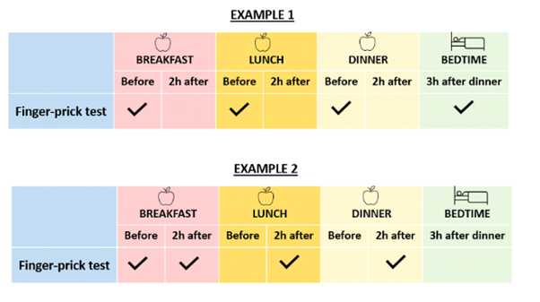
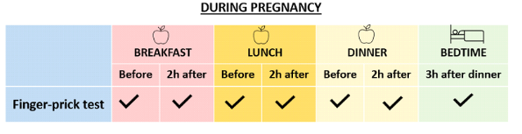

Appendix 2. Guidelines for Self-Blood Glucose Monitoring

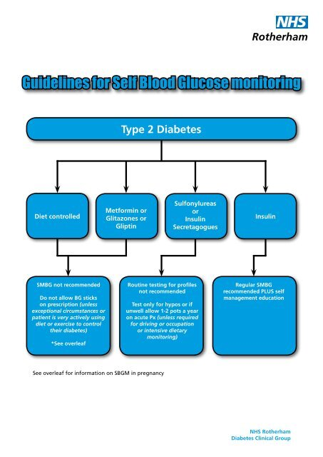

Appendix 3. Principles and recommendations of diet and nutrition for adult diabetics
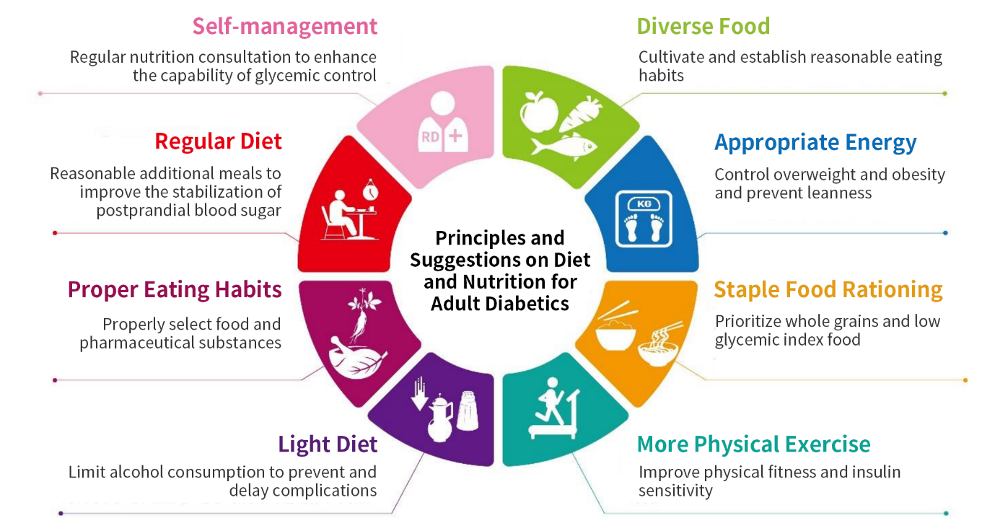
Source: Guidelines for Diet and Nutrition for Adults with Diabetes (2023 Edition)

