OpenAPI in Spring
To preface this tutorial, we are going to have to work around an annoying issue within SpringFox, the library which provisions OpenAPI. Specifically, SpringFox does not yet support Spring 2.x, (despite promising support for about a year). Upshot: we’ll have to revert to Spring 1.x – not at all difficult, but slightly perplexing, given that pretty much everyone now uses Spring 2. This has a knock-on implication, requiring us to explicitly tell Spring to use hibernate/Jackson in our project.
Finally, SpringFox does not yet support Swagger 3.0, despite this being in development since September 2017. Again, this is an annoyance more than a big issue.
I mention these issues in detail, rather than obfuscate them, because this is often the reality of software engineering – we have the tools that we have and either we work with them, or build better ones. In the absence of half a year of free time, we’re currently stuck with the former – so we’ll make it work with what we have.

Working around SpringFox
Firstly, we’ll need to revert SpringBoot to the latest version of 1.x. In your Maven configuration, change the version back to 1.5.19 (at time of writing).
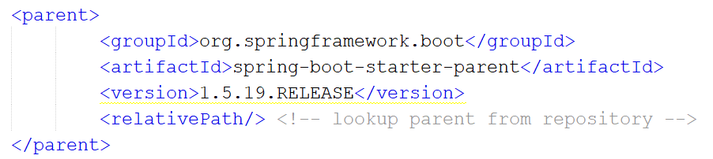
(use the latest version of SpringBoot 1.x.x).
You’ll notice some unhappy yellow underline in most IDEs – the warning message reminds you that you’re being forced into supporting a poorly-maintained framework by reverting to an older version .
Because Spring 1.x doesn’t do it automatically, we’ll need to add a few specific libraries for handling type conversion during marshalling:
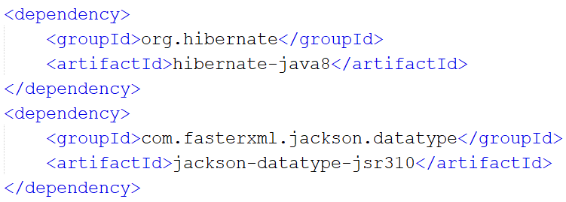
To support testing, you may also need to add:

<dependency>
<groupId>org.junit.jupiter</groupId>
<artifactId>junit-jupiter-api</artifactId>
<version>5.6.0</version>
<scope>test</scope>
</dependency>

Finally, we’ll include support for the SpringFox libraries to handle Swagger:
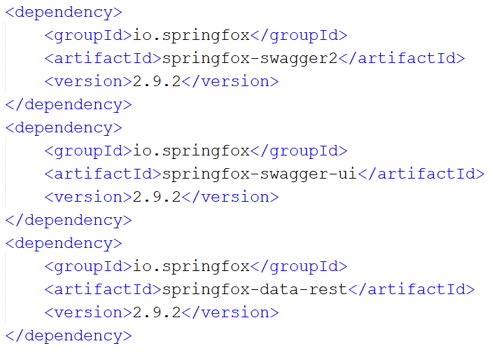
From here, however, enabling Swagger output is easy. Annotate the class which contains main with:
@EnableSwagger2
@Import(SpringDataRestConfiguration.class)

If there’s an error with your Spring configuration, it’ll display on the second of these statements.
Next, we need to add a Swagger configuration class:
import org.springframework.context.annotation.Bean;
import org.springframework.context.annotation.Configuration;
import springfox.documentation.builders.PathSelectors;
import springfox.documentation.builders.RequestHandlerSelectors;
import springfox.documentation.spi.DocumentationType;
import springfox.documentation.spring.web.plugins.Docket;

@Configuration
public class SwaggerConfig {
@Bean
public Docket api() {
return new Docket(DocumentationType.SWAGGER_2)
.select()
.apis(RequestHandlerSelectors.any())
.paths(PathSelectors.any())
.build();
}
}

This specifies that we will have Swagger documentation autogenerated for each endpoint. Finally, we need to annotate our repositories with:
@Api(tags = "Address Entity")
Which specifies that they will be exposed through Swagger.

Run your code. Navigate to http://localhost:8080/swagger-ui.html
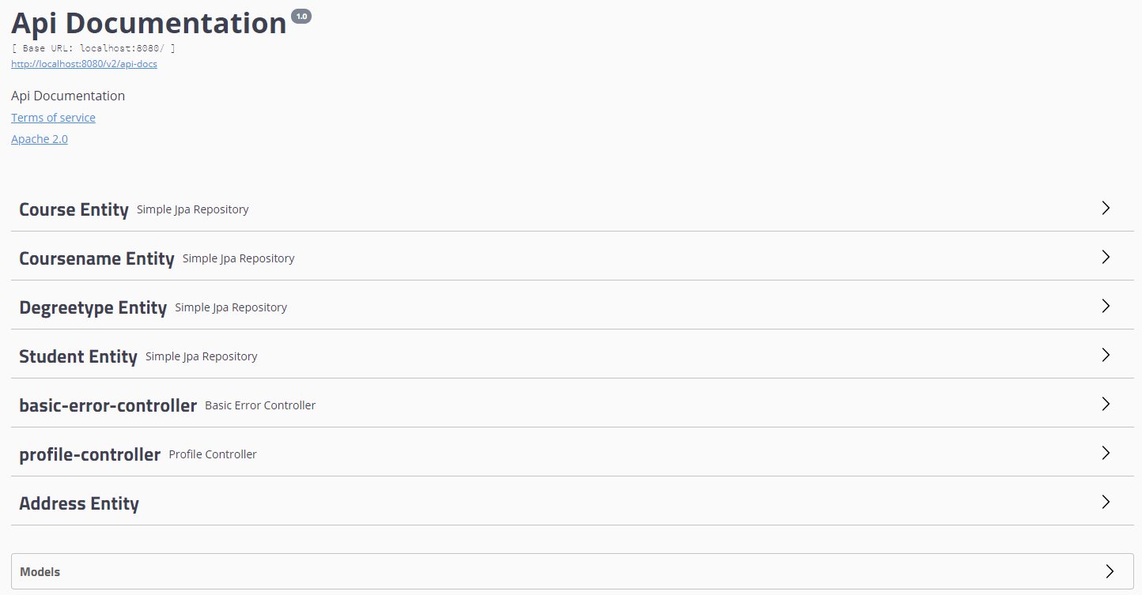
You may also like to click the link at the top of the page which leads to http://localhost:8080/v2/api-docs
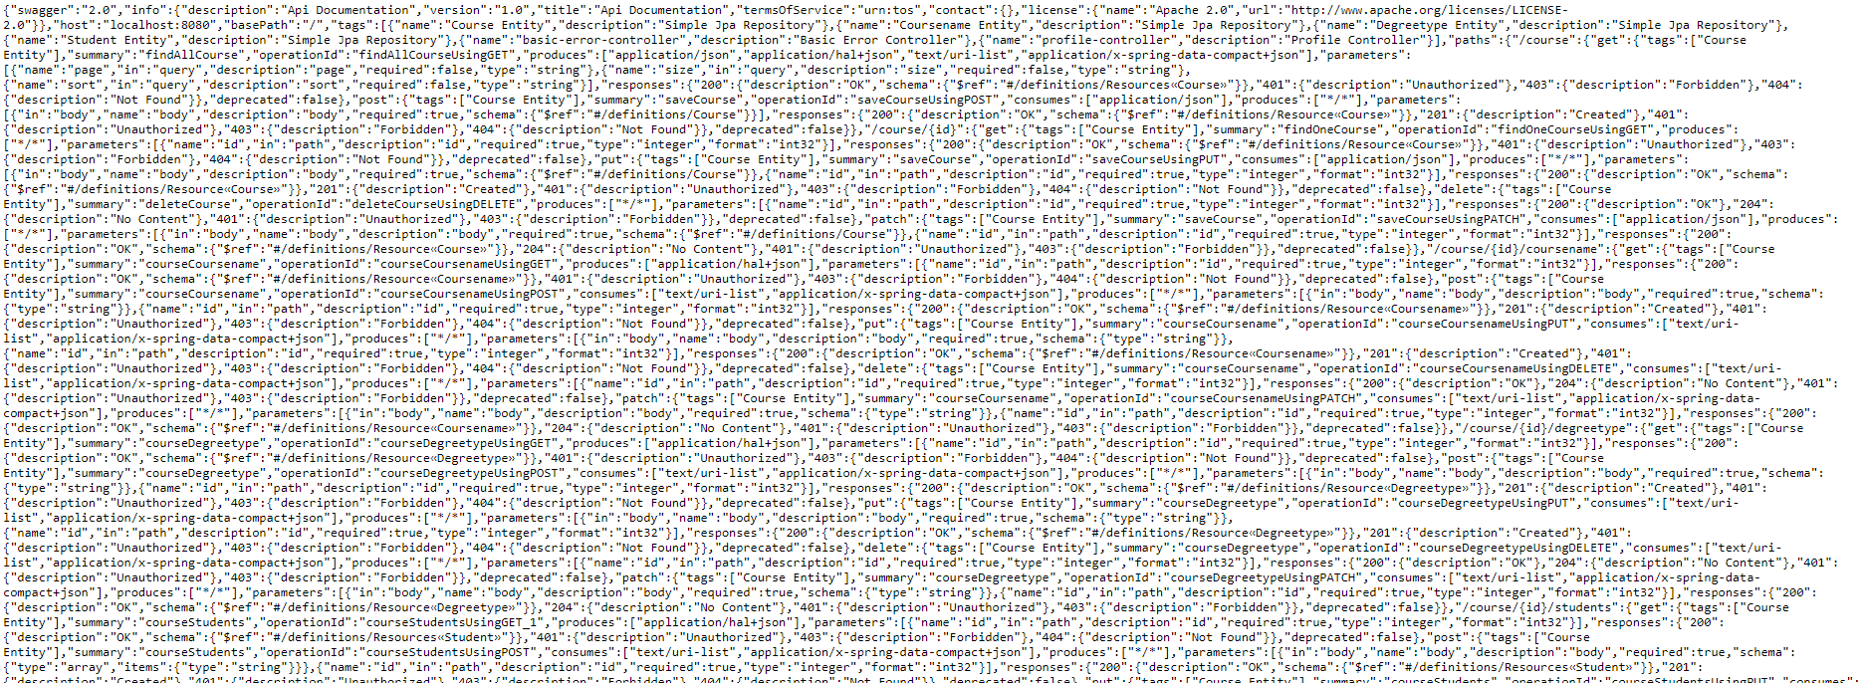
(this goes on for some time…)
You can run this json through a formatter to look at it yourself if you’d like, but remember, this is not really intended to be human-readable.
Instead, we will generate a client. Hopefully, as instructed, you have already installed Swagger Codegen. We will use this to create an automatic client.
We will be creating a Java client for the purpose of this exercise. Of course, web clients are more usually written in web-based languages – but I’m not certain how strong your JavaScript/PHP/etc. are, so we’re sticking with what we know – the joy of OpenAPI is its interoperability, so the principles are the same.

Building a Java client
We will use Swagger Codegen to build the client functionality for us.
Make sure your service is running.
We’re going to run swagger-codegen-cli in generate mode with three parameters:
i: the interface, specifically a link to the json we wish to autogenerate from.
l: the language. In this case Java, but there’s a pretty huge list of possibilities. Remember: everything we are doing is system-agnostic. The client absolutely does not need to be in the same language as the service. We can access our service in any language which can send http requests.
o: the output folder. Where on our filesystem we wish to generate the files.
e.g. from the swagger codegen folder:
java -jar swagger-codegen-cli.jar generate -l java -i http://localhost:8080/v2/api-docs -o "/home/soac/NetBeansProjects/SwaggerClientExample"
Now open this in your IDE (as usual, I’ll be using NetBeans).
Add a class to contain your main and write a main function.
public class MainClass
{
public static void main(String[] args) throws ApiException
{

In our main, we start by specifying our endpoint URL, then creating an APIClient. The APIClient specifies a lot of information about how we connect to our service, including the location, endpoint security, necessary access tokens, etc. At present, our service does not include any security (we’ll look at this next week), so we only need to set the URL.
String apiUrl = "http://localhost:8080/";
ApiClient client = new ApiClient();
client.setBasePath(apiUrl);

Take a look at our swagger-ui configuration page – a list of entities we can access and methods we can call. Let’s create an example which downloads a student and builds information about the course they are studying.
To do this, we can either obtain data from our Student Entity or Address Entity controllers. You can dig into the methods attached to these using the web configuration page. Either is completely valid so, for this example, we’ll use the top-level address controller, then dig into the more granular controllers for the subsequent requests to see both.
AddressEntityApi addressAPI = new AddressEntityApi(client);
This is an automatically generated class, created by the Swagger client. We can take a look at this class if we like, though shouldn’t need to and certainly don’t want to ever change it manually.
We can issue a REST request and unserialise into a POJO (plain old java object) using:
ResourceStudent student = addressAPI.findOneStudentUsingGET(2);
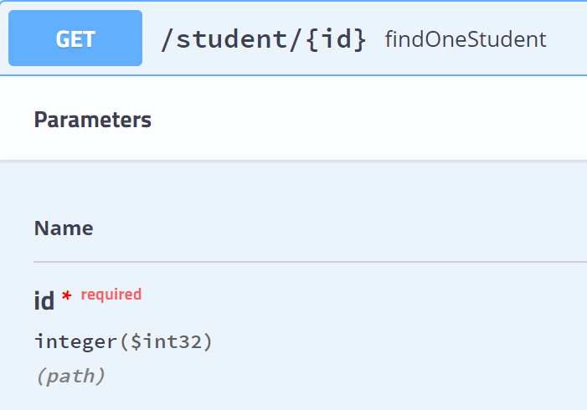
This requests the student with id 2. Again, ResourceStudent is an autogenerated class which supports Links. A version of it which does not support Links is named “Student”. Look at these classes – you’ll notice that, while very similar to our Student.java service class, they’re not the same – in fact, they’re autogenerated by the Swagger client.
Out of curiosity, let’s take a look at this object:
System.out.println(student);
Which gives us:
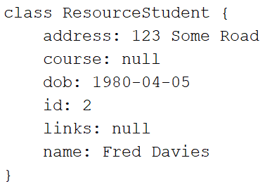
So most of the information seems good – but crucially, course is null. This is because course is a link – if you think about the json generated by this request, it simply doesn’t contain a definition of the course, only a link. We need to resolve this chain manually.
We can obtain some information about the course linked to this student using:
StudentEntityApi studentAPI = new StudentEntityApi(client);
int courseID = studentAPI.studentCourseUsingGET(2).getCourseid();

This is the same as a query to http://localhost:8080/student/2/course - of course, you can print this object to again see that degreetype and coursename are null because they’re links. The id field we are reading into the courseID integer, however, is usable to obtain this information.

String course;

CourseEntityApi courseAPI = new CourseEntityApi(client);
course = courseAPI.courseDegreetypeUsingGET(courseID).getShortcode();
course += " ";
course += courseAPI.courseCoursenameUsingGET(courseID).getCoursename();

Here, we use the API to interact with the course endpoint to obtain the degree type (resolves to a DegreetypeResource), then pull the shortcode, writing it into a string.
The process is repeated, appending the course’s name.
Finally, we can print all of this information.
System.out.println(student.getName());
System.out.println(student.getAddress());
System.out.println(student.getDob());
System.out.println(course);

Run the code to see:
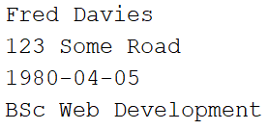
Swagger is a very powerful tool for making the life of a developer easy in implementing a client. We do need some awareness of the linkages between our endpoints where they exist, but these are easy to work around when needed.
Remember: while we have implemented a Java client here, we can create a client in almost any language simply by specifying a different –l parameter in Swagger codegen.
You may notice that Swagger codegen doesn’t generate JavaScript. This is because there’s a better, dynamic library specifically for this.
As an exercise before next week, take a look at it – it’s very easy to use and reasonably well-documented.

Task
Add functionality to your Web Service to support Lecturers and Modules. Lecturer will probably be similar to student – consider which attributes you should include. Modules should have a title, one or more lecturers and one or more students. Consider your database scheme carefully.
Generate Swagger metadata for this, then build a java client (you’ll need to go back through the codegen process) to allow you to view information about a module you specify. This should display the name of the module, information about the lecturer(s) and information about the student(s).

