A handbook for practitioners.

Contents

Introduction of transitions p 2
The needs of the child p 3-5
The role of the adult p
Partnership p
Interventions p
Outcomes p
Reference list p

Introduction
Baker (2020) suggests a transition is a period of change which takes place once starting to move from one significant stage or experience to another. As children progress, they could well eventually face a variety of transitions and significant events that will have different impacts on them. Many of these transformation occasions are common to most children and can usually be expected or predicted, so although others may be unexpected or unanticipated. In all situations, young children will require varying levels of assistance to cope with these changes in their lives. It is critical to remember that transition is a process rather than just a one-time event. Careful plan should be developed ahead of time to expect and meet the needs of the child and their family. Add to that the effect of COVID over the last two years, and we know that this year's transition has the possibility to be far more challenging, but with careful monitoring and preparation, we can all take steps to ensure a positive experience for all. Devon county council (2021). Allingham (2011) suggested Transitions throughout the Early Years is the perfect source to how young children cope emotionally and physically with key stage and setting transitions. This useful handbook Includes a concise definition of transition, Explains the significance of a key person strategy, how to create a realistic environment, and how to work effectively with families during transitions.
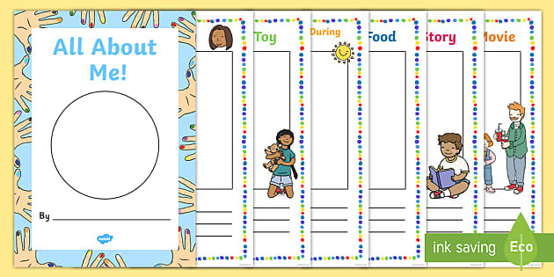 (Pinterest)

The needs of the child
When preparing for a classroom, consider that the main objective should not be to assess his or her learning capacity. It's about supporting him or her in creating good self-esteem and confidence. A child's preparedness for school will be assisted by a positive outlook. Oxfordshire county council (2017). Transitions are significant events in the lives of children and have an important impact on their development. They are excellent opportunities of change, as well as times of new opportunities in the future for every child. They can also be times of confusion, when the environments are different, the expectations and guidelines are different, and the faces are new. Early years matters (2021). Early research of baby and toddler transitions managed to somehow be purely psychological, emphasizing the role of attachment in children's relationships with their care workers and the effect of detachment on children's emotional wellbeing (Dalli 2000). Maslow's motivation theory is known as the "hierarchy of needs." Maslow suggests that humans have five levels of needs, which are prioritised in the following order: Physiological Needs include: I the need to eat, ii) the need to drink, iii) the need to work, iv) the need to sleep, and v) the need to reproduce. Belonging Needs – I) the desire to be a part of a group
ii) the requirement for acceptance. Needs for Self-Esteem – I) the desire to feel competent and self - determining; ii) the desire to be recognised in one's accomplishments. Needs for Self-Esteem – I) the desire to feel good about oneself; ii) the desire to be recognised in one's great achievements. Needs for Self-Realization – I) the emphasis on personal accomplishment
ii) the requirement to learn and expand. Maslow believes that people will not move down the pyramid of needs only until previous set(s) of needs have indeed been fulfilled. Each young person has the right to make choices, feelings, and desires in all matters affecting them, and to also have their personal views considered and considered seriously. This preference always, as well as during immigration proceedings, accommodation decisions, as well as the children's daily home environment. UNCRC (2019). 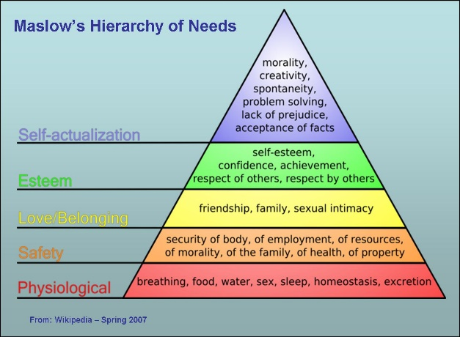 (tastessightssounds)
The new curriculum
The Curriculum for Wales guidance is a concise statement of what is required to provide a wider and reasonable education. The four goals represent a common vision and ambitions for every child and adolescent. In order to achieve these goals, we must set high expectations for all, enhance employee and national fellow human, combat misunderstanding and miscommunication, and start encouraging vital and community - based involvement. Welsh government (2017). The Encouraging Processes Recommendations has been established to support settings and schools in the academic achievement of children ages 3-5, along with learners with additional learning needs (ALN) or profound or multiple learning difficulties (PMLD) who may be at or near the early stages of their educational journey throughout one or maybe more areas. NDNA (2020).
Every child matters
What are the EYFS's four guiding themes and principles?

The Individual Child: From birth, every child is a capable learner capable of being adaptable, capable, self-assured, and identity.
Positive relationships: Children are learning to be strong and confident by growing up in nurturing and safeguard parental support and/or a key figure.
Enabling Environment: The environment is important in trying to promote and widening children's academic achievement.
Learning and Development: Children acquire new knowledge in a variety of ways and at varying levels of intensity, and all aspects of Growth and Teaching are vital and highly integrated. (huggie bears family childcare).
(bing.com).

The role of the adult
The Montessori elementary classroom is built around the art of interacting with children. In order to encourage further adventure, practical application, and deep understanding, it is essential to pique people's interest. The position of the educator is complex. Bergamo,t (1976). This is the place to start for almost any early education professional, as it enables you to gain knowledge regarding children ’s needs, strengths, and weaknesses. observing This seems to be essential information around each child so the surroundings can indeed be successfully scheduled to meet the needs and skills among all children. Numerous settings use their own set charts and frameworks for recording and reporting analyses, so that you can recognise together in range of methods. All conclusions operate the same way: Look, Listen, and Note. This can then be recorded in the form of a single image, stories, tracking file, along with a wide range of other sampling techniques. It is critical that all these statements be gathered and then used to apprise the very next process of preparation. Early years career (2015). Planning Once children interact in lifelong learning, you have always had the ability to engage with them instead than to just make descriptive aspects, which is an important basis of the modern primary education policy changes. This is highly relevant even though your knowledge could very well establish how and why the surroundings is addressed by ensuring. Developing a very well surrounding also requires the organisation of guidelines, limits, and rules of behaviour. When children obey the consequences and what has been anticipated of them, those who will become more self - assured in trying to carry out their experiments. Moore (2020). Key person Starting to settle Just before children start at an early year setting, the Key Person joins with both the child and their caregiver, whether it be at home as well as in the nursery, to organise an appropriate settling in scheme. Those that investigate trivial evidence about the child, including who seems to be in his\her household, what they enjoy doing, and how they recommend being held. It is also the Key Person's responsibility to welcome the child there at beginning of each session and to assist the parent and child as they say their goodbyes. Fulton,d (2003).

Reference list
https://www.twinkl.co.uk/blog/different-types-of-transitions-in-child-development#:~:text=%20Examples%20of%20good%20practice%20for%20supporting%20early,times%20of%20transition.%20Create%20visual%20timetables...%20More%20 Different Types of Transitions in Child Development July 13, 2020 (accessed:20th November 2021).

https://www.pinterest.co.uk/pin/230598443402783630/
Baker, B. et al Children’s Learning and Development Early Years Educator Pearson (2020).

https://www.devon.gov.uk/eycs/supporting-transition-in-the-early-years/ (accessed:20th November 2021).
Allingham,S. (2012) Transitions in the Early Years London.

https://www2.oxfordshire.gov.uk/cms/sites/default/files/folders/documents/childreneducationandfamilies/informationforchildcareproviders/Toolkit/goodpractice/EYTransitionPack.pdf (assessed:22nd November 2021).

https://www.earlyyearsmatters.co.uk/eyfs/positive-relationships/transitions/ (assessed:22nd November 2021).

Dalli, C. (2000) Starting child care: what young children learn about relating to adults in the ﬁrst weeks of starting child care, Early Childhood Research and Practice , 2(2): 1– 31.

https://www.callofthewild.co.uk/library/theory/maslows-hierarchy-of-needs-how-to-motivate-your-staff/ (accessed:23rd November 2021)

https://www.tastessightssounds.com/2015/12/maslows-hierarchy-of-needs.html

https://www.unicef.org.uk/wp-content/uploads/2019/10/UNCRC_summary-1_1.pdf article 12 (accessed: 24th November 2021).

https://gov.wales/curriculum-wales-overview

https://www.ndna.org.uk/NDNA/Cymru/Curriculum_for_Wales_2022.aspx (accessed: 24th November 2021).

https://huggie-bears.co.uk/every-child-matters#:~:text=The%20overarching%20aim%20of%20the%20EYFS%20is%20to,Making%20a%20positive%20contribution%205%20Achieving%20economic%20wellbeing (accessed: 24th November 2021).

https://www.bing.com/search?q=every+child+matters+early+years&cvid=142b020bec4a45feb924f72756d8bad7&aqs=edge.1.69i57j0l2.12259j0j4&FORM=ANAB01&PC=ACTS

https://montessoriguide.org/the-role-of-the-adult/#:~:text=The%20adult%E2%80%99s%20role%20is%20multifaceted.%20Inspiring%20the%20children,over%20the%20three-year%20relationship%2C%20is%20at%20the%20root. (Accessed: 26th November 2021).

https://www.earlyyearscareers.com/eyc/early-years-practice/adults-role-enhancing-continuous-provision/ (accessed: 26th November 2021).

https://cornerstoneseducation.co.uk/news/the-importance-of-continuous-provision-in-the-early-years/ (Accessed: 26th November 2021).

https://eyfs.info/articles.html/general/attachment-theory-and-the-key-person-approach-r64/ ( accessed: 26th November 2021).

